
SECTION 7 Part 135 GH 4A Part 133 GH 4L
Congested Area Plan
Operator: Guardian Helicopters, Inc
67 D STREET
Fillmore CA. 93015
Phone (818) 442-9904
FAX (818) 442-9901
PROJECT: EDISON POLE REPLACEMENT WORK ORDER #: TD 1495601 TD 1491717
ADDRESS: LADERA LANE AND RAMERO CANYON , : SANTA BARBARA CA
LZ STAGING AREA LATITUDE 34°26'41.51"N LONGITUDE 119°35'53.68"W
433581E LATITUDE 34°26'42.64"N LONGITUDE 119°35'59.30"W 40 CL 3 1100 LBS
POLE STAGING AREA LATITUDE 34°26'42.85"N LONGITUDE 119°34'48.07"W
1016095E LATITUDE 34°26'45.66"N LONGITUDE 119°34'49.02"W 35 CL 2 1200 LBS
CONTRACTOR’S NAME: WAYNE RHODES PHONE#: 209-401-6364
CONTACT AT SITE; WAYNE RHODES PHONE#: 209-401-6364
PILOT’S NAME(S): 1. JOHN OLSON CERT #: 2769166
2. BUCKEY MACKAY CERT #: #:2778051
3. MARTIN RODRIGUEZ CERT #: 3555121
4. MICHAEL KLINK CERT# 33018828
TYPE OF AIRCRAFT:
BELL 407 N# N407GH A/C CATEGORY: STANDARD
BELL 205A1 N# N216GH A/C CATEGORY: STANDARD
AS350 B2 N# N498PT A/C CATEGORY: STANDARD
AS350 B3 N# N718GH A/C CATEGORY: STANDARD
AS350 B3 N# N215GH A/C CATEGORY: STANDARD
TYPE OF ITEM LIFTING: POLE AERODYNAMIC NON- AERODYNAMIC
IF SAFETY DICTATES AND OR THE CUSTOMER REQUESTS ADDITIONAL LIFTS THE LIFTS WILL BE CONDUCTED REMAINING WITHIN THE APPROVED TIME PARAMETERS.
TYPE OF LIFTS(1) 40 FT CL 2 1200 LBS (1) 35 CL 3 1100 LBS CLASS OF LOAD: EXTERNAL CL B NO. OF LIFTS: 4 LONG LINE: (NO) XXX (YES) LESS THEN 100 FT+40 POLE +5 RIGGING=145 FT (LENGTH)
OPERATIONAL ALTITUDE: < 50 STREET CLOSING: XX (N0) (YES)
DATE AND TIMES OPERATION WILL BEGIN AND TERMINATE:
FLIGHT DATES | TIME BEGIN |  | TIME END |  | TODAY’S DATE
10-29-2019 | SUNRISE |  | SUNSET |  | 6-25-2019
AGENCY NAME: |  | PHONE#: |  | PERSON NOTIFIED: |  | DATE:
SANTA BARBARA SHERIFF |  | 805-928-3781 |  | WATCH COMMANDER |  | NOTIFY
SANTA BARBARA COUNTY FIRE |  | 805-681-5518 |  | STATION 18 |  | NOTIFY
Evacuation Crowd Control Street Closure
□No Evacuated Structures Operator Yes □ No
Evacuated Structures Contractor Contractor
□Operator

Congested Area Plan (Continued)

LIST OF BUILDINGS THAT SHALL EITHER BE PARTIALLY OR ENTIRELY UNOCCUPIED PERSONS ALSO HOMES THAT WILL BE NOTIFIED OF ACTIVITY:
BUILDING DESCRIPTION/ADDRESS | REMARKS | METHOD
927 LADERA LN | VACANT DURING OPS | HAND DELIVER
925 LADERA LN | VACANT DURING OPS | HAND DELIVER
965 LADERA LN | VACANT DURING OPS | HAND DELIVER
811 ROMERO CANYON RD | VACANT DURING OPS | HAND DELIVER
777 ROMERO CANYON RD | VACANT DURING OPS | HAND DELIVER
975 LILAC DR | VACANT DURING OPS | HAND DELIVER
ALL HOMES WITHIN OPERATING AREA | VACANT DURING OPS | HAND DELIVER
SEE DIAGRAM = V | VACANT DURING OPS | HAND DELIVER
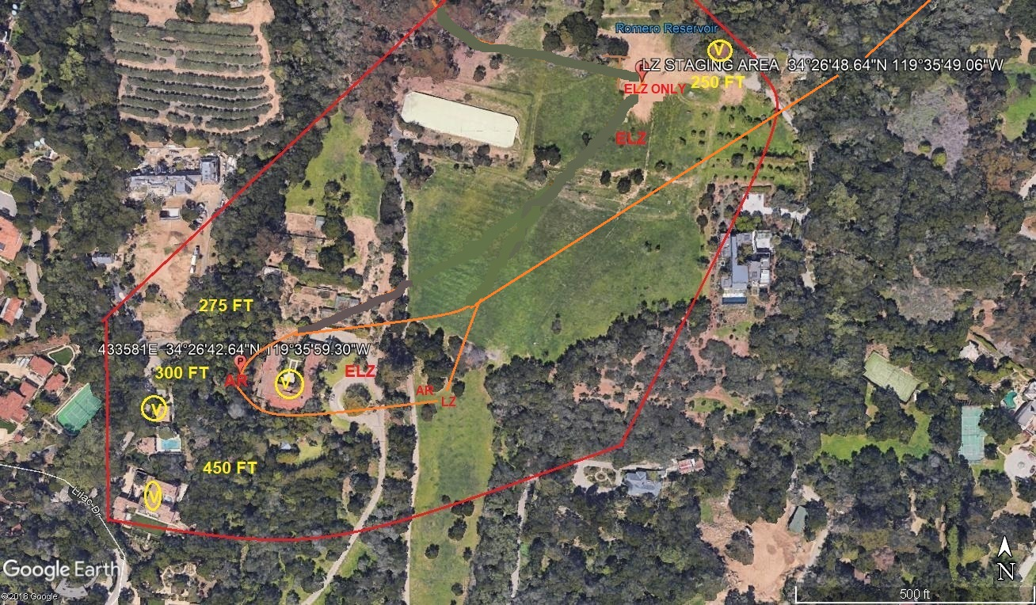
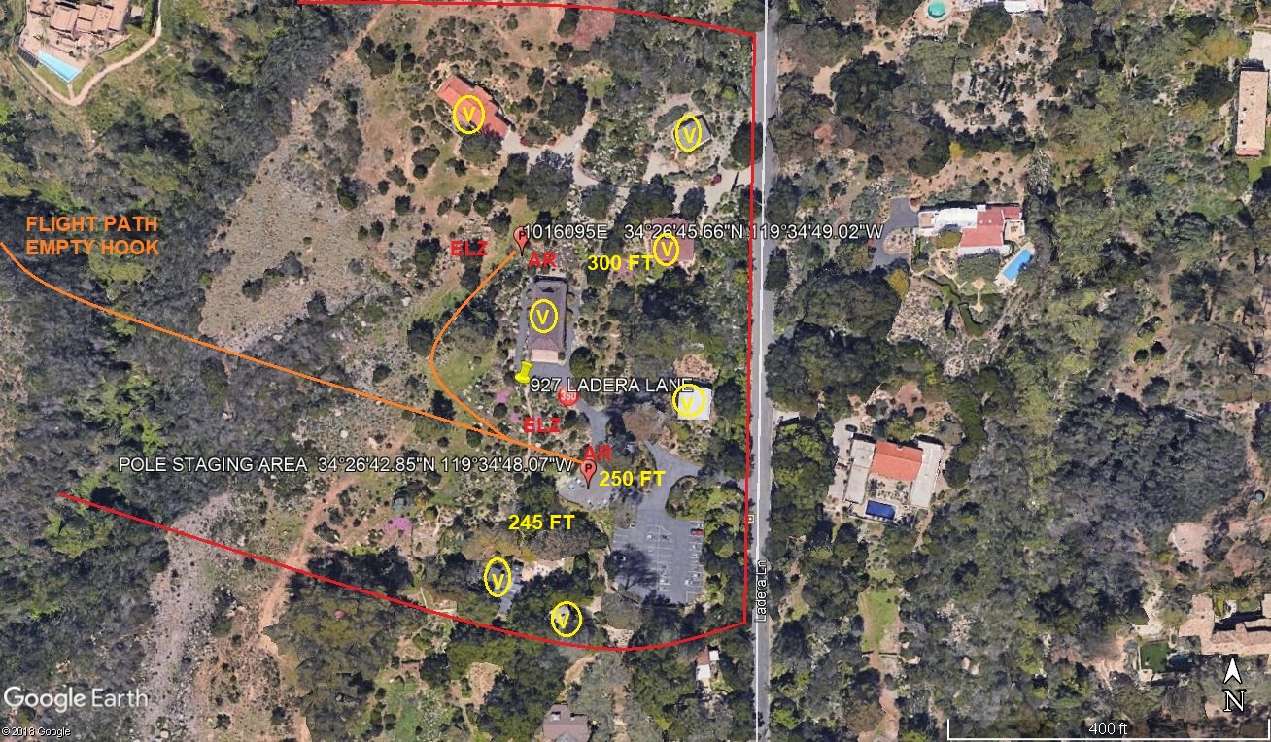
Narrative description of pick-up site, route, delivery site, and plan for ceasing operation if unauthorized persons enter operational area or real hazard occurs.
SITE INSPECTION NOTES

ONLY PERSONNEL ESSENTIAL TO COMPLETING THE JOB SAFELY WILL BE PERMITTED TO PARTICIPATE IN THE EVOLUTION. ONLY PERSONNEL PARTICIPATING IN THE SAFETY BRIEF WILL BE PERMITTED TO BE IN THE AREA OF OPERATIONS. ONLY AUTHORIZED ESSENTIAL PERSONAL WILL BE PERMITTED IN THE IMMEDIATE AREA OF OPERATIONS. IN THE EVENT AN UNAUTHORIZED PERSON ENTERS THE OPERATIONS AREA OR A POTENTIAL HAZARD IS IDENTIFIED THE PILOT WILL HOLD THE AIRCRAFT IN RELATIVE POSITION. THIS WILL BE ACHIEVED WITHOUT OVER FLYING THE GROUND CREW. ALL OPERATIONS WILL BE CEASED UNTIL THE PROBLEM IS RECTIFIED. IN THE EVENT OF AN AIRCRAFT EMERGENCY, THE PILOT WILL RADIO GROUND PERSONNEL AND WILL ATTEMPT TO LAND IN THE EMERGENCY LANDING AREA.
DURING THE LIFT EVOLUTION THE AIRCRAFT AND GROUND CREW WILL ALL BE IN RADIO COMMUNICATIONS. IN THE EVENT OF LOSS COMMUNICATIONS THE CREW WILL USE STANDARD HAND SIGNALS TO COMMUNICATE WITH THE PILOT. WHEN THE PILOT IS CLEAR HE WILL MOVE THE AIRCRAFT TO A SAFE LOCATION TO ALLOW THE COMMUNICATION PROBLEM TO BE RECTIFIED.
THE OPERATIONS AREA IS WITHIN THE SECURED AREA. ALL ESSENTIAL CREW WITHIN THE OPERATIONS AREA WILL NOT BE INVOLVED IN TAKING PICTURES OR ANY OTHER USE OF CELL PHONES.

A TAILBOARD SAFETY MEETING WILL BE HELD AT THE ASSIGNED AREA PRIOR TO BEGINNING HELICOPTER OPERATIONS
- HELICOPTER WILL LAND AT THE ROMARO CANYON LZ STAGING AREA AND WILL ATTACH A LONG LINE. THE HELICOPTER WILL FLY THE LONGLINE TO THE LADERA LN POLE STAGING AREA WITHOUT OVER FLYING ANY POPULATED AREAS
- THE TAILBOARD SAFETY BRIEF WILL BE CONDUCTED AT THE POLES STAGING AREA
- THE TREES AROUND THE POLE WILL NEED TO BE TRIMMED PRIOR TO FLIGHT OPERATIONS
- FUELING WILL NOT BE CONDUCTED AT THE ROMARO CANYON LZ IF REQUIRED
- NO STREET CLOSURES
- 7 HOMES WILL BE EVACUATED DURING OPERATIONS SEE DIAGRAM
- LOCAL AUTHORITIES WILL BE CONTACTED PRIOR TO FLIGHT OPERATIONS

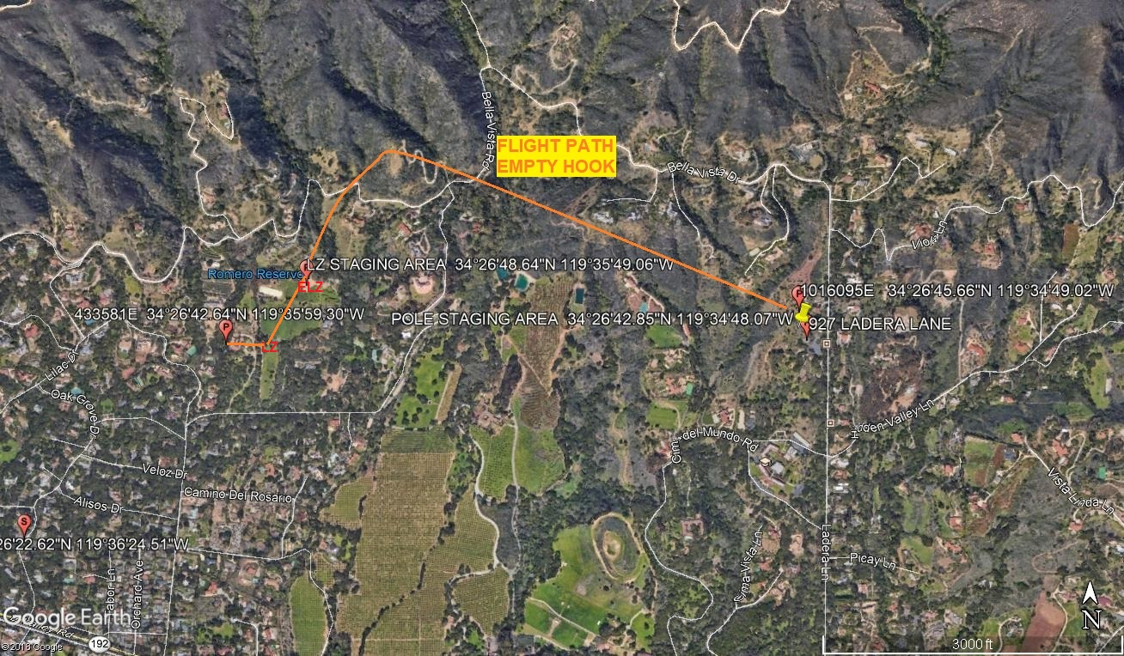
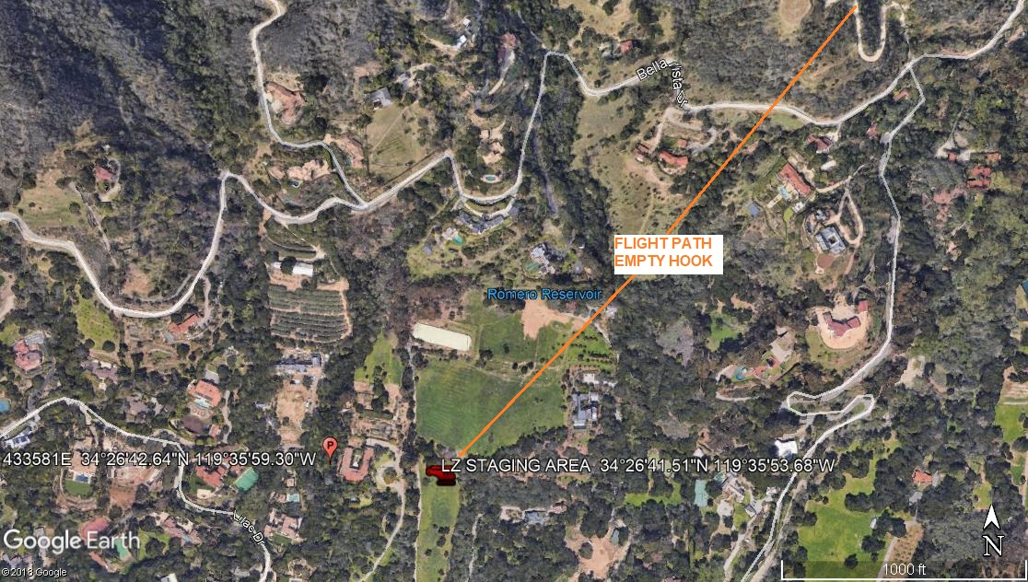LEGEND
SITE PLAN SYMBOLS: EVACUATION FLIGHT PATH
LANDING AREA = (LZ) | STREET BLOCKED = XXXX | TOP TWO FLOORS = UBT2
ATTACH AREA = (A) | RELEASE AREA = (R)
FLIGHT PATH = >>> | EMERGENCY LAND = (ELZ)
UNOCCUPIED BUILDING = (UBA) | UNOCCUPIED BUILDING TOP FLOOR = (UBT1)
7-12-2019 
DATE OF SUBMISSION COMPANY OFFICIAL / TITLE

