
SECTION 7 Part 135 GH 4A Part 133 GH 4L
Congested Area Plan
(Submit in duplicate)
Operator: Guardian Helicopters, Inc
67 D STREET
Fillmore CA. 93015
Phone (818) 442-9904
FAX (818) 442-9901
EDISON POLE REPLACEMENT WORK ORDER NUMBER: TD1536844 TD1536625
ADDRESS 737 LA BUENA TIERRA : SANTA BARBARA CA
LANDING ZONE LATITUDE 34°27'12.62"N 119°48'17.64"W
POLE STAGING AREA LATITUDE 34°27'8.14"N LONGITUDE 119°48'21.22"W
S17096Y LATITUDE 34°27'6.09"N LONGITUDE 119°48'22.22"W 35 CL 2 COMP 1000 LBS
4428705E LATITUDE 34°27'6.03"N LONGITUDE 119°48'22.37"W 45 CL 1 COMP W/ TRANS 1500 LBS
CONTRACTOR’S NAME: HOT LINE CONSTRUCTION PHONE#: 209-401-6364
CONTACT AT SITE; WAYNE RHODES PHONE #: 209-401-6364
PILOT’S NAME(S): 1. JOHN OLSEN CERT #: 2769166
2. BUCKEY MACKAY CERT #:2778051
3. MARTIN RODRIGUEZ CERT #: 3555121
4. MICHAEL KLINK CERT# 3018828
TYPE OF AIRCRAFT:
BELL 205A1 N# N216GH A/C CATEGORY: STANDARD
BELL 407 N# N407GH A/C CATEGORY: STANDARD
AS350 B2 N# N498PT A/C CATEGORY: STANDARD
AS350 B3 N# N718GH A/C CATEGORY: STANDARD
AS350 B3 N# N215GH A/C CATEGORY: STANDARD
TYPE OF ITEM LIFTING: POLE AERODYNAMIC NON- AERODYNAMIC
IF SAFETY DICTATES AND OR THE CUSTOMER REQUESTS ADDITIONAL LIFTS THE LIFTS WILL BE CONDUCTED REMAINING WITHIN THE APPROVED TIME PARAMETERS.
TYPE OF LIFTS: 2 POLE 2 POLE 45 CL 1 COMPOSITE 1250 LBS
MAX SINGLE – LIFT WEIGHT: 1300 LBS CLASS OF LOAD: EXTERNAL
NO. OF LIFTS: 4 LONG LINE: (NO) XXX (YES) 100 FT + 50 FT POLE = 150 FT (LENGTH) WE WILL MAINTAIN A MINIMUM OF THAT SUM AWAY FROM HOMES EDGE OF OPERATING AREA
OPERATIONAL ALTITUDE: < 250 STREET CLOSING: (N0) XXX (YES)
DATE AND TIMES OPERATION WILL BEGIN AND TERMINATE:
FLIGHT DATES | TIME BEGIN | TIME END | TODAY’S DATE
11-6-2019 | 0800 | 1600 | 4-10-2019
AGENCY NAME: | PHONE#: | PERSON NOTIFIED: | DATE:
POLICE DEPARTMENT | 805-681-4100 | WATCH COMMANDER | NOTIFIED
FIRE DEPARTMENT | 805-365-5254 | STATION 4 | NOTIFIED
AIR TRAFFIC CONTROL | 805-683-4011 | SANTA BARBARA AIRPORT | NOTIFIED
Evacuation Crowd Control Street Closure
□No Evacuated Structures Operator Yes □ No
Evacuated Structures Contractor Contractor
□Operator
LIST OF BUILDINGS THAT SHALL EITHER BE PARTIALLY OR ENTIRELY UNOCCUPIED PERSONS ALSO HOMES THAT WILL BE NOTIFIED OF ACTIVITY:
BUILDING DESCRIPTION/ADDRESS | REMARKS | PHONE #:
731 LA BUENA TIERRA | VACANT DURING OPS | HAND DELIVER
737 LA BUENA TIERRA | VACANT DURING OPS | HAND DELIVER
5225 CATHEDRAL OAKS DR | VACANT DURING OPS | HAND DELIVER
5215 CATHEDRAL OAKS RD | VACANT DURING OPS | HAND DELIVER
ALL HOMES WITHIN OPERATING AREA | VACANT DURING OPS | HAND DELIVER
SEE DIAGRAM = V | VACANT DURING OPS | HAND DELIVER
Narrative description of pick-up site, route, delivery site, and plan for ceasing operation if unauthorized persons enter operational area or real hazard occurs.
SITE INSPECTION NOTES
ONLY PERSONNEL ESSENTIAL TO COMPLETING THE JOB SAFELY WILL BE PERMITTED TO PARTICIPATE IN THE EVOLUTION. ONLY PERSONNEL PARTICIPATING IN THE SAFETY BRIEF WILL BE PERMITTED TO BE IN THE AREA OF OPERATIONS. ONLY AUTHORIZED ESSENTIAL PERSONAL WILL BE PERMITTED IN THE IMMEDIATE AREA OF OPERATIONS. IN THE EVENT AN UNAUTHORIZED PERSON ENTERS THE OPERATIONS AREA OR A POTENTIAL HAZARD IS IDENTIFIED THE PILOT WILL HOLD THE AIRCRAFT IN RELATIVE POSITION. THIS WILL BE ACHIEVED WITHOUT OVER FLYING THE GROUND CREW. ALL OPERATIONS WILL BE CEASED UNTIL THE PROBLEM IS RECTIFIED. IN THE EVENT OF AN AIRCRAFT EMERGENCY, THE PILOT WILL RADIO GROUND PERSONNEL AND WILL ATTEMPT TO LAND IN THE EMERGENCY LANDING AREA. ALL BUILDINGS IN THE OPERATING AREA WILL BE VACANT.
DURING THE LIFT EVOLUTION THE AIRCRAFT AND GROUND CREW WILL ALL BE IN RADIO COMMUNICATIONS. IN THE EVENT OF LOSS COMMUNICATIONS THE CREW WILL USE STANDARD HAND SIGNALS TO COMMUNICATE WITH THE PILOT. WHEN THE PILOT IS CLEAR HE WILL MOVE THE AIRCRAFT TO A SAFE LOCATION TO ALLOW THE COMMUNICATION PROBLEM TO BE RECTIFIED.
THE OPERATIONS AREA IS WITHIN THE SECURED AREA. ALL ESSENTIAL CREW WITHIN THE OPERATIONS AREA WILL NOT BE INVOLVED IN TAKING PICTURES OR ANY OTHER USE OF CELL PHONES.
A TAILBOARD SAFETY MEETING WILL BE HELD AT THE ASSIGNED AREA PRIOR TO BEGINNING HELICOPTER OPERATIONS
- THE HELICOPTER WILL FUEL AND THE LONGLINE WILL BE ATTACHED AT LZ IN THE CUL-DE-SAC AT THE END OF POINSETTIA WAY
- THE EMPTY LONGLINE WILL BE FLOWN FROM THE LZ TO THE POLE STAGING AREA
- THE POLE STAGING AREA IS TO THE SOUTH OF CATHEDRAL OAKS RD
- 4 HOMES WILL BE EVACUATED. STREET CLOSURE CREW WILL ASSIST IN VERIFYING VACANCY
- WATER TRUCK NOT REQUIRED
- POINSETTIA WAY , CATHEDRAL OAKS AND LA GUENA TIERRA PLACE WILL EXPERIENCE INTERMITTENT STREET CLOSURES
- EMERGENCY LANDING ZONE IS NEAR THE POLE SET SITE AND STAGING AREA
- SANTA BARBARA COUNTY SHERIFF AND FIRE DEPARTMENT WILL BE NOTIFIED.
- THE SECURE AREA IS GREATER THEN 300 FT IN ALL DIRECTIONS FROM THE ATTACH AND RELEASE AREAS
OPERATIONS AREA DIAGRAM

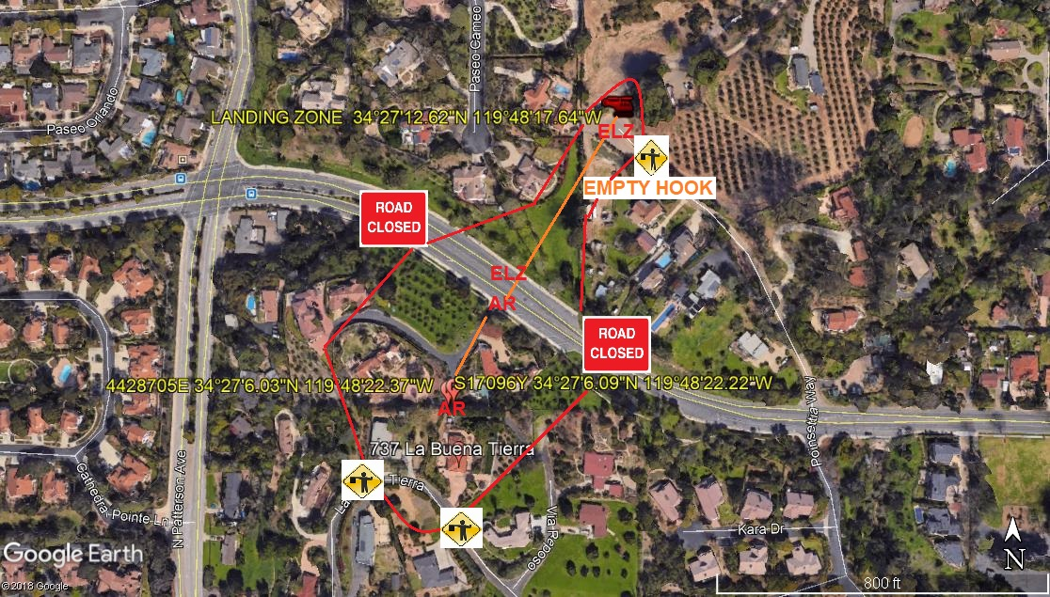
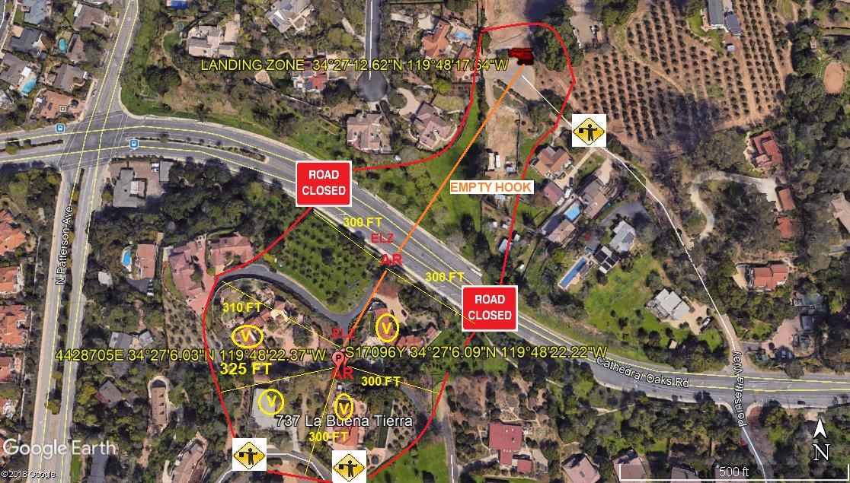
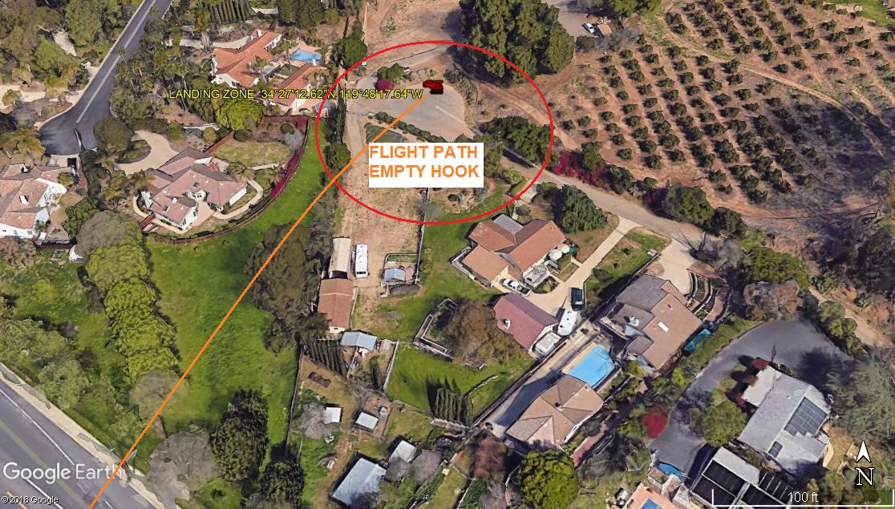
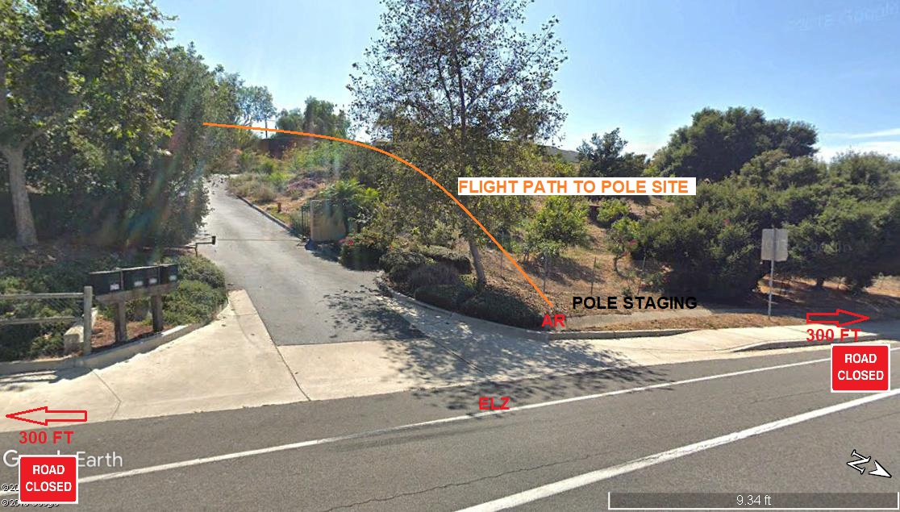
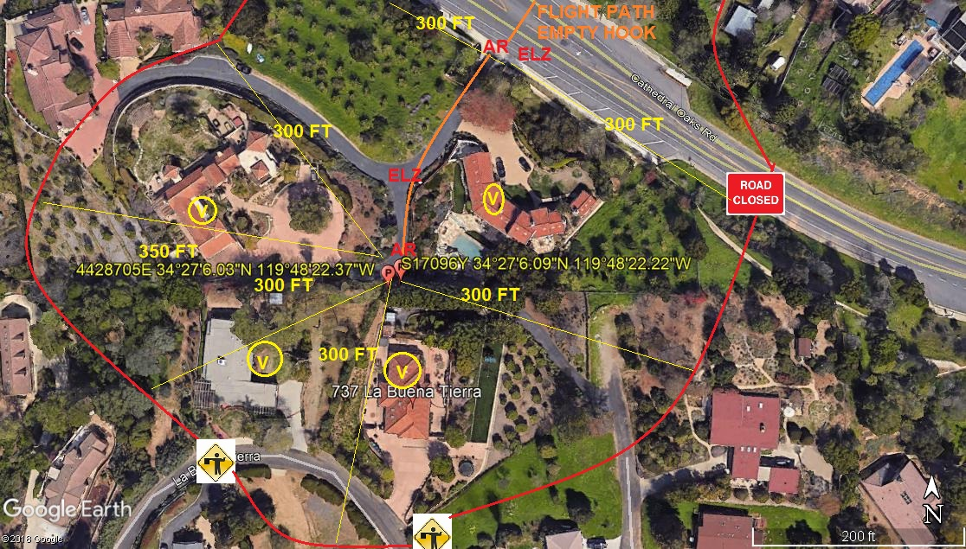
LEGEND
SITE PLAN SYMBOLS: EVACUATION FLIGHT PATH
LANDING AREA = (LZ) | STREET BLOCKED = XXXX | TOP TWO FLOORS = UBT2
ATTACH AREA = (A) | RELEASE AREA = (R) | V = VACANT
FLIGHT PATH = >>> | EMERGENCY LAND = (ELZ)
UNOCCUPIED BUILDING = (UBA) | UNOCCUPIED BUILDING TOP FLOOR = (UBT1)

10-30-2019 
DATE OF SUBMISSION COMPANY OFFICIAL / TITLE

