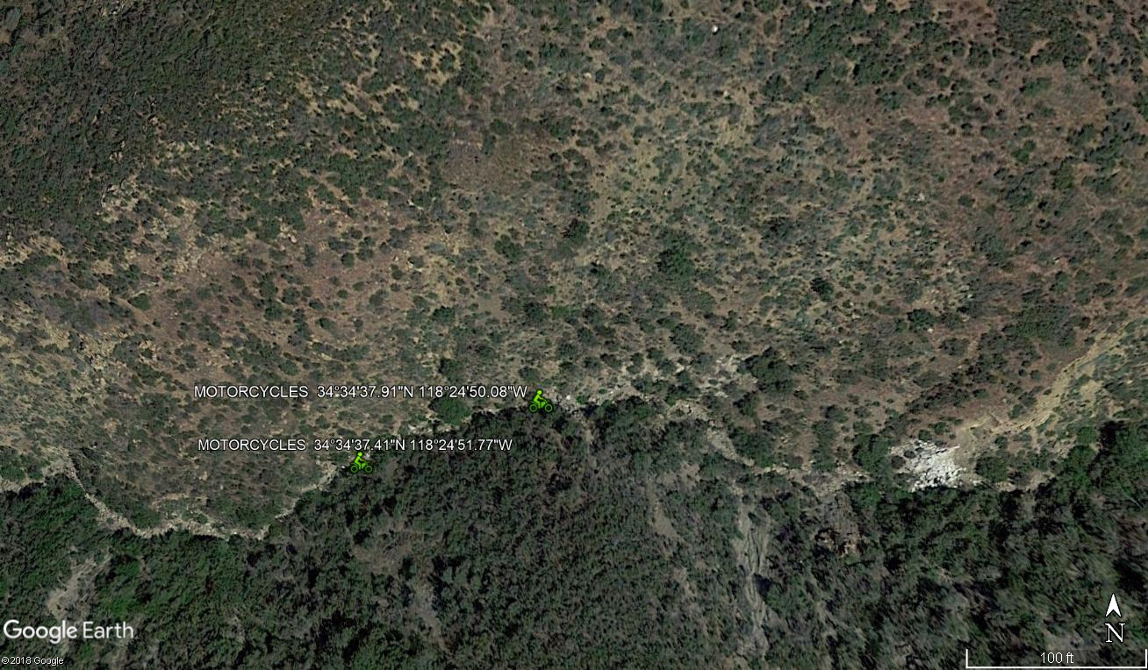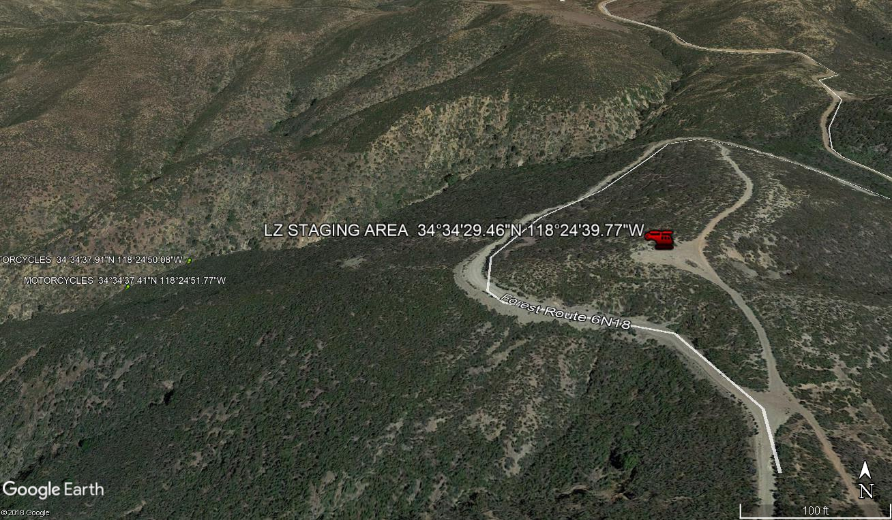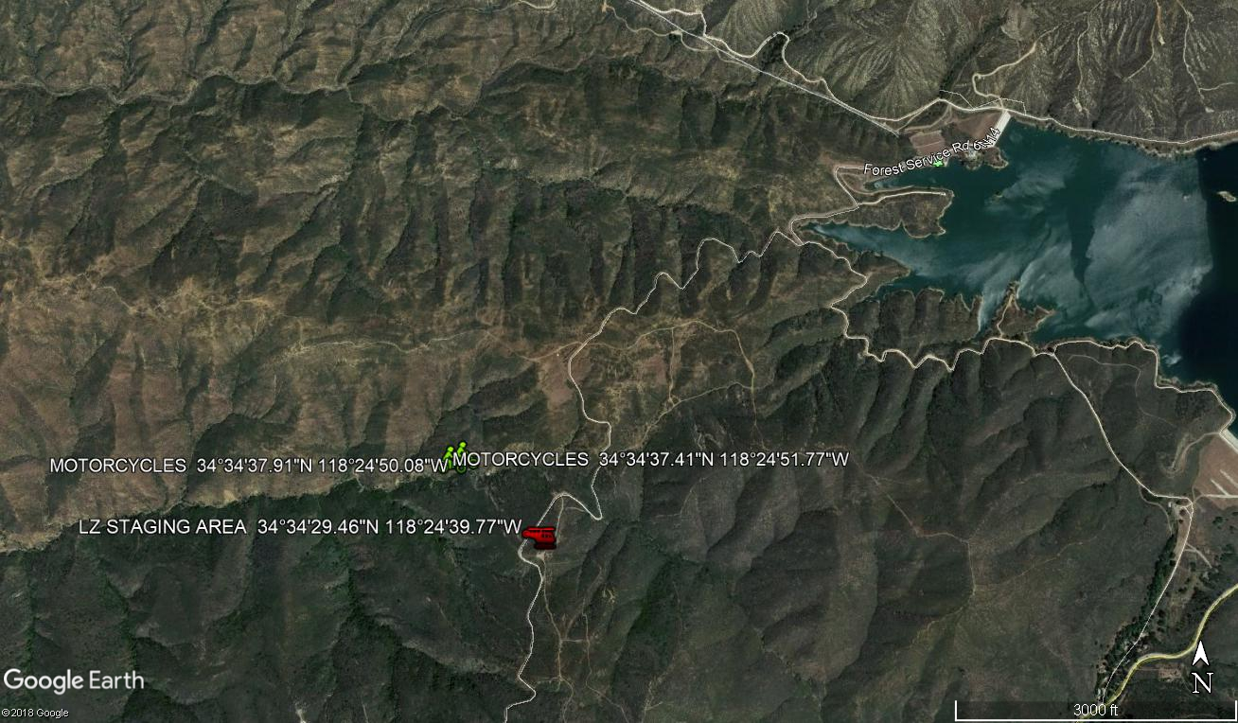

Hi Jeffrery ,thanks again for helping with the motorcycle recovery!
Location of the 3 bikes from our cell phones:

34°34'37.1"N 118°24'51.5”W
Location via my Garmin (slightly different but along the same creek):
N34.577198 W118.413911
This could be a good drop off location since it’s an open area on top of the ridge-line next to 6N18 where we will have a truck ready.
34°34'29.5"N 118°24'39.8"W
please let me know if you need any more details or information i’m around anytime. i know you have my number but here it is just incase. 323-481-9261

