
SECTION 7 Part 135 GH 4A Part 133 GH 4L

Congested Area Plan
Operator: Guardian Helicopters, Inc
67 D STREET
Fillmore CA. 93015
Phone (818) 442-9904
FAX (818) 442-9901
PROJECT: EDISON POLE REPLACEMENT WORK ORDER #: TD 140476
ADDRESS: 3919 ANTONE ROAD : SANTA BARBARA CA
POLE STAGING AREA LATITUDE 34°27'23.95"N LONGITUDE 119°45'5.35"W
4466786E LATITUDE 34°27'22.94"N LONGITUDE 119°45'9.48"W
CONTRACTOR’S NAME: WAYNE RHODES PHONE#: 209-401-6364
CONTACT AT SITE; HOTLINE CONSTRUCTION PHONE #: 209-401-6364
PILOT’S NAME(S):
1. JOHN OLSON CERT #: 2769166
2. BUCKEY MACKAY CERT #: 2778051
3. MARTIN RODRIGUEZ CERT #: 3555121
4. MICHAEL KLINK CERT# 3018828
TYPE OF AIRCRAFT:
BELL UH-1H N# N711GH A/C CATEGORY: RESTRICTED
BELL UH-1H N# N214KK A/C CATEGORY: RESTRICTED
BELL 407 N# N407GH A/C CATEGORY: STANDARD
BELL 205A1 N# N216GH A/C CATEGORY: STANDARD
AS350 B2 N# N498PT A/C CATEGORY: STANDARD
AS350 B3 N# N718GH A/C CATEGORY: STANDARD
AS350 B3 N# N215GH A/C CATEGORY: STANDARD
TYPE OF ITEM LIFTING: POLE AERODYNAMIC NON- AERODYNAMIC
IF SAFETY DICTATES AND OR THE CUSTOMER REQUESTS ADDITIONAL LIFTS THE LIFTS WILL BE CONDUCTED REMAINING WITHIN THE APPROVED TIME PARAMETERS.
TYPE OF LIFTS 1 POLES LARGEST 45 CL 3 1500 LBS
MAX SINGLE – LIFT WEIGHT: 1500 LBS CLASS OF LOAD: EXTERNAL CL B
NO. OF LIFTS: 2 LONG LINE: (NO) XXX (YES) LESS THEN 100 FT+45 POLE +5 RIGGING=150 FT (LENGTH)
OPERATIONAL ALTITUDE: < 50 STREET CLOSING: XX (N0) (YES)
DATE AND TIMES OPERATION WILL BEGIN AND TERMINATE:
FLIGHT DATES | TIME BEGIN |  | TIME END | TODAY’S DATE
11-8-2019 | SUNRISE |  | SUNSET | 10-5-2019
AGENCY NAME: | PHONE#: | PERSON NOTIFIED: |  | DATE:
SANTA BARBARA SHERIFF | 805-928-3781 | WATCH COMMANDER |  | NOTIFY
SANTA BARBARA COUNTY FIRE | 805-681-5518 | STATION 18 |  | NOTIFY

Evacuation Crowd Control Street Closure
□No Evacuated Structures Operator Yes □ No
Evacuated Structures Contractor Contractor
□Operator
LIST OF BUILDINGS THAT SHALL EITHER BE PARTIALLY OR ENTIRELY UNOCCUPIED PERSONS ALSO HOMES THAT WILL BE NOTIFIED OF ACTIVITY:
BUILDING DESCRIPTION/ADDRESS | REMARKS | METHOD
3919 ANTONE RD | VACANT DURING OPS | HAND DELIVER
3929 ANTONE RD | VACANT DURING OPS | HAND DELIVER
3933 ANTONE RD | VACANT DURING OPS | HAND DELIVER
3923 ANTONE RD | VACANT DURING OPS | HAND DELIVER
3930 ANTONE RD | VACANT DURING OPS | HAND DELIVER
3924 ANTONE RD | VACANT DURING OPS | HAND DELIVER
3914 ANTONE RD | VACANT DURING OPS | HAND DELIVER
3917 ANTONE RD | VACANT DURING OPS | HAND DELIVER
3914 ANTONE RD | VACANT DURING OPS | HAND DELIVER
3916 ANTONE RD | VACANT DURING OPS | HAND DELIVER
3924 ANTONE RD | VACANT DURING OPS | HAND DELIVER
ALL HOMES WITHIN OPERATING AREA | VACANT DURING OPS | HAND DELIVER
SEE DIAGRAM = V | VACANT DURING OPS | HAND DELIVER
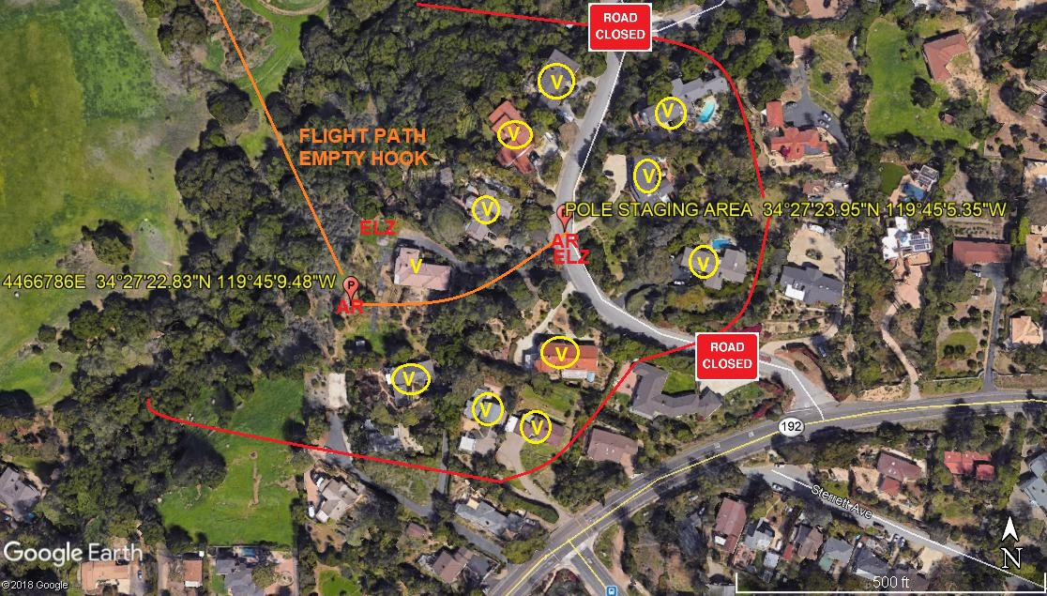

Congested Area Plan (Continued)

Narrative description of pick-up site, route, delivery site, and plan for ceasing operation if unauthorized persons enter operational area or real hazard occurs.
SITE INSPECTION NOTES

ONLY PERSONNEL ESSENTIAL TO COMPLETING THE JOB SAFELY WILL BE PERMITTED TO PARTICIPATE IN THE EVOLUTION. ONLY PERSONNEL PARTICIPATING IN THE SAFETY BRIEF WILL BE PERMITTED TO BE IN THE AREA OF OPERATIONS. ONLY AUTHORIZED ESSENTIAL PERSONAL WILL BE PERMITTED IN THE IMMEDIATE AREA OF OPERATIONS. IN THE EVENT AN UNAUTHORIZED PERSON ENTERS THE OPERATIONS AREA OR A POTENTIAL HAZARD IS IDENTIFIED THE PILOT WILL HOLD THE AIRCRAFT IN RELATIVE POSITION. THIS WILL BE ACHIEVED WITHOUT OVER FLYING THE GROUND CREW. ALL OPERATIONS WILL BE CEASED UNTIL THE PROBLEM IS RECTIFIED. IN THE EVENT OF AN AIRCRAFT EMERGENCY, THE PILOT WILL RADIO GROUND PERSONNEL AND WILL ATTEMPT TO LAND IN THE EMERGENCY LANDING AREA.
DURING THE LIFT EVOLUTION THE AIRCRAFT AND GROUND CREW WILL ALL BE IN RADIO COMMUNICATIONS. IN THE EVENT OF LOSS COMMUNICATIONS THE CREW WILL USE STANDARD HAND SIGNALS TO COMMUNICATE WITH THE PILOT. WHEN THE PILOT IS CLEAR HE WILL MOVE THE AIRCRAFT TO A SAFE LOCATION TO ALLOW THE COMMUNICATION PROBLEM TO BE RECTIFIED.
THE OPERATIONS AREA IS WITHIN THE SECURED AREA. ALL ESSENTIAL CREW WITHIN THE OPERATIONS AREA WILL NOT BE INVOLVED IN TAKING PICTURES OR ANY OTHER USE OF CELL PHONES.

A TAILBOARD SAFETY MEETING WILL BE HELD AT THE ASSIGNED AREA PRIOR TO BEGINNING HELICOPTER OPERATIONS

- HELICOPTER WILL LAND AT A REMOTE LZ TO THE NORTH TO CONNECT LONGLINE AND FLY AN EMPTY HOOK TO THE POLE STAGING AREA WITHOUT OVERFLYING ANY BUILDINGS OR OCCUPIED ROADWAYS
- A TAILBOARD SAFETY BRIEF WILL BE HELD AT THE POLE STAGING AREA PRIOR TO COMMENCING OPERATIONS
- THE GROUND CREW AND STREET EVACUATION PERSONNEL WILL ENSURE ALL ASSIGNED HOMES ARE VACANT
- WATER TRUCK IS NOT REQUIRED
- 11 HOMES WILL BE EVACUATED
- ANTONE ROAD WILL EXPERIENCE INTERMITTENT CLOSURES
- CUSTOMER WILL ENSURE THE TREES ARE TRIMMED IF REQUIRED.
- THE POLE WILL BE STAGED ON ANTONE ROAD. THE POLE WILL BE LIFTED AND FLOWN WITHOUT OVERFLYING ANY HOMES

10-1-2019 
DATE OF SUBMISSION COMPANY OFFICIAL / TITLE

-23-


Part 135 GH 4A Part 133 GH 4L
OPERATIONS AREA DIAGRAM
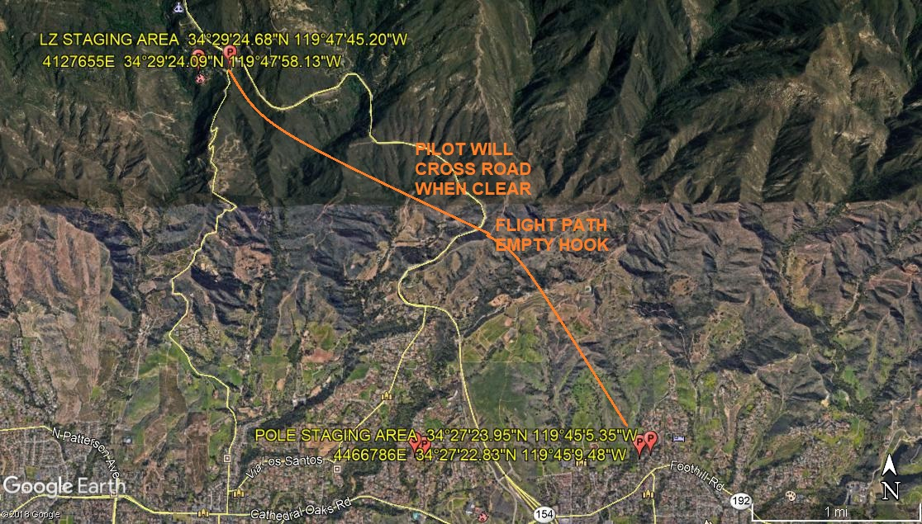
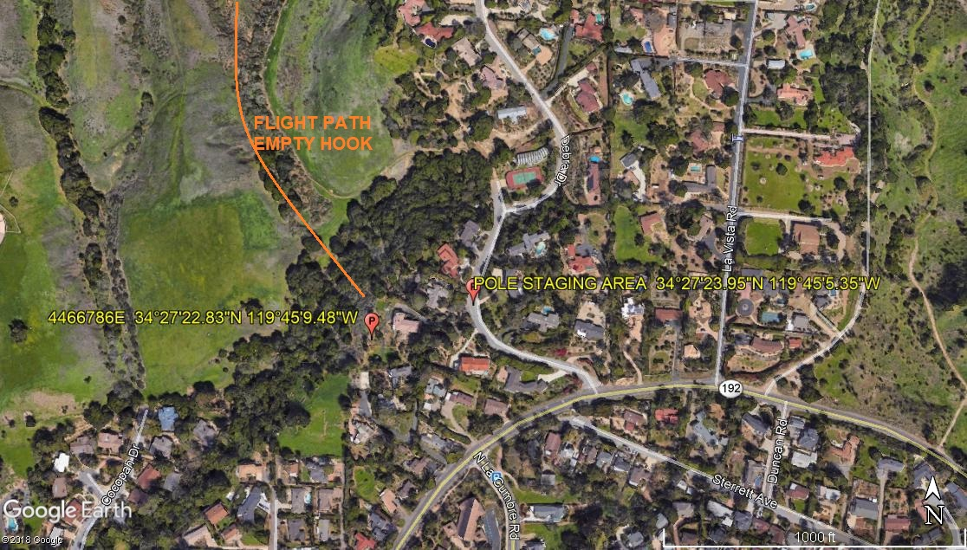
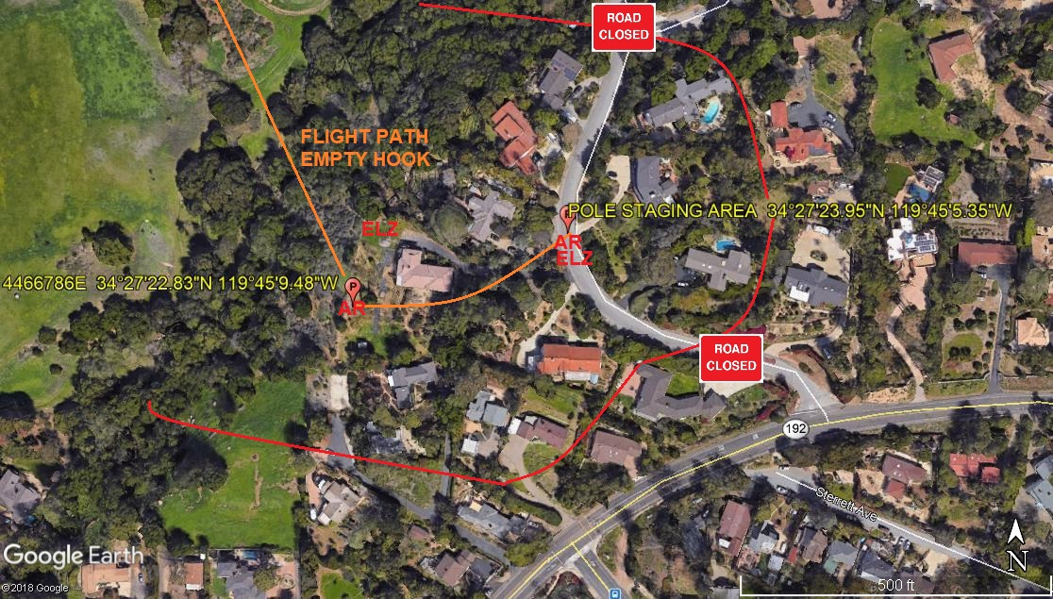
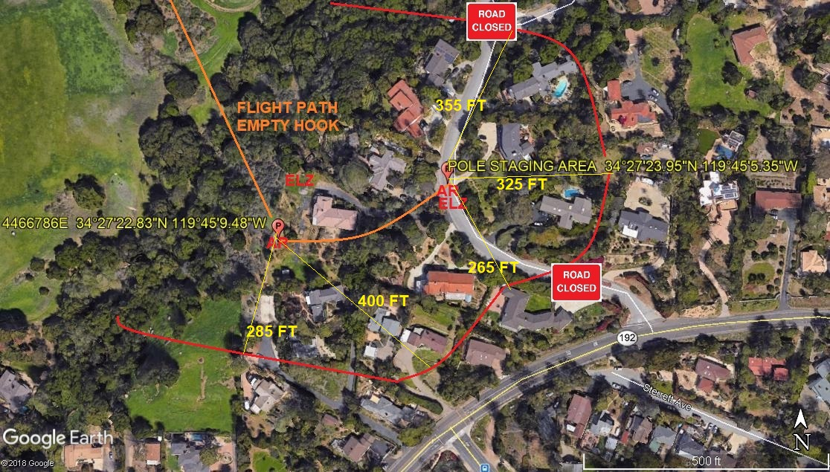
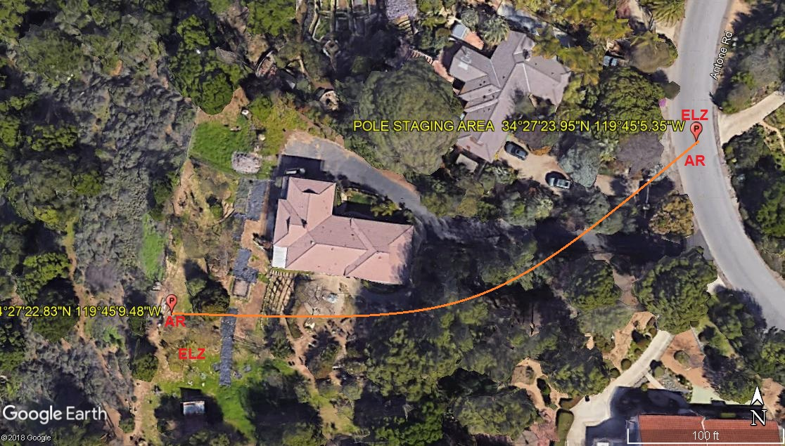
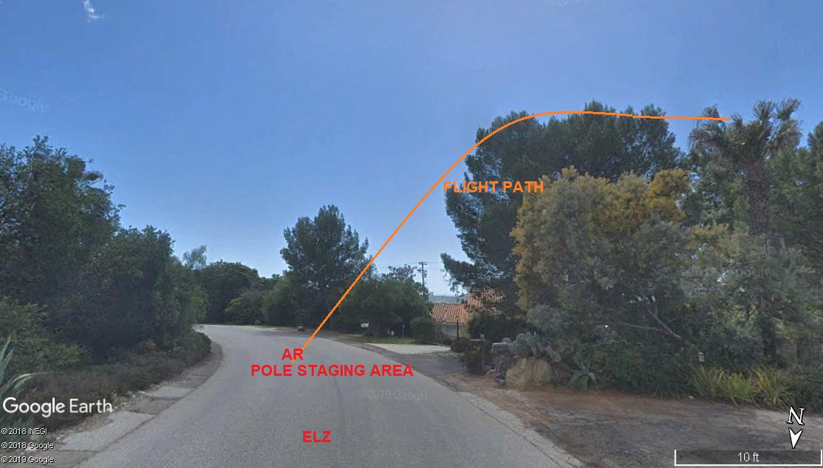
LEGEND
SITE PLAN SYMBOLS: EVACUATION FLIGHT PATH
LANDING AREA = (LZ) | STREET BLOCKED = XXXX | TOP TWO FLOORS = UBT2
ATTACH AREA = (A) | RELEASE AREA = (R)
FLIGHT PATH = >>> | EMERGENCY LAND = (ELZ)
UNOCCUPIED BUILDING = (UBA) | UNOCCUPIED BUILDING TOP FLOOR = (UBT1)
AREA SURVEY CONDUCTED BY :

