
SECTION 7 Part 135 GH 4A Part 133 GH 4L
NON-Congested Area Plan
Operator: Guardian Helicopters, Inc
67 D STREET
Fillmore CA. 93015
Phone (818) 442-9904
FAX (818) 442-9901
PROJECT : EDISON POLE REPLACEMENT WORK ORDER #: TD 1342432 TD1332755
ADDRESS: CHINA PEAK : MAMOTH POOL HUNTINGTON LK CA
LZ TAILBOARD 0730 LATITUDE 37°14'7.76"N LONGITUDE 119° 9'9.72"W
POLE STAGING AREA LATITUDE 37°14'33.38"N LONGITUDE 119° 9'57.83"W
1030955E LATITUDE 37°14'55.00"N LONGITUDE 119°10'54.02"W
1030975E LATITUDE 37°14'46.05"N LONGITUDE 119°11'22.96"W
LZ STAGING AREA LATITUDE 37°19'39.07"N LONGITUDE 119°19'28.78"W
1215424E LATITUDE 37°18'43.40"N LONGITUDE 119°20'57.47"W
CONTRACTOR’S NAME: HOTLINE COLBY WHITE PHONE#: 925-529-0524
CONTACT AT SITE; CHARLES CALVO PHONE #: 559-280-7850
CONTACT AT SITE; KEVIN HOLMES PHONE #: 559-331-9091
PILOT’S NAME(S): 1. JOHN OLSON CERT #: 2769166
2. BUCKEY MACKAY CERT #: #:2778051
3. MARTIN RODRIGUEZ CERT #: 3555121
4. MICHAEL KLINK CERT# 33018828
5. IAN GOODALE CERT# 3741973
TYPE OF AIRCRAFT:BELL UH-1H N# N711GH A/C CATEGORY: RESTRICTED
BELL UH-1H N# N214KK A/C CATEGORY: RESTRICTED
BELL 205A1 N# N216GH A/C CATEGORY: STANDARD
BELL 407 N# N407GH A/C CATEGORY: STANDARD
AS350 B2 N# N498PT A/C CATEGORY: STANDARD
AS350 B3 N# N718GH A/C CATEGORY: STANDARD
AS350 B3 N# N215GH A/C CATEGORY: STANDARD
TYPE OF ITEM LIFTING: POLE AERODYNAMIC NON- AERODYNAMIC
IF SAFETY DICTATES AND OR THE CUSTOMER REQUESTS ADDITIONAL LIFTS THE LIFTS WILL BE CONDUCTED REMAINING WITHIN THE APPROVED TIME PARAMETERS.
TYPE OF LIFTS: (3 ) 50 CL 1 COMP POLE LESS 1600LBS
MAX SINGLE – LIFT WEIGHT: 2000 LBS CLASS OF LOAD: EXTERNAL
NO. OF LIFTS: 30 LONG LINE: (NO) XXX (YES) 150 FT (LENGTH)
OPERATIONAL ALTITUDE: < 250 STREET CLOSING: (N0) XX (YES)
DATE AND TIMES OPERATION WILL BEGIN AND TERMINATE:
FLIGHT DATES | TIME BEGIN |  | TIME END |  | TODAY’S DATE
11-4-2019 | 0800 |  | 1600 |  | 10-30-2019
AGENCY NAME: |  | PHONE#: |  | PERSON NOTIFIED: |  | DATE:
KERN COUNTY SHERIFF |  | 760-549-2100 |  | LAKE ISALBELLA |  | NOTIFY
KERN COUNTY FIRE |  | 760-376-2219 |  | STATION 76 |  | NOTIFY
NON- Congested Area Plan (Continued)
Evacuation Crowd Control Street Closure

No Evacuated Structures Operator Yes □ No
□Evacuated Structures Contractor Contractor
□Operator

LIST OF BUILDINGS THAT SHALL EITHER BE PARTIALLY OR ENTIRELY UNOCCUPIED PERSONS:
BUILDING DESCRIPTION/ADDRESS | OWNER(S): | PHONE #:
N/A | N/A | N/A

Narrative description of pick-up site, route, delivery site, and plan for ceasing operation if unauthorized persons enter operational area or real hazard occurs.
SITE INSPECTION NOTES

ONLY PERSONNEL ESSENTIAL TO COMPLETING THE JOB SAFELY WILL BE PERMITTED TO PARTICIPATE IN THE EVOLUTION. ONLY PERSONNEL PARTICIPATING IN THE SAFETY BRIEF WILL BE PERMITTED TO BE IN THE AREA OF OPERATIONS. ONLY AUTHORIZED ESSENTIAL PERSONAL WILL BE PERMITTED IN THE IMMEDIATE AREA OF OPERATIONS. IN THE EVENT AN UNAUTHORIZED PERSON ENTERS THE OPERATIONS AREA OR A POTENTIAL HAZARD IS IDENTIFIED THE PILOT WILL HOLD THE AIRCRAFT IN RELATIVE POSITION. THIS WILL BE ACHIEVED WITHOUT OVER FLYING THE GROUND CREW. ALL OPERATIONS WILL BE CEASED UNTIL THE PROBLEM IS RECTIFIED. IN THE EVENT OF AN AIRCRAFT EMERGENCY, THE PILOT WILL RADIO GROUND PERSONNEL AND WILL ATTEMPT TO LAND IN THE EMERGENCY LANDING AREA.
DURING THE LIFT EVOLUTION THE AIRCRAFT AND GROUND CREW WILL ALL BE IN RADIO COMMUNICATIONS. IN THE EVENT OF LOSS COMMUNICATIONS THE CREW WILL USE STANDARD HAND SIGNALS TO COMMUNICATE WITH THE PILOT. WHEN THE PILOT IS CLEAR HE WILL MOVE THE AIRCRAFT TO A SAFE LOCATION TO ALLOW THE COMMUNICATION PROBLEM TO BE RECTIFIED.
THE OPERATIONS AREA IS WITHIN THE SECURED AREA. ALL ESSENTIAL CREW WITHIN THE OPERATIONS AREA WILL NOT BE INVOLVED IN TAKING PICTURES OR ANY OTHER USE OF CELL PHONES.

TAIL BOARD SAFETY MEETING WILL BE HELD AT A PREARRANGED LOCATION PRIOR TO BEGINNING OPERATIONS
1. HELICOPTER WILL LAND AT THE CHINA PEAK PARKING LOT
2. FUELING WILL ONLY BE CONDUCTED AT CHINA PEAK STAGING AREA
3. EMERGENCY LANDING ZONE IS AT THE STAGING AREA AND ALONG THE FLIGHT PATH
4. REMOTE AREA OPERATING AREA NO BUILDING EVACUATION REQUIRED
5. WATER TRUCK WILL BE PROVIDED STAGING LANDING AREA
6. THE BOAT DOCK WILL NEED TO BE CLEAR OF PEDESTRIANS
7. FLAGMAN WILL BE PROVIDED PER THE DRAWING

10-30-2019 
DATE OF SUBMISSION COMPANY OFFICIAL / TITLE

OPERATIONS AREA DIAGRAM
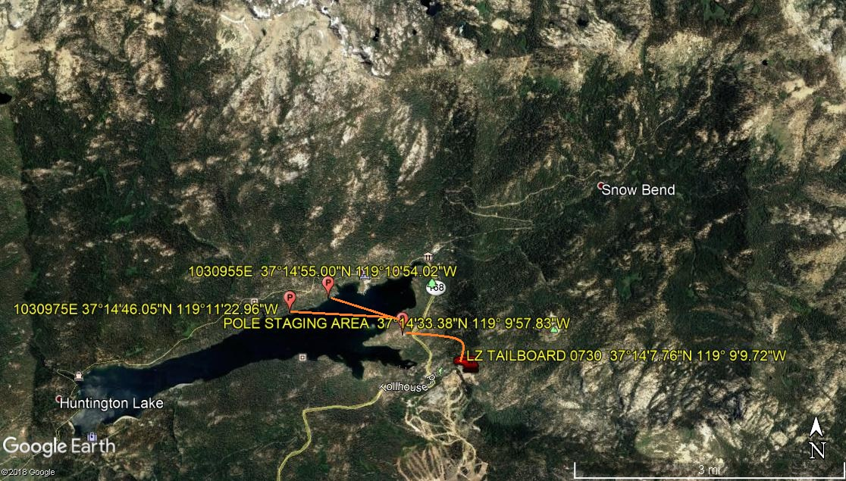

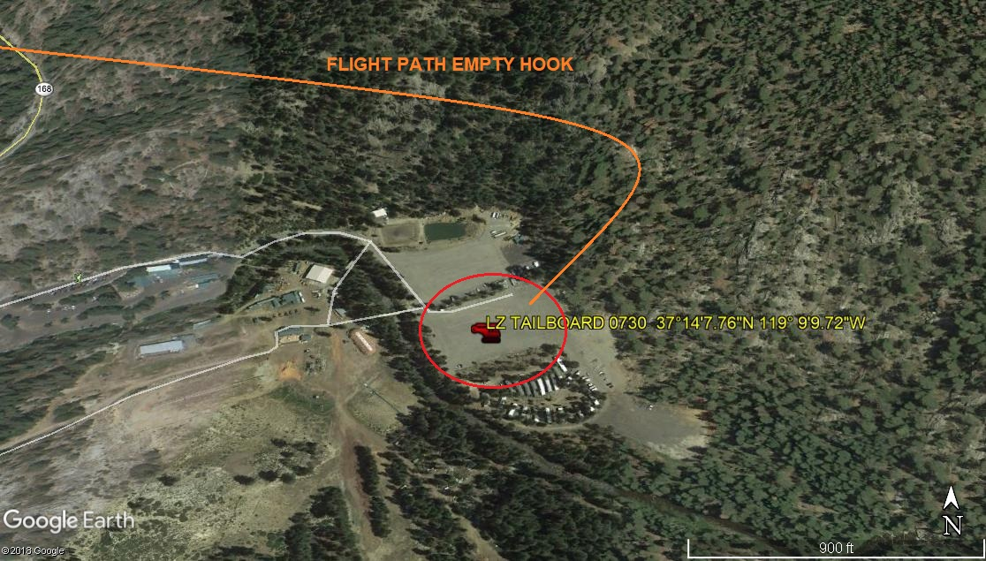

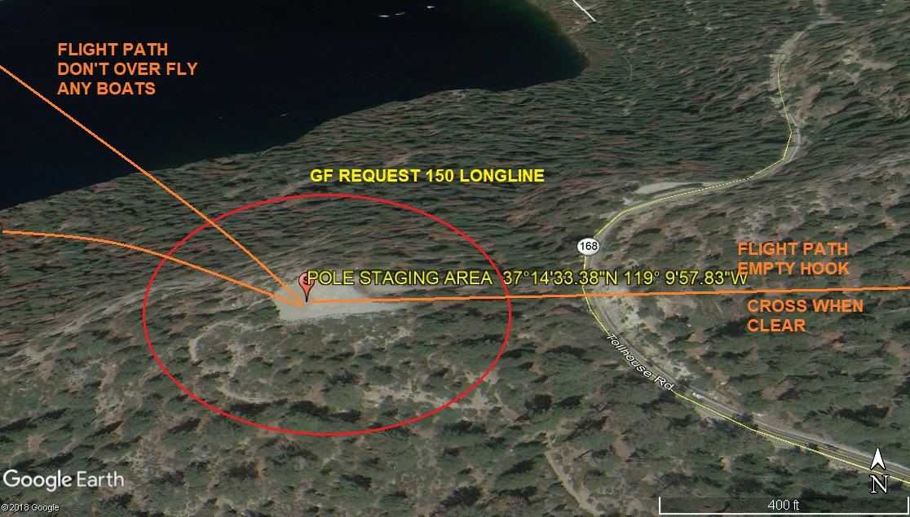

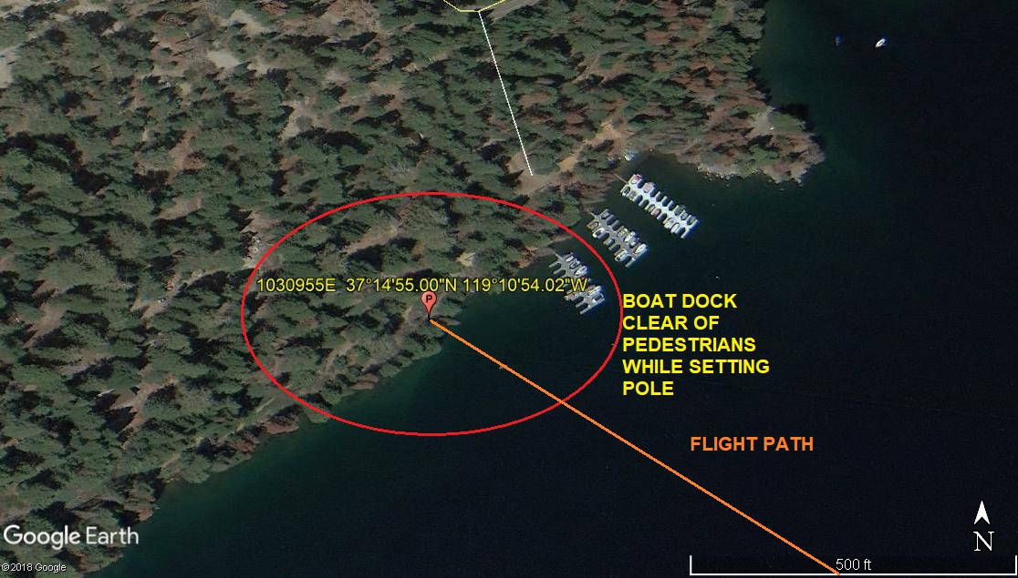
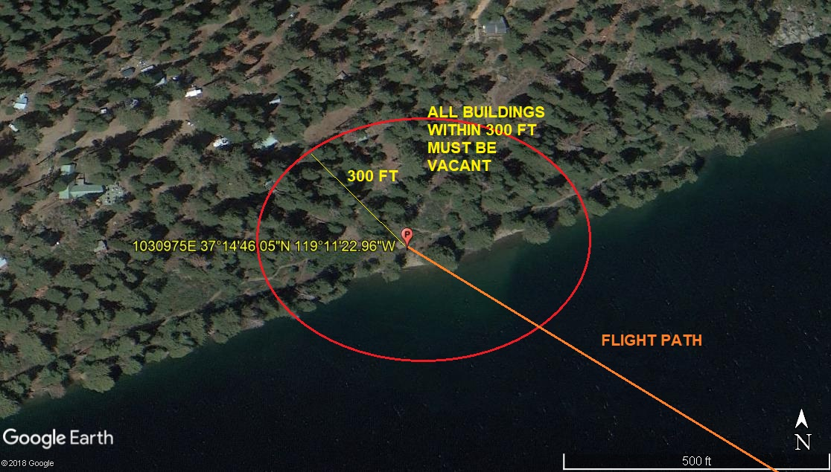
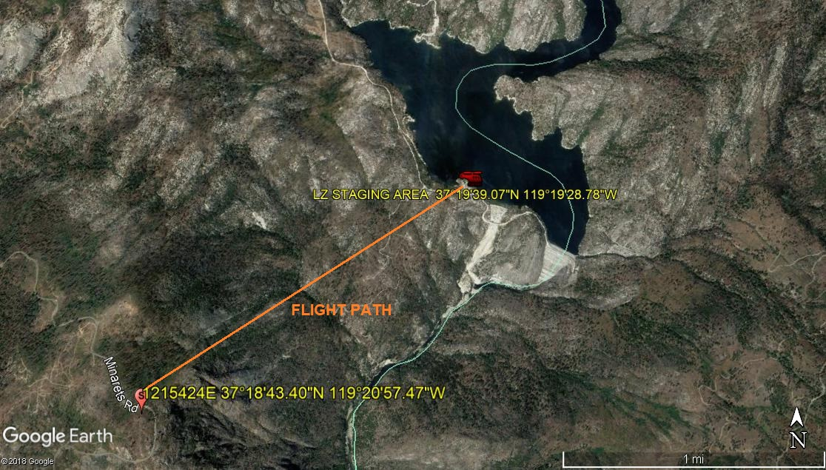
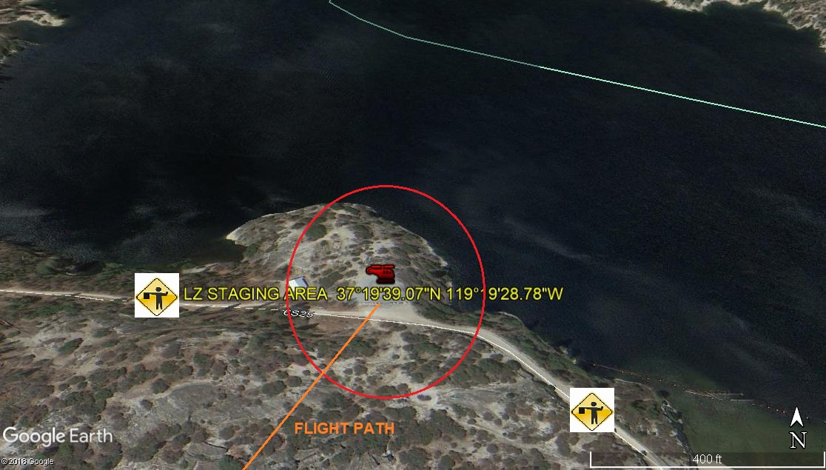
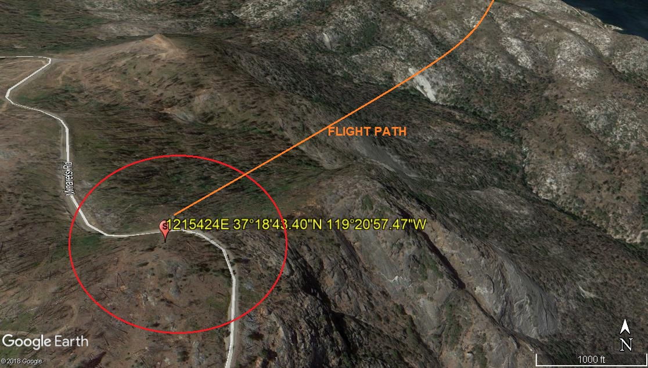
LEGEND
SITE PLAN SYMBOLS: EVACUATION FLIGHT PATH
LANDING AREA = (LZ) | STREET BLOCKED = XXXX | TOP TWO FLOORS = UBT2
ATTACH AREA = (A) | RELEASE AREA = (R)
FLIGHT PATH = >>> | EMERGENCY LAND = (ELZ)
UNOCCUPIED BUILDING = (UBA) | UNOCCUPIED BUILDING TOP FLOOR = (UBT1)
AREA SURVEY CONDUCTED BY :

