
SECTION 7 Part 135 GH 4A Part 133 GH 4L
NON-Congested Area Plan
Operator: Guardian Helicopters, Inc
67 D STREET
Fillmore CA. 93015
Phone (818) 442-9904
FAX (818) 442-9901
PROJECT :EDISON HEC EQUIPMENT AND POLES WORK ORDER NUMBER: TD1296914 TD 1417014 TD334483 TD10168666 TD1282399 TD1309615 TD1329458
ADDRESS: HWY 38 /VALLEY OF THE FALLS DR : ANGELUS OAKS CA
LZ STAGING AREA 34° 5'40.21"N 116°56'49.33"W
1764175E 34° 6'49.09"N 116°59'15.94"W
1764113E 34° 6'22.66"N 116°59'33.39"W
1609676E 34° 6'25.32"N 116°59'29.69"W
1609678E 34° 6'27.64"N 116°59'24.05"W
1609681E 34° 6'40.98"N 116°59'28.10"W
4939495E 34° 6'41.75"N 116°59'25.79"W
1610050E 34° 7'45.18"N 116°59'15.71"W
1764118E 34° 7'51.39"N 116°59'13.06"W
4912059E 272113S 34° 7'31.93"N 116°59'23.43"W
1609146E 1609145E 34° 7'3.51"N 116°59'13.75"W
CONTRACTOR’S NAME: DIVERSIFIED JOHN WHARTON PHONE#: 661-864-6051
CONTACT AT SITE; DIVERSIFIED UTILITY SERVICE PHONE #: 661-864-6051
PILOT’S NAME(S): 1. JOHN OLSON CERT #: 2769166
2. BUCKEY MACKAY CERT #: 2778051
3. MARTIN RODRIGUEZ CERT #: 3555121
4. MICHAEL KLINK CERT# 33018828
TYPE OF AIRCRAFT:BELL UH-1H N# N711GH A/C CATEGORY: RESTRICTED
BELL UH-1H N# N214KK A/C CATEGORY: RESTRICTED
BELL 205A1 N# N216GH A/C CATEGORY: STANDARD
BELL 407 N# 407GH A/C CATEGORY: STANDARD
AS350 B2 N# N498PT A/C CATEGORY: STANDARD
AS350 B3 N# N718GH A/C CATEGORY: STANDARD
AS350 B3 N# N215GH A/C CATEGORY: STANDARD
TYPE OF ITEM LIFTING: POLE AERODYNAMIC NON- AERODYNAMIC
IF SAFETY DICTATES AND OR THE CUSTOMER REQUESTS ADDITIONAL LIFTS THE LIFTS WILL BE CONDUCTED REMAINING WITHIN THE APPROVED TIME PARAMETERS.
TYPE OF LIFTS: HEC SMALL COMPRESSORS AND POLES HEAVIEST POLE IS 2000 LBS
MAX SINGLE – LIFT WEIGHT: 2000 LBS CLASS OF LOAD: EXTERNAL CL B
LONG LINE: (NO) XXX (YES) LESS THEN 150 FT (LENGTH)
OPERATIONAL ALTITUDE: < 250 STREET CLOSING: XX (N0) (YES)
DATE AND TIMES OPERATION WILL BEGIN AND TERMINATE:
FLIGHT DATES | TIME BEGIN |  | TIME END |  | TODAY’S DATE
11-25-2019 | SUNRISE |  | SUNSET |  | 11-20-2019
11-26-2019 | SUNRISE |  | SUNSET |  | 11-20-2019
11-27-2019 | SUNRISE |  | SUNSET |  | 11-20-2019
12-2-2019 | SUNRISE |  | SUNSET |  | 11-20-2019
12-3-2019 | SUNRISE |  | SUNSET |  | 11-20-2019
12-4-2019 | SUNRISE |  | SUNSET |  | 11-20-2019
12-5-2019 | SUNRISE |  | SUNSET |  | 11-20-2019
AGENCY NAME: |  | PHONE#: |  | PERSON NOTIFIED: |  | DATE:
YUCAIPA POLICE DEPARTMENT |  | 909-918-2305 |  | WATCH COMMANDER |  | NOTIFY
ANGELUS OAKS FIRE DEPARTMENT |  | 909-794-3227 |  | WATCH COMMANDER |  | NOTIFY
Evacuation Crowd Control Street Closure
No Evacuated Structures Operator Yes □ No
□Evacuated Structures Contractor Contractor
□Operator
LIST OF BUILDINGS THAT SHALL EITHER BE PARTIALLY OR ENTIRELY UNOCCUPIED PERSONS:
BUILDING DESCRIPTION/ADDRESS | OWNER(S): | PHONE #:

Narrative description of pick-up site, route, delivery site, and plan for ceasing operation if unauthorized persons enter operational area or real hazard occurs.
SITE INSPECTION NOTES

ONLY PERSONNEL ESSENTIAL TO COMPLETING THE JOB SAFELY WILL BE PERMITTED TO PARTICIPATE IN THE EVOLUTION. ONLY PERSONNEL PARTICIPATING IN THE SAFETY BRIEF WILL BE PERMITTED TO BE IN THE AREA OF OPERATIONS. ONLY AUTHORIZED ESSENTIAL PERSONAL WILL BE PERMITTED IN THE IMMEDIATE AREA OF OPERATIONS. IN THE EVENT AN UNAUTHORIZED PERSON ENTERS THE OPERATIONS AREA OR A POTENTIAL HAZARD IS IDENTIFIED THE PILOT WILL HOLD THE AIRCRAFT IN RELATIVE POSITION. THIS WILL BE ACHIEVED WITHOUT OVER FLYING THE GROUND CREW. ALL OPERATIONS WILL BE CEASED UNTIL THE PROBLEM IS RECTIFIED. IN THE EVENT OF AN AIRCRAFT EMERGENCY, THE PILOT WILL RADIO GROUND PERSONNEL AND WILL ATTEMPT TO LAND IN THE EMERGENCY LANDING AREA.
DURING THE LIFT EVOLUTION THE AIRCRAFT AND GROUND CREW WILL ALL BE IN RADIO COMMUNICATIONS. IN THE EVENT OF LOSS COMMUNICATIONS THE CREW WILL USE STANDARD HAND SIGNALS TO COMMUNICATE WITH THE PILOT. WHEN THE PILOT IS CLEAR HE WILL MOVE THE AIRCRAFT TO A SAFE LOCATION TO ALLOW THE COMMUNICATION PROBLEM TO BE RECTIFIED.
THE OPERATIONS AREA IS WITHIN THE SECURED AREA. ALL ESSENTIAL CREW WITHIN THE OPERATIONS AREA WILL NOT BE INVOLVED IN TAKING PICTURES OR ANY OTHER USE OF CELL PHONES.
A TAILBOARD SAFETY MEETING WILL BE HELD AT A PRE-DESIGNATED AREA PRIOR TO DAILY HELICOPTER OPERATIONS
1. HELICOPTER WILL LAND IN THE STAGING / FUEL AREA AT COUNTY YARD OFF OF HWY 38 AND VALLEY OF THE FALLS DR
2. FUELING WILL ONLY BE CONDUCTED AT THE STAGING AREA
3. EMERGENCY LANDING ZONE IS AT THE STAGING AREA AND ALONG THE FLIGHT PATH
4. REMOTE AREA NO BUILDINGS ARE IN THE OPERATING AREA.
5. PROVIDE A WATER TRUCK AT THE LANDING ZONES
6. DRIVE INTO YARD WILL BE SECURED FLAGMAN NOT REQUIRED
7. EQUIPMENT AND HEC PICK UP TBD
8. 38 MUST BE CLOSED WHEN FLYING A LOAD ACROSS
9. THE POLES TO THE WEST WILL BE STAGED ALONG HWY 38 REQUIRING THE STREET TO BE CLOSED.

11-20-2019 
DATE OF SUBMISSION COMPANY OFFICIAL / TITLE

Part 135 GH 4A Part 133 GH 4L
OPERATIONS AREA DIAGRAM

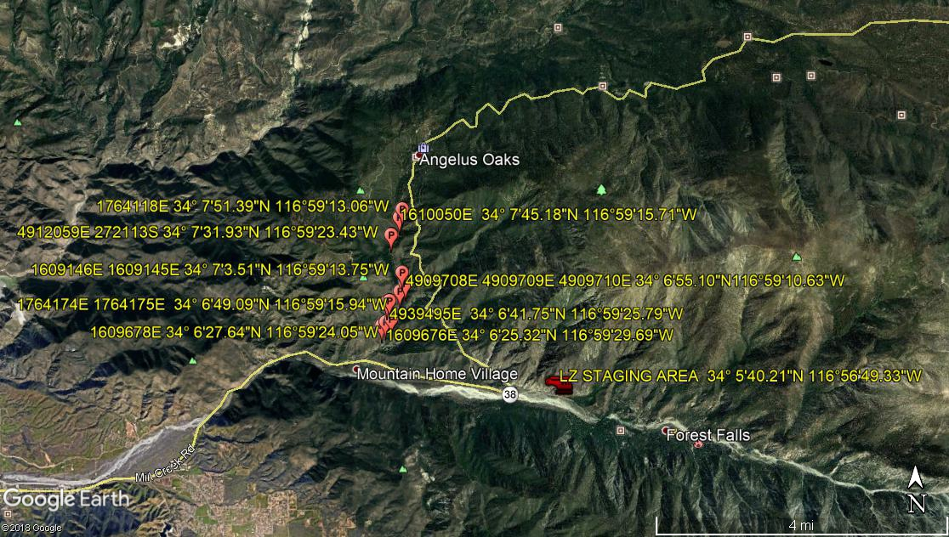

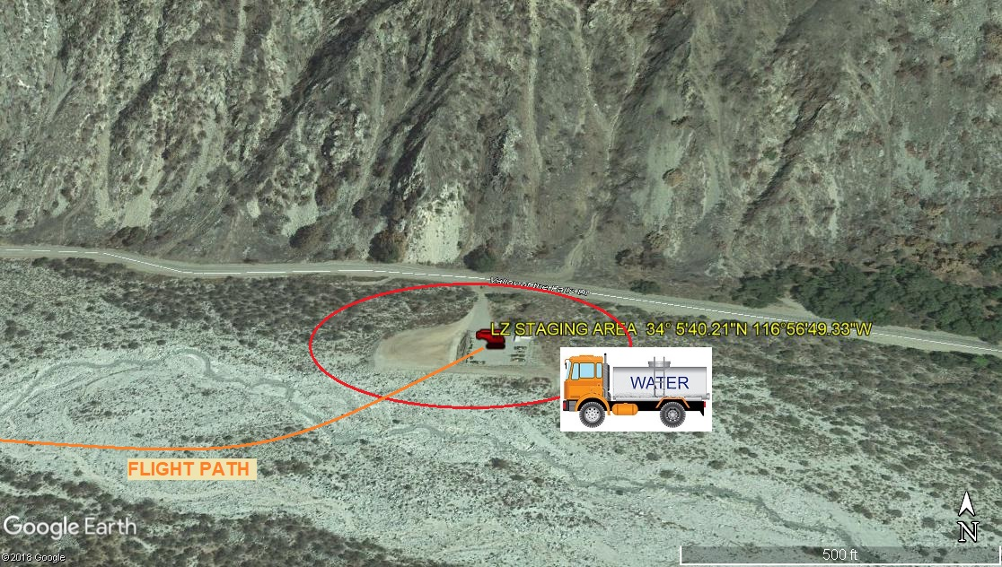

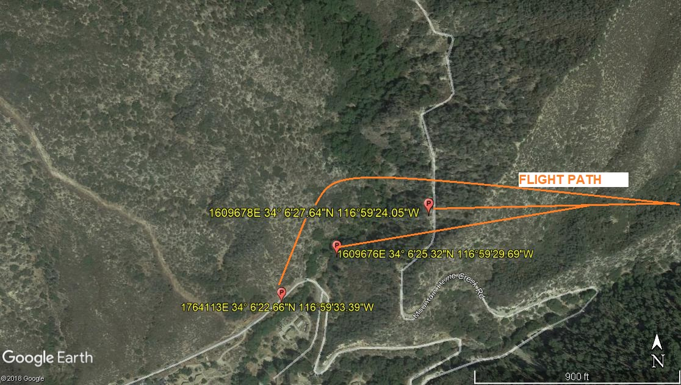

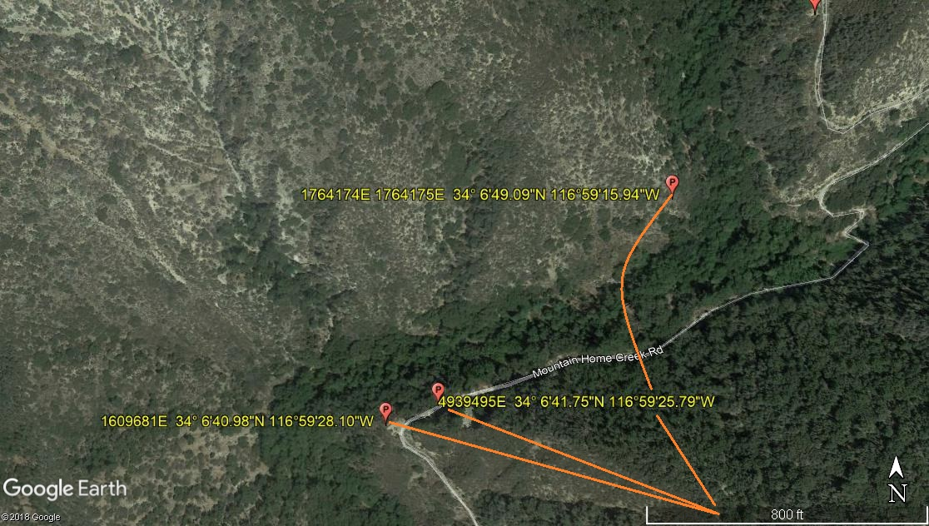
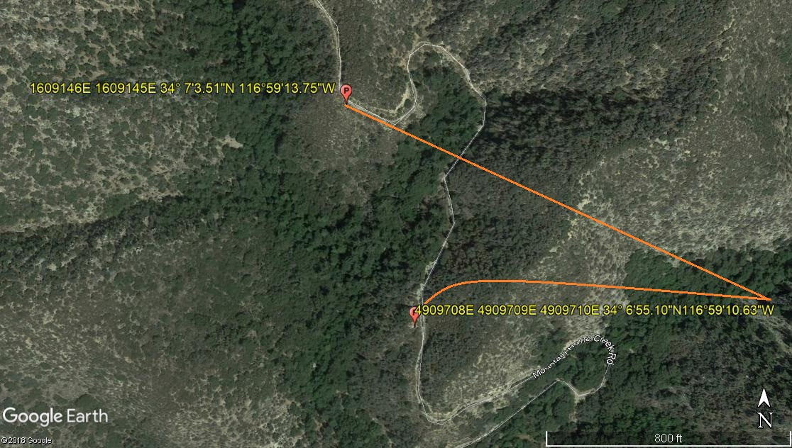
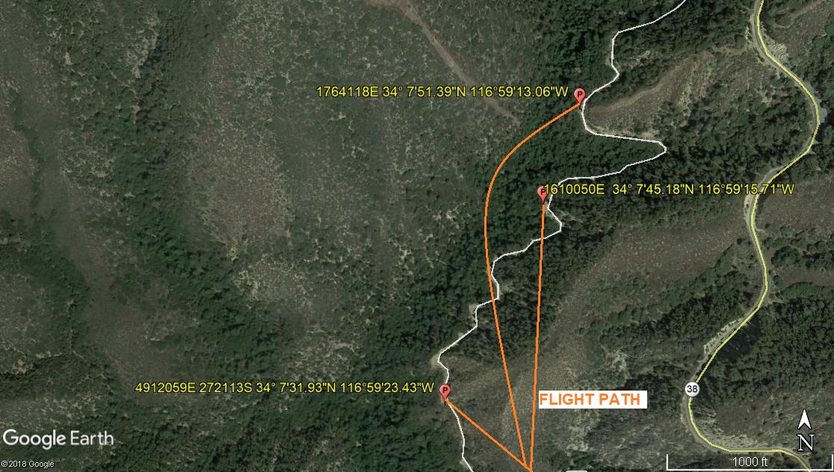

LEGEND
SITE PLAN SYMBOLS: EVACUATION FLIGHT PATH
LANDING AREA = (LZ) | STREET BLOCKED = XXXX | TOP TWO FLOORS = UBT2
ATTACH AREA = (A) | RELEASE AREA = (R)
FLIGHT PATH = >>> | EMERGENCY LAND = (ELZ)
UNOCCUPIED BUILDING = (UBA) | UNOCCUPIED BUILDING TOP FLOOR = (UBT1)

AREA SURVEY CONDUCTED BY :

