
SECTION 7 Part 135 GH 4A Part 133 GH 4L
NON-congested Area Plan
Operator: Guardian Helicopters, Inc
67 D STREET
Fillmore CA. 93015
Phone (818) 442-9904
FAX (818) 442-9901
PROJECT: EDISON POLE REPLACEMENT WORK ORDER #: TD1475512 TD1512846
ADDRESS: PT CONCEPCION AND HOLISTER RANCH : GAVIOTA CA
LZ STAGING AREA LATITUDE 34°27'54.50"N LONGITUDE 120°20'20.75"W
708534 E 1413173E LATITUDE 34°28'6.38"N LONGITUDE 120°19'45.22"W
708498E LATITUDE 34°28'15.48"N LONGITUDE 120°19'45.33"W
1524537E LATITUDE 34°28'21.34"N LONGITUDE 120°13'49.77"W
CONTRACTOR’S NAME: HOT LINE CONSTRUCTION PHONE#: 961-282-1467
CONTACT AT SITE; CHRIS BROWN PHONE #: 961-282-1467
PILOT’S NAME(S): 1. JOHN OLSON CERT #: 2769166
2. BUCKEY MACKAY CERT #:2778051
3. MARTIN RODRIGUEZ CERT #: 3555121
4. MICHAEL KLINK CERT# 3018828
TYPE OF AIRCRAFT:BELL UH-1H N# N711GH A/C CATEGORY: RESTRICTED
BELL UH-1H N# N214KK A/C CATEGORY: RESTRICTED
BELL 407 N# N407GH A/C CATEGORY: STANDARD
BELL 205A1 N# N216GH A/C CATEGORY: STANDARD
AS350 B2 N# N498PT A/C CATEGORY: STANDARD
AS350 B3 N# N718GH A/C CATEGORY: STANDARD
AS350 B3 N# N215GH A/C CATEGORY: STANDARD
TYPE OF ITEM LIFTING: POLE AERODYNAMIC NON- AERODYNAMIC
IF SAFETY DICTATES AND OR THE CUSTOMER REQUESTS ADDITIONAL LIFTS THE LIFTS WILL BE CONDUCTED REMAINING WITHIN THE APPROVED TIME PARAMETERS.
TYPE OF LIFTS: COMPRESSOR POLES AND EQUIPMENT
MAX SINGLE – LIFT WEIGHT: 2500 LBS CLASS OF LOAD: EXTERNAL CL B
NO. OF LIFTS: TBD LONG LINE: (NO) XXX (YES) LESS THEN 150 FT (LENGTH)
OPERATIONAL ALTITUDE: < 250 STREET CLOSING: XX (N0) (YES)
DATE AND TIMES OPERATION WILL BEGIN AND TERMINATE:
FLIGHT DATES | TIME BEGIN | TIME END | TODAY’S DATE
11-18-2019 HEC AND UH-1H | SUNRISE | SUNSET | 11-12-2019
11-19-2019 HEC AND UH-1H | SUNRISE | SUNSET | 11-12-2019
11-20-2019 HEC AND UH-1H | SUNRISE | SUNSET | 11-12-2019
CROWD CONTROL
AGENCY NAME: | PHONE#: | PERSON NOTIFIED: | DATE:
SANTA BARBARA SHERIFF | 805-686-8150 | BUELTON | NOTIFY
SANTA BARBARA COUNTY FIRE | 805-681-5518 | STATION 18 | NOTIFY

NON- Congested Area Plan (Continued)
Evacuation Crowd Control Street Closure
- No Evacuated Structures Operator Yes □ No
□Evacuated Structures Contractor Contractor
□Operator

LIST OF BUILDINGS THAT SHALL EITHER BE PARTIALLY OR ENTIRELY UNOCCUPIED PERSONS:
BUILDING DESCRIPTION/ADDRESS | OWNER(S): | PHONE #:
N/A | N/A | N/A
N/A | N/A | N/A
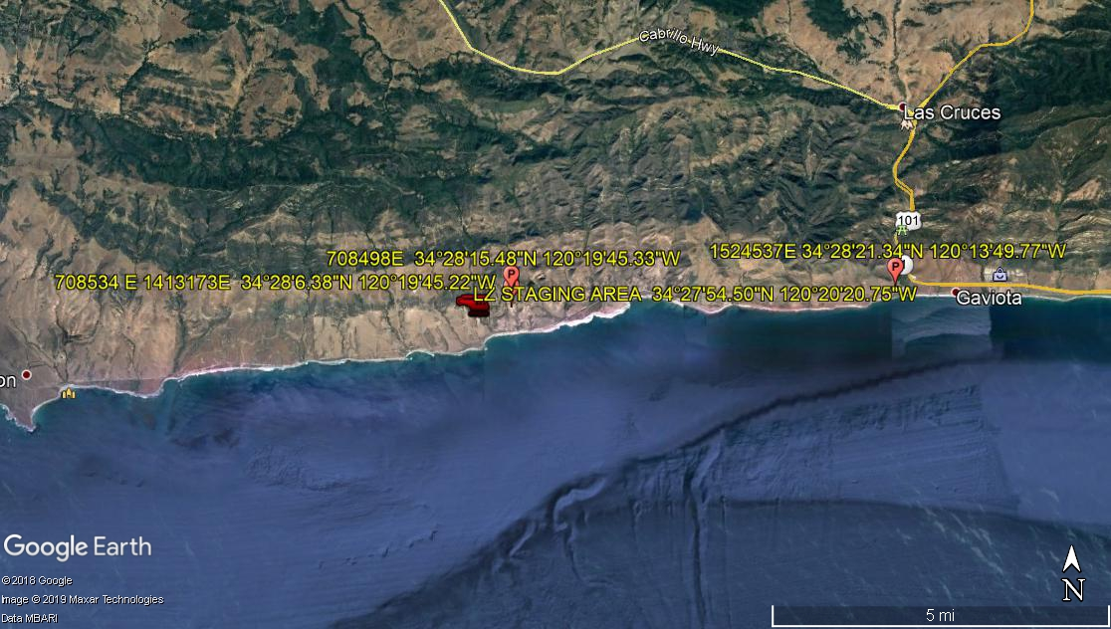

Narrative description of pick-up site, route, delivery site, and plan for ceasing operation if unauthorized persons enter operational area or real hazard occurs.
SITE INSPECTION NOTES

ONLY PERSONNEL ESSENTIAL TO COMPLETING THE JOB SAFELY WILL BE PERMITTED TO PARTICIPATE IN THE EVOLUTION. ONLY PERSONNEL PARTICIPATING IN THE SAFETY BRIEF WILL BE PERMITTED TO BE IN THE AREA OF OPERATIONS. ONLY AUTHORIZED ESSENTIAL PERSONAL WILL BE PERMITTED IN THE IMMEDIATE AREA OF OPERATIONS. IN THE EVENT AN UNAUTHORIZED PERSON ENTERS THE OPERATIONS AREA OR A POTENTIAL HAZARD IS IDENTIFIED THE PILOT WILL HOLD THE AIRCRAFT IN RELATIVE POSITION. THIS WILL BE ACHIEVED WITHOUT OVER FLYING THE GROUND CREW. ALL OPERATIONS WILL BE CEASED UNTIL THE PROBLEM IS RECTIFIED. IN THE EVENT OF AN AIRCRAFT EMERGENCY, THE PILOT WILL RADIO GROUND PERSONNEL AND WILL ATTEMPT TO LAND IN THE EMERGENCY LANDING AREA.
DURING THE LIFT EVOLUTION THE AIRCRAFT AND GROUND CREW WILL ALL BE IN RADIO COMMUNICATIONS. IN THE EVENT OF LOSS COMMUNICATIONS THE CREW WILL USE STANDARD HAND SIGNALS TO COMMUNICATE WITH THE PILOT. WHEN THE PILOT IS CLEAR HE WILL MOVE THE AIRCRAFT TO A SAFE LOCATION TO ALLOW THE COMMUNICATION PROBLEM TO BE RECTIFIED.
THE OPERATIONS AREA IS WITHIN THE SECURED AREA. ALL ESSENTIAL CREW WITHIN THE OPERATIONS AREA WILL NOT BE INVOLVED IN TAKING PICTURES OR ANY OTHER USE OF CELL PHONES.
A TAIL BOARD SAFETY MEETING WILL BE HELD AT BOTH THE STAGING AREAS PRIOR TO HELICOPTER OPERATIONS
1. HELICOPTER WILL LAND AT THE AT THE LZ STAGING AREA TO CONNECT LONG LINE AND TAILBOARD. THE POLE WILL FRAMED NEAR THE LZ STAGING AREAS
2. FUELING WILL ONLY BE CONDUCTED AT THE HOLISTER STAGING AREA
3. EMERGENCY LANDING ZONE IS AT THE STAGING AREA AND ALONG THE FLIGHT PATH
4. REMOTE AREA OPERATING AREA. NO EVACUATIONS
5. PROVIDE WATER TRUCK FOR HOLISTER LZ STAGING AREA
6. NO STREET CLOSURES FLAGMAN TO STOP TRAFFIC WHILE REMOVING IDLE PS320

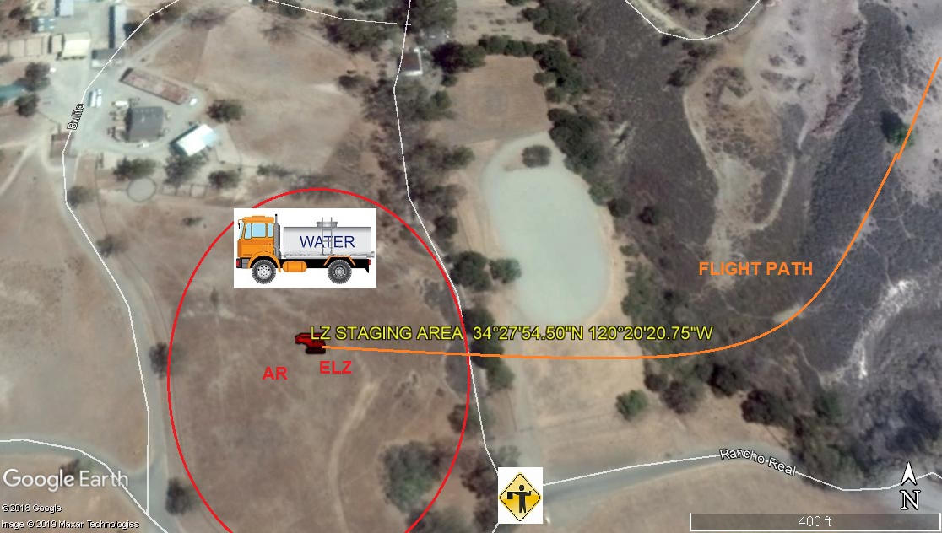

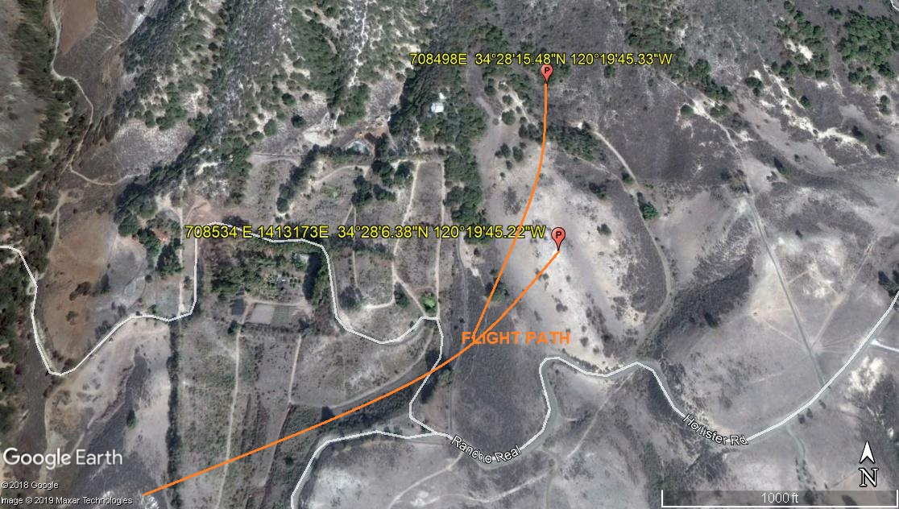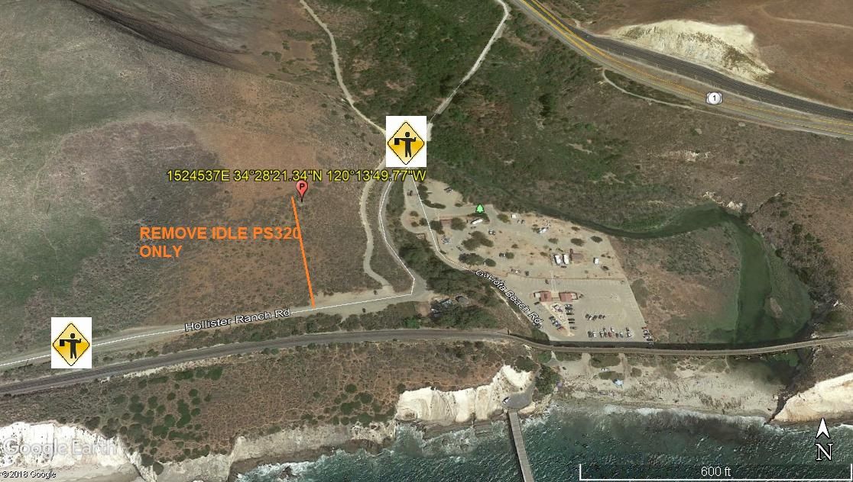

11-12-2019 
DATE OF SUBMISSION COMPANY OFFICIAL / TITLE

