
SECTION 7 Part 135 GH 4A Part 133 GH 4L
NON Congested Area Plan
Operator: Guardian Helicopters, Inc
67 D STREET
Fillmore CA. 93015
Phone (818) 442-9904
FAX (818) 442-9901
PROJECT: EDISON POLE REPLACEMENT WORK ORDER #: TD 1509934
ADDRESS: 15 SAN MARCOS TROUT CLUB : SANTA BARBARA CA
LZ STAGING AREA LATITUDE 34°29'24.68"N LONGITUDE 119°47'45.20"W ELEV: 700 FT
4127655E LATITUDE 34°29'24.09"N LONGITUDE 119°47'58.13"W35 CL 5 800 LBS
CONTRACTOR’S NAME: HOTLINE CONSTURCTION PHONE#: 209-401-6364
CONTACT AT SITE; WAYNE RHODES PHONE #: 209-401-6364
PILOT’S NAME(S):
1. JOHN OLSON CERT #: 2769166
2. BUCKEY MACKAY CERT #: 2778051
3. MARTIN RODRIGUEZ CERT #: 3555121
4. MICHAEL KLINK CERT# 3018828
TYPE OF AIRCRAFT:
BELL UH-1H N# N711GH A/C CATEGORY: RESTRICTED
BELL UH-1H N# N214KK A/C CATEGORY: RESTRICTED
BELL 407 N# N407GH A/C CATEGORY: STANDARD
BELL 205A1 N# N216GH A/C CATEGORY: STANDARD
AS350 B2 N# N498PT A/C CATEGORY: STANDARD
AS350 B3 N# N718GH A/C CATEGORY: STANDARD
AS350 B3 N# N215GH A/C CATEGORY: STANDARD
TYPE OF ITEM LIFTING: POLE AERODYNAMIC NON- AERODYNAMIC
IF SAFETY DICTATES AND OR THE CUSTOMER REQUESTS ADDITIONAL LIFTS THE LIFTS WILL BE CONDUCTED REMAINING WITHIN THE APPROVED TIME PARAMETERS.
TYPE OF LIFTS: (1) 35 FT CL5 800 LBS (1) 35 FT CL5 800 LBS
MAX SINGLE – LIFT WEIGHT: 1000 LBS CLASS OF LOAD: EXTERNAL CL B
NO. OF LIFTS: 2 LONG LINE: (NO) XXX (YES) LESS THEN 150 FT (LENGTH)
OPERATIONAL ALTITUDE: < 250 STREET CLOSING: XX (N0) (YES)
DATE AND TIMES OPERATION WILL BEGIN AND TERMINATE:
FLIGHT DATES | TIME BEGIN |  | TIME END | TODAY’S DATE
11-8-2019 | 0800 |  | 1700 | 11-1-2019
AGENCY NAME: | PHONE#: | PERSON NOTIFIED: |  | DATE:
SANTA BARBARA COUNTY FIRE | 805-681-5500 | STATION 13 |  | NOTIFY
SBC SHERIFF DEPARTMENT | 805-681-4100 | DISPATCH |  | NOTIFY
WRA PASS VOLUNTEER FIRE | 805-964-7194 | DISPATCH |  | NOTIFY
-21-

NON- Congested Area Plan (Continued)
Evacuation Crowd Control Street Closure
□No Evacuated Structures Operator Yes □ No
Evacuated Structures Contractor Contractor
□Operator
LIST OF BUILDINGS THAT SHALL EITHER BE PARTIALLY OR ENTIRELY UNOCCUPIED PERSONS ALSO HOMES THAT WILL BE NOTIFIED OF ACTIVITY:
BUILDING DESCRIPTION/ADDRESS | REMARKS | METHOD
15 SAN MARCOS TROUT CLUB RD | VACANT DURING OPS | HAND DELIVER
16 SAN MARCOS TROUT CLUB RD | VACANT DURING OPS | HAND DELIVER
18 SAN MARCOS TROUT CLUB RD | VACANT DURING OPS | HAND DELIVER
ALL HOMES WITHIN OPERATING AREA | VACANT DURING OPS | HAND DELIVER

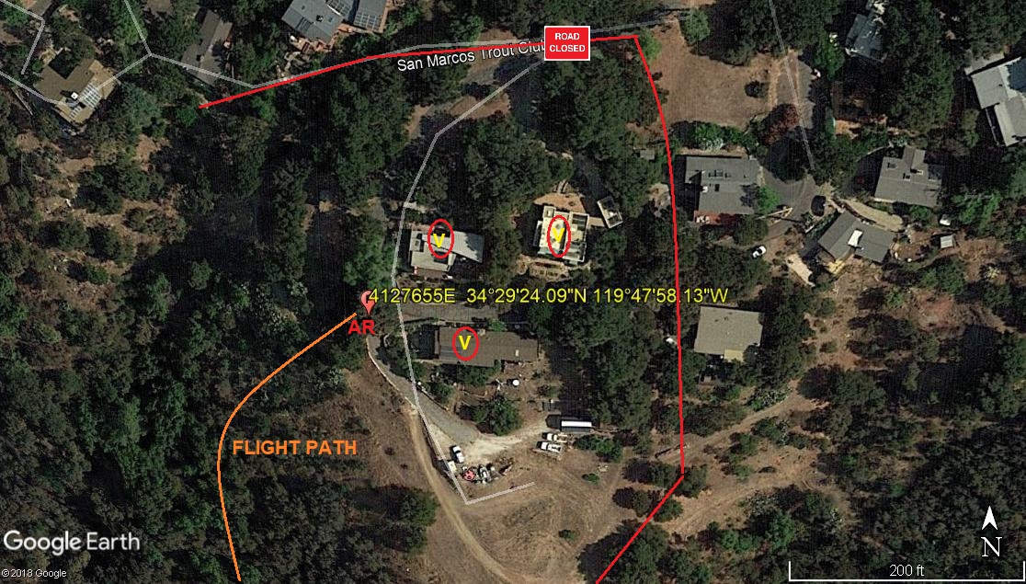

-22-

Narrative description of pick-up site, route, delivery site, and plan for ceasing operation if unauthorized persons enter operational area or real hazard occurs.
SITE INSPECTION NOTES

ONLY PERSONNEL ESSENTIAL TO COMPLETING THE JOB SAFELY WILL BE PERMITTED TO PARTICIPATE IN THE EVOLUTION. ONLY PERSONNEL PARTICIPATING IN THE SAFETY BRIEF WILL BE PERMITTED TO BE IN THE AREA OF OPERATIONS. ONLY AUTHORIZED ESSENTIAL PERSONAL WILL BE PERMITTED IN THE IMMEDIATE AREA OF OPERATIONS. IN THE EVENT AN UNAUTHORIZED PERSON ENTERS THE OPERATIONS AREA OR A POTENTIAL HAZARD IS IDENTIFIED THE PILOT WILL HOLD THE AIRCRAFT IN RELATIVE POSITION. THIS WILL BE ACHIEVED WITHOUT OVER FLYING THE GROUND CREW. ALL OPERATIONS WILL BE CEASED UNTIL THE PROBLEM IS RECTIFIED. IN THE EVENT OF AN AIRCRAFT EMERGENCY, THE PILOT WILL RADIO GROUND PERSONNEL AND WILL ATTEMPT TO LAND IN THE EMERGENCY LANDING AREA.
DURING THE LIFT EVOLUTION THE AIRCRAFT AND GROUND CREW WILL ALL BE IN RADIO COMMUNICATIONS. IN THE EVENT OF LOSS COMMUNICATIONS THE CREW WILL USE STANDARD HAND SIGNALS TO COMMUNICATE WITH THE PILOT. WHEN THE PILOT IS CLEAR HE WILL MOVE THE AIRCRAFT TO A SAFE LOCATION TO ALLOW THE COMMUNICATION PROBLEM TO BE RECTIFIED.
THE OPERATIONS AREA IS WITHIN THE SECURED AREA. ALL ESSENTIAL CREW WITHIN THE OPERATIONS AREA WILL NOT BE INVOLVED IN TAKING PICTURES OR ANY OTHER USE OF CELL PHONES.

TAILBOARD / SAFETY BRIEF WILL BE CONDUCTED AT THE STAGING AREA PRIOR TO WORK STARTING

1. HELICOPTER WILL LAND IN THE STAGING / FUEL AREA EAST OF SAN MARCOS RD
2. FUELING WILL ONLY BE CONDUCTED AT THE STAGING AREA
3. POLES WILL BE STAGED IN THE LANDING ZONE / STAGING AREA
4. PROVIDE A WATER TRUCK AT THE LANDING ZONES / STAGING AREA
5. EMERGENCY LANDING ZONE IS AT THE STAGING AREA AND ALONG THE FLIGHT PATH
4. 3 HOMES WILL BE EVACUATED DURING THE OPERATION. SEE DIAGRAM BELOW
6. SAN MARCOS TROUT CLUB ROAD WILL EXPERIENCE INTERMITTENT ROAD CLOSURES.
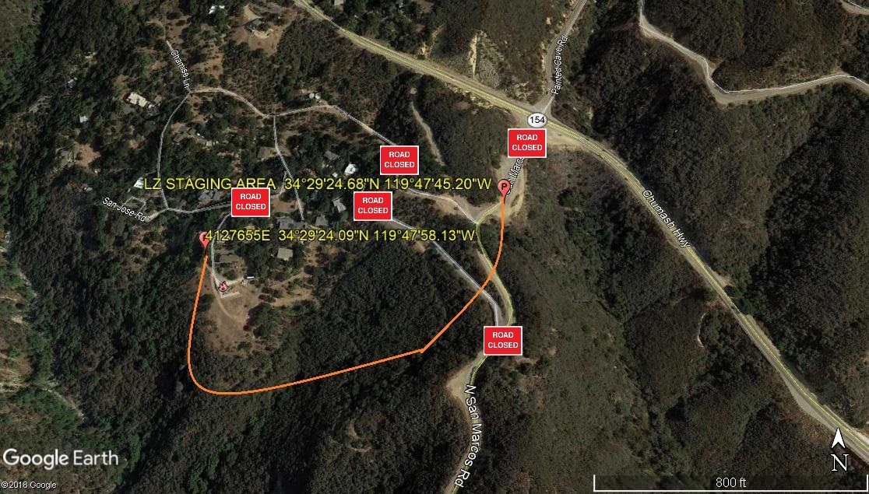
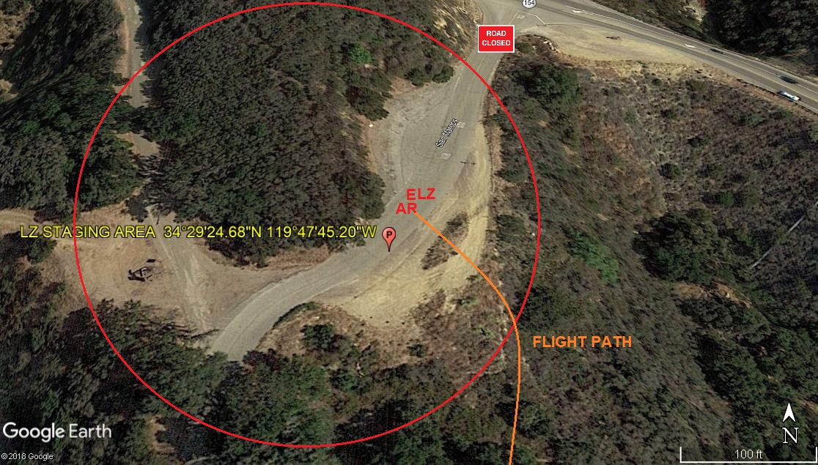
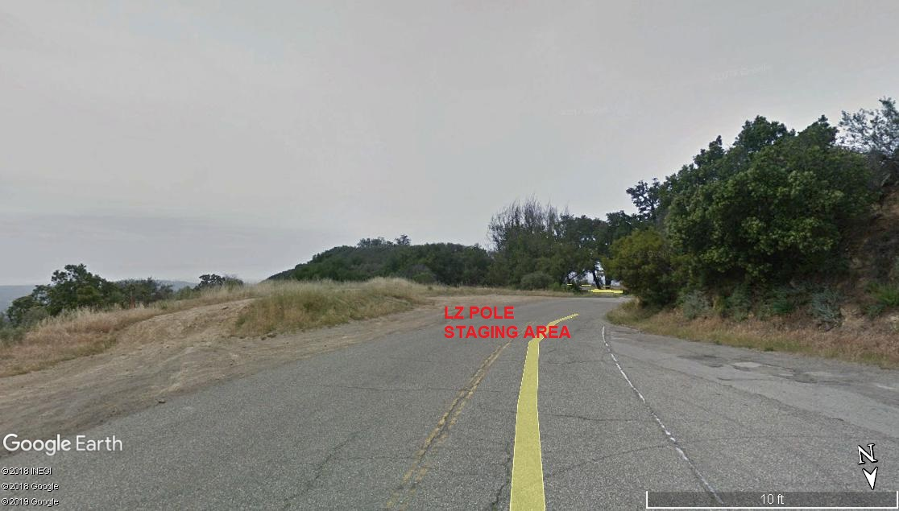

11-1-2019 
DATE OF SUBMISSION COMPANY OFFICIAL / TITLE

-23-

LEGEND
SITE PLAN SYMBOLS: EVACUATION FLIGHT PATH
LANDING AREA = (LZ) | STREET BLOCKED = XXXX | TOP TWO FLOORS = UBT2
ATTACH AREA = (A) | RELEASE AREA = (R)
FLIGHT PATH = >>> | EMERGENCY LAND = (ELZ)
UNOCCUPIED BUILDING = (UBA) | UNOCCUPIED BUILDING TOP FLOOR = (UBT1)

AREA SURVEY CONDUCTED BY :

