
SECTION 7 Part 135 GH 4A Part 133 GH 4L
Congested Area Plan
(Submit in duplicate)
Operator: Guardian Helicopters, Inc
67 D STREET
Fillmore CA. 93015
Phone (818) 442-9904
FAX (818) 442-9901
PROJECT: EDISON POLE REPLACEMENT WORK ORDER NUMBER: TD1499150 TD1500098 TD 1493751 TD1493753
ADDRESS: 1055 TORO CANYON ROAD : SANTA BARBARA CA
LZ LATITUDE 34°27'19.78"N LONGITUDE 119°34'7.63"W
1996071E LATITUDE 34°27'22.23"N LONGITUDE 119°34'6.50"W45 CL 2 1652 LBS
1675192E LATITUDE 34°27'24.50"N LONGITUDE 119°33'53.64"W45 CL 2 1652 LBS
1675193E LATITUDE 34°27'26.01"N LONGITUDE 119°33'54.62"W 45 CL 2 1652 LBS
2024126E LATITUDE 34°27'26.21"N LONGITUDE 119°33'58.33"W45 CL 2 1652 LBS
CONTRACTOR’S NAME: WAYNE RHODES PHONE#: 209-401-6364
CONTACT AT SITE; THOMAS OLIVA PHONE #: 213-216-0938
PILOT’S NAME(S): 1. JOHN OLSON CERT #: 2769166
2. BUCKEY MACKAY CERT #: #:2778051
3. MARTIN RODRIGUEZ CERT #: 3555121
4. MICHAEL KLINK CERT# 33018828
TYPE OF AIRCRAFT:BELL UH-1H N# N711GH A/C CATEGORY: RESTRICTED
BELL UH-1H N# N214KK A/C CATEGORY: RESTRICTED
BELL 407 N# N407GH A/C CATEGORY: STANDARD
BELL 205A1 N# N216GH A/C CATEGORY: STANDARD
AS350 B2 N# N498PT A/C CATEGORY: STANDARD
AS350 B3 N# N718GH A/C CATEGORY: STANDARD
AS350 B3 N# N215GH A/C CATEGORY: STANDARD
TYPE OF ITEM LIFTING: POLE AERODYNAMIC NON- AERODYNAMIC
IF SAFETY DICTATES AND OR THE CUSTOMER REQUESTS ADDITIONAL LIFTS THE LIFTS WILL BE CONDUCTED REMAINING WITHIN THE APPROVED TIME PARAMETERS.
TYPE OF LIFTS: 4 POLE 4 POLE 45 FT CL 2 1600 LBS PLUS TRANSFORMERS
MAX SINGLE – LIFT WEIGHT: 1600 LBS CLASS OF LOAD: EXTERNAL CL B
NO. OF LIFTS 8 LONG LINE: (NO) XXX (YES) 100 FT + 45 FT POLE = 145 FT (LENGTH) WE WILL MAINTAIN A MINIMUM OF THAT SUM AWAY FROM HOMES EDGE OF OPERATING AREA
OPERATIONAL ALTITUDE: < 50 STREET CLOSING: (N0) XXX (YES)
DATE AND TIMES OPERATION WILL BEGIN AND TERMINATE:
FLIGHT DATES | TIME BEGIN | TIME END |  | TODAY’S DATE
11-14-2019 | SUNRISE | SUNSET |  | 9-12-2019
AGENCY NAME: | PHONE#: |  | PERSON NOTIFIED: |  | DATE:
POLICE DEPARTMENT | 805-686-5000 |  | WATCH COMMANDER |  | NOTIFIED
FIRE DEPARTMENT | 805-686-5058 |  | STATION 2 |  | NOTIFIED
AIR TRAFFIC CONTROL | 805-688-8390 |  | SANTA YNES AIRPORT |  | NOTIFIED

Congested Area Plan (Continued)
(Submit in duplicate)
Evacuation Crowd Control Street Closure
□No Evacuated Structures Operator Yes □ No
Evacuated Structures Contractor Contractor
□Operator
LIST OF BUILDINGS THAT SHALL EITHER BE PARTIALLY OR ENTIRELY UNOCCUPIED PERSONS ALSO HOMES THAT WILL BE NOTIFIED OF ACTIVITY:
BUILDING DESCRIPTION/ADDRESS | REMARKS | METHOD
1210 TORO CANYON ROAD | VACANT DURING OPS | HAND DELIVER
1055 TORO CANYON ROAD | VACANT DURING OPS | HAND DELIVER
1204 TORO CANYON ROAD | VACANT DURING OPS | HAND DELIVER
TOTAL OF 4 HOME AND OUT BUILDINGS | VACANT DURING OPS | HAND DELIVER
ALL HOMES WITHIN OPERATING AREA | VACANT DURING OPS | HAND DELIVER
SEE DIAGRAM = V | VACANT DURING OPS | HAND DELIVER
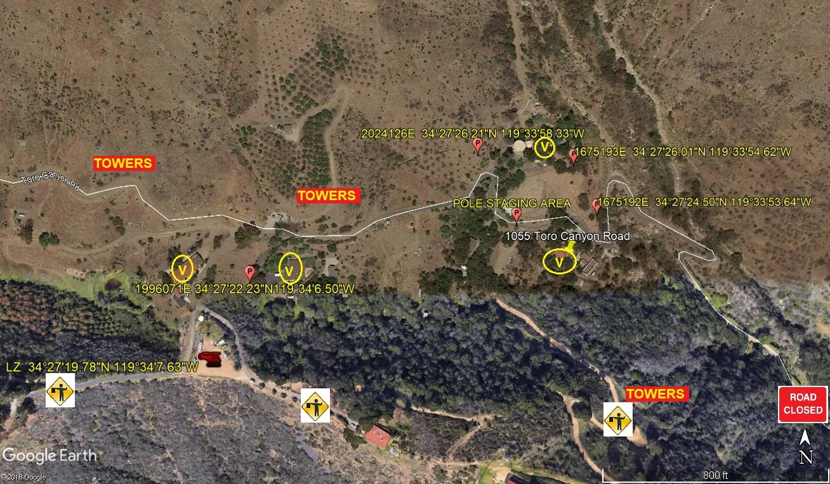

Narrative description of pick-up site, route, delivery site, and plan for ceasing operation if unauthorized persons enter operational area or real hazard occurs.
SITE INSPECTION NOTES

ONLY PERSONNEL ESSENTIAL TO COMPLETING THE JOB SAFELY WILL BE PERMITTED TO PARTICIPATE IN THE EVOLUTION. ONLY PERSONNEL PARTICIPATING IN THE SAFETY BRIEF WILL BE PERMITTED TO BE IN THE AREA OF OPERATIONS. ONLY AUTHORIZED ESSENTIAL PERSONAL WILL BE PERMITTED IN THE IMMEDIATE AREA OF OPERATIONS. IN THE EVENT AN UNAUTHORIZED PERSON ENTERS THE OPERATIONS AREA OR A POTENTIAL HAZARD IS IDENTIFIED THE PILOT WILL HOLD THE AIRCRAFT IN RELATIVE POSITION. THIS WILL BE ACHIEVED WITHOUT OVER FLYING THE GROUND CREW. ALL OPERATIONS WILL BE CEASED UNTIL THE PROBLEM IS RECTIFIED. IN THE EVENT OF AN AIRCRAFT EMERGENCY, THE PILOT WILL RADIO GROUND PERSONNEL AND WILL ATTEMPT TO LAND IN THE EMERGENCY LANDING AREA.. ALL BUILDINGS IN THE OPERATING AREA WILL BE VACANT.
DURING THE LIFT EVOLUTION THE AIRCRAFT AND GROUND CREW WILL ALL BE IN RADIO COMMUNICATIONS. IN THE EVENT OF LOSS COMMUNICATIONS THE CREW WILL USE STANDARD HAND SIGNALS TO COMMUNICATE WITH THE PILOT. WHEN THE PILOT IS CLEAR HE WILL MOVE THE AIRCRAFT TO A SAFE LOCATION TO ALLOW THE COMMUNICATION PROBLEM TO BE RECTIFIED.
THE OPERATIONS AREA IS WITHIN THE SECURED AREA. ALL ESSENTIAL CREW WITHIN THE OPERATIONS AREA WILL NOT BE INVOLVED IN TAKING PICTURES OR ANY OTHER USE OF CELL PHONES.

A TAILBOARD SAFETY MEETING WILL BE CONDUCTED PRIOR TO BEGINNING ANY HELICOPTER OPERATIONS
- THE HELICOPTER LAND WILL LAND AT THE LZ TO CONNECT THE LONGLINE
- TAILBOARD WILL OCCUR AT THE LANDING ZONE
- POLE NUMBER 1996071E WILL BE STAGED AT THE LANDING ZONE THE REMAINING POLES AND EQUIPMENT WILL BE STAGED AT THE STAGING AREA
- 4 HOMES AND OUT BUILDINGS IN RED OPERATIONS AREA WILL BE EVACUATED
- WATER TRUCK IS REQUIRED AT LANDING ZONE
- THE EMERGENCY LANDING ZONE IS AT THE STAGING AREA AND ALONG THE CLEARING ON THE FLIGHT PATH
- SANTA BARBARA COUNTY SHERIFF AND FIRE DEPARTMENT WILL BE NOTIFIED.
- THE SECURE AREA IS GREATER THEN 300 FT IN ALL DIRECTIONS FROM THE ATTACH AND RELEASE AREAS
- CUSTOMER WILL ENSURE TREES NEAR THE POLE SET SITE ARE TRIMMED IF REQUIRED

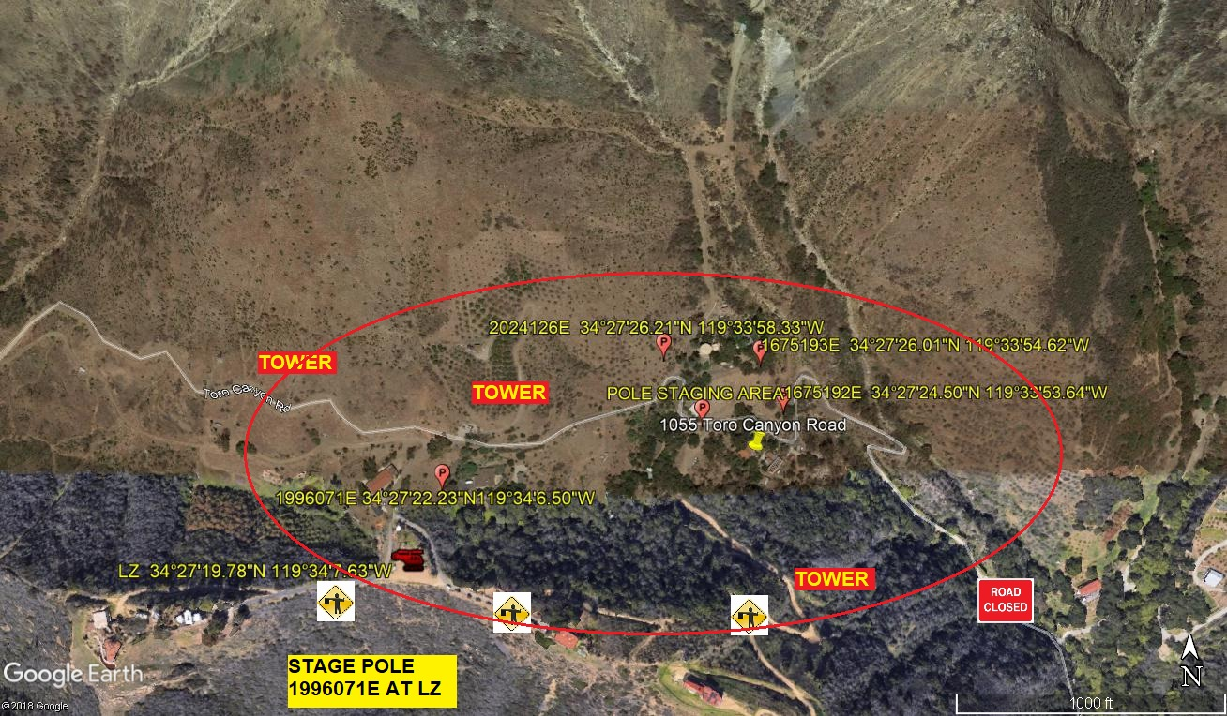
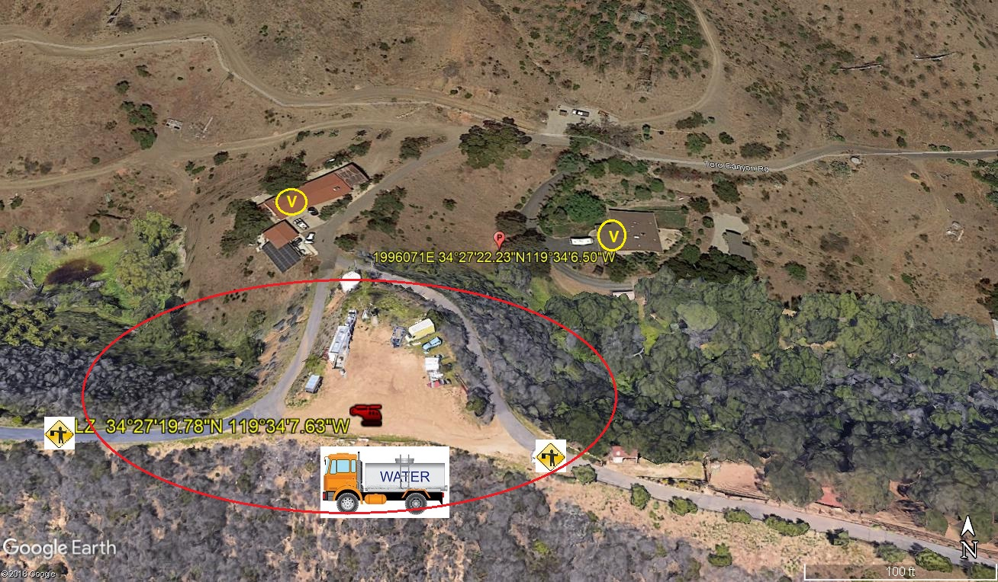

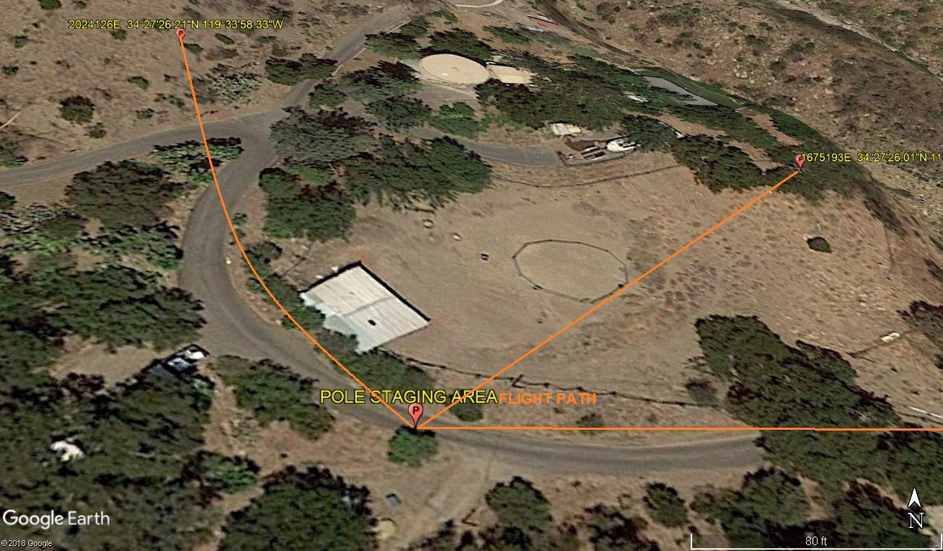

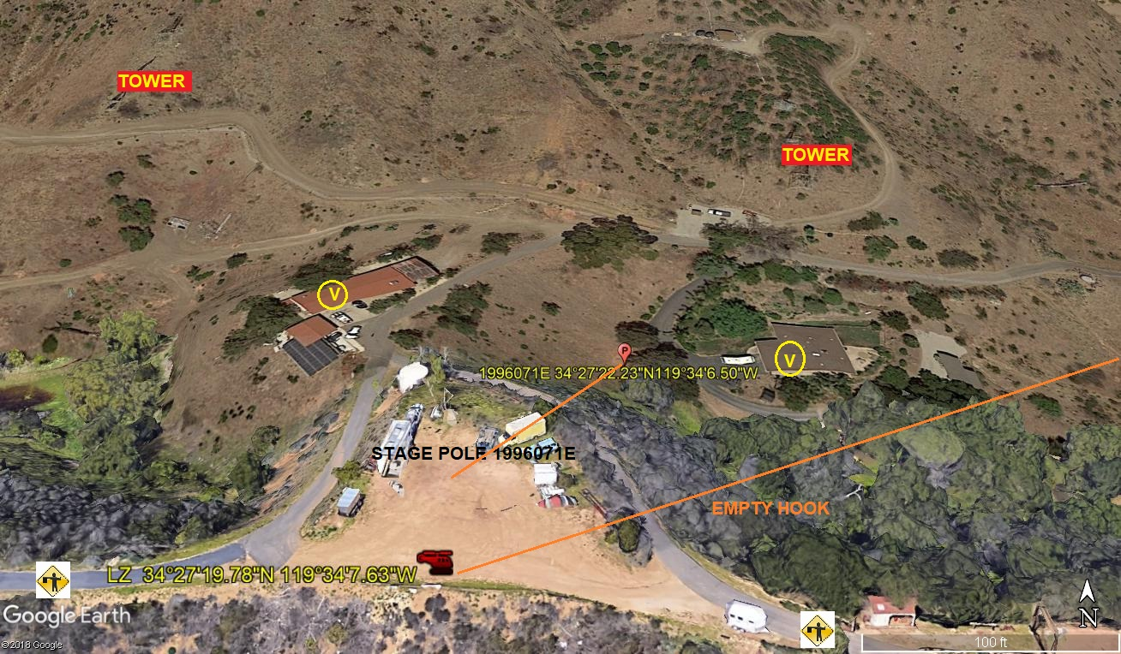

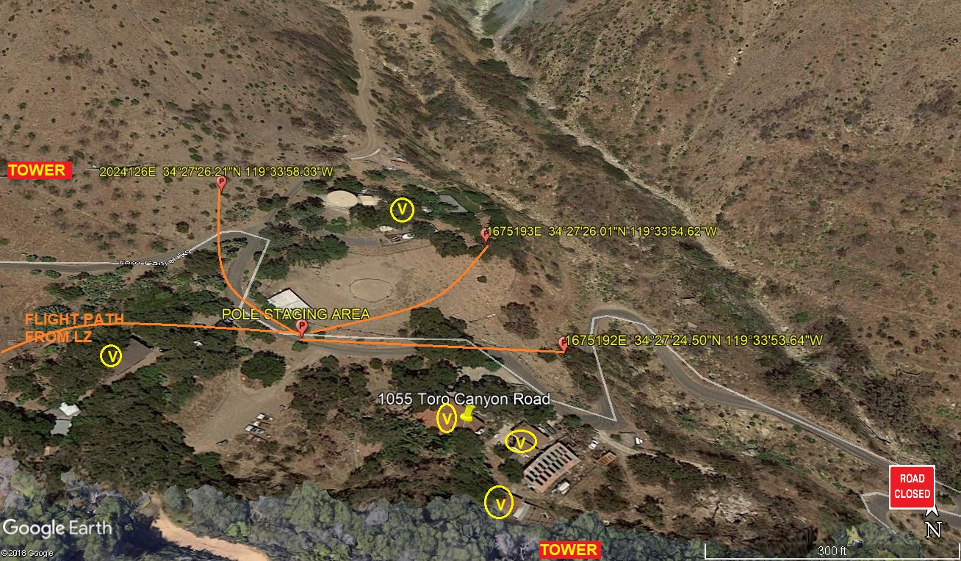

LEGEND
SITE PLAN SYMBOLS: EVACUATION FLIGHT PATH
LANDING AREA = (LZ) | STREET BLOCKED = XXXX | TOP TWO FLOORS = UBT2
ATTACH AREA = (A) | RELEASE AREA = (R)
FLIGHT PATH = >>> | EMERGENCY LAND = (ELZ)
UNOCCUPIED BUILDING = (UBA) | UNOCCUPIED BUILDING TOP FLOOR = (UBT1)

6-14-2019 
DATE OF SUBMISSION COMPANY OFFICIAL / TITLE

