
SECTION 7 Part 135 GH 4A Part 133 GH 4L
NON-Congested Area Plan
Operator: Guardian Helicopters, Inc
67 D STREET
Fillmore CA. 93015
Phone (818) 442-9904
FAX (818) 442-9901
PROJECT: EDISON POLE REPLACEMENT WORK ORDER #: TD 1539636
ADDRESS: TABLE MOUNTAIN RD : WRIGHTWOOD CA
LZ STAGING AREA LATITUDE 34°22'52.73"N LONGITUDE 117°41'25.70"W ELV 7300 FT
1001150E LATITUDE 34°22'54.92"N LONGITUDE 117°41'16.79"W 40CL2 1300 LBS
CONTRACTOR’S NAME: DIVERSIFIED PHONE#: 661-437-2819
PILOT’S NAME(S):
1. JOHN OLSON CERT #: 2769166
2. BUCKEY MACAY CERT #: 2778051
3. MARTIN RODRIGUEZ CERT #: 3555121
4. MICHAEL KLINK CERT# 33018828
5. IAN GOODALE CERT# 3741973
TYPE OF AIRCRAFT:
BELL UH-1H N# N711GH A/C CATEGORY: RESTRICTED
BELL UH-1H N# N214KK A/C CATEGORY: RESTRICTED
BELL 407 N# N407GH A/C CATEGORY: STANDARD
BELL 205A1 N# N216GH A/C CATEGORY: STANDARD
AS350 B2 N# N498PT A/C CATEGORY: STANDARD
AS350 B3 N# N718GH A/C CATEGORY: STANDARD
AS350 B3 N# N215GH A/C CATEGORY: STANDARD
TYPE OF ITEM LIFTING: POLE AERODYNAMIC NON- AERODYNAMIC
IF SAFETY DICTATES AND OR THE CUSTOMER REQUESTS ADDITIONAL LIFTS THE LIFTS WILL BE CONDUCTED REMAINING WITHIN THE APPROVED TIME PARAMETERS.
TYPE OF LIFTS: (1) (1) < POLES LESS 1400 LBS LBS, EQUIPMENT
MAX SINGLE – LIFT WEIGHT: 1400 LBS CLASS OF LOAD: EXTERNAL
NO. OF LIFTS: TBD LONG LINE: (NO) XXX (YES) LESS THEN 150 FT (LENGTH)
OPERATIONAL ALTITUDE: < 250 FT STREET CLOSING: XX (N0) (YES)
DATE AND TIMES OPERATION WILL BEGIN AND TERMINATE:
FLIGHT DATES | TIME BEGIN | TIME END | TODAY’S DATE
10-31-2019 | 0800 | 1600 | 10-25-2019
AGENCY NAME: | PHONE#: | PERSON NOTIFIED: | DATE:
POLICE DEPARTMENT | 661-272-2400 | WATCH COMMANDER | WILL NOTIFY
FIRE DEPARTMENT | 661-944-1260 | DISPATCH | WILL NOTIFY
ANSF | EMAIL |  | SENT
SECTION 7 Part 135 GH 4A Part 133 GH 4L
NON-Congested Area Plan
LIST OF BUILDINGS THAT SHALL EITHER BE PARTIALLY OR ENTIRELY UNOCCUPIED PERSONS:
BUILDING DESCRIPTION/ADDRESS | OWNER(S): | PHONE #:
N/A | N/A | N/A

Evacuation Crowd Control Street Closure

No Evacuated Structures Operator Yes □ No
□Evacuated Structures Contractor Contractor
□Operator
Narrative description of pick-up site, route, delivery site, and plan for ceasing operation if unauthorized persons enter operational area or real hazard occurs.
SITE INSPECTION NOTES

ONLY PERSONNEL ESSENTIAL TO COMPLETING THE JOB SAFELY WILL BE PERMITTED TO PARTICIPATE IN THE EVOLUTION. ONLY PERSONNEL PARTICIPATING IN THE SAFETY BRIEF WILL BE PERMITTED TO BE IN THE AREA OF OPERATIONS. ONLY AUTHORIZED ESSENTIAL PERSONAL WILL BE PERMITTED IN THE IMMEDIATE AREA OF OPERATIONS. IN THE EVENT AN UNAUTHORIZED PERSON ENTERS THE OPERATIONS AREA OR A POTENTIAL HAZARD IS IDENTIFIED THE PILOT WILL HOLD THE AIRCRAFT IN RELATIVE POSITION. THIS WILL BE ACHIEVED WITHOUT OVER FLYING THE GROUND CREW. ALL OPERATIONS WILL BE CEASED UNTIL THE PROBLEM IS RECTIFIED. IN THE EVENT OF AN AIRCRAFT EMERGENCY, THE PILOT WILL RADIO GROUND PERSONNEL AND WILL ATTEMPT TO LAND IN THE EMERGENCY LANDING AREA. THE EMERGENCY LANDING AREA IS IN THE FIELD TO THE WEST OF FENNNER CAMP #41. THE HELICOPTER WILL LAND IN THE LZ TO HOOK UP THE LONG LINE. REMOTE AREA NO BUILDINGS IN OPERATING AREA .
DURING THE LIFT EVOLUTION THE AIRCRAFT AND GROUND CREW WILL ALL BE IN RADIO COMMUNICATIONS. IN THE EVENT OF LOSS COMMUNICATIONS THE CREW WILL USE STANDARD HAND SIGNALS TO COMMUNICATE WITH THE PILOT. WHEN THE PILOT IS CLEAR HE WILL MOVE THE AIRCRAFT TO A SAFE LOCATION TO ALLOW THE COMMUNICATION PROBLEM TO BE RECTIFIED.
THE OPERATIONS AREA IS WITHIN THE SECURED AREA. ALL ESSENTIAL CREW WITHIN THE OPERATIONS AREA WILL NOT BE INVOLVED IN TAKING PICTURES OR ANY OTHER USE OF CELL PHONES.

A SAFETY BRIEF TAILBOARD WILL BE CONDUCTED AT THE STAGING AREA PRIOR TO WORK EVERYDAY.
1. LANDING ZONE AND EMERGENCY LANDING ZONE IS OFF OF TABLE MOUNTAIN RD
2. TABLE MOUNTAIN RD WILL BE CLOSED INTERMITTENTLY DURING OPERATION
3. ALL AREA IN THE SECURE AREA WILL BE UNOCCUPIED.
4. PEDESTRIANS WILL NOT BE PERMITTED OPERATING AREA
5. RESIDENTIAL EVACUATION IN NOT REQUIRED
6. WATER TRUCK IS REQUIRED AT LZ STAGING AREA
7. SECURITY/ STREET CLOSURE WILL BE PROVIDED SEE PLAN
8. A SPECIAL USAGE NOTIFICATION HAS BEEN SUBMITTED TO THE ANGELS FOREST SERVICE
9. CUSTOMER WILL ENSURE TREE TRIMMING HAS OCCURRED IF REQUIRED.
10-25-2019 
DATE OF SUBMISSION COMPANY OFFICIAL / TITLE
OPERATIONS AREA DIAGRAM
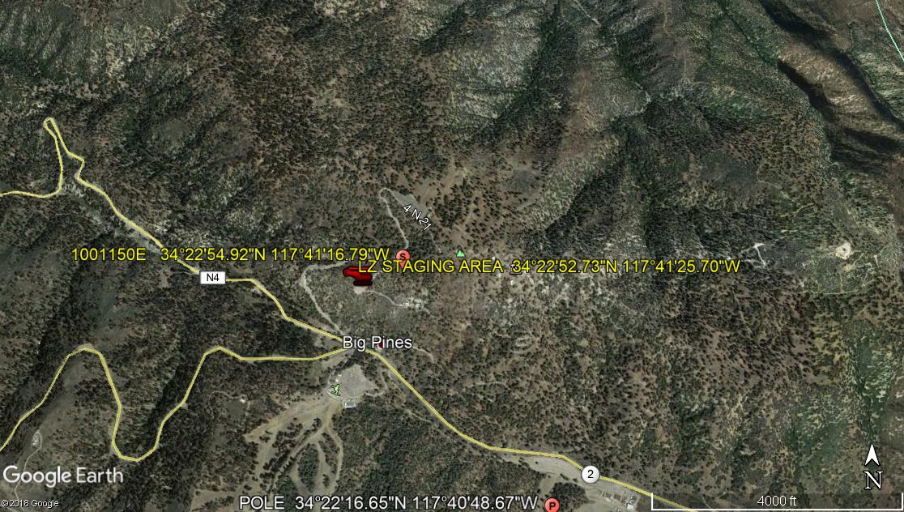
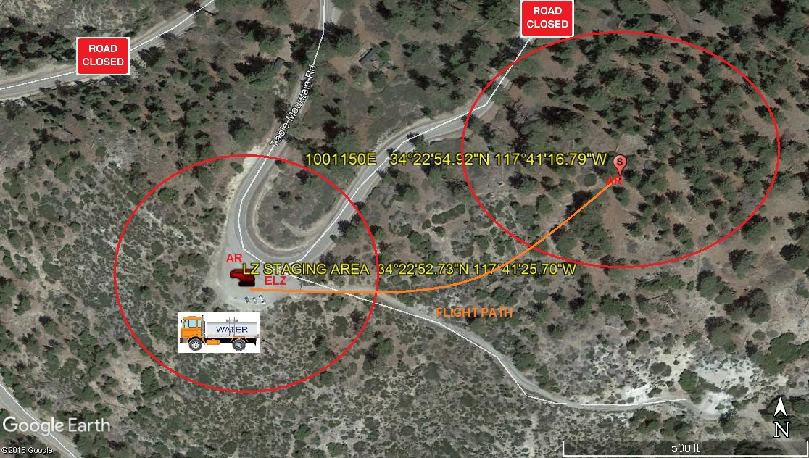
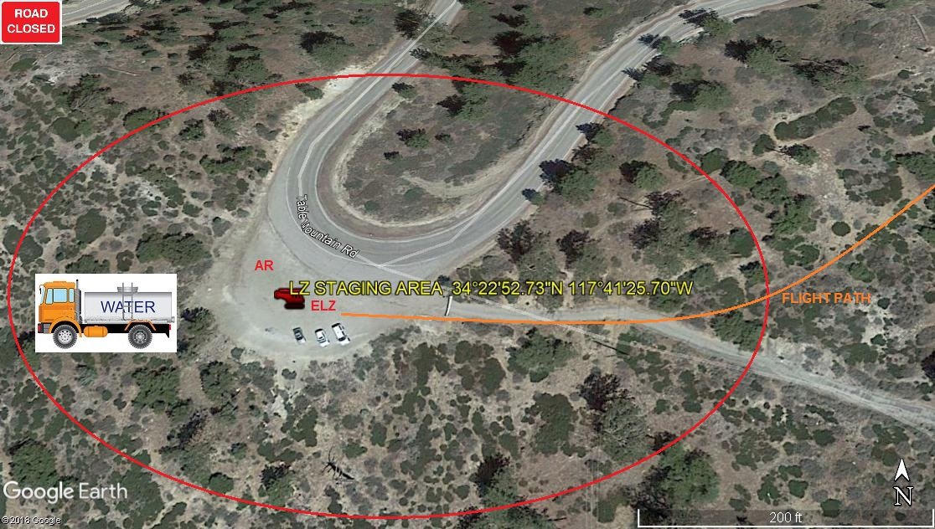
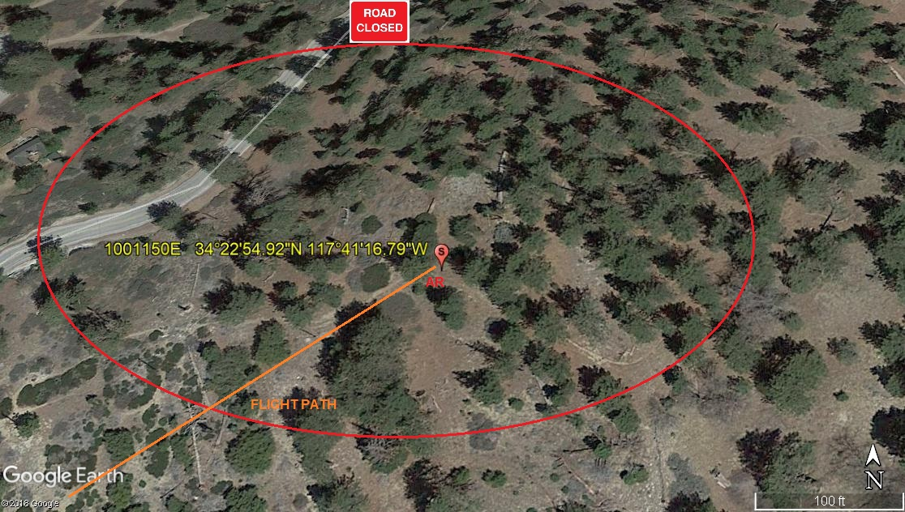
LEGEND
SITE PLAN SYMBOLS: EVACUATION FLIGHT PATH
LANDING AREA = (LZ) | STREET BLOCKED = XXXX | TOP TWO FLOORS = UBT2
ATTACH AREA = (A) | RELEASE AREA = (R)
FLIGHT PATH = >>> | EMERGENCY LAND = (ELZ)
UNOCCUPIED BUILDING = (UBA) | UNOCCUPIED BUILDING TOP FLOOR = (UBT1)
AREA SURVEY CONDUCTED BY :

