
SECTION 7 Part 135 GH 4A Part 133 GH 4L
Congested Area Plan
Operator: Guardian Helicopters, Inc
67 D STREET Phone (818) 442-9904
Fillmore CA. 93015 FAX (818) 442-9901

PROJECT: EDISON POLE REPLACEMENT WORK ORDER #: TD1516593
ADDRESS: THACHER ROAD : OJIA CA
LZ STAGING AREA LATITUDE 34°27'53.38"N LATITUDE 119°11'10.72"W
4619658E LATITUDE 34°27'49.03"N LATITUDE 119°11'25.58"W 45 CL 1 COMP 1200 LBS
1424570E LATITUDE 34°27'50.21"N LATITUDE 119°11'25.66"W 40 CL 1 COMP 1000 LBS
1424572E LATITUDE 34°27'53.83"N LATITUDE 119°11'26.07"W 45 CL 1 COMP 1200 LBS
CONTACT AT SITE; RITO DE LA CRUZ PHONE#: 805-616-5200
PILOT’S NAME(S): 1. JOHN OLSON CERT #: 2769166
2. BUCKEY MACKAY CERT #: #:2778051
3. MARTIN RODRIGUEZ CERT #: 3555121
4. MICHAEL KLINK CERT# 33018828
TYPE OF AIRCRAFT:
BELL UH-1H N# N711GH A/C CATEGORY: RESTRICTED
BELL UH-1H N# N214KK A/C CATEGORY: RESTRICTED
BELL 407 N# N407GH A/C CATEGORY: STANDARD
BELL 205A1 N# N216GH A/C CATEGORY: STANDARD
AS350 B2 N# N498PT A/C CATEGORY: STANDARD
AS350 B3 N# N718GH A/C CATEGORY: STANDARD
AS350 B3 N# N215GH A/C CATEGORY: STANDARD
IF SAFETY DICTATES AND OR THE CUSTOMER REQUESTS ADDITIONAL LIFTS THE LIFTS WILL BE CONDUCTED REMAINING WITHIN THE APPROVED TIME PARAMETERS.
TYPE OF LIFTS: :( 3) 45 CL 1 COMP (3) 45 CL 1 COMPOSITE 1000 LBS 3600 FT OF 1/0A COVERED LINE CLASS OF LOAD:EXTL CL B TYPE OF ITEM LIFTING: ERODYNAMIC NON- AERODYNAMIC MAX 2000 LBS
NO. OF LIFTS: 20 LONG LINE: (NO) XXX (YES) LESS THEN 150 FT +45 ft Pole 195ft total (LENGTH)
OPERATIONAL ALTITUDE: < 250 STREET CLOSING: (N0) XX (YES)
DATE AND TIMES OPERATION WILL BEGIN AND TERMINATE:
FLIGHT DATES | TIME BEGIN | TIME END | TODAY’S DATE
11-12-2019 | SUNRISE | SUNSET | 11-5-2019
AGENCY NAME: | PHONE#: | PERSON NOTIFIED: | DATE:
OJAI POLICE | 805-656-1414 | WATCH COMMANDER | NOTIFY
VENTURA COUNTY FIRE | 805-371-1111 | STATION 21 | NOTIFY

SECTION 7 Part 135 GH 4A Part 133 GH 4L
Congested Area Plan
Operator: Guardian Helicopters, Inc
67 D Street
Fillmore, California 93015
Evacuation Crowd Control Street Closure
□No Evacuated Structures Operator Yes □ No
Evacuated Structures Contractor Contractor
□Operator
LIST OF BUILDINGS THAT SHALL EITHER BE PARTIALLY OR ENTIRELY UNOCCUPIED PERSONS ALSO HOMES THAT WILL BE NOTIFIED OF ACTIVITY:
BUILDING DESCRIPTION/ADDRESS | REMARKS | METHOD
4295 THACHER RD | VACANT DURING OPS | HAND DELIVER
4255 THACHER RD | VACANT DURING OPS | HAND DELIVER
4245 THACHER RD | VACANT DURING OPS | HAND DELIVER
ALL HOMES WITHIN RED OPERATING AREA | VACANT DURING OPS | HAND DELIVER
SEE DIAGRAM = VACANT | VACANT DURING OPS | HAND DELIVER
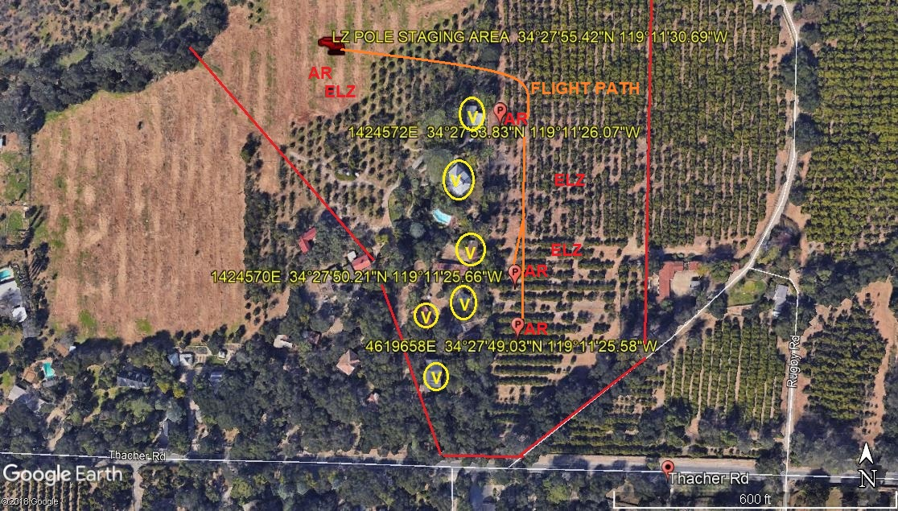

Narrative description of pick-up site, route, delivery site, and plan for ceasing operation if unauthorized persons enter operational area or real hazard occurs.
SITE INSPECTION NOTES

ONLY PERSONNEL ESSENTIAL TO COMPLETING THE JOB SAFELY WILL BE PERMITTED TO PARTICIPATE IN THE EVOLUTION. ONLY PERSONNEL PARTICIPATING IN THE SAFETY BRIEF WILL BE PERMITTED TO BE IN THE AREA OF OPERATIONS. ONLY AUTHORIZED ESSENTIAL PERSONAL WILL BE PERMITTED IN THE IMMEDIATE AREA OF OPERATIONS. IN THE EVENT AN UNAUTHORIZED PERSON ENTERS THE OPERATIONS AREA OR A POTENTIAL HAZARD IS IDENTIFIED THE PILOT WILL HOLD THE AIRCRAFT IN RELATIVE POSITION. THIS WILL BE ACHIEVED WITHOUT OVER FLYING THE GROUND CREW. ALL OPERATIONS WILL BE CEASED UNTIL THE PROBLEM IS RECTIFIED. IN THE EVENT OF AN AIRCRAFT EMERGENCY, THE PILOT WILL RADIO GROUND PERSONNEL AND WILL ATTEMPT TO LAND IN THE EMERGENCY LANDING AREA.
DURING THE LIFT EVOLUTION THE AIRCRAFT AND GROUND CREW WILL ALL BE IN RADIO COMMUNICATIONS. IN THE EVENT OF LOSS COMMUNICATIONS, THE CREW WILL USE STANDARD HAND SIGNALS TO COMMUNICATE WITH THE PILOT. WHEN THE PILOT IS CLEAR HE WILL MOVE THE AIRCRAFT TO A SAFE LOCATION TO ALLOW THE COMMUNICATION PROBLEM TO BE RECTIFIED.
THE OPERATIONS AREA IS WITHIN THE SECURED AREA. ALL ESSENTIAL CREW WITHIN THE OPERATIONS AREA WILL NOT BE INVOLVED IN TAKING PICTURES OR ANY OTHER USE OF CELL PHONES.
PRIOR TO BEGINNING OPERATIONS, A TAILBOARD SAFETY BRIEF WILL BE CONDUCTED.
- HELICOPTER WILL LAND AT THE LZ TO CONNECT THE LONGLINE. THE POLES WILL BE STAGED AT THE LANDING ZONE .
- FUELING WILL BE CONDUCTED AT THE LANDING ZONE
- EMERGENCY LANDING ZONE IS AT THE STAGING AREA AND ALONG THE FLIGHT PATH
- TAILBOARD SAFETY BRIEF CONDUCTED AT THE STAGING AREA PRIOR TO FLIGHT
- DRIVEWAY CLOSURE WILL BE PER DRAWING BELOW
- HOME EVACUATION WILL BE PER DRAWING. ALL HOMES WITHIN THE RED OPERATING AREA WILL BE VERIFIED VACANT
- WATER TRUCK REQUIRED AT LANDING ZONE
- STREET CLOSURE, CONTRACTOR AND GHI PERSONAL WILL VERIFY EVACUATION COMPLIANCE
- THE CONTRACTOR WILL TRIM TREES IF REQUIRED

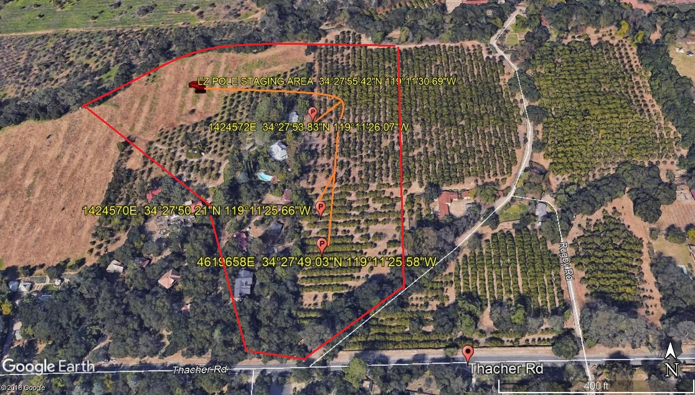

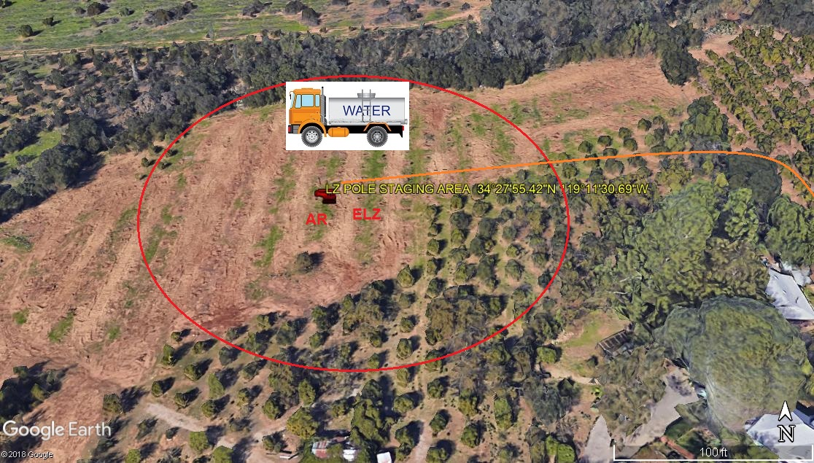
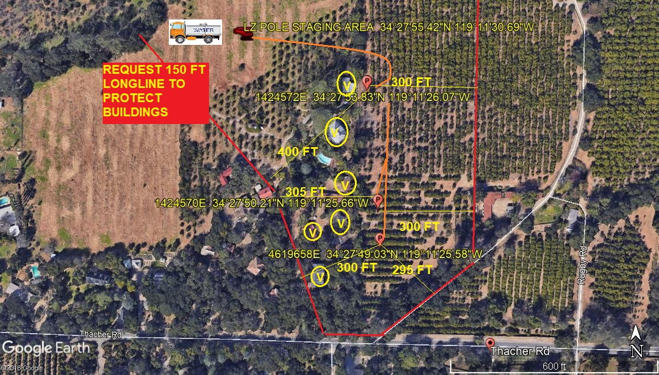

10-5-2019 
DATE OF SUBMISSION COMPANY OFFICIAL / TITLE

