
SECTION 7 Part 135 GH 4A Part 133 GH 4L
NON-Congested Area Plan
Operator: Guardian Helicopters, Inc
67 D STREET
Fillmore CA. 93015
Phone (818) 442-9904
FAX (818) 442-9901
PROJECT: AMJACK STRUCTURE SUPPORT WORK ORDER NUMBER:
ADDRESS: TOLLHOUSE RD :TOLLHOUSE CA
LZ AREA LATITUDE 36°56'47.90"N LONGITUDE 119°26'52.82"W
STAGING AREA LATITUDE 37° 1'31.18"N LONGITUDE 119°22'46.74"W
M18-T5 LATITUDE 37° 1'7.29"N LONGITUDE 119°23'11.16"W
CONTRACTOR’S NAME: CHRIS STASIUK PHONE#: 204-631-2510
CONTACT PERSON: CHRIS STASIUK CELL PHONE#: 204-785-3044
PILOT’S NAME(S): 1. JOHN OLSON CERT #: 2769166
2. BUCKEY MACKAY CERT #: #:2778051
3. MARTIN RODRIGUEZ CERT #: 3555121
4. MICHAEL KLINK CERT# 33018828
TYPE OF AIRCRAFT:BELL UH-1H N# N711GH A/C CATEGORY: RESTRICTED
BELL UH-1H N# N214KK A/C CATEGORY: RESTRICTED
BELL 407 N# N407GH A/C CATEGORY: STANDARD
BELL 205A1 N# N216GH A/C CATEGORY: STANDARD
AS350 B2 N# N498PT A/C CATEGORY: STANDARD
AS350 B3 N# N718GH A/C CATEGORY: STANDARD
AS350 B3 N# N215GH A/C CATEGORY: STANDARD

TYPE OF ITEM LIFTING: EQUIPMENT AERODYNAMIC NON- AERODYNAMIC
IF SAFETY DICTATES AND OR THE CUSTOMER REQUESTS ADDITIONAL LIFTS THE LIFTS WILL BE CONDUCTED REMAINING WITHIN THE APPROVED TIME PARAMETERS.
TYPE OF LIFTS: EQUIPMENT UP TO 2200 LBS HIGHEST ELEVATION 3600 FT
MAX SINGLE – LIFT WEIGHT: 1750 LBS CLASS OF LOAD: EXTERNAL CL B
NO. OF LIFTS: TBD LONG LINE: (NO) XXX (YES) 100 – 150 FT
OPERATIONAL ALTITUDE: < 250 STREET CLOSING: XX (N0) (YES)
DATE AND TIMES OPERATION WILL BEGIN AND TERMINATE:
FLIGHT DATES | TIME BEGIN | TIME END | TODAY’S DATE
12-13-2019 | SUNRISE | SUNSET | 11-27-2019
12-21-2019 | SUNRISE | SUNSET | 11-27-2019
AGENCY NAME: | PHONE#: | PERSON NOTIFIED: | DATE:
FIRE DEPARTMENT | 559-841-3360 | DISPATCH | NOTIFY
CAL FIRE | 559-841-7774 | DISPATCH | NOTIFY

NON- Congested Area Plan (Continued)

Evacuation Crowd Control Street Closure
No Evacuated Structures Operator □Yes □ No
□Evacuated Structures Contractor □Contractor
□Operator

LIST OF BUILDINGS THAT SHALL EITHER BE PARTIALLY OR ENTIRELY UNOCCUPIED PERSONS ALSO HOMES THAT WILL BE NOTIFIED OF ACTIVITY:
BUILDING DESCRIPTION/ADDRESS | REMARKS | PHONE #:
ALL STRUCTURES WITHIN 300 FT OF FLIGHT PATH OR POLE SITES | VACANT | HAND DELIVERED

Narrative description of pick-up site, route, delivery site, and plan for ceasing operation if unauthorized persons enter operational area or real hazard occurs.
SITE INSPECTION NOTES

ONLY PERSONNEL ESSENTIAL TO COMPLETING THE JOB SAFELY WILL BE PERMITTED TO PARTICIPATE IN THE EVOLUTION. ONLY PERSONNEL PARTICIPATING IN THE SAFETY BRIEF WILL BE PERMITTED TO BE IN THE AREA OF OPERATIONS. ONLY AUTHORIZED ESSENTIAL PERSONAL WILL BE PERMITTED IN THE IMMEDIATE AREA OF OPERATIONS. IN THE EVENT AN UNAUTHORIZED PERSON ENTERS THE OPERATIONS AREA OR A POTENTIAL HAZARD IS IDENTIFIED THE PILOT WILL HOLD THE AIRCRAFT IN RELATIVE POSITION. THIS WILL BE ACHIEVED WITHOUT OVER FLYING THE GROUND CREW. ALL OPERATIONS WILL BE CEASED UNTIL THE PROBLEM IS RECTIFIED. IN THE EVENT OF AN AIRCRAFT EMERGENCY, THE PILOT WILL RADIO GROUND PERSONNEL AND WILL ATTEMPT TO LAND IN THE EMERGENCY LANDING AREA.
DURING THE LIFT EVOLUTION THE AIRCRAFT AND GROUND CREW WILL ALL BE IN RADIO COMMUNICATIONS. IN THE EVENT OF LOSS COMMUNICATIONS, THE CREW WILL USE STANDARD HAND SIGNALS TO COMMUNICATE WITH THE PILOT. WHEN THE PILOT IS CLEAR HE WILL MOVE THE AIRCRAFT TO A SAFE LOCATION TO ALLOW THE COMMUNICATION PROBLEM TO BE RECTIFIED.
THE OPERATIONS AREA IS WITHIN THE SECURED AREA. ALL ESSENTIAL CREW WITHIN THE OPERATIONS AREA WILL NOT BE INVOLVED IN TAKING PICTURES OR ANY OTHER USE OF CELL PHONES.
A DAILY TAILBOARD SAFETY MEETING WILL BE HELD AT THE ASSIGNED LOCATING PRIOR TO BEING OPERATIONS
- HELICOPTER WILL LAND AT THE DESIGNATED LANDING ZONE FOR FUELING AND TAILBOARD.
- EQUIPMENT WILL BE STAGED AT THE ASSIGNED POLE STAGING AREA
- WATER TRUCK IS REQUIRED AT LZ AND STAGING AREA
- EMERGENCY LANDING ZONE IS AT THE LANDING ZONE, STAGING AREA AND IN ROUTE TO POLE SITES IF REQUIRED
- TOLLHOUSE ROAD WILL EXPERIENCE INTERMITTENT CLOSURE DURING EQUIPMENT SETTING

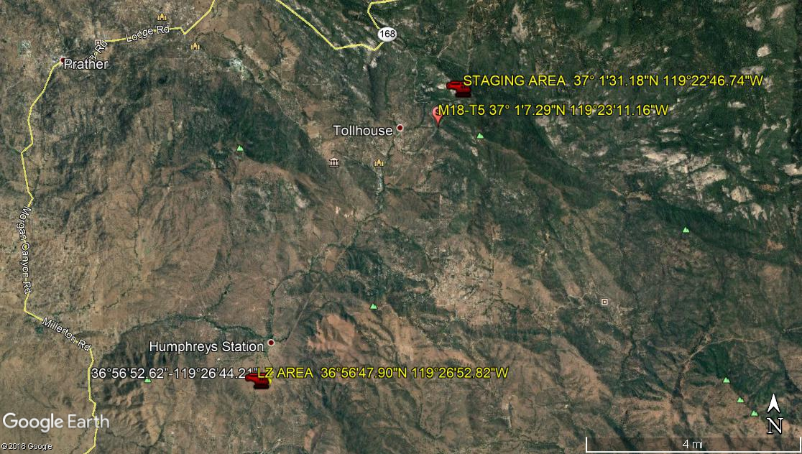
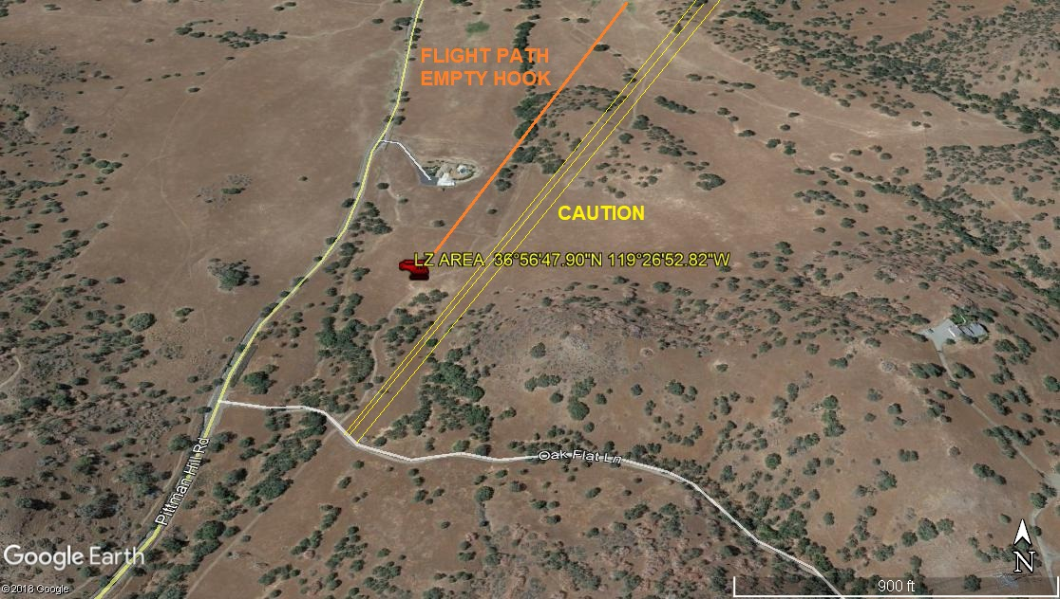
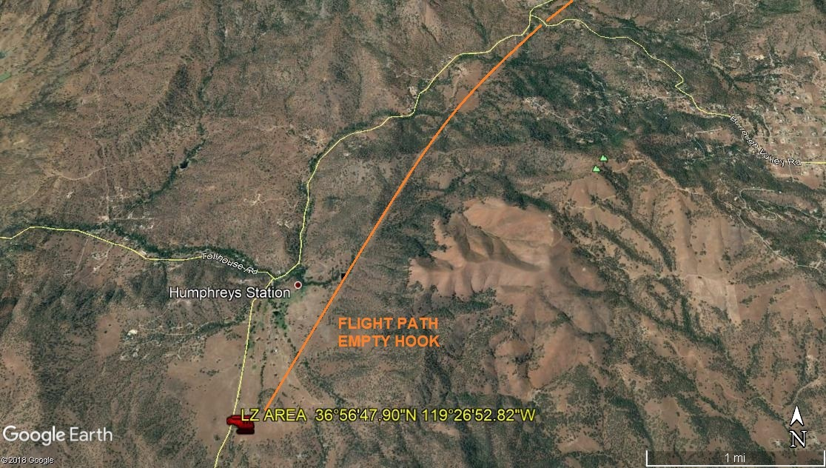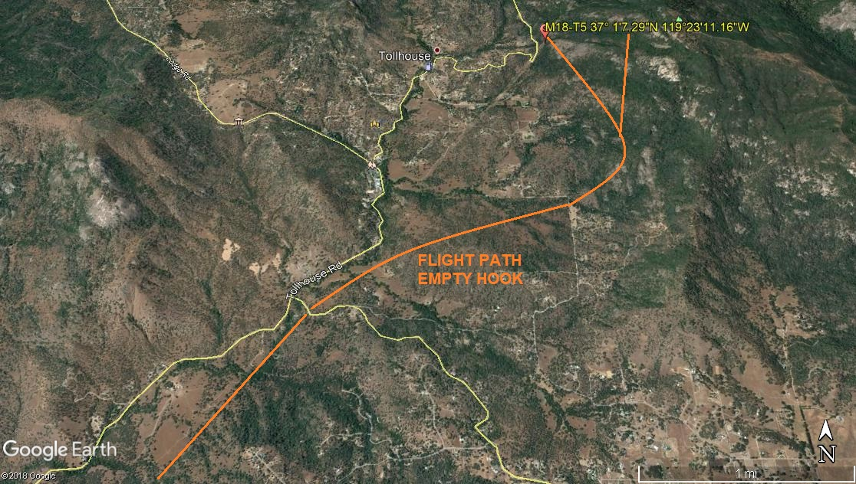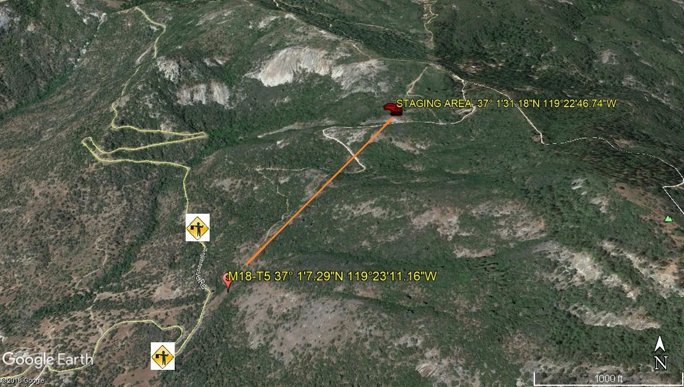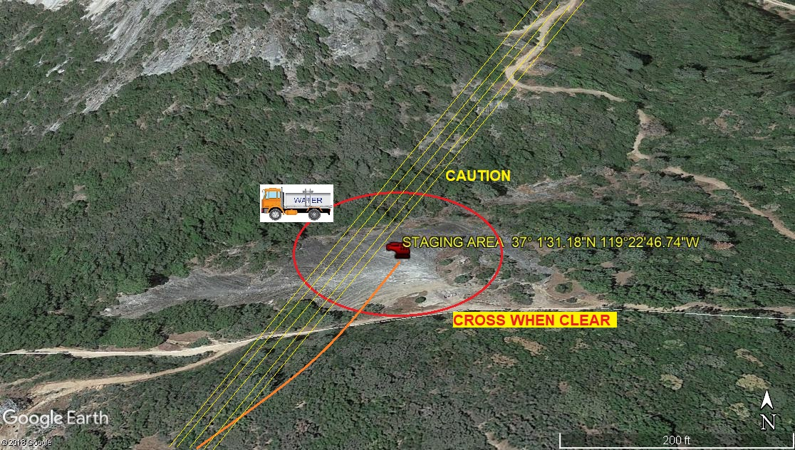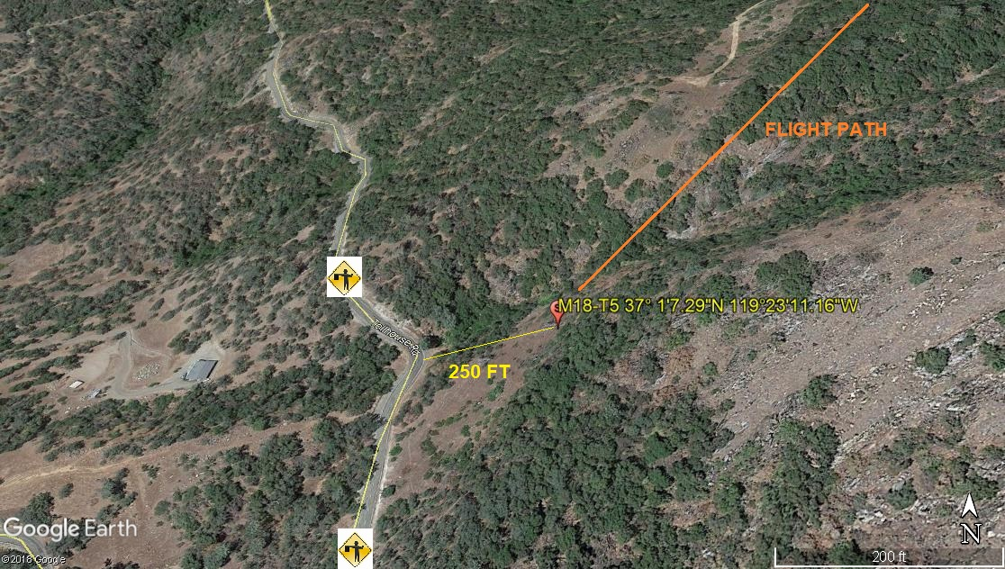LEGEND
SITE PLAN SYMBOLS: EVACUATION FLIGHT PATH
LANDING AREA = (LZ) | STREET BLOCKED = XXXX | TOP TWO FLOORS = UBT2
ATTACH AREA = (A) | RELEASE AREA = (R)
FLIGHT PATH = >>> | EMERGENCY LAND = (ELZ)
UNOCCUPIED BUILDING = (UBA) | UNOCCUPIED BUILDING TOP FLOOR = (UBT1)

11-27-2019 
DATE OF SUBMISSION COMPANY OFFICIAL / TITLE

