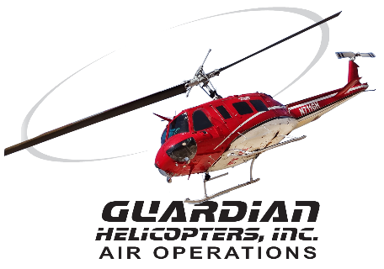
SECTION 7 Part 135 GH 4A Part 133 GH 4L
NON Congested Area Plan
Operator: Guardian Helicopters, Inc
67 D STREET
Fillmore CA. 93015
Phone (818) 442-9904
FAX (818) 442-9901
PROJECT: EDISON POLE REPLACEMENT WORK ORDER #: TD1570131 TD 1571785
ADDRESS: 1234 YUKON DR : ARROWHEAD CA
LZ LATITUDE 34°16'19.78"N LONGITUDE 117°16'58.53"W ELEV 3700 FT
POLE STAGING AREA LATITUDE 34°16'31.25"N LONGITUDE 117°12'26.34"W
1947514E LATITUDE 34°16'24.00"N LONGITUDE 117°12'28.57"W 55 CL 4 2000 LBS
2007852E LATITUDE 34°16'23.11"N LONGITUDE 117°12'28.25"W 50 CL 1 2000 LBS
CONTACT AT SITE; PROENERGY REY RUIZ PHONE#: 714-402-2328
CRYSTAL PELHAM PHONE#: 310-988-8985
PILOT’S NAME(S): 1. JOHN OLSON CERT #: 2769166
2. BUCKEY MACKAY CERT #: 2778051
3. MARTIN RODRIGUEZ CERT #: 3555121
4. MICHAEL KLINK CERT# 3018828
TYPE OF AIRCRAFT:BELL UH-1H N# N711GH A/C CATEGORY: RESTRICTED
BELL UH-1H N# N214KK A/C CATEGORY: RESTRICTED
BELL 407 N# N407GH A/C CATEGORY: STANDARD
BELL 205A1 N# N216GH A/C CATEGORY: STANDARD
AS350 B2 N# N498PT A/C CATEGORY: STANDARD
AS350 B3 N# N718GH A/C CATEGORY: STANDARD
AS350 B3 N# N215GH A/C CATEGORY: STANDARD
IF SAFETY DICTATES AND OR THE CUSTOMER REQUESTS ADDITIONAL LIFTS THE LIFTS WILL BE CONDUCTED REMAINING WITHIN THE APPROVED TIME PARAMETERS.
TYPE OF LIFTS: :( 2) 2000 LBS (4) 2000 LBS CLASS OF LOAD:EXTL CL B TYPE OF ITEM LIFTING: POLE AERODYNAMIC NON- AERODYNAMIC MAX 1600 LBS
NO. OF LIFTS: 4 LONG LINE: (NO) XXX (YES) LESS THEN 150 FT (LENGTH)
OPERATIONAL ALTITUDE: < 250 STREET CLOSING: (N0) XX (YES)
DATE AND TIMES OPERATION WILL BEGIN AND TERMINATE:
FLIGHT DATES | TIME BEGIN | TIME END | TODAY’S DATE
11-22-2019 | SUNRISE | SUNSET | 11-18-2019
AGENCY NAME: | PHONE#: | PERSON NOTIFIED: | DATE:
TWIN PEAK POLICE | 909-336-0600 | WATCH COMMANDER | NOTIFY
SANT BERNARDINO FIRE | 909-338-0660 | STATION 91 | NOTIFY
Evacuation Crowd Control Street Closure
□No Evacuated Structures Operator Yes □ No
Evacuated Structures (13) Contractor Contractor
□Operator
SECTION 7 Part 135 GH 4A Part 133 GH 4L
Congested Area Plan
LIST OF BUILDINGS THAT SHALL EITHER BE PARTIALLY OR ENTIRELY UNOCCUPIED PERSONS ALSO HOMES THAT WILL BE NOTIFIED OF ACTIVITY:
BUILDING DESCRIPTION/ADDRESS | REMARKS | METHOD
1258 YUKON CT | VACANT DURING OPS | HAND DELIVER
1260 YUKON CT | VACANT DURING OPS | HAND DELIVER
1256 YUKON CT | VACANT DURING OPS | HAND DELIVER
1248 YUKON DR | VACANT DURING OPS | HAND DELIVER
1238 YUKON DR | VACANT DURING OPS | HAND DELIVER
1234 YUKON DR | VACANT DURING OPS | HAND DELIVER
1230 YUKON DR | VACANT DURING OPS | HAND DELIVER
1226 YUKON DR | VACANT DURING OPS | HAND DELIVER
1222 YUKON DR | VACANT DURING OPS | HAND DELIVER
1381 YUKON DR | VACANT DURING OPS | HAND DELIVER
1399 YUKON DR | VACANT DURING OPS | HAND DELIVER
1333 FINGER WAY | VACANT DURING OPS | HAND DELIVER
1336 FINGER WAY | VACANT DURING OPS | HAND DELIVER
ALL HOMES WITHIN RED OPERATING AREA | VACANT DURING OPS | HAND DELIVER
SEE DIAGRAM V= VACANT | VACANT DURING OPS | HAND DELIVER
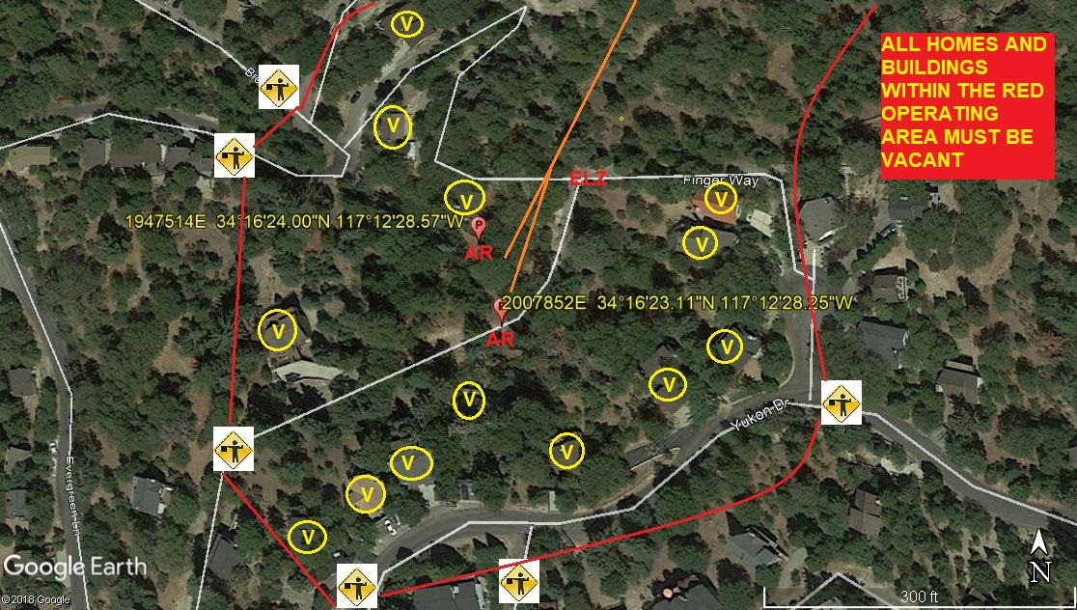

SITE INSPECTION NOTES

ONLY PERSONNEL ESSENTIAL TO COMPLETING THE JOB SAFELY WILL BE PERMITTED TO PARTICIPATE IN THE EVOLUTION. ONLY PERSONNEL PARTICIPATING IN THE SAFETY BRIEF WILL BE PERMITTED TO BE IN THE AREA OF OPERATIONS. ONLY AUTHORIZED ESSENTIAL PERSONAL WILL BE PERMITTED IN THE IMMEDIATE AREA OF OPERATIONS. IN THE EVENT AN UNAUTHORIZED PERSON ENTERS THE OPERATIONS AREA OR A POTENTIAL HAZARD IS IDENTIFIED THE PILOT WILL HOLD THE AIRCRAFT IN RELATIVE POSITION. THIS WILL BE ACHIEVED WITHOUT OVER FLYING THE GROUND CREW. ALL OPERATIONS WILL BE CEASED UNTIL THE PROBLEM IS RECTIFIED. IN THE EVENT OF AN AIRCRAFT EMERGENCY, THE PILOT WILL RADIO GROUND PERSONNEL AND WILL ATTEMPT TO LAND IN THE EMERGENCY LANDING AREA.
DURING THE LIFT EVOLUTION THE AIRCRAFT AND GROUND CREW WILL ALL BE IN RADIO COMMUNICATIONS. IN THE EVENT OF LOSS COMMUNICATIONS, THE CREW WILL USE STANDARD HAND SIGNALS TO COMMUNICATE WITH THE PILOT. WHEN THE PILOT IS CLEAR HE WILL MOVE THE AIRCRAFT TO A SAFE LOCATION TO ALLOW THE COMMUNICATION PROBLEM TO BE RECTIFIED.
THE OPERATIONS AREA IS WITHIN THE SECURED AREA. ALL ESSENTIAL CREW WITHIN THE OPERATIONS AREA WILL NOT BE INVOLVED IN TAKING PICTURES OR ANY OTHER USE OF CELL PHONES.
Narrative description of pick-up site, route, delivery site, and plan for ceasing operation if unauthorized persons enter operational area or real hazard occurs.

PRIOR TO BEGINNING OPERATIONS, A TAILBOARD SAFETY BRIEF WILL BE CONDUCTED.
- HELICOPTER WILL LAND AT THE LZ TO CONNECT THE LONGLINE. THE POLES WILL BE STAGED AT THE POLE STAGING AREA. THE HELICOPTER WILL FLY THE EMPTY LONGLINE TO THE STAGING AREA
- FUELING WILL BE CONDUCTED AT THE LANDING ZONE
- EMERGENCY LANDING ZONE IS AT THE STAGING AREA AND ALONG THE FLIGHT PATH
- TAILBOARD SAFETY BRIEF CONDUCTED AT THE STAGING AREA PRIOR TO FLIGHT
- FLAGMAN WILL NEED TO STOP TRAFFIC WHILE HELICOPTER IS CROSSING THE STREET.
- SEE DRAWING BELOW FOR LOCATIONS OF CLOSURES
- WATER TRUCK REQUIRED AT LANDING ZONE
- 13 HOMES/BUILDINGS WITHIN THE OPREATION AREA WILL BE VACANT
- THE CONTRACTOR WILL TRIM TREES IF REQUIRED

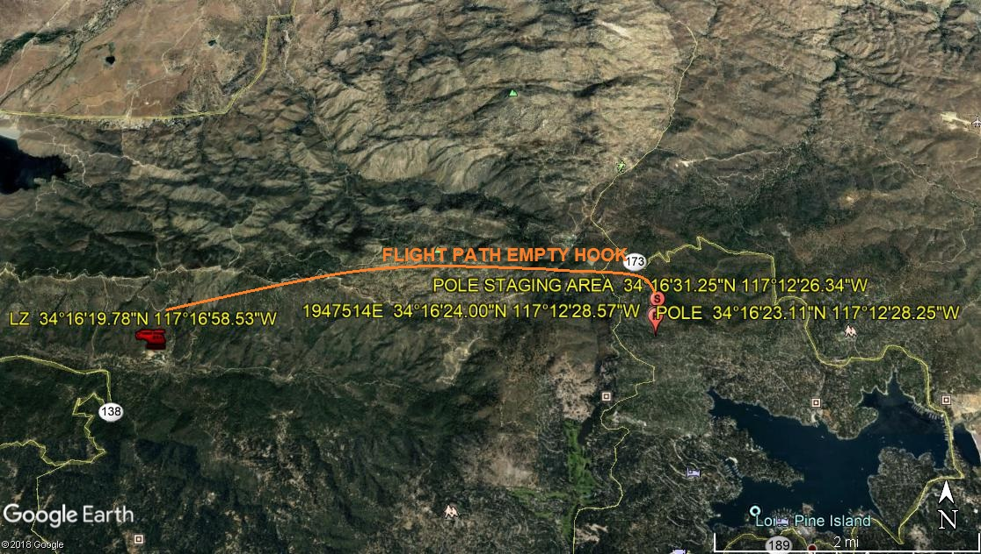

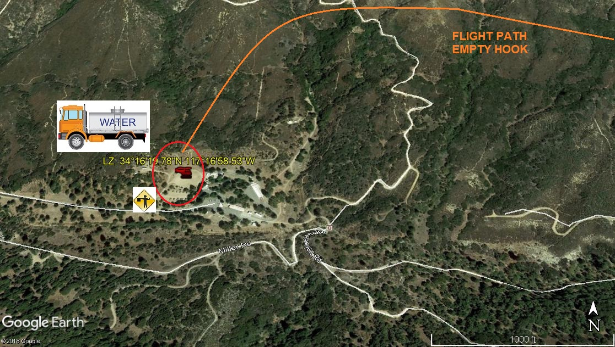
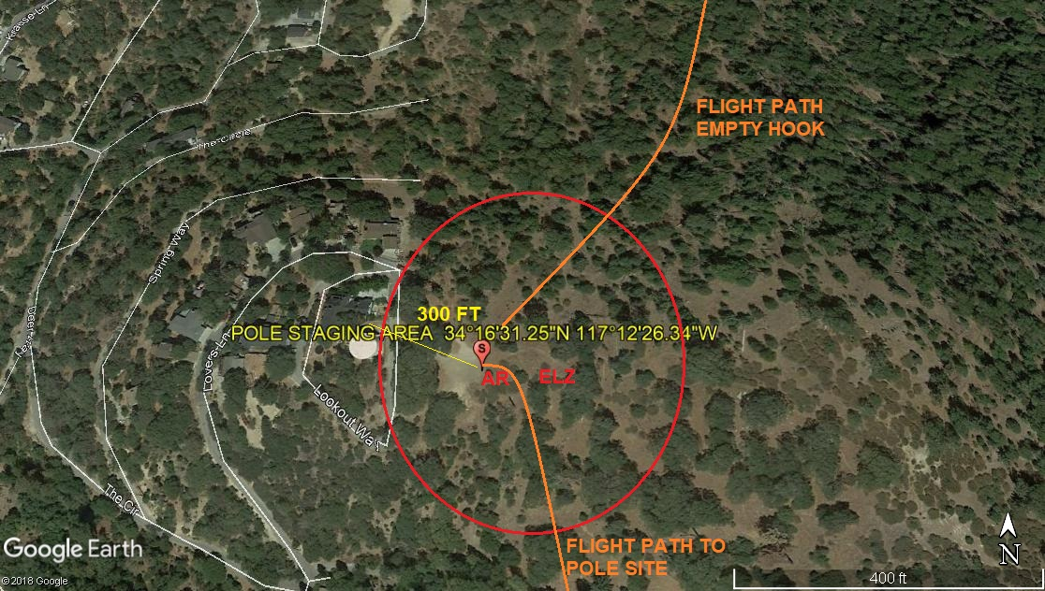
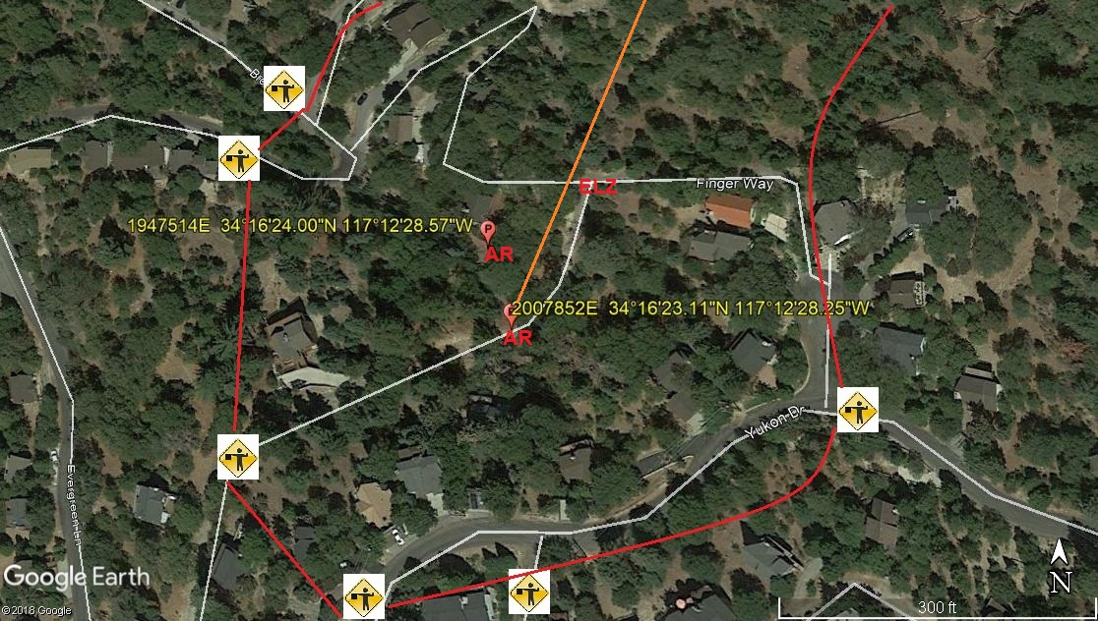
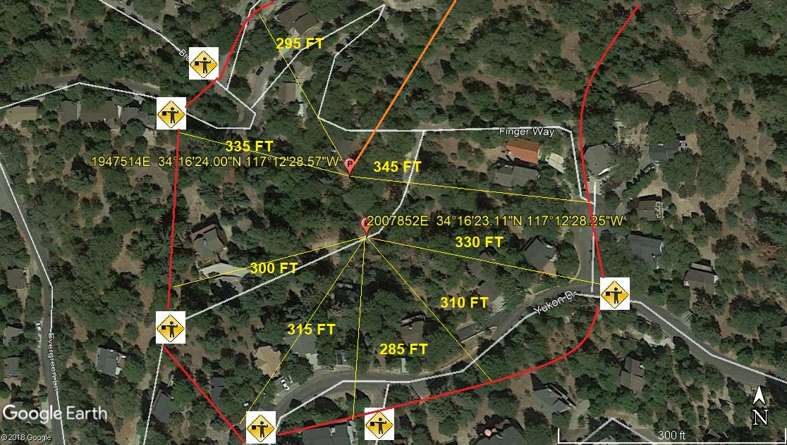

11-18-2019 
DATE OF SUBMISSION COMPANY OFFICIAL / TITLE

