
SECTION 7 Part 135 GH 4A Part 133 GH 4L
NON - Congested Area Plan
Operator: Guardian Helicopters, Inc
67 D STREET
Fillmore CA. 93015
Phone (818) 442-9904
FAX (818) 442-9901
PROJECT: EDISON POLE REPLACEMENT WORK ORDER #: TD 1470822 TD 1459457 TD 1425854 TD 1540320 TD 1544145 TD 1481258 ADDRESS: SAN GABRIEL CANYON ROAD : ASUZA CA
EAST FORK LZ STAGING AREA 34°13'55.00"N 117°47'8.13"W
1304195E 34°12'3.42"N 117°46'1.19"W 45 CL 1 COMPOSITE
1304194E 34°12'3.42"N 117°46'1.19"W 45 CL 1 COMPOSITE
CONTRACTOR’S NAME: MIKE SANFORD PHONE#: 951-423-4789
CONTACT AT SITE; MIKE SANFORD PHONE#: 951-423-4789
PILOT’S NAME(S): 1. JOHN OLSON CERT #: 2769166
2. BUCKEY MACKAY CERT #: 2778051
3. MARTIN RODRIGUEZ CERT #: 3555121
4. MICHAEL KLINK CERT# 3018828
5. IAN GOODALE CERT# 3741973
TYPE OF AIRCRAFT:BELL UH-1H N# N711GH A/C CATEGORY: RESTRICTED
BELL UH-1H N# N214KK A/C CATEGORY: RESTRICTED
BELL 407 N# N407GH A/C CATEGORY: STANDARD
BELL 205A1 N# N216GH A/C CATEGORY: STANDARD
AS350 B2 N# N498PT A/C CATEGORY: STANDARD
AS350 B3 N# N718GH A/C CATEGORY: STANDARD
AS350 B3 N# N215GH A/C CATEGORY: STANDARD
TYPE OF ITEM LIFTING: POLE AERODYNAMIC NON- AERODYNAMIC
IF SAFETY DICTATES AND OR THE CUSTOMER REQUESTS ADDITIONAL LIFTS THE LIFTS WILL BE CONDUCTED REMAINING WITHIN THE APPROVED TIME PARAMETERS.
TYPE OF LIFTS: HEC AND (2) POLES 45 LC 1 COMPOSITE 1200 LBS CLASS OF LOAD: EXTERNAL CL B
NO. OF LIFTS: TBD LONG LINE: (NO) XXX (YES) LESS THEN 150 FT (LENGTH)
OPERATIONAL ALTITUDE: < 250
DATE AND TIMES OPERATION WILL BEGIN AND TERMINATE:
FLIGHT DATES | TIME BEGIN | TIME END | TODAY’S DATE
11-9-2019 | SUNRISE | SUNSET | 11-8-2019
AGENCY NAME: | PHONE#: | PERSON NOTIFIED: | DATE:
POLICE | 909-450-2700 | WATCH COMMANDER | NOTIFY
FIRE | 626-334-0011 | STATION 32 | NOTIFY
Evacuation Crowd Control Street Closure
No Evacuated Structures □Operator Yes □ No
□Evacuated Structures □Contractor □Contractor
□Operator
SECTION 7 Part 135 GH 4A Part 133 GH 4L
NON-Congested Area Plan

Operator: Guardian Helicopters, Inc
67 D Street
Fillmore, California 93015
LIST OF BUILDINGS THAT SHALL EITHER BE PARTIALLY OR ENTIRELY UNOCCUPIED PERSONS ALSO HOMES THAT WILL BE NOTIFIED OF ACTIVITY:
BUILDING DESCRIPTION/ADDRESS | REMARKS | METHOD
ALL HOMES WITHIN OPERATING AREA | VACANT DURING OPS | HAND DELIVER
SEE DIAGRAM = V | VACANT DURING OPS | HAND DELIVER
Narrative description of pick-up site, route, delivery site, and plan for ceasing operation if unauthorized persons enter operational area or real hazard occurs.
SITE INSPECTION NOTES
ONLY PERSONNEL ESSENTIAL TO COMPLETING THE JOB SAFELY WILL BE PERMITTED TO PARTICIPATE IN THE EVOLUTION. ONLY PERSONNEL PARTICIPATING IN THE SAFETY BRIEF WILL BE PERMITTED TO BE IN THE AREA OF OPERATIONS. ONLY AUTHORIZED ESSENTIAL PERSONAL WILL BE PERMITTED IN THE IMMEDIATE AREA OF OPERATIONS. IN THE EVENT AN UNAUTHORIZED PERSON ENTERS THE OPERATIONS AREA OR A POTENTIAL HAZARD IS IDENTIFIED THE PILOT WILL HOLD THE AIRCRAFT IN RELATIVE POSITION. THIS WILL BE ACHIEVED WITHOUT OVER FLYING THE GROUND CREW. ALL OPERATIONS WILL BE CEASED UNTIL THE PROBLEM IS RECTIFIED. IN THE EVENT OF AN AIRCRAFT EMERGENCY, THE PILOT WILL RADIO GROUND PERSONNEL AND WILL ATTEMPT TO LAND IN THE EMERGENCY LANDING AREA.
DURING THE LIFT EVOLUTION THE AIRCRAFT AND GROUND CREW WILL ALL BE IN RADIO COMMUNICATIONS. IN THE EVENT OF LOSS COMMUNICATIONS, THE CREW WILL USE STANDARD HAND SIGNALS TO COMMUNICATE WITH THE PILOT. WHEN THE PILOT IS CLEAR HE WILL MOVE THE AIRCRAFT TO A SAFE LOCATION TO ALLOW THE COMMUNICATION PROBLEM TO BE RECTIFIED.
THE OPERATIONS AREA IS WITHIN THE SECURED AREA. ALL ESSENTIAL CREW WITHIN THE OPERATIONS AREA WILL NOT BE INVOLVED IN TAKING PICTURES OR ANY OTHER USE OF CELL PHONES.
EVERYDAY PRIOR TO COMMENCING OPERATIONS A SAFETY TAILBOARD WILL BE CONDUCTED AT A PRE-DETERMINED LZ
HEC TRAINING WILL BE CONDUCTED FOR ALL HEC PARTICIPANTS PRIOR TO BEGINNING OPERATIONS.
1. HELICOPTER WILL LAND IN THE PRE-DETERMINE LZ/ STAGING / FUEL AREA
2. FUELING WILL ONLY BE CONDUCTED AT THE STAGING AREA
3. EMERGENCY LANDING ZONES ARE AT THE STAGING AREA AND ALONG THE FLIGHT PATH
4. ALL STRUCTURES WITHIN THE OPERATING AREA WILL BE EVACUATED AND WILL BE VERIFIED PRIOR TO HELICOPTER OPERATIONS
5. THE PILOT WILL ENSURE ALL HIGHWAY AND RIVER CROSSINGS ARE CLEAR OF VEHICLES AND MEMBERS OF THE PUBLIC PRIOR TO PROCEEDING
6. ALL DIRT STAGING AREAS WILL REQUIRE A WATER TRUCK
7. ROADS WILL BE CLOSED AS ASSIGNED IN DIAGRAM BELOW
8. EQUIPMENT WILL BE STAGED AT THE ASSIGNED LZ/STAGING AREA
9. PILOT WILL MONITOR ACCESS ROADS AND TRAILS TO ENSURE MEMBERS OF THE NON-PARTICIPATING PUBLIC DON’T ENTER THE OPERATING AREA DURING ALL EXTERNAL LOAD OPERATIONS
10. PLEASE TRIM TREES IF REQUIRED.
11-8-2019 
DATE OF SUBMISSION COMPANY OFFICIAL / TITLE

NON Congested Area Plan (continued)

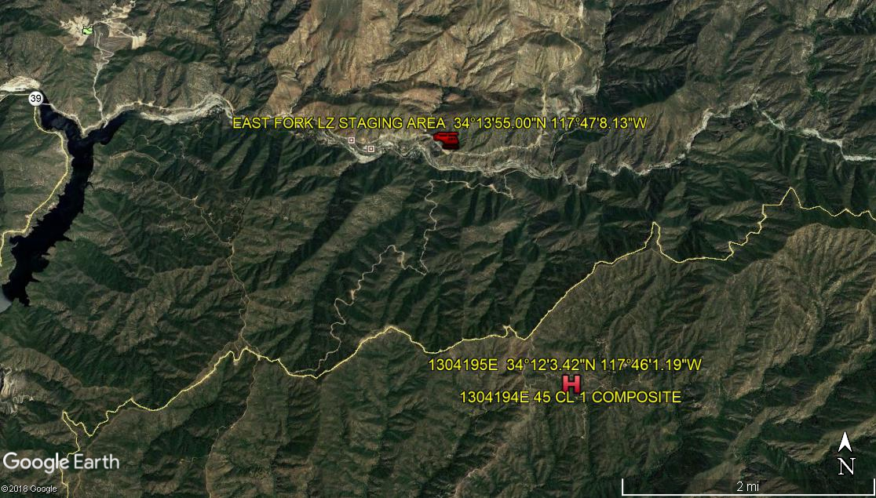
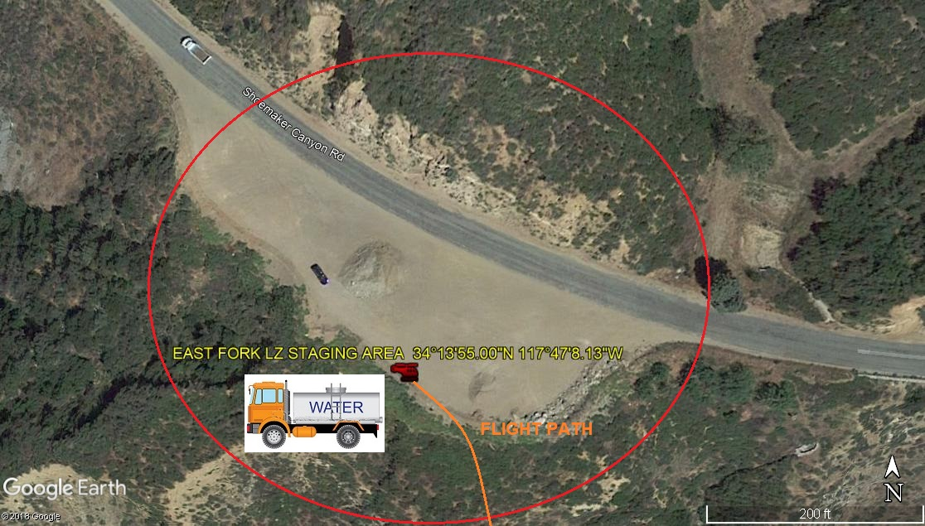

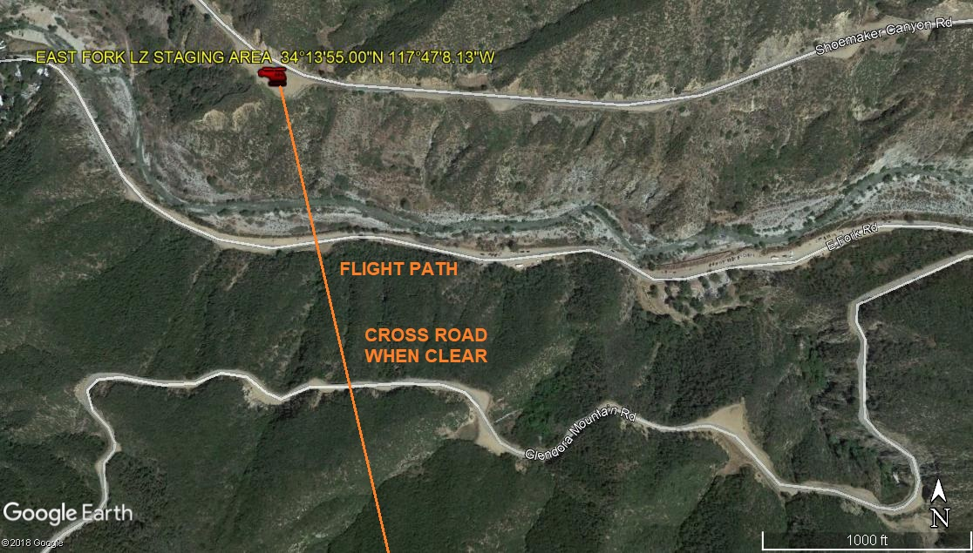
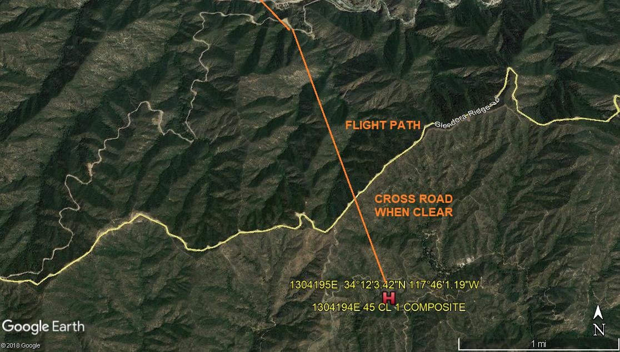

LEGEND
SITE PLAN SYMBOLS: EVACUATION FLIGHT PATH
LANDING AREA = (LZ) | STREET BLOCKED = XXXX | TOP TWO FLOORS = (UBT2
ATTACH AREA = (A) | RELEASE AREA = (R)
FLIGHT PATH = >>> ORANGE LINE | EMERGENCY LAND = (ELZ)
UNOCCUPIED BUILDING = (UBA) (V) | UNOCCUPIED BUILDING TOP FLOOR = (UBT1)

AREA SURVEY CONDUCTED BY :

