
SECTION 7 Part 135 GH 4A Part 133 GH 4L
NON-Congested Area Plan
Operator: Guardian Helicopters, Inc
67 D STREET
Fillmore CA. 93015
Phone (818) 442-9904
FAX (818) 442-9901
PROJECT: EDISON POLE REPLACEMENT WORK ORDER NUMBER: 902836675
ADDRESS: SOLEDAD CANYON RD :SANTA CLARITA CA
LZ STAGING AREA LATTITUDE 34°25'49.91"N LONGITUDE 118°21'16.68"W ELEV 1500 FT
1848281E LATTITUDE 34°25'53.50"N LONGITUDE 118°21'4.76"W 45 CL 1 2000 LBS
CONTRACTOR’S NAME: RICHARD SMITH PHONE#: 909-635-7068
CONTACT PERSON: ROKSTAD POWER PHONE#: 909-635-7068
PILOT’S NAME(S): 1. JOHN OLSON CERT #: 2769166
2. BUCKEY MACKAY CERT #: 2778051
3. MARTIN RODRIGUEZ CERT #: 3555121
4. MICHAEL KLINK CERT# 3018828
5. IAN GOODALE CERT# 3741973

TYPE OF AIRCRAFT:BELL UH-1H N# N711GH A/C CATEGORY: RESTRICTED
BELL UH-1H N# N214KK A/C CATEGORY: RESTRICTED
BELL 407 N# N407GH A/C CATEGORY: STANDARD
BELL 205A1 N# N216GH A/C CATEGORY: STANDARD
AS350 B2 N# N498PT A/C CATEGORY: STANDARD
AS350 B3 N# N718GH A/C CATEGORY: STANDARD
AS350 B3 N# N215GH A/C CATEGORY: STANDARD

TYPE OF ITEM LIFTING: POLE AERODYNAMIC NON- AERODYNAMIC
IF SAFETY DICTATES AND OR THE CUSTOMER REQUESTS ADDITIONAL LIFTS THE LIFTS WILL BE CONDUCTED REMAINING WITHIN THE APPROVED TIME PARAMETERS.
TYPE OF LIFTS: DAY 1 HEC COMPRESSOR 950 LBS DAY 2 HEC 2000 LBS POLE
MAX SINGLE – LIFT WEIGHT: 2000 LBS CLASS OF LOAD: EXTERNAL CL B
NO. OF LIFTS: TBD LONG LINE: (NO) XXX (YES) 100 – 150 FT
OPERATIONAL ALTITUDE: < 250 STREET CLOSING: XX (N0) (YES)
DATE AND TIMES OPERATION WILL BEGIN AND TERMINATE:
FLIGHT DATES | TIME BEGIN | TIME END | TODAY’S DATE
11-6-2019 HEC COMPRESSOR | SUNRISE | SUNSET | 11-1-2019
11-9-2019HEC POLE | SUNRISE | SUNSET | 11-1-2019
AGENCY NAME: | PHONE#: | PERSON NOTIFIED: | DATE:
CHP DEPARTMENT | 559-841-8473 | DISPATCH | NOTIFY
FIRE DEPARTMENT | 559-841-3360 | DISPATCH | NOTIFY
CAL FIRE | 559-841-7774 | DISPATCH | NOTIFY

NON- Congested Area Plan (Continued)

Evacuation Crowd Control Street Closure
No Evacuated Structures Operator Yes □ No
□Evacuated Structures Contractor Contractor
□Operator
LIST OF BUILDINGS THAT SHALL EITHER BE PARTIALLY OR ENTIRELY UNOCCUPIED PERSONS ALSO HOMES THAT WILL BE NOTIFIED OF ACTIVITY:
BUILDING DESCRIPTION/ADDRESS | REMARKS | METHOD
ALL HOMES WITHIN RED OPERATING AREA | VACANT DURING OPS | HAND DELIVER
SEE DIAGRAM = VACANT | VACANT DURING OPS | HAND DELIVER

Narrative description of pick-up site, route, delivery site, and plan for ceasing operation if unauthorized persons enter operational area or real hazard occurs.
SITE INSPECTION NOTES

ONLY PERSONNEL ESSENTIAL TO COMPLETING THE JOB SAFELY WILL BE PERMITTED TO PARTICIPATE IN THE EVOLUTION. ONLY PERSONNEL PARTICIPATING IN THE SAFETY BRIEF WILL BE PERMITTED TO BE IN THE AREA OF OPERATIONS. ONLY AUTHORIZED ESSENTIAL PERSONAL WILL BE PERMITTED IN THE IMMEDIATE AREA OF OPERATIONS. IN THE EVENT AN UNAUTHORIZED PERSON ENTERS THE OPERATIONS AREA OR A POTENTIAL HAZARD IS IDENTIFIED THE PILOT WILL HOLD THE AIRCRAFT IN RELATIVE POSITION. THIS WILL BE ACHIEVED WITHOUT OVER FLYING THE GROUND CREW. ALL OPERATIONS WILL BE CEASED UNTIL THE PROBLEM IS RECTIFIED. IN THE EVENT OF AN AIRCRAFT EMERGENCY, THE PILOT WILL RADIO GROUND PERSONNEL AND WILL ATTEMPT TO LAND IN THE EMERGENCY LANDING AREA.
DURING THE LIFT EVOLUTION THE AIRCRAFT AND GROUND CREW WILL ALL BE IN RADIO COMMUNICATIONS. IN THE EVENT OF LOSS COMMUNICATIONS, THE CREW WILL USE STANDARD HAND SIGNALS TO COMMUNICATE WITH THE PILOT. WHEN THE PILOT IS CLEAR HE WILL MOVE THE AIRCRAFT TO A SAFE LOCATION TO ALLOW THE COMMUNICATION PROBLEM TO BE RECTIFIED.
THE OPERATIONS AREA IS WITHIN THE SECURED AREA. ALL ESSENTIAL CREW WITHIN THE OPERATIONS AREA WILL NOT BE INVOLVED IN TAKING PICTURES OR ANY OTHER USE OF CELL PHONES.
A DAILY TAILBOARD SAFETY MEETING WILL BE HELD AT THE ASSIGNED LOCATING PRIOR TO BEING OPERATIONS
- HELICOPTER WILL LAND AT THE DESIGNATED LANDING ZONE TO CONDUCT HEC TRAINING AND A TAILBOARD SAFETY BRIEF.
- FUELING WILL ONLY BE CONDUCTED AT THE STAGING AREA
- POLE WIL BE STAGED AT THE ASSIGNED POLE STAGING AREA
- WATER TRUCK IS REQUIRED AT LZ
- EMERGENCY LANDING ZONE IS AT THE LANDING ZONE, STAGING AREA AND IN ROUTE TO POLE SITES IF REQUIRED
- SOLEDAD CANYON ROAD WILL EXPERIENCE INTERMITTENT STREET CLOSURES
- LZ WILL BE AS FAR FROM ANY OBSTACLES AS POSSIBLE
- BUILDINGS WITHIN RED OPERATING ZONE WILL BE VACANT DURING OPERATIONS

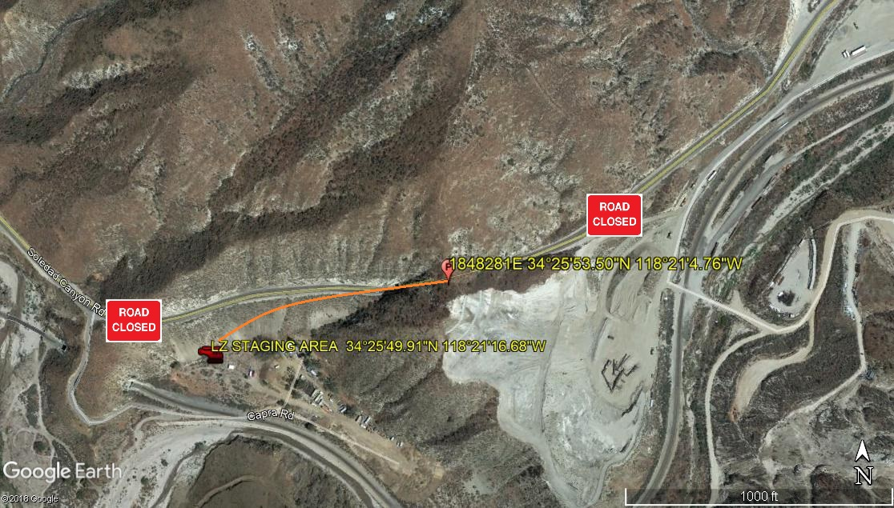
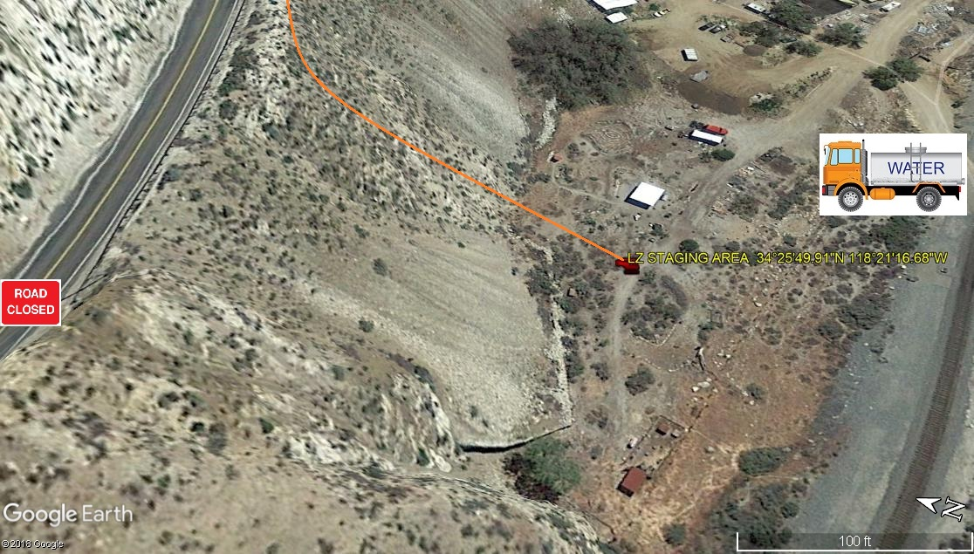
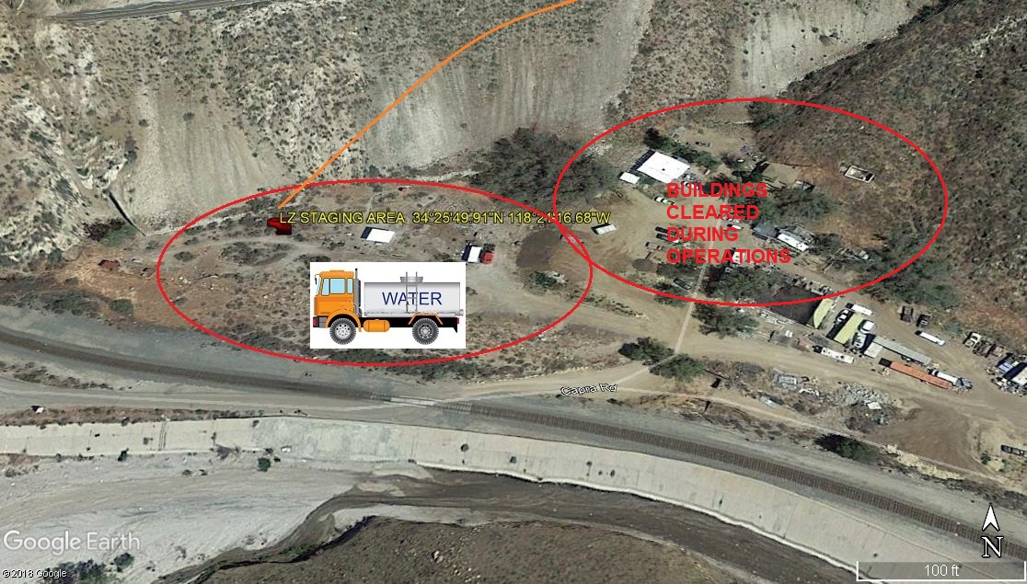
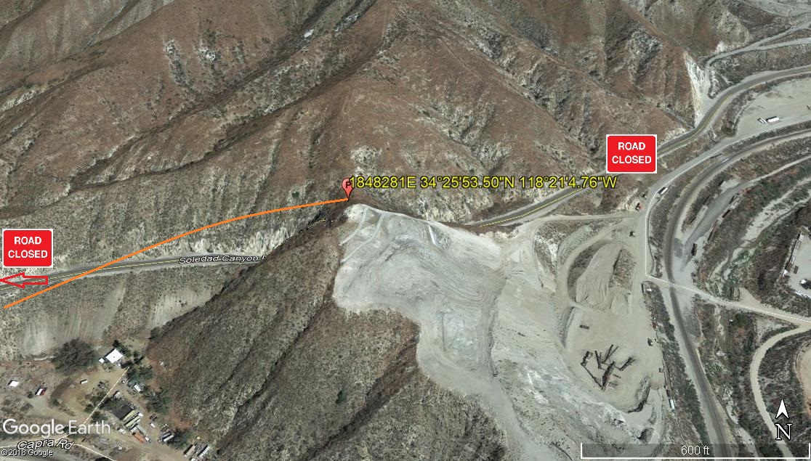
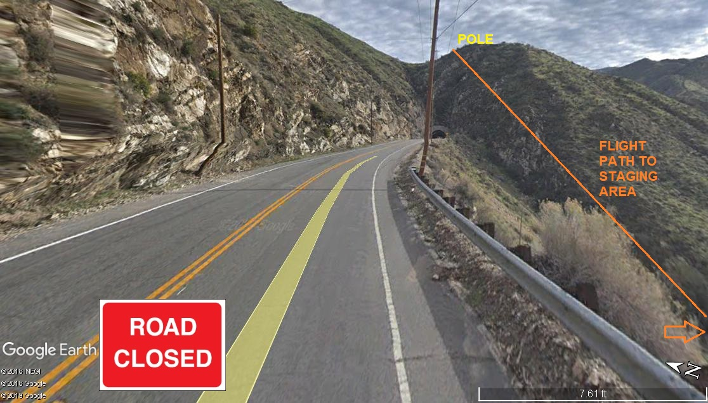
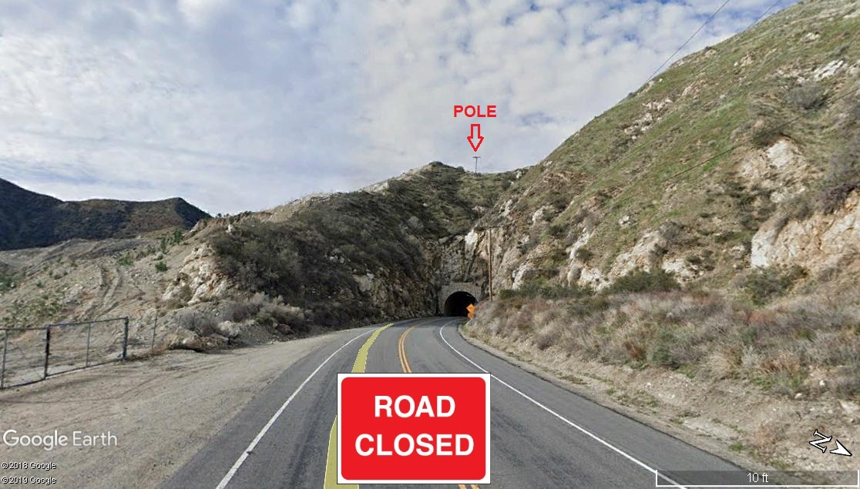LEGEND
SITE PLAN SYMBOLS: EVACUATION FLIGHT PATH
LANDING AREA = (LZ) | STREET BLOCKED = XXXX | TOP TWO FLOORS = UBT2
ATTACH AREA = (A) | RELEASE AREA = (R)
FLIGHT PATH = >>> | EMERGENCY LAND = (ELZ)
UNOCCUPIED BUILDING = (UBA) | UNOCCUPIED BUILDING TOP FLOOR = (UBT1)

10-11-2019 
DATE OF SUBMISSION COMPANY OFFICIAL / TITLE

