
SECTION 7 Part 135 GH 4A Part 133 GH 4L
NON Congested Area Plan
Operator: Guardian Helicopters, Inc
67 D STREET
Fillmore CA. 93015
Phone (818) 442-9904
FAX (818) 442-9901
PROJECT: EDISON POLE AND HEC WORK ORDER #: TD1576898 902748081 TD1537489
ADDRESS: WILLARD CANYON RD : SANTA PAULA CA
POLE STAGING AREA LATITUDE 34°21'2.12"N LONGITUDE 119° 0'49.57"W
2358853E 34°20'52.61"N 119° 0'32.84"W45 CL 1 COMPOSITE 1300 LBS
1703142E 34°21'4.46"N119° 0'38.74"W 45 CL 1 COMPOSITE 1300 LBS
141897E 34°19'39.02"N119° 0'35.90"W 60FT CL 2 COMPOSITE 2100 LBS
CONTRACTOR’S JACOB YONKERS PHONE#: 310-613-3224
CONTACT AT SITE; MOOREPARK SCE PHONE#: 310-613-3224
PILOT’S NAME(S): 1. JOHN OLSON CERT #: 2769166
2. BUCKEY MACKAY CERT #: #:2778051
3. MARTIN RODRIGUEZ CERT #: 3555121
4. MICHAEL KLINK CERT# 3018828
TYPE OF AIRCRAFT:BELL UH-1H N# N711GH A/C CATEGORY: RESTRICTED
BELL UH-1H N# N214KK A/C CATEGORY: RESTRICTED
BELL 407 N# N407GH A/C CATEGORY: STANDARD
BELL 205A1 N# N216GH A/C CATEGORY: STANDARD
AS350 B2 N# N498PT A/C CATEGORY: STANDARD
AS350 B3 N# N718GH A/C CATEGORY: STANDARD
AS350 B3 N# N215GH A/C CATEGORY: STANDARD
TYPE OF ITEM LIFTING: POLE AERODYNAMIC NON- AERODYNAMIC
IF SAFETY DICTATES AND OR THE CUSTOMER REQUESTS ADDITIONAL LIFTS THE LIFTS WILL BE CONDUCTED REMAINING WITHIN THE APPROVED TIME PARAMETERS.
TYPE OF LIFTS:( 3) (3) POSSIBLE HEC 2100 LBS CLASS OF LOAD:EXTL CL B
NO. OF LIFTS: 4 LONG LINE: (NO) XXX (YES) LESS THEN 150 FT (LENGTH)
OPERATIONAL ALTITUDE: < 250 STREET CLOSING: (N0) XX (YES)
DATE AND TIMES OPERATION WILL BEGIN AND TERMINATE:
FLIGHT DATES | TIME BEGIN | TIME END | TODAY’S DATE
12-16-2019 | SUNRISE | SUNSET | 12-6-2019
AGENCY NAME: | PHONE#: | PERSON NOTIFIED: | DATE:
FILLMORE POLICE | 805-524-2233 | DISPATCH | NOTIFY
FILLMORE FIRE | 802-524-0586 | DISPATCH | NOTIFY
SANTA PAULA POLICE | 805-525-4474 | DISPATCH | NOTIFY
SANTA PAULA FIRE | 805-933-4225 | DISPATCH | NOTIFY
SECTION 7 Part 135 GH 4A Part 133 GH 4L
NON Congested Area Plan
Operator: Guardian Helicopters, Inc
67 D Street
Fillmore, California 93015
Evacuation Crowd Control Street Closure
No Evacuated Structures Operator □Yes □ No
□Evacuated Structures Contractor Contractor
□Operator

LIST OF BUILDINGS THAT SHALL EITHER BE PARTIALLY OR ENTIRELY UNOCCUPIED PERSONS ALSO HOMES THAT WILL BE NOTIFIED OF ACTIVITY:
BUILDING DESCRIPTION/ADDRESS | REMARKS | METHOD
NONE | VACANT DURING OPS | HAND DELIVER
ALL HOMES WITHIN RED OPERATING AREA | VACANT DURING OPS | HAND DELIVER
SEE DIAGRAM = VACANT | VACANT DURING OPS | HAND DELIVER
Narrative description of pick-up site, route, delivery site, and plan for ceasing operation if unauthorized persons enter operational area or real hazard occurs.
SITE INSPECTION NOTES
ONLY PERSONNEL ESSENTIAL TO COMPLETING THE JOB SAFELY WILL BE PERMITTED TO PARTICIPATE IN THE EVOLUTION. ONLY PERSONNEL PARTICIPATING IN THE SAFETY BRIEF WILL BE PERMITTED TO BE IN THE AREA OF OPERATIONS. ONLY AUTHORIZED ESSENTIAL PERSONAL WILL BE PERMITTED IN THE IMMEDIATE AREA OF OPERATIONS. IN THE EVENT AN UNAUTHORIZED PERSON ENTERS THE OPERATIONS AREA OR A POTENTIAL HAZARD IS IDENTIFIED THE PILOT WILL HOLD THE AIRCRAFT IN RELATIVE POSITION. THIS WILL BE ACHIEVED WITHOUT OVER FLYING THE GROUND CREW. ALL OPERATIONS WILL BE CEASED UNTIL THE PROBLEM IS RECTIFIED. IN THE EVENT OF AN AIRCRAFT EMERGENCY, THE PILOT WILL RADIO GROUND PERSONNEL AND WILL ATTEMPT TO LAND IN THE EMERGENCY LANDING AREA.
DURING THE LIFT EVOLUTION THE AIRCRAFT AND GROUND CREW WILL ALL BE IN RADIO COMMUNICATIONS. IN THE EVENT OF LOSS COMMUNICATIONS, THE CREW WILL USE STANDARD HAND SIGNALS TO COMMUNICATE WITH THE PILOT. WHEN THE PILOT IS CLEAR HE WILL MOVE THE AIRCRAFT TO A SAFE LOCATION TO ALLOW THE COMMUNICATION PROBLEM TO BE RECTIFIED.
THE OPERATIONS AREA IS WITHIN THE SECURED AREA. ALL ESSENTIAL CREW WITHIN THE OPERATIONS AREA WILL NOT BE INVOLVED IN TAKING PICTURES OR ANY OTHER USE OF CELL PHONES.
PRIOR TO BEGINNING OPERATIONS, A TAILBOARD SAFETY BRIEF WILL BE CONDUCTED.
- HELICOPTER WILL BASE FROM GHI FACILITY IN FILMORE. THE HELICOPTER WILL FLY EMPTY HOOK FROM GHI TO POLE STAGING AREA WITHOUT OVERFLIGHT OF HOMES AND CROSSING THE ROAD WHEN CLEAR.
- THE SAFETY TAILBOARD WILL BE CONDUCTED AT THE POLE STAGING AREA
- EMERGENCY LANDING ZONE IS AT THE STAGING AREA AND ALONG THE FLIGHT PATH
- WILLARD CANYON ROAD WILL EXPERIENCE INTERMITTENT STREET CLOSURES
- WATER TRUCK NOT REQUIRED
- THE POLES WILL BE LIFTED FROM THE STAGING AREA
- THE CONTRACTOR WILL TRIM TREES IF REQUIRED

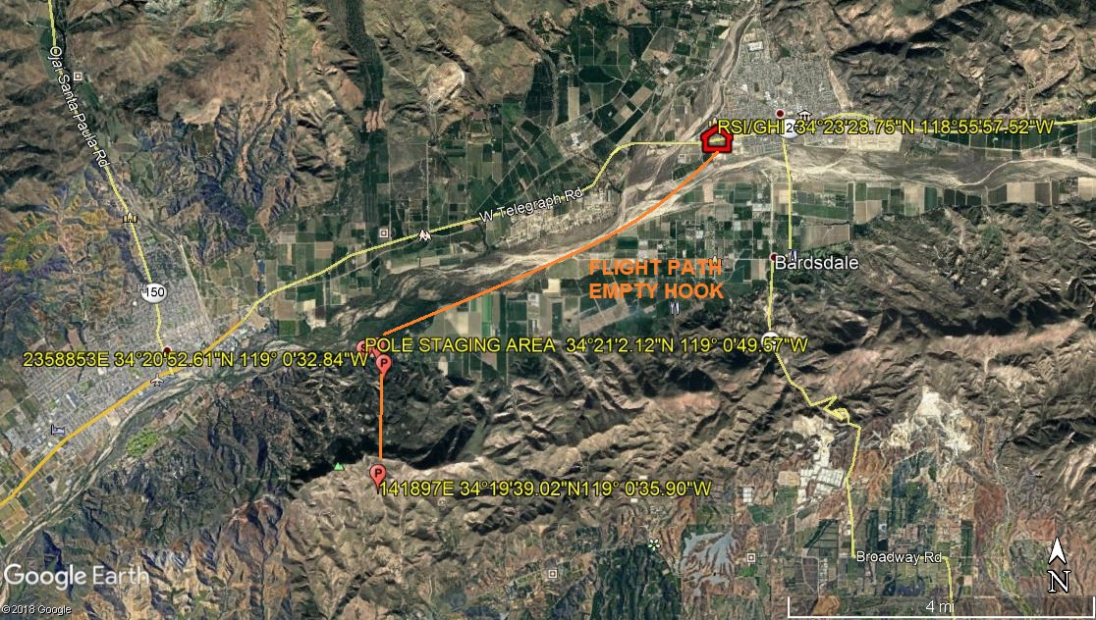
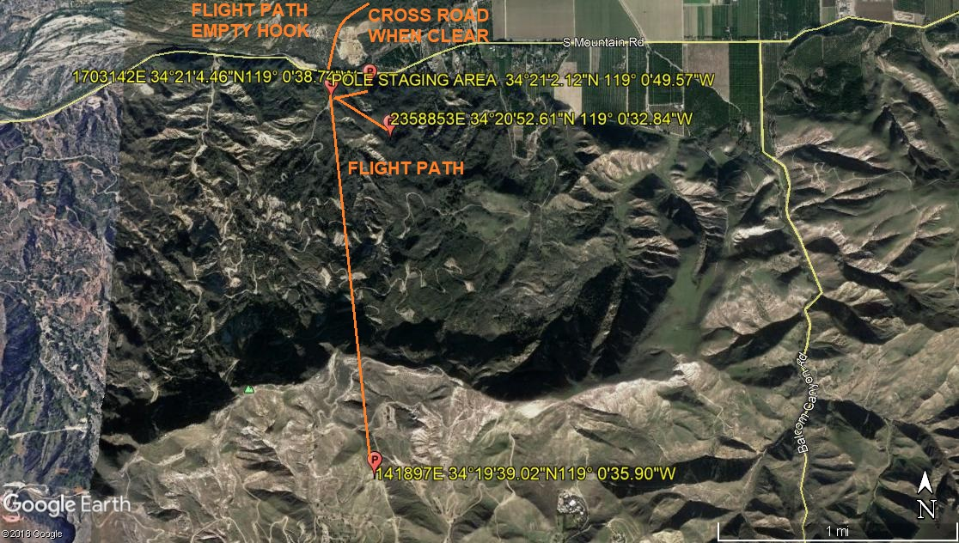
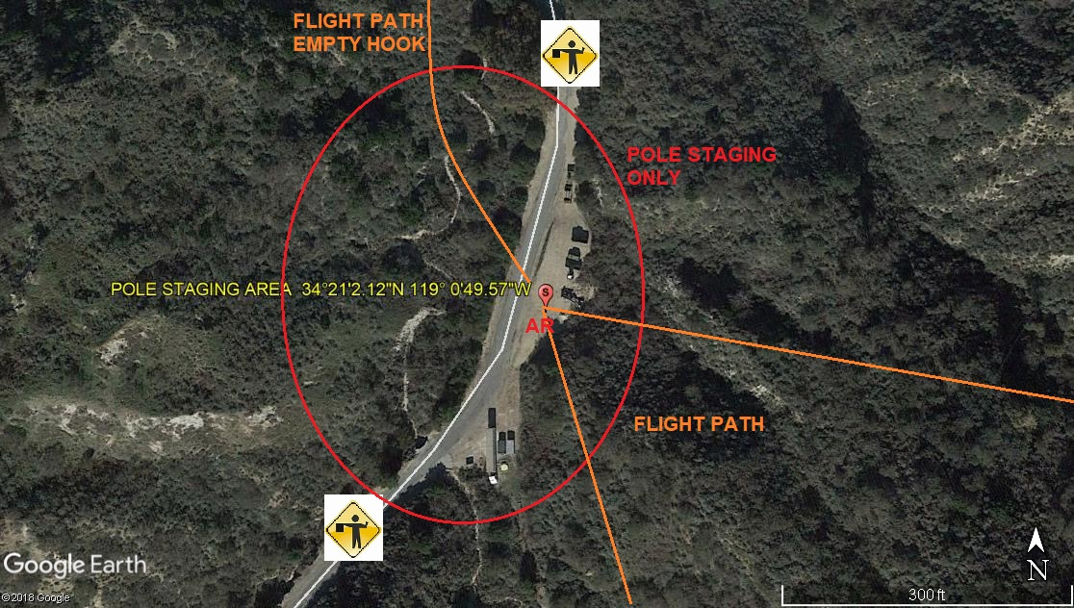
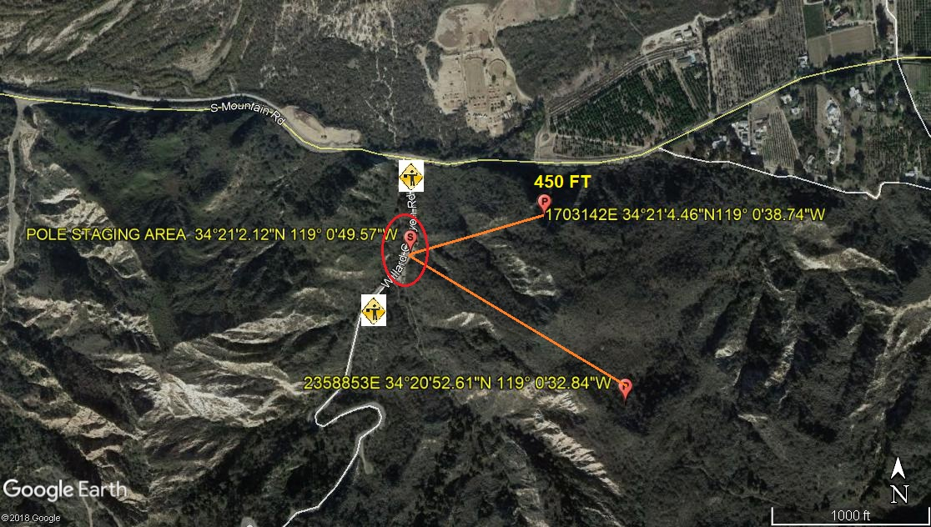
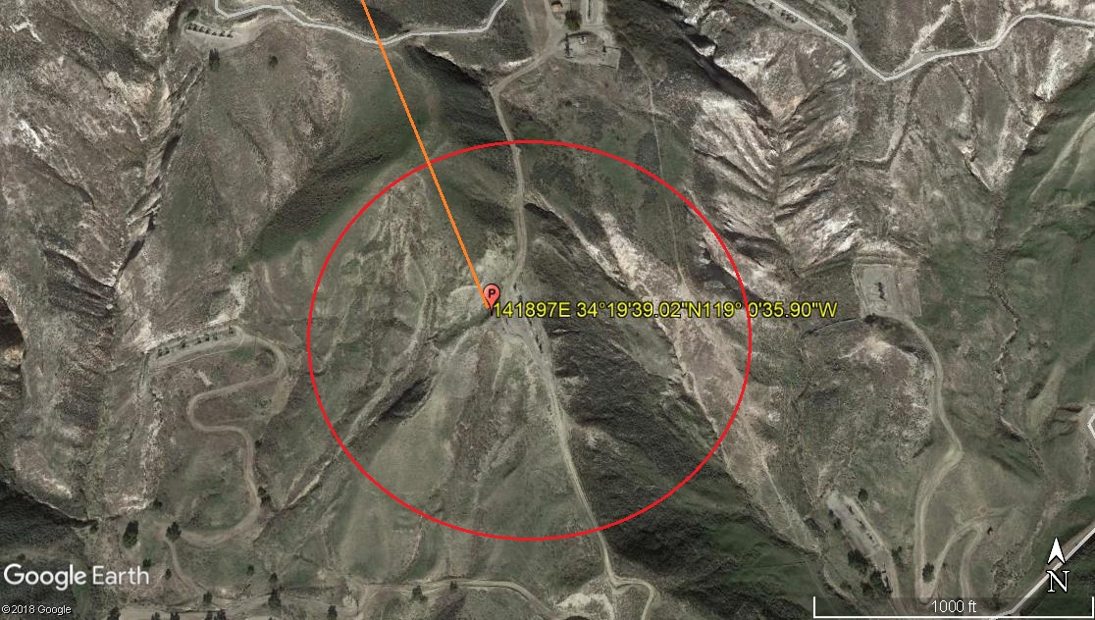

12-6-2019 
DATE OF SUBMISSION COMPANY OFFICIAL / TITLE

