
SECTION 7 Part 135 GH 4A Part 133 GH 4L
NON Congested Area Plan
Operator: Guardian Helicopters, Inc
67 D STREET
Fillmore CA. 93015
Phone (818) 442-9904
FAX (818) 442-9901
PROJECT: EDISON HEC EQUIP WORK ORDER #: TD1533103; TD1535554; TD1535551; TD1558681
ADDRESS: 126 HWY : SANTA CLARITA CA
ADDRESS: SUNSET RIDGE : GOLETA CA
LZ STAGING AREA 34°27'31.41"N 119°51'58.13"W
1345154E 1345155E 34°27'35.87"N 119°50'31.40"W
LZ STAGING AREA 34°25'27.79"N 118°40'26.73"W
848234E 848235E 34°25'24.36"N 118°39'9.34"W
848259E 848260E 34°24'37.02"N 118°40'33.04"W
CONTACT AT SITE; Jay Clark Wilson Construction PHONE#: 971-645-3912
PILOT’S NAME(S): 1. JOHN OLSON CERT #: 2769166
2. BUCKEY MACKAY CERT #: 2778051
3. MARTIN RODRIGUEZ CERT #: 3555121
4. MICHAEL KLINK CERT# 3018828
5. IAN GOODALE CERT# 3741973
TYPE OF AIRCRAFT:
BELL 407 N# N407GH A/C CATEGORY: STANDARD
BELL 205A1 N# N216GH A/C CATEGORY: STANDARD
AS350 B2 N# N498PT A/C CATEGORY: STANDARD
AS350 B3 N# N718GH A/C CATEGORY: STANDARD
AS350 B3 N# N215GH A/C CATEGORY: STANDARD
IF SAFETY DICTATES AND OR THE CUSTOMER REQUESTS ADDITIONAL LIFTS THE LIFTS WILL BE CONDUCTED REMAINING WITHIN THE APPROVED TIME PARAMETERS.
TYPE OF LIFTS: HEC EQUIPMENT CREW SUPPORT LOAD:EXTL CL B TYPE OF ITEM LIFTING: FLIGHT BAGS AERODYNAMIC NON- AERODYNAMIC MAX 1600 LBS
NO. OF LIFTS: TBD LONG LINE: (NO) XXX (YES) LESS THEN 150 FT (LENGTH)
OPERATIONAL ALTITUDE: < 250 STREET CLOSING: (N0) XX (YES)
DATE AND TIMES OPERATION WILL BEGIN AND TERMINATE:
FLIGHT DATES | TIME BEGIN | TIME END | TODAY’S DATE
12-16-2019 THRU 12-19-2019 | SUNRISE | SUNSET | 12-6-2019
AGENCY NAME: | PHONE#: | PERSON NOTIFIED: | DATE:
SCV SHERIFF | 661-255-1121 | DISPATCH | NOTIFY
LA COUNTY FIRE | 661-254-4404 | STAGION 124 | NOTIFY
Evacuation Crowd Control Street Closure
- No Evacuated Structures Operator Yes □ No
□Evacuated Structures Contractor Contractor
□Operator
SECTION 7 Part 135 GH 4A Part 133 GH 4L
NON Congested Area Plan
Operator: Guardian Helicopters, Inc
67 D Street
Fillmore, California 93015
LIST OF BUILDINGS THAT SHALL EITHER BE PARTIALLY OR ENTIRELY UNOCCUPIED PERSONS ALSO HOMES THAT WILL BE NOTIFIED OF ACTIVITY:
BUILDING DESCRIPTION/ADDRESS | REMARKS | METHOD
NONE
ALL HOMES WITHIN RED OPERATING AREA | VACANT DURING OPS | HAND DELIVER
SEE DIAGRAM = VACANT | VACANT DURING OPS | HAND DELIVER

Narrative description of pick-up site, route, delivery site, and plan for ceasing operation if unauthorized persons enter operational area or real hazard occurs.
SITE INSPECTION NOTES

ONLY PERSONNEL ESSENTIAL TO COMPLETING THE JOB SAFELY WILL BE PERMITTED TO PARTICIPATE IN THE EVOLUTION. ONLY PERSONNEL PARTICIPATING IN THE SAFETY BRIEF WILL BE PERMITTED TO BE IN THE AREA OF OPERATIONS. ONLY AUTHORIZED ESSENTIAL PERSONAL WILL BE PERMITTED IN THE IMMEDIATE AREA OF OPERATIONS. IN THE EVENT AN UNAUTHORIZED PERSON ENTERS THE OPERATIONS AREA OR A POTENTIAL HAZARD IS IDENTIFIED THE PILOT WILL HOLD THE AIRCRAFT IN RELATIVE POSITION. THIS WILL BE ACHIEVED WITHOUT OVER FLYING THE GROUND CREW. ALL OPERATIONS WILL BE CEASED UNTIL THE PROBLEM IS RECTIFIED. IN THE EVENT OF AN AIRCRAFT EMERGENCY, THE PILOT WILL RADIO GROUND PERSONNEL AND WILL ATTEMPT TO LAND IN THE EMERGENCY LANDING AREA.
DURING THE LIFT EVOLUTION THE AIRCRAFT AND GROUND CREW WILL ALL BE IN RADIO COMMUNICATIONS. IN THE EVENT OF LOSS COMMUNICATIONS, THE CREW WILL USE STANDARD HAND SIGNALS TO COMMUNICATE WITH THE PILOT. WHEN THE PILOT IS CLEAR HE WILL MOVE THE AIRCRAFT TO A SAFE LOCATION TO ALLOW THE COMMUNICATION PROBLEM TO BE RECTIFIED.
THE OPERATIONS AREA IS WITHIN THE SECURED AREA. ALL ESSENTIAL CREW WITHIN THE OPERATIONS AREA WILL NOT BE INVOLVED IN TAKING PICTURES OR ANY OTHER USE OF CELL PHONES.
PRIOR TO BEGINNING OPERATIONS, A TAILBOARD SAFETY BRIEF WILL BE CONDUCTED.
- HELICOPTER WILL LAND AT THE LZ TO CONNECT THE LONGLINE. HEC TRAINING AND SAFETY TAILBOARD WILL BE CONDUCTED
- FUELING WILL BE CONDUCTED AT THE LANDING ZONE
- EMERGENCY LANDING ZONE IS AT THE STAGING AREA AND ALONG THE FLIGHT PATH
- TAILBOARD SAFETY BRIEF CONDUCTED AT THE STAGING AREA PRIOR TO FLIGHT
- RADIOS WILL BE PROVIDED TO EACH POLE SITE
- WATER TRUCK REQUIRED AT LANDING ZONE
- STREET CLOSED WHILE AIRCRAFT FLYS OVER ROAD. SEE DIAGRAM
- THE CONTRACTOR WILL TRIM TREES IF REQUIRED

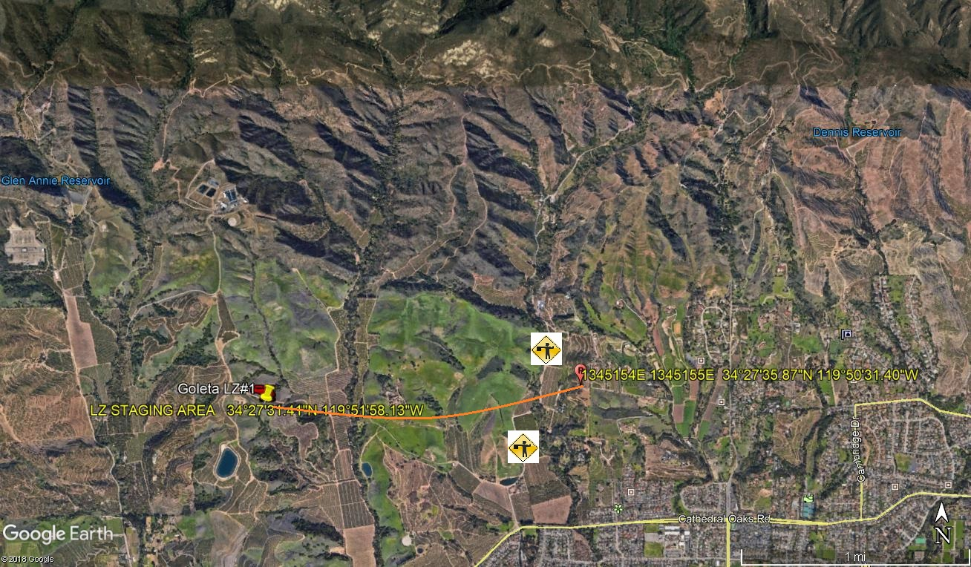
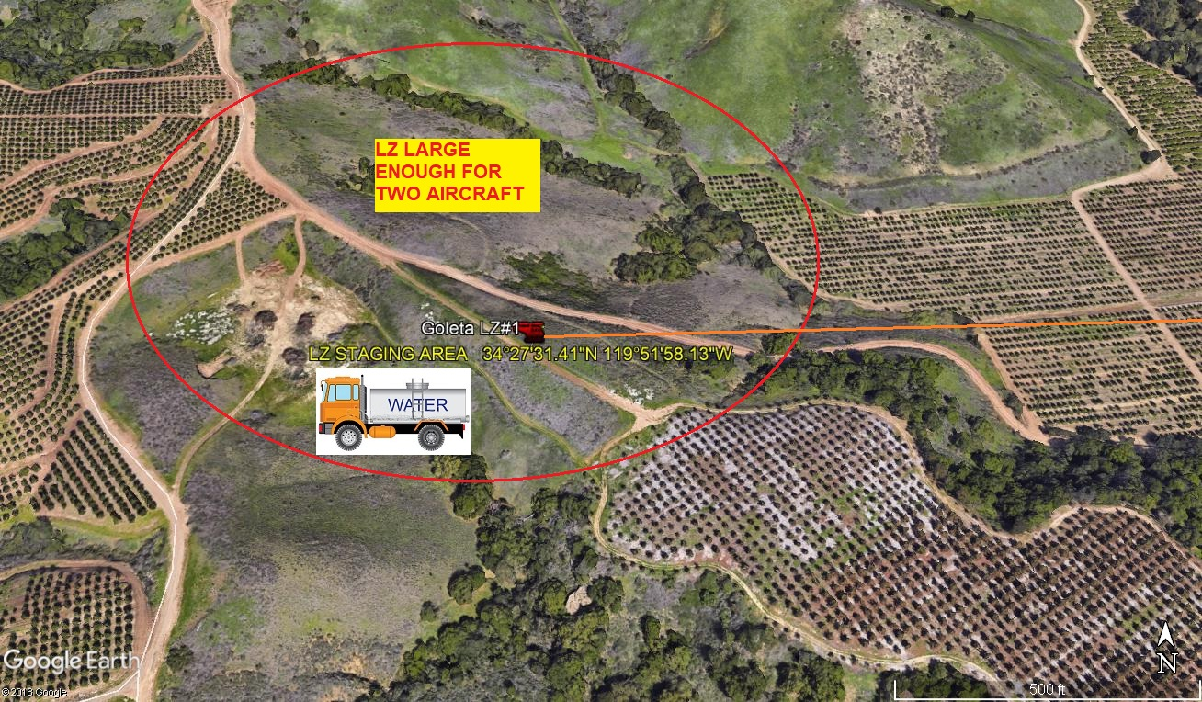
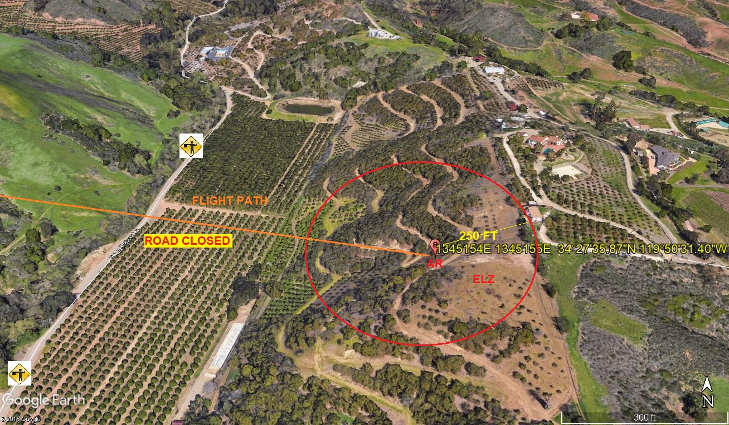
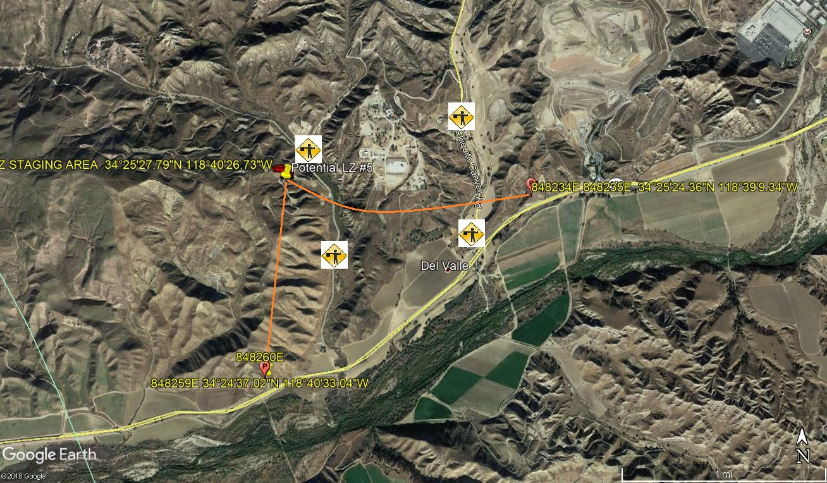
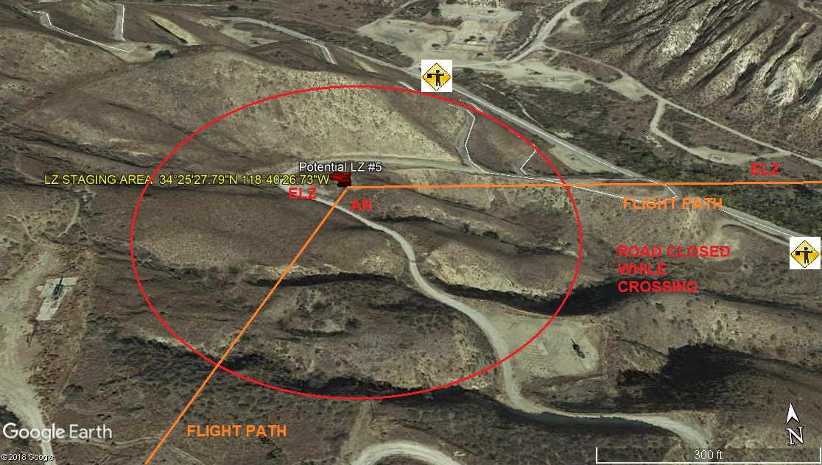
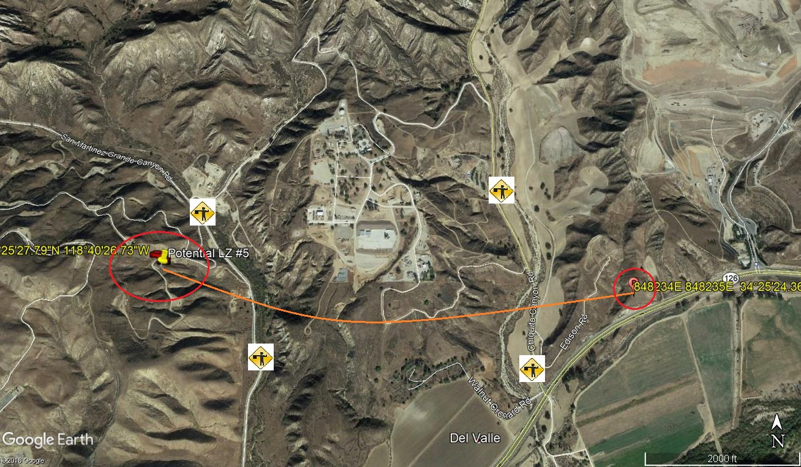
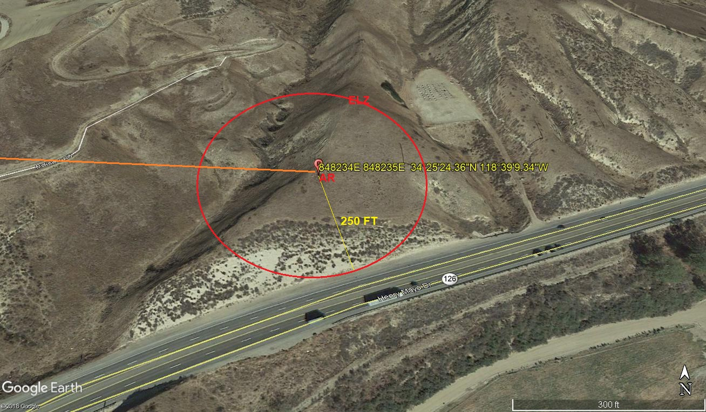
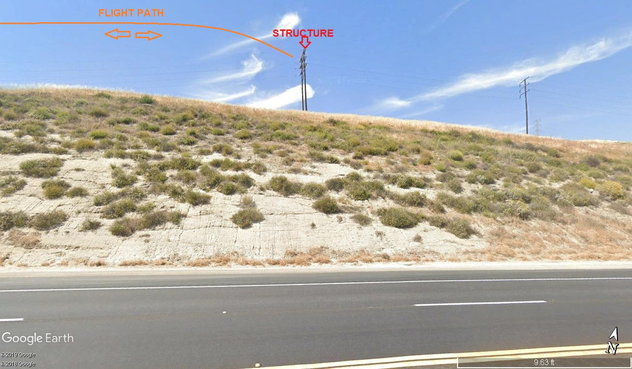
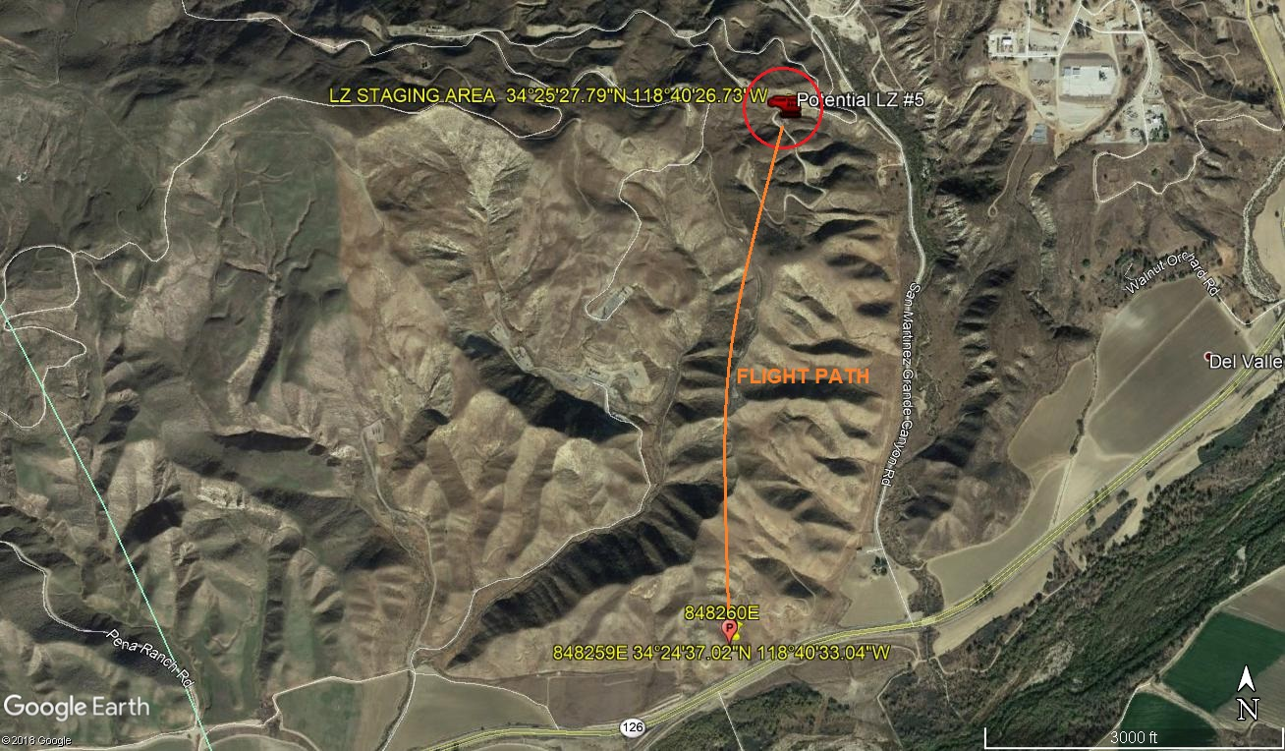
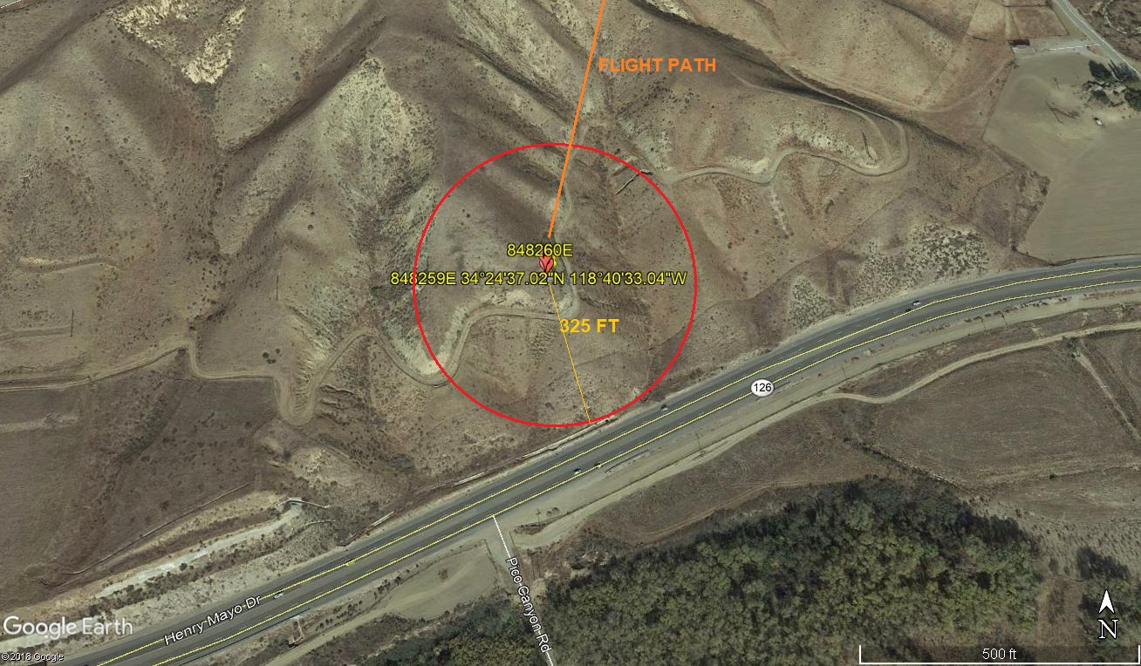
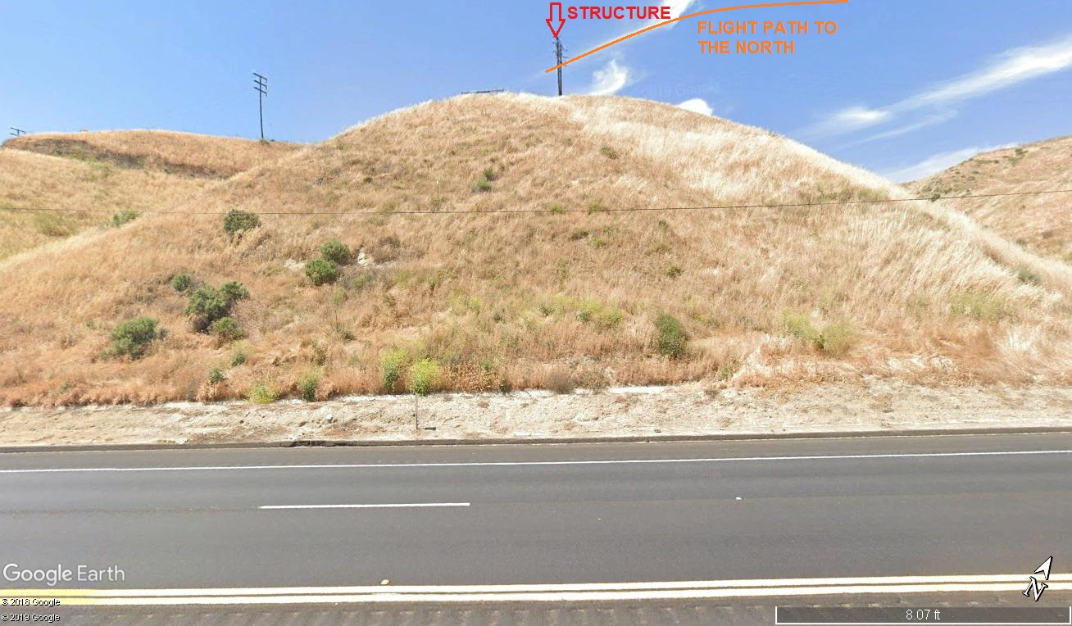
12-2-2019 
DATE OF SUBMISSION COMPANY OFFICIAL / TITLE

