Dear neighbor,
Guardian Helicopters Inc is a subcontractor of Southern California Edison (SCE). We will be working in your neighborhood to upgrade its electrical facilities to provide you a modern and reliable power grid. Your safety is our highest priority during this construction activity. We apologize for any inconvenience this may cause and will make every effort to minimize potential impacts during construction activities. Thank you for your patience as we complete these upgrades for you.
Upgrades in Your Area
We will be using a helicopter to set new utility pole.
What to Expect
- Federal Aviation Administration regulations require we take certain precautions to ensure the safety of the public during our operation. To do this your residence must be completely vacated while the helicopter sets the new utility pole. At no time will our helicopter over fly any residence with a load attached.
- FOOTHILL ROAD WILL BE CLOSED DURING OPERATIONS
- Guardian Helicopters primary concern during this operation is the general safety of the general public. We recommend measure to ensure the safety and control of any livestock during the period of helicopter operations.
- Work Timeline*
- Date: 1-9-2020
- Hours: 8:00 a.m. – 6:00 p.m.
The timeframe for the evacuation is approximately 120 minutes once all residents have left.
A Guardian Helicopter Inc representative will make contact with you and/or any responsible persons at your residence with further instructions shortly before the aircraft operation is to take place. Please notify all family members, workers, or anyone who may be at your residence on this date of the evacuation. It is important to us that our activity presents as little inconvenience to you as possible.
Project Area
THE POLES BEING REPLACED ARE OFF OF FOOTHILL ROAD. THE POLES WILL BE STAGED FROM FOOTHILL ROAD
LIST OF BUILDINGS THAT SHALL EITHER BE PARTIALLY OR ENTIRELY UNOCCUPIED PERSONS ALSO HOMES THAT WILL BE NOTIFIED OF ACTIVITY:
BUILDING DESCRIPTION/ADDRESS | REMARKS | METHOD
1296 FOOTHILL ROAD | VACANT DURING OPS | HAND DELIVER
# UNKNOWN FOOTHILL ROAD | VACANT DURING OPS | HAND DELIVER
1787 FOOTHILL ROAD | VACANT DURING OPS | HAND DELIVER
# UNKNOWN FOOTHILL ROAD | VACANT DURING OPS | HAND DELIVER
ALL HOMES WITHIN RED OPERATING AREA | VACANT DURING OPS | HAND DELIVER
SEE DIAGRAM = VACANT | VACANT DURING OPS | HAND DELIVER
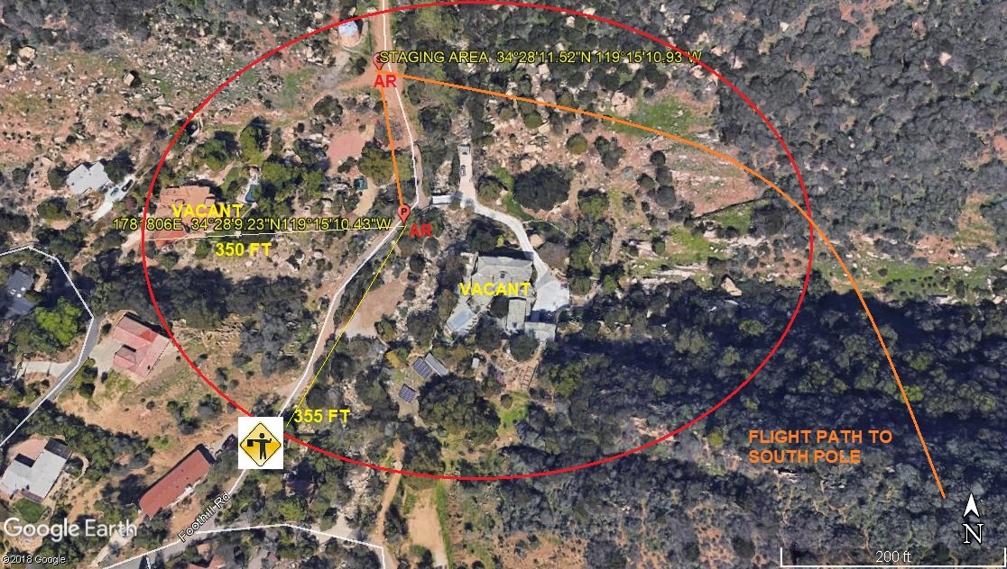
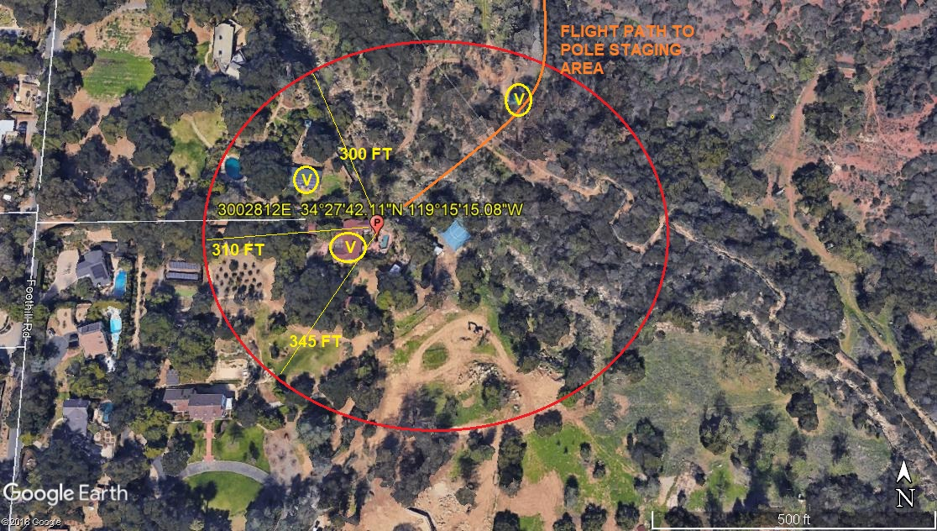Safety Tips
- Please close and secure back yard umbrellas and canopies
- Close all doors and windows to prevent dust from entering your home
- If possible, ensure your animals are secure or clear of the area.
If you have any questions or concerns please feel free to give me a call. In addition, I will be on site and can be reached on my cell phone.
Best regards,

Jeffrey M. Teubner
Flight Coordinator
818-442-9904 office
818-621-3794 cell

