
SECTION 7 Part 135 GH 4A Part 133 GH 4L
Congested Area Plan
Operator: Guardian Helicopters, Inc
67 D STREET
Fillmore CA. 93015
Phone (818) 442-9904
FAX (818) 442-9901
PROJECT: EDISON POLE REPLACEMENT WORK ORDER #: TD 1535048
ADDRESS: FOOTHILL RD SANTA BARBARA CA
HOVER HOOK UP LATITUDE 34°26'52.23"N LONGITUDE 119°42'26.92"W
POLE STAGING LATITUDE 34°26'51.50"N LONGITUDE 119°42'21.90"W
1413315E LATITUDE 34°26'52.69"N LONGITUDE 119°42'27.97"W 40 FT CL 1 COMP 1200 LBS
4371474E LATITUDE 34°26'57.83"N LONGITUDE 119°42'23.35"W 45 CL 1 COMP 1500 LBS
CONTACT AT SITE; JACOB YONKER PHONE#: 931-625-6216
PILOT’S NAME(S): 1. JOHN OLSON CERT #: 2769166
2. BUCKEY MACKAY CERT #: #:2778051
3. MARTIN RODRIGUEZ CERT #: 3555121
4. MICHAEL KLINK CERT# 3018828
TYPE OF AIRCRAFT:BELL UH-1H N# N711GH A/C CATEGORY: RESTRICTED
BELL UH-1H N# N214KK A/C CATEGORY: RESTRICTED
BELL 407 N# N407GH A/C CATEGORY: STANDARD
BELL 205A1 N# N216GH A/C CATEGORY: STANDARD
AS350 B2 N# N498PT A/C CATEGORY: STANDARD
AS350 B3 N# N718GH A/C CATEGORY: STANDARD
AS350 B3 N# N215GH A/C CATEGORY: STANDARD
IF SAFETY DICTATES AND OR THE CUSTOMER REQUESTS ADDITIONAL LIFTS THE LIFTS WILL BE CONDUCTED REMAINING WITHIN THE APPROVED TIME PARAMETERS.
TYPE OF LIFTS: :( 2) (2) CLASS OF LOAD:EXTL CL B TYPE OF ITEM LIFTING: POLE AERODYNAMIC NON- AERODYNAMIC MAX 1600 LBS
NO. OF LIFTS: 4 LONG LINE: (NO) XXX (YES) LESS THEN 100 FT (LENGTH)
OPERATIONAL ALTITUDE: < 250 STREET CLOSING: (N0) XX (YES)
DATE AND TIMES OPERATION WILL BEGIN AND TERMINATE:
FLIGHT DATES | TIME BEGIN | TIME END | TODAY’S DATE
12-19-2019 | SUNRISE | SUNSET | 12-10-2019
AGENCY NAME: | PHONE#: | PERSON NOTIFIED: | DATE:
SANTA BARBARA SHERIFF | 805-928-3781 | WATCH COMMANDER | NOTIFY
SANTA BARBARA COUNTY FIRE | 805-681-5518 | STATION 18 | NOTIFY
Evacuation Crowd Control Street Closure
□No Evacuated Structures Operator Yes □ No
Evacuated Structures Contractor Contractor
□Operator
SECTION 7 Part 135 GH 4A Part 133 GH 4L
Congested Area Plan
Operator: Guardian Helicopters, Inc
67 D Street
Fillmore, California 93015

LIST OF BUILDINGS THAT SHALL EITHER BE PARTIALLY OR ENTIRELY UNOCCUPIED PERSONS ALSO HOMES THAT WILL BE NOTIFIED OF ACTIVITY:

BUILDING DESCRIPTION/ADDRESS | REMARKS | METHOD
2360 FOOTHILL RD | VACANT DURING OPS | HAND DELIVER
TOTAL 6 HOMES NORTH OF 2360 FOOTHILL | VACANT DURING OPS | HAND DELIVER
ALL HOMES WITHIN RED OPERATING AREA | VACANT DURING OPS | HAND DELIVER
SEE DIAGRAM = VACANT | VACANT DURING OPS | HAND DELIVER
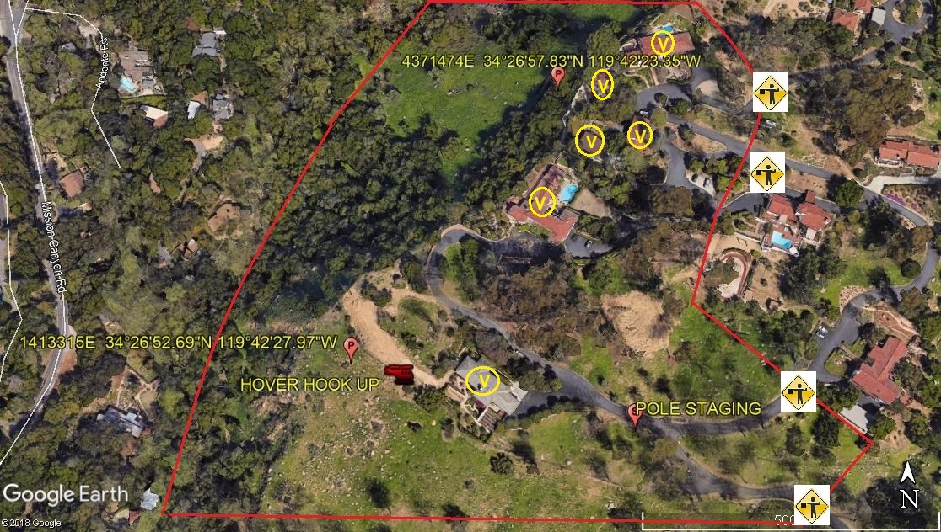

Narrative description of pick-up site, route, delivery site, and plan for ceasing operation if unauthorized persons enter operational area or real hazard occurs.
SITE INSPECTION NOTES

ONLY PERSONNEL ESSENTIAL TO COMPLETING THE JOB SAFELY WILL BE PERMITTED TO PARTICIPATE IN THE EVOLUTION. ONLY PERSONNEL PARTICIPATING IN THE SAFETY BRIEF WILL BE PERMITTED TO BE IN THE AREA OF OPERATIONS. ONLY AUTHORIZED ESSENTIAL PERSONAL WILL BE PERMITTED IN THE IMMEDIATE AREA OF OPERATIONS. IN THE EVENT AN UNAUTHORIZED PERSON ENTERS THE OPERATIONS AREA OR A POTENTIAL HAZARD IS IDENTIFIED THE PILOT WILL HOLD THE AIRCRAFT IN RELATIVE POSITION. THIS WILL BE ACHIEVED WITHOUT OVER FLYING THE GROUND CREW. ALL OPERATIONS WILL BE CEASED UNTIL THE PROBLEM IS RECTIFIED. IN THE EVENT OF AN AIRCRAFT EMERGENCY, THE PILOT WILL RADIO GROUND PERSONNEL AND WILL ATTEMPT TO LAND IN THE EMERGENCY LANDING AREA.
DURING THE LIFT EVOLUTION THE AIRCRAFT AND GROUND CREW WILL ALL BE IN RADIO COMMUNICATIONS. IN THE EVENT OF LOSS COMMUNICATIONS, THE CREW WILL USE STANDARD HAND SIGNALS TO COMMUNICATE WITH THE PILOT. WHEN THE PILOT IS CLEAR HE WILL MOVE THE AIRCRAFT TO A SAFE LOCATION TO ALLOW THE COMMUNICATION PROBLEM TO BE RECTIFIED.
THE OPERATIONS AREA IS WITHIN THE SECURED AREA. ALL ESSENTIAL CREW WITHIN THE OPERATIONS AREA WILL NOT BE INVOLVED IN TAKING PICTURES OR ANY OTHER USE OF CELL PHONES.
PRIOR TO BEGINNING OPERATIONS, A TAILBOARD SAFETY BRIEF WILL BE CONDUCTED.
- THE HELICOPTER WILL PERFORM A HOVER HOOK UP OF THE LONGLINE NEAR THE STAGING AREA HH
- POLES WILL BE STAGED AT STAGING AREA
- NO LANDING OR FUEL
- EMERGENCY LANDING ZONE IS AT THE STAGING AREA AND ALONG THE FLIGHT PATH
- TAILBOARD SAFETY BRIEF CONDUCTED AT THE POLE STAGING AREA PRIOR TO FLIGHT
- THE DRIVE WAY LEADING UP TO 2360 FOOTHIL ROAD AND THE DRIVEWAYS WITHIN THE RED OPERATIONS AREA WILL BE CLOSED .
- SEE DRAWING BELOW FOR LOCATIONS OF CLOSURES
- WATER TRUCK IS NOT REQUIRED
- 6 HOME WILL BE EVACUATED DURING OPERATIONS. SEE HOMES MARKED WITH A V ON DIAGRAM. STREET ADDRESSES UNKNOWN
- THE CONTRACTOR WILL TRIM TREES IF REQUIRED
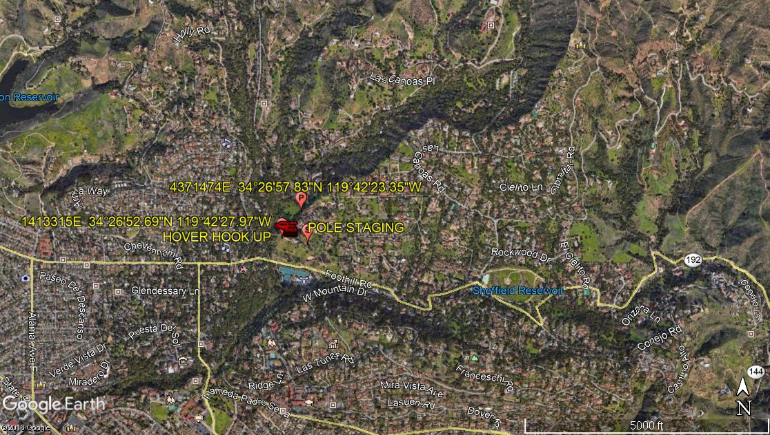
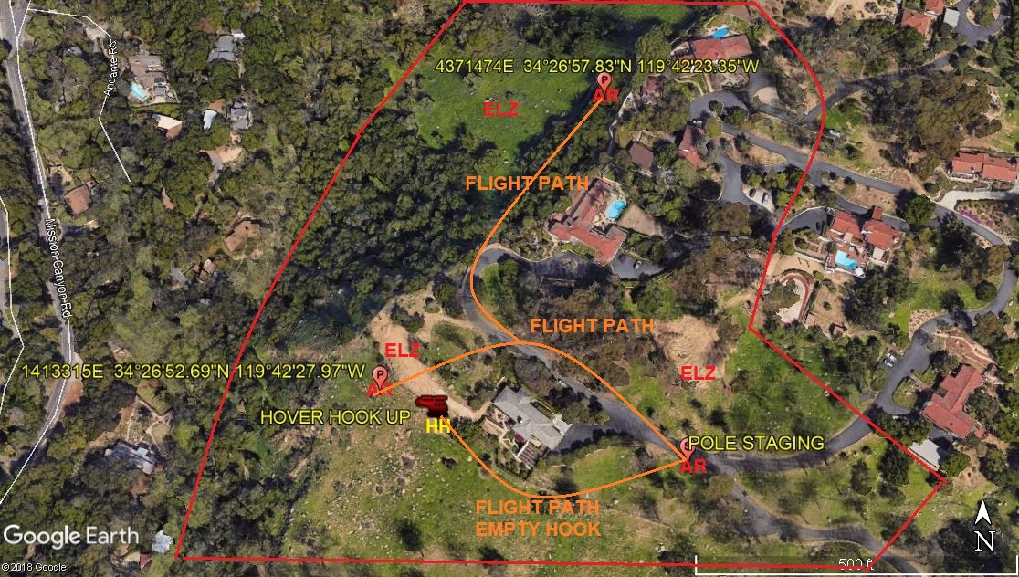
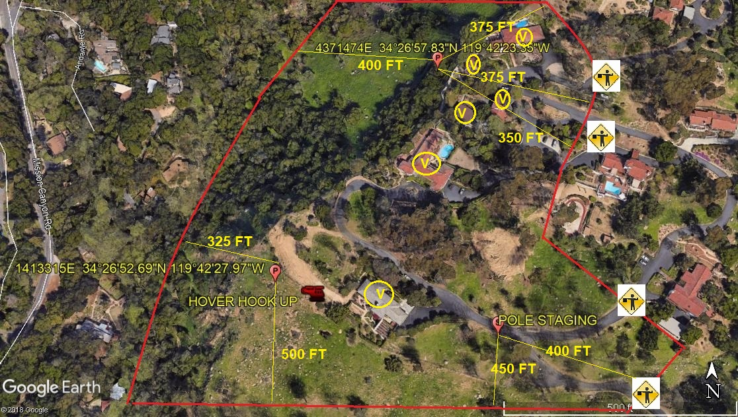
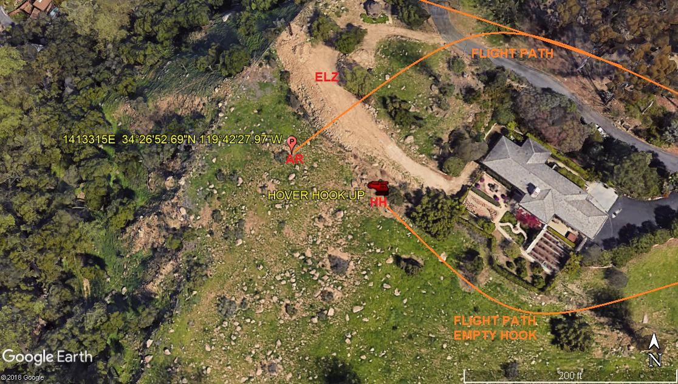
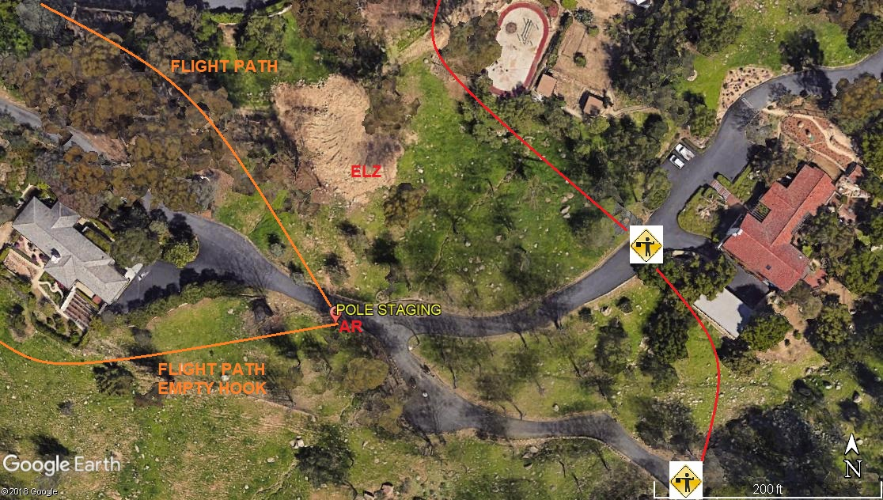
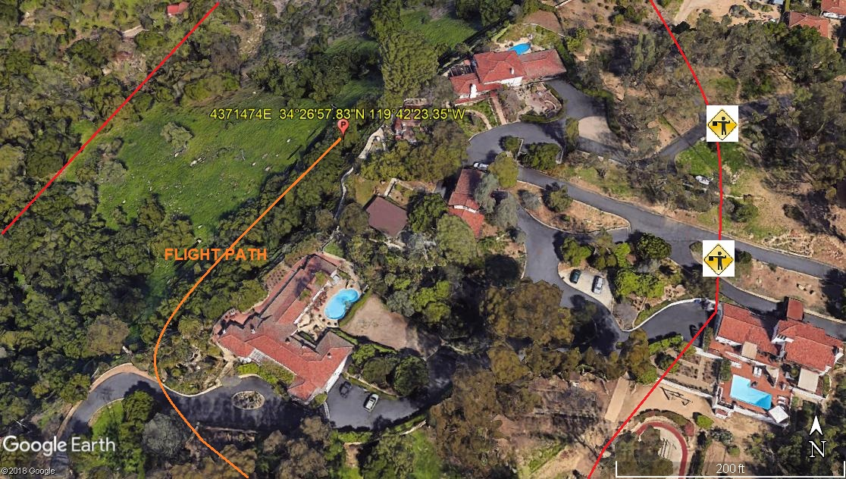

12-10-2019 
DATE OF SUBMISSION COMPANY OFFICIAL / TITLE

