Dear neighbor,

Guardian Helicopters Inc is a subcontractor of Southern California Edison (SCE). We will be working in your neighborhood to upgrade its electrical facilities to provide you a modern and reliable power grid. Your safety is our highest priority during this construction activity. We apologize for any inconvenience this may cause and will make every effort to minimize potential impacts during construction activities. Thank you for your patience as we complete these upgrades for you.

Upgrades in Your Area

We will be using a helicopter to set new utility pole.

What to Expect

- Federal Aviation Administration regulations require we take certain precautions to ensure the safety of the public during our operation. To do this your residence must be completely vacated while the helicopter sets the new utility pole. At no time will our helicopter over fly any residence with a load attached.
- CREEK ROAD WILL EXPERIENCE INTERMITTENT CLOSURES DURING OPERATIONS
- Guardian Helicopters primary concern during this operation is the general safety of the general public. We recommend measure to ensure the safety and control of any livestock during the period of helicopter operations.
- Work Timeline*
- Date: 2-7-2020
- Hours: 8:00 a.m. – 6:00 p.m.
The timeframe for the evacuation is approximately 120 minutes once all residents have left.

A Guardian Helicopter Inc representative will make contact with you and/or any responsible persons at your residence with further instructions shortly before the aircraft operation is to take place. Please notify all family members, workers, or anyone who may be at your residence on this date of the evacuation. It is important to us that our activity presents as little inconvenience to you as possible.

Project Area
THE POLES BEING REPLACED ARE NORTH OF CREEK ROAD AND SOUTH OF PORTAL ST THE POLES WILL BE STAGED AT 10139 CREEK ROAD

LIST OF BUILDINGS THAT SHALL EITHER BE PARTIALLY OR ENTIRELY UNOCCUPIED PERSONS ALSO HOMES THAT WILL BE NOTIFIED OF ACTIVITY:
BUILDING DESCRIPTION/ADDRESS | REMARKS | METHOD
10139 CREEK ROAD | VACANT DURING OPS | HAND DELIVER
10132 CREEK ROAD | VACANT DURING OPS | HAND DELIVER
10144 CREEK ROAD | VACANT DURING OPS | HAND DELIVER
10156 CREEK ROAD | VACANT DURING OPS | HAND DELIVER
10165 CREEK ROAD | VACANT DURING OPS | HAND DELIVER
10019 CREEK ROAD | VACANT DURING OPS | HAND DELIVER
10015 CREEK ROAD | VACANT DURING OPS | HAND DELIVER
695 OLD GRADE ROAD | VACANT DURING OPS | HAND DELIVER
194 PORTAL ST | VACANT DURING OPS | HAND DELIVER
192 PORTAL ST | VACANT DURING OPS | HAND DELIVER
190 PORTAL ST | VACANT DURING OPS | HAND DELIVER
150 PORTAL ST | VACANT DURING OPS | HAND DELIVER
140 PORTAL ST | VACANT DURING OPS | HAND DELIVER
100 PORTAL ST | VACANT DURING OPS | HAND DELIVER
108 PORTAL ST | VACANT DURING OPS | HAND DELIVER
ALL HOMES WITHIN RED OPERATING AREA | VACANT DURING OPS | HAND DELIVER
SEE DIAGRAM = VACANT | VACANT DURING OPS | HAND DELIVER
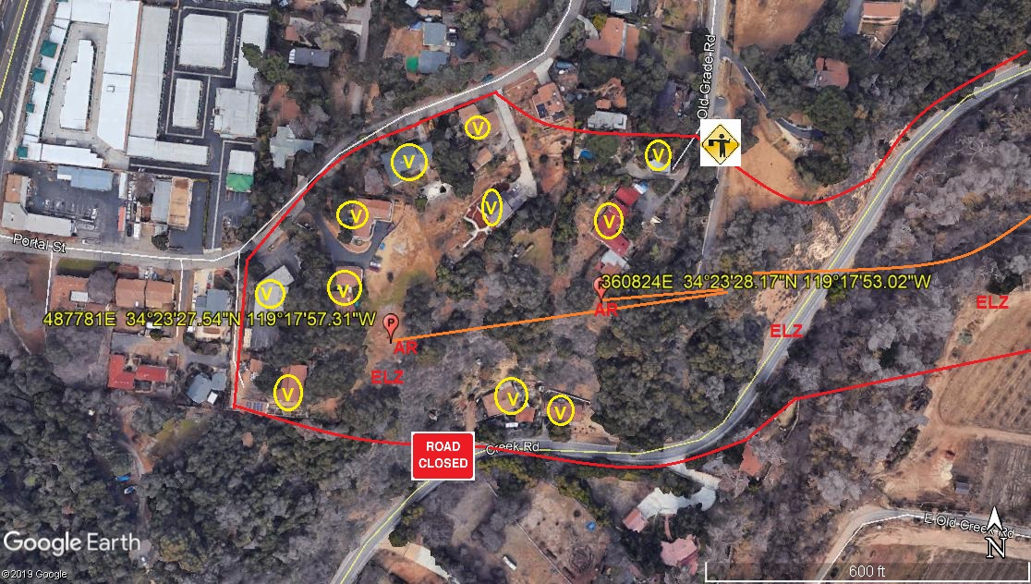
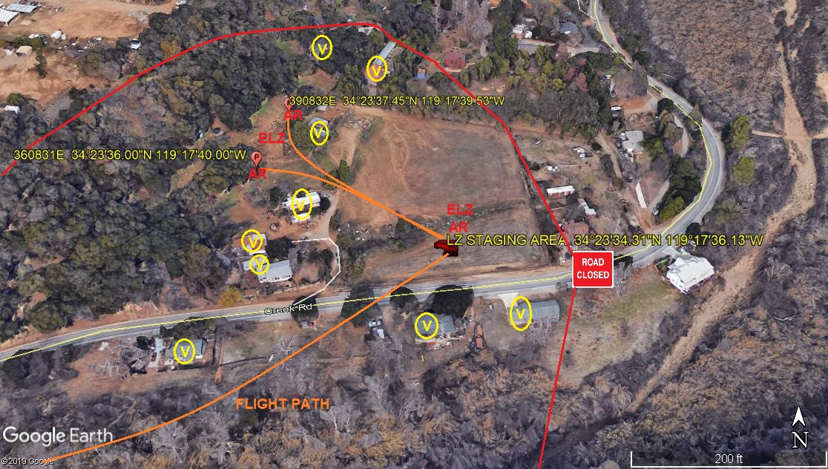
Safety Tips
- Please close and secure back yard umbrellas and canopies
- Close all doors and windows to prevent dust from entering your home
- If possible, ensure your animals are secure or clear of the area.
If you have any questions or concerns please feel free to give me a call. In addition, I will be on site and can be reached on my cell phone.
Best regards,

Jeffrey M. Teubner
Flight Coordinator
818-442-9904 office
818-621-3794 cell

