
SECTION 7 Part 135 GH 4A Part 133 GH 4L
Congested Area Plan
Operator: Guardian Helicopters, Inc
67 D STREET
Fillmore CA. 93015
Phone (818) 442-9904
FAX (818) 442-9901
PROJECT: EDISON POLE REPLACEMENT WORK ORDER #: TD 1524198
ADDRESS: W AVE W 6 AND HISEY RANCH ROAD ACTON CA
LZ STAGING AREA LATITUDE 34°28'40.87"N LONGITUDE 118°13'49.81"W
4154700E LATITUDE 34°29'21.42"N LONGITUDE 118°14'13.44"W45 CL 2 WOOD 1800 LBS
4154699E LATITUDE 34°29'18.68"N LONGITUDE 118°14'13.24"W 50 CL 1 COMPOSITE 1500 LBS
4154698E LATITUDE 34°29'17.24"N LONGITUDE 118°14'13.11"W 45 CL1 COMPOSITE 1300 LBS
4154697E LATITUDE 34°29'14.65"N LONGITUDE 118°14'12.84"W 45 CL1 COMPOSITE 1300 LBS
4154696E LATITUDE 34°29'14.43"N LONGITUDE 118°14'9.61"W45 CL1 COMPOSITE 1300 LBS
CONTACT AT SITE; BRENNAN RHODES PHONE#: 951-692-8906
CONTRACTOR: HOTLINE CONSTRUCTION EDISON PHONE#: 951-692-8906
PILOT’S NAME(S): 1. JOHN OLSON CERT #: 2769166
2. BUCKEY MACKAY CERT #: 2778051
3. MICHAEL KLINK CERT# 3018828
4. IAN GOODALE CERT# 3741973
TYPE OF AIRCRAFT:BELL UH-1H N# N711GH A/C CATEGORY: RESTRICTED
BELL UH-1H N# N214KK A/C CATEGORY: RESTRICTED
BELL 407 N# N407GH A/C CATEGORY: STANDARD
BELL 205A1 N# N216GH A/C CATEGORY: STANDARD
AS350 B2 N# N498PT A/C CATEGORY: STANDARD
AS350 B3 N# N718GH A/C CATEGORY: STANDARD
AS350 B3 N# N215GH A/C CATEGORY: STANDARD
IF SAFETY DICTATES AND OR THE CUSTOMER REQUESTS ADDITIONAL LIFTS THE LIFTS WILL BE CONDUCTED REMAINING WITHIN THE APPROVED TIME PARAMETERS.
TYPE OF LIFTS: 5 EQUIPMENT BAGS 1200 LBS ( 5) LBS (5) LARGEST 1800 LBS CLASS OF LOAD:EXTL CL B TYPE OF ITEM LIFTING: POLE AERODYNAMIC NON- AERODYNAMIC MAX 2000 LBS NO. OF LIFTS: 15 LONG LINE: (NO) XXX (YES) LESS THEN 100 FT (LENGTH)
OPERATIONAL ALTITUDE: < 250 STREET CLOSING: (N0) XX (YES)
DATE AND TIMES OPERATION WILL BEGIN AND TERMINATE:
FLIGHT DATES |  | TIME BEGIN | TIME END |  | TODAY’S DATE
2-13-2020 |  | SUNRISE | SUNSET |  | 1-24-2020
AGENCY NAME: |  | PHONE#: | PERSON NOTIFIED: |  | DATE:
LOS ANGELES COUNTY FIRE | 661-268-0638 |  |  | STATION 81 | NOTIFY
PALMDALE SHERIFF STATION | 661-272-2400 |  |  | DISPATCH | NOTIFY
Evacuation Crowd Control Street Closure
□No Evacuated Structures Operator Yes □ No
- Evacuated Structures Contractor Contractor
□Operator
SECTION 7 Part 135 GH 4A Part 133 GH 4L
Congested Area Plan
Operator: Guardian Helicopters, Inc
67 D Street
Fillmore, California 93015
LIST OF BUILDINGS THAT SHALL EITHER BE PARTIALLY OR ENTIRELY UNOCCUPIED PERSONS ALSO HOMES THAT WILL BE NOTIFIED OF ACTIVITY:
BUILDING DESCRIPTION/ADDRESS | REMARKS | METHOD
WEST AVENUE W6 NUMBER UNKNOWN | VACANT DURING OPS | HAND DELIVER
HISEY RANCH ROAD NUMBER UNKNOWN | VACANT DURING OPS | HAND DELIVER
ALL HOMES WITHIN RED OPERATING AREA | VACANT DURING OPS | HAND DELIVER
SEE DIAGRAM = VACANT | VACANT DURING OPS | HAND DELIVER

Narrative description of pick-up site, route, delivery site, and plan for ceasing operation if unauthorized persons enter operational area or real hazard occurs.
SITE INSPECTION NOTES

ONLY PERSONNEL ESSENTIAL TO COMPLETING THE JOB SAFELY WILL BE PERMITTED TO PARTICIPATE IN THE EVOLUTION. ONLY PERSONNEL PARTICIPATING IN THE SAFETY BRIEF WILL BE PERMITTED TO BE IN THE AREA OF OPERATIONS. ONLY AUTHORIZED ESSENTIAL PERSONAL WILL BE PERMITTED IN THE IMMEDIATE AREA OF OPERATIONS. IN THE EVENT AN UNAUTHORIZED PERSON ENTERS THE OPERATIONS AREA OR A POTENTIAL HAZARD IS IDENTIFIED THE PILOT WILL HOLD THE AIRCRAFT IN RELATIVE POSITION. THIS WILL BE ACHIEVED WITHOUT OVER FLYING THE GROUND CREW. ALL OPERATIONS WILL BE CEASED UNTIL THE PROBLEM IS RECTIFIED. IN THE EVENT OF AN AIRCRAFT EMERGENCY, THE PILOT WILL RADIO GROUND PERSONNEL AND WILL ATTEMPT TO LAND IN THE EMERGENCY LANDING AREA.
DURING THE LIFT EVOLUTION THE AIRCRAFT AND GROUND CREW WILL ALL BE IN RADIO COMMUNICATIONS. IN THE EVENT OF LOSS COMMUNICATIONS, THE CREW WILL USE STANDARD HAND SIGNALS TO COMMUNICATE WITH THE PILOT. WHEN THE PILOT IS CLEAR HE WILL MOVE THE AIRCRAFT TO A SAFE LOCATION TO ALLOW THE COMMUNICATION PROBLEM TO BE RECTIFIED.
THE OPERATIONS AREA IS WITHIN THE SECURED AREA. ALL ESSENTIAL CREW WITHIN THE OPERATIONS AREA WILL NOT BE INVOLVED IN TAKING PICTURES OR ANY OTHER USE OF CELL PHONES.
PRIOR TO BEGINNING OPERATIONS, A TAILBOARD SAFETY BRIEF WILL BE CONDUCTED.
- HELICOPTER WILL LAND AT THE LZ TO CONNECT THE LONGLINE AND CONDUCT A TAILBOARD SAFETY BRIEF
- POLES WILL BE STAGED AT STAGING AREA
- FUELING WILL OCCUR AT THE LZ
- EMERGENCY LANDING ZONE IS AT THE STAGING AREA AND ALONG THE FLIGHT PATH
- TAILBOARD SAFETY BRIEF CONDUCTED AT THE LZ PRIOR TO FLIGHT
- HUBBARD ROAD WILL EXPERIENCE INTERMITTENT CLOSURES
- SEE DRAWING BELOW FOR LOCATIONS OF CLOSURES
- WATER TRUCK IS REQUIRED
- TWO HOMES WILL BE EVACUATED SEE DIAGRAM ALL HOMES WITHIN 300 FT OF OPERATION AREA WILL BE EVACUATED
- THE CONTRACTOR WILL TRIM TREES IF REQUIRED
THE HELICOPTER WILL LAND AT THE LANDINGS ZONE TO CONDUCT A SAFETY BRIEF. WHEN THE LINE CREW IS READY THE GROUND CREW WILL MAKE SURE THE TWO HOMES ARE EVACUATED. ONCE THE AREA IS CLEAR THE STREET CLOSURE CREW WILL CLOSE HUBBARD ROAD. THE HELICOPTER WILL DELIVER EQUIPMENT BAGS TO THE POLE SITES. WHEN THE CREW IS READY FOR THE POLES THE NEW POLES WILL BE SET IN PLACE AND ONCE ALL 5 POLES ARE SET POLE NUMBER ONE CREW SHOULD BE READY TO REMOVE THE OLD POLE. THE REMAINING 4 POLES WILL BE REMOVED IN ORDER. ONCE THE CREW IS COMPLETE THE HELICOPTER WILL REMOVE EQUIPMENT FOR THE POLE SITES. THE EQUIPMENT AND OLD POLES WILL BE RETURNED TO THE LZ STAGING AREA. ONCE THE AIRCRAFT IS CLEAR THE ROAD WILL REOPEN.
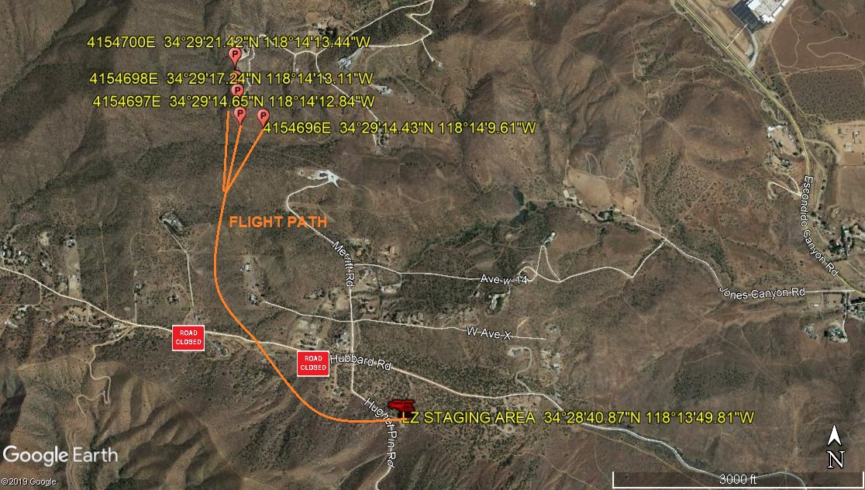
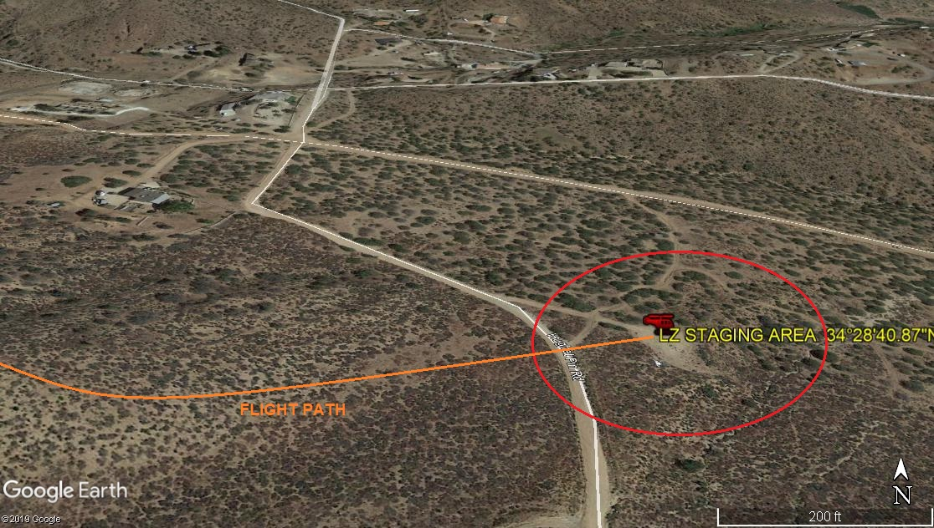
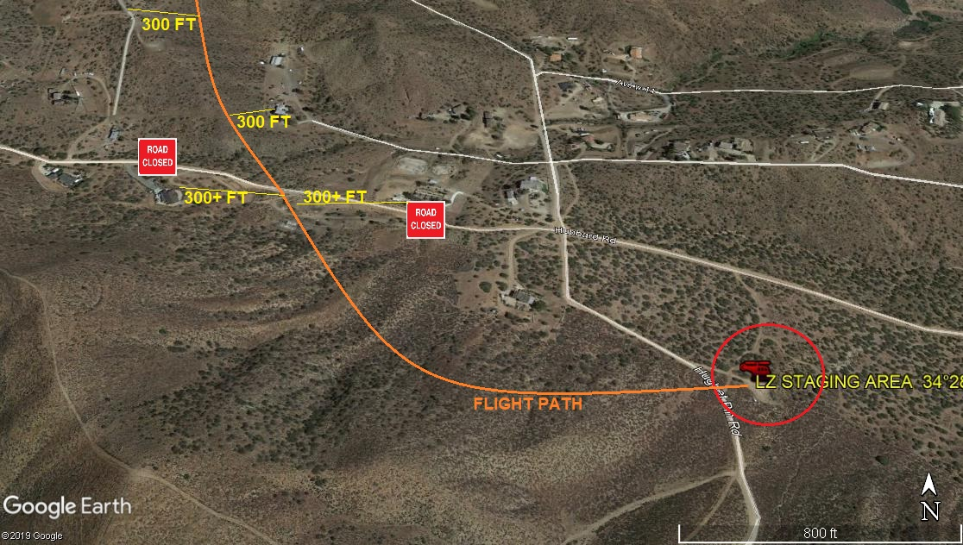
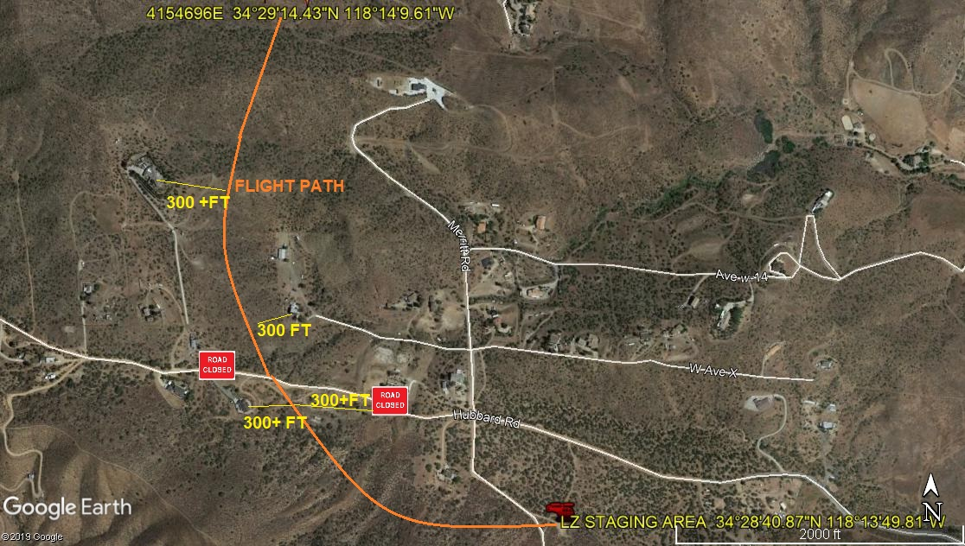
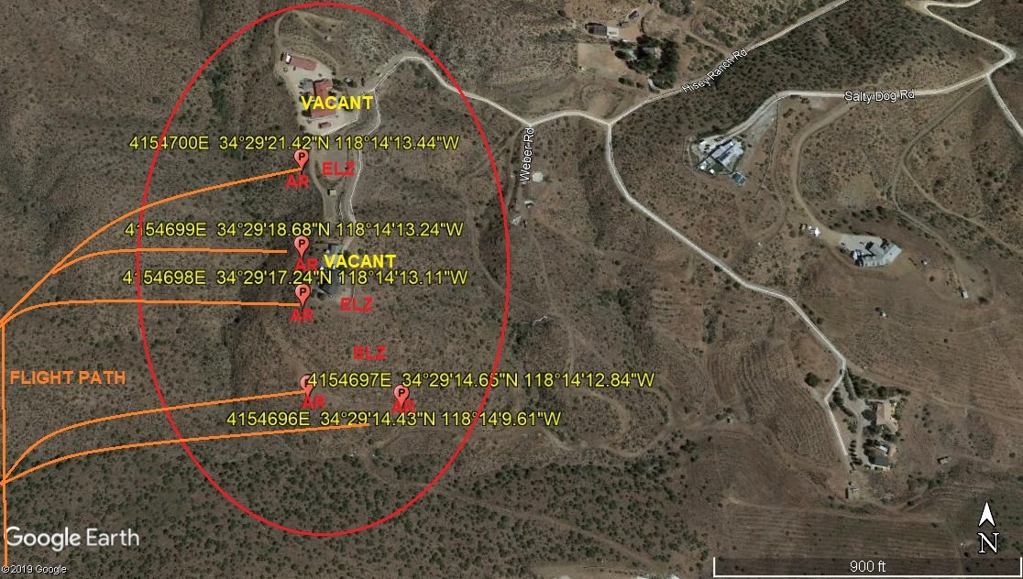

2-5-2020 
DATE OF SUBMISSION COMPANY OFFICIAL / TITLE

