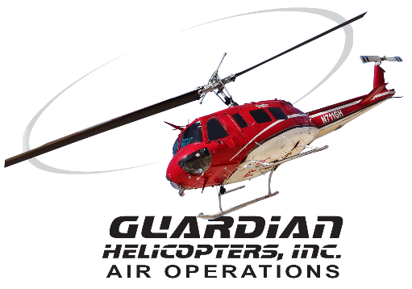
SECTION 7 Part 135 GH 4A Part 133 GH 4L
NON-Congested Area Plan
Operator: Guardian Helicopters, Inc
67 D STREET
Fillmore CA. 93015
Phone (818) 442-9904
FAX (818) 442-9901
PROJECT : EDISON POLE REPLACEMENT WORK ORDER #: TD 1608587
ADDRESS: SADDLE RIDGE RD : HEMET CA
LZ STAGING AREA LATITUDE 33°39'15.00"N LONGITUDE 116°58'16.06"W
219519S LATITUDE 33°39'4.66"N LONGITUDE 116°58'4.66"W 45 CL3 1600 LBS
CONTRACTOR’S NAME: MARK SCRIBNER PHONE#: 909-703-9703
ADAM PEPIN PHONE# 909-247-8773
PILOT’S NAME(S): 1. JOHN OLSON CERT #: 2769166
2. BUCKEY MACKAY CERT #:2778051
3. MICHAEL KLINK CERT# 3018828
TYPE OF AIRCRAFT:BELL UH-1H N# N711GH A/C CATEGORY: RESTRICTED
BELL UH-1H N# N214KK A/C CATEGORY: RESTRICTED
BELL 205A1 N# N216GH A/C CATEGORY: STANDARD
BELL 407 N# N407GH A/C CATEGORY: STANDARD
AS350 B2 N# N498PT A/C CATEGORY: STANDARD
AS350 B3 N# N718GH A/C CATEGORY: STANDARD
AS350 B3 N# N215GH A/C CATEGORY: STANDARD
TYPE OF ITEM LIFTING: POLE AERODYNAMIC NON- AERODYNAMIC
IF SAFETY DICTATES AND OR THE CUSTOMER REQUESTS ADDITIONAL LIFTS THE LIFTS WILL BE CONDUCTED REMAINING WITHIN THE APPROVED TIME PARAMETERS.
TYPE OF LIFTS: 1 1 POLES MAX SINGLE LIFT WEIGHT:1600 LBS CLASS OF LOAD: EXT CL B
NO. OF LIFTS: 3 LONG LINE: (NO) XXX (YES) LESS THEN 150 FT (LENGTH)
OPERATIONAL ALTITUDE: < 250 STREET CLOSING: (N0) XX (YES)
DATE AND TIMES OPERATION WILL BEGIN AND TERMINATE:
FLIGHT DATES | TIME BEGIN |  | TIME END |  | TODAY’S DATE
1-24-2020 | SUNRISE |  | SUNSET |  | 6-6-2019
AGENCY NAME: |  | PHONE#: |  | PERSON NOTIFIED: |  | DATE:
HEMET POLICE DEPARTMENT |  | 951-765-2400 |  | DISPATCH |  | NOTIFY
HEMET FIRE DEPARTMENT |  | 951-765-2450 |  | DISPATCH |  | NOTIFY
Evacuation Crowd Control Street Closure
- No Evacuated Structures Operator Yes □ No
□Evacuated Structures Contractor Contractor
□Operator
Part 135 GH 4A Part 133 GH 4L
NON- Congested Area Plan (Continued)

Narrative description of pick-up site, route, delivery site, and plan for ceasing operation if unauthorized persons enter operational area or real hazard occurs.
SITE INSPECTION NOTES

ONLY PERSONNEL ESSENTIAL TO COMPLETING THE JOB SAFELY WILL BE PERMITTED TO PARTICIPATE IN THE EVOLUTION. ONLY PERSONNEL PARTICIPATING IN THE SAFETY BRIEF WILL BE PERMITTED TO BE IN THE AREA OF OPERATIONS. ONLY AUTHORIZED ESSENTIAL PERSONAL WILL BE PERMITTED IN THE IMMEDIATE AREA OF OPERATIONS. IN THE EVENT AN UNAUTHORIZED PERSON ENTERS THE OPERATIONS AREA OR A POTENTIAL HAZARD IS IDENTIFIED THE PILOT WILL HOLD THE AIRCRAFT IN RELATIVE POSITION. THIS WILL BE ACHIEVED WITHOUT OVER FLYING THE GROUND CREW. ALL OPERATIONS WILL BE CEASED UNTIL THE PROBLEM IS RECTIFIED. IN THE EVENT OF AN AIRCRAFT EMERGENCY, THE PILOT WILL RADIO GROUND PERSONNEL AND WILL ATTEMPT TO LAND IN THE EMERGENCY LANDING AREA.
DURING THE LIFT EVOLUTION THE AIRCRAFT AND GROUND CREW WILL ALL BE IN RADIO COMMUNICATIONS. IN THE EVENT OF LOSS COMMUNICATIONS THE CREW WILL USE STANDARD HAND SIGNALS TO COMMUNICATE WITH THE PILOT. WHEN THE PILOT IS CLEAR HE WILL MOVE THE AIRCRAFT TO A SAFE LOCATION TO ALLOW THE COMMUNICATION PROBLEM TO BE RECTIFIED.
THE OPERATIONS AREA IS WITHIN THE SECURED AREA. ALL ESSENTIAL CREW WITHIN THE OPERATIONS AREA WILL NOT BE INVOLVED IN TAKING PICTURES OR ANY OTHER USE OF CELL PHONES.

TAIL BOARD SAFETY MEETING WILL BE HELD AT A BOTH LANDING ZONES PRIOR TO HELICOPTER OPERATIONS.
1. HELICOPTER WILL LAND STAGE FOR TAILBOARD AND CONNECTING LONGLINE
2. EMERGENCY LANDING ZONE IS AT THE STAGING AREA AND ALONG THE FLIGHT PATH
3. REMOTE AREA NO HOME EVACUATION REQUIRED
4. SEE DIAGRAM FOR STREET CLOSURE REQUIREMENTS
5. WATER TRUCK WILL BE REQUIRED AT BOTH LANDING ZONES.

1-24-2020 
DATE OF SUBMISSION COMPANY OFFICIAL / TITLE

-23-

Part 135 GH 4A Part 133 GH 4L
NON- Congested Area Plan (Continued)
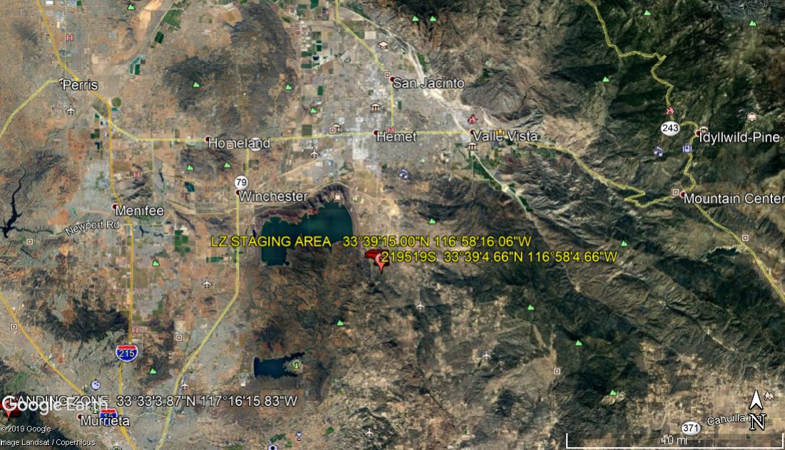
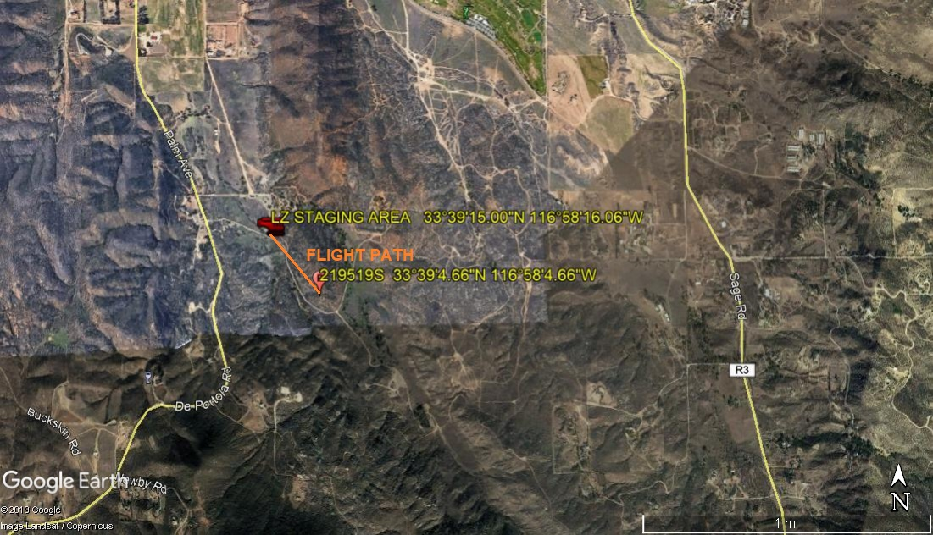
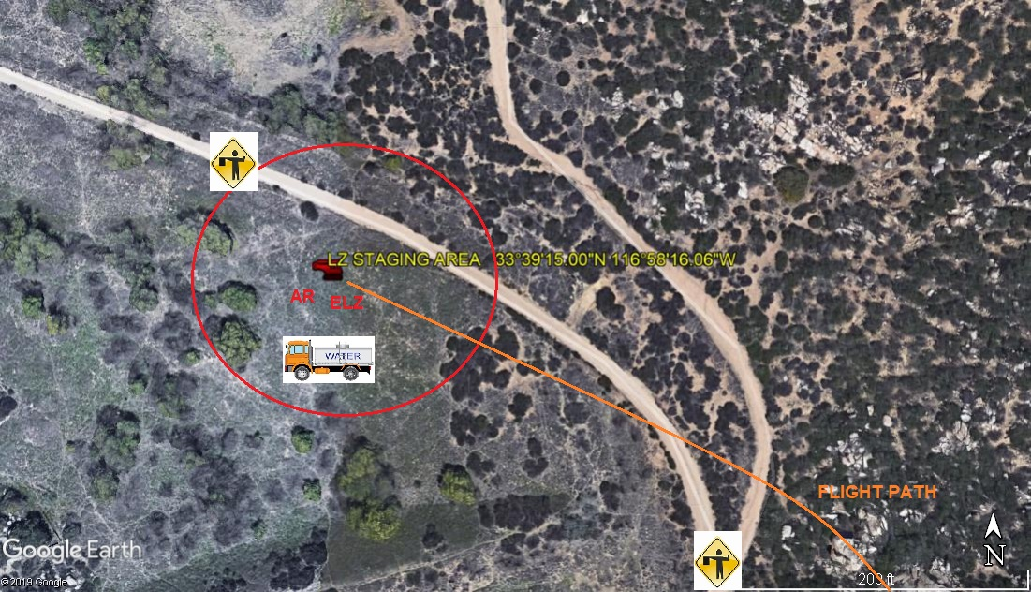

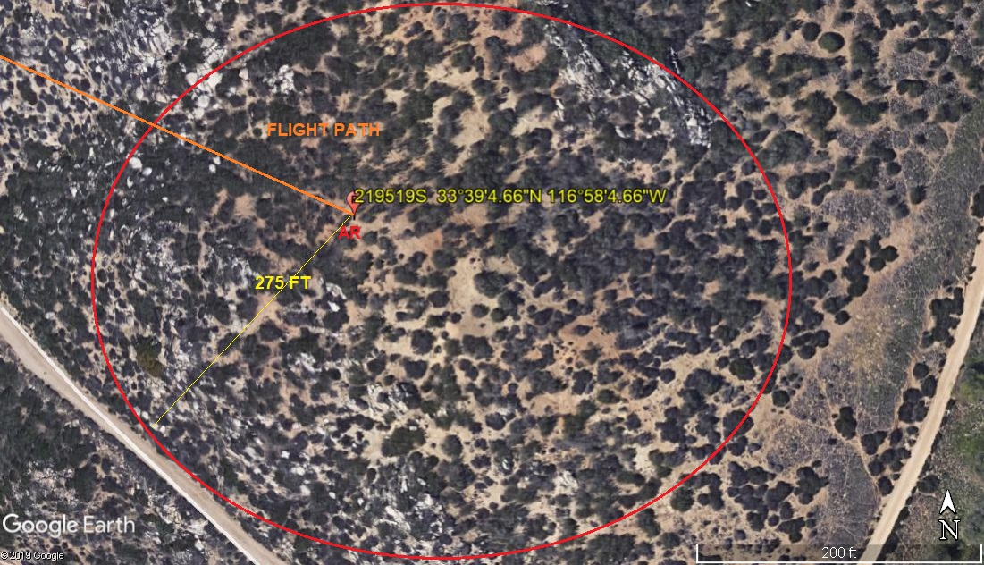

LEGEND
SITE PLAN SYMBOLS: EVACUATION FLIGHT PATH
LANDING AREA = (LZ) | STREET BLOCKED = XXXX | TOP TWO FLOORS = UBT2
ATTACH AREA = (A) | RELEASE AREA = (R)
FLIGHT PATH = >>> | EMERGENCY LAND = (ELZ)
UNOCCUPIED BUILDING = (UBA) | UNOCCUPIED BUILDING TOP FLOOR = (UBT1)

AREA SURVEY CONDUCTED BY :

