
SECTION 7 Part 135 GH 4A Part 133 GH 4L
NON Congested Area Plan
Operator: Guardian Helicopters, Inc
67 D STREET Phone (818) 442-9904
Fillmore CA. 93015 FAX (818) 442-9901
PROJECT: EDISON HEC AND POLE REPLACEMENT WORK ORDER #: TD 1575957 TD1495098
ADDRESS GOLETA CA : SANTA BARBARA CA
LZ STAGING AREA LATITUDE 34°27'44.68"N LONGITUDE 119°58'3.72"W
2134280E LATITUDE 34°27'39.30"N LONGITUDE 119°58'2.10"W 40 CL 1 COMPOSITE 1200 LBS
LZ STAGING AREA LATITUDE 34°30'17.34"N LONGITUDE 120° 3'56.82"W
4611324E LATITUDE 34°30'28.72"N LONGITUDE 120° 3'51.43"W 45 CL 1 COMPOSITE 1400 LBS
COMPRESSOR AT BOTH LOCATIONS 1200 LBS
CONTACT AT SITE: JASON SPEARS PHONE#: 909-329-0742
CONTRACTOR: HOTLINE CONSTRUCTION PHONE#: 909-329-0742
PILOT’S NAME(S): 1. JOHN OLSON CERT #: 2769166
2. BUCKEY MACKAY CERT #: 2778051
3. MICHAEL KLINK CERT# 3018828
4. IAN GOODALE CERT# 3741973
TYPE OF AIRCRAFT:BELL UH-1H N# N711GH A/C CATEGORY: RESTRICTED
BELL UH-1H N# N214KK A/C CATEGORY: RESTRICTED
BELL 407 N# N407GH A/C CATEGORY: STANDARD
BELL 205A1 N# N216GH A/C CATEGORY: STANDARD
AS350 B2 N# N498PT A/C CATEGORY: STANDARD
AS350 B3 N# N718GH A/C CATEGORY: STANDARD
AS350 B3 N# N215GH A/C CATEGORY: STANDARD
IF SAFETY DICTATES AND OR THE CUSTOMER REQUESTS ADDITIONAL LIFTS THE LIFTS WILL BE CONDUCTED REMAINING WITHIN THE APPROVED TIME PARAMETERS.
TYPE OF LIFTS: (2) POLES COMPRESSOR HEC CARGO LOAD:EXTL CL B TYPE OF ITEM LIFTING: AERODYNAMIC NON- AERODYNAMIC MAX 1500 LBS HEC ALL DAYS
NO. OF LIFTS: 10 LONG LINE: (NO) XXX (YES) LESS THEN 150 FT (LENGTH)
OPERATIONAL ALTITUDE: < 250 STREET CLOSING: (N0) XX (YES)
DATE AND TIMES OPERATION WILL BEGIN AND TERMINATE:
FLIGHT DATES | TIME BEGIN | TIME END | TODAY’S DATE
2-17-2020 HEC CARGO | SUNRISE | SUNSET | 2-10-2020
2-18-2020 HEC CARGO | SUNRISE | SUNSET | 2-10-2020
2-19-2020 HEC POLE | SUNRISE | SUNSET | 2-10-2020
AGENCY NAME: | PHONE#: | PERSON NOTIFIED: | DATE:
GOLETA POLICE DEPARTMENT | 805-681-4100 | WATCH COMMANDER | WILL NOTIFY
SANTA BARBARA COUNTY FIRE STATION | 805-681-5518 | STATION 38 | WILL NOTIFY
Evacuation Crowd Control Street Closure
No Evacuated Structures Operator Yes □No
□Evacuated Structures Contractor Contractor
□Operator

Part 135 GH 4A Part 133 GH 4L
NON Congested Area Plan

LIST OF BUILDINGS THAT SHALL EITHER BE PARTIALLY OR ENTIRELY UNOCCUPIED PERSONS ALSO HOMES THAT WILL BE NOTIFIED OF ACTIVITY:
BUILDING DESCRIPTION/ADDRESS | REMARKS | METHOD
REMOTE NO EVACAUTIONS | VACANT DURING OPS | HAND DELIVER
ALL HOMES WITHIN RED OPERATING AREA | VACANT DURING OPS | HAND DELIVER
SEE DIAGRAM = VACANT | VACANT DURING OPS | HAND DELIVER

Narrative description of pick-up site, route, delivery site, and plan for ceasing operation if unauthorized persons enter operational area or real hazard occurs.
SITE INSPECTION NOTES

ONLY PERSONNEL ESSENTIAL TO COMPLETING THE JOB SAFELY WILL BE PERMITTED TO PARTICIPATE IN THE EVOLUTION. ONLY PERSONNEL PARTICIPATING IN THE SAFETY BRIEF WILL BE PERMITTED TO BE IN THE AREA OF OPERATIONS. ONLY AUTHORIZED ESSENTIAL PERSONAL WILL BE PERMITTED IN THE IMMEDIATE AREA OF OPERATIONS. IN THE EVENT AN UNAUTHORIZED PERSON ENTERS THE OPERATIONS AREA OR A POTENTIAL HAZARD IS IDENTIFIED THE PILOT WILL HOLD THE AIRCRAFT IN RELATIVE POSITION. THIS WILL BE ACHIEVED WITHOUT OVER FLYING THE GROUND CREW. ALL OPERATIONS WILL BE CEASED UNTIL THE PROBLEM IS RECTIFIED. IN THE EVENT OF AN AIRCRAFT EMERGENCY, THE PILOT WILL RADIO GROUND PERSONNEL AND WILL ATTEMPT TO LAND IN THE EMERGENCY LANDING AREA.
DURING THE LIFT EVOLUTION THE AIRCRAFT AND GROUND CREW WILL ALL BE IN RADIO COMMUNICATIONS. IN THE EVENT OF LOSS COMMUNICATIONS, THE CREW WILL USE STANDARD HAND SIGNALS TO COMMUNICATE WITH THE PILOT. WHEN THE PILOT IS CLEAR HE WILL MOVE THE AIRCRAFT TO A SAFE LOCATION TO ALLOW THE COMMUNICATION PROBLEM TO BE RECTIFIED.
THE OPERATIONS AREA IS WITHIN THE SECURED AREA. ALL ESSENTIAL CREW WITHIN THE OPERATIONS AREA WILL NOT BE INVOLVED IN TAKING PICTURES OR ANY OTHER USE OF CELL PHONES.
PRIOR TO BEGINNING OPERATIONS, A TAILBOARD SAFETY BRIEF WILL BE CONDUCTED.
- DAY ONE AND DAY TWO THE HELICOPTER WILL LAND AT THE WEST POLE LZ AND CONDUCT HEC TRAINING AND A SAFETY MEETING. WHEN COMPLETE THE HELICOPTER WILL FLY THE MEN AND EQUIPMENT TO THE POLE SITE.
- WHEN COMPLETE THE HELICOPTER WILL FLY TO THE EAST POLE LZ AREA AND CONDUCT HEC TRAINING AND A SAFETY MEETING. WHEN COMPLETE THE HELICOPTER WILL FLY THE MEN AND EQUIPMENT TO THE POLE SITE.
- WHEN COMPLETE THE HELICOPTER WILL STANDBY FOR EXTRACTION OF MEN
- DAY THREE THE HELICOPTER WILL LAND AT THE WEST POLE LZ CONDUCT TRAINING AND SAFETY MEETING. FLY MEN AND EQUIPMENT TO THE POLE SITE. THE HELICOPTER WILL THEN FLY TO THE EAST POLE SITE TO CONDUCT TRAINING AND SAFETY MEETING AND FLY MEN AND EQUIPMENT TO THE POLE SITE. WHICH EVER CREW IS READY FOR THE NEW POLE FIRST WILL HAVE THE POLE DELIVERED. ONCE BOTH POLES ARE SET WHEN THE CREWS ARE READY THE HELICOPTER WILL FLY EQUIPMENT AND OLD POLES OUT FOLLOWED BY EXTRACTION OF THE CREW
- WEST SIDE POLE REQUIRES STREET CLOSURE DURING OPERATIONS
- BOTH SITES REQUIRE WATER TRUCK AT LZ STAGING AREA
- WEST POLE LZ MAY NEED TO HAVE TALL GRASS REMOVED FOR LZ
- IF TREE TRIMMING IS REQUIRED THE CONTRACTOR WILL COMPLETE PRIOR TO START DATE
- REMOTE AREA NO HOME EVACUATIONS

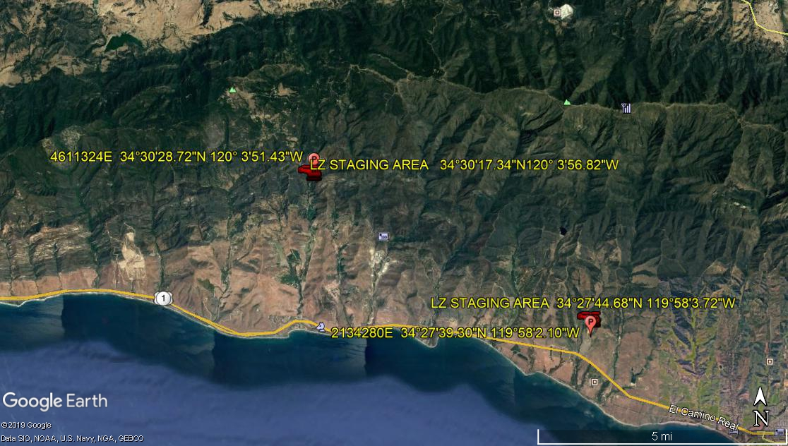
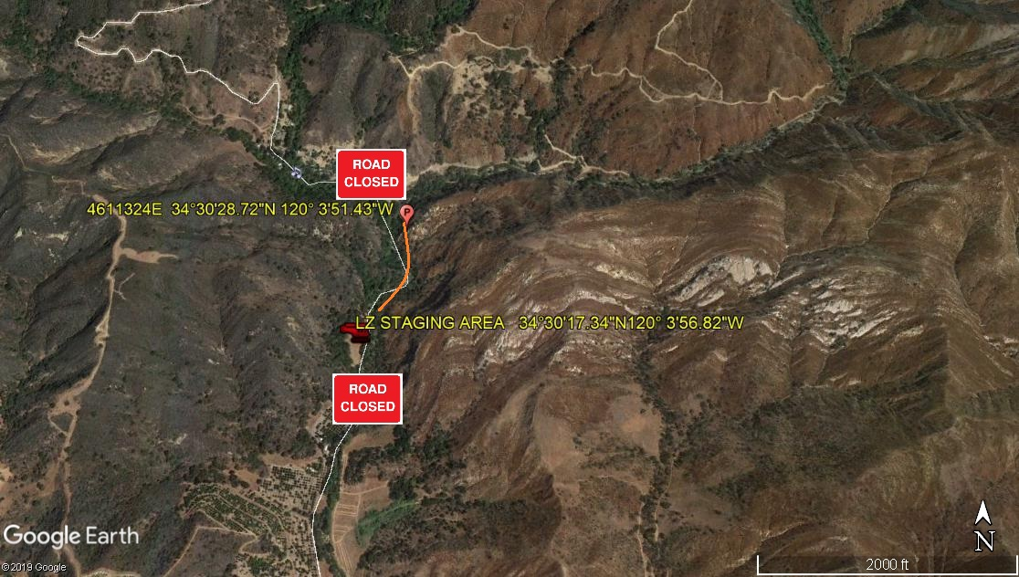
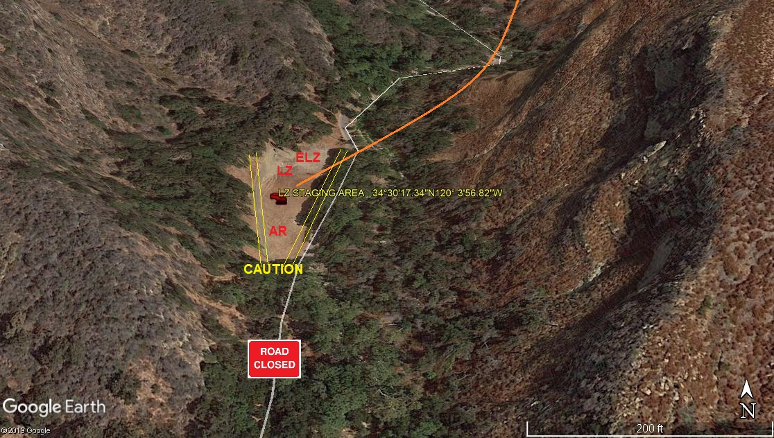
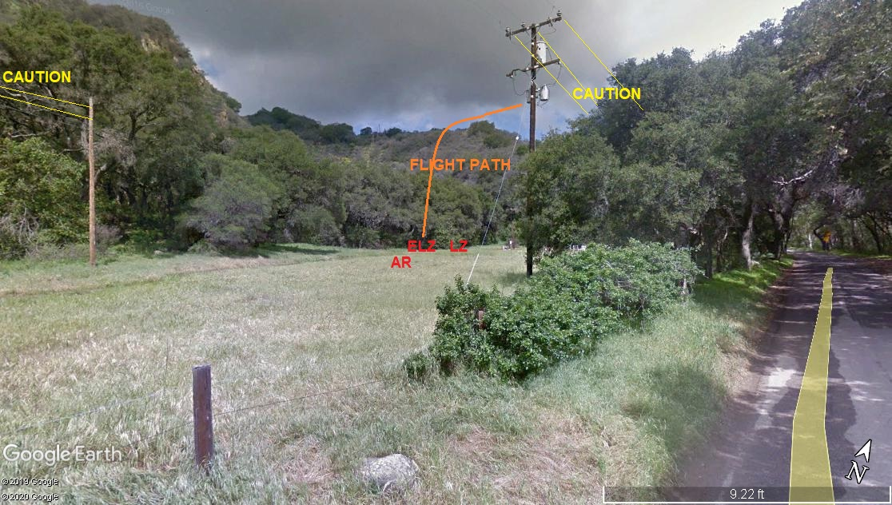
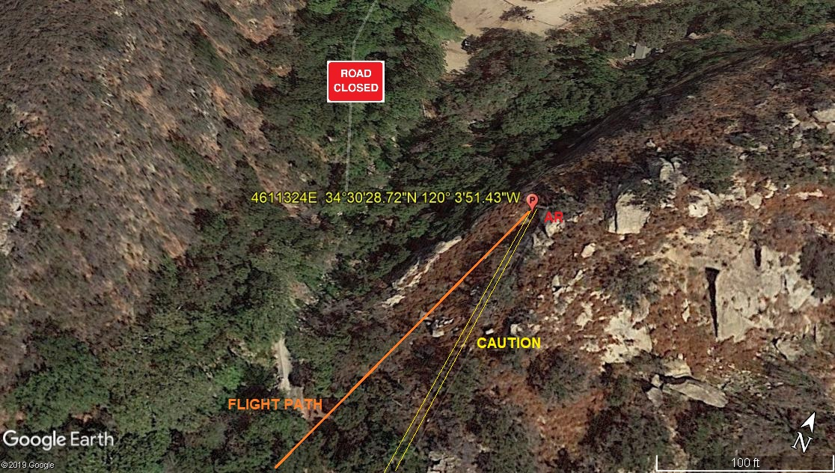
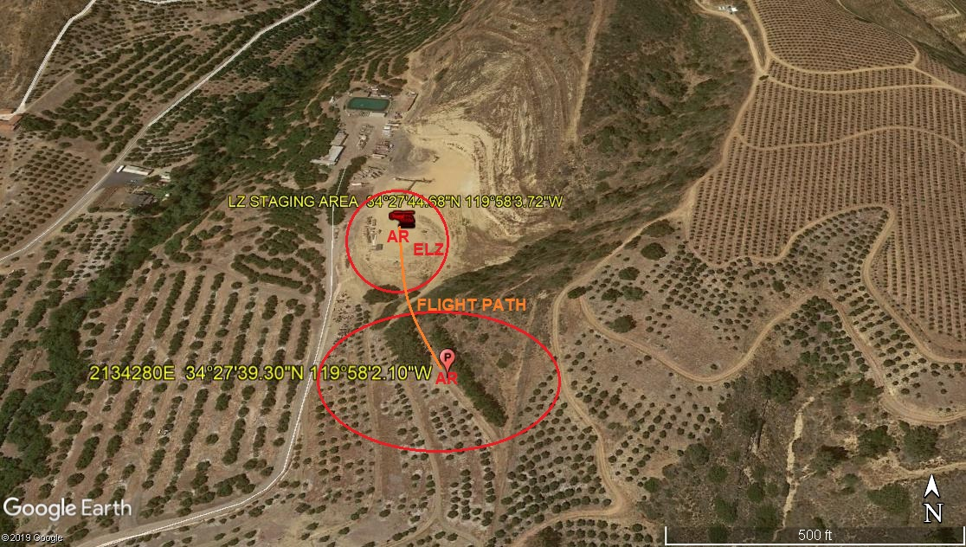
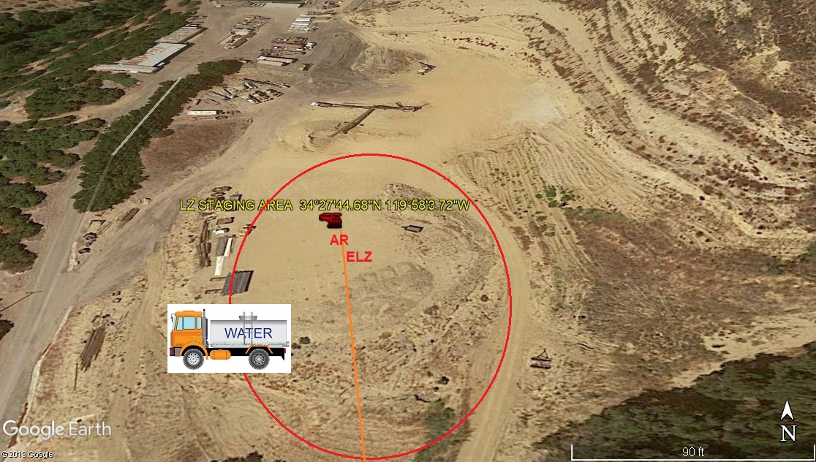
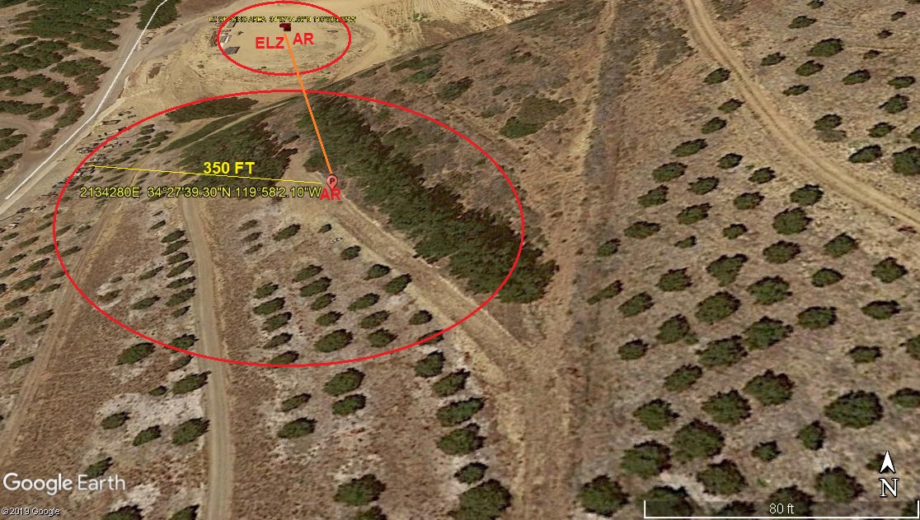

2-10-2020 
DATE OF SUBMISSION COMPANY OFFICIAL / TITLE

