
SECTION 7 Part 135 GH 4A Part 133 GH 4L
Congested Area Plan
Operator: Guardian Helicopters, Inc
67 D STREET
Fillmore CA. 93015
Phone (818) 442-9904
FAX (818) 442-9901
PROJECT: EDISON POLE REPLACEMENT WORK ORDER #: TD 1261405
ADDRESS 39399 CII EL FUENTE : GREEN VALLEY CA
LZ LATITUDE 34°36'36.93"N LONGITUDE 118°26'25.08"W
4487785E LATITUDE 34°37'2.08"N LONGITUDE 118°25'2.33"W 45 H1 2500 LBS
665691E LATITUDE 34°37'3.16"N LONGITUDE 118°25'18.16"W 45 CL 1 2000 LBS
CONTACT AT SITE: WAYNE RHODES PHONE#: 909-203-0737
CONTRACTOR: HAMPTON TEDDER EDISON SUB
PILOT’S NAME(S): 1. JOHN OLSON CERT #: 2769166
2. BUCKEY MACKAY CERT #: 2778051
3. MICHAEL KLINK CERT# 3018828
4. IAN GOODALE CERT# 3741973
TYPE OF AIRCRAFT:
BELL UH-1H N# N711GH A/C CATEGORY: RESTRICTED
BELL UH-1H N# N777GH A/C CATEGORY: RESTRICTED
BELL 407 N# N407GH A/C CATEGORY: STANDARD
BELL 205A1 N# N216GH A/C CATEGORY: STANDARD
AS350 B2 N# N498PT A/C CATEGORY: STANDARD
AS350 B3 N# N718GH A/C CATEGORY: STANDARD
AS350 B3 N# N215GH A/C CATEGORY: STANDARD
IF SAFETY DICTATES AND OR THE CUSTOMER REQUESTS ADDITIONAL LIFTS THE LIFTS WILL BE CONDUCTED REMAINING WITHIN THE APPROVED TIME PARAMETERS.
TYPE OF LIFTS: (2) POLES IN (2) POLES OUT (2) CARGO LOAD:EXTL CL B TYPE OF ITEM LIFTING: AERODYNAMIC NON- AERODYNAMIC MAX 2500 LBS
NO. OF LIFTS: 6 LONG LINE: (NO) XXX (YES) LESS THEN 150 FT (LENGTH)
OPERATIONAL ALTITUDE: < 250 STREET CLOSING: (N0) XX (YES)
DATE AND TIMES OPERATION WILL BEGIN AND TERMINATE:
FLIGHT DATES | TIME BEGIN | TIME END | TODAY’S DATE
2-24-2020 | SUNRISE | SUNSET | 2-12-2020
AGENCY NAME: | PHONE#: | PERSON NOTIFIED: | DATE:
SANTA CLARITA SHERIFF DEPARTMENT | 661-255-1121 | WATCH COMMANDER | NOTIFY
LOS ANGELES COUNTY FIRE | 661-724-3331 | STATION 157 | NOTIFY

Part 135 GH 4A Part 133 GH 4L
Congested Area Plan

Evacuation Crowd Control Street Closure
□No Evacuated Structures Operator Yes □No
Evacuated Structures Contractor Contractor
□Operator
LIST OF BUILDINGS THAT SHALL EITHER BE PARTIALLY OR ENTIRELY UNOCCUPIED PERSONS ALSO HOMES THAT WILL BE NOTIFIED OF ACTIVITY:
BUILDING DESCRIPTION/ADDRESS | REMARKS | METHOD
39399 CII EL FUENTE | VACANT DURING OPS | HAND DELIVER
39407 CII EL FUENTE | VACANT DURING OPS | HAND DELIVER
16329 PASTEL WALK | VACANT DURING OPS | HAND DELIVER
16303 PASTEL WALK | VACANT DURING OPS | HAND DELIVER
ALL HOMES WITHIN RED OPERATING AREA | VACANT DURING OPS | HAND DELIVER
SEE DIAGRAM = VACANT | VACANT DURING OPS | HAND DELIVER
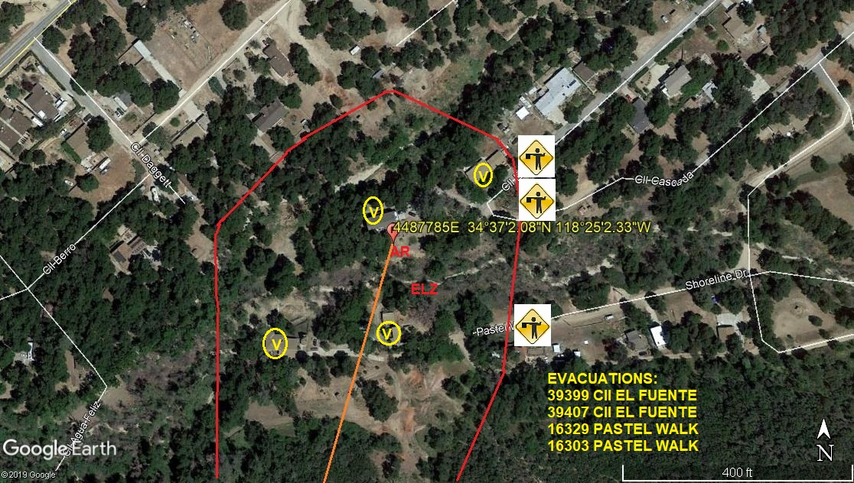

Narrative description of pick-up site, route, delivery site, and plan for ceasing operation if unauthorized persons enter operational area or real hazard occurs.
SITE INSPECTION NOTES

ONLY PERSONNEL ESSENTIAL TO COMPLETING THE JOB SAFELY WILL BE PERMITTED TO PARTICIPATE IN THE EVOLUTION. ONLY PERSONNEL PARTICIPATING IN THE SAFETY BRIEF WILL BE PERMITTED TO BE IN THE AREA OF OPERATIONS. ONLY AUTHORIZED ESSENTIAL PERSONAL WILL BE PERMITTED IN THE IMMEDIATE AREA OF OPERATIONS. IN THE EVENT AN UNAUTHORIZED PERSON ENTERS THE OPERATIONS AREA OR A POTENTIAL HAZARD IS IDENTIFIED THE PILOT WILL HOLD THE AIRCRAFT IN RELATIVE POSITION. THIS WILL BE ACHIEVED WITHOUT OVER FLYING THE GROUND CREW. ALL OPERATIONS WILL BE CEASED UNTIL THE PROBLEM IS RECTIFIED. IN THE EVENT OF AN AIRCRAFT EMERGENCY, THE PILOT WILL RADIO GROUND PERSONNEL AND WILL ATTEMPT TO LAND IN THE EMERGENCY LANDING AREA.
DURING THE LIFT EVOLUTION THE AIRCRAFT AND GROUND CREW WILL ALL BE IN RADIO COMMUNICATIONS. IN THE EVENT OF LOSS COMMUNICATIONS, THE CREW WILL USE STANDARD HAND SIGNALS TO COMMUNICATE WITH THE PILOT. WHEN THE PILOT IS CLEAR HE WILL MOVE THE AIRCRAFT TO A SAFE LOCATION TO ALLOW THE COMMUNICATION PROBLEM TO BE RECTIFIED.
THE OPERATIONS AREA IS WITHIN THE SECURED AREA. ALL ESSENTIAL CREW WITHIN THE OPERATIONS AREA WILL NOT BE INVOLVED IN TAKING PICTURES OR ANY OTHER USE OF CELL PHONES.
PRIOR TO BEGINNING OPERATIONS, A TAILBOARD SAFETY BRIEF WILL BE CONDUCTED.
- HELICOPTER WILL LAND AT THE LZ TO CONNECT THE LONGLINE AND CONDUCT A SAFETY TAILBOARD
- POLE WILL BE STAGED AT THE LZ
- FUELING WILL BE CONDUCTED AT THE LANDING ZONE
- EMERGENCY LANDING ZONE IS AT THE STAGING AREA AND ALONG THE FLIGHT PATH
- RADIOS WILL BE PROVIDED TO EACH POLE SITE
- WATER TRUCK REQUIRED AT LANDING ZONE
- SAN FRANCISQUITO CANYON ROAD AND CI EL FUENTE WILL EXPERIENCE INTERMITTENT CLOSURES
- SEE DIAGRAM FOR STREET CLOSURE AND FLAGMAN REQUIREMENTS.
- THE CONTRACTOR WILL TRIM TREES IF REQUIRED
THE HELICOPTER WILL LAND AT THE LANDING ZONE CONDUCT A SAFETY BRIEF AND WHEN THE LINEMAN ARE READY THE STREET CLOSURE AND GROUND CREW WILL KNOCK ON DOORS TO VERIFY VACANCY. WHEN THE LINEMAN ARE READY THE STREETS WILL BE CLOSED AND IF REQUIRED THE HELICOPTER WILL FLY TOOLS AND CARGO TO THE POLE SET SITES. WHEN THE LINEMAN ARE READY FOR THE NEW POLES THE HELICOPTER WILL FLY THE POLES FROM THE LANDING ZONE TO THE POLE SET SITES. WHEN THE LINEMAN ARE READY TO REMOVE THE OLD POLES THE HELICOPTER WILL FLY THE OLD POES FROM THE POEL SET SITE TO THE LANDIN ZONE. WHEN COMPLETE THE HELICOPTER WILL FLY THE TOOLS AND EQUIPMENT OUT OF THE SITE. THE HOMES AND STREETS WILL OPEN WHEN THE HELICOPTER IS CLEAR.
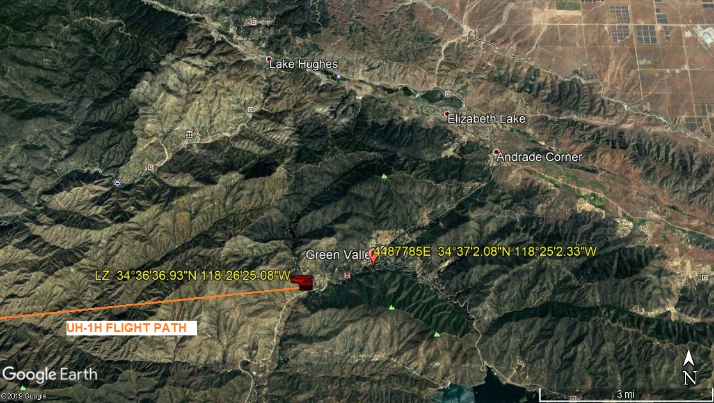

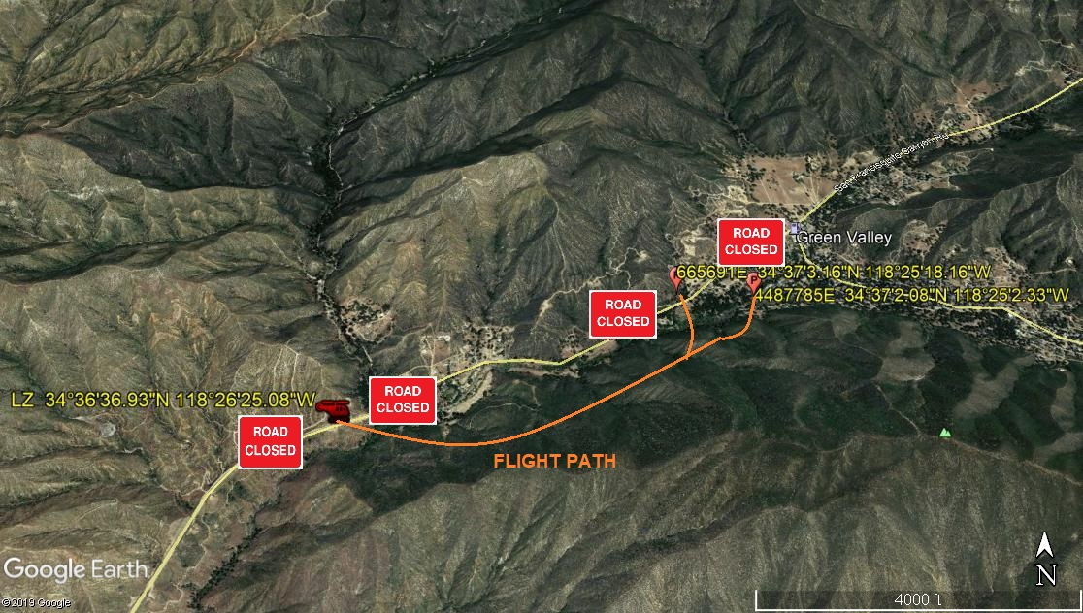
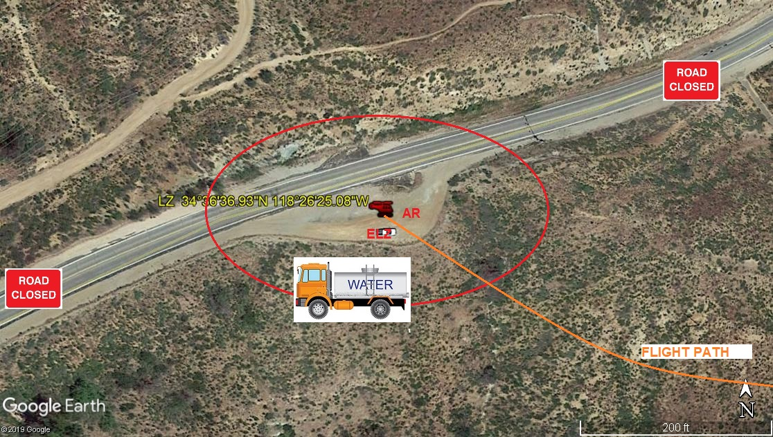
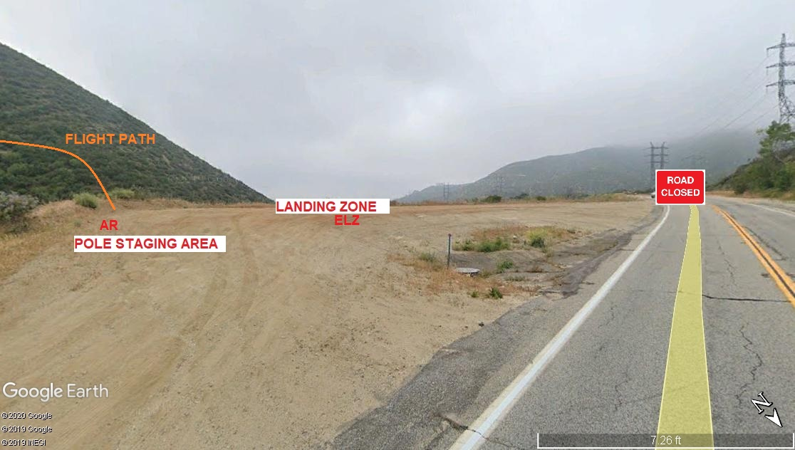
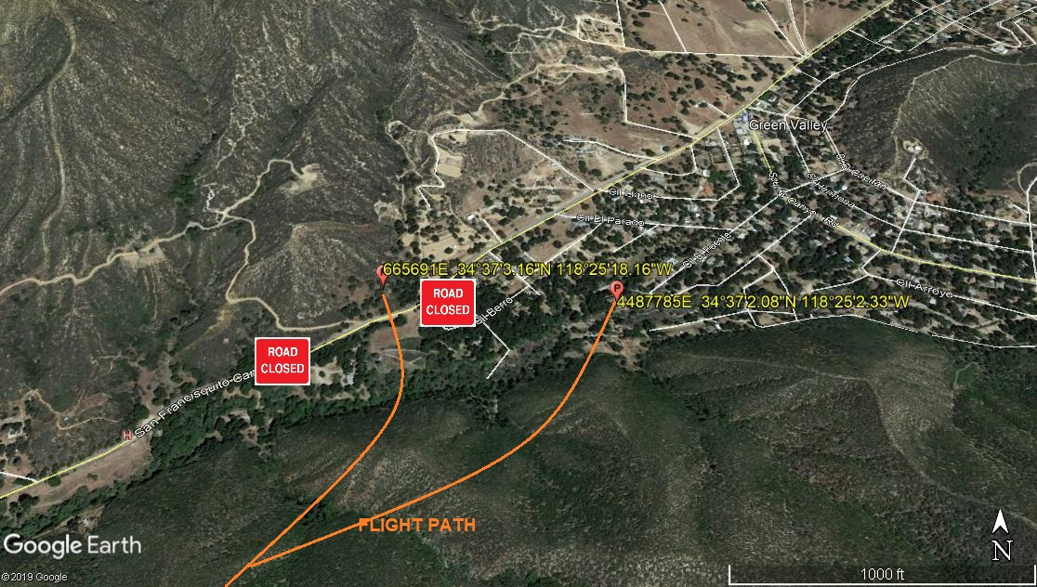
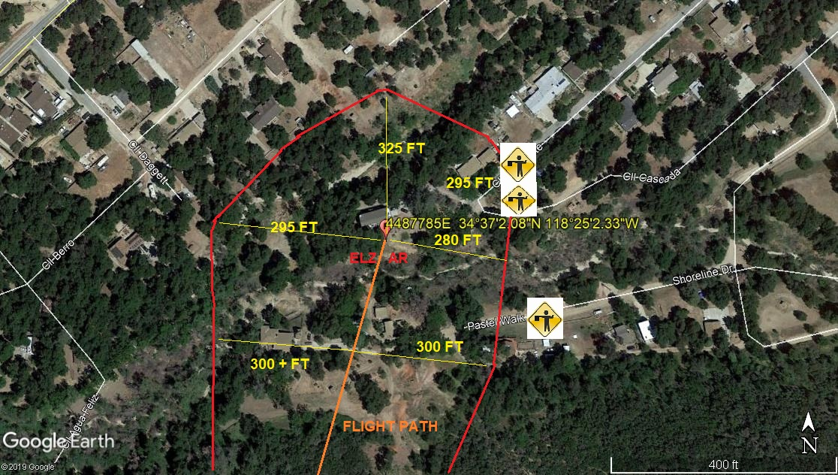
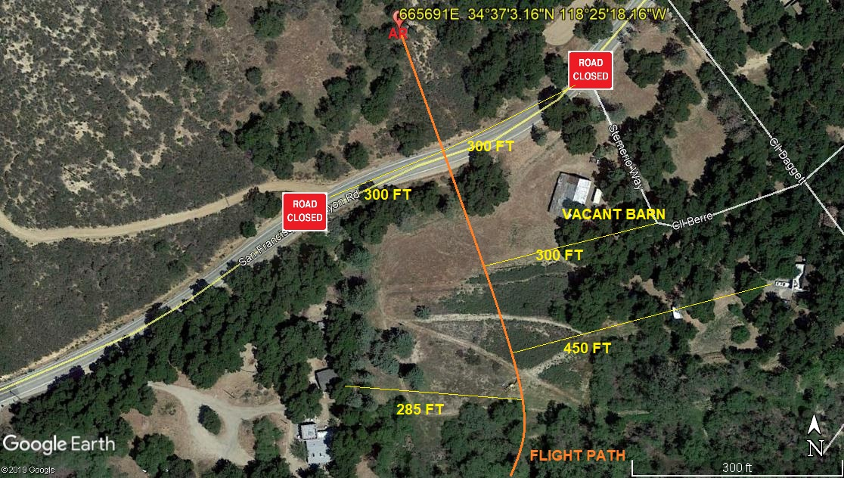
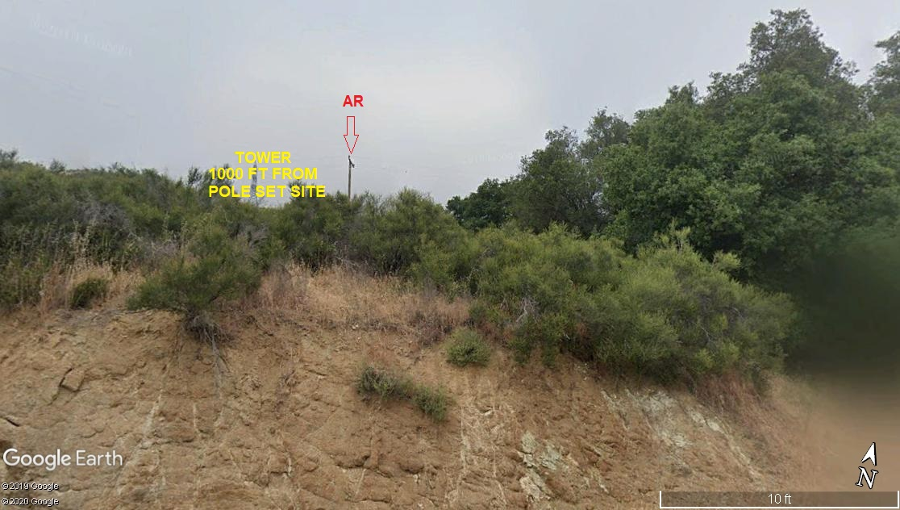
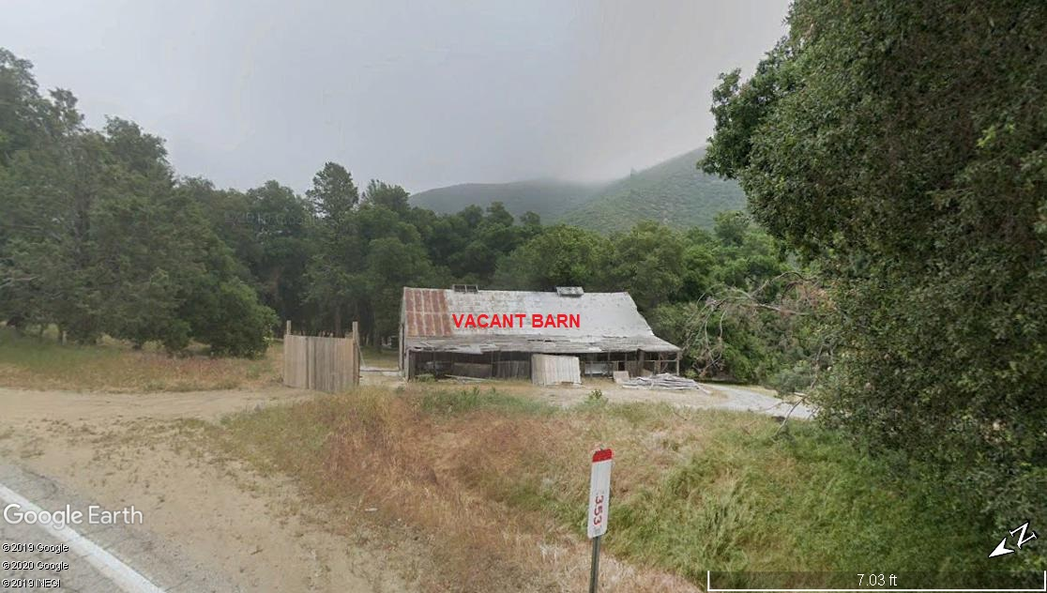
2-12-2020 
DATE OF SUBMISSION COMPANY OFFICIAL / TITLE

