
SECTION 7 Part 135 GH 4A Part 133 GH 4L
NON Congested Area Plan
Operator: Guardian Helicopters, Inc
67 D STREET Phone (818) 442-9904
Fillmore CA. 93015 FAX (818) 442-9901
PROJECT: EDISON HEC AND POLE REPLACEMENT WORK ORDER #: TD 1382320
ADDRESS PLACERITA CANYON : SANTA CLARITA CA
HEC SHIP LZ LATITUDE 34°21'36.55"N LONGITUDE 118°28'12.26"W
UH-1H LZ STAGING AREA 34°21'36.22"N LONGITUDE 118°27'14.40"W
4510143E LATITUDE 34°21'12.90"N LONGITUDE 118°27'52.20"W 45 CL 2 1800 LBS
4510137E LATITUDE 34°21'29.70"N LONGITUDE 118°28'19.30"W 45 CL 1 1950 LBS
4510127E LATITUDE 34°22'20.19"N LONGITUDE 118°28'36.34"W 45 CL 1 1950 LBS
CONTACT AT SITE: PEDRO LEMUS PHONE#: 909-306-8203
CONTRACTOR: HAMPTON TEDDER PHONE#: 909-306-8203
PILOT’S NAME(S): 1. JOHN OLSON CERT #: 2769166
2. BUCKEY MACKAY CERT #: 2778051
3. MICHAEL KLINK CERT# 3018828
4. IAN GOODALE CERT# 3741973
TYPE OF AIRCRAFT:BELL UH-1H N# N711GH A/C CATEGORY: RESTRICTED
BELL UH-1H N# N214KK A/C CATEGORY: RESTRICTED
BELL 407 N# N407GH A/C CATEGORY: STANDARD
BELL 205A1 N# N216GH A/C CATEGORY: STANDARD
AS350 B2 N# N498PT A/C CATEGORY: STANDARD
AS350 B3 N# N718GH A/C CATEGORY: STANDARD
AS350 B3 N# N215GH A/C CATEGORY: STANDARD
IF SAFETY DICTATES AND OR THE CUSTOMER REQUESTS ADDITIONAL LIFTS THE LIFTS WILL BE CONDUCTED REMAINING WITHIN THE APPROVED TIME PARAMETERS.
TYPE OF LIFTS: (3 ) POLES 10 LOADS HEAVIEST 2400 LBS COMPRESSOR LOAD:EXTL CL B TYPE OF ITEM LIFTING: AERODYNAMIC NON- AERODYNAMIC MAX 2700 LBS
NO. OF LIFTS: 10 LONG LINE: (NO) XXX (YES) LESS THEN 150 FT (LENGTH)
OPERATIONAL ALTITUDE: < 250 STREET CLOSING: (N0) XX (YES)
DATE AND TIMES OPERATION WILL BEGIN AND TERMINATE:
FLIGHT DATES | TIME BEGIN | TIME END | TODAY’S DATE
3-25-2020 HEC CARGO | SUNRISE | SUNSET | 2-3-2020
3-26-2020 HEC POLE | SUNRISE | SUNSET | 2-3-2020
3-27-2020 HEC POLE | SUNRISE | SUNSET | 2-3-2020
AGENCY NAME: | PHONE#: | PERSON NOTIFIED: | DATE:
POLICE DEPARTMENT | 661-272-2400 | WATCH COMMANDER | WILL NOTIFY
FIRE DEPARTMENT | 661-944-1260 | DISPATCH | WILL NOTIFY
Evacuation Crowd Control Street Closure
No Evacuated Structures Operator □Yes No
□Evacuated Structures Contractor Contractor
□Operator

Part 135 GH 4A Part 133 GH 4L
NON Congested Area Plan

LIST OF BUILDINGS THAT SHALL EITHER BE PARTIALLY OR ENTIRELY UNOCCUPIED PERSONS ALSO HOMES THAT WILL BE NOTIFIED OF ACTIVITY:
BUILDING DESCRIPTION/ADDRESS | REMARKS | METHOD
REMOTE NO EVACAUTIONS | VACANT DURING OPS | HAND DELIVER
ALL HOMES WITHIN RED OPERATING AREA | VACANT DURING OPS | HAND DELIVER
SEE DIAGRAM = VACANT | VACANT DURING OPS | HAND DELIVER

Narrative description of pick-up site, route, delivery site, and plan for ceasing operation if unauthorized persons enter operational area or real hazard occurs.
SITE INSPECTION NOTES

ONLY PERSONNEL ESSENTIAL TO COMPLETING THE JOB SAFELY WILL BE PERMITTED TO PARTICIPATE IN THE EVOLUTION. ONLY PERSONNEL PARTICIPATING IN THE SAFETY BRIEF WILL BE PERMITTED TO BE IN THE AREA OF OPERATIONS. ONLY AUTHORIZED ESSENTIAL PERSONAL WILL BE PERMITTED IN THE IMMEDIATE AREA OF OPERATIONS. IN THE EVENT AN UNAUTHORIZED PERSON ENTERS THE OPERATIONS AREA OR A POTENTIAL HAZARD IS IDENTIFIED THE PILOT WILL HOLD THE AIRCRAFT IN RELATIVE POSITION. THIS WILL BE ACHIEVED WITHOUT OVER FLYING THE GROUND CREW. ALL OPERATIONS WILL BE CEASED UNTIL THE PROBLEM IS RECTIFIED. IN THE EVENT OF AN AIRCRAFT EMERGENCY, THE PILOT WILL RADIO GROUND PERSONNEL AND WILL ATTEMPT TO LAND IN THE EMERGENCY LANDING AREA.
DURING THE LIFT EVOLUTION THE AIRCRAFT AND GROUND CREW WILL ALL BE IN RADIO COMMUNICATIONS. IN THE EVENT OF LOSS COMMUNICATIONS, THE CREW WILL USE STANDARD HAND SIGNALS TO COMMUNICATE WITH THE PILOT. WHEN THE PILOT IS CLEAR HE WILL MOVE THE AIRCRAFT TO A SAFE LOCATION TO ALLOW THE COMMUNICATION PROBLEM TO BE RECTIFIED.
THE OPERATIONS AREA IS WITHIN THE SECURED AREA. ALL ESSENTIAL CREW WITHIN THE OPERATIONS AREA WILL NOT BE INVOLVED IN TAKING PICTURES OR ANY OTHER USE OF CELL PHONES.
PRIOR TO BEGINNING OPERATIONS, A TAILBOARD SAFETY BRIEF WILL BE CONDUCTED.
- THE HEC SHIP WILL LAND AT THE PRIMARY LZ TO CONNECT THE LONGLINE AND CONDUCT A SAFETY TAILBOARD AND HEC TRIANING
- THE UH-1H WILL LAND AT THE SECONDARY LZ TO CONNECT THE LONGLINE AND WAIT FOR THE CREW TO BE READY FOR THE COMPRESSORS OR POLES
- HEC TRAINING WILL BE CONDUCTED AT THE LZ
- POLES AND EQUIPMENT WILL BE STAGED TO THE SOUTH OF THE PRIMARY LZ BY 250 FT
- FUELING WILL BE CONDUCTED AT THE LANDING ZONE
- EMERGENCY LANDING ZONE IS AT THE STAGING AREA AND ALONG THE FLIGHT PATH
- RADIOS WILL BE PROVIDED TO EACH POLE SITE
- WATER TRUCK REQUIRED AT BOTH LANDING ZONES
- NO STREET CLOSURES
- THE HELCOPTER WILL CONDUCT A LOW RECON FLIGHT PRIOR TO STARTING OPERATIONS.
DAY 1 THE HEC SHIP WILL LAND AT THE PRIMARY LZ AND CONDUCT TRAINING AND TAILBOARD.
THE UH-1 WILL LAND AT THE SECONDARY LZ TO CONNECT THE LONGLINE.
THE HEC SHIP WILL FLY THE DIGGING CREW TO THE POLE SITES. THE HEC SHIP WILL LAND AT THE PRIMARY LANDING ZONE, ONCE THE AIRCRAFT IS SHUTDOWN AND THE CREW IS READY FOR THE COMPRESSORS THE UH-1H WILL PICK THE COMPRESSORS AND CARGO FROM THE STAGING AREA AND FLY TO THE POLE SITES. ONCE THE DELIVERY IS COMPLETE THE UH-1H WILL BE RELEASED AND HEC SHIP WILL STANDBY FOR EXTRACTION.
DAY 2 BOTH SHIPS WILL ARRIVE AT THE PRIMARY AND SECONDARY LANDING ZONES TO CONDUCT HEC TRAINING AND SAFETY TAILBOARD. THE HEC SHIP WILL FLY THE LINEMAN TO THE POLE SITES. ONCE THEY ARE READY THE UH-1H WILL EXTRACT THE COMPRESSORS AND SET THE POLES. WHEN THE PROJECT IS COMPLETE THE HEC SHIP WILL EXTRACT THE LINEMAN AND REMOVE ANY CARGO.

- THE CONTRACTOR WILL TRIM TREES IF REQUIRED

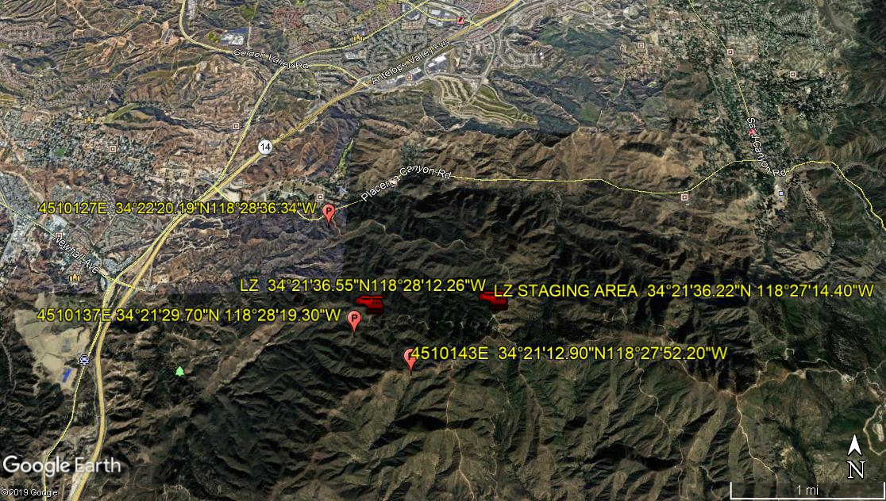
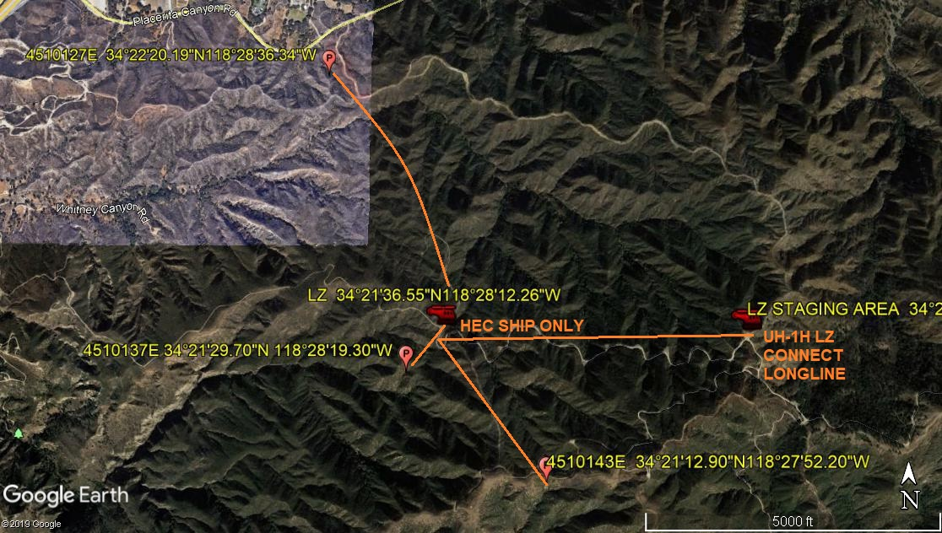

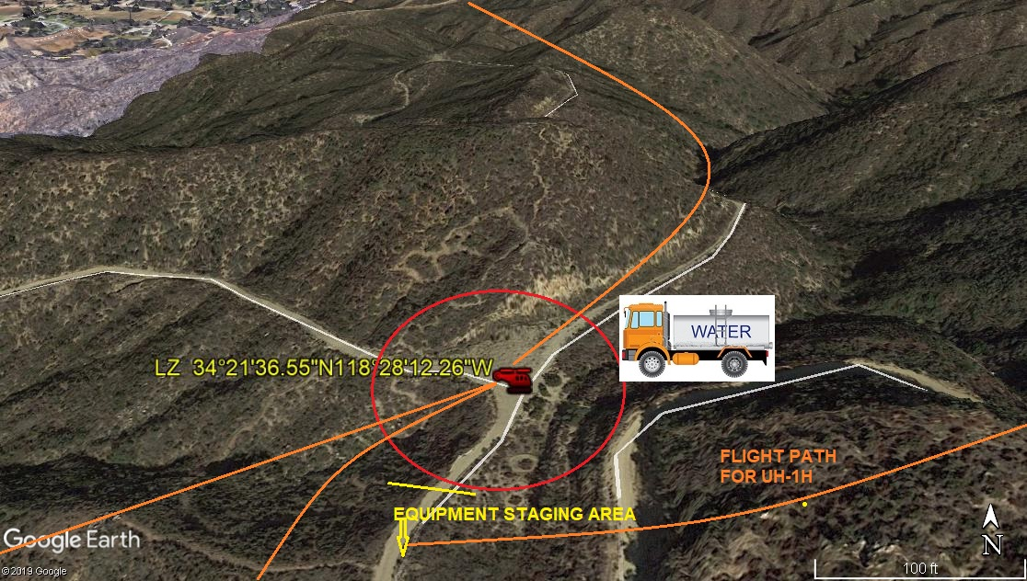
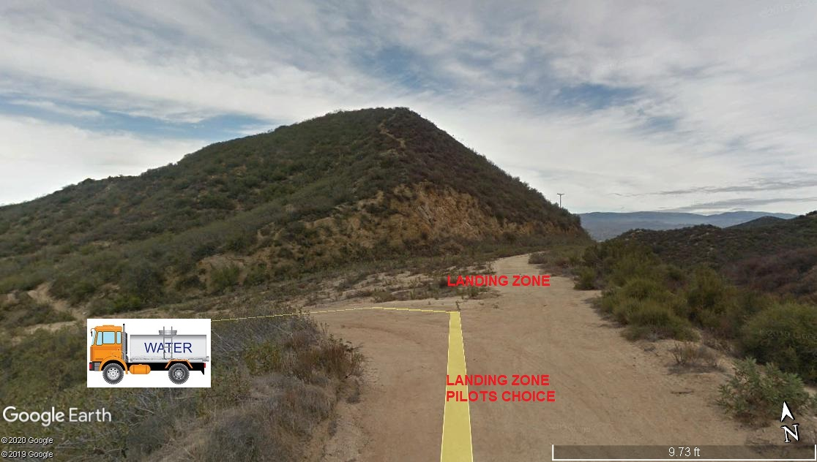
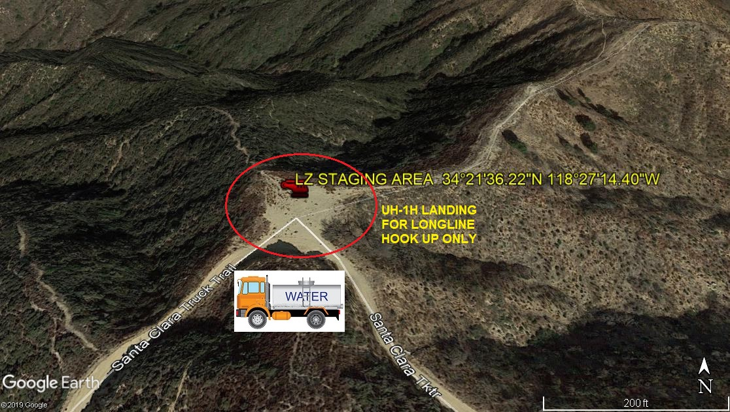
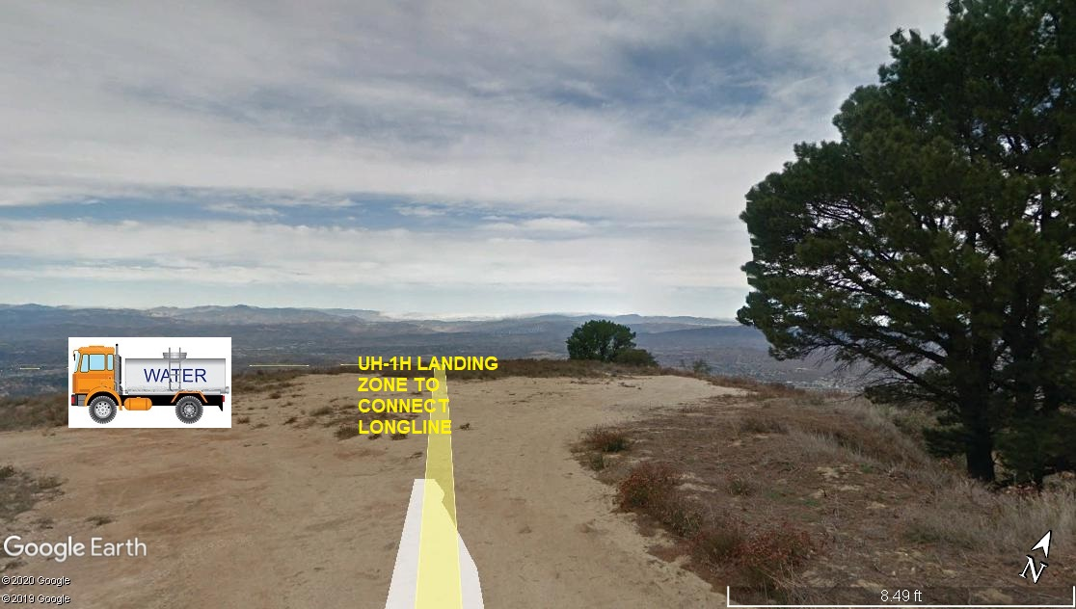
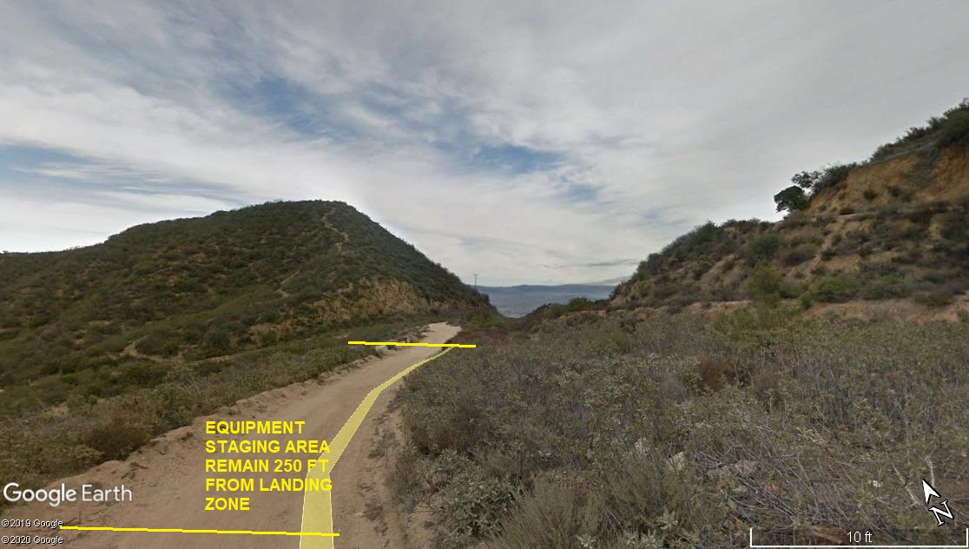
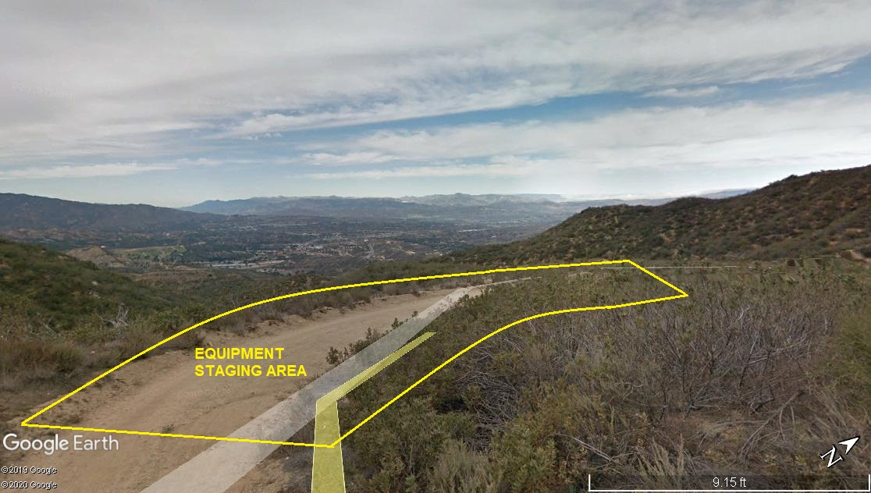

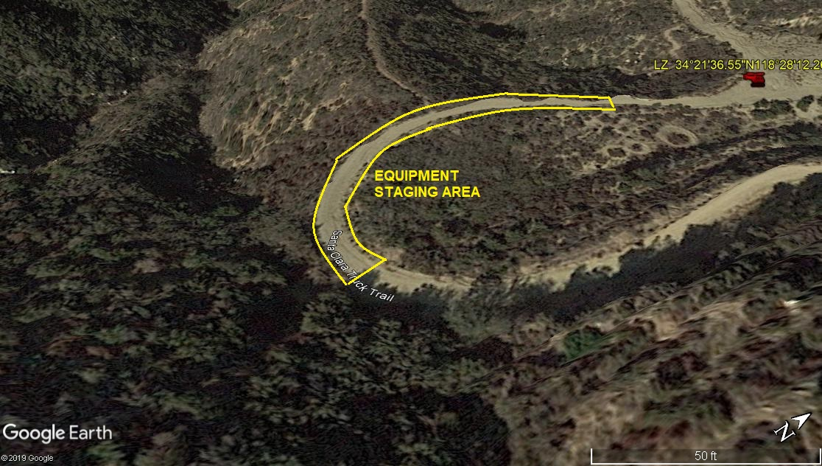
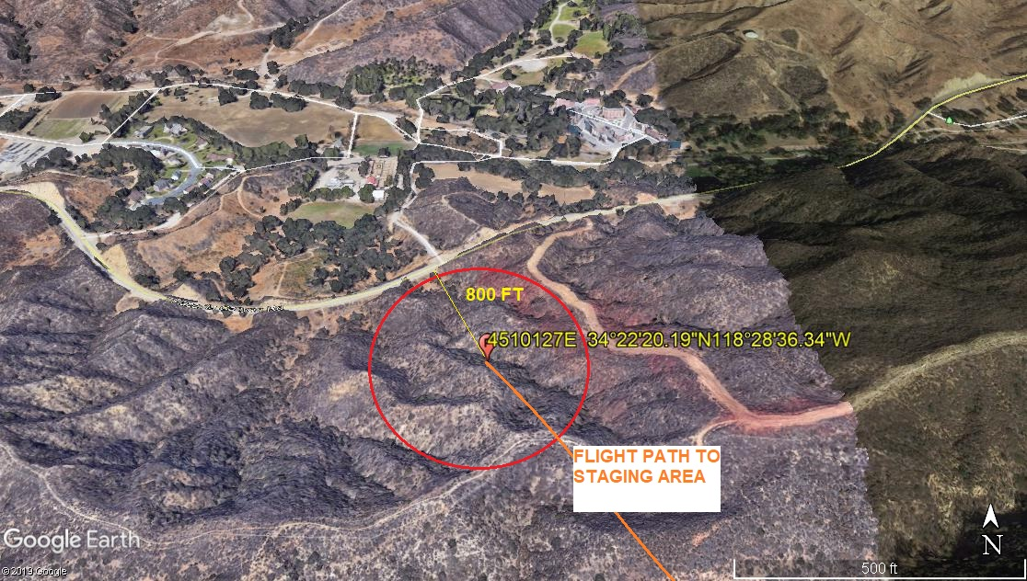
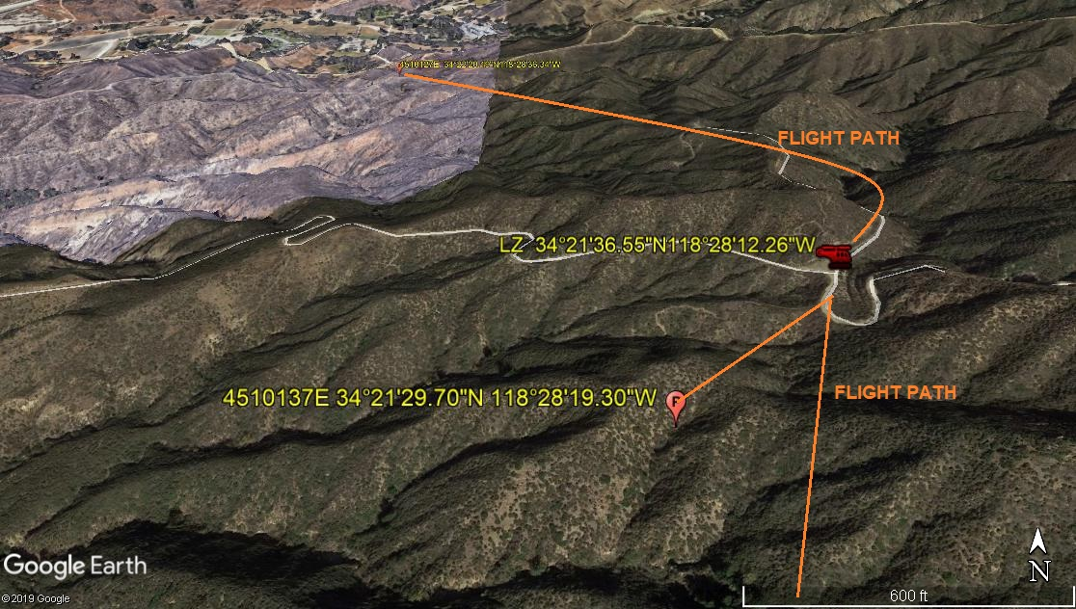
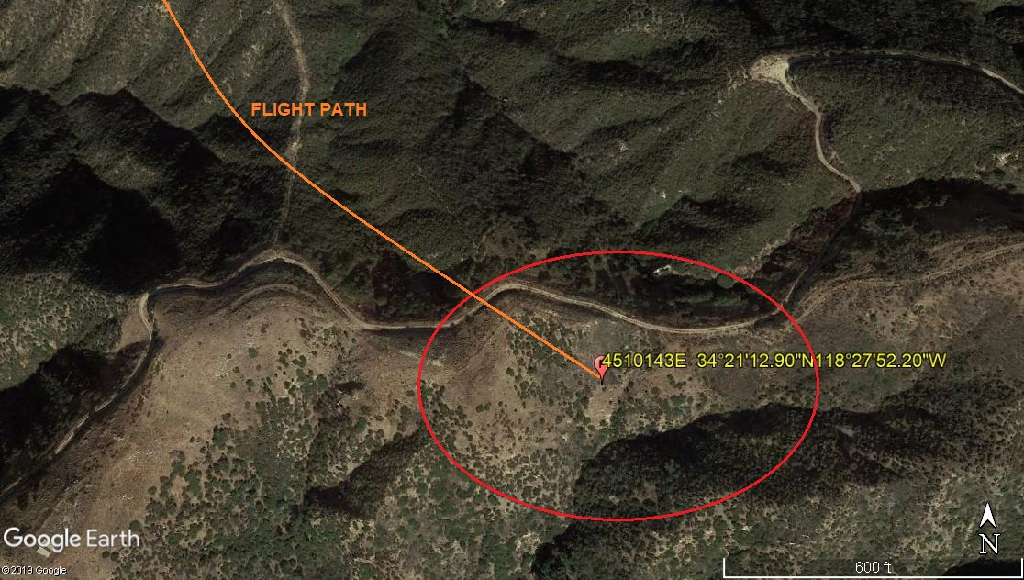
2-3-2020 
DATE OF SUBMISSION COMPANY OFFICIAL / TITLE

