
SECTION 7 Part 135 GH 4A Part 133 GH 4L
Congested Area Plan
Operator: Guardian Helicopters, Inc
67 D STREET
Fillmore CA. 93015
Phone (818) 442-9904
FAX (818) 442-9901
PROJECT: EDISON POLE REPLACEMENT WORK ORDER #: TD 1254958
ADDRESS: 5 FWYAND 14 FWY INTERSECTION : SANTA CLARITA CA
LANIDNG ZONE LATITUDE 34°19'41.62"N LONGITUDE 118°30'7.41"W
M18-T7 STRUCTURE LATITUDE 34°19'31.60"N LONGITUDE 118°30'4.04"W
LINE PULL LATITUDE 34°19'27.54"N LONGITUDE 118°30'17.03"W
CONTRACTOR’S CASEY MITCHELL PHONE#: 209-639-2671
CONTACT AT SITE; HOTLINE CONSTRUCTION PHONE#: 209-639-2671
PILOT’S NAME(S): 1. JOHN OLSON CERT #: 2769166
2. BUCKEY MACKAY CERT #: #:2778051
3. MICHAEL KLINK CERT# 3018828
4. IAN GOODALE CERT# 3741973
TYPE OF AIRCRAFT:BELL
BELL 407 N# N407GH A/C CATEGORY: STANDARD
BELL 205A1 N# N216GH A/C CATEGORY: STANDARD
AS350 B2 N# N498PT A/C CATEGORY: STANDARD
AS350 B3 N# N718GH A/C CATEGORY: STANDARD
AS350 B3 N# N215GH A/C CATEGORY: STANDARD
TYPE OF ITEM LIFTING: POLE AERODYNAMIC NON- AERODYNAMIC
IF SAFETY DICTATES AND OR THE CUSTOMER REQUESTS ADDITIONAL LIFTS THE LIFTS WILL BE CONDUCTED REMAINING WITHIN THE APPROVED TIME PARAMETERS.
TYPE OF LIFTS: HEC EQUIPMENT AND PULLING LINE. CARGO EXTERNAL CL B
NO. OF LIFTS: TBD LONG LINE: (NO) XXX (YES) LESS THEN 150 FT (LENGTH)
OPERATIONAL ALTITUDE: < 250 STREET CLOSING: (N0) XX (YES)
DATE AND TIMES OPERATION WILL BEGIN AND TERMINATE:

FLIGHT DATES | TIME BEGIN | TIME END | TODAY’S DATE
February 22, 23, 29, 2020 | SUNRISE | SUNSET | 2-12-2020
March 7, 8, 14, 15, 21, 22, 28, 29, 2020 | SUNRISE | SUNSET | 2-12-2020
April 4, 5, 11, 12, 2020 | SUNRISE | SUNSET | 2-12-2020
AGENCY NAME: | PHONE#: | PERSON NOTIFIED: | DATE:
SCV SHERIFF DEPARTMENT | 661-255-1121 | WATCH COMMANDER | NOTIFIED
SCV CHP | 661-294-5540 | WATCH COMMANDER | NOTIFIED
LA COUNTY FIRE | 661-254-9661 | STATION 73 | NOTIFIED
Part 135 GH 4A Part 133 GH 4L
Congested Area Plan
Evacuation Crowd Control Street Closure

No Evacuated Structures Operator Yes □ No
□Evacuated Structures Contractor Contractor
□Operator
STREET CLOSURES | REMARKS | METHOD
5 FWY TRUCK ROUTE | NORTH AND SOUTH | CHP
FOOTHILL BLVD | NORTH AND SOUTH | CHP
SEE DIAGRAM FOR CLOSURE LOCATION
LIST OF BUILDINGS THAT SHALL EITHER BE PARTIALLY OR ENTIRELY UNOCCUPIED PERSONS ALSO HOMES THAT WILL BE NOTIFIED OF ACTIVITY:
BUILDING DESCRIPTION/ADDRESS | REMARKS | METHOD
SEE DIAGRAM | VACANT DURING OPS | HAND DELIVER
ALL HOMES WITHIN RED OPERATING AREA | VACANT DURING OPS | HAND DELIVER
SEE DIAGRAM = VACANT | VACANT DURING OPS | HAND DELIVER
Narrative description of pick-up site, route, delivery site, and plan for ceasing operation if unauthorized persons enter operational area or real hazard occurs.
SITE INSPECTION NOTES

ONLY PERSONNEL ESSENTIAL TO COMPLETING THE JOB SAFELY WILL BE PERMITTED TO PARTICIPATE IN THE EVOLUTION. ONLY PERSONNEL PARTICIPATING IN THE SAFETY BRIEF WILL BE PERMITTED TO BE IN THE AREA OF OPERATIONS. ONLY AUTHORIZED ESSENTIAL PERSONAL WILL BE PERMITTED IN THE IMMEDIATE AREA OF OPERATIONS. IN THE EVENT AN UNAUTHORIZED PERSON ENTERS THE OPERATIONS AREA OR A POTENTIAL HAZARD IS IDENTIFIED THE PILOT WILL HOLD THE AIRCRAFT IN RELATIVE POSITION. THIS WILL BE ACHIEVED WITHOUT OVER FLYING THE GROUND CREW. ALL OPERATIONS WILL BE CEASED UNTIL THE PROBLEM IS RECTIFIED. IN THE EVENT OF AN AIRCRAFT EMERGENCY, THE PILOT WILL RADIO GROUND PERSONNEL AND WILL ATTEMPT TO LAND IN THE EMERGENCY LANDING AREA.
DURING THE LIFT EVOLUTION THE AIRCRAFT AND GROUND CREW WILL ALL BE IN RADIO COMMUNICATIONS. IN THE EVENT OF LOSS COMMUNICATIONS, THE CREW WILL USE STANDARD HAND SIGNALS TO COMMUNICATE WITH THE PILOT. WHEN THE PILOT IS CLEAR HE WILL MOVE THE AIRCRAFT TO A SAFE LOCATION TO ALLOW THE COMMUNICATION PROBLEM TO BE RECTIFIED.
THE OPERATIONS AREA IS WITHIN THE SECURED AREA. ALL ESSENTIAL CREW WITHIN THE OPERATIONS AREA WILL NOT BE INVOLVED IN TAKING PICTURES OR ANY OTHER USE OF CELL PHONES.
PRIOR TO BEGINNING OPERATIONS, A TAILBOARD SAFETY BRIEF WILL BE CONDUCTED.
- HELICOPTER WILL LAND AT THE LZ TO CONNECT THE LONGLINE AND CONDUCT A TAILBOARD SAFETY MEETING THE LZ STAGING AREAS IS TO THE EAST OF THE 5 FWY TRUCK ROUTE
- WATER TRUCK IS REQUIRED AT THE LANDING ZONE
- FUELING WILL BE CONDUCTED AT THE LANDING ZONE
- THE HELICOPTER WILL FLY HUMAN EXTERNAL CARGO, AND EQUIPMENT FROM THE EQUIPMENT STAGING AREA TO THE BASE OF STRUCTURE M 8-T7 . WHEN CUSTOMER READY THE HELICOPTER WILL PULL ROPE FROM FOOTHILL BLVD TO THE STRUCTURE
- EMERGENCY LANDING ZONE IS AT THE STAGING AREA AND ALONG THE FLIGHT PATH
- FOOTHILL, INTERSTATE 5 TRUCK ROUTE NORTH AND SOUTH WILL BE CLOSED DURING OPERATIONS.
- CUSTOMER WILL HAVE INTERSTATE 5 AND 14 NORTH AND SOUTH CLOSED
- NO STRUCTURES WITHIN THE OPERATING AREA
- FOR HELICOPTER OPERATIONS ALL ACTIVITIES WILL REMAIN TO THE EAST OF THE HWY. THE HWY WILL BE CLOSED FOR LINEMAN OPERATIONS.
THE HELICOPTER WILL LAND AT THE LZ AND CONDUCT HEC TRAINING AND A SAFETY TAILBOARD EACH DAY PRIOR TO STARTING WORK. WHEN READY THE HELICOPTER WILL HEC CREWS TO THE STRUCTURE. THEN FLY TOOLS AND EQUIPMENT TO THE STRUCTURE. WHEN THE LINEMAN NEED THE LINE PULLED THE HELICOPTER WILL PULL THE LINE FORM THE FOOTHILL BLVD UP THE HILL TO THE STRUCTURE. AT NO TIME WILL THE HELICOPTER FLY OVER THE FREEWAY. ALL HELICOPTER OPERATION WILL REMAIN TO THE EAST OF THE FREEWAY. THE TRUCK 5 FWY TRUCK ROUTE NORTH AND SOUTH AND FOOTHILL WILL BE CLOSED DURING HELICOPTER OPERATIONS.

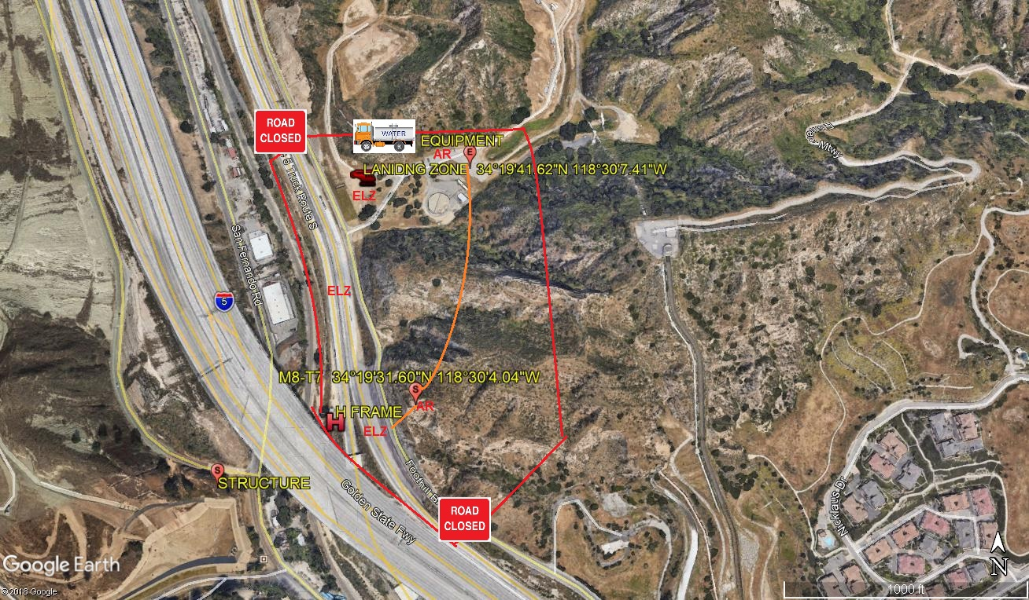
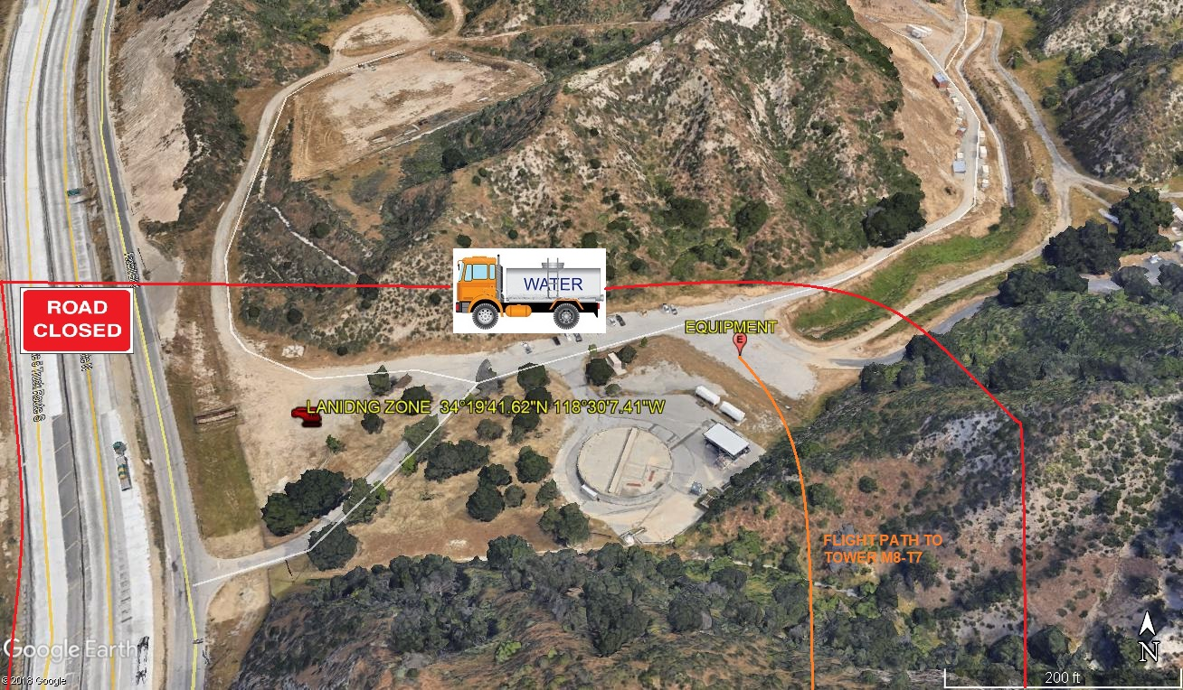
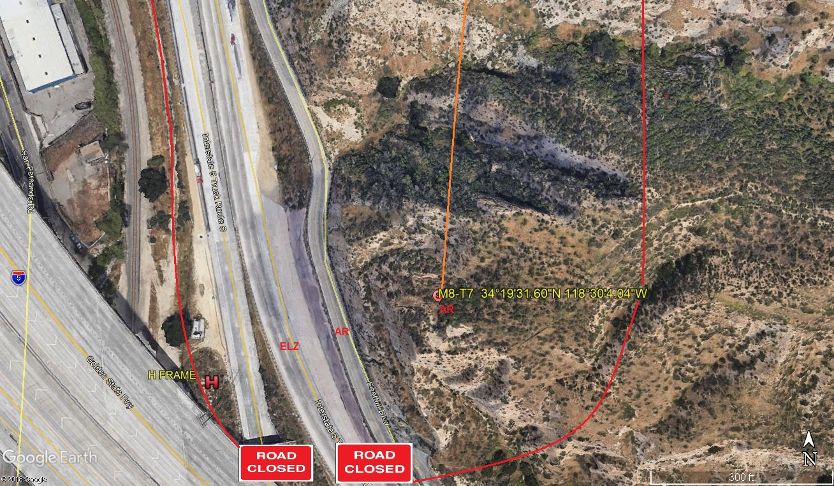

LEGEND
SITE PLAN SYMBOLS: EVACUATION FLIGHT PATH
LANDING AREA = (LZ) | STREET BLOCKED = XXXX | TOP TWO FLOORS = UBT2
ATTACH AREA = (A) | RELEASE AREA = (R)
FLIGHT PATH = >>ORANGE LINE | EMERGENCY LAND = (ELZ)
UNOCCUPIED BUILDING = (V) YELLOW | UNOCCUPIED BUILDING TOP FLOOR = (UBT1)

2-12-2020 
DATE OF SUBMISSION COMPANY OFFICIAL / TITLE

