
SECTION 7 Part 135 GH 4A Part 133 GH 4L
NON Congested Area Plan
Operator: Guardian Helicopters, Inc
67 D STREET Phone (818) 442-9904 FAX (818) 442-9901
Fillmore CA. 93015
PROJECT: EDISON POLE AND HEC WORK ORDER #: TD 1589932
ADDRESS: LOTUS CANYON ROAD SOUTH MOUNTAIN RD : SANTA PAULA CA
LZ STAGING AREA LATITUDE 34°21'27.85"N LONGITUDE 119° 0'13.55"W
1281855E LATITUDE 34°21'11.08"N LONGITUDE 119° 0'31.42"W 45 CL 1 COMP W TRANSFORMER
CONTRACTOR’S WAYNE RHODES HAMPTON TEDDER PHONE#: 909-203-0737
CONTACT AT SITE; GARRET ILLMAN HAMPTON TEDDER PHONE#: 909-573-3856
PILOT’S NAME(S):
1. JOHN OLSON CERT #: 2769166
2. BUCKEY MACKAY CERT #: 2778051
3. MICHAEL KLINK CERT# 3018828
4. IAN GOODALE CERT# 3741973
5. ROSS GOULET CERT# 339677
TYPE OF AIRCRAFT:
BELL UH-1H N# N711GH A/C CATEGORY: RESTRICTED
BELL UH-1H N# N777GH A/C CATEGORY: RESTRICTED
BELL 407 N# N407GH A/C CATEGORY: STANDARD
BELL 205A1 N# N216GH A/C CATEGORY: STANDARD
AS350 B2 N# N498PT A/C CATEGORY: STANDARD
AS350 B3 N# N718GH A/C CATEGORY: STANDARD
AS350 B3 N# N215GH A/C CATEGORY: STANDARD
TYPE OF ITEM LIFTING: POLE AERODYNAMIC NON- AERODYNAMIC
IF SAFETY DICTATES AND OR THE CUSTOMER REQUESTS ADDITIONAL LIFTS THE LIFTS WILL BE CONDUCTED REMAINING WITHIN THE APPROVED TIME PARAMETERS.
TYPE OF LIFTS:( 1) (1) 45 CL1 COMP WITH TRANSFORMER 1900 LBS CLASS OF LOAD:EXTL CL B NO. OF LIFTS: 4 LONG LINE: (NO) XXX (YES) LESS THEN 150 FT (LENGTH)
OPERATIONAL ALTITUDE: < 250 STREET CLOSING: (N0) XX (YES)
DATE AND TIMES OPERATION WILL BEGIN AND TERMINATE:
FLIGHT DATES | TIME BEGIN | TIME END | TODAY’S DATE
5-14-2020 | SUNRISE | SUNSET | 5-4-2020
AGENCY NAME: | PHONE#: | PERSON NOTIFIED: | DATE:
SANTA PAULA POLICE | 805-525-4474 | DISPATCH | NOTIFY
SANTA PAULA FIRE | 805-933-4225 | DISPATCH | NOTIFY

Evacuation Crowd Control Street Closure
No Evacuated Structures Operator Yes □ No
□Evacuated Structures Contractor Contractor
□Operator

SECTION 7 Part 135 GH 4A Part 133 GH 4L
NON Congested Area Plan
Operator: Guardian Helicopters, Inc
67 D Street
Fillmore, California 93015

LIST OF BUILDINGS THAT SHALL EITHER BE PARTIALLY OR ENTIRELY UNOCCUPIED PERSONS ALSO HOMES THAT WILL BE NOTIFIED OF ACTIVITY:
BUILDING DESCRIPTION/ADDRESS | REMARKS | METHOD
NONE | VACANT DURING OPS | HAND DELIVER
ALL HOMES WITHIN RED OPERATING AREA | VACANT DURING OPS | HAND DELIVER
SEE DIAGRAM = VACANT | VACANT DURING OPS | HAND DELIVER
Narrative description of pick-up site, route, delivery site, and plan for ceasing operation if unauthorized persons enter operational area or real hazard occurs.
SITE INSPECTION NOTES
ONLY PERSONNEL ESSENTIAL TO COMPLETING THE JOB SAFELY WILL BE PERMITTED TO PARTICIPATE IN THE EVOLUTION. ONLY PERSONNEL PARTICIPATING IN THE SAFETY BRIEF WILL BE PERMITTED TO BE IN THE AREA OF OPERATIONS. ONLY AUTHORIZED ESSENTIAL PERSONAL WILL BE PERMITTED IN THE IMMEDIATE AREA OF OPERATIONS. IN THE EVENT AN UNAUTHORIZED PERSON ENTERS THE OPERATIONS AREA OR A POTENTIAL HAZARD IS IDENTIFIED THE PILOT WILL HOLD THE AIRCRAFT IN RELATIVE POSITION. THIS WILL BE ACHIEVED WITHOUT OVER FLYING THE GROUND CREW. ALL OPERATIONS WILL BE CEASED UNTIL THE PROBLEM IS RECTIFIED. IN THE EVENT OF AN AIRCRAFT EMERGENCY, THE PILOT WILL RADIO GROUND PERSONNEL AND WILL ATTEMPT TO LAND IN THE EMERGENCY LANDING AREA.
DURING THE LIFT EVOLUTION THE AIRCRAFT AND GROUND CREW WILL ALL BE IN RADIO COMMUNICATIONS. IN THE EVENT OF LOSS COMMUNICATIONS, THE CREW WILL USE STANDARD HAND SIGNALS TO COMMUNICATE WITH THE PILOT. WHEN THE PILOT IS CLEAR HE WILL MOVE THE AIRCRAFT TO A SAFE LOCATION TO ALLOW THE COMMUNICATION PROBLEM TO BE RECTIFIED.
THE OPERATIONS AREA IS WITHIN THE SECURED AREA. ALL ESSENTIAL CREW WITHIN THE OPERATIONS AREA WILL NOT BE INVOLVED IN TAKING PICTURES OR ANY OTHER USE OF CELL PHONES.
PRIOR TO BEGINNING OPERATIONS, A TAILBOARD SAFETY BRIEF WILL BE CONDUCTED.
- HELICOPTER WILL LAND AT THE LZ STAGING AREA TO CONDUCT A SAFETY TAILBOARD, CONNECT THE LONGLINE AND FOR FUELING
- WATER TRUCK IS REQUIRED AT THE LZ STAGING AREA
- SOUTH MOUNTAIN ROAD WILL EXPERIENCE INTERMITTENT CLOSURES DURING OPERATIONS
- EMERGENCY LANDING ZONE IS AT THE STAGING AREA AND ALONG THE FLIGHT PATH
- NO FARM WORKERS WILL BE ALLOWED IN THE OPERATIONS AREA
- THE CONTRACTOR WILL TRIM TREES IF REQUIRED

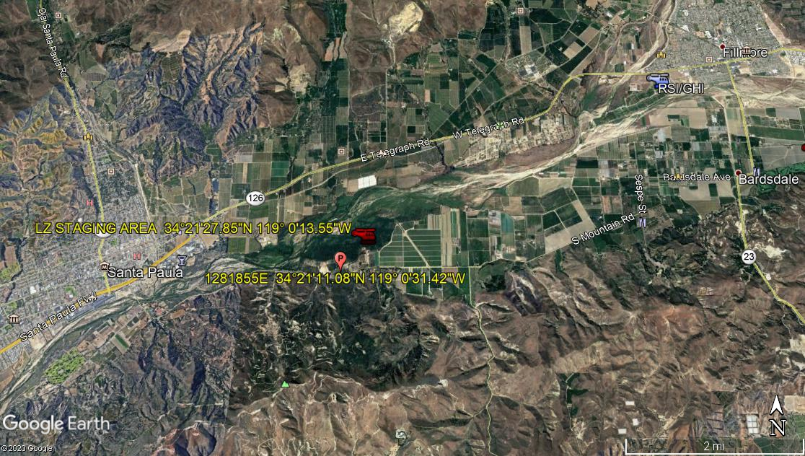
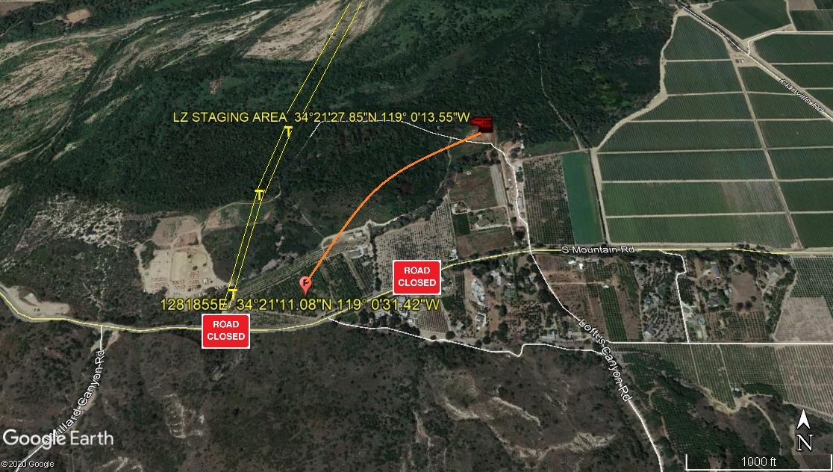
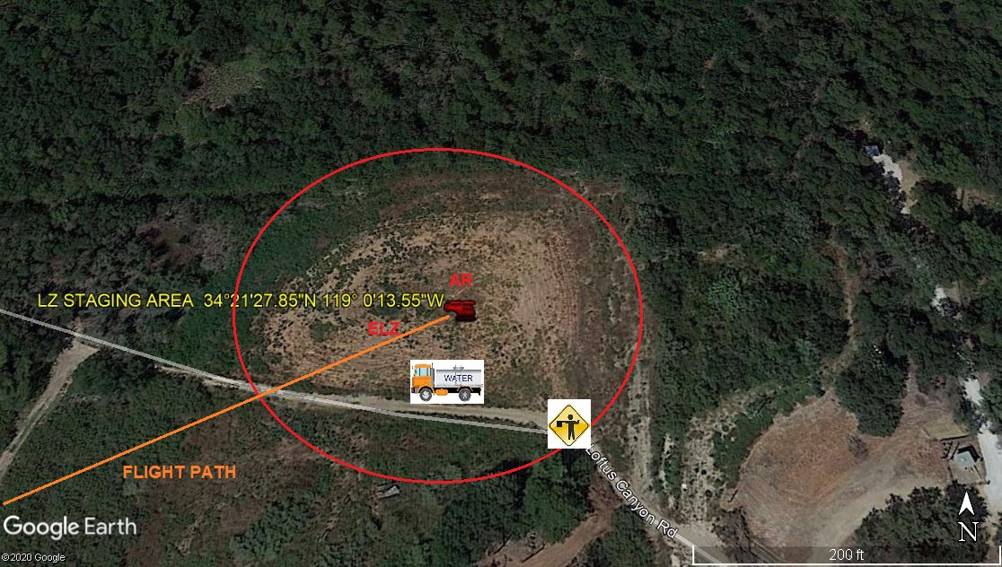
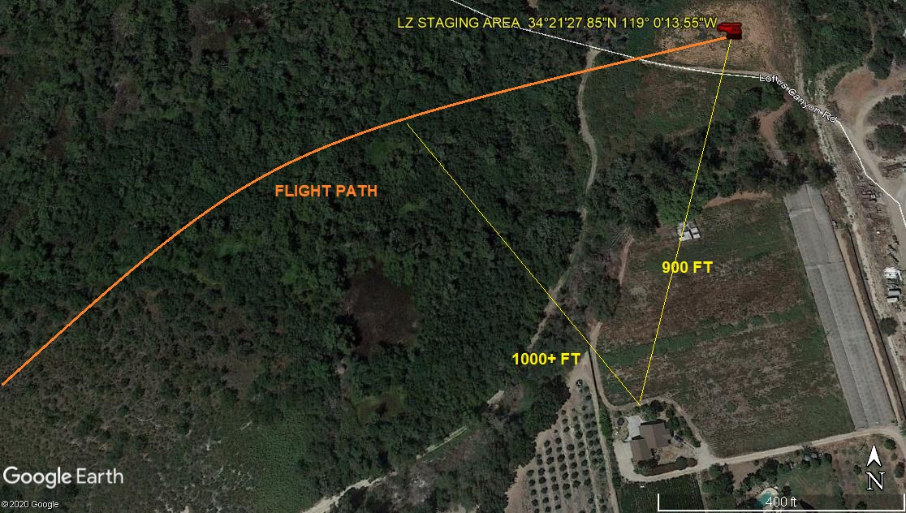
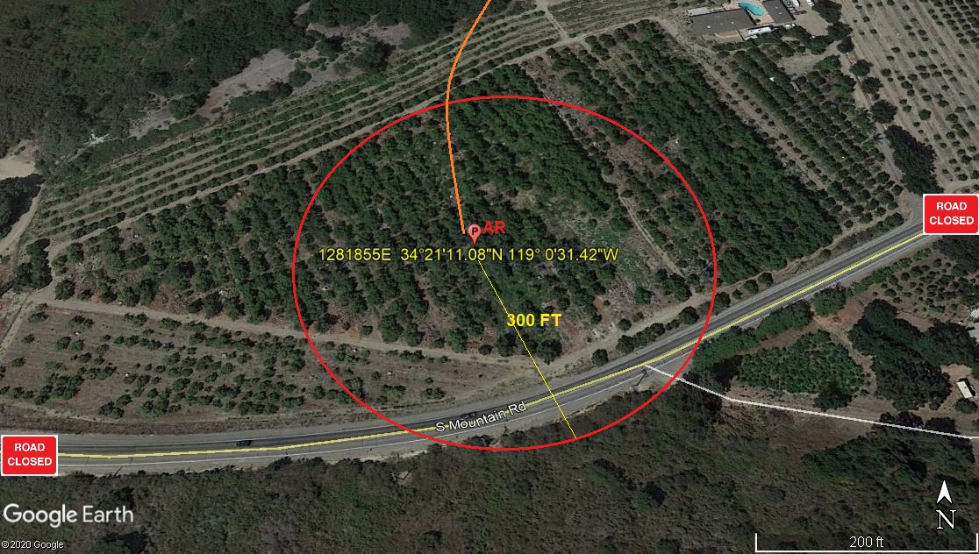
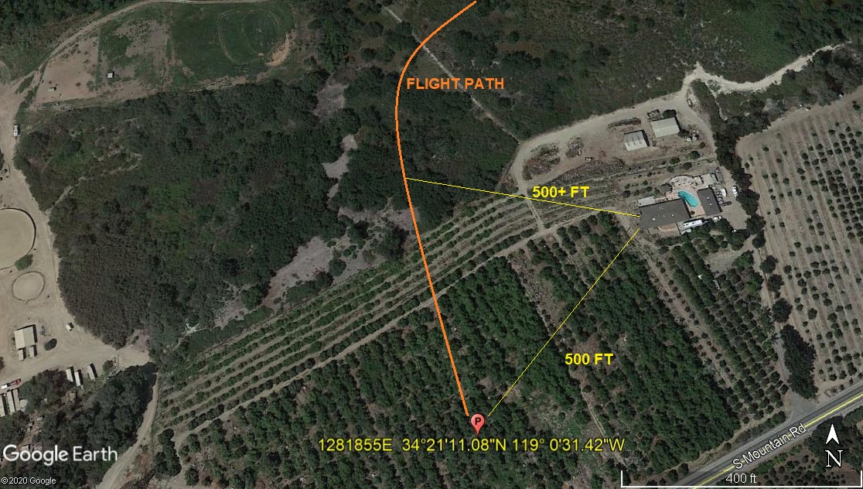

5-5-2020 
DATE OF SUBMISSION COMPANY OFFICIAL / TITLE

