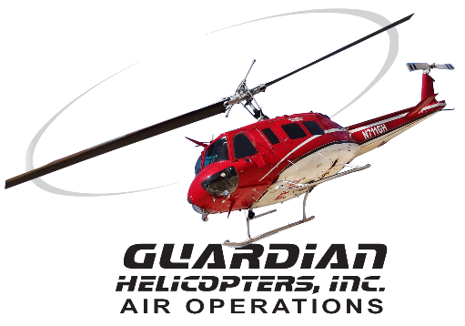
SECTION 7 Part 135 GH 4A Part 133 GH 4L
NON-Congested Area Plan
Operator: Guardian Helicopters, Inc Phone (818) 442-9904
67 D STREET (818) 442-9901
FILLMORE , CA 93015
PROJECT NAME: AMJACK HEC AND EQUIPMENT WORK ORDER # TBD
ADDRESS: ANGELES CREST HWY : LA CANADA FLINTRIDGE CA
LZ LATITUDE 34°16'22.47"N LONGITUDE 118° 9'36.49"W
M13-T3 LATITUDE 34°17'28.26"N LONGITUDE 118°10'36.09"W
M14-T1 M14-T1A LATITUDE 34°17'12.69"N LONGITUDE 118°10'42.30"W
M14-T2 LATITUDE 34°17'4.41"N LONGITUDE 118°10'44.78"W
M14-T3 LATITUDE 34°16'52.43"N LONGITUDE 118°10'48.63"W
M15-T1 LATITUDE 34°16'21.86"N LONGITUDE 118°10'58.19"W
HUNTINGTON MEMORIAL HOSPITAL HP2 LATITUDE 34° 8'3.88"N LONGITUDE 118° 9'7.64"W ADDRESS: 100 W CALIFORNIA BLVD PASADENA CA 91105 PHONE: 626-397-5000
CONTRACTOR’S NAME: CHRIS STASIUK AMPJACK PHONE# 204-631-2510
PILOT’S NAME(S):
1. JOHN OLSON CERT #: 2769166
2. BUCKEY MACKAY CERT #: 2778051
3. MICHAEL KLINK CERT# 3018828
4. IAN GOODALE CERT# 3741973
5. ROSS GOULET CERT# 339677
TYPE OF AIRCRAFT:
BELL UH-1H N# N711GH A/C CATEGORY: RESTRICTED
BELL UH-1H N# N214KK A/C CATEGORY: RESTRICTED
BELL 205A1 N# N216GH A/C CATEGORY: STANDARD
BELL 407 N# N407GH A/C CATEGORY: STANDARD
AS350 B2 N# N498PT A/C CATEGORY: STANDARD
AS350 B3 N# N718GH A/C CATEGORY: STANDARD
AS350 B3 N# N215GH A/C CATEGORY: STANDARD
TYPE OF ITEM LIFTING: POLE AERODYNAMIC NON- AERODYNAMIC
IF SAFETY DICTATES AND OR THE CUSTOMER REQUESTS ADDITIONAL LIFTS THE LIFTS WILL BE CONDUCTED REMAINING WITHIN THE APPROVED TIME PARAMETERS.
TYPE OF LIFTS: HEC AND EQUIPMENT LESS THEN 1900 LBS
MAX SINGLE – LIFT WEIGHT: 1900 LBS CLASS OF LOAD: EXTERNAL
NO. OF LIFTS: TBD LONG LINE: (NO) XXX (YES) LESS THEN 150 FT (LENGTH)
OPERATIONAL ALTITUDE: < 250 STREET CLOSING: (N0) XX (YES)
FLIGHT DATES | TIME BEGIN | TIME END | TODAY’S DATE
3-16-2020 THRU 3-23-2020 | SUNRISE | SUNSET | 3-1-2020
AGENCY NAME: | PHONE#: | PERSON NOTIFIED: | DATE:
LACFD | 818-249-1562 | STATION 19 | NOTIFY
CRESCENTA VALLEY SHERIFF | 818-248-3464 | DISPATCH | NOTIFY
DATE AND TIMES OPERATION WILL BEGIN AND TERMINATE
NON- Congested Area Plan (Continued)
Evacuation Crowd Control Street Closure
No Evacuated Structures Operator Yes □No
□Evacuated Structures Contractor Contractor
□Operator
LIST OF BUILDINGS THAT SHALL EITHER BE PARTIALLY OR ENTIRELY UNOCCUPIED PERSONS ALSO HOMES THAT WILL BE NOTIFIED OF ACTIVITY:
BUILDING DESCRIPTION/ADDRESS | REMARKS | METHOD OF CONTACT
NONE | VACANT DURING OPERATION | HAND DELIVER
Narrative description of pick-up site, route, delivery site, and plan for ceasing operation if unauthorized persons enter operational area or real hazard occurs.
SITE INSPECTION NOTES

ONLY PERSONNEL ESSENTIAL TO COMPLETING THE JOB SAFELY WILL BE PERMITTED TO PARTICIPATE IN THE EVOLUTION. ONLY PERSONNEL PARTICIPATING IN THE SAFETY BRIEF WILL BE PERMITTED TO BE IN THE AREA OF OPERATIONS. ONLY AUTHORIZED ESSENTIAL PERSONAL WILL BE PERMITTED IN THE IMMEDIATE AREA OF OPERATIONS. IN THE EVENT AN UNAUTHORIZED PERSON ENTERS THE OPERATIONS AREA OR A POTENTIAL HAZARD IS IDENTIFIED THE PILOT WILL HOLD THE AIRCRAFT IN RELATIVE POSITION. THIS WILL BE ACHIEVED WITHOUT OVER FLYING THE GROUND CREW. ALL OPERATIONS WILL BE CEASED UNTIL THE PROBLEM IS RECTIFIED. IN THE EVENT OF AN AIRCRAFT EMERGENCY, THE PILOT WILL RADIO GROUND PERSONNEL AND WILL ATTEMPT TO LAND IN THE EMERGENCY LANDING AREA.
DURING THE LIFT EVOLUTION THE AIRCRAFT AND GROUND CREW WILL ALL BE IN RADIO COMMUNICATIONS. IN THE EVENT OF LOSS COMMUNICATIONS, THE CREW WILL USE STANDARD HAND SIGNALS TO COMMUNICATE WITH THE PILOT. WHEN THE PILOT IS CLEAR HE WILL MOVE THE AIRCRAFT TO A SAFE LOCATION TO ALLOW THE COMMUNICATION PROBLEM TO BE RECTIFIED.
THE OPERATIONS AREA IS WITHIN THE SECURED AREA. ALL ESSENTIAL CREW WITHIN THE OPERATIONS AREA WILL NOT BE INVOLVED IN TAKING PICTURES OR ANY OTHER USE OF CELL PHONES.

TAIL BOARD SAFETY MEETING WILL BE HELD AT A PRE AGGREED-ON LOCATION PRIOR TO EACH DAY.
1. HELICOPTER WILL LANDED AT THE ASSIGNED STAGING AREA ONLY.
2. FUELING WILL ONLY BE CONDUCTED AT THE AIRPORT OR ASSIGNED LANDING STAGING AREA
3. EMERGENCY LANDING ZONE IS AT THE STAGING AREA AND ALONG THE FLIGHT PATH
4. NO STRUCTURES WILL BE EVACUATED
5. WATER TRUCK WILL BE PROVIDED STAGING LANDING AREA
6. HEC TRAINING WILL BE CONDUCTED AT THE STAGING AREA PRIOR TO START TIMES
7. HEC WILL BE PLACED ON THE STRUCTURE.
8. EQUIPMENT WILL BE PLACED ON THE STRUCTURE. LADDERS AND TOOLS
9. ANGELES CREST HIGHWAY WILL EXPERIENCE ROLLING CLOSURES TO ALLOW AIRCRAFT TO CROSS AND WORK AT THE STRUCTURES CLOSEST TO THE ROAD.

3-1-2020 
DATE OF SUBMISSION COMPANY OFFICIAL / TITLE
OPERATIONS AREA DIAGRAM
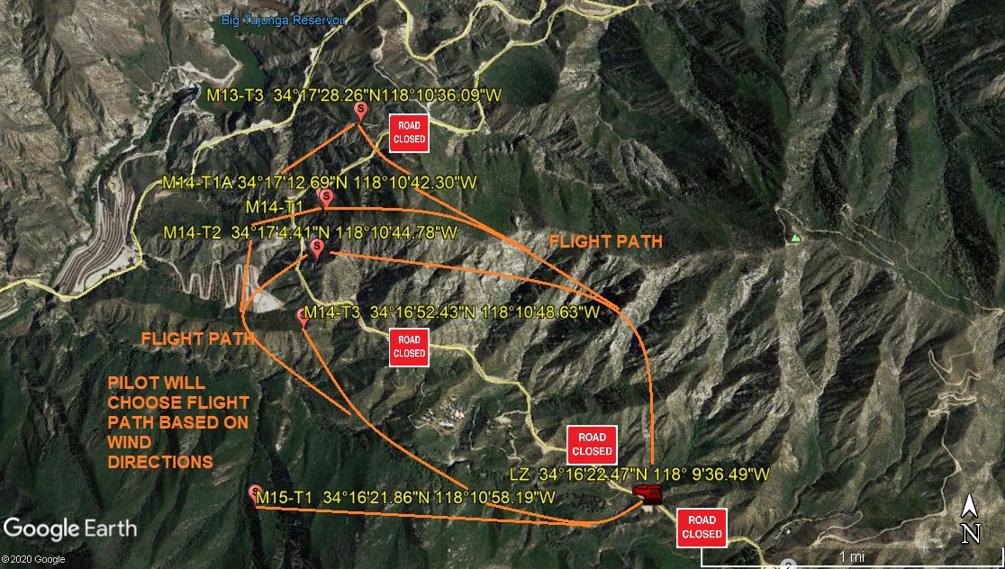
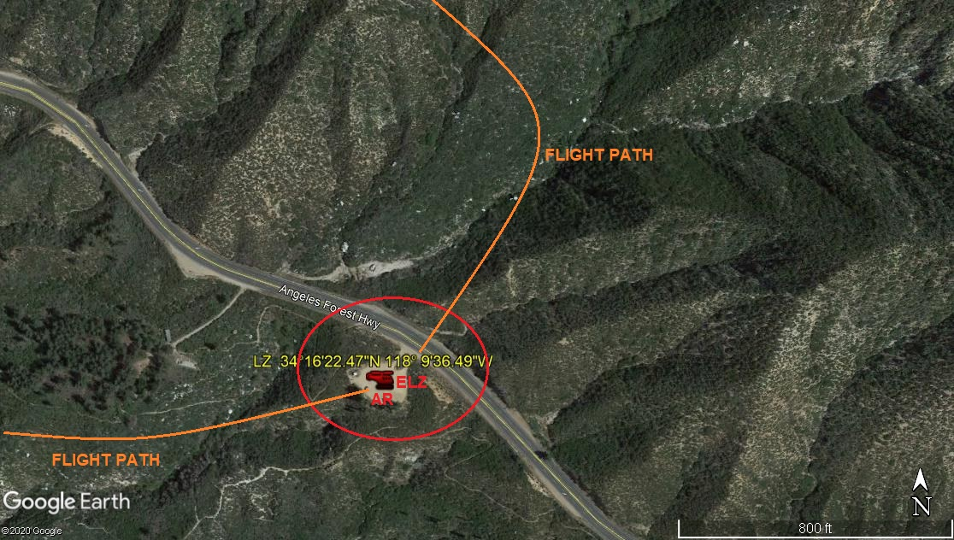

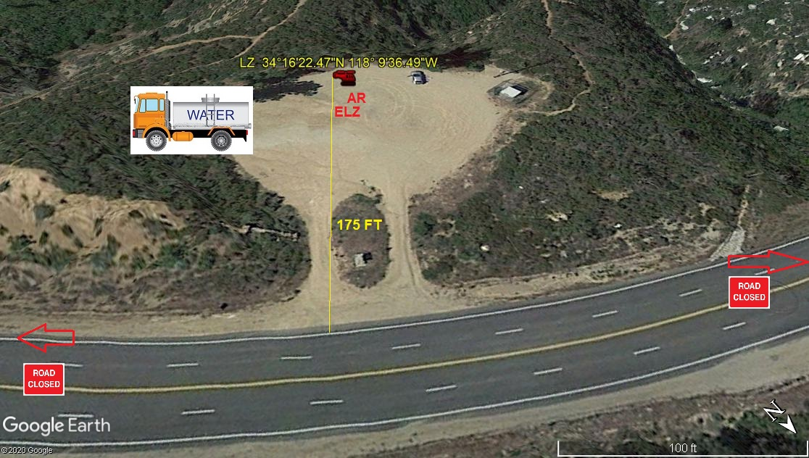
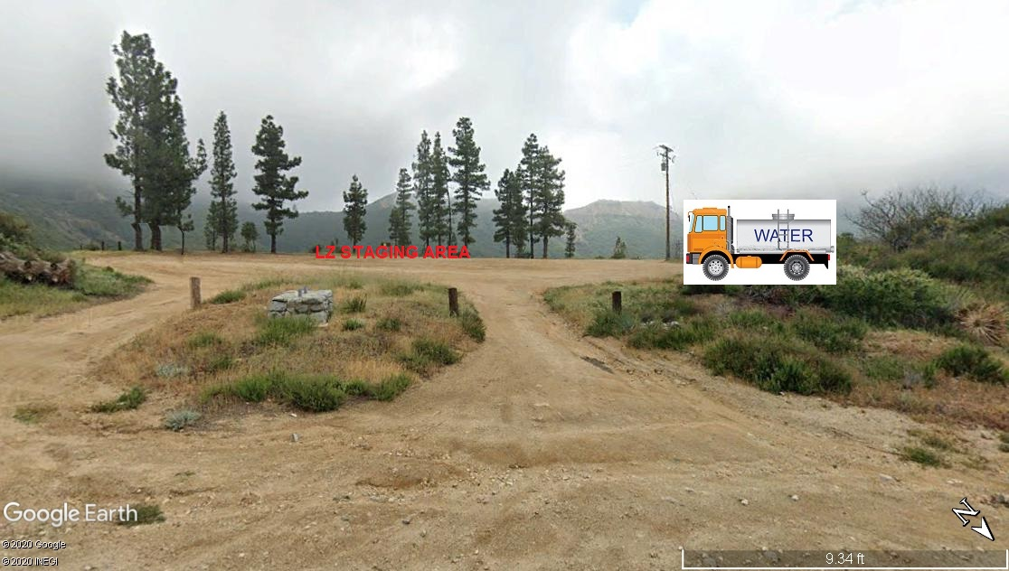
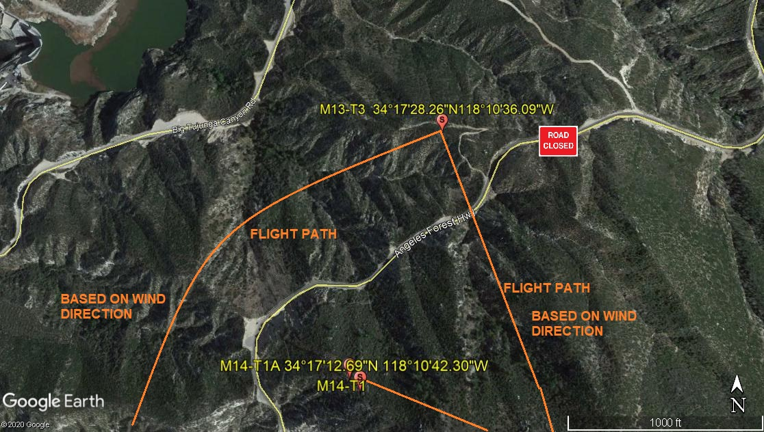
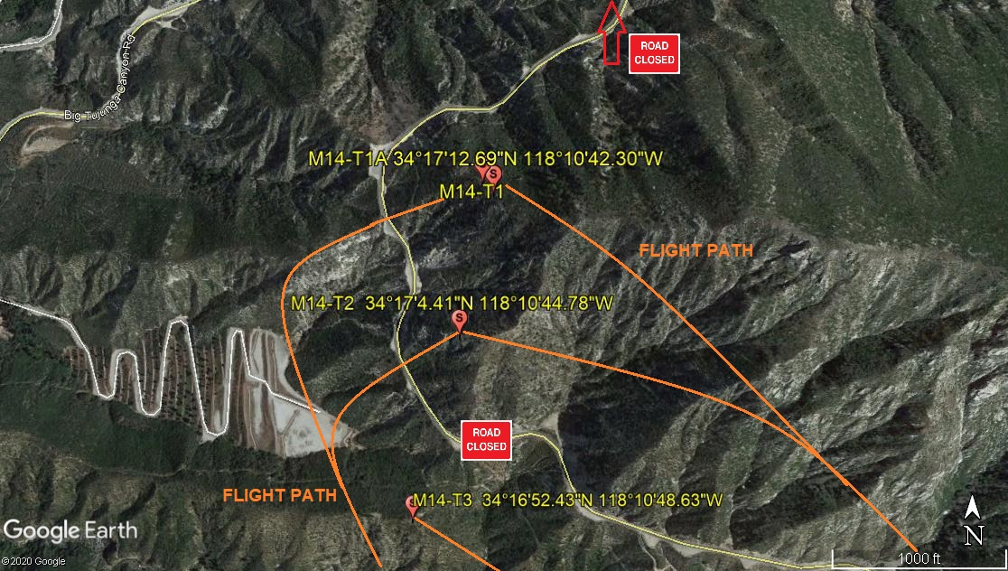
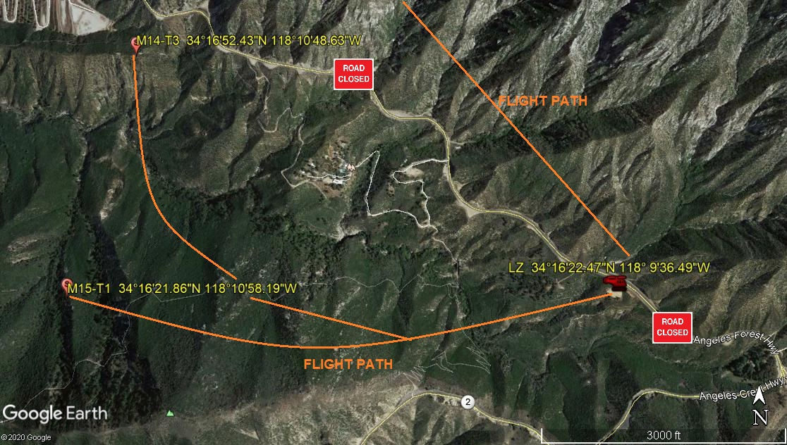
LEGEND
SITE PLAN SYMBOLS: EVACUATION FLIGHT PATH
LANDING AREA = (LZ) | STREET BLOCKED = XXXX | TOP TWO FLOORS = UBT2
ATTACH AREA = (A) | RELEASE AREA = (R)
FLIGHT PATH = >>> | EMERGENCY LAND = (ELZ)
UNOCCUPIED BUILDING = (UBA) | UNOCCUPIED BUILDING TOP FLOOR = (UBT1)

AREA SURVEY CONDUCTED BY :

