
SECTION 7 Part 135 GH 4A Part 133 GH 4L
Congested Area Plan
Operator: Guardian Helicopters, Inc
67 D STREET Phone (818) 442-9904
Fillmore CA. 93015 FAX (818) 442-9901

PROJECT: EDISON POLE REPLACEMENT WORK ORDER #: TD 1341924
ADDRESS 4464 VIA ALEGRE : SANTA BARBARA CA
NO LZ LOWER LONGLINE FROM HELICOPTER OR HOVER HOOKUP WAITING ON HOME OWNER TO APPROVE
POLE STAGING AREA LATITUDE 34°25'45.17"N LONGITUD119°46'22.34"W
4563176E LATITUDE 34°25'52.63"N LONGITUDE 119°46'25.52"W 45 CL1 COMPOSITE 1100 LBS
CONTACT AT SITE: JEREMY BRIGG PHONE#: 805-807-6272
CONTRACTOR: HOTLINE CONSTRUCTION INC. PHONE#: 805-807-6272
PILOT’S NAME(S): 1. JOHN OLSON CERT #: 2769166
2. BUCKEY MACKAY CERT #: 2778051
3. MICHAEL KLINK CERT#: 3018828
4. IAN GOODALE CERT#: 3741973
5. ROSS GOULET CERT#: 3396777
TYPE OF AIRCRAFT: BELL UH-1H N# N711GH A/C CATEGORY: RESTRICTED
BELL UH-1H N# N214KK A/C CATEGORY: RESTRICTED
BELL 407 N# N407GH A/C CATEGORY: STANDARD
BELL 205A1 N# N216GH A/C CATEGORY: STANDARD
AS350 B2 N# N498PT A/C CATEGORY: STANDARD
AS350 B3 N# N718GH A/C CATEGORY: STANDARD
AS350 B3 N# N215GH A/C CATEGORY: STANDARD
IF SAFETY DICTATES AND OR THE CUSTOMER REQUESTS ADDITIONAL LIFTS THE LIFTS WILL BE CONDUCTED REMAINING WITHIN THE APPROVED TIME PARAMETERS.
TYPE OF LIFTS: (1 ) 1100 LBS POLE LOAD:EXTL CL B TYPE OF ITEM LIFTING: AERODYNAMIC NON- AERODYNAMIC MAX 1200 LBS
NO. OF LIFTS: 1 1 1200LBS MAX LONG LINE: (NO) XXX (YES) LESS THEN 150 FT (LENGTH)
OPERATIONAL ALTITUDE: < 250 STREET CLOSING: (N0) XX (YES)
DATE AND TIMES OPERATION WILL BEGIN AND TERMINATE:
FLIGHT DATES | TIME BEGIN | TIME END | TODAY’S DATE
4-17-2020 | SUNRISE | SUNSET | 4-12-2020
AGENCY NAME: | PHONE#: | PERSON NOTIFIED: | DATE:
POLICE DEPARTMENT | 805-681-4100 | WATCH COMMANDER | NOTIFIED
FIRE DEPARTMENT | 805-365-5254 | STATION 4 | NOTIFIED
AIR TRAFFIC CONTROL | 805-683-4011 | SANTA BARBARA AIRPORT | NOTIFIED

Evacuation Crowd Control Street Closure
□No Evacuated Structures Operator Yes □No
Evacuated Structures Contractor Contractor
□Operator

Part 135 GH 4A Part 133 GH 4L
Congested Area Plan
LIST OF BUILDINGS THAT SHALL EITHER BE PARTIALLY OR ENTIRELY UNOCCUPIED PERSONS ALSO HOMES THAT WILL BE NOTIFIED OF ACTIVITY:
BUILDING DESCRIPTION/ADDRESS | REMARKS | METHOD
4464 VIA ALEGRE | VACANT DURING OPS | HAND DELIVER
4468 VIA ALEGRE | VACANT DURING OPS | HAND DELIVER
4460 VIA ALEGRE | VACANT DURING OPS | HAND DELIVER
4477 VIA ALEGRE | VACANT DURING OPS | HAND DELIVER
4465 VIA ALEGRE | VACANT DURING OPS | HAND DELIVER
ALL HOMES WITHIN RED OPERATING AREA | VACANT DURING OPS | HAND DELIVER
SEE DIAGRAM = VACANT | VACANT DURING OPS | HAND DELIVER
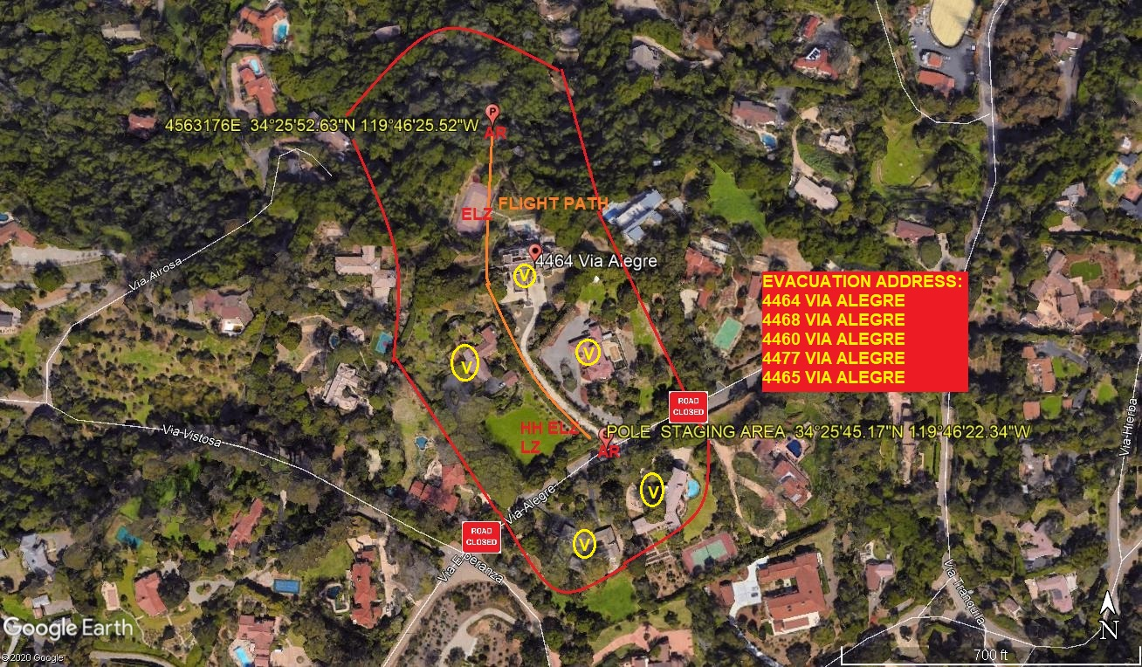
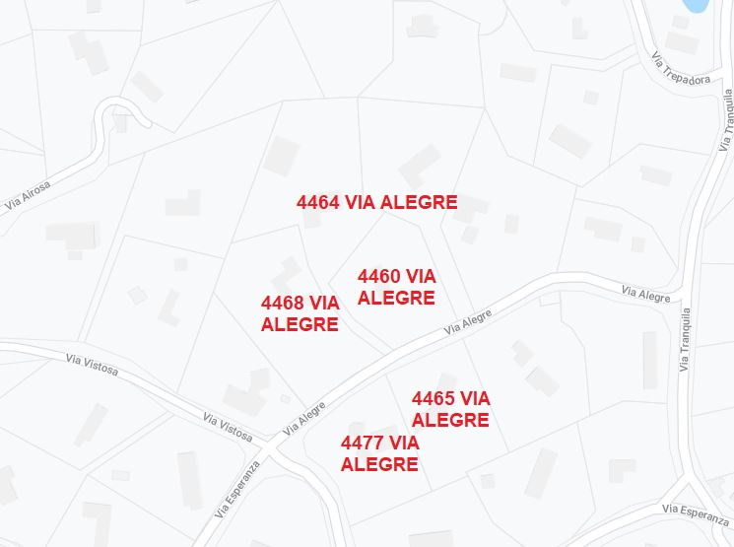
Narrative description of pick-up site, route, delivery site, and plan for ceasing operation if unauthorized persons enter operational area or real hazard occurs.
SITE INSPECTION NOTES
ONLY PERSONNEL ESSENTIAL TO COMPLETING THE JOB SAFELY WILL BE PERMITTED TO PARTICIPATE IN THE EVOLUTION. ONLY PERSONNEL PARTICIPATING IN THE SAFETY BRIEF WILL BE PERMITTED TO BE IN THE AREA OF OPERATIONS. ONLY AUTHORIZED ESSENTIAL PERSONAL WILL BE PERMITTED IN THE IMMEDIATE AREA OF OPERATIONS. IN THE EVENT AN UNAUTHORIZED PERSON ENTERS THE OPERATIONS AREA OR A POTENTIAL
HAZARD IS IDENTIFIED THE PILOT WILL HOLD THE AIRCRAFT IN RELATIVE POSITION. THIS WILL BE ACHIEVED WITHOUT OVER FLYING THE GROUND CREW. ALL OPERATIONS WILL BE CEASED UNTIL THE PROBLEM IS RECTIFIED. IN THE EVENT OF AN AIRCRAFT EMERGENCY, THE PILOT WILL RADIO GROUND PERSONNEL AND WILL ATTEMPT TO LAND IN THE EMERGENCY LANDING AREA.
DURING THE LIFT EVOLUTION THE AIRCRAFT AND GROUND CREW WILL ALL BE IN RADIO COMMUNICATIONS. IN THE EVENT OF LOSS COMMUNICATIONS, THE CREW WILL USE STANDARD HAND SIGNALS TO COMMUNICATE WITH THE PILOT. WHEN THE PILOT IS CLEAR HE WILL MOVE THE AIRCRAFT TO A SAFE LOCATION TO ALLOW THE COMMUNICATION PROBLEM TO BE RECTIFIED.
THE OPERATIONS AREA IS WITHIN THE SECURED AREA. ALL ESSENTIAL CREW WITHIN THE OPERATIONS AREA WILL NOT BE INVOLVED IN TAKING PICTURES OR ANY OTHER USE OF CELL PHONES.
PRIOR TO BEGINNING OPERATIONS, A TAILBOARD SAFETY BRIEF WILL BE CONDUCTED.
- TAILBOARD WILL BE CONDUCTED AT THE LANDING ZONE
- THE AIRCRAFT WILL MAY LAND AT THE LZ IF PERMISSION IS GRANTED. IF NOT LAND NO FUELING
- WATER TRUCK NOT REQUIRED
- POLE WILL BE STAGED AT THE AT THE DRIVEWAY OF 4464 VIA ALEGRE
- EMERGENCY LANDING ZONE IS AT THE STAGING AREA AND ALONG THE FLIGHT PATH
- RADIOS WILL BE PROVIDED TO POLE SITE
- 7 HOMES WILL BE EVACUATED
- VIA ALEGRE WILL BE CLOSED DURING OPERATIONS
- THE CONTRACTOR WILL TRIM TREES IF REQUIRED
- THE HELICOPTER WILL LAND AT SANTA BARBARA AIRPORT. THE PILOT WILL COORDINATE WITH THE SB TOWER. GHI GROUND CREW WILL BE AT THE STAGING AREA TO CONDUCT A TAILBOARD SAFETY BRIEF. IF THE LAND OWNER GIVES PERMISSION TO LAND AT THE LANDING ZONE THE HELICOPTER WILL FLY TO THE LANDING ZONE IF PERMISSION HAS NOT BEEN GRANTED THE GHI CREW WILL HAVE THE REMOTE HOOK WITH THEM. WHEN THE LINEMAN ARE READY THE STREET CLOSURE AND GROUND CREW WILL KNOCK ON DOORS TO ENSURE EVERYONE WITHIN THE OPERATING AREA IS EVACUATED. ONCE EVACUATIONS ARE VERIFIED THE PILOT WILL FLY INTO THE OPERATING AREA. A FLIGHT CREWMEMBER WILL LOWER THE LONGLINE OUR OF THE AIRCRAFT AND THE GROUND CREW WILL CONNECT THE REMOTE HOOK AND CONDUCT AN OPERATIONAL CHECK. THE PILOT WILL THEN LIFT THE NEW POLE AND PUT IT IN PLACE. THE LINEMAN WILL HAVE THE OLD POLE READY TO REMOVE AND FLY THE OLD POLE BACK TO THE STAGING AREA. THE GROUND CREW WILL DISCONNECT THE REMOTE HOOK AND THE FLIGHT CREW WILL PULL THE LONGLINE BACK INTO THE AIRCRAFT. ONCE THE AIRCRAFT IS CLEAR THE STREETS AND THE HOMES WILL BE REOPENED.
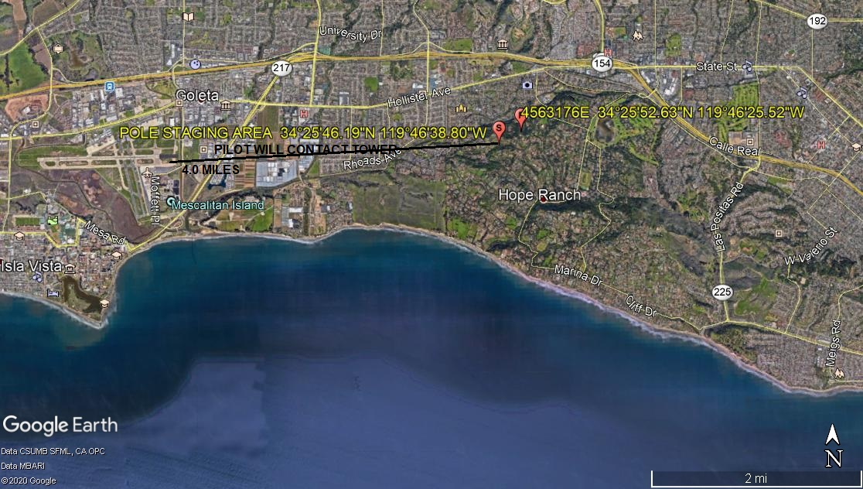
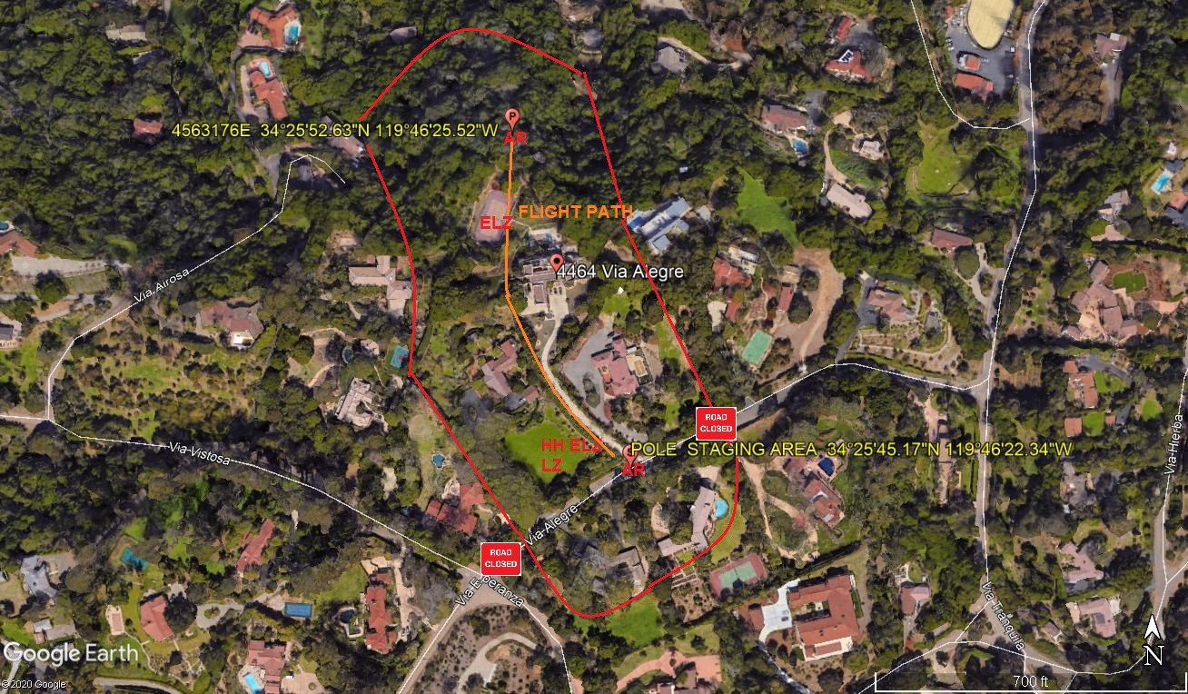
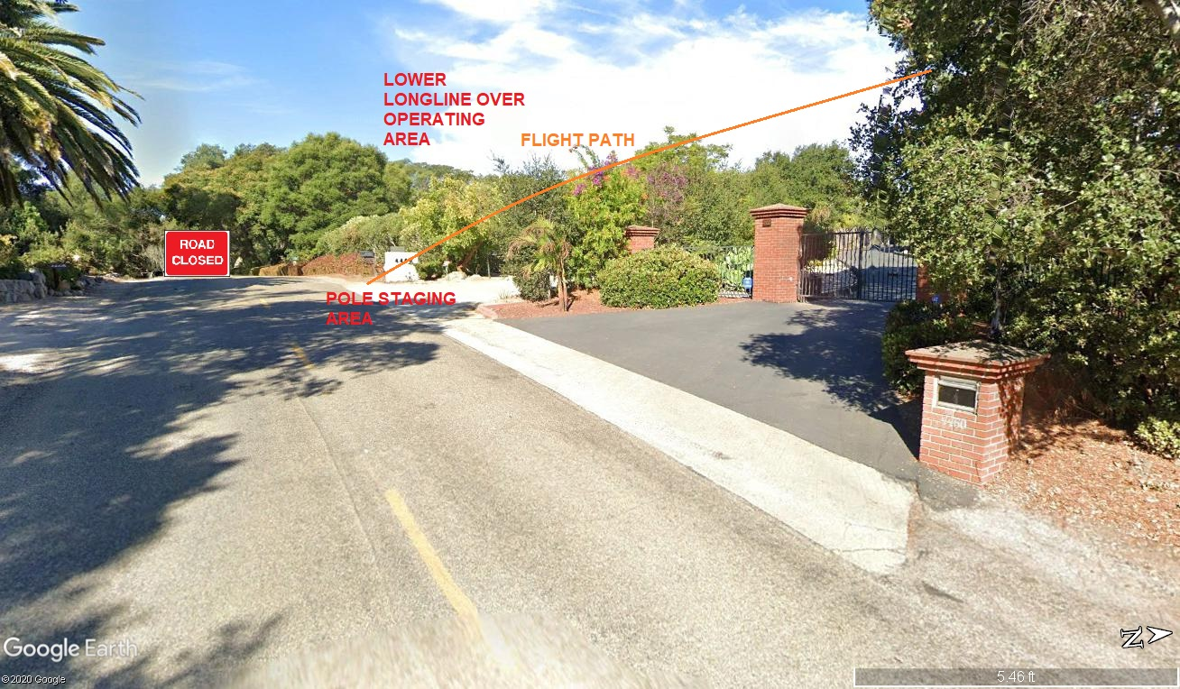

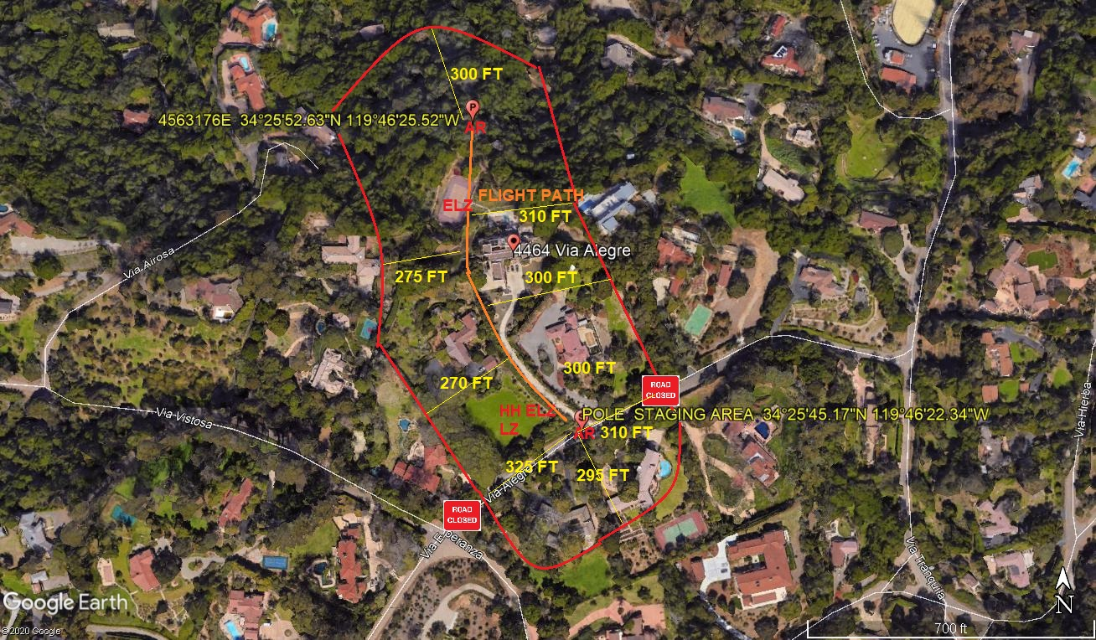
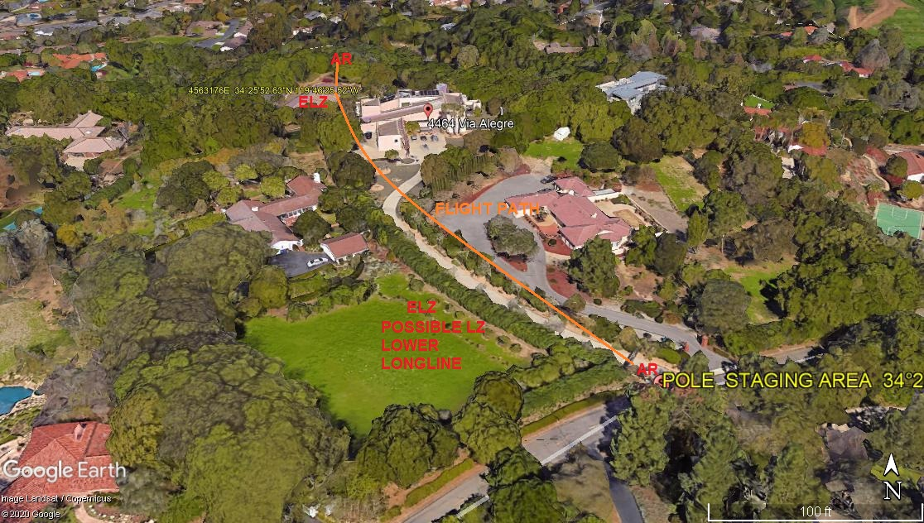

4-12-2020 
DATE OF SUBMISSION COMPANY OFFICIAL / TITLE

