Please respond within 1 hour to acknowledge receipt

Hello Team,

Immediate action is required on your part to remediate the following Priority 1 condition found by Aerial Inspections.

If unable to immediately remediate, update the notification Long Text field with what type of temporary measures were taken to make the condition safe, who made them and the date this occurred.

Any changes to this notification NEED to be updated in the LONG TEXT section of the notification.

Basic Info:

Type (Transmission, Distribution, Veg., Bird Nest) | Choose an item.
SAP Notification # | 410672645
SAP Order # | 903039567
Date and Time Reported (Identified by inspector) | 03/09/2020
Inspector’s Name | JASON REDMOND
Inspector’s Windows UserID | REDMONJ1
Inspector’s Company (SCE or if Contractor, enter company name and abbreviation) | PRO ENERGY
Reviewer’s Name | THOMAS MCNEILL
Reviewer’s Windows UserID | MCNEILT2
Reviewer’s Contact Info | 661-310-6701
Structure/FLOC # | 716617E
Flight Company | HAWCS
Reason (English language – for long text) | DAMAGED CROSS ARM
Problem Statement | REPLACE DAMAGED PRI CROSS ARM POLE
Circuit Name | RUSTIC
Circuit Voltage | 12KV
District/GRID/Veg Zone | 43-SADDLEBACK
Latitude | 33.682421
Longitude | -117.574438
Location | PP 104' W/O E/L & 4144' N/O S/L SEC 2
Picture Reference # (folder and structure) | TRABUCO CANYON Please verify correct structure # upon arrival
Aerial due diligence was performed in determining structure locations. In some cases due to errors in mapping or other factors, location precision is unobtainable. A highly researched location approximation is given in this notice.
EXISTING SAP NOTIFICATIONS (PERTAINING TO NOTICE)
Circuit Map or FIM
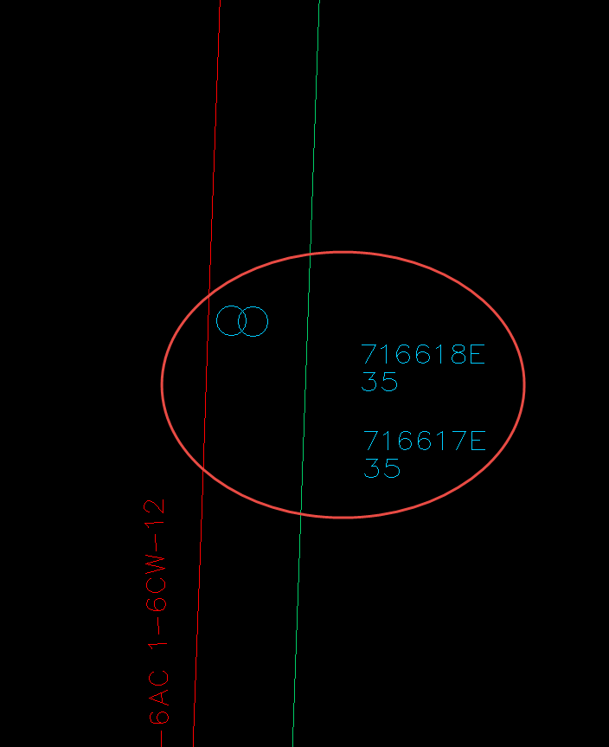

Structure Photos

