
SECTION 7 Part 135 GH 4A Part 133 GH 4L
NON-Congested Area Plan
Operator: Guardian Helicopters, Inc
67 D STREET
Fillmore CA. 93015
Phone (818) 442-9904
FAX (818) 442-9901
BUILDING NAME: CALIFORNIA CITY CORRECTIONAL FACILITY BUILDING # ALL
ADDRESS: 22844 VIRGINIA BLVD : CALIFORNIA CITY CA 93505
POSITION: LATITUDE 35º.09’ 17.16 “N LONGITUDE 117º.51’ 30.87” W ELEVATION: 2500 FT
CONTRACTOR’S NAME: HELIX MECHANICAL PHONE#: 619-447-6675
CONTACT AT SITE; PAT HARRELSON PHONE #: 619-778-0076
PILOT’S NAME(S): 1. JOHN OLSON CERT #: 2769166
2. BUCKEY MACKAY CERT #: 2778051
3. MICHAEL KLINK CERT#: 3018828
4. IAN GOODALE CERT#: 3741973
5. ROSS GOULET CERT# :3396777
6. BRIAN HUMPHERY CERT#: 3179775
7. ROBERT J. SATZ CERT#: 2629853
TYPE OF AIRCRAFT: BELL UH-1H N# N711GH A/C CATEGORY: RESTRICTED
BELL UH-1H N# N16TV A/C CATEGORY: RESTRICTED
BELL 205A1 N# N216GH A/C CATEGORY: STANDARD
BELL 407 N# N407GH A/C CATEGORY: STANDARD
AS350 B2 N# N498PT A/C CATEGORY: STANDARD
AS350 B3 N# N718GH A/C CATEGORY: STANDARD
AS350 B3 N# N215GH A/C CATEGORY: STANDARD
TYPE OF ITEM LIFTING: AC UNITS AERODYNAMIC NON- AERODYNAMIC
IF SAFETY DICTATES AND OR THE CUSTOMER REQUESTS ADDITIONAL LIFTS THE LIFTS WILL BE CONDUCTED REMAINING WITHIN THE APPROVED TIME PARAMETERS.
TYPE OF LIFTS: (11) (11) < 1500 LBS MAX SINGLE – LIFT WEIGHT:1500 LBS CLASS OF LOAD:EXTERNAL CL B NO. OF LIFTS: 22 LONG LINE: (NO) XXX (YES) LESS THEN 50 FT (LENGTH) OPERATIONAL ALTITUDE: < 100 STREET CLOSING: XX (N0) YES)
DATE AND TIMES OPERATION WILL BEGIN AND TERMINATE:
FLIGHT DATES | TIME BEGIN | TIME END | TODAY’S DATE
5-15-2020 | SUNRISE | SUNSET | 3-29-2020
AGENCY NAME: | PHONE#: | PERSON NOTIFIED: | DATE:
FIRE DEPARTMENT |  | CORRECTIONAL FACILITY | NOTIFY
SHERRIFF DEPARTMENT |  | CORRECTIONAL FACILITY | NOTIFY
Evacuation Crowd Control Street Closure
□No Evacuated Structures Operator □Yes No
Evacuated Structures Contractor Contractor
□Operator

NON- Congested Area Plan (Continued)

Operator: Guardian Helicopters, Inc
67 D STREET
Fillmore CA. 93015
Phone (818) 442-9904
FAX (818) 442-9901

LIST OF BUILDINGS THAT SHALL EITHER BE PARTIALLY OR ENTIRELY UNOCCUPIED PERSONS:
BUILDING DESCRIPTION/ADDRESS | OWNER(S): | PHONE #:
SEE DIAGRAM | N/A | N/A

Narrative description of pick-up site, route, delivery site, and plan for ceasing operation if unauthorized persons enter operational area or real hazard occurs.
SITE INSPECTION NOTES

ONLY PERSONNEL ESSENTIAL TO COMPLETING THE JOB SAFELY WILL BE PERMITTED TO PARTICIPATE IN THE EVOLUTION. ONLY PERSONNEL PARTICIPATING IN THE SAFETY BRIEF WILL BE PERMITTED TO BE IN THE AREA OF OPERATIONS. ONLY AUTHORIZED ESSENTIAL PERSONAL WILL BE PERMITTED IN THE IMMEDIATE AREA OF OPERATIONS. IN THE EVENT AN UNAUTHORIZED PERSON ENTERS THE OPERATIONS AREA OR A POTENTIAL HAZARD IS IDENTIFIED THE PILOT WILL HOLD THE AIRCRAFT IN RELATIVE POSITION. THIS WILL BE ACHIEVED WITHOUT OVER FLYING THE GROUND CREW. ALL OPERATIONS WILL BE CEASED UNTIL THE PROBLEM IS RECTIFIED. IN THE EVENT OF AN AIRCRAFT EMERGENCY, THE PILOT WILL RADIO GROUND PERSONNEL AND WILL ATTEMPT TO LAND IN THE EMERGENCY LANDING AREA. THE LANDING AND EMERGENCY LANDING AREA IS IN THE PARKING LOT TO THE SOUTH OF THE FACILITY . THE HELICOPTER WILL LAND IN THE LZ TO HOOK UP THE LONG LINE. ALL BUILDINGS IN THE OPERATING AREA WILL BE VACANT.
DURING THE LIFT EVOLUTION THE AIRCRAFT AND GROUND CREW WILL ALL BE IN RADIO COMMUNICATIONS. IN THE EVENT OF LOSS COMMUNICATIONS THE CREW WILL USE STANDARD HAND SIGNALS TO COMMUNICATE WITH THE PILOT. WHEN THE PILOT IS CLEAR HE WILL MOVE THE AIRCRAFT TO A SAFE LOCATION TO ALLOW THE COMMUNICATION PROBLEM TO BE RECTIFIED.
THE OPERATIONS AREA IS WITHIN THE SECURED AREA. ALL ESSENTIAL CREW WITHIN THE OPERATIONS AREA WILL NOT BE INVOLVED IN TAKING PICTURES OR ANY OTHER USE OF CELL PHONES.

1. LANDING ZONE AND EMERGENCY LANDING ZONE IS TO THE SOUTH OF THE FACILITY PARKING LOT
2. ALL AREA IN THE SECURE AREA WILL BE UNOCCUPIED.
3. PEDESTRIANS WILL NOT BE PERMITTED OPERATING AREA

4-27-2020 
DATE COMPLETED COMPANY OFFICIAL / TITLE

-23-

Part 135 GH 4A Part 133 GH 4L
OPERATIONS AREA DIAGRAM
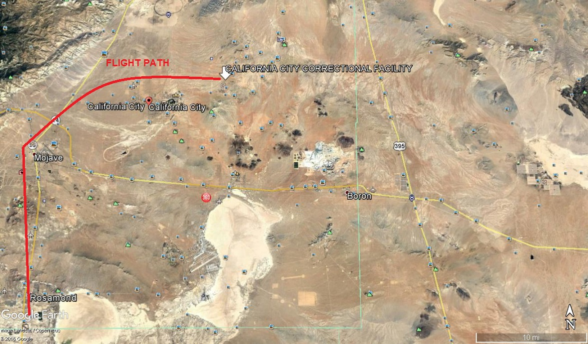
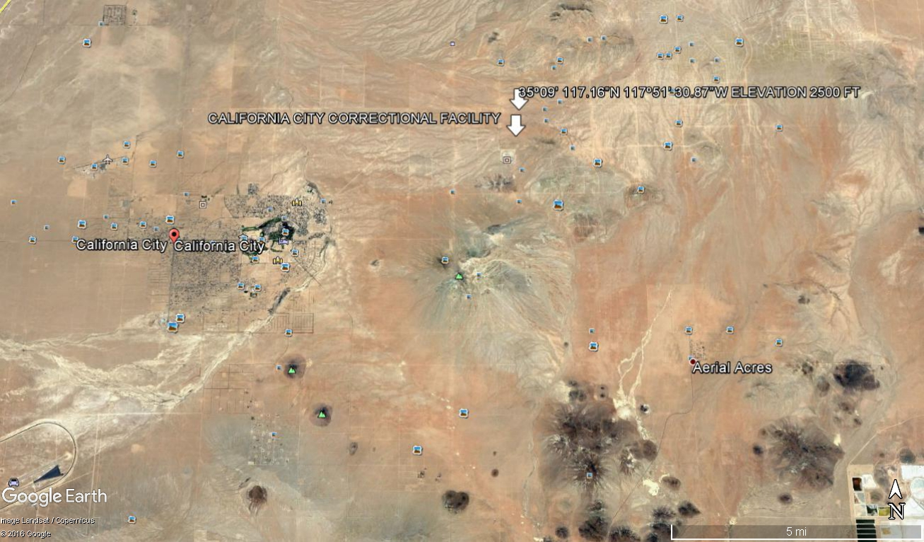
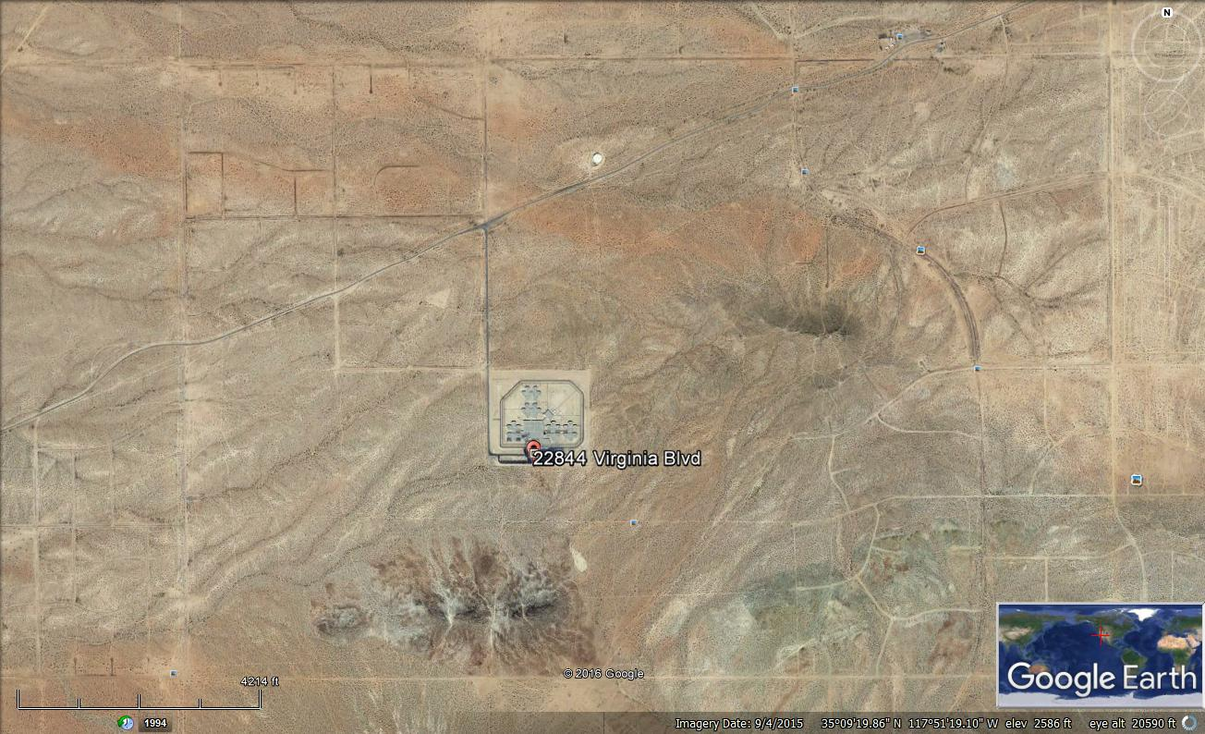

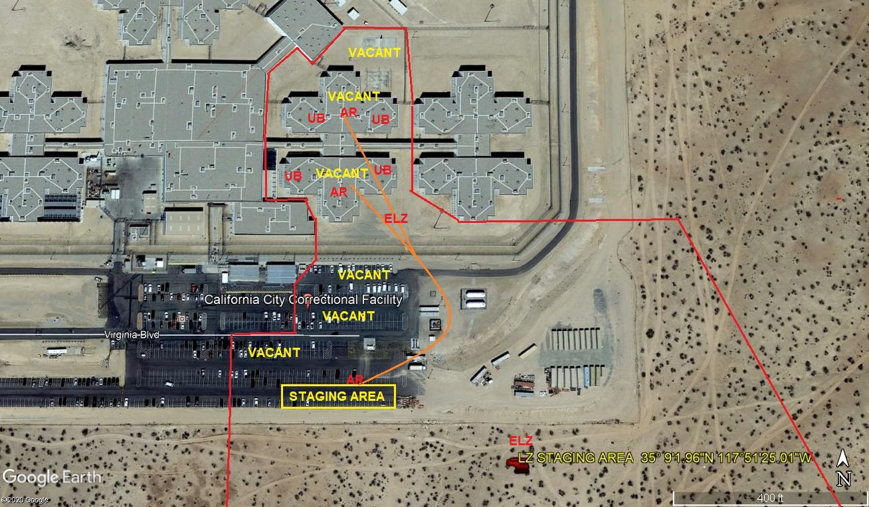
LEGEND
SITE PLAN SYMBOLS: EVACUATION FLIGHT PATH
LANDING AREA = (LZ) | STREET BLOCKED = XXXX | TOP TWO FLOORS = UBT2
ATTACH AREA = (A) | RELEASE AREA = (R)
FLIGHT PATH = >>> | EMERGENCY LAND = (E)
UNOCCUPIED BUILDING = (UBA) | UNOCCUPIED BUILDING TOP FLOOR = (UBT1)

