
SECTION 7 Part 135 GH 4A Part 133 GH 4L
NON Congested Area Plan
Operator: Guardian Helicopters, Inc
67 D STREET
Fillmore CA. 93015
Phone (818) 442-9904
FAX (818) 442-9901
PROJECT: EDISON POLE REPLACEMENT WORK ORDER #: 801756799 FR00323
ADDRESS: 155 / 495 : KERNVILLE CA
LZ STAGING AREA LATITUDE 35°43'46.09"N LONGITUDE 118°25'13.88"W
LZ STAGING AREA LATITUDE 35°42'49.51"N LONGITUDE 118°26'17.89"W
LZ STAGING AREA LATITUDE 35°41'30.27"N LONGITUDE 118°27'37.88"W
LZ STAGING AREA LATITUDE 35°40'15.39"N LONGITUDE 118°28'9.81"W
LZ STAGING AREA LATITUDE 35°39'21.35"N LONGITUDE 118°28'45.46"W
LZ STAGING AREA LATITUDE 35°38'42.81"N LONGITUDE 118°28'42.60"W
LZ STAGING AREA LATITUDE 35°38'37.12"N LONGITUDE 118°28'41.06"W
SEE ATTACHED FOR POLE NUMBER AND LOCATION
FOR ANY MEDICAL EMERGENCY KERNVILLE AIRPORT WILL BE THE DESIGNATED DROP OFF LOCATION.

CONTRACTOR’S KENNETH WILLIAMS PHONE#: 626-201-0001
CONTACT AT SITE; CASEY O BRIEN HENKELS PHONE#: 909-455-5035
FOREMAN: BOB SCHIELDS PHONE#: 937-552-1132

PILOT’S NAME(S): 1. JOHN OLSON CERT #: 2769166
2. BUCKEY MACKAY CERT #:2778051
3 MICHAEL KLINK CERT#: 3018828
4. IAN GOODALE CERT# :3741973
5. ROSS GOULET CERT#: 3396777
TYPE OF AIRCRAFT:
BELL UH-1H N# N711GH A/C CATEGORY: RESTRICTED
BELL UH-1H N# N777GH A/C CATEGORY: RESTRICTED
BELL 407 N# N407GH A/C CATEGORY: STANDARD
BELL 205A1 N# N216GH A/C CATEGORY: STANDARD
AS350 B2 N# N498PT A/C CATEGORY: STANDARD
AS350 B3 N# N718GH A/C CATEGORY: STANDARD
AS350 B3 N# N215GH A/C CATEGORY: STANDARD
TYPE OF ITEM LIFTING: POLE AERODYNAMIC NON- AERODYNAMIC
IF SAFETY DICTATES AND OR THE CUSTOMER REQUESTS ADDITIONAL LIFTS THE LIFTS WILL BE CONDUCTED REMAINING WITHIN THE APPROVED TIME PARAMETERS.
TYPE OF LIFTS POLE CARGO CLASS OF LOAD:EXTL CL B MAX WEIGHT 2600 LBS
NO. OF LIFTS: TBD LONG LINE: (NO) XXX (YES) LESS THEN 150 FT (LENGTH)
OPERATIONAL ALTITUDE: < 250 STREET CLOSING: (N0) XX (YES)
SECTION 7 Part 135 GH 4A Part 133 GH 4L
NON Congested Area Plan

Operator: Guardian Helicopters, Inc
67 D Street
Fillmore, California 93015

DATE AND TIMES OPERATION WILL BEGIN AND TERMINATE:
FLIGHT DATES |  | TIME BEGIN | TIME END |  | TODAY’S DATE
5-6-2020 THRU 5-14-2020 |  | SUNRISE | SUNSET |  | 4-27-2020
AGENCY NAME: |  | PHONE#: | PERSON NOTIFIED: |  | DATE:
KERN COUNTY SHERIFF | 760-549-2100 |  |  | LAKE ISALBELLA | NOTIFY
KERN COUNTY FIRE | 760-376-2219 |  |  | STATION 76 | NOTIFY
Evacuation Crowd Control Street Closure
No Evacuated Structures Operator □Yes □No
□Evacuated Structures Contractor Contractor
□Operator

LIST OF BUILDINGS THAT SHALL EITHER BE PARTIALLY OR ENTIRELY UNOCCUPIED PERSONS ALSO HOMES THAT WILL BE NOTIFIED OF ACTIVITY:
BUILDING DESCRIPTION/ADDRESS | REMARKS | METHOD
NO EVACUATIONS | VACANT DURING OPS | HAND DELIVER
ALL HOMES WITHIN RED OPERATING AREA | VACANT DURING OPS | HAND DELIVER
SEE DIAGRAM = VACANT | VACANT DURING OPS | HAND DELIVER

Narrative description of pick-up site, route, delivery site, and plan for ceasing operation if unauthorized persons enter operational area or real hazard occurs.

SITE INSPECTION NOTES

ONLY PERSONNEL ESSENTIAL TO COMPLETING THE JOB SAFELY WILL BE PERMITTED TO PARTICIPATE IN THE EVOLUTION. ONLY PERSONNEL PARTICIPATING IN THE SAFETY BRIEF WILL BE PERMITTED TO BE IN THE AREA OF OPERATIONS. ONLY AUTHORIZED ESSENTIAL PERSONAL WILL BE PERMITTED IN THE IMMEDIATE AREA OF OPERATIONS. IN THE EVENT AN UNAUTHORIZED PERSON ENTERS THE OPERATIONS AREA OR A POTENTIAL HAZARD IS IDENTIFIED THE PILOT WILL HOLD THE AIRCRAFT IN RELATIVE POSITION. THIS WILL BE ACHIEVED WITHOUT OVER FLYING THE GROUND CREW. ALL OPERATIONS WILL BE CEASED UNTIL THE PROBLEM IS RECTIFIED. IN THE EVENT OF AN AIRCRAFT EMERGENCY, THE PILOT WILL RADIO GROUND PERSONNEL AND WILL ATTEMPT TO LAND IN THE EMERGENCY LANDING AREA.
DURING THE LIFT EVOLUTION THE AIRCRAFT AND GROUND CREW WILL ALL BE IN RADIO COMMUNICATIONS. IN THE EVENT OF LOSS COMMUNICATIONS, THE CREW WILL USE STANDARD HAND SIGNALS TO COMMUNICATE WITH THE PILOT. WHEN THE PILOT IS CLEAR HE WILL MOVE THE AIRCRAFT TO A SAFE LOCATION TO ALLOW THE COMMUNICATION PROBLEM TO BE RECTIFIED.
THE OPERATIONS AREA IS WITHIN THE SECURED AREA. ALL ESSENTIAL CREW WITHIN THE OPERATIONS AREA WILL NOT BE INVOLVED IN TAKING PICTURES OR ANY OTHER USE OF CELL PHONES.
PRIOR TO BEGINNING OPERATIONS, A TAILBOARD SAFETY BRIEF WILL BE CONDUCTED.
- HELICOPTER WILL LAND AT THE LZ TO CONNECT THE LONGLINE AND CONDUCT A TAILBOARD SAFETY BRIEF
- FUELING WILL BE CONDUCTED AT THE LANDING ZONE
- EMERGENCY LANDING ZONE IS AT THE STAGING AREA AND ALONG THE FLIGHT PATH
- STREET CLOSURE PER DIAGRAMS
- WATER TRUCK REQUIRED AT IDENTIFIED LZ STAGING AREA
- ADDITIONAL FLAGMAN WILL BE STATIONED PER DIAGRAM
- EVACUATION NOT REQUIRED
- POLES AND EQUIPMENT WILL BE AT IDENTIFIED STAGING AREA
- ORDER OF OPERATION WILL BE DISCUSSED AT THE END OF EACH DAY TO DETERMINE THE NEXT DAY LZ AND STAGING AREA.
- THE CONTRACTOR WILL TRIM TREES IF REQUIRED

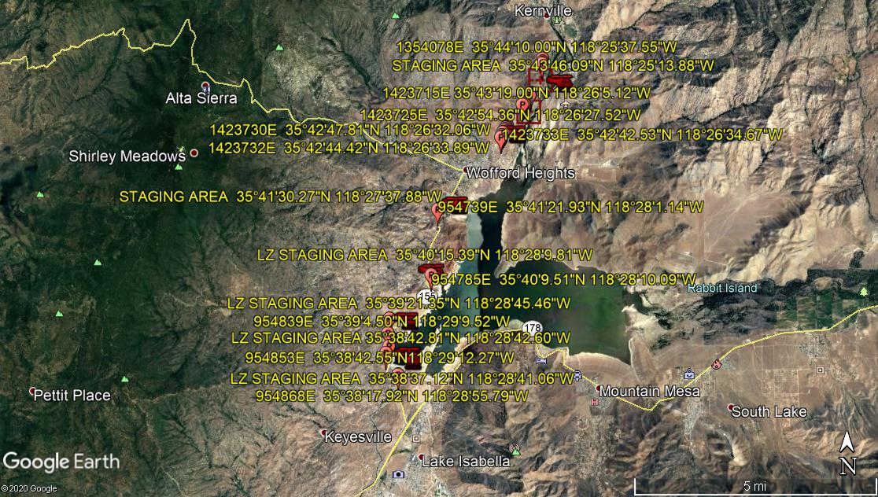
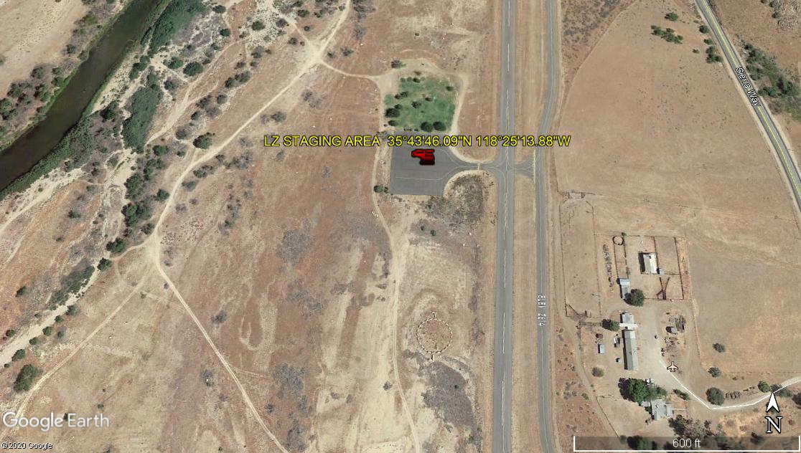
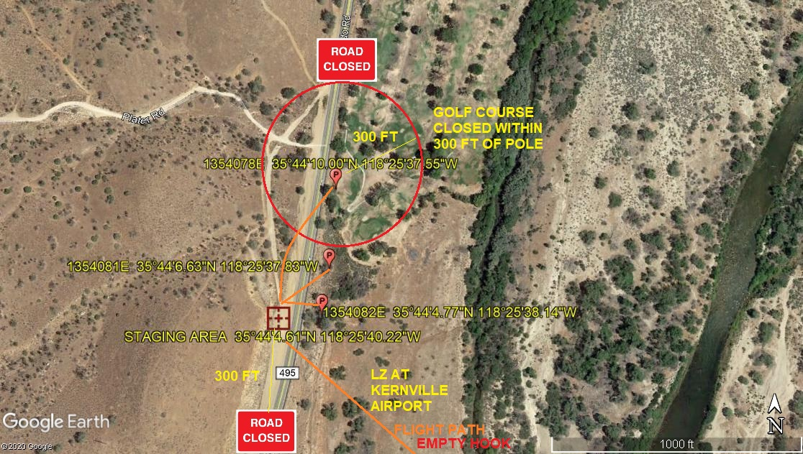
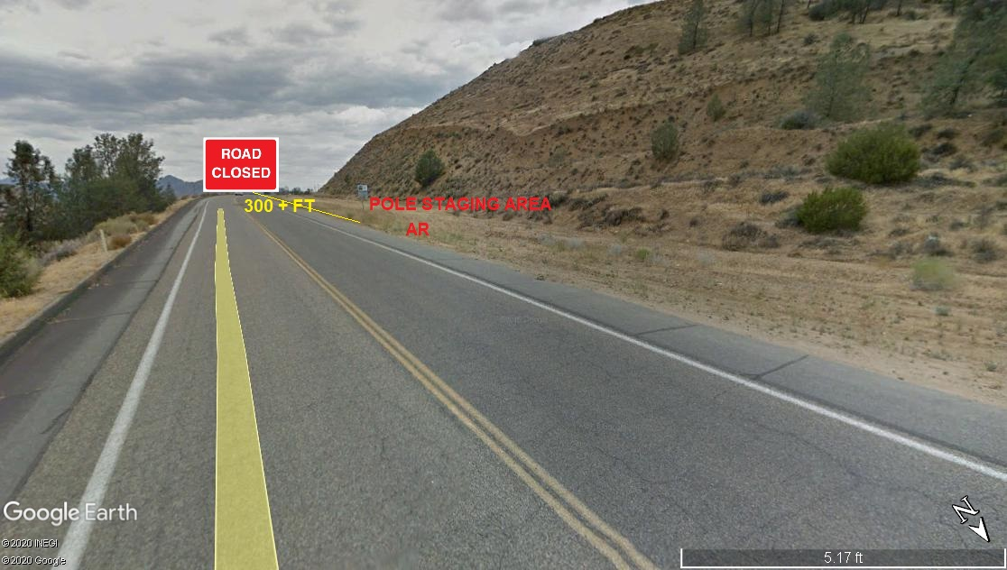
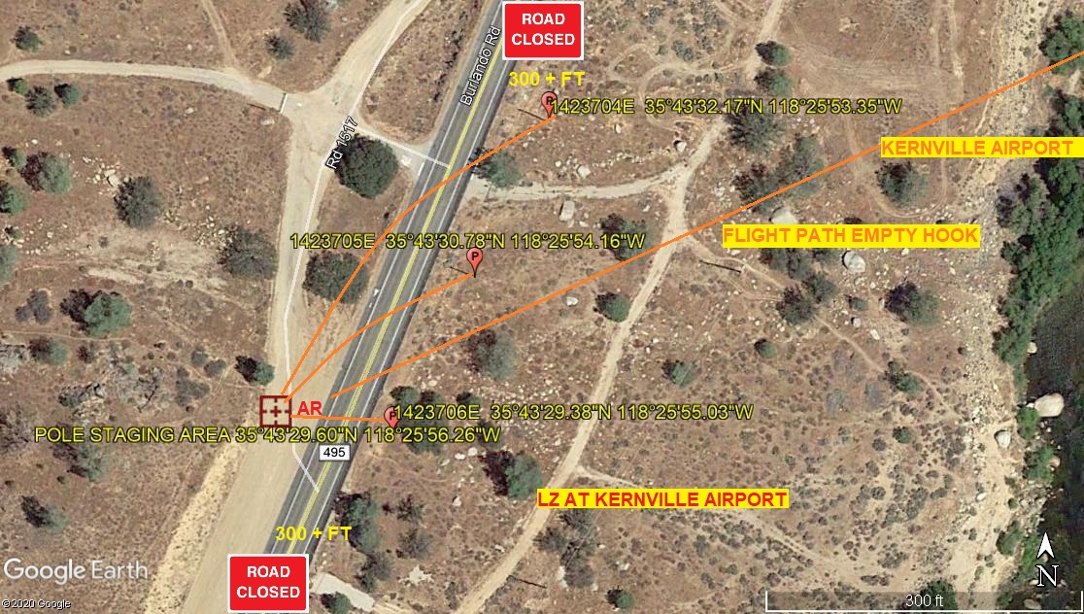
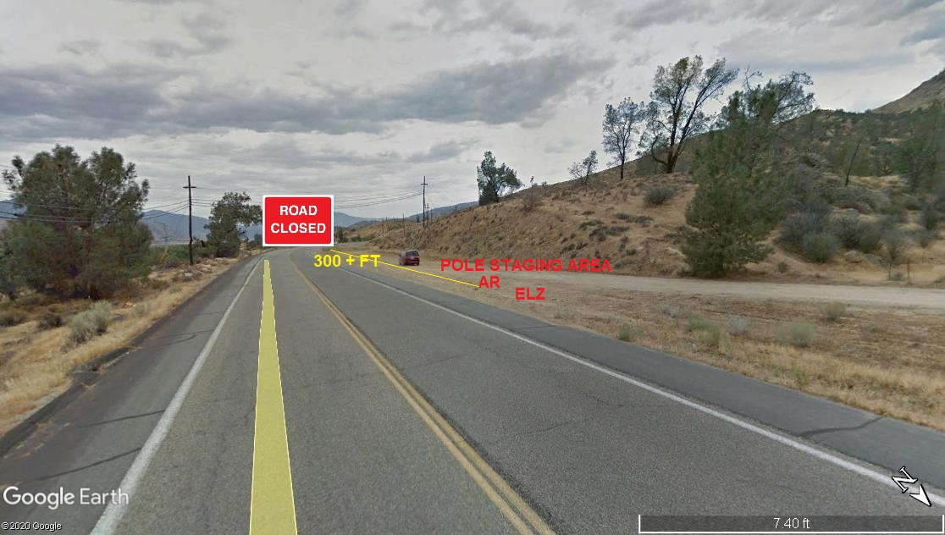
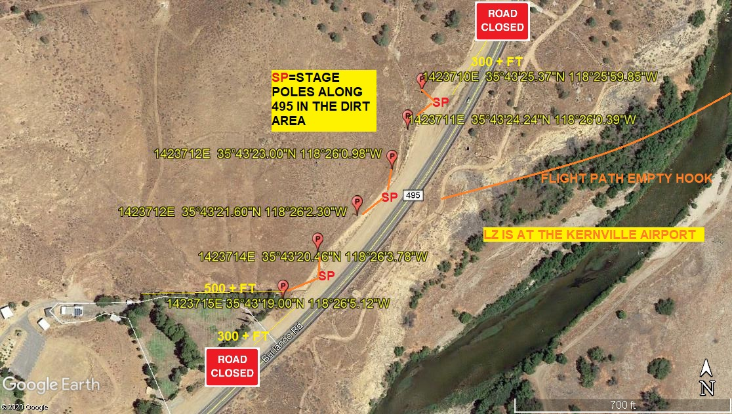
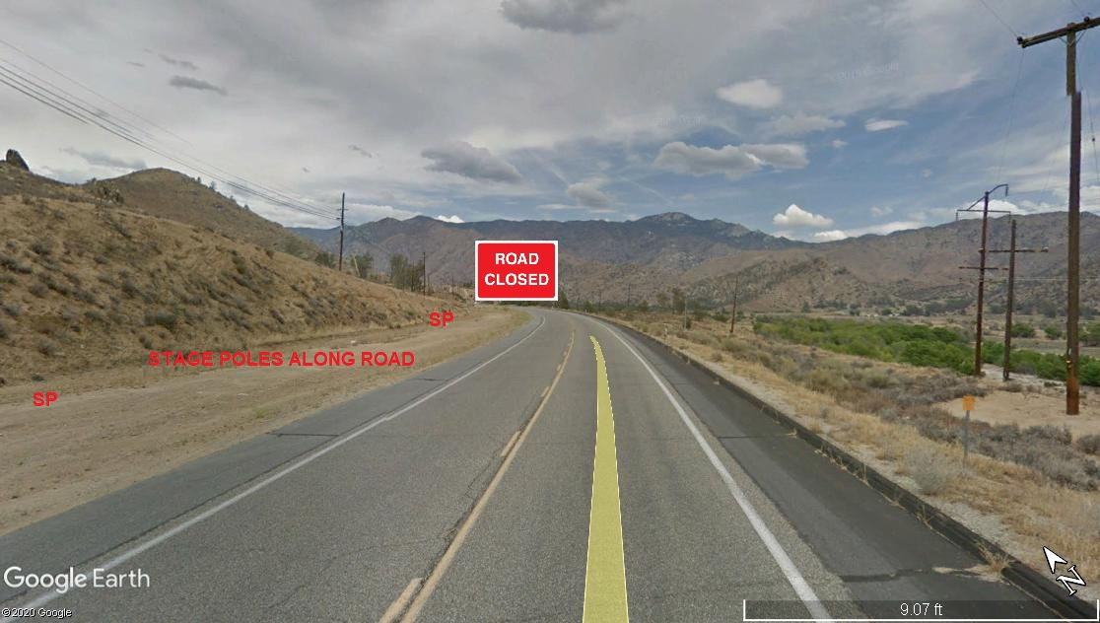
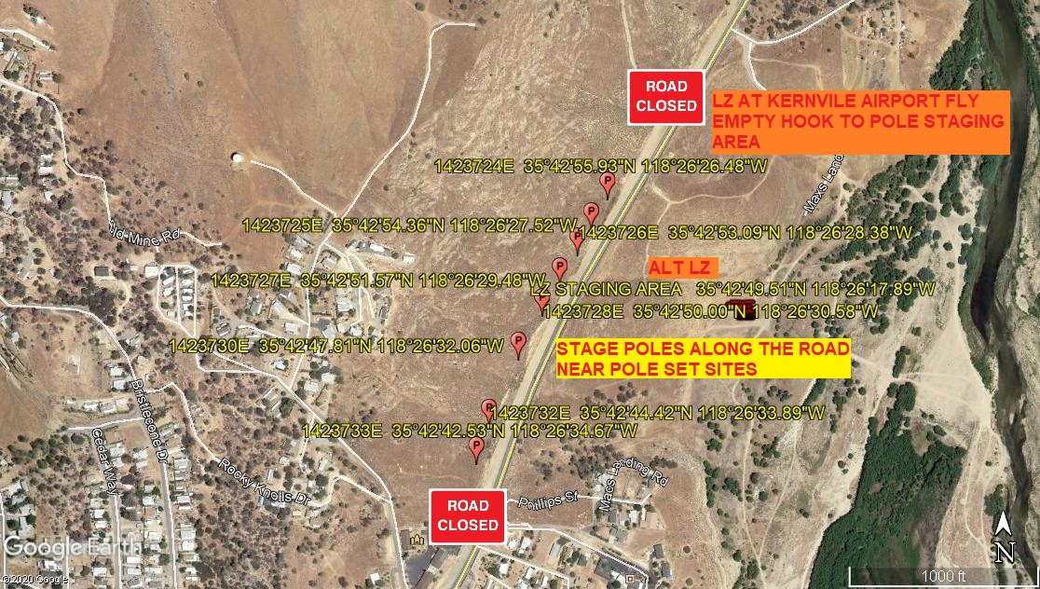
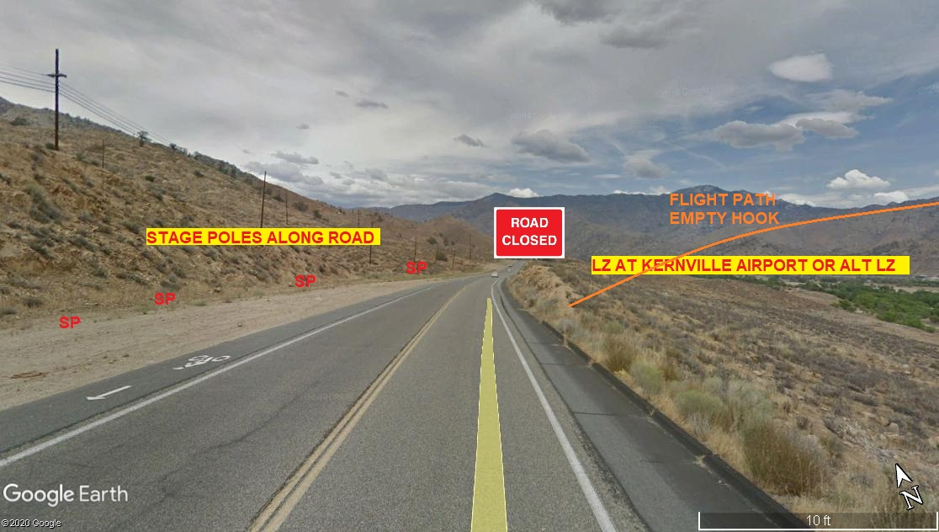
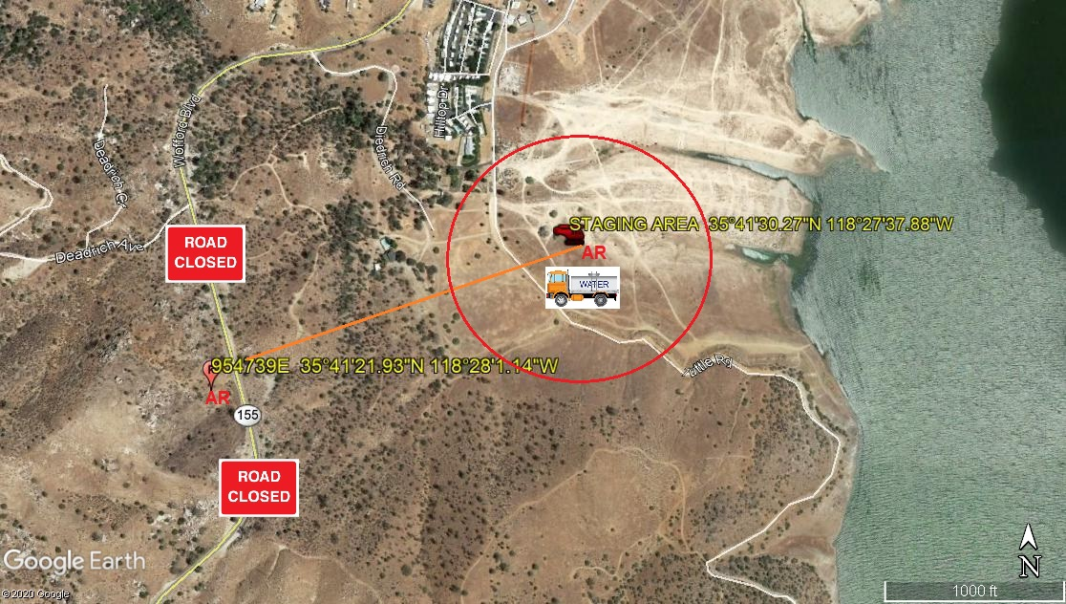
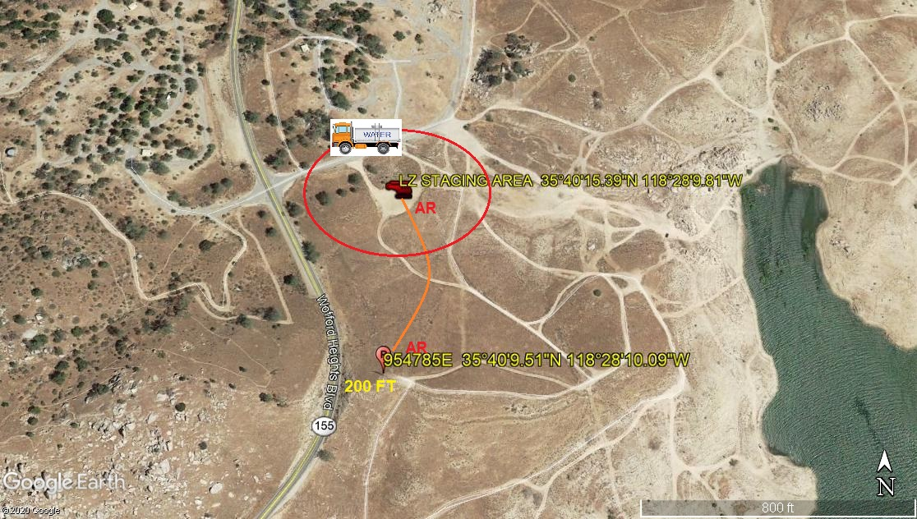
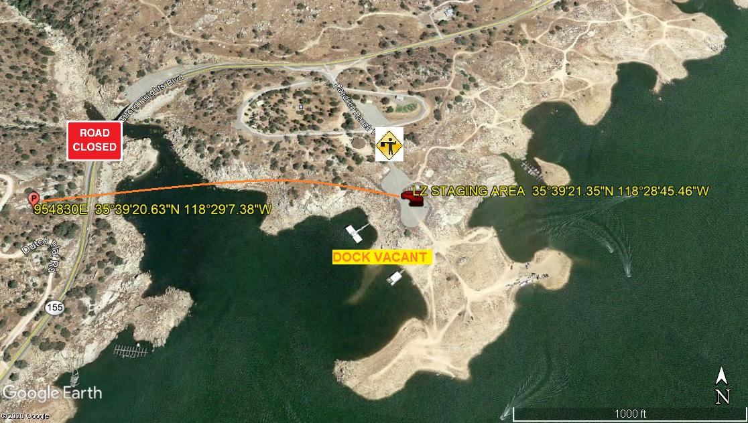
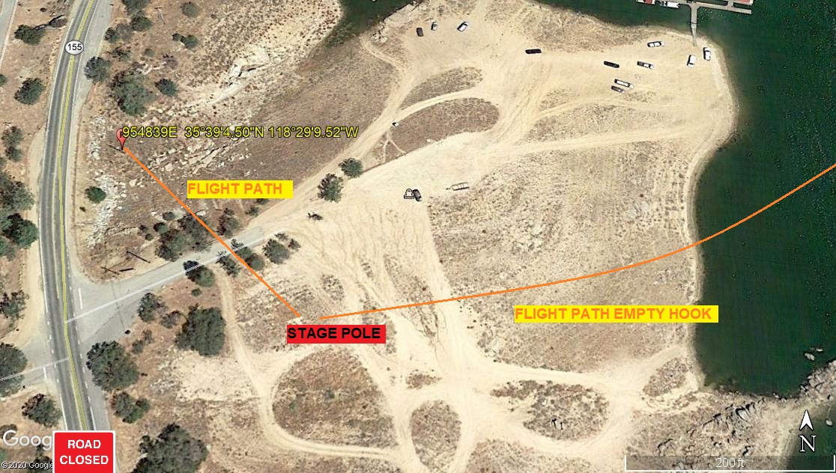
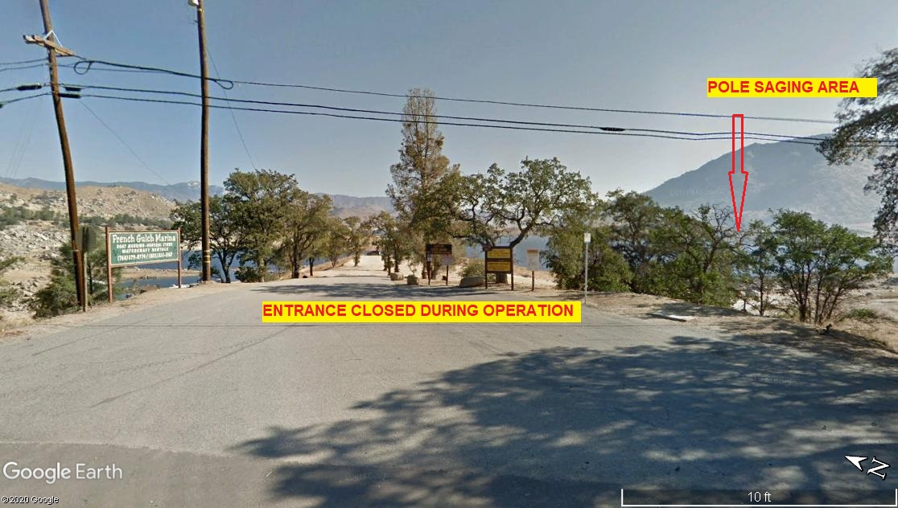

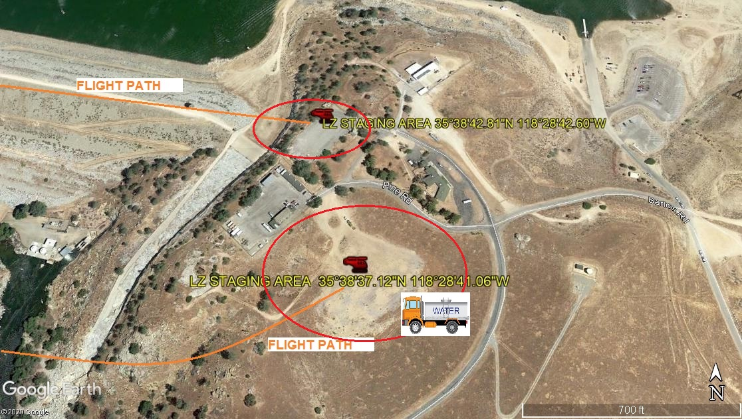
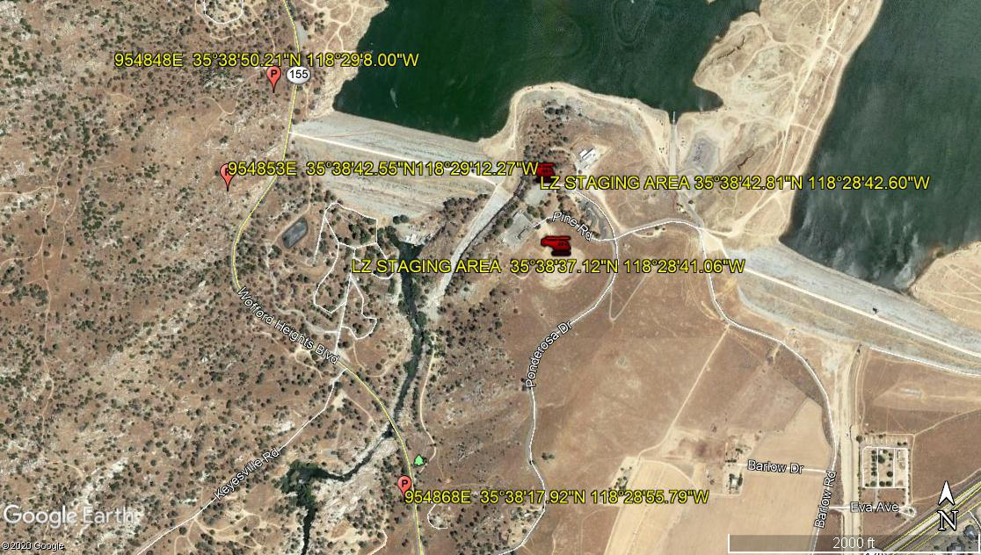
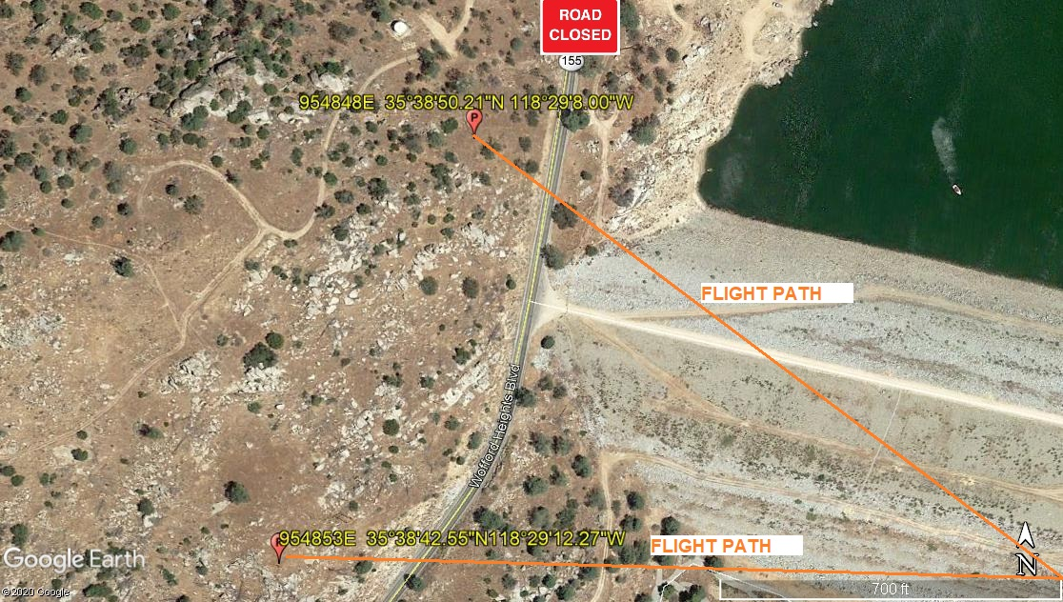
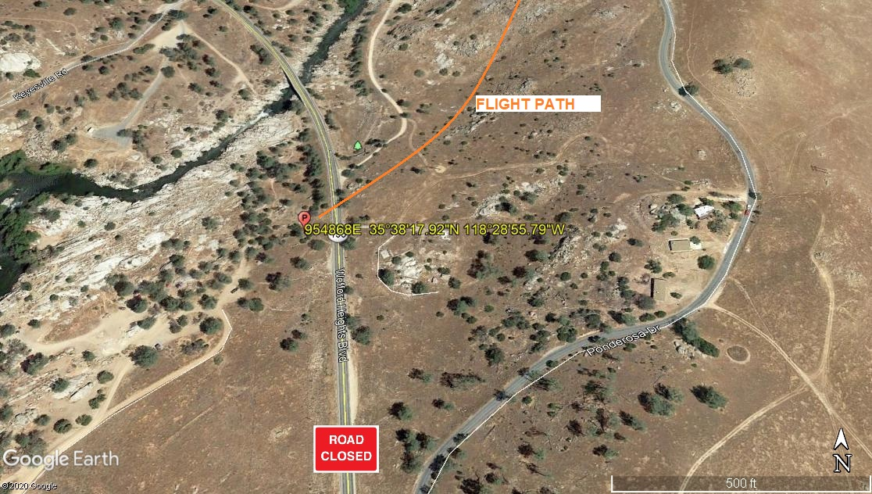
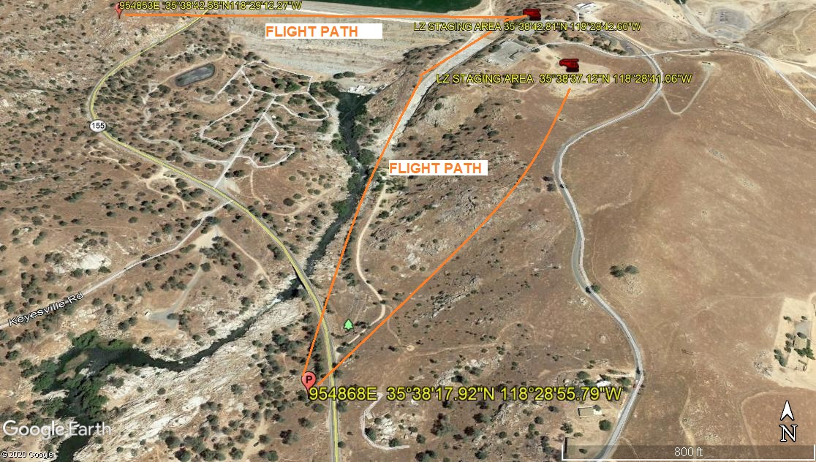
Pole #s | GPS Locations | LOC
954868E | 35.3818.13, -118285564 | 40
954853E | 35.3842.51, -118291225 | 41
954848E | 35.3850.25, -11829796 | 45
954839E | 35.651250, -118485979 | ???
954830E | 35.655730, -118485382 | 29
954785E | 35.669307, -118.469469 | 39
954739E | 35.6892234, -118466935 | 28
1423730E | 35.713281, -118.442240 | 20
1423732E | 35.712340, -118.442746 | 21
1423733E | 35.711813, -118.442964 | 22
1423713E | 35.722667, -118.433973 | 11
1423714E | 35.722349, -118434383 | 12
1423715E | 35.721945, -118434755 | 13
1423724E | 35.715537, -118.440688 | 15
1423725E | 35.715099, -118.440979 | 16
1423726E | 35.714748, -118.441216 | 17
1423727E | 35.714324, -118.441521 | 18
1423728E | 35.713889, -118.441827 | 19
1423704E | 35.725602, -118.431487 | 4
1423705E | 35.725217, -118.4317121 | 5
1423706E | 35.724829, - 118.431954 | 6
1423710E | 35.723713, -118.433291 | 8
1423711E | 35.723407, -118.433442 | 9
1423712E | 35.723407, -118.433613 | 10
1354081E | 35.735152, -118.427188 | 2
1354082E | 35.734668, -118.427268 | 3
1354078E | 35.441005, -118.253757 | 1

4-27-2020 
DATE OF SUBMISSION COMPANY OFFICIAL / TITLE

