
SECTION 7 Part 135 GH 4A Part 133 GH 4L
NON Congested Area Plan
Operator: Guardian Helicopters, Inc
67 D STREET
Fillmore CA. 93015
Phone (818) 442-9904
FAX (818) 442-9901
PROJECT: EDISON HEC AND POLE REPLACEMENT WORK ORDER #: TD 1526104
ADDRESS 18651 PINE CANYON RD : LAKE HUGHES CA 93532
LANDING ZONE 34°41'18.20"N 118°27'29.11"W
POLE STAGING AREA 34°41'19.22"N LONGITUDE 118°27'33.72"W
1870210E LATITUDE 34°41'5.31"N LONGITUDE 118°27'34.85"W 50 H1 3000 LBS
1870209E LATITUDE 34°41'5.35"N LONGITUDE 118°27'32.41"W50 H1 3000 LBS
1870208E LATITUDE 34°41'8.35"N LONGITUDE 118°27'27.99"W50 H1 3000 LBS
1870214E LATITUDE 34°41'3.39"N LONGITUDE 118°27'43.38"W50 H1 3000 LBS
1870212E LATITUDE 34°41'6.39"N LONGITUDE 118°27'39.97"W50 H1 3000 LBS
4412756E LATITUDE 34°41'5.39"N LONGITUDE 118°27'28.10"W50 H1 3000 LBS
CONTACT AT SITE: JAY RODRIGUEZ PHONE#: 951-550-6923
CONTRACTOR: ROCKSTAD POWER
PILOT’S NAME(S): 1. JOHN OLSON CERT #: 2769166
2. BUCKEY MACKAY CERT #: 2778051
3. MICHAEL KLINK CERT#: 3018828
4. IAN GOODALE CERT# :3741973
5. ROSS GOULET CERT# : 339677
TYPE OF AIRCRAFT:
BELL UH-1H N# N711GH A/C CATEGORY: RESTRICTED
BELL UH-1H N# N777GH A/C CATEGORY: RESTRICTED
BELL 407 N# N407GH A/C CATEGORY: STANDARD
BELL 205A1 N# N216GH A/C CATEGORY: STANDARD
AS350 B2 N# N498PT A/C CATEGORY: STANDARD
AS350 B3 N# N718GH A/C CATEGORY: STANDARD
AS350 B3 N# N215GH A/C CATEGORY: STANDARD
IF SAFETY DICTATES AND OR THE CUSTOMER REQUESTS ADDITIONAL LIFTS THE LIFTS WILL BE CONDUCTED REMAINING WITHIN THE APPROVED TIME PARAMETERS.
TYPE OF LIFTS: (6) POLES IN (6) POLES HEC CARGO LOAD:EXTL CL B TYPE OF ITEM LIFTING: AERODYNAMIC NON- AERODYNAMIC MAX 3000 LBS
NO. OF LIFTS: 20 LONG LINE: (NO) XXX (YES) LESS THEN 150 FT (LENGTH)
OPERATIONAL ALTITUDE: < 250 STREET CLOSING: (N0) XX (YES)
DATE AND TIMES OPERATION WILL BEGIN AND TERMINATE:
FLIGHT DATES | TIME BEGIN | TIME END | TODAY’S DATE
4-27-2020 | SUNRISE | SUNSET | 4-22-2020
4-28-2020 | SUNRISE | SUNSET | 4-22-2020
AGENCY NAME: | PHONE#: | PERSON NOTIFIED: | DATE:
SANTA CLARITA SHERIFF DEPARTMENT | 661-255-1121 | WATCH COMMANDER | NOTIFY
LOS ANGELES COUNTY FIRE | 661-724-3331 | STATION 157 | NOTIFY

Part 135 GH 4A Part 133 GH 4L
NON Congested Area Plan
Evacuation Crowd Control Street Closure
□No Evacuated Structures Operator Yes □No
Evacuated Structures Contractor Contractor
□Operator
LIST OF BUILDINGS THAT SHALL EITHER BE PARTIALLY OR ENTIRELY UNOCCUPIED PERSONS ALSO HOMES THAT WILL BE NOTIFIED OF ACTIVITY:
BUILDING DESCRIPTION/ADDRESS | REMARKS | METHOD
THE OAK CAMP AND CONFERENCE CENTER | VACANT DURING OPS | HAND DELIVER
POLE 6 JUDAY FLATS MOUNTAINWAY | VACANT DURING OPS | HAND DELIVER
ALL HOMES WITHIN RED OPERATING AREA | VACANT DURING OPS | HAND DELIVER
SEE DIAGRAM = VACANT | VACANT DURING OPS | HAND DELIVER

Narrative description of pick-up site, route, delivery site, and plan for ceasing operation if unauthorized persons enter operational area or real hazard occurs.
SITE INSPECTION NOTES

ONLY PERSONNEL ESSENTIAL TO COMPLETING THE JOB SAFELY WILL BE PERMITTED TO PARTICIPATE IN THE EVOLUTION. ONLY PERSONNEL PARTICIPATING IN THE SAFETY BRIEF WILL BE PERMITTED TO BE IN THE AREA OF OPERATIONS. ONLY AUTHORIZED ESSENTIAL PERSONAL WILL BE PERMITTED IN THE IMMEDIATE AREA OF OPERATIONS. IN THE EVENT AN UNAUTHORIZED PERSON ENTERS THE OPERATIONS AREA OR A POTENTIAL HAZARD IS IDENTIFIED THE PILOT WILL HOLD THE AIRCRAFT IN RELATIVE POSITION. THIS WILL BE ACHIEVED WITHOUT OVER FLYING THE GROUND CREW. ALL OPERATIONS WILL BE CEASED UNTIL THE PROBLEM IS RECTIFIED. IN THE EVENT OF AN AIRCRAFT EMERGENCY, THE PILOT WILL RADIO GROUND PERSONNEL AND WILL ATTEMPT TO LAND IN THE EMERGENCY LANDING AREA.
DURING THE LIFT EVOLUTION THE AIRCRAFT AND GROUND CREW WILL ALL BE IN RADIO COMMUNICATIONS. IN THE EVENT OF LOSS COMMUNICATIONS, THE CREW WILL USE STANDARD HAND SIGNALS TO COMMUNICATE WITH THE PILOT. WHEN THE PILOT IS CLEAR HE WILL MOVE THE AIRCRAFT TO A SAFE LOCATION TO ALLOW THE COMMUNICATION PROBLEM TO BE RECTIFIED.
THE OPERATIONS AREA IS WITHIN THE SECURED AREA. ALL ESSENTIAL CREW WITHIN THE OPERATIONS AREA WILL NOT BE INVOLVED IN TAKING PICTURES OR ANY OTHER USE OF CELL PHONES.
PRIOR TO BEGINNING OPERATIONS, A TAILBOARD SAFETY BRIEF WILL BE CONDUCTED.
- HELICOPTER WILL LAND AT THE LZ TO CONNECT THE LONGLINE AND CONDUCT A SAFETY TAILBOARD AND HEC TRAINING
- POLE WILL BE STAGED AT THE POLE STAGING AREA
- FUELING WILL BE CONDUCTED AT THE LANDING ZONE
- EMERGENCY LANDING ZONE IS AT THE STAGING AREA AND ALONG THE FLIGHT PATH
- RADIOS WILL BE PROVIDED TO EACH POLE SITE
- WATER TRUCK REQUIRED AT LANDING ZONE
- JUDAY FLATS MOUNTAINWAY AND THE ROAD INTO THE OAKS CAMP AND CONFERENCE CENTER WILL EXPERIENCE INTERMITTENT CLOSURES
- SEE DIAGRAM FOR STREET CLOSURE AND FLAGMAN REQUIREMENTS.
- THE CONTRACTOR WILL TRIM TREES IF REQUIRED
THE HELICOPTER WILL LAND AT THE LANDING ZONE CONDUCT A SAFETY BRIEF AND WHEN THE LINEMAN ARE READY THE STREETS WILL BE CLOSED. IF REQUIRED THE HELICOPTER WILL HEC THE CREW TO THE POLE SITE AND DELIVER CARGO / TOOLS . WHEN THE LINEMAN ARE READY FOR THE NEW POLE THE HELICOPTER WILL FLY THE POLES FROM THE LANDING ZONE TO THE POLE SET SITES. WHEN THE LINEMAN ARE READY TO REMOVE THE OLD POLE THE HELICOPTER WILL FLY THE OLD POLE FROM THE POLE SET SITE TO THE LANDING ZONE. WHEN COMPLETE THE HELICOPTER WILL HEC CREWS OUT AND FLY THE TOOLS AND EQUIPMENT OUT OF THE SITE. THE STREET WILL ONLY BE CLOSED WHEN THE HELICOPTER IS FLYING.

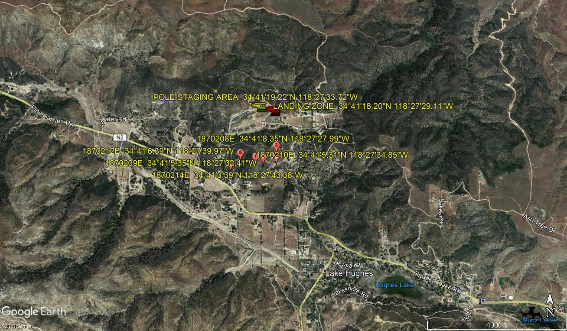

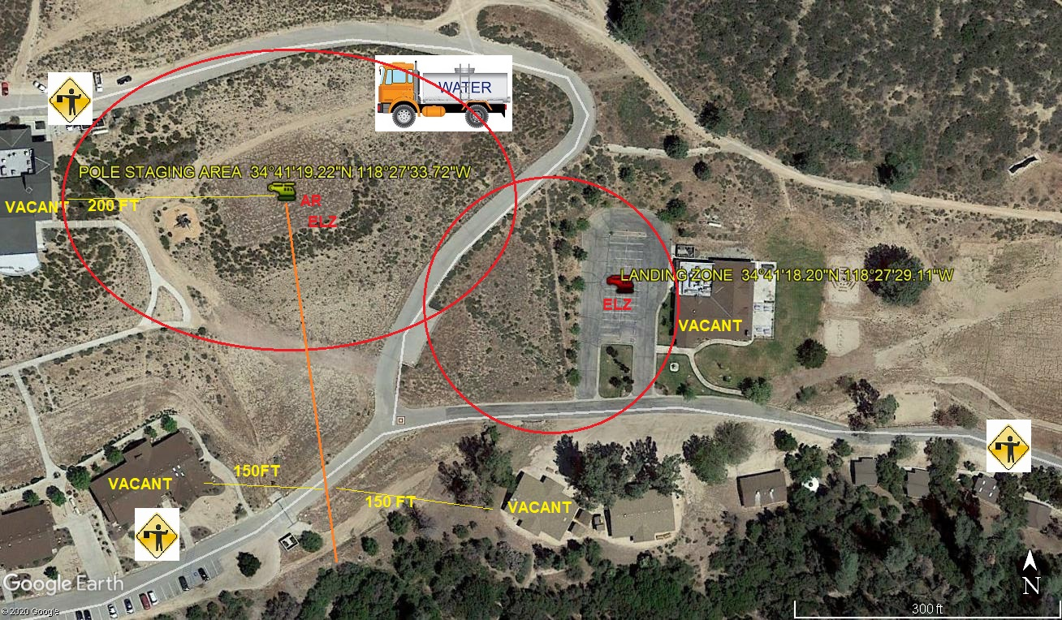

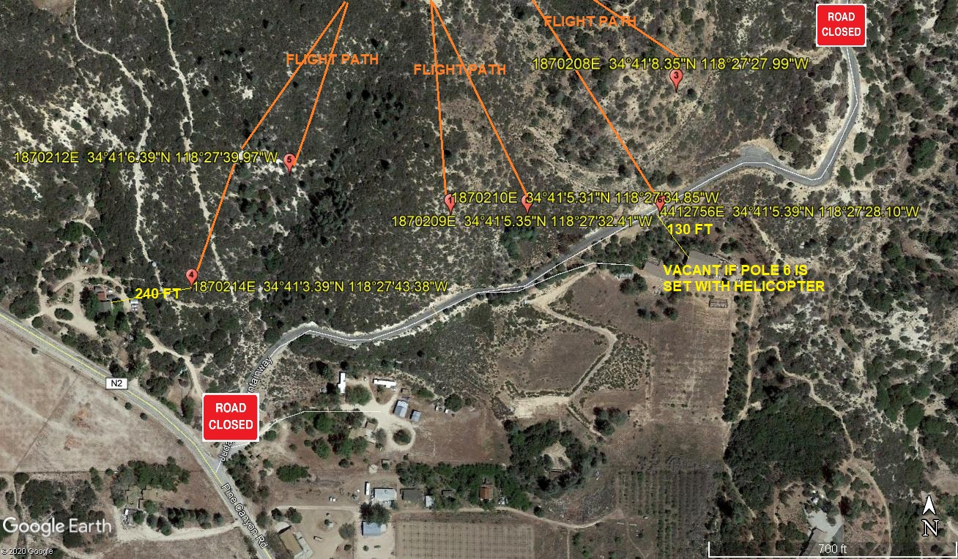
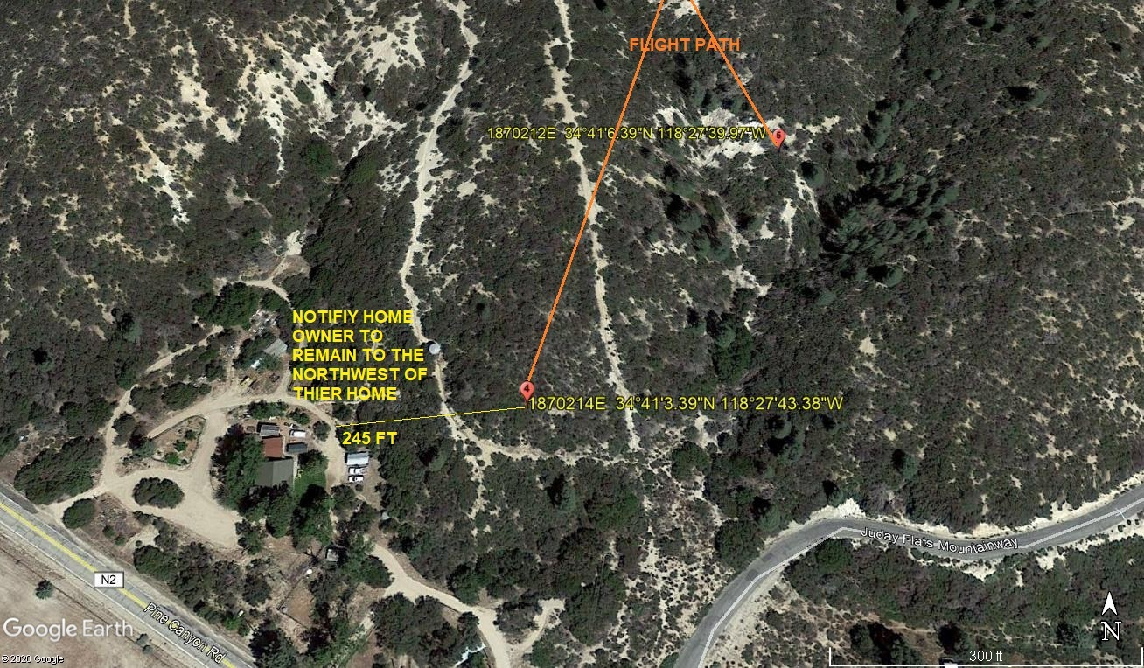

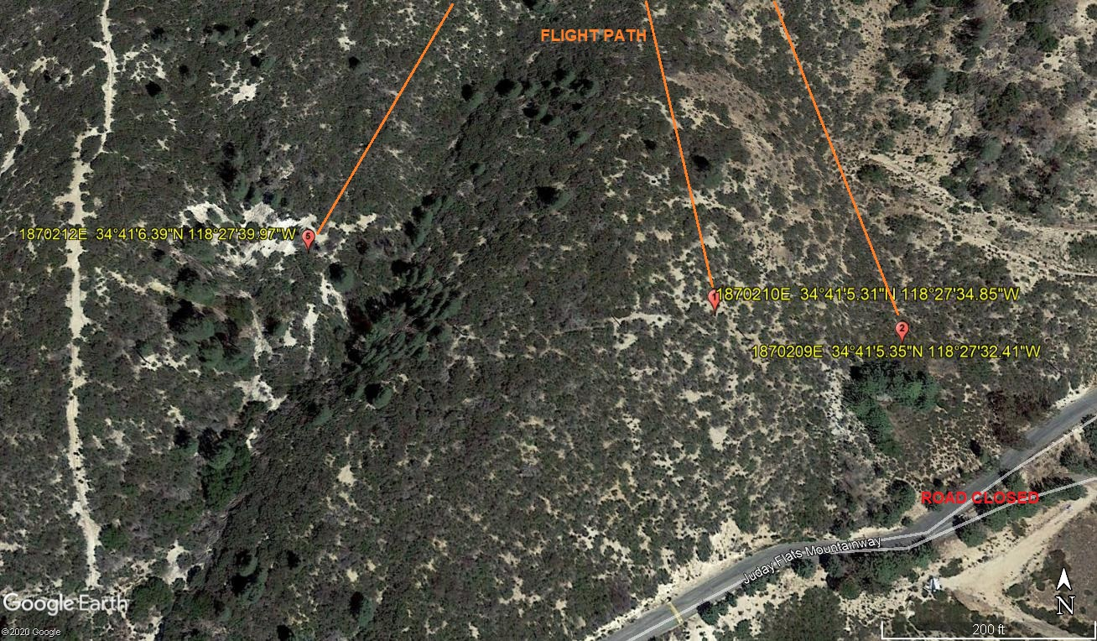
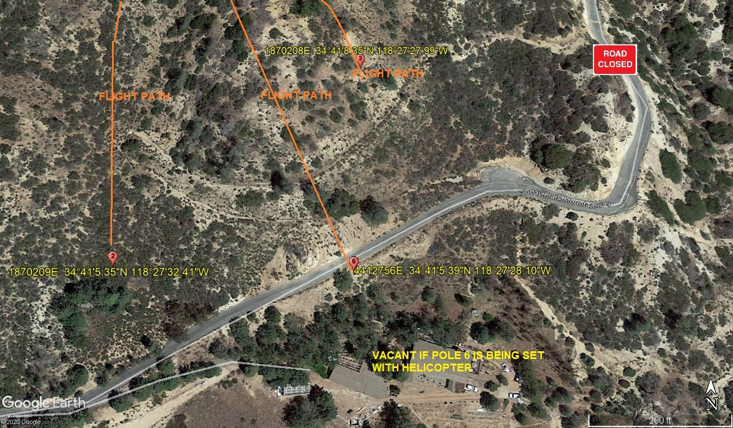

4-22-2020 
DATE OF SUBMISSION COMPANY OFFICIAL / TITLE

