
SECTION 7 Part 135 GH 4A Part 133 GH 4L
Congested Area Plan
Operator: Guardian Helicopters, Inc
67 D STREET Phone (818) 442-9904
Fillmore CA. 93015 FAX (818) 442-9901

PROJECT: A/C UNITS WORK ORDER #: Q2020-340
ADDRESS 2185 CITRACADO PARKWAY : ESCONDIDO CA
LATITUDE 33° 7'23.28"N LONGITUDE 117° 7'19.37"W 14 A/C 1600 LBS
CONTACT AT SITE: FAIRLIFT PHONE#: 707-235-4048
CONTRACTOR: PALOMAR MEDICAL CENTER PHONE#: 412-281-5000
PILOT’S NAME(S): 1. JOHN OLSON CERT #: 2769166
2. BUCKEY MACKAY CERT #: 2778051
3. MICHAEL KLINK CERT#: 3018828
4. IAN GOODALE CERT#: 3741973
5. ROSS GOULET CERT#: 3396777
TYPE OF AIRCRAFT: BELL UH-1H N# N711GH A/C CATEGORY: RESTRICTED
BELL UH-1H N# N214KK A/C CATEGORY: RESTRICTED
BELL 407 N# N407GH A/C CATEGORY: STANDARD
BELL 205A1 N# N216GH A/C CATEGORY: STANDARD
AS350 B2 N# N498PT A/C CATEGORY: STANDARD
AS350 B3 N# N718GH A/C CATEGORY: STANDARD
AS350 B3 N# N215GH A/C CATEGORY: STANDARD
IF SAFETY DICTATES AND OR THE CUSTOMER REQUESTS ADDITIONAL LIFTS THE LIFTS WILL BE CONDUCTED REMAINING WITHIN THE APPROVED TIME PARAMETERS.
TYPE OF LIFTS: (10 ) 1600 LBS UNITS 9.5 FT X 4.5 FT LOAD:EXTL CL B TYPE OF ITEM LIFTING: AERODYNAMIC NON- AERODYNAMIC MAX 1600 LBS NO. OF LIFTS: 10 1600 LBS MAX LONG LINE: (NO) XXX (YES) LESS THEN 125 FT (LENGTH)
OPERATIONAL ALTITUDE: < 250 STREET CLOSING: (N0) XX (YES)
DATE AND TIMES OPERATION WILL BEGIN AND TERMINATE:
FLIGHT DATES | TIME BEGIN | TIME END | TODAY’S DATE
4-20-2020 | 1300 | 1600 | 4-15-2020
AGENCY NAME: | PHONE#: | PERSON NOTIFIED: | DATE:
POLICE DEPARTMENT | 760-839-4722 | WATCH COMMANDER | NOTIFIED
FIRE DEPARTMENT | 760-839-5400 | STATION 4 | NOTIFIED
AIR TRAFFIC CONTROL | N/A | N/A | N/A

Evacuation Crowd Control Street Closure
□No Evacuated Structures Operator Yes □No
Evacuated Structures Contractor Contractor
□Operator

Part 135 GH 4A Part 133 GH 4L
Congested Area Plan
LIST OF BUILDINGS THAT SHALL EITHER BE PARTIALLY OR ENTIRELY UNOCCUPIED PERSONS ALSO HOMES THAT WILL BE NOTIFIED OF ACTIVITY:
BUILDING DESCRIPTION/ADDRESS | REMARKS | METHOD
2185 CITRACADO PARKWAY 412-281-5000 | VACANT DURING OPS | HAND DELIVER
ALL HOMES WITHIN RED OPERATING AREA | VACANT DURING OPS | HAND DELIVER
SEE DIAGRAM = VACANT | VACANT DURING OPS | HAND DELIVER

Narrative description of pick-up site, route, delivery site, and plan for ceasing operation if unauthorized persons enter operational area or real hazard occurs.
SITE INSPECTION NOTES
ONLY PERSONNEL ESSENTIAL TO COMPLETING THE JOB SAFELY WILL BE PERMITTED TO PARTICIPATE IN THE EVOLUTION. ONLY PERSONNEL PARTICIPATING IN THE SAFETY BRIEF WILL BE PERMITTED TO BE IN THE AREA OF OPERATIONS. ONLY AUTHORIZED ESSENTIAL PERSONAL WILL BE PERMITTED IN THE IMMEDIATE AREA OF OPERATIONS. IN THE EVENT AN UNAUTHORIZED PERSON ENTERS THE OPERATIONS AREA OR A POTENTIAL
HAZARD IS IDENTIFIED THE PILOT WILL HOLD THE AIRCRAFT IN RELATIVE POSITION. THIS WILL BE ACHIEVED WITHOUT OVER FLYING THE GROUND CREW. ALL OPERATIONS WILL BE CEASED UNTIL THE PROBLEM IS RECTIFIED. IN THE EVENT OF AN AIRCRAFT EMERGENCY, THE PILOT WILL RADIO GROUND PERSONNEL AND WILL ATTEMPT TO LAND IN THE EMERGENCY LANDING AREA.
DURING THE LIFT EVOLUTION THE AIRCRAFT AND GROUND CREW WILL ALL BE IN RADIO COMMUNICATIONS. IN THE EVENT OF LOSS COMMUNICATIONS, THE CREW WILL USE STANDARD HAND SIGNALS TO COMMUNICATE WITH THE PILOT. WHEN THE PILOT IS CLEAR HE WILL MOVE THE AIRCRAFT TO A SAFE LOCATION TO ALLOW THE COMMUNICATION PROBLEM TO BE RECTIFIED.
THE OPERATIONS AREA IS WITHIN THE SECURED AREA. ALL ESSENTIAL CREW WITHIN THE OPERATIONS AREA WILL NOT BE INVOLVED IN TAKING PICTURES OR ANY OTHER USE OF CELL PHONES.
PRIOR TO BEGINNING OPERATIONS, A TAILBOARD SAFETY BRIEF WILL BE CONDUCTED.
- TAILBOARD WILL BE CONDUCTED AT THE LANDING ZONE
- THE AIRCRAFT WILL LAND AT THE STAGING AREA TO CONNECT THE LONGLINE AND CONDUCT FUELING
- WATER TRUCK NOT REQUIRED
- EQUIPMENT WILL BE STAGED IN THE STAGING AREA TO THE EAST OF THE LANDING ZONE
- EMERGENCY LANDING ZONE IS AT THE STAGING AREA AND ALONG THE FLIGHT PATH
- PILOT AND GROUND CREW WILL BE IN RADIO COMMUNICATIONS
- TOP FLOOR WITHIN THE OPERATING AREA WILL BE VACANT.
- ALL EGRESS FROM THE HOSPITAL TO THE OPERATIONS AREA WILL BE SECURED
- ROAD AND PARKING LOTS WILL BE CLOSED PER DIAGRAM
- INGRESS FROM THE PARKING LOT INTO THE OPERATING AREA WILL BE CONTROLLED BY FLAGMAN
- THE HELICOPTER WILL LAND AT THE STAGING AREA TO CONDUCT SAFETY BRIEF. ONCE THE UNITS ARE RIGGED THE PILOT WILL FLY THE GHI ROOF CREW TO THE HELIPAD ON THE ROOF OF THE HOSPITAL. THE HELICOPTER WILL LAND AT THE LZ AND WAIT FOR THE ROOF CREW TO BE READY FOR THE UNITS. ONCE EVERYONE IS IN PLACE THE PILOT WILL START THE OPERATION. THE FIRST UNIT SET WILL BE ON THE SOUTH SIDE OF THE NORTH / SOUTH LINE, WORKING THE WAY NORTH. THEN THE WEST MOST UNIT WILL BE SET ON THE WEST/EAST LINE. ONCE THE UNITS ARE SET THE PILOT WILL LAND AT THE LANDING ZONE AND WAIT FOR THE ROOF CREW TO BE READY TO BE PICKED UP ON THE HEIPAD. ONCE THE AIRCRAFT HAS DEPARTED THE AREA THE OPERATING AREA WILL BE REOPENED.

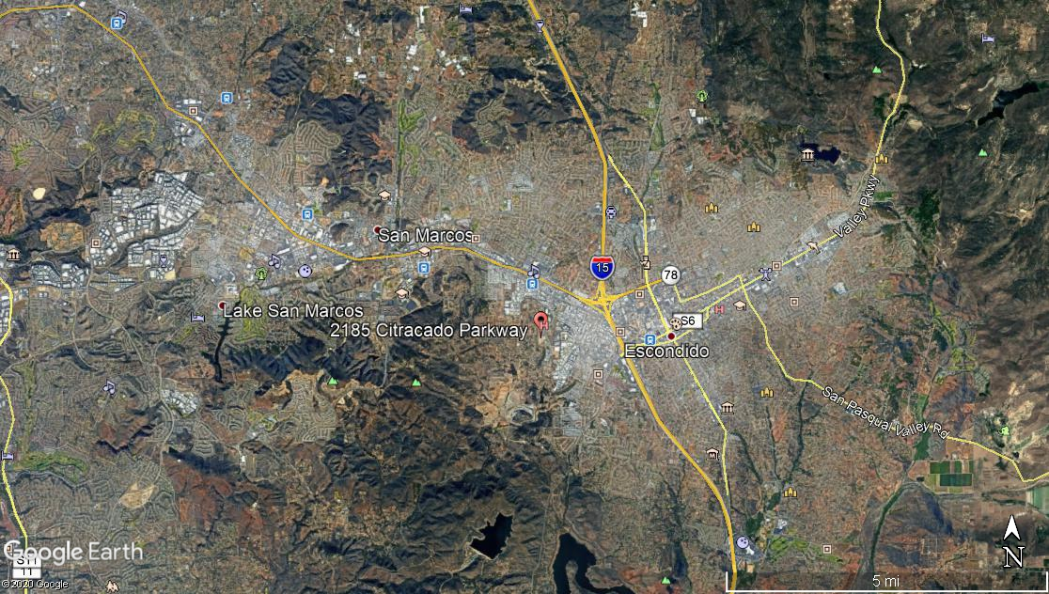
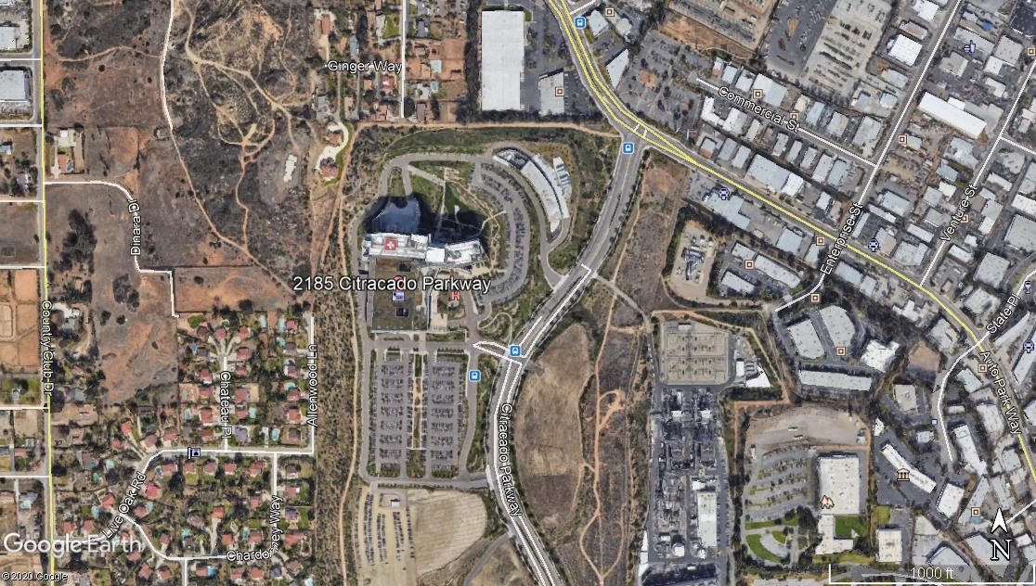
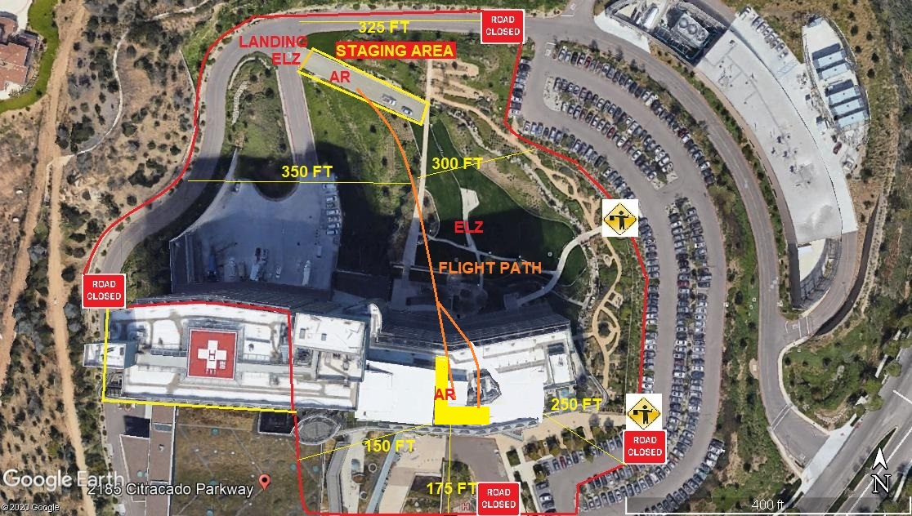
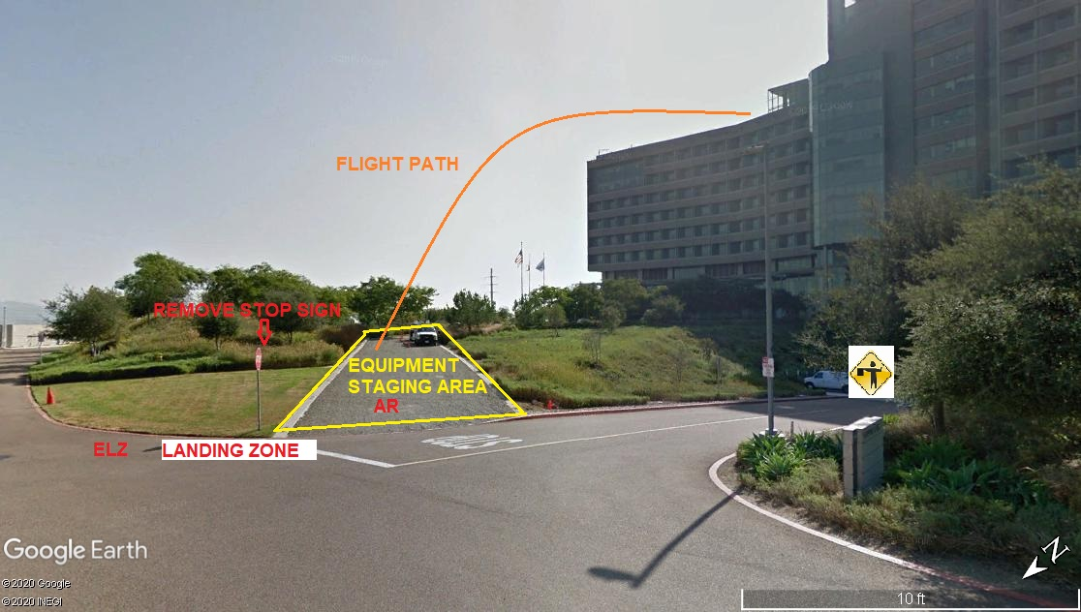
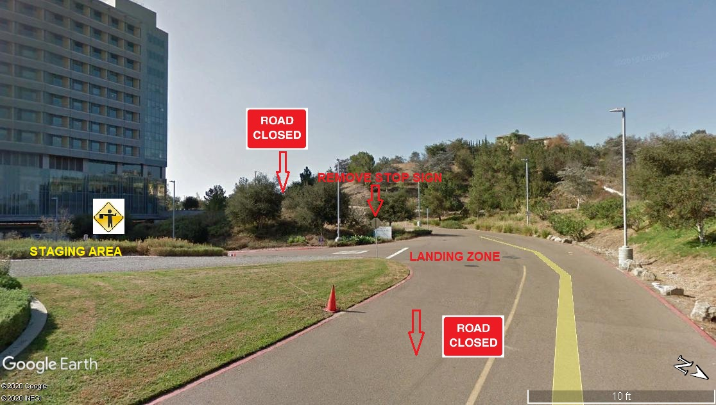
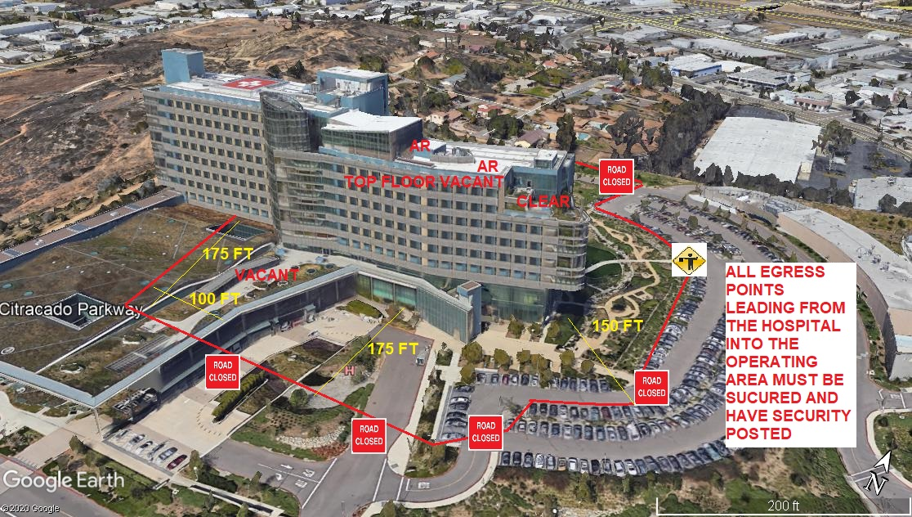
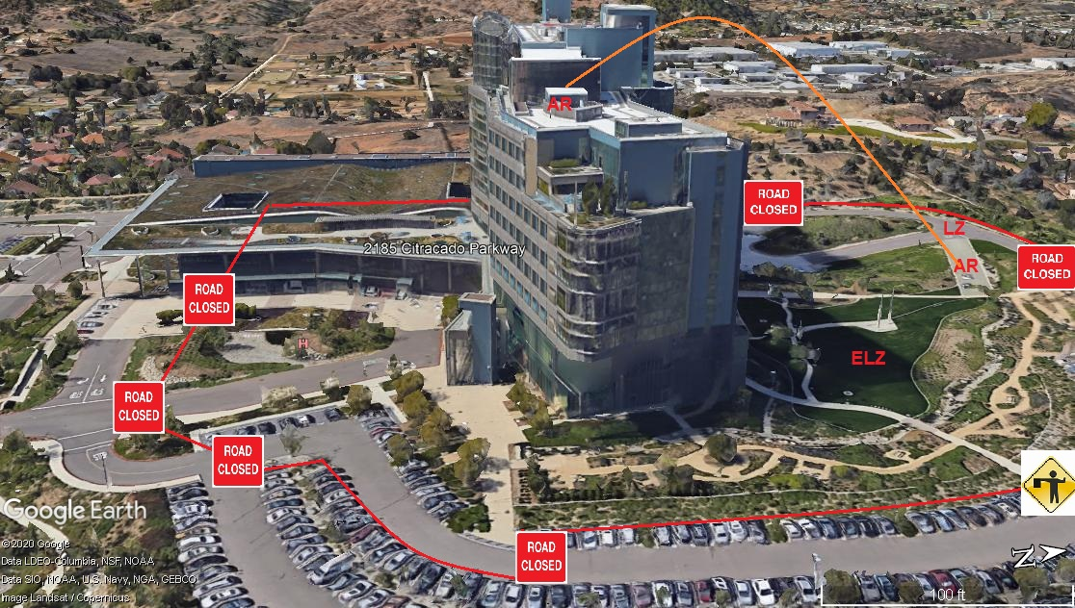
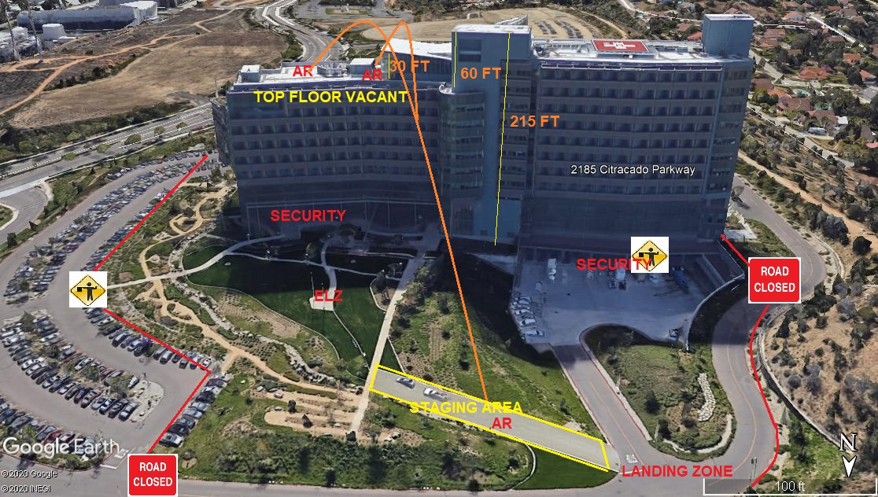
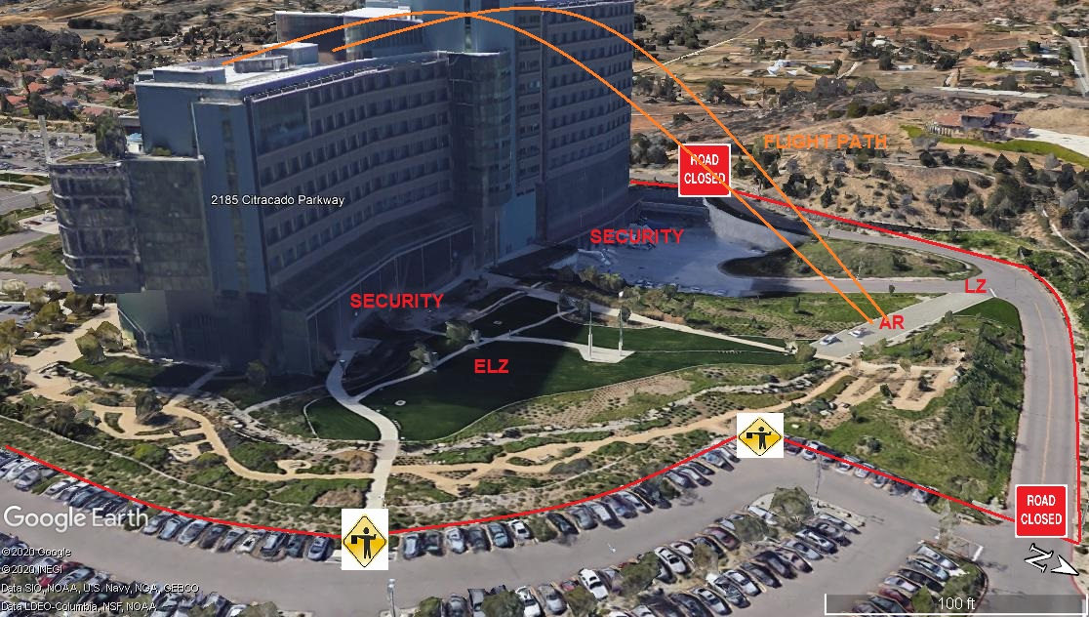
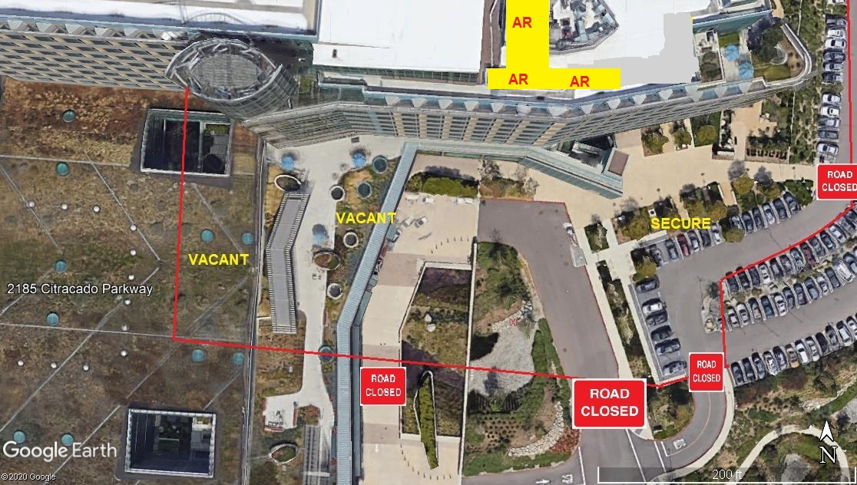
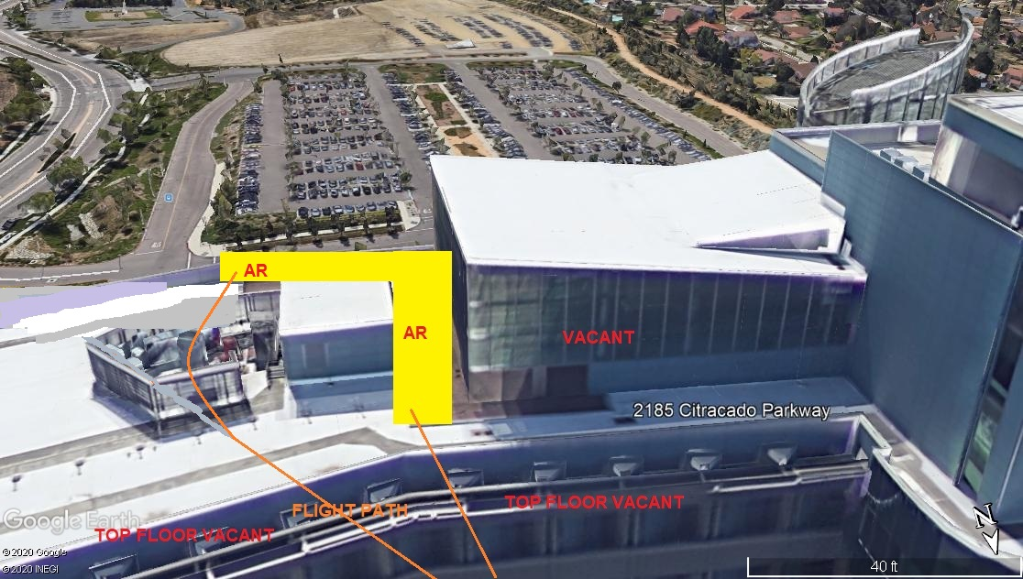
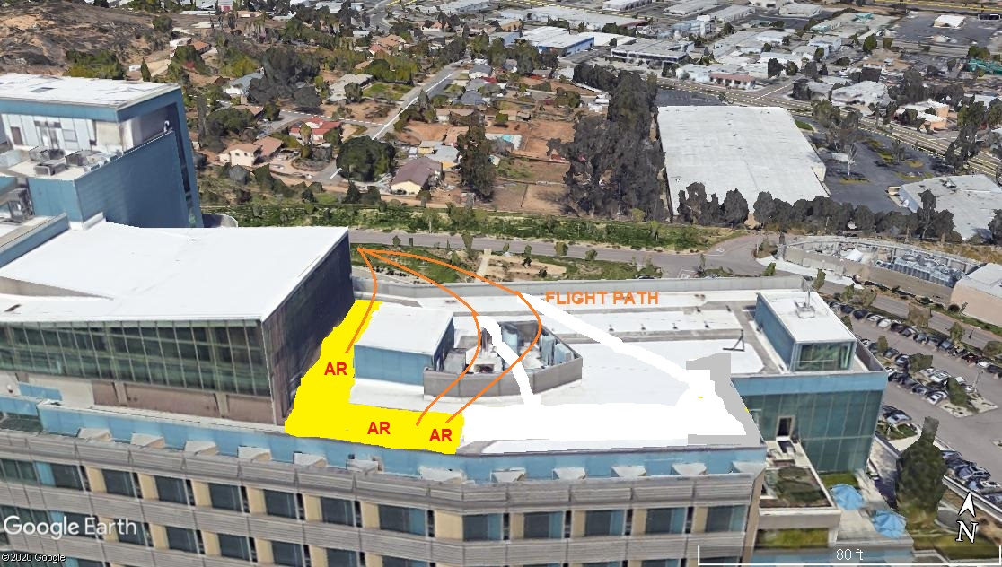

4-12-2020 
DATE OF SUBMISSION COMPANY OFFICIAL / TITLE

