
SECTION 7 Part 135 GH 4A Part 133 GH 4L
Congested Area Plan
Operator: Guardian Helicopters, Inc
67 D STREET Phone (818) 442-9904
FILLMORE, CA 93015 FAX (818) 442-9901

PROJECT: EDISON POLE REPLACEMENT WORK ORDER #: TD 1639930
ADDRESS: 2084 ALISOS DR : MONTECITO CA
POLE STAGING AREA LATITUDE 34°26'25.92"N LONGITUDE 119°36'26.81"W
4940057E LATITUDE 34°26'30.10"N LONGITUDE 119°36'25.75"W 45 CL 1 FR WOOD 2100 LBS
CUSTOMER WILL PHYSICALLY CHECK POLE WEIGHT PRIOR TO JOB
CONTRACTOR’S NAME: GARRET ILLMAN PHONE#: 909-573-3856
PILOT’S NAME(S): 1. JOHN OLSON CERT #: 2769166
2. BUCKEY MACKAY CERT #: 2778051
3. MICHAEL KLINK CERT#: 3018828
4. IAN GOODALE CERT# :3741973
5. ROSS GOULET CERT# : 3396777
TYPE OF AIRCRAFT:
BELL UH-1H N# N711GH A/C CATEGORY: RESTRICTED
BELL UH-1H N# N777GH A/C CATEGORY: RESTRICTED
BELL 407 N# N407GH A/C CATEGORY: STANDARD
BELL 407 N# N447GH A/C CATEGORY: STANDARD
BELL 205A1 N# N216GH A/C CATEGORY: STANDARD
AS350 B2 N# N498PT A/C CATEGORY: STANDARD
AS350 B3 N# N718GH A/C CATEGORY: STANDARD
AS350 B3 N# N215GH A/C CATEGORY: STANDARD
TYPE OF ITEM LIFTING: POLE AERODYNAMIC NON- AERODYNAMIC
IF SAFETY DICTATES AND OR THE CUSTOMER REQUESTS ADDITIONAL LIFTS THE LIFTS WILL BE CONDUCTED REMAINING WITHIN THE APPROVED TIME PARAMETERS.
TYPE OF LIFTS 1 POLES POLE REPLACEMENT ONLY
MAX SINGLE – LIFT WEIGHT: 2100 LBS CLASS OF LOAD: EXTERNAL CL B
NO. OF LIFTS: 4 LONG LINE: (NO) XXX (YES) LESS THEN 100 FT (LENGTH)
OPERATIONAL ALTITUDE: < 250 AGL STREET CLOSING: (N0) XX (YES)
DATE AND TIMES OPERATION WILL BEGIN AND TERMINATE:
FLIGHT DATES | TIME BEGIN | TIME END | TODAY’S DATE
7-9-2020 | SUNRISE | SUNSET | 6-30-2020
AGENCY NAME: | PHONE#: | PERSON NOTIFIED: | DATE:
MONTECITO FIRE DEPARTMENT | 805-969-7762 | DISPATCH | NOTIFY
SANTA BARBARA COUNTY SHERIFF | 805-897-2465 | DISPATCH | NOTIFY
NON- Congested Area Plan (Continued)
Evacuation Crowd Control Street Closure
□No Evacuated Structures Operator Yes □ No
Evacuated Structures Contractor Contractor
□Operator

LIST OF BUILDINGS THAT SHALL EITHER BE PARTIALLY OR ENTIRELY UNOCCUPIED PERSONS ALSO HOMES THAT WILL BE NOTIFIED OF ACTIVITY:
BUILDING DESCRIPTION/ADDRESS | REMARKS | METHOD
2084 ALISOS DR | VACANT DURING OPS | HAND DELIVER
715 OAK GROVE DR | VACANT DURING OPS | HAND DELIVER
660 LILAC DR | VACANT DURING OPS | HAND DELIVER
891 OAK GROVE DR | VACANT DURING OPS | HAND DELIVER
2091 ALISOS DR | VACANT DURING OPS | HAND DELIVER
ALL HOMES WITHIN OPERATING AREA | VACANT DURING OPS | HAND DELIVER
SEE DIAGRAM = V | VACANT DURING OPS | HAND DELIVER
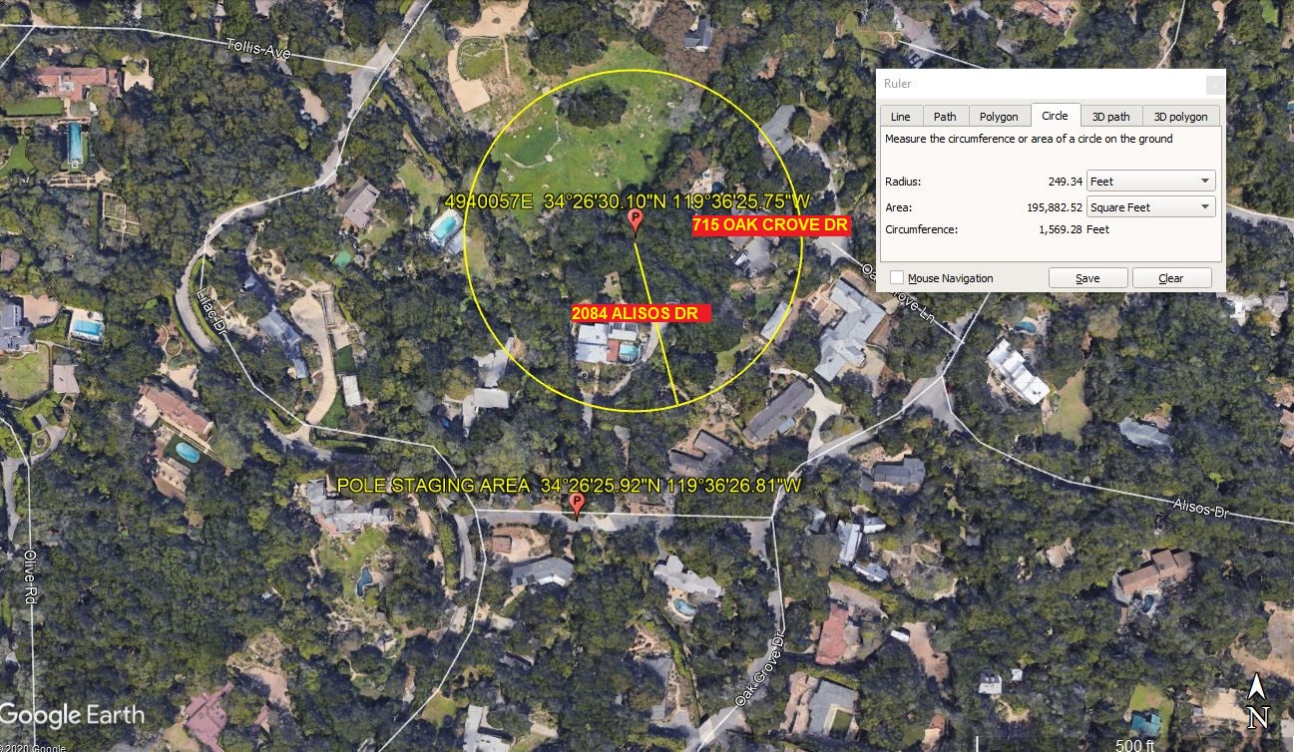
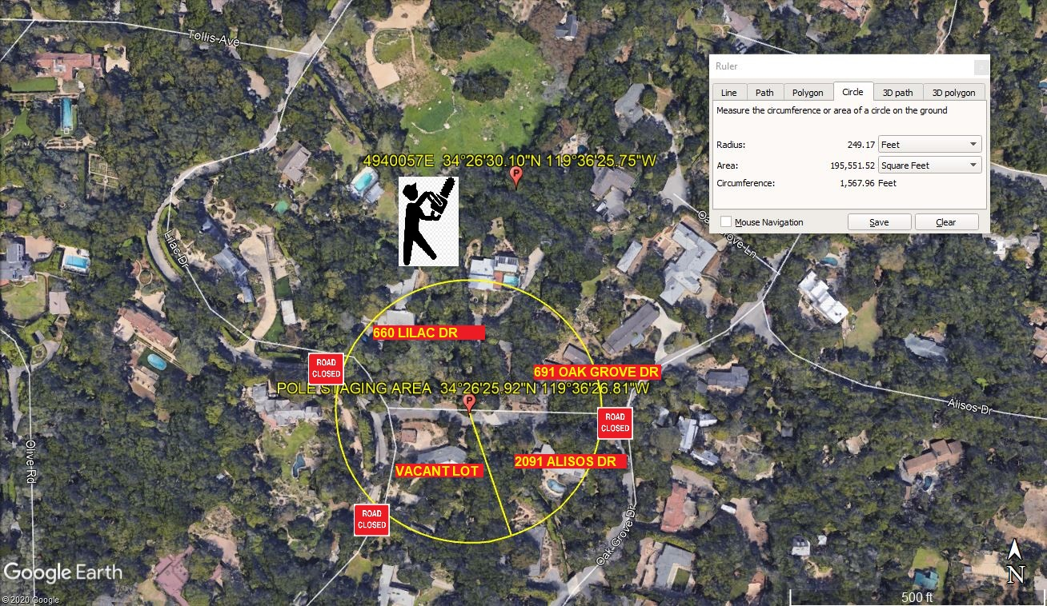

Narrative description of pick-up site, route, delivery site, and plan for ceasing operation if unauthorized persons enter operational area or real hazard occurs.
SITE INSPECTION NOTES

ONLY PERSONNEL ESSENTIAL TO COMPLETING THE JOB SAFELY WILL BE PERMITTED TO PARTICIPATE IN THE EVOLUTION. ONLY PERSONNEL PARTICIPATING IN THE SAFETY BRIEF WILL BE PERMITTED TO BE IN THE AREA OF OPERATIONS. ONLY AUTHORIZED ESSENTIAL PERSONAL WILL BE PERMITTED IN THE IMMEDIATE AREA OF OPERATIONS. IN THE EVENT AN UNAUTHORIZED PERSON ENTERS THE OPERATIONS AREA OR A POTENTIAL HAZARD IS IDENTIFIED THE PILOT WILL HOLD THE AIRCRAFT IN RELATIVE POSITION. THIS WILL BE ACHIEVED WITHOUT OVER FLYING THE GROUND CREW. ALL OPERATIONS WILL BE CEASED UNTIL THE PROBLEM IS RECTIFIED. IN THE EVENT OF AN AIRCRAFT EMERGENCY, THE PILOT WILL RADIO GROUND PERSONNEL AND WILL ATTEMPT TO LAND IN THE EMERGENCY LANDING AREA.
DURING THE LIFT EVOLUTION THE AIRCRAFT AND GROUND CREW WILL ALL BE IN RADIO COMMUNICATIONS. IN THE EVENT OF LOSS COMMUNICATIONS THE CREW WILL USE STANDARD HAND SIGNALS TO COMMUNICATE WITH THE PILOT. WHEN THE PILOT IS CLEAR HE WILL MOVE THE AIRCRAFT TO A SAFE LOCATION TO ALLOW THE COMMUNICATION PROBLEM TO BE RECTIFIED.
THE OPERATIONS AREA IS WITHIN THE SECURED AREA. ALL ESSENTIAL CREW WITHIN THE OPERATIONS AREA WILL NOT BE INVOLVED IN TAKING PICTURES OR ANY OTHER USE OF CELL PHONES.
A TAILBOARD SAFETY MEETING WILL BE HELD AT THE ASSIGNED AREA PRIOR TO BEGINNING HELICOPTER OPERATIONS
- GHI GROUND CREW WILL CONDUCT A TAILBOARD SAFETY BRIEF AT THE STAGING AREA
- WHEN THE LINECREW IS READY FOR THE POLE SET GHI GROUND CREW AND STREET CLOSURE TEAM WILL KNOCK ON THE DOORS OF THE HOME REQUIRING EVACUATION. ONCE CLEAR GHI GROUND CREW WILL CALL PILOT TO CLEAR HIM INTO THE OPERATING AREA
- THE HELICOPTER WILL HAVE AN EXTRA PERSON IN THE AIRCRAFT TO LOWER THE LONGLINE OVER THE STAGING AREA
- THE HELICOPTER WILL FLY THE NEW POLE TO THE POLE SITE NOT OVERFLYING ANY HOMES. THE HELICOPTER WILL THEN FLY THE OLD POLE BACK TO THE STAGING AREA.
- THE LONGLINE WILL THEN BE PULLED BACK INTO THE AIRCRAFT AND THE HELICOPTER WILL DEPART THE AREA.
- NO SCHEDULED LANDINGS OR FUELING
- THE POLES WILL BE STAGED AT THE STAGING AREA OFF OF ALISOS DR
- EMERGENCY LANDING ZONE IS AT THE STAGING AREA (VACANT LOT) AND ALONG THE FLIGHT PATH
- 6 ADDRESSES WILL BE VACANT DURING OPERATIONS SEE DIAGRAM
- WATER TRUCK IS NOT REQUIRED
- ALISOS DR AND LILAC DR WILL BE CLOSED DURING OPERATIONS. SEE DIAGRAM
- TREE TRIMMING IS REQUIRED PRIOR TO START DATE
OPERATIONS AREA DIAGRAM

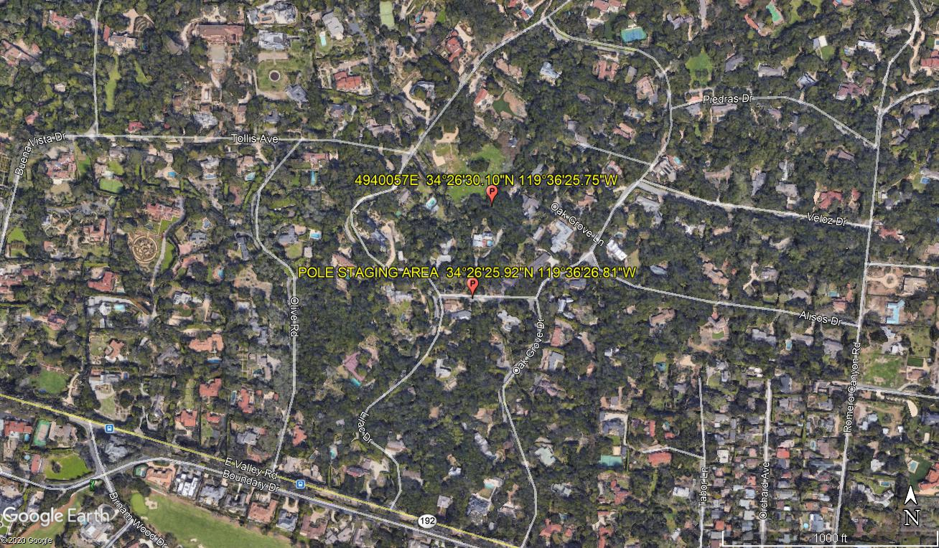
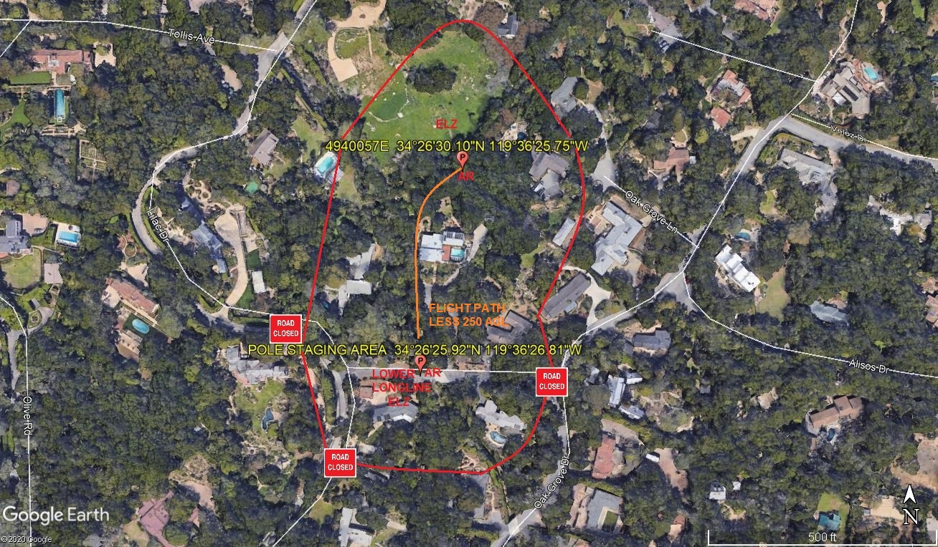

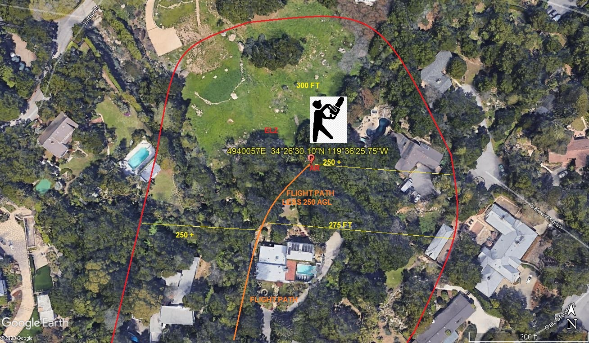
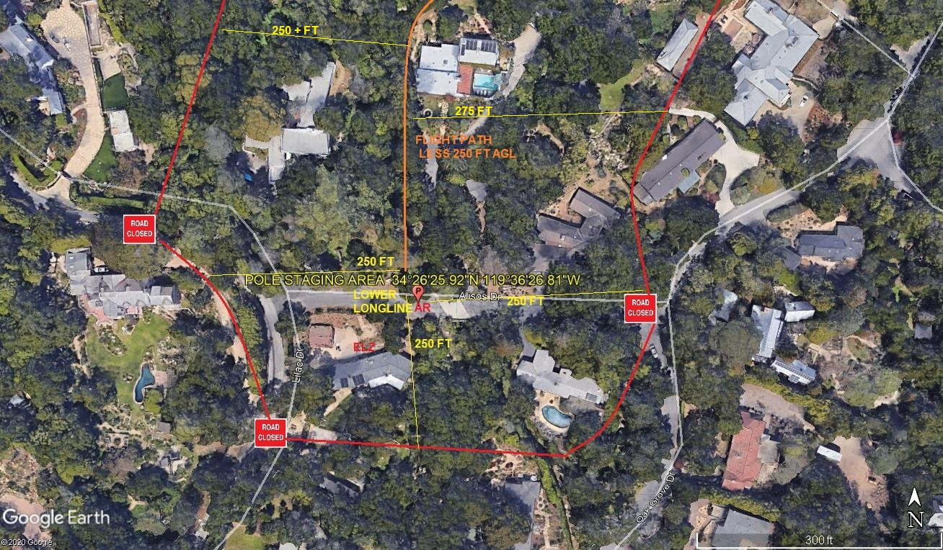
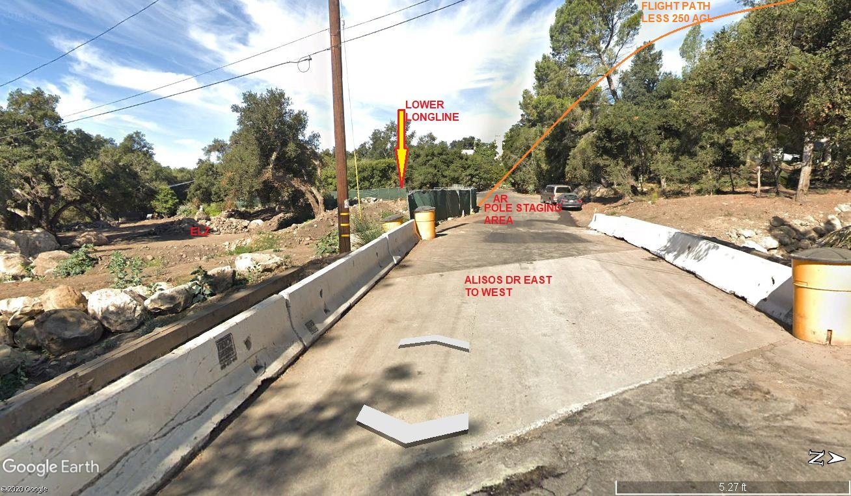
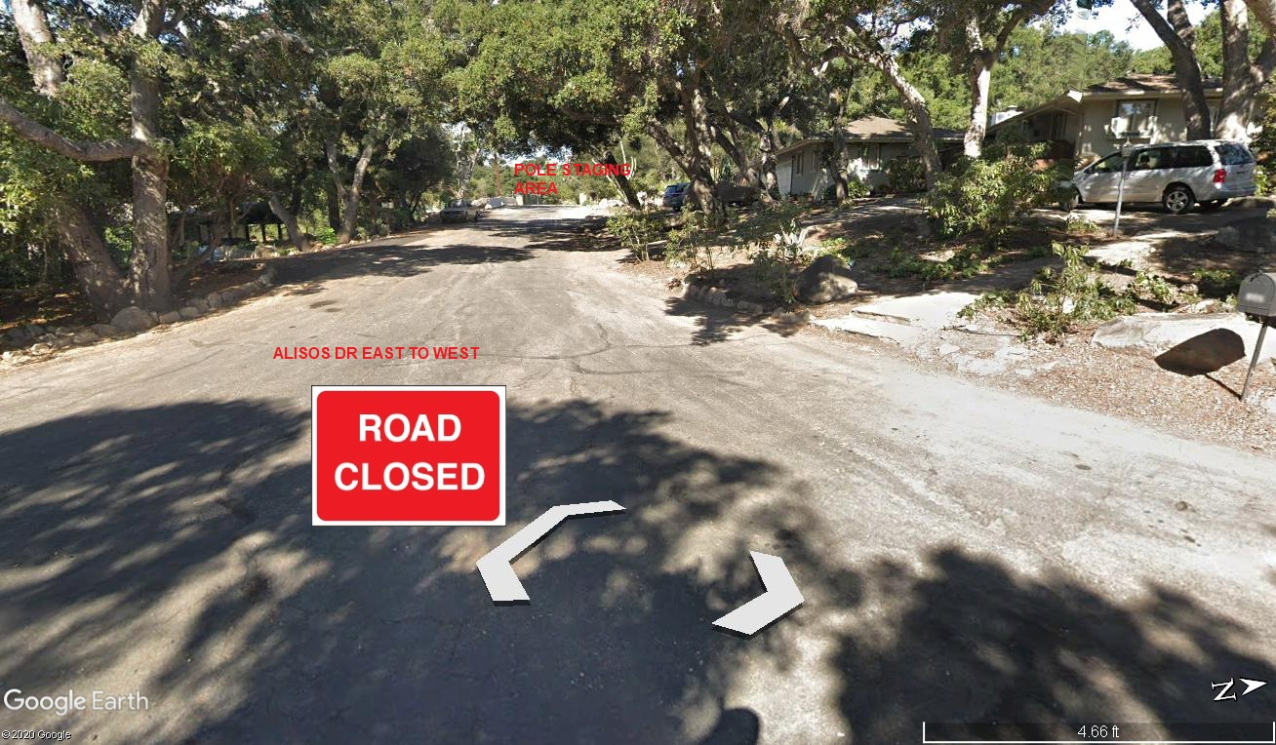
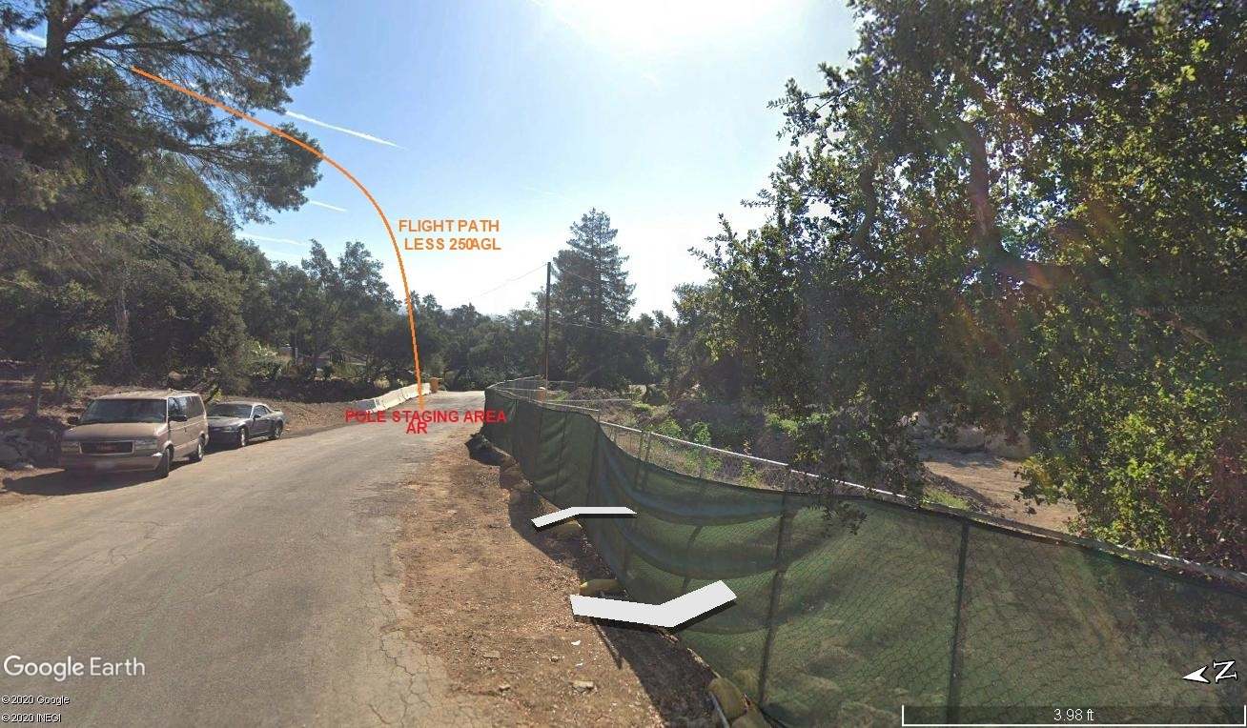

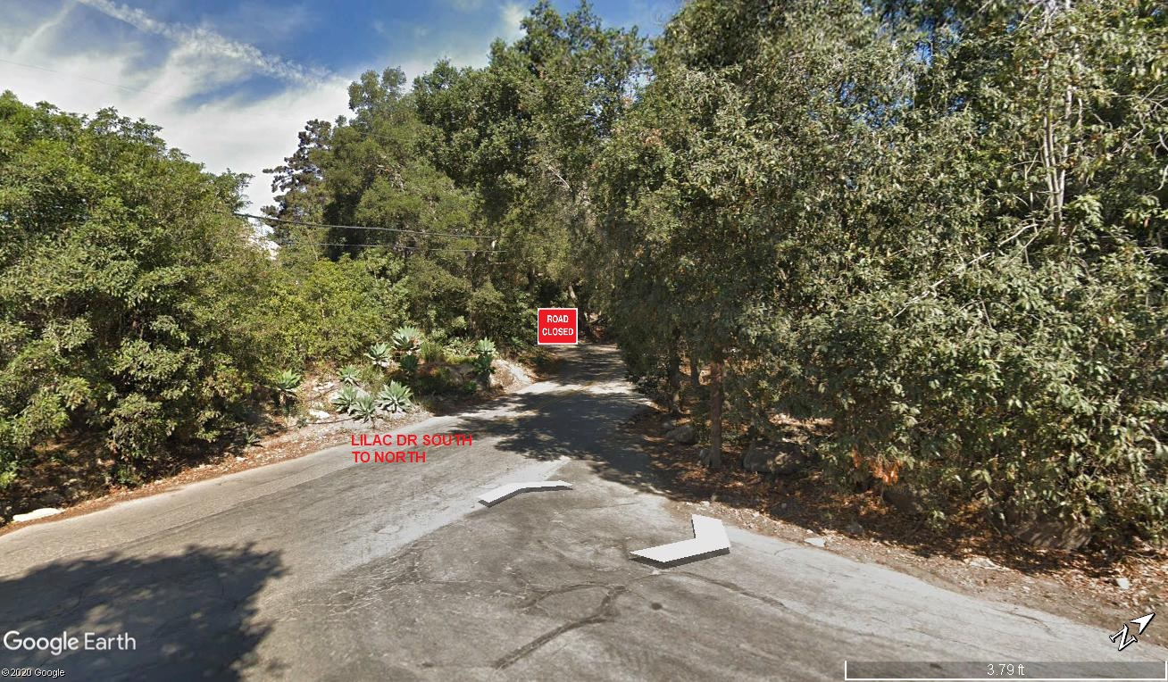
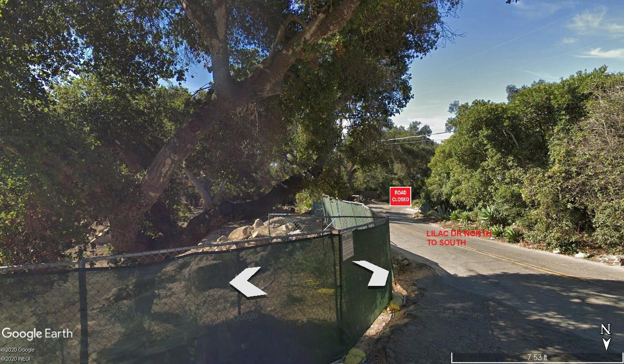LEGEND
SITE PLAN SYMBOLS: EVACUATION FLIGHT PATH
LANDING AREA = (LZ) | STREET BLOCKED = XXXX | TOP TWO FLOORS = UBT2
ATTACH AREA = (A) | RELEASE AREA = (R)
FLIGHT PATH = >>> | EMERGENCY LAND = (ELZ)
UNOCCUPIED BUILDING = (UBA) | UNOCCUPIED BUILDING TOP FLOOR = (UBT1)
AREA SURVEY CONDUCTED BY : 

