
SECTION 7 Part 135 GH 4A Part 133 GH 4L
Non Congested Area Plan
Operator: Guardian Helicopters, Inc
67 D STREET
Fillmore CA. 93015
Phone (818) 442-9904
FAX (818) 442-9901
PROJECT: EDISON POLE REPLACEMENT WORK ORDER #: TD 1531332
ADDRESS: CALIENTE CREEK RD TEHACHAPI CA
LZ STAGING AREA LATITUDE 35°18'45.85"N LONGITUDE 118°33'24.09"W
HEC STAGING AREA LATITUDE 35°18'49.91"N LONGITUDE 118°30'16.16"W
686313E 686312E LATITUDE 35°18'32.43"N LONGITUDE 118°29'51.81"W 45 H3 2600 LBS 40 CL 5 12O0 LBS
CONTACT AT SITE; WILLIAM WADE PHONE#: 626-393-9686
PILOT’S NAME(S): 1. JOHN OLSON CERT #: 2769166
2. BUCKEY MACKAY CERT #: 2778051
3. MICHAEL KLINK CERT#: 3018828
4. IAN GOODALE CERT# :3741973
5. ROSS GOULET CERT# : 3396777
TYPE OF AIRCRAFT:BELL UH-1H N# N711GH A/C CATEGORY: RESTRICTED
BELL UH-1H N# N777GH A/C CATEGORY: RESTRICTED
BELL 407 N# N447GH A/C CATEGORY: STANDARD
BELL 407 N# N407GH A/C CATEGORY: STANDARD
BELL 205A1 N# N216GH A/C CATEGORY: STANDARD
AS350 B2 N# N498PT A/C CATEGORY: STANDARD
AS350 B3 N# N718GH A/C CATEGORY: STANDARD
AS350 B3 N# N215GH A/C CATEGORY: STANDARD
IF SAFETY DICTATES AND OR THE CUSTOMER REQUESTS ADDITIONAL LIFTS THE LIFTS WILL BE CONDUCTED REMAINING WITHIN THE APPROVED TIME PARAMETERS.
TYPE OF LIFTS: HEC COMPRESSOR LESS 1500 LBS POLES LESS 2600 LBS CLASS OF LOAD:EXTL CL B TYPE OF ITEM LIFTING: POLE AERODYNAMIC NON- AERODYNAMIC MAX 1500 LBS
NO. OF LIFTS: TBD LONG LINE: (NO) XXX (YES) LESS THEN 100 FT (LENGTH)
OPERATIONAL ALTITUDE: < 250 STREET CLOSING: (N0) XX (YES)
DATE AND TIMES OPERATION WILL BEGIN AND TERMINATE:
FLIGHT DATES |  | TIME BEGIN | TIME END |  | TODAY’S DATE
6-8 THRU 6-10-2020 HEC |  | SUNRISE | SUNSET |  | 5-28-2020
6-10-2020 HEC AND UH-1H |  | SUNRISE | SUNSET |  | 5-28-2020
AGENCY NAME: |  | PHONE#: | PERSON NOTIFIED: |  | DATE:
KERN COUNTY FIRE | 661-867-2311 |  |  | STATION 78 | NOTIFY
KERN COUNTRY SHERIFF | 661-823-6060 |  |  | DISPATCH | NOTIFY
SECTION 7 Part 135 GH 4A Part 133 GH 4L
Non Congested Area Plan
Operator: Guardian Helicopters, Inc
67 D Street
Fillmore, California 93015
Evacuation Crowd Control Street Closure
□No Evacuated Structures Operator Yes □ No
- Evacuated Structures Contractor Contractor
□Operator

LIST OF BUILDINGS THAT SHALL EITHER BE PARTIALLY OR ENTIRELY UNOCCUPIED PERSONS ALSO HOMES THAT WILL BE NOTIFIED OF ACTIVITY:
BUILDING DESCRIPTION/ADDRESS | REMARKS | METHOD
ALL HOMES WITHIN RED OPERATING AREA | VACANT DURING OPS | HAND DELIVER
SEE DIAGRAM = VACANT | VACANT DURING OPS | HAND DELIVER
Narrative description of pick-up site, route, delivery site, and plan for ceasing operation if unauthorized persons enter operational area or real hazard occurs.
SITE INSPECTION NOTES

ONLY PERSONNEL ESSENTIAL TO COMPLETING THE JOB SAFELY WILL BE PERMITTED TO PARTICIPATE IN THE EVOLUTION. ONLY PERSONNEL PARTICIPATING IN THE SAFETY BRIEF WILL BE PERMITTED TO BE IN THE AREA OF OPERATIONS. ONLY AUTHORIZED ESSENTIAL PERSONAL WILL BE PERMITTED IN THE IMMEDIATE AREA OF OPERATIONS. IN THE EVENT AN UNAUTHORIZED PERSON ENTERS THE OPERATIONS AREA OR A POTENTIAL HAZARD IS IDENTIFIED THE PILOT WILL HOLD THE AIRCRAFT IN RELATIVE POSITION. THIS WILL BE ACHIEVED WITHOUT OVER FLYING THE GROUND CREW. ALL OPERATIONS WILL BE CEASED UNTIL THE PROBLEM IS RECTIFIED. IN THE EVENT OF AN AIRCRAFT EMERGENCY, THE PILOT WILL RADIO GROUND PERSONNEL AND WILL ATTEMPT TO LAND IN THE EMERGENCY LANDING AREA.
DURING THE LIFT EVOLUTION THE AIRCRAFT AND GROUND CREW WILL ALL BE IN RADIO COMMUNICATIONS. IN THE EVENT OF LOSS COMMUNICATIONS, THE CREW WILL USE STANDARD HAND SIGNALS TO COMMUNICATE WITH THE PILOT. WHEN THE PILOT IS CLEAR HE WILL MOVE THE AIRCRAFT TO A SAFE LOCATION TO ALLOW THE COMMUNICATION PROBLEM TO BE RECTIFIED.
THE OPERATIONS AREA IS WITHIN THE SECURED AREA. ALL ESSENTIAL CREW WITHIN THE OPERATIONS AREA WILL NOT BE INVOLVED IN TAKING PICTURES OR ANY OTHER USE OF CELL PHONES.
PRIOR TO BEGINNING OPERATIONS, A TAILBOARD SAFETY BRIEF WILL BE CONDUCTED.
- HELICOPTER WILL LAND AT THE LZ TO CONNECT THE LONGLINE AND CONDUCT A TAILBOARD SAFETY BRIEF AND HEC TRAINING
- THE HEC SHIP WILL PROVIDE SUPPORT ALL THREE DAYS THE UH-1H WILL LIFT POLES ON DAY 3
- FUELING WILL OCCUR AT THE LZ
- HEC PICK UP AND POLES WILL BE STAGED TO THE NORTH OF LANDING ZONE
- EMERGENCY LANDING ZONE IS AT THE STAGING AREA AND ALONG THE FLIGHT PATH
- TAILBOARD SAFETY BRIEF CONDUCTED AT THE LZ PRIOR TO FLIGHT
- CALIENTE CREEK ROAD WILL EXPERIENCE INTERMITTENT CLOSURES
- SEE DRAWING BELOW FOR LOCATIONS OF CLOSURES
- WATER TRUCK IS REQUIRED AT THE LANDING ZONE
- REMOTE AREA NO EVACUATIONS
- THE CONTRACTOR WILL TRIM TREES IF REQUIRED

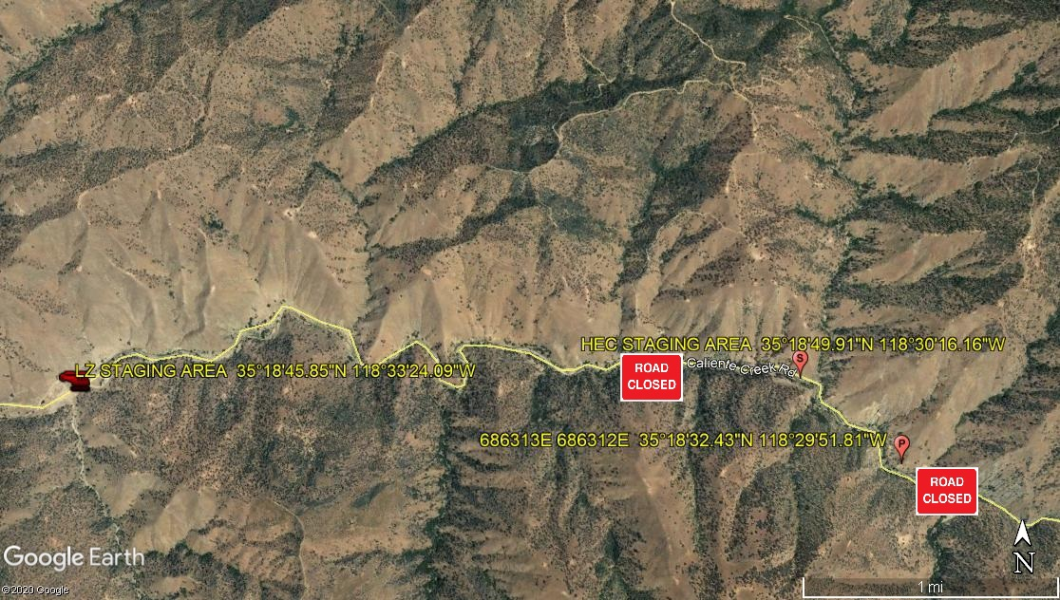
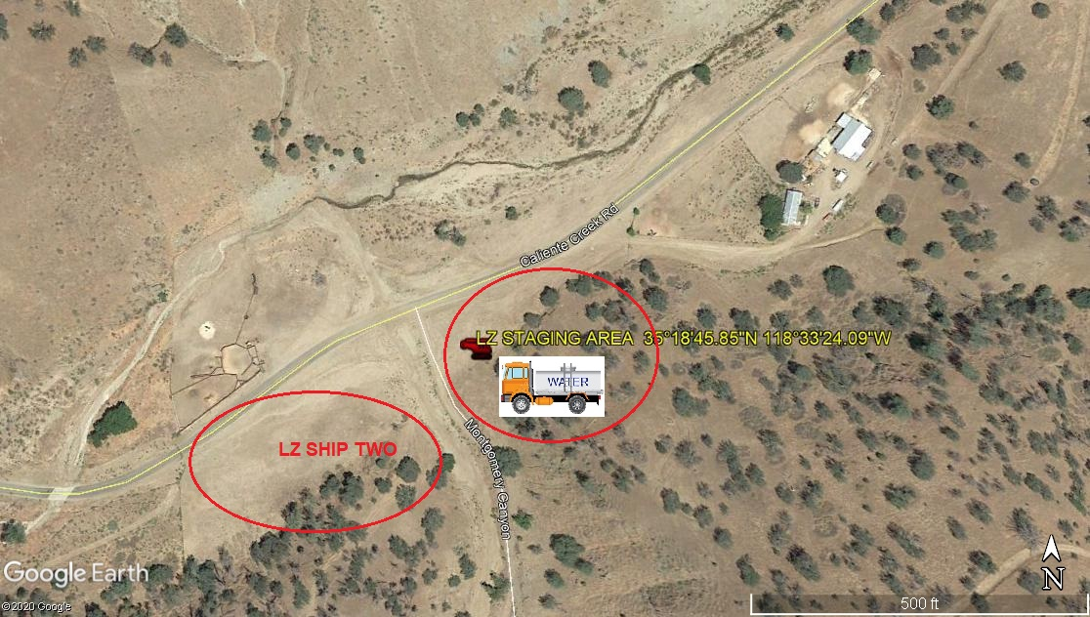
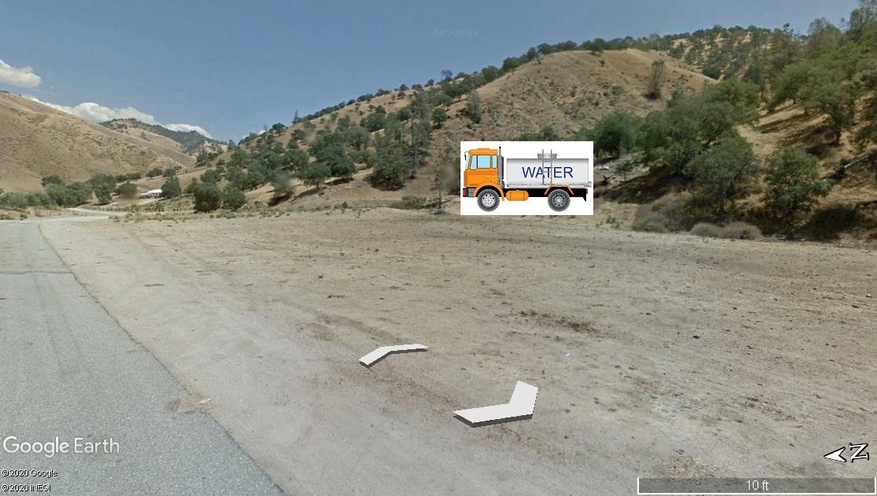
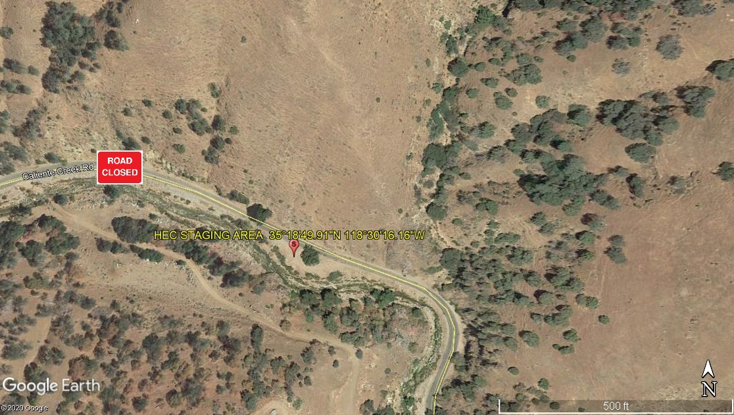
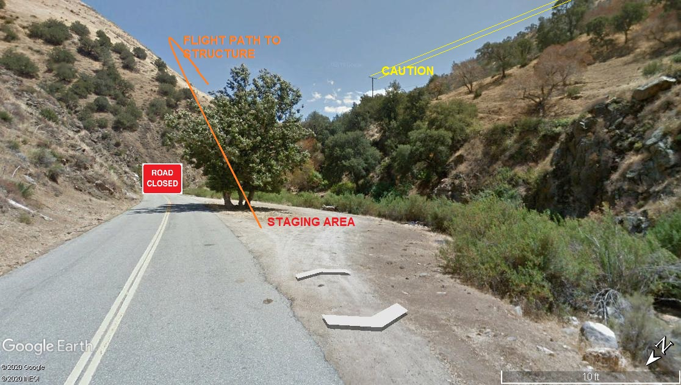
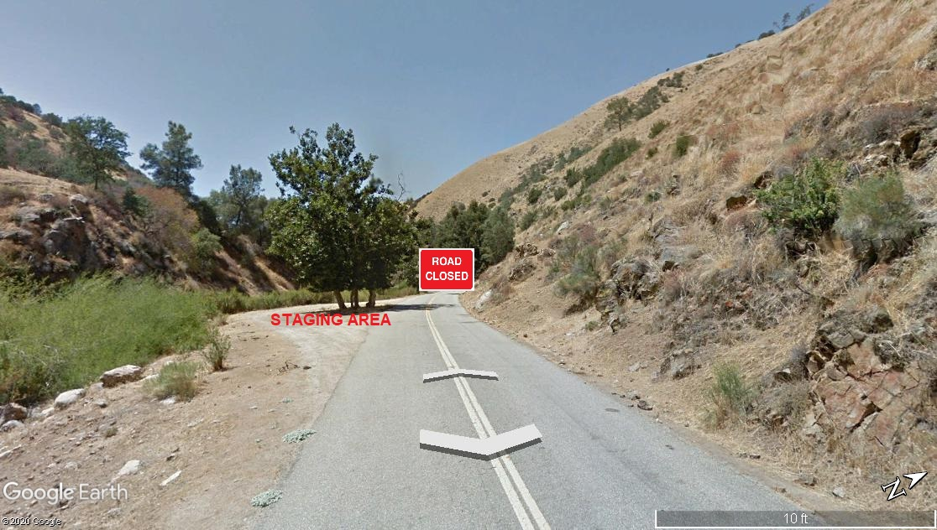
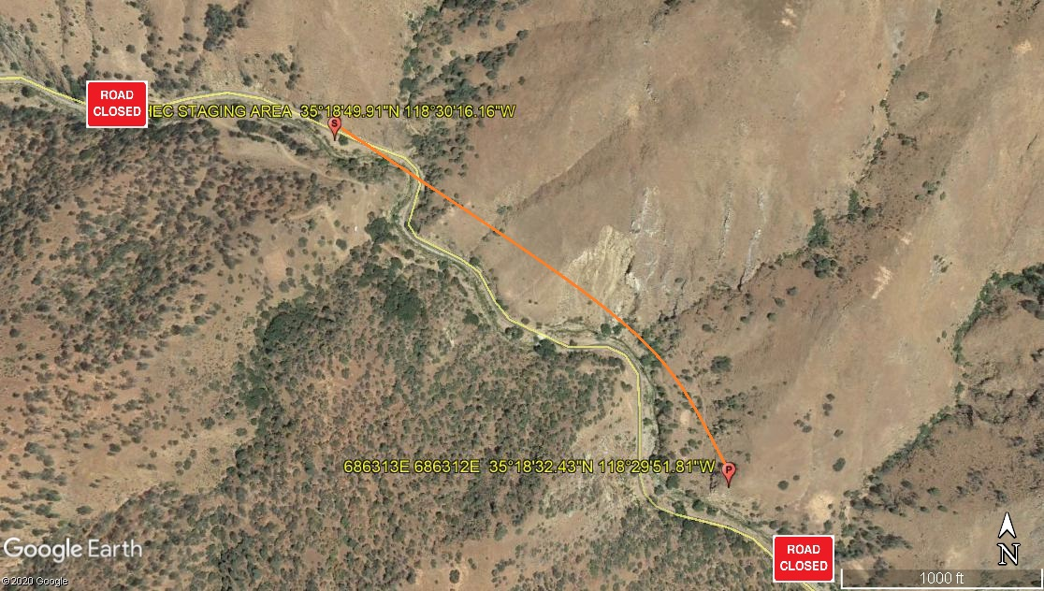
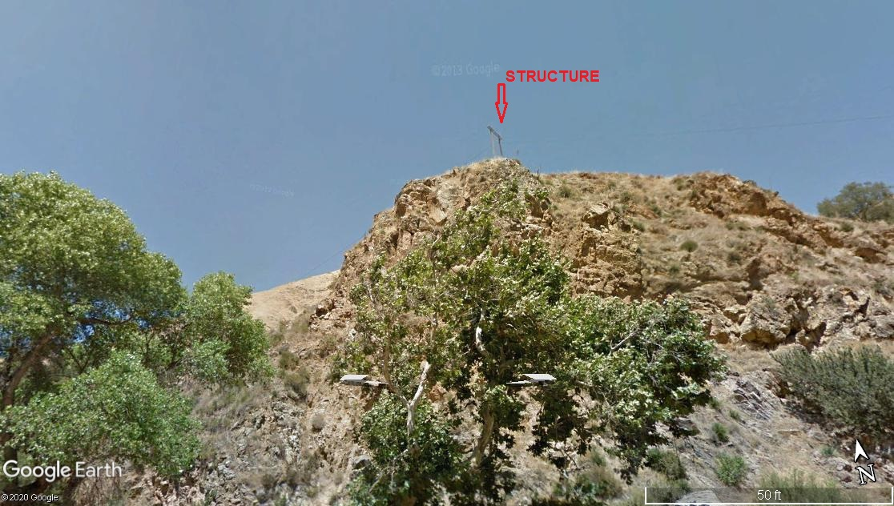

5-28-2020 
DATE OF SUBMISSION COMPANY OFFICIAL / TITLE

