
SECTION 7 Part 135 GH 4A Part 133 GH 4L
NON Congested Area Plan
Operator: Guardian Helicopters, Inc
67 D STREET
Fillmore CA. 93015
Phone (818) 442-9904
FAX (818) 442-9901
PROJECT: EDISON HEC ONLY WORK ORDER #: SEE ATTACHED LIST
ADDRESS: AIRPORT IN THE SKY : CATALINA ISLAND CA
SEE KMZ FILE AND ATTACHED LIST FOR POLE POSITIONS AND LZ STAGING AREA
CONTACT AT SITE; MIKE PACHECO PHONE#: 949-812-9583
PILOT’S NAME(S): 1. JOHN OLSON CERT #: 2769166
2. BUCKEY MACKAY CERT #: 2778051
3. MICHAEL KLINK CERT #: 3018828
4. IAN GOODALE CERT #:3741973
5. ROSS GOULET CERT#:339677
TYPE OF AIRCRAFT:BELL UH-1H N# N711GH A/C CATEGORY: RESTRICTED
BELL UH-1H N# N214KK A/C CATEGORY: RESTRICTED
BELL 407 N# N407GH A/C CATEGORY: STANDARD
BELL 205A1 N# N216GH A/C CATEGORY: STANDARD
AS350 B2 N# N498PT A/C CATEGORY: STANDARD
AS350 B3 N# N718GH A/C CATEGORY: STANDARD
AS350 B3 N# N215GH A/C CATEGORY: STANDARD
IF SAFETY DICTATES AND OR THE CUSTOMER REQUESTS ADDITIONAL LIFTS THE LIFTS WILL BE CONDUCTED REMAINING WITHIN THE APPROVED TIME PARAMETERS.
TYPE OF LIFTS: HEC ONLY CLASS OF LOAD:EXTL CL B TYPE OF ITEM LIFTING: POLE AERODYNAMIC NON- AERODYNAMIC MAX 1600 LBS
NO. OF LIFTS: TBD LONG LINE: (NO) XXX (YES) LESS THEN 150 FT (LENGTH)
OPERATIONAL ALTITUDE: < 250 STREET CLOSING: (N0) XX (YES)
DATE AND TIMES OPERATION WILL BEGIN AND TERMINATE:
FLIGHT DATES | TIME BEGIN | TIME END | TODAY’S DATE
7-18-2020 | SUNRISE | SUNSET | 7-8-2020
7-19-2020 | SUNRISE | SUNSET | 7-8-2020
7-21-2020 | SUNRISE | SUNSET | 7-8-2020
7-24-2020 | SUNRISE | SUNSET | 7-8-2020
AGENCY NAME: | PHONE#: | PERSON NOTIFIED: | DATE:
AVALON POLICE DEPARTMENT | 310-510-0174 | WATCH COMMANDER | NOTIFY
CATALINA FIRE DEPARTMENT | 310-510-0203 | STATION | NOTIFY
Evacuation Crowd Control Street Closure
- No Evacuated Structures Operator □Yes No
□Evacuated Structures Contractor Contractor
□Operator
SECTION 7 Part 135 GH 4A Part 133 GH 4L
NON Congested Area Plan
Operator: Guardian Helicopters, Inc
67 D Street
Fillmore, California 93015
LIST OF BUILDINGS THAT SHALL EITHER BE PARTIALLY OR ENTIRELY UNOCCUPIED PERSONS ALSO HOMES THAT WILL BE NOTIFIED OF ACTIVITY:
BUILDING DESCRIPTION/ADDRESS | REMARKS | METHOD
ALL HOMES WITHIN RED OPERATING AREA | VACANT DURING OPS | HAND DELIVER
SEE DIAGRAM = VACANT | VACANT DURING OPS | HAND DELIVER

Narrative description of pick-up site, route, delivery site, and plan for ceasing operation if unauthorized persons enter operational area or real hazard occurs.
SITE INSPECTION NOTES

ONLY PERSONNEL ESSENTIAL TO COMPLETING THE JOB SAFELY WILL BE PERMITTED TO PARTICIPATE IN THE EVOLUTION. ONLY PERSONNEL PARTICIPATING IN THE SAFETY BRIEF WILL BE PERMITTED TO BE IN THE AREA OF OPERATIONS. ONLY AUTHORIZED ESSENTIAL PERSONAL WILL BE PERMITTED IN THE IMMEDIATE AREA OF OPERATIONS. IN THE EVENT AN UNAUTHORIZED PERSON ENTERS THE OPERATIONS AREA OR A POTENTIAL HAZARD IS IDENTIFIED THE PILOT WILL HOLD THE AIRCRAFT IN RELATIVE POSITION. THIS WILL BE ACHIEVED WITHOUT OVER FLYING THE GROUND CREW. ALL OPERATIONS WILL BE CEASED UNTIL THE PROBLEM IS RECTIFIED. IN THE EVENT OF AN AIRCRAFT EMERGENCY, THE PILOT WILL RADIO GROUND PERSONNEL AND WILL ATTEMPT TO LAND IN THE EMERGENCY LANDING AREA.
DURING THE LIFT EVOLUTION THE AIRCRAFT AND GROUND CREW WILL ALL BE IN RADIO COMMUNICATIONS. IN THE EVENT OF LOSS COMMUNICATIONS, THE CREW WILL USE STANDARD HAND SIGNALS TO COMMUNICATE WITH THE PILOT. WHEN THE PILOT IS CLEAR HE WILL MOVE THE AIRCRAFT TO A SAFE LOCATION TO ALLOW THE COMMUNICATION PROBLEM TO BE RECTIFIED.
THE OPERATIONS AREA IS WITHIN THE SECURED AREA. ALL ESSENTIAL CREW WITHIN THE OPERATIONS AREA WILL NOT BE INVOLVED IN TAKING PICTURES OR ANY OTHER USE OF CELL PHONES.
PRIOR TO BEGINNING OPERATIONS, A TAILBOARD SAFETY BRIEF WILL BE CONDUCTED.
- HELICOPTER WILL LAND AT THE AIRPORT OR DESIGNATED LZ TO CONNECT LONGLINE AND CONDUCT HEC TRAINING / SAFETY TAILBOARD
- HEC WILL BE CONDUCTED FROM ASSIGNED LZ
- FUELING WILL BE CONDUCTED FROM IEX HELIPORT NEAR AVALON
- EMERGENCY LANDING ZONE IS AT THE STAGING AREA AND ALONG THE FLIGHT PATH
- REMOTE NO STREET CLOSURES
- WATER TRUCK REQUIRED AT LZ
- REMOTE NO EVACUATIONS
WO # | Pole # | Location |  | Zone | SEA |  | CREWS SWD | FOREMAN
TD1382338 | 1492744E | Big Springs |  | 1 | N |  | 7/19/2020 | RODRIGUEZ
TD1382345 | X10143E | Cape Canyon |  |  |  |  | 7/24/2020 | JAEGER
TD1382338 | 1492734E | Marble Quarry |  | 1 | N |  | 7/19/2020 | JAEGER
TD1382338 | 1492742E | Big Springs |  | 1 | N |  | 7/19/2020 | RODRIGUEZ
TD1382338 | 1492735E | Marble Quarry |  | 1 | N |  | 7/19/2020 | JAEGER
TD1382338 | 1492743E | Big Springs |  | 1 | N |  | 7/19/2020 | RODRIGUEZ
TD1382338 | 1492710E | Below Airport |  | 2 | N |  | 7/21/2020 | RODRIGUEZ
TD1382349 | 1492711E | Below Airport |  | 2 | N |  | 7/21/2020 | RODRIGUEZ
TD1382349 | 1492712E | Below Airport |  | 2 | N |  | 7/21/2020 | JAEGER
TD1382345 | 1492689E | Black Jack |  | 1 | N |  | 7/24/2020 | LAZA
TD1382349 | 1492691E | Black Jack |  | 2 | N |  | 7/24/2020 | RODRIGUEZ
TD1382345 | 1492690E | Black Jack |  | 1 | N |  | 7/24/2020 | LAZA
TD1382349 | 1492692E | Black Jack |  | 2 | N |  | 7/24/2020 | RODRIGUEZ
TD1147210 | 1492496E | USC Tap Line - HOEFS |  | 1 | N |  | 7/18/2020 | RODRIGUEZ
TD1382353 | 4296702E | Toyon Tap Line - HOEFS |  | 0 | N |  |  | LAZA

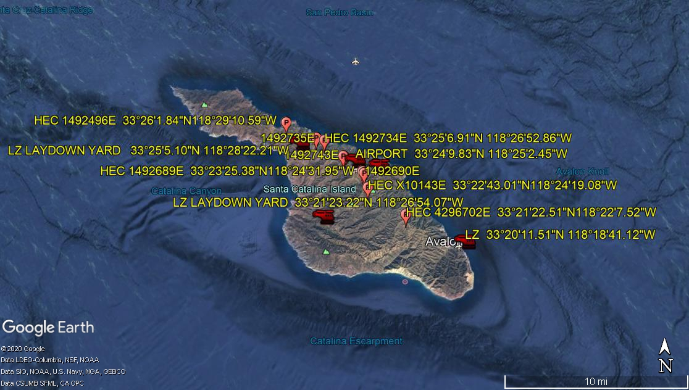
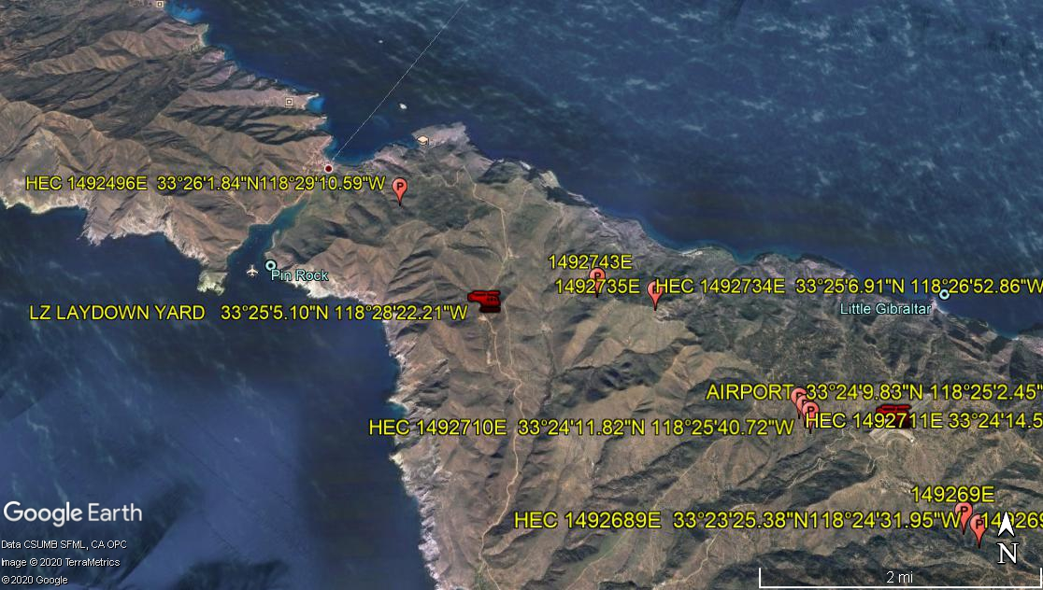
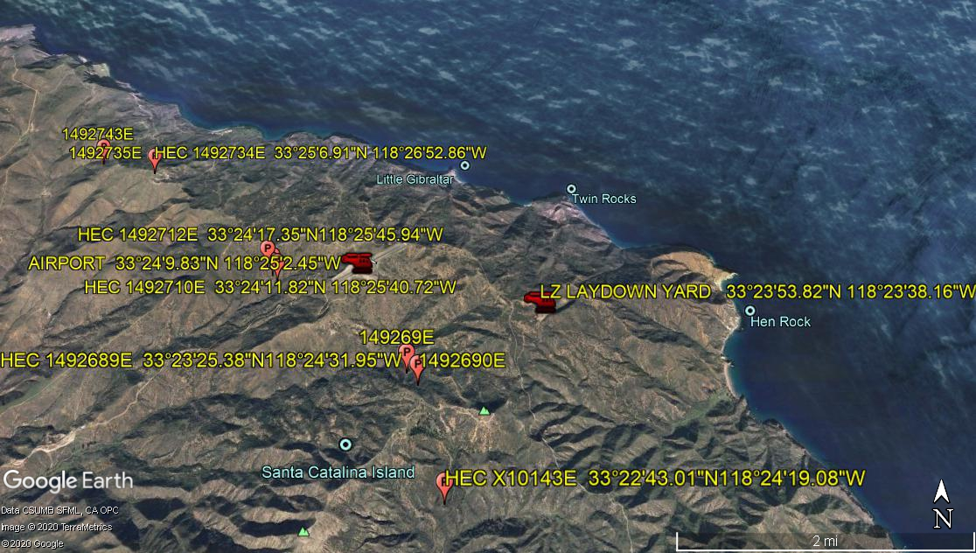
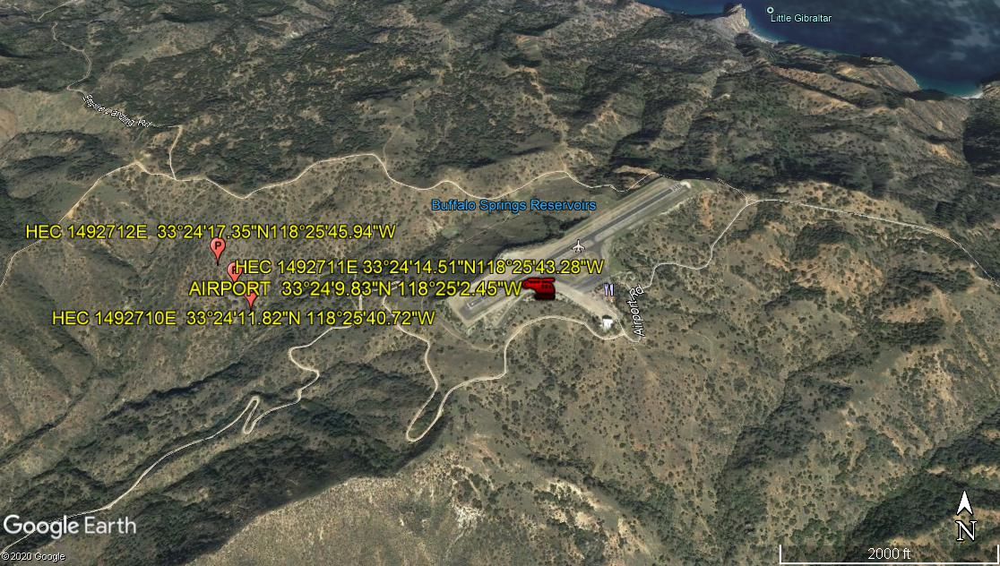
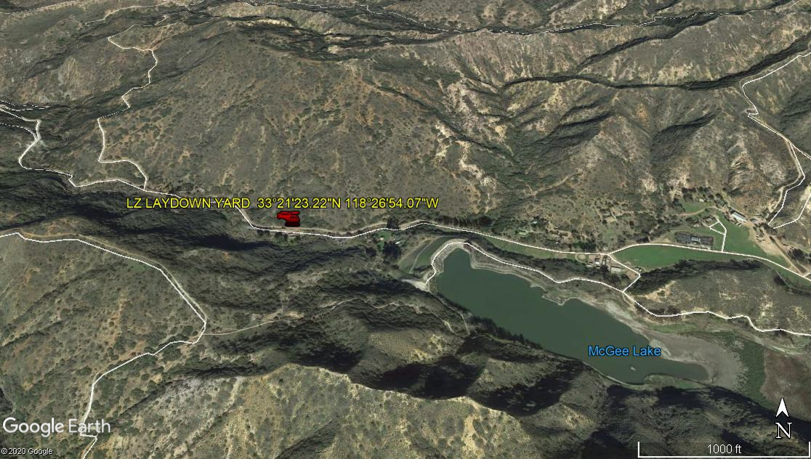
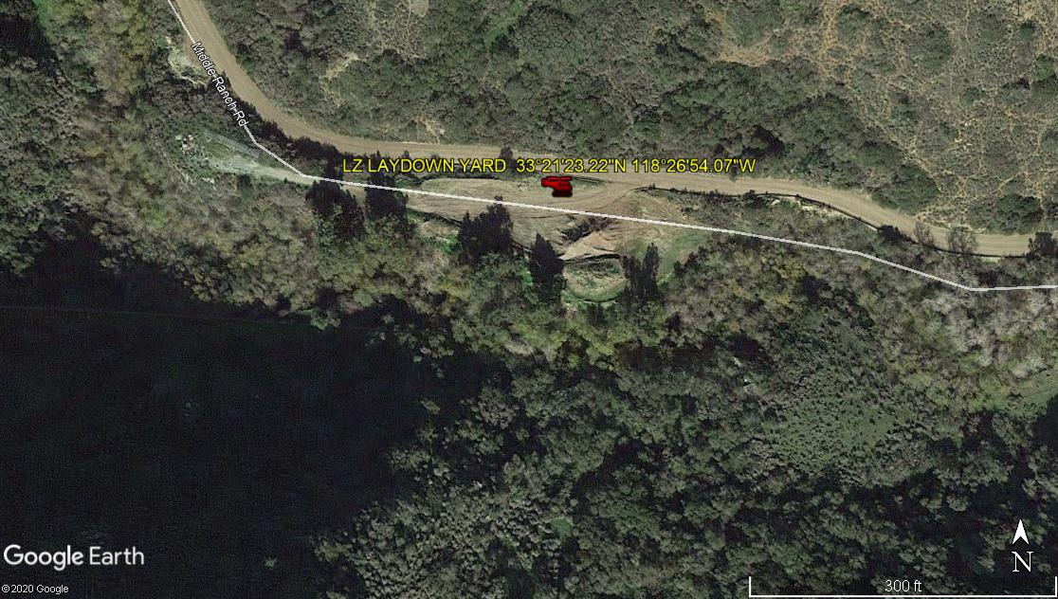
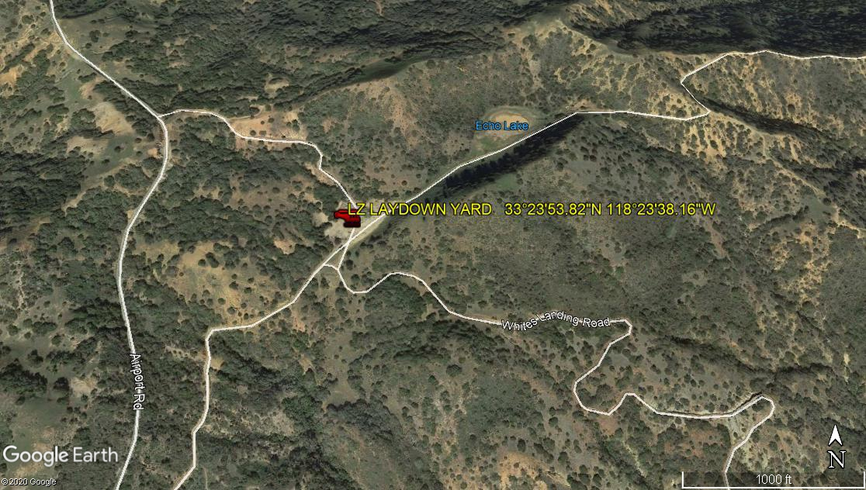
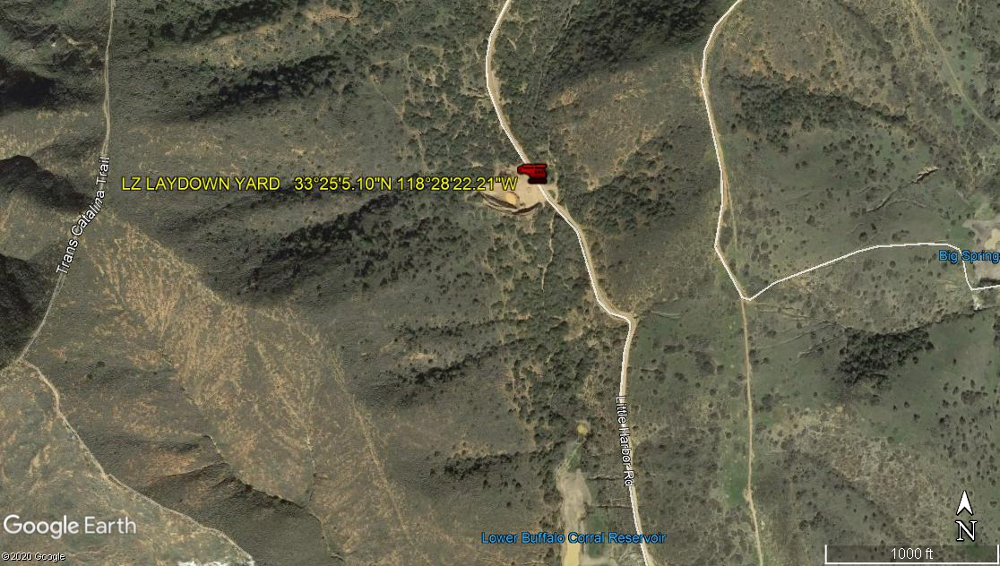
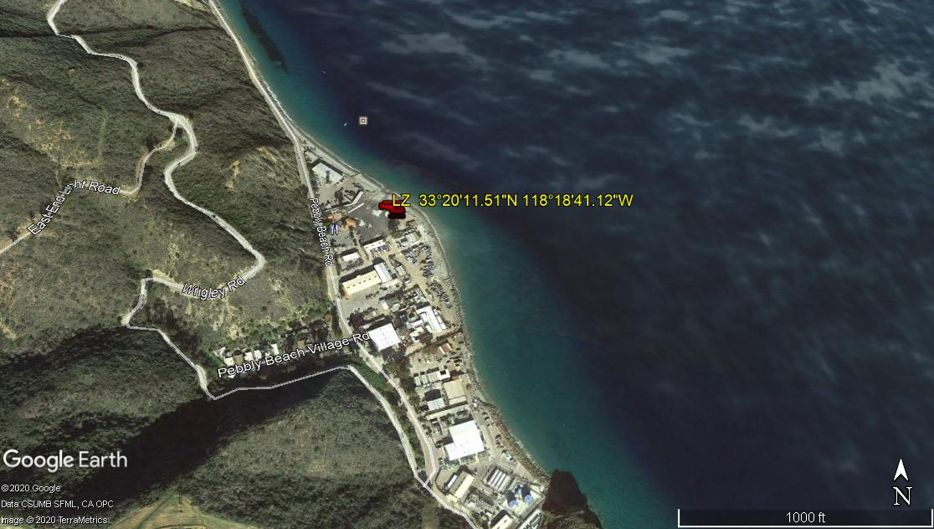
7-8-2020 
DATE OF SUBMISSION COMPANY OFFICIAL / TITLE

