
SECTION 7 Part 135 GH 4A Part 133 GH 4L
NON Congested Area Plan
Operator: Guardian Helicopters, Inc
67 D STREET
FILLMORE , CA 93015
Phone (818) 442-9904
FAX (818) 442-9901
PROJECT: EDISON POLE REPLACEMENT WORK ORDER #: TD 1533733
ADDRESS: YOKOHI VALLEY RD : SPRINGVILLE CA
LZ STAGING AREA LATITUDE 36°13'51.83"N LONGITUDE 118°52'38.88"W
CONTRACTOR’S NAME: JEFF MILHOUS PHONE#: 559-476-1399
CONTRACTOR’S NAME: RON MAURER PHONE#: 559-331-1399
FOREMAN NAME : TODD BARTON PHONE#: 925-529-5899
FOREMAN NAME : JEFF EMERSON PHONE#: 559-376-3870
PILOT’S NAME(S): 1. JOHN OLSON CERT #: 2769166
2. BUCKEY MACKAY CERT #: 2778051
3. MICHAEL KLINK CERT#: 3018828
4. IAN GOODALE CERT# :3741973
5. ROSS GOULET CERT# : 3396777
TYPE OF AIRCRAFT:
BELL UH-1H N# N711GH A/C CATEGORY: RESTRICTED
BELL UH-1H N# N777GH A/C CATEGORY: RESTRICTED
BELL 407 N# N407GH A/C CATEGORY: STANDARD
BELL 407 N# N447GH A/C CATEGORY: STANDARD
BELL 205A1 N# N216GH A/C CATEGORY: STANDARD
AS350 B2 N# N498PT A/C CATEGORY: STANDARD
AS350 B3 N# N718GH A/C CATEGORY: STANDARD
AS350 B3 N# N215GH A/C CATEGORY: STANDARD
TYPE OF ITEM LIFTING: POLE AERODYNAMIC NON- AERODYNAMIC
IF SAFETY DICTATES AND OR THE CUSTOMER REQUESTS ADDITIONAL LIFTS THE LIFTS WILL BE CONDUCTED REMAINING WITHIN THE APPROVED TIME PARAMETERS.
TYPE OF LIFTS3 POLES POLE REPLACEMENT ONLY
MAX SINGLE – LIFT WEIGHT: SEE CHART CLASS OF LOAD: EXTERNAL CL B
NO. OF LIFTS: TBD LONG LINE: (NO) XXX (YES) LESS THEN 100 FT (LENGTH)
OPERATIONAL ALTITUDE: < 50 STREET CLOSING: (N0) XX (YES)
DATE AND TIMES OPERATION WILL BEGIN AND TERMINATE:
FLIGHT DATES | TIME BEGIN | TIME END | TODAY’S DATE
7-25-2020 | SUNRISE | SUNSET | 7-15-2020
7-26-2020 | SUNRISE | SUNSET | 7-15-2020
AGENCY NAME: | PHONE#: | PERSON NOTIFIED: | DATE:
SPRINGVILLE | 559-539-2626 | TULARE STATION 22 | NOTIFY
SHERIFF | 559-782-9650 | TULARE COUNTY SHERIFF | NOTIFY
NON- Congested Area Plan (Continued)
Evacuation Crowd Control Street Closure
No Evacuated Structures Operator Yes □ No
□Evacuated Structures Contractor Contractor
□Operator
LIST OF BUILDINGS THAT SHALL EITHER BE PARTIALLY OR ENTIRELY UNOCCUPIED PERSONS ALSO HOMES THAT WILL BE NOTIFIED OF ACTIVITY:
BUILDING DESCRIPTION/ADDRESS | REMARKS | METHOD
REMOTE NO EVACUATIONS | VACANT DURING OPS | HAND DELIVER
ALL HOMES WITHIN OPERATING AREA | VACANT DURING OPS | HAND DELIVER
SEE DIAGRAM = V | VACANT DURING OPS | HAND DELIVER

Narrative description of pick-up site, route, delivery site, and plan for ceasing operation if unauthorized persons enter operational area or real hazard occurs.
SITE INSPECTION NOTES

ONLY PERSONNEL ESSENTIAL TO COMPLETING THE JOB SAFELY WILL BE PERMITTED TO PARTICIPATE IN THE EVOLUTION. ONLY PERSONNEL PARTICIPATING IN THE SAFETY BRIEF WILL BE PERMITTED TO BE IN THE AREA OF OPERATIONS. ONLY AUTHORIZED ESSENTIAL PERSONAL WILL BE PERMITTED IN THE IMMEDIATE AREA OF OPERATIONS. IN THE EVENT AN UNAUTHORIZED PERSON ENTERS THE OPERATIONS AREA OR A POTENTIAL HAZARD IS IDENTIFIED THE PILOT WILL HOLD THE AIRCRAFT IN RELATIVE POSITION. THIS WILL BE ACHIEVED WITHOUT OVER FLYING THE GROUND CREW. ALL OPERATIONS WILL BE CEASED UNTIL THE PROBLEM IS RECTIFIED. IN THE EVENT OF AN AIRCRAFT EMERGENCY, THE PILOT WILL RADIO GROUND PERSONNEL AND WILL ATTEMPT TO LAND IN THE EMERGENCY LANDING AREA.
DURING THE LIFT EVOLUTION THE AIRCRAFT AND GROUND CREW WILL ALL BE IN RADIO COMMUNICATIONS. IN THE EVENT OF LOSS COMMUNICATIONS THE CREW WILL USE STANDARD HAND SIGNALS TO COMMUNICATE WITH THE PILOT. WHEN THE PILOT IS CLEAR HE WILL MOVE THE AIRCRAFT TO A SAFE LOCATION TO ALLOW THE COMMUNICATION PROBLEM TO BE RECTIFIED.
THE OPERATIONS AREA IS WITHIN THE SECURED AREA. ALL ESSENTIAL CREW WITHIN THE OPERATIONS AREA WILL NOT BE INVOLVED IN TAKING PICTURES OR ANY OTHER USE OF CELL PHONES.
A TAILBOARD SAFETY MEETING WILL BE HELD AT THE ASSIGNED AREA PRIOR TO BEGINNING HELICOPTER OPERATIONS
1. HELICOPTER WILL AT THE LANDING ZONE AREA TO CONDUCT A TAILBOARD
2. FUELING WILL ONLY BE CONDUCTED AT THE LZ STAGING AREA
3 THE POLES WILL BE STAGED AT THE STAGING AREA OFF
6. EMERGENCY LANDING ZONE IS AT THE STAGING AREA AND ALONG THE FLIGHT PATH
7. REMOTE NO EVACUATIONS
8. WATER TRUCK IS REQUIRED AT POLE STAGING AREA
9 YOKOHI VALLEY RD WILL EXPERIENCE INTERMITTENT CLOSURES DURING OPERATION SEE DIAGRAM
10. TREE TRIMMER IS REQUIRED

OPERATIONS AREA DIAGRAM
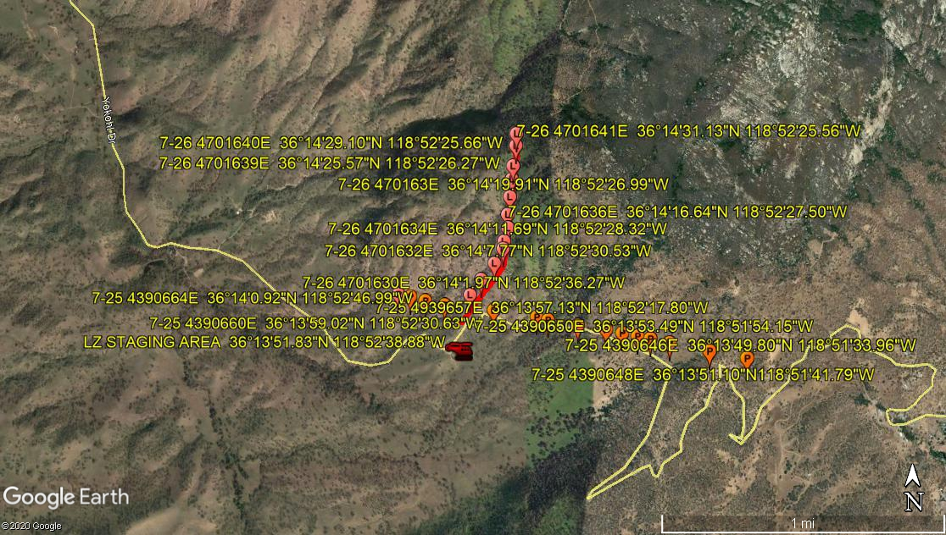
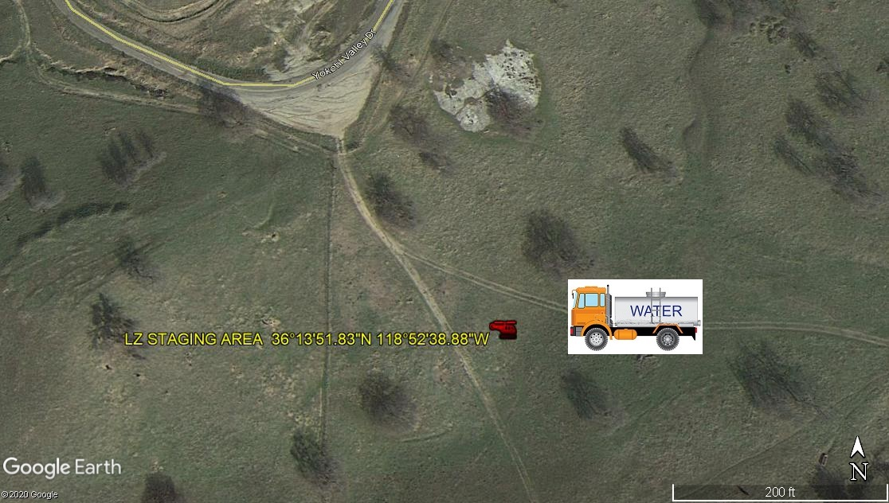

7-25-2020
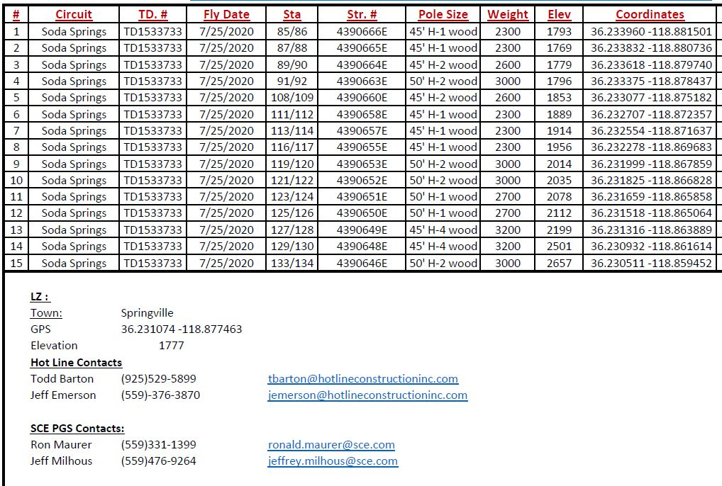
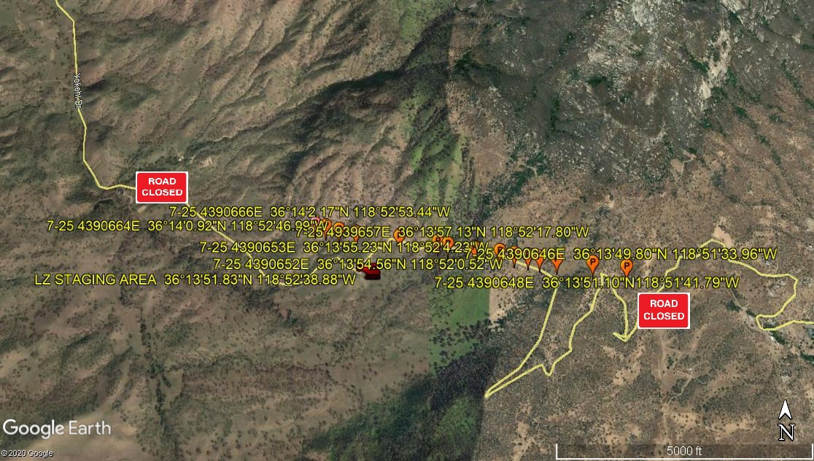

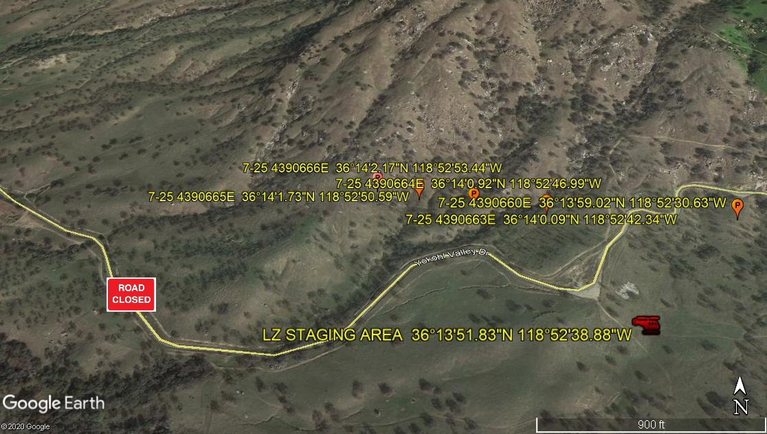
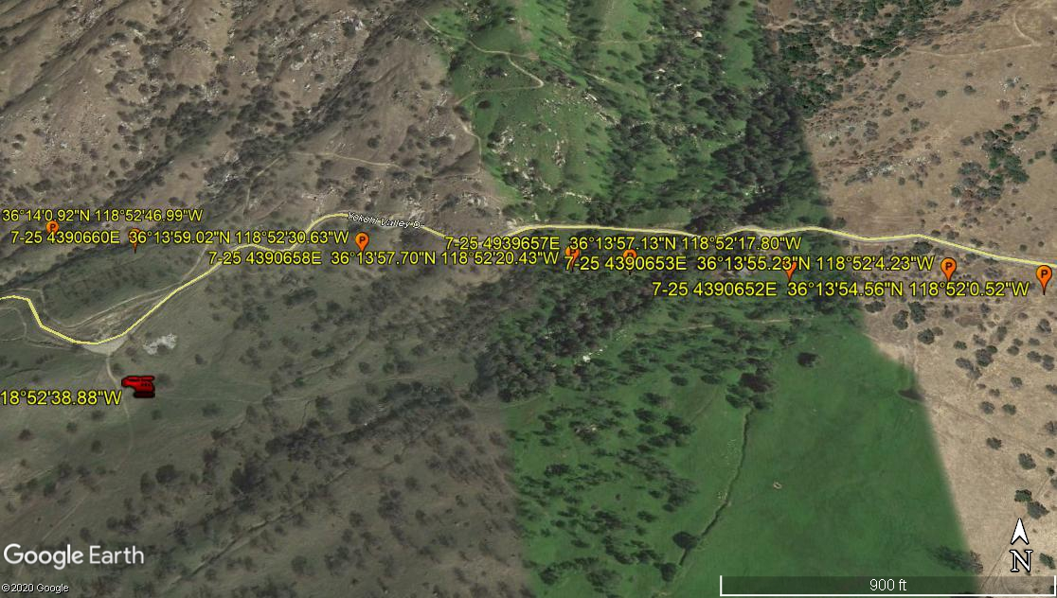
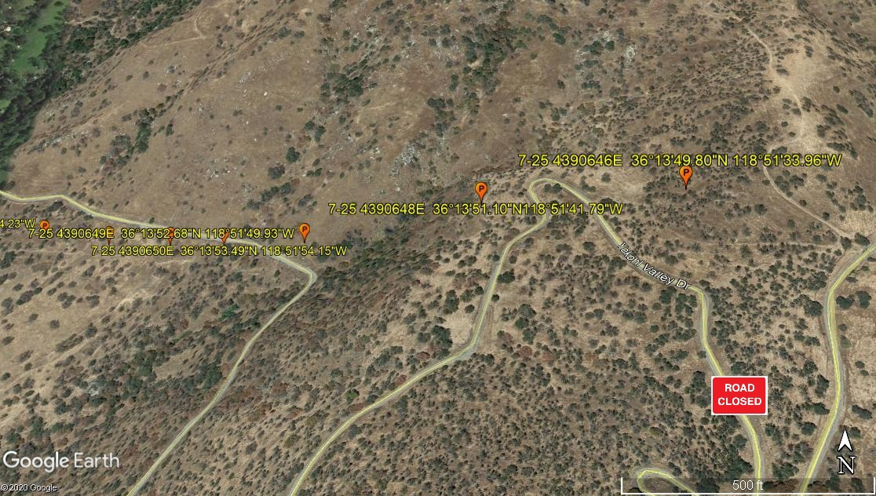
7-26-2020
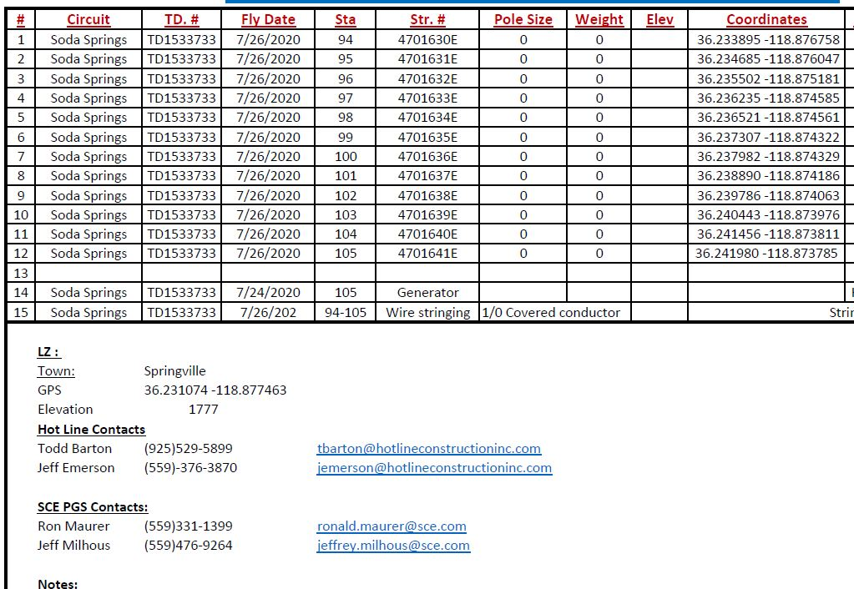

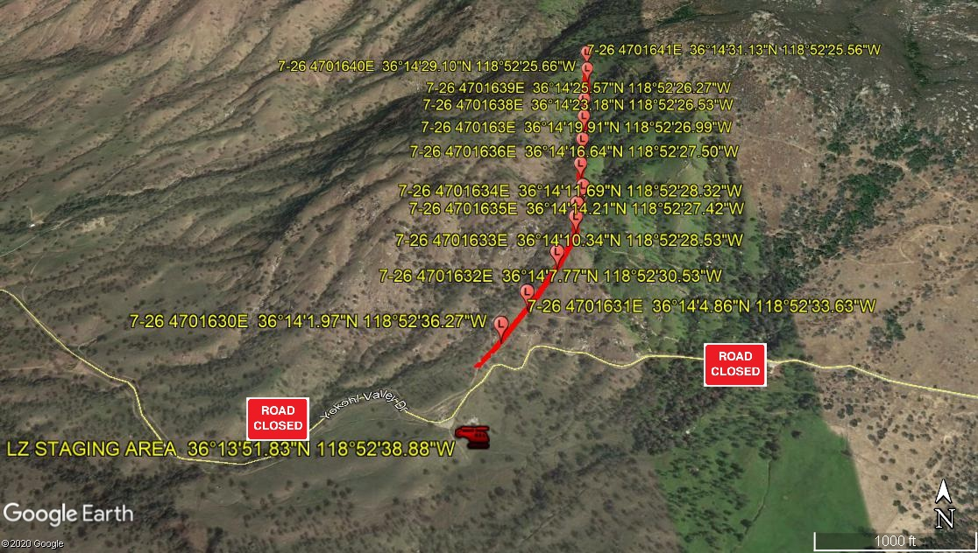
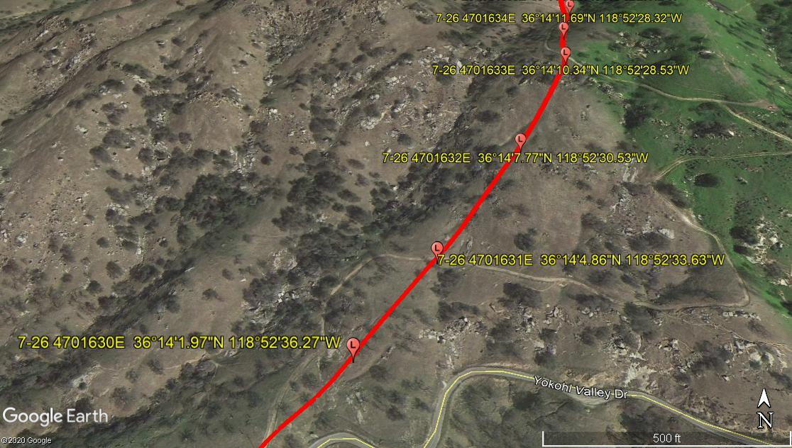
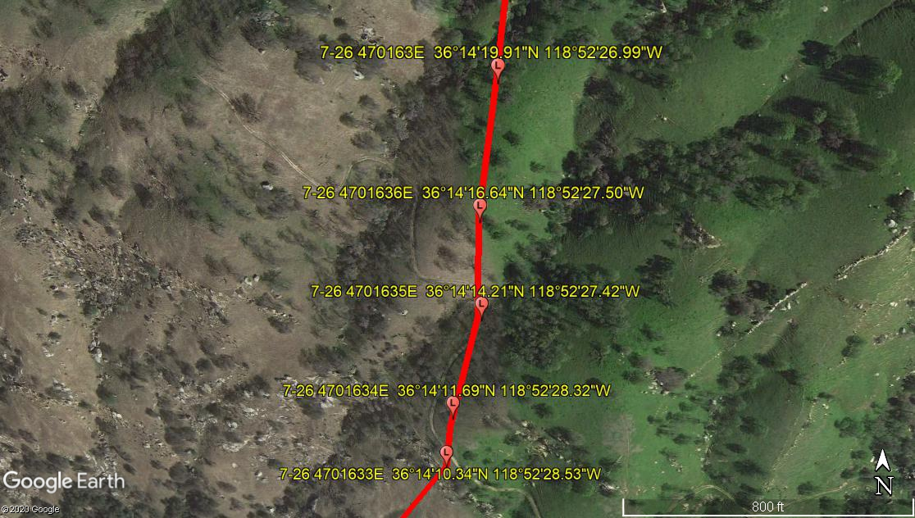
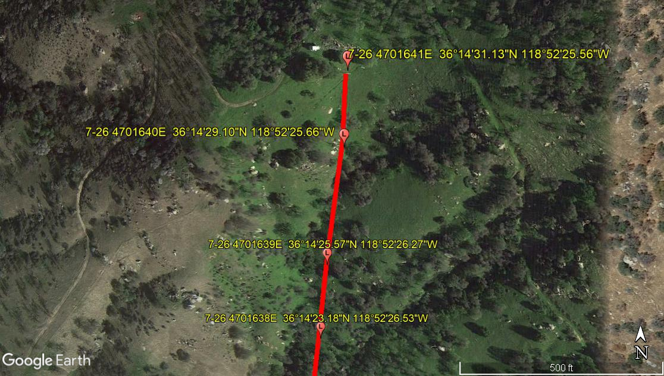
LEGEND
SITE PLAN SYMBOLS: EVACUATION FLIGHT PATH
LANDING AREA = (LZ) | STREET BLOCKED = XXXX | TOP TWO FLOORS = UBT2
ATTACH AREA = (A) | RELEASE AREA = (R)
FLIGHT PATH = >>> | EMERGENCY LAND = (ELZ)
UNOCCUPIED BUILDING = (UBA) | UNOCCUPIED BUILDING TOP FLOOR = (UBT1)
AREA SURVEY CONDUCTED BY : 

