
SECTION 7 Part 135 GH 4A Part 133 GH 4L
Congested Area Plan
Operator: Guardian Helicopters, Inc
67 D STREET
FILLMORE , CA 93015
Phone (818) 442-9904
FAX (818) 442-9901
PROJECT: EDISON POLE REPLACEMENT WORK ORDER #: TD1525978
ADDRESS: TRUMAN TRAIL : FRAZIER PARK CA

LZ STAGING AREA LATITUDE 34°48'39.76"N LONGITUDE 118°53'16.03"W
1964001E LATITUDE 34°48'58.03"N LONGITUDE 118°57'33.05"W 45 CL 3 1600 LBS
1964002E LATITUDE 34°48'57.77"N LONGITUDE 118°57'30.73"W 50 CL 3 1800 LBS
1964003E LATITUDE 34°48'58.68"N LONGITUDE 118°57'28.96"W 50 CL 3 1800 LBS
4393803E LATITUDE 34°49'1.33"N LONGITUDE 118°57'26.14"W 55 CL 3 2100 LBS
4875633E LATITUDE 34°49'3.59"N LONGITUDE 118°57'23.22"W 55 CL 1 2800 LBS

CONTRACTOR’S NAME: HAMPTON TEDDER PHONE#: 909-203-0737
CONTRACTOR’S NAME: WAYNE RHODES PHONE#: 909-203-0737

PILOT’S NAME(S): 1. JOHN OLSON CERT#:2769166
2. BUCKEY MACKAY CERT#:2778051
3. MICHAEL KLINK CERT#:3018828
4. IAN GOODALE CERT#:3741973
5. ROSS GOULET CERT#:339677
6.CHRIS CURRIER CERT#:3093383
TYPE OF AIRCRAFT:
BELL UH-1H N#: N711GH A/C CATEGORY: RESTRICTED
BELL UH-1H N#: N777GH A/C CATEGORY: RESTRICTED
BELL 407 N#: N407GH A/C CATEGORY: STANDARD
BELL 407 N#: N447GH A/C CATEGORY: STANDARD
BELL 205A1 N#: N216GH A/C CATEGORY: STANDARD
AS350 B2 N#: N498PT A/C CATEGORY: STANDARD
AS350 B3 N#: N718GH A/C CATEGORY: STANDARD
AS350 B3 N#: N215GH A/C CATEGORY: STANDARD

IF SAFETY DICTATES AND OR THE CUSTOMER REQUESTS ADDITIONAL LIFTS THE LIFTS WILL BE CONDUCTED REMAINING WITHIN THE APPROVED TIME PARAMETERS.

TYPE OF ITEM LIFTING: POLE AERODYNAMIC NON- AERODYNAMIC
MAX SINGLE – LIFT WEIGHT: 2800 LBS CLASS OF LOAD: EXTERNAL CL B
NO. OF LIFTS: 12 LONG LINE: (NO) XXX (YES) LESS THEN 100 FT (LENGTH)
OPERATIONAL ALTITUDE: < 350 AGL STREET CLOSING: (N0) XX (YES)

Congested Area Plan (Continued)

DATE AND TIMES OPERATION WILL BEGIN AND TERMINATE:

FLIGHT DATES | TIME BEGIN | TIME END | TODAY’S DATE
8-6-2020 | SUNRISE | SUNSET | 7-23-2020
AGENCY NAME: | PHONE#: | PERSON NOTIFIED: | DATE:
KERN COUNTY SHERIFF DEPT | 661-245-3440 | DEPUTY MARANDA | NOTIFIED
KERN COUNTY FIRE STATION | 661-245-3706 | STATION 57 | NOTIFIED

Evacuation Crowd Control Street Closure
No Evacuated Structures Operator □Yes No
□Evacuated Structures Contractor □Contractor
□Operator

MARK “X” WHERE PERTAINING TO THE LIFT PLAN:
_______Copy of written agreement with local officials for the exclusion of unauthorized persons

__XX__Responsibility is delegated to the operator (fill in below)

Official’s Name: DEPUTY MARANDA
Phone #: 661-245-3440

LIST OF BUILDINGS THAT SHALL EITHER BE PARTIALLY OR ENTIRELY UNOCCUPIED PERSONS ALSO HOMES THAT WILL BE NOTIFIED OF ACTIVITY:

BUILDING DESCRIPTION/ADDRESS | REMARKS | METHOD
667 TRUMAN TRAIL DR | VACANT DURING OPS | HAND DELIVER
580 TRUMAN TRAIL DR | VACANT DURING OPS | HAND DELIVER
589 TRUMAN TRAIL DR | VACANT DURING OPS | HAND DELIVER
NUMBER UNKNOWN ROOSEVELT DR | VACANT DURING OPS | HAND DELIVER
ALL HOMES WITHIN OPERATING AREA | VACANT DURING OPS | HAND DELIVER
SEE DIAGRAM = V | VACANT DURING OPS | HAND DELIVER
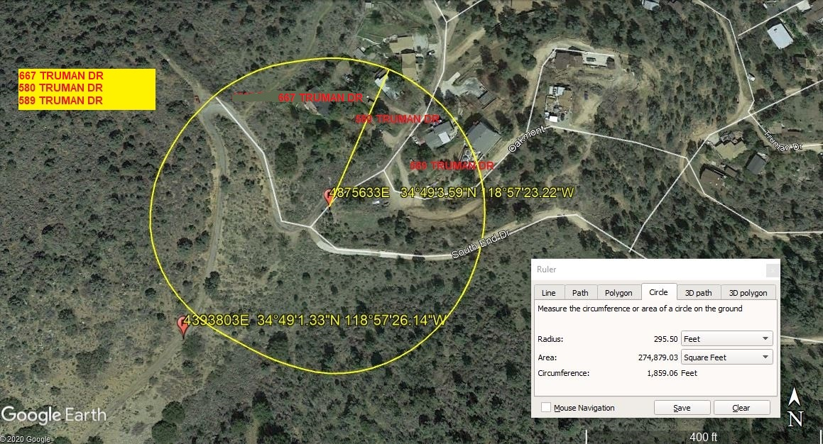
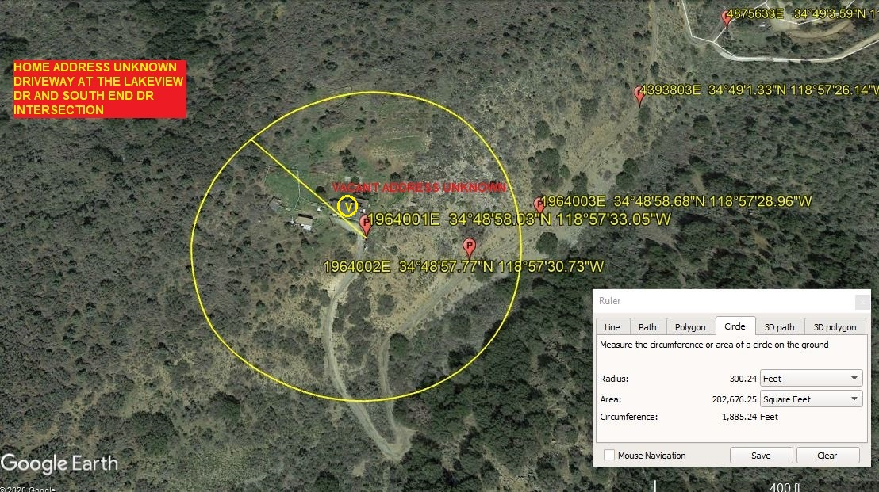

Narrative description of pick-up site, route, delivery site, and plan for ceasing operation if unauthorized persons enter operational area or real hazard occurs.
SITE INSPECTION NOTES

ONLY PERSONNEL ESSENTIAL TO COMPLETING THE JOB SAFELY WILL BE PERMITTED TO PARTICIPATE IN THE EVOLUTION. ONLY PERSONNEL PARTICIPATING IN THE SAFETY BRIEF WILL BE PERMITTED TO BE IN THE AREA OF OPERATIONS. ONLY AUTHORIZED ESSENTIAL PERSONAL WILL BE PERMITTED IN THE IMMEDIATE AREA OF OPERATIONS. IN THE EVENT AN UNAUTHORIZED PERSON ENTERS THE OPERATIONS AREA OR A POTENTIAL HAZARD IS IDENTIFIED THE PILOT WILL HOLD THE AIRCRAFT IN RELATIVE POSITION. THIS WILL BE ACHIEVED WITHOUT OVER FLYING THE GROUND CREW. ALL OPERATIONS WILL BE CEASED UNTIL THE PROBLEM IS RECTIFIED. IN THE EVENT OF AN AIRCRAFT EMERGENCY, THE PILOT WILL RADIO GROUND PERSONNEL AND WILL ATTEMPT TO LAND IN THE EMERGENCY LANDING AREA.
DURING THE LIFT EVOLUTION THE AIRCRAFT AND GROUND CREW WILL ALL BE IN RADIO COMMUNICATIONS. IN THE EVENT OF LOSS COMMUNICATIONS THE CREW WILL USE STANDARD HAND SIGNALS TO COMMUNICATE WITH THE PILOT. WHEN THE PILOT IS CLEAR HE WILL MOVE THE AIRCRAFT TO A SAFE LOCATION TO ALLOW THE COMMUNICATION PROBLEM TO BE RECTIFIED.
THE OPERATIONS AREA IS WITHIN THE SECURED AREA. ALL ESSENTIAL CREW WITHIN THE OPERATIONS AREA WILL NOT BE INVOLVED IN TAKING PICTURES OR ANY OTHER USE OF CELL PHONES.

A TAILBOARD SAFETY MEETING WILL BE HELD AT THE ASSIGNED AREA PRIOR TO BEGINNING HELICOPTER OPERATIONS
- HELICOPTER WILL LAND AT THE LANDING ZONE TO CONNECT LONGLINE AND TO CONDUCT A TAILBOARD SAFETY BRIEF
- WATER TRUCK IS REQUIRED NOT REQUIRED LZ APPROVED CONCRETE HELIPAD
- FUELING WILL BE CONDUCTED AT THE LZ ONLY
- ONCE LINE CREW IS READY THE STREET CLOSURE AND GHI GROUND CREW WILL KNOCK ON THE DOORS OF THE HOME TO BE EVACUATION. ONCE VERIFIED CLEAR OPERATIONS WILL BEGIN
- RADIOS WILL BE GIVEN TO EACH CREW TO ENSURE COMMS WITH THE PILOT
- THE NEW POLES WILL BE FLOWN FROM THE LZ TO THE POLE SITES MAINTAINING 500 FT FROM ANY DWELLING. ONCE THE NEW POLES ARE SET AND THE LINEMAN ARE READY THE HELICOPTER WILL PULL THE OLD POLES AND FLY THEM BACK TO THE LZ STAGING AREA
- EMERGENCY LANDING ZONE IS AT THE STAGING AREA AND ALONG THE FLIGHT PATH
- 4 ADDRESSES WILL BE VACANT. ALL BUILDINGS WITHIN THE OPERATING AREA WILL BE CLEAR
- REMOTE ROADS WILL BE CLOSED WITH A FLAGMAN
- TREE TRIMMING MAYBE REQUIRED PRIOR TO OPERATIONS
OPERATIONS AREA DIAGRAM
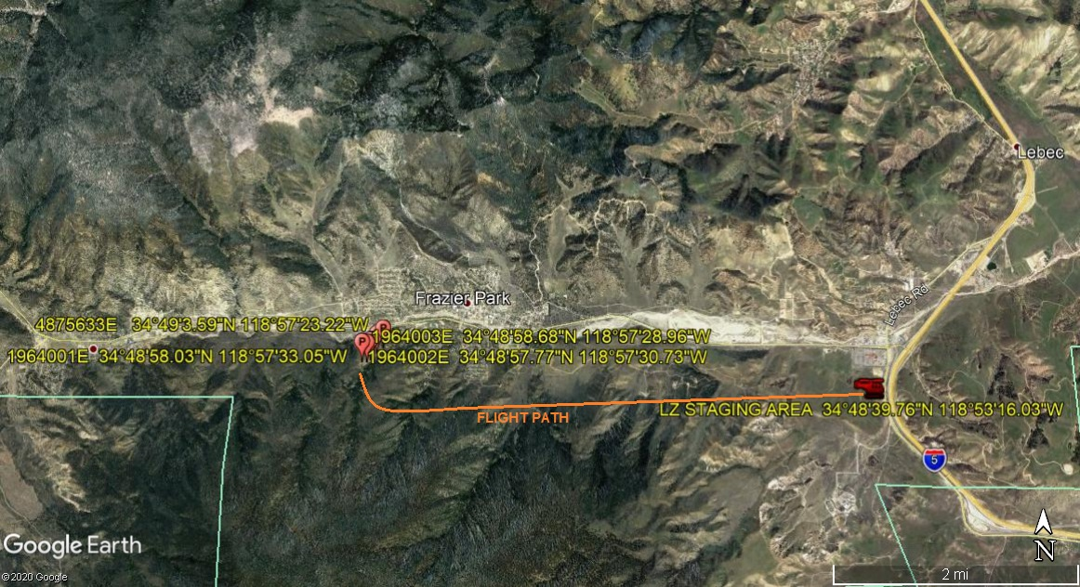

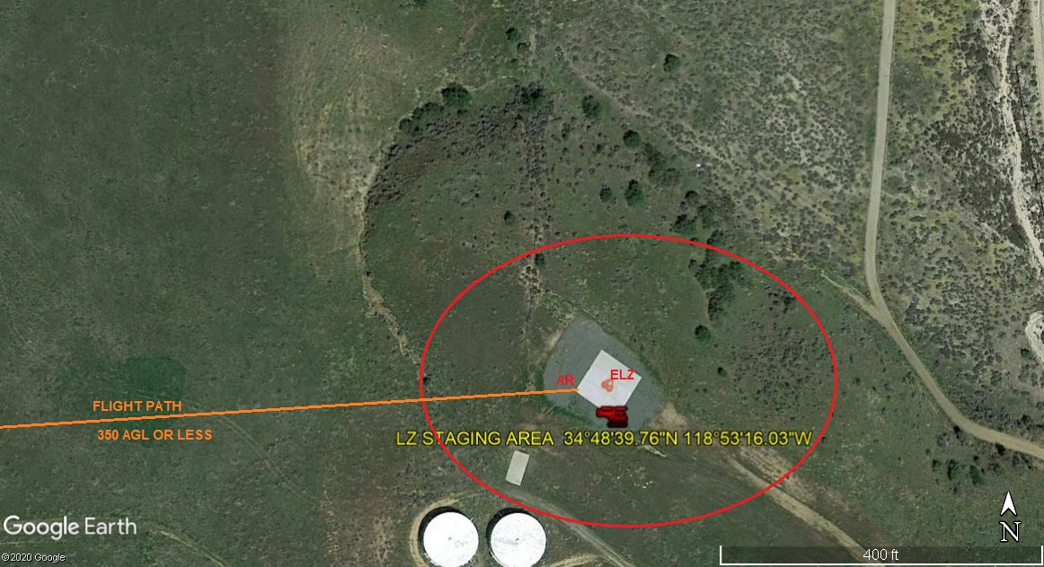
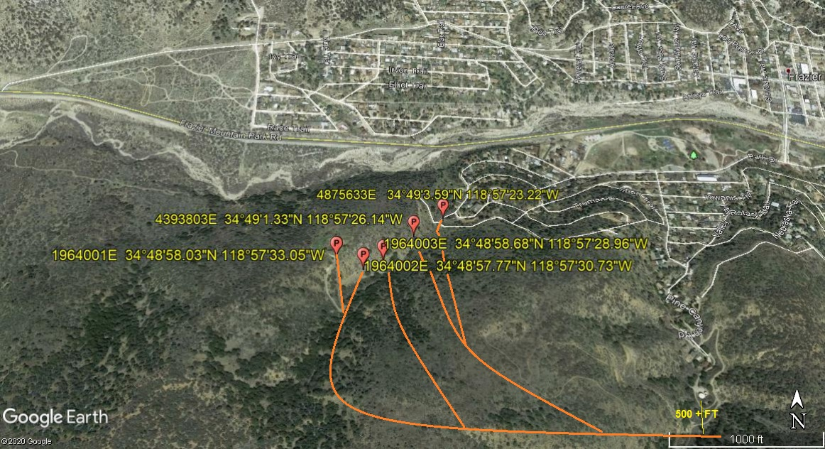
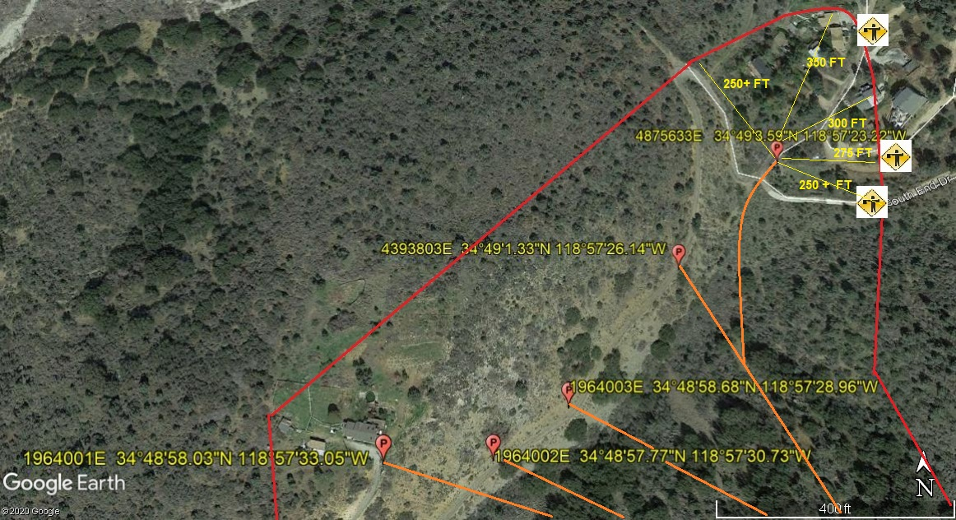
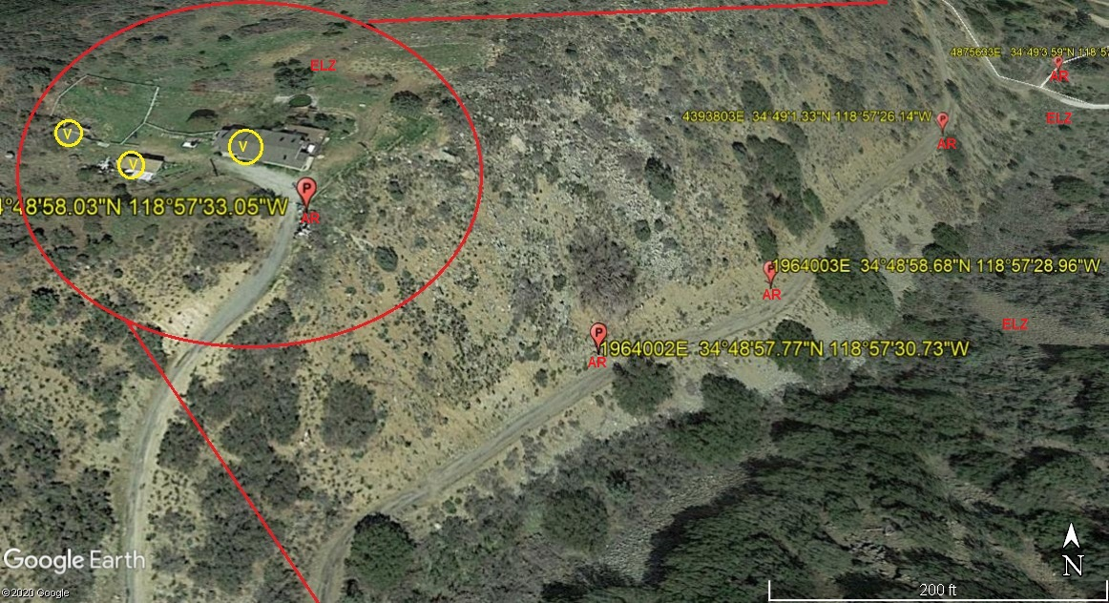
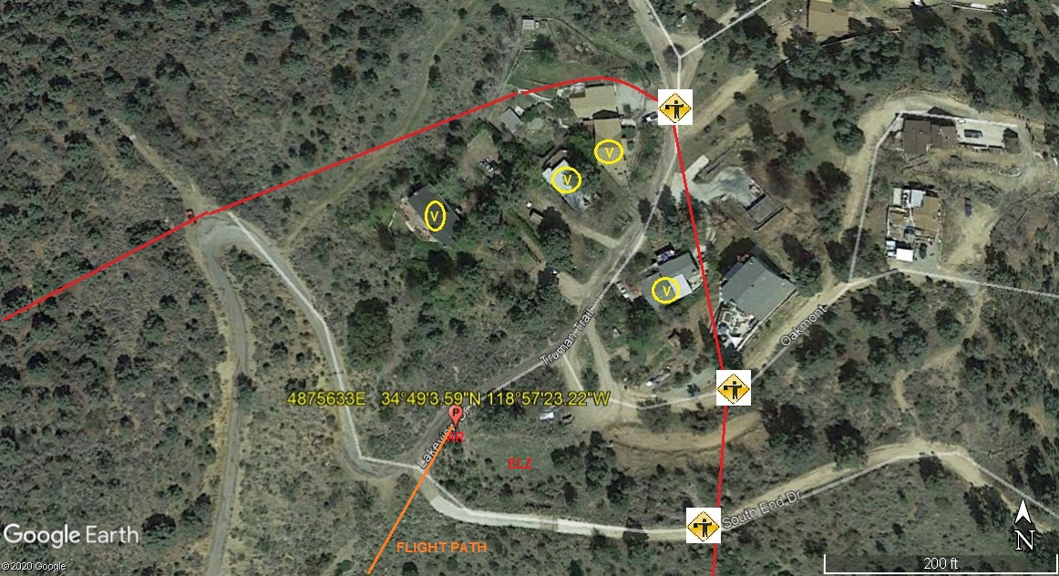

LEGEND
SITE PLAN SYMBOLS: EVACUATION FLIGHT PATH
LANDING AREA = (LZ) | STREET BLOCKED = XXXX | TOP TWO FLOORS = UBT2
ATTACH AREA = (A) | RELEASE AREA = (R)
FLIGHT PATH = >>> | EMERGENCY LAND = (ELZ)
UNOCCUPIED BUILDING = (UBA) | UNOCCUPIED BUILDING TOP FLOOR = (UBT1)

AREA SURVEY CONDUCTED BY : 

SUBMITTED BY: JEFFREY M. TEUBNER DATE: 7-23-2020
TITLE: FLIGHT COORDINATOR

