
SECTION 7 Part 135 GH 4A Part 133 GH 4L
NON-congested Area Plan
Operator: Guardian Helicopters, Inc
67 D STREET
Fillmore CA. 93015 Phone (818) 442-9904 FAX (818) 442-990
PROJECT: EDISON HEC POLE REPLACEMENT WORK ORDER #: TD 1472464 TD 1572100 TD 1569651 TD 1576985 TD1577031
ADDRESS: RANCHO REAL : HOLLISTER CA
LANDING ZONE LATITUDE 34°27'56.78"N LONGITUDE 120°20'47.67"W
708491E 708490E LATITUDE 34°28'13.77"N LONGITUDE 120°16'10.75"W HF 1700 LBS FRAMED
712122E 712121E LATITUDE 34°28'3.78"N LONGITUDE 120°21'35.42"W HF 1995 LBS FRAMED
712134E 4476366E LATITUDE 34°28'8.38"N LONGITUDE 120°22'43.17"W HF 1500 LBS FRAMED
712154E 712155E LATITUDE 34°27'54.85"N LONGITUDE 120°24'17.76"W HF 1500 LBS FRAMED
712168E LATITUDE 34°27'51.38"N LONGITUDE 120°25'30.44"W SINGLE POEL 1200 LBS
CONTRACTOR’S NAME: HOT LINE CONSTRUCTION PHONE#: 805-561-2410
CONTACT AT SITE; CHRISTIAN OROZCO PHONE #: 805-561-2410
PILOT’S NAME(S): 1. JOHN OLSON CERT #: 2769166
2. BUCKEY MACKAY CERT #: 2778051
3. MICHAEL KLINK CERT#: 3018828
4. IAN GOODALE CERT# :3741973
5. ROSS GOULET CERT# : 339677
6.CHRIS CURRIER CERT#: 3093383
TYPE OF AIRCRAFT: BELL UH-1H N# N711GH A/C CATEGORY: RESTRICTED
BELL UH-1H N# N777GH A/C CATEGORY: RESTRICTED
BELL 407 N# N407GH A/C CATEGORY: STANDARD
BELL 407 N# N447GH A/C CATEGORY: STANDARD
BELL 205A1 N# N216GH A/C CATEGORY: STANDARD
AS350 B2 N# N498PT A/C CATEGORY: STANDARD
AS350 B3 N# N718GH A/C CATEGORY: STANDARD
AS350 B3 N# N215GH A/C CATEGORY: STANDARD
TYPE OF ITEM LIFTING: POLE HEC AERODYNAMIC NON- AERODYNAMIC
IF SAFETY DICTATES AND OR THE CUSTOMER REQUESTS ADDITIONAL LIFTS THE LIFTS WILL BE CONDUCTED REMAINING WITHIN THE APPROVED TIME PARAMETERS.
TYPE OF LIFTS: COMPRESSOR POLES AND EQUIPMENT
MAX SINGLE – LIFT WEIGHT: 2000 LBS CLASS OF LOAD: EXTERNAL CL B
NO. OF LIFTS: TBD LONG LINE: (NO) XXX (YES) LESS THEN 150 FT (LENGTH)
OPERATIONAL ALTITUDE: < 250
DATE AND TIMES OPERATION WILL BEGIN AND TERMINATE:
FLIGHT DATES | TIME BEGIN | TIME END | TODAY’S DATE
7-28-2020 | SUNRISE | SUNSET | 7-21-2020
AGENCY NAME: | PHONE#: | PERSON NOTIFIED: | DATE:
SANTA BARBARA SHERIFF | 805-686-8150 | BUELTON | NOTIFY
SANTA BARBARA COUNTY FIRE | 805-681-5518 | STATION 18 | NOTIFY

NON- Congested Area Plan (Continued)

Evacuation Crowd Control Street Closure
No Evacuated Structures Operator □Yes No
□Evacuated Structures Contractor Contractor
□Operator
LIST OF BUILDINGS THAT SHALL EITHER BE PARTIALLY OR ENTIRELY UNOCCUPIED PERSONS:
BUILDING DESCRIPTION/ADDRESS | OWNER(S): | PHONE #:
N/A | N/A | N/A
N/A | N/A | N/A

Narrative description of pick-up site, route, delivery site, and plan for ceasing operation if unauthorized persons enter operational area or real hazard occurs.
SITE INSPECTION NOTES

ONLY PERSONNEL ESSENTIAL TO COMPLETING THE JOB SAFELY WILL BE PERMITTED TO PARTICIPATE IN THE EVOLUTION. ONLY PERSONNEL PARTICIPATING IN THE SAFETY BRIEF WILL BE PERMITTED TO BE IN THE AREA OF OPERATIONS. ONLY AUTHORIZED ESSENTIAL PERSONAL WILL BE PERMITTED IN THE IMMEDIATE AREA OF OPERATIONS. IN THE EVENT AN UNAUTHORIZED PERSON ENTERS THE OPERATIONS AREA OR A POTENTIAL HAZARD IS IDENTIFIED THE PILOT WILL HOLD THE AIRCRAFT IN RELATIVE POSITION. THIS WILL BE ACHIEVED WITHOUT OVER FLYING THE GROUND CREW. ALL OPERATIONS WILL BE CEASED UNTIL THE PROBLEM IS RECTIFIED. IN THE EVENT OF AN AIRCRAFT EMERGENCY, THE PILOT WILL RADIO GROUND PERSONNEL AND WILL ATTEMPT TO LAND IN THE EMERGENCY LANDING AREA.
DURING THE LIFT EVOLUTION THE AIRCRAFT AND GROUND CREW WILL ALL BE IN RADIO COMMUNICATIONS. IN THE EVENT OF LOSS COMMUNICATIONS THE CREW WILL USE STANDARD HAND SIGNALS TO COMMUNICATE WITH THE PILOT. WHEN THE PILOT IS CLEAR HE WILL MOVE THE AIRCRAFT TO A SAFE LOCATION TO ALLOW THE COMMUNICATION PROBLEM TO BE RECTIFIED.
THE OPERATIONS AREA IS WITHIN THE SECURED AREA. ALL ESSENTIAL CREW WITHIN THE OPERATIONS AREA WILL NOT BE INVOLVED IN TAKING PICTURES OR ANY OTHER USE OF CELL PHONES.
A TAIL BOARD SAFETY MEETING WILL BE HELD AT BOTH THE STAGING AREAS PRIOR TO HELICOPTER OPERATIONS
1. HELICOPTER WILL LAND AT THE AT THE LZ STAGING AREA TO CONNECT LONG LINE AND CONDUCT HEC TRAINING AND A SAFETY TAILBOARD. THE POLE WILL FRAMED AT THE STAGING AREAS
2. FUELING WILL ONLY BE CONDUCTED AT STAGING AREA
3. EMERGENCY LANDING ZONE IS AT THE STAGING AREA AND ALONG THE FLIGHT PATH
4. REMOTE AREA OPERATING AREA. NO EVACUATIONS
5. PROVIDE WATER TRUCK FOR LZ STAGING AREA
6. NO STREET CLOSURES
7-21-2020 
DATE OF SUBMISSION COMPANY OFFICIAL / TITLE

OPERATIONS AREA DIAGRAM
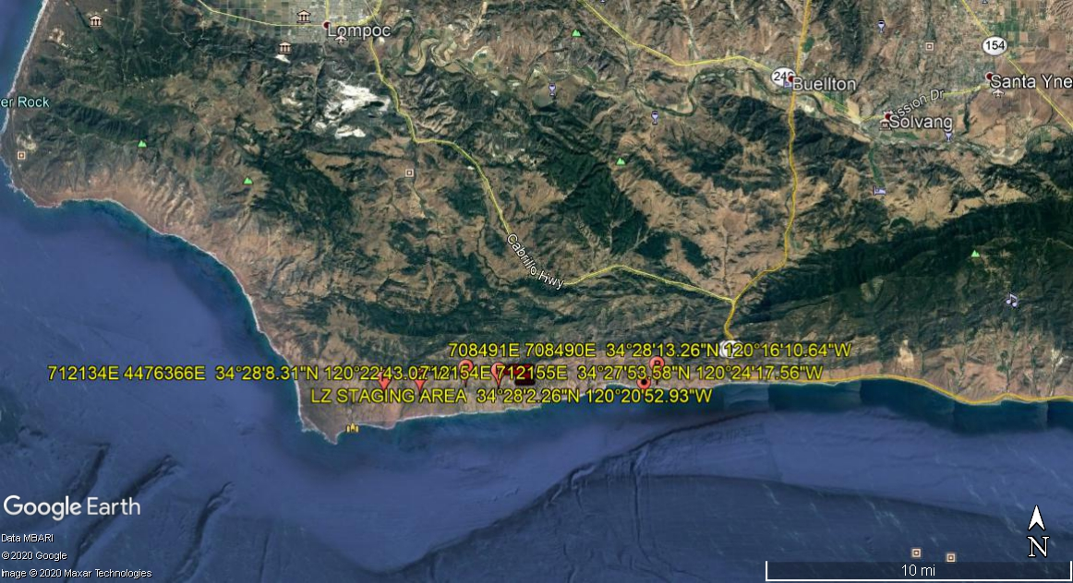
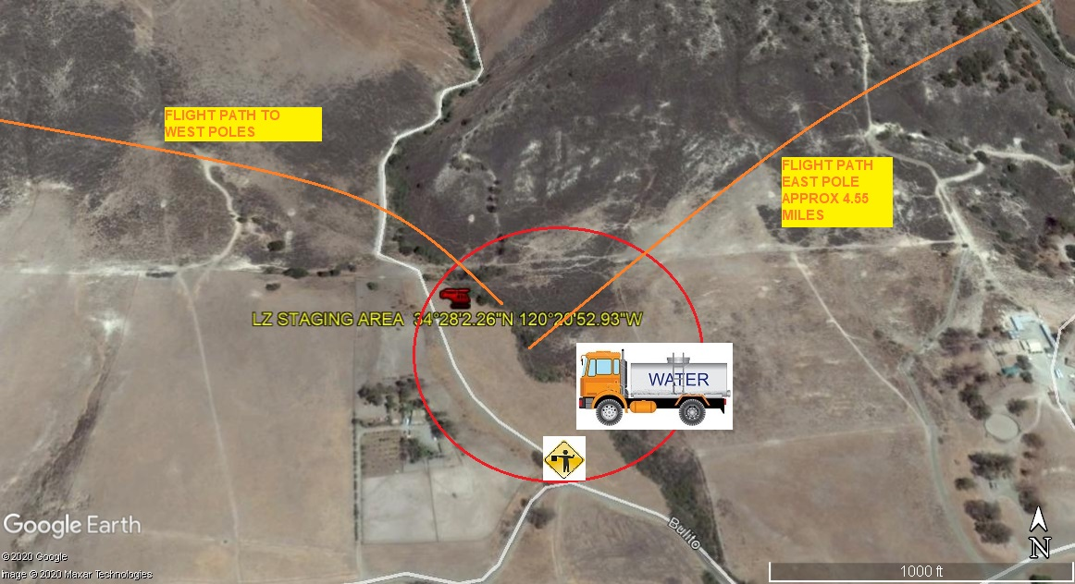
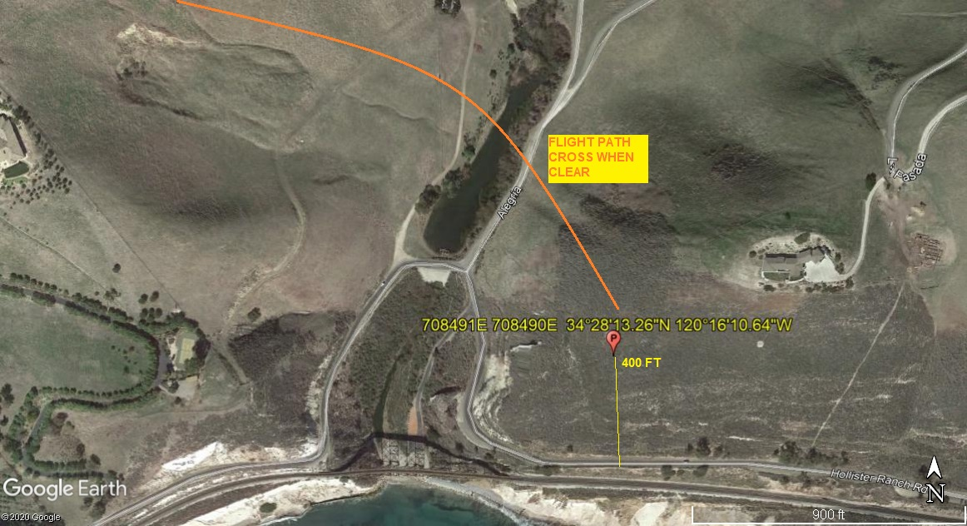
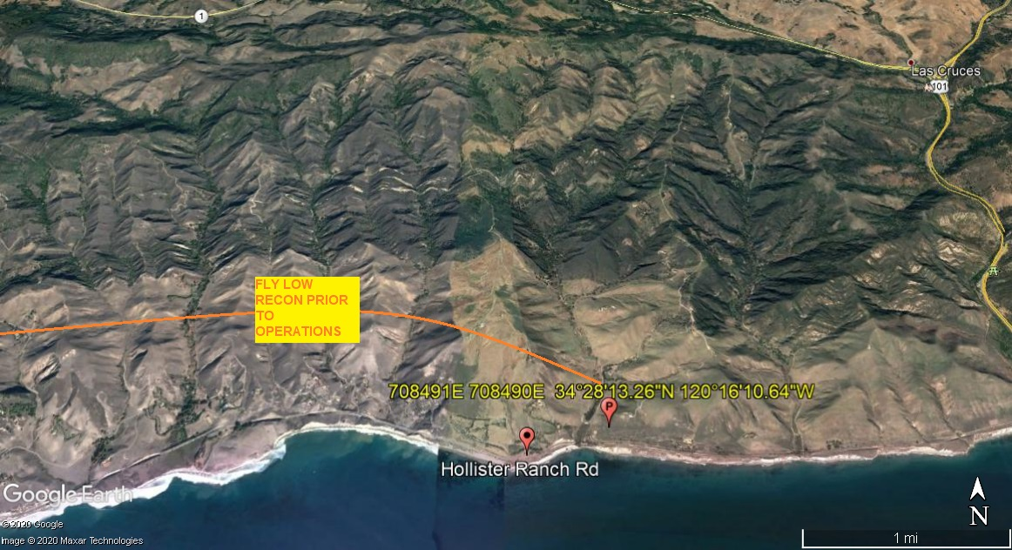
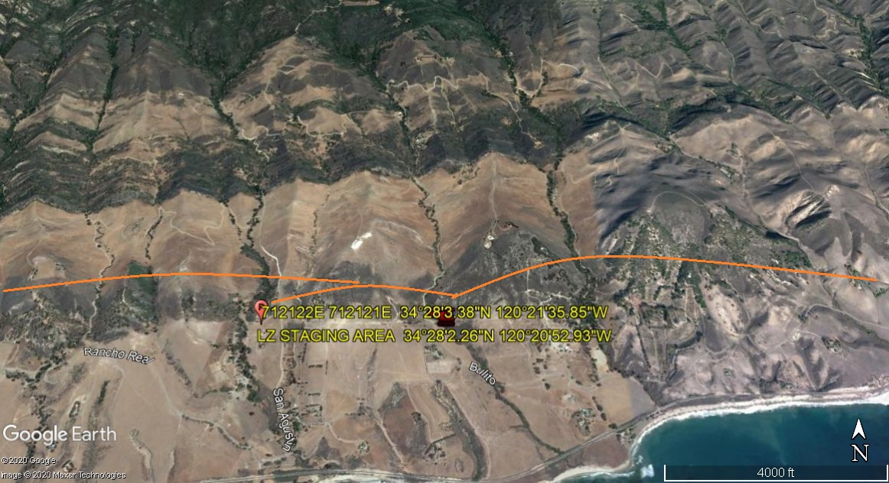
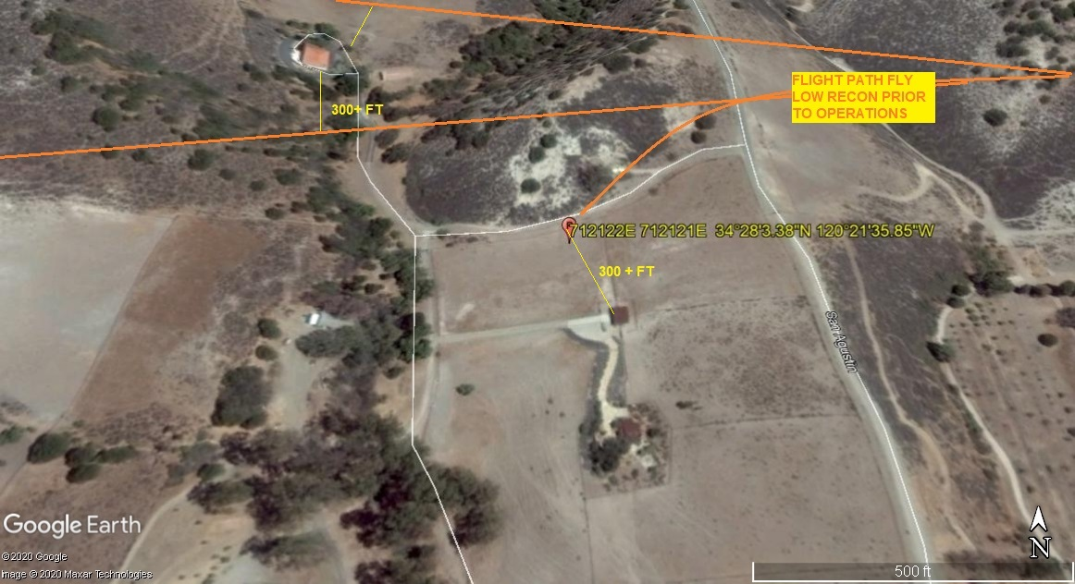
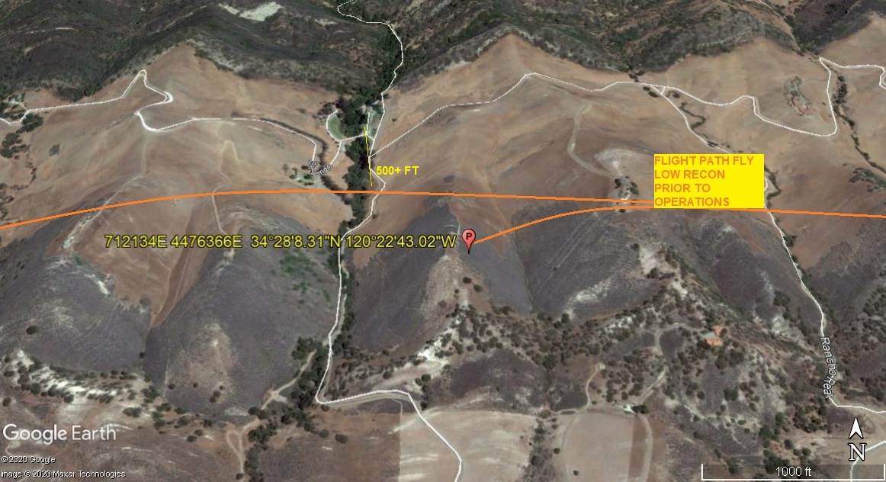
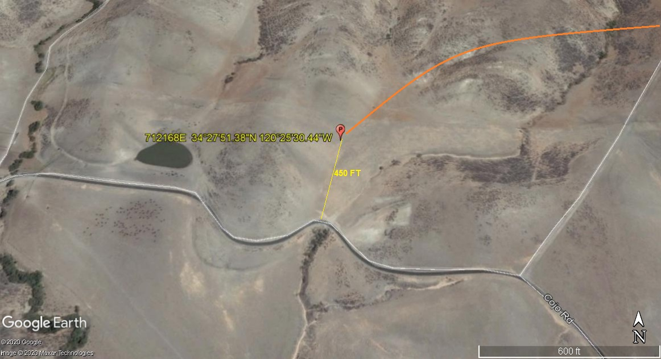
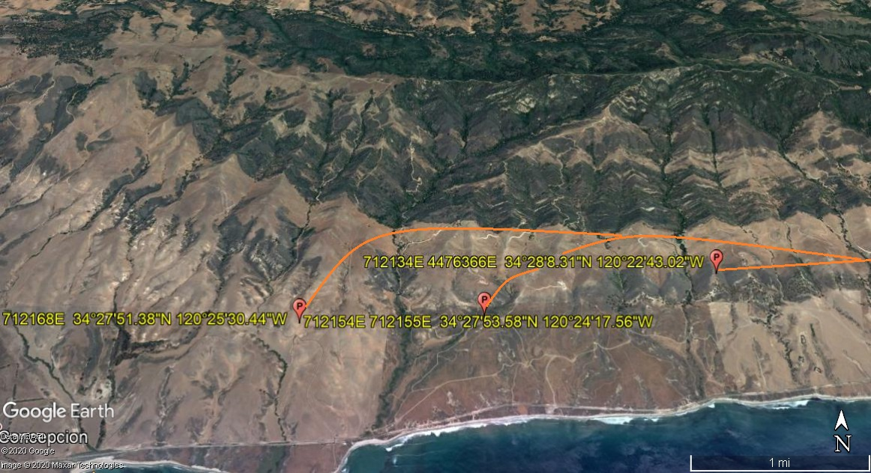

LEGEND
SITE PLAN SYMBOLS: EVACUATION FLIGHT PATH
LANDING AREA = (LZ) | STREET BLOCKED = XXXX | TOP TWO FLOORS = UBT2
ATTACH AREA = (A) | RELEASE AREA = (R)
FLIGHT PATH = >>> | EMERGENCY LAND = (ELZ)
UNOCCUPIED BUILDING = (UBA) | UNOCCUPIED BUILDING TOP FLOOR = (UBT1)

