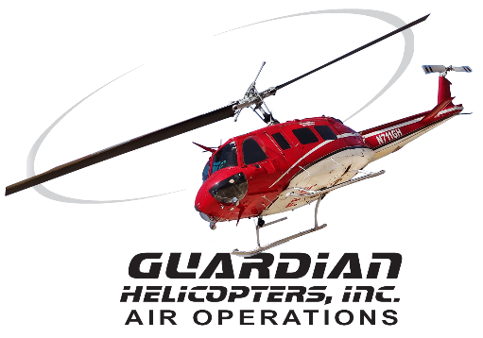
SECTION 7 Part 135 GH 4A Part 133 GH 4L
NON Congested Area Plan
Operator: Guardian Helicopters, Inc
67 D STREET
FILLMORE , CA 93015
Phone (818) 442-9904
FAX (818) 442-9901
PROJECT: EDISON POLE REPLACEMENT WORK ORDER #: TD 1679361
ADDRESS: AVENUE 146 : PORTERVILLE CA
PORTERVILLE TAILBOARD LATITUDE 36° 1'46.07"N LONGITUDE 119° 3'38.45"W (TAILBOARD)
LZ LATITUDE 36° 6'28.28"N LONGITUDE 118°56'20.29"W (CONNECT LONGLINE)
POLE STAGING AREA LATITUDE 36° 3'46.79"N LONGITUDE 118°55'42.43"W
1399296E LATITUDE 36° 3'56.38"N LONGITUDE 118°55'41.26"W45 CL 2 1800 LBS

CONTRACTOR’S NAME: JEFF MILHOUS PHONE#: 925-237-6937
CONTRACTOR’S NAME: STUART RUSSELL PHONE#: 559-476-9264

PILOT’S NAME(S): 1. JOHN OLSON CERT#:2769166
2. BUCKEY MACKAY CERT#:2778051
3. MICHAEL KLINK CERT#:3018828
4. IAN GOODALE CERT#:3741973
5. ROSS GOULET CERT#:339677
6.CHRIS CURRIER CERT#:3093383
TYPE OF AIRCRAFT:
BELL UH-1H N#: N711GH A/C CATEGORY: RESTRICTED
BELL UH-1H N#: N777GH A/C CATEGORY: RESTRICTED
BELL 407 N#: N407GH A/C CATEGORY: STANDARD
BELL 407 N#: N447GH A/C CATEGORY: STANDARD
BELL 205A1 N#: N216GH A/C CATEGORY: STANDARD
AS350 B2 N#: N498PT A/C CATEGORY: STANDARD
AS350 B3 N#: N718GH A/C CATEGORY: STANDARD
AS350 B3 N#: N215GH A/C CATEGORY: STANDARD
TYPE OF ITEM LIFTING: POLE AERODYNAMIC NON- AERODYNAMIC
IF SAFETY DICTATES AND OR THE CUSTOMER REQUESTS ADDITIONAL LIFTS THE LIFTS WILL BE CONDUCTED REMAINING WITHIN THE APPROVED TIME PARAMETERS.
TYPE OF LIFTS POLE 45 CL 2 , CARGO AND EQUIPMENT
MAX SINGLE – LIFT WEIGHT: 1800 LBS CLASS OF LOAD: EXTERNAL CL B
NO. OF LIFTS: TBD LONG LINE: (NO) XXX (YES) LESS THEN 200 FT (LENGTH)
OPERATIONAL ALTITUDE: < 250 AGL STREET CLOSING: (N0) XX (YES)
DATE AND TIMES OPERATION WILL BEGIN AND TERMINATE:
FLIGHT DATES | TIME BEGIN | TIME END | TODAY’S DATE
7-24-2020 | SUNRISE | SUNSET | 7-18-2020
AGENCY NAME: | PHONE#: | PERSON NOTIFIED: | DATE:
PORTERVILLE POLICE DEPT | 559-782-7400 | DISPATCH | NOTIFY
DOYLE COLONY FIRE STATION | 559-784-7628 | STATION 20 TULARE | NOTIFY

NON- Congested Area Plan (Continued)

Evacuation Crowd Control Street Closure
No Evacuated Structures Operator □Yes No
□Evacuated Structures Contractor Contractor
□Operator
LIST OF BUILDINGS THAT SHALL EITHER BE PARTIALLY OR ENTIRELY UNOCCUPIED PERSONS ALSO HOMES THAT WILL BE NOTIFIED OF ACTIVITY:
BUILDING DESCRIPTION/ADDRESS | REMARKS | METHOD
REMOTE NO EVACUATIONS | VACANT DURING OPS | HAND DELIVER
ALL HOMES WITHIN OPERATING AREA | VACANT DURING OPS | HAND DELIVER
SEE DIAGRAM = V | VACANT DURING OPS | HAND DELIVER

Narrative description of pick-up site, route, delivery site, and plan for ceasing operation if unauthorized persons enter operational area or real hazard occurs.
SITE INSPECTION NOTES

ONLY PERSONNEL ESSENTIAL TO COMPLETING THE JOB SAFELY WILL BE PERMITTED TO PARTICIPATE IN THE EVOLUTION. ONLY PERSONNEL PARTICIPATING IN THE SAFETY BRIEF WILL BE PERMITTED TO BE IN THE AREA OF OPERATIONS. ONLY AUTHORIZED ESSENTIAL PERSONAL WILL BE PERMITTED IN THE IMMEDIATE AREA OF OPERATIONS. IN THE EVENT AN UNAUTHORIZED PERSON ENTERS THE OPERATIONS AREA OR A POTENTIAL HAZARD IS IDENTIFIED THE PILOT WILL HOLD THE AIRCRAFT IN RELATIVE POSITION. THIS WILL BE ACHIEVED WITHOUT OVER FLYING THE GROUND CREW. ALL OPERATIONS WILL BE CEASED UNTIL THE PROBLEM IS RECTIFIED. IN THE EVENT OF AN AIRCRAFT EMERGENCY, THE PILOT WILL RADIO GROUND PERSONNEL AND WILL ATTEMPT TO LAND IN THE EMERGENCY LANDING AREA.
DURING THE LIFT EVOLUTION THE AIRCRAFT AND GROUND CREW WILL ALL BE IN RADIO COMMUNICATIONS. IN THE EVENT OF LOSS COMMUNICATIONS, THE CREW WILL USE STANDARD HAND SIGNALS TO COMMUNICATE WITH THE PILOT. WHEN THE PILOT IS CLEAR HE WILL MOVE THE AIRCRAFT TO A SAFE LOCATION TO ALLOW THE COMMUNICATION PROBLEM TO BE RECTIFIED.
THE OPERATIONS AREA IS WITHIN THE SECURED AREA. ALL ESSENTIAL CREW WITHIN THE OPERATIONS AREA WILL NOT BE INVOLVED IN TAKING PICTURES OR ANY OTHER USE OF CELL PHONES.
A TAILBOARD SAFETY MEETING WILL BE HELD AT THE ASSIGNED AREA PRIOR TO BEGINNING HELICOPTER OPERATIONS
- HELICOPTER WILL LAND AT PORTERVILLE AIRPORT TO CONDUCT A TAILBOARD SAFETY BRIEF.
- THE HELICOPTER WILL FLY TO THE EDISON FACILITY OFF OF AVE 176 TO CONNECT THE LONGLINE
- WATER TRUCK REQUIRED AT EDISON YARD
- PILOT WILL FLY LOW RECON PRIOR TO OPERATIONS TO VERIFY CLEAR FLIGHT PATH TO POLE SITE
- FUELING WILL ONLY BE CONDUCTED AT THE EDISON YARD
- EMERGENCY LANDING ZONE IS AT THE STAGING AREA AND ALONG THE FLIGHT PATH
- NO EVACUATION
- NO STREET WILL EXPERIENCE INTERMITTENT CLOSURES
- TREE TRIMMING MAYBE REQUIRED PRIOR TO OPERATIONS

OPERATIONS AREA DIAGRAM
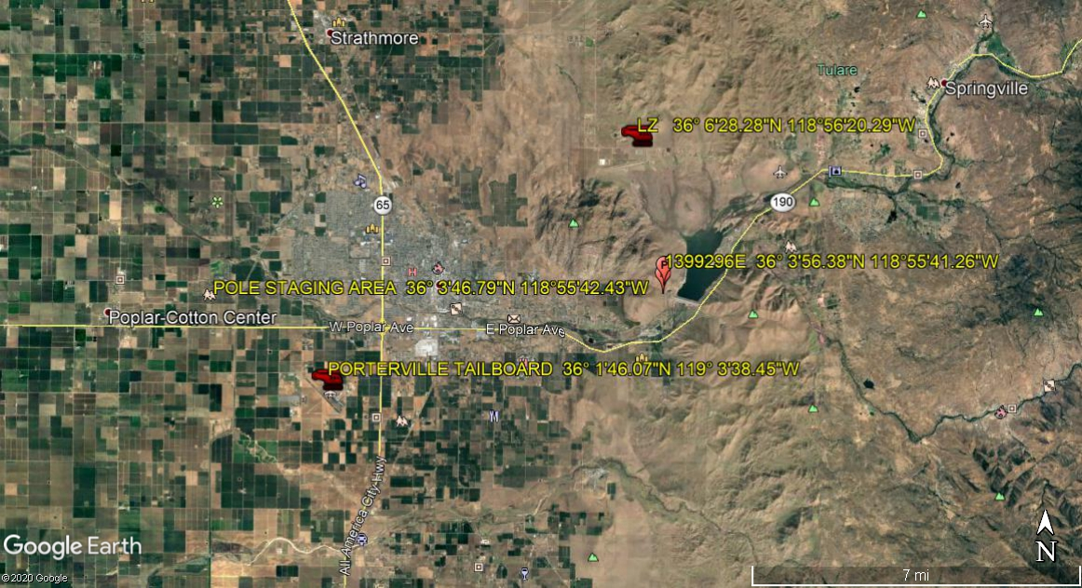
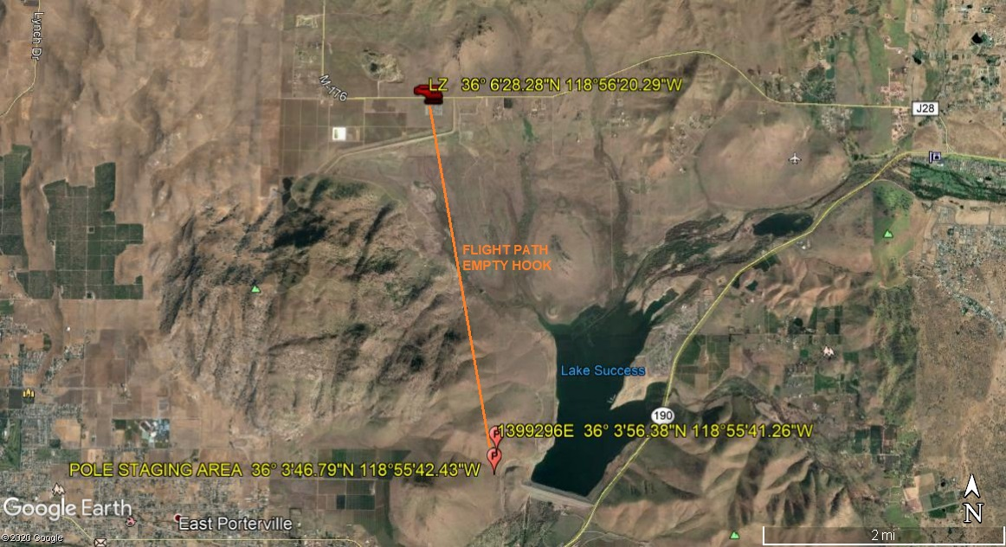
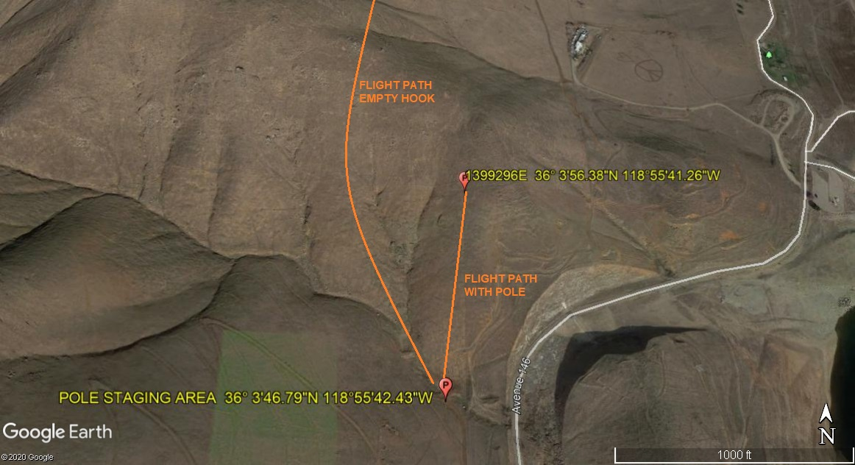
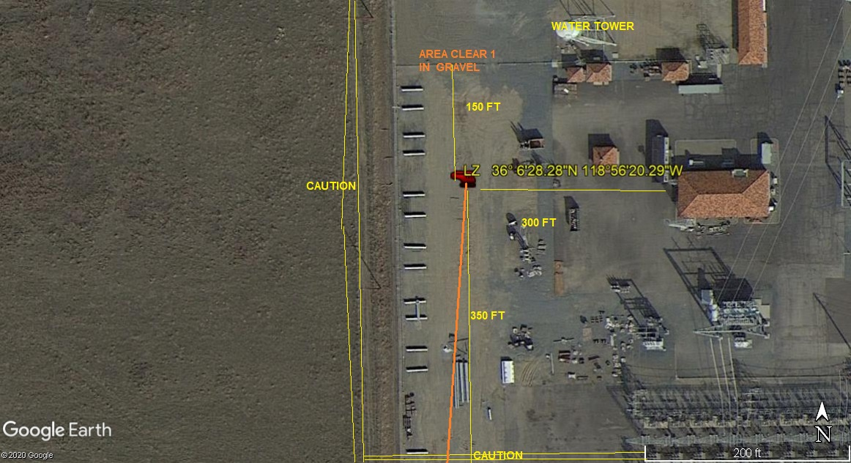
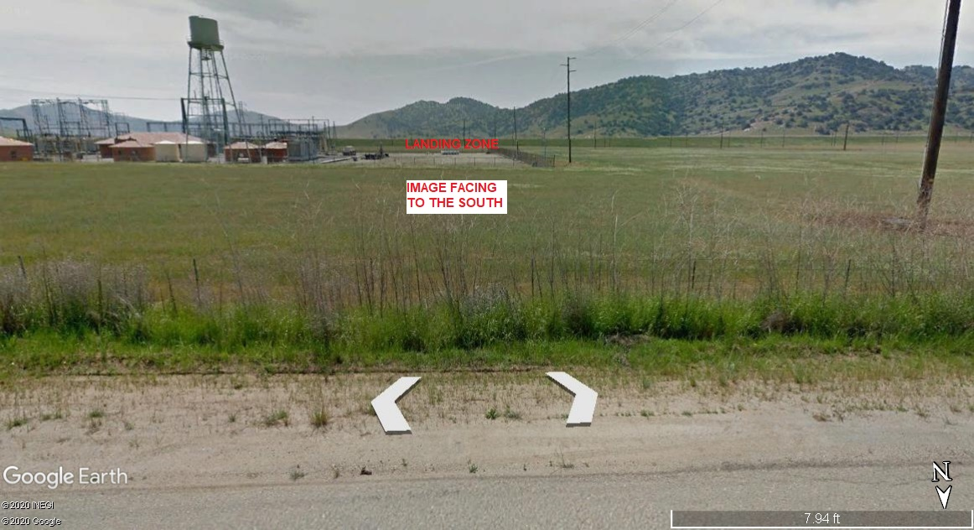
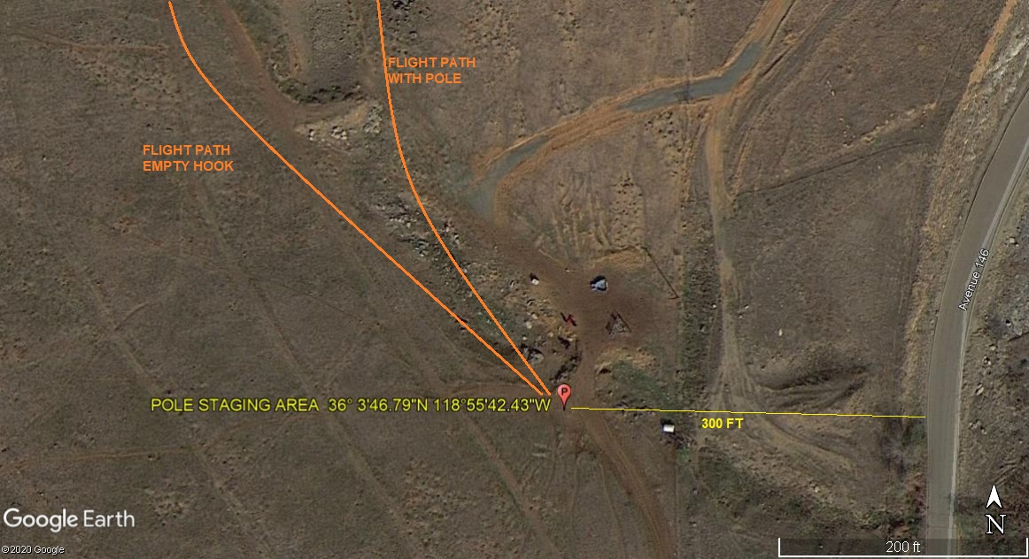

LEGEND
SITE PLAN SYMBOLS: EVACUATION FLIGHT PATH
LANDING AREA = (LZ) | STREET BLOCKED = XXXX | TOP TWO FLOORS = UBT2
ATTACH AREA = (A) | RELEASE AREA = (R)
FLIGHT PATH = >>> | EMERGENCY LAND = (ELZ)
UNOCCUPIED BUILDING = (UBA) | UNOCCUPIED BUILDING TOP FLOOR = (UBT1)
AREA SURVEY CONDUCTED BY : 

