
SECTION 7 Part 135 GH 4A Part 133 GH 4L
Congested Area Plan
Operator: Guardian Helicopters, Inc
67 D STREET
FILLMORE , CA 93015
Phone (818) 442-9904
FAX (818) 442-9901
PROJECT: A/C UNIT REPLACEMENT WORK ORDER #: Q2020-358
ADDRESS: 48650 SEMINOLE DR : CABAZON CA 92230
CABAZON OUTLETS LATITUDE 33°55'41.08"N LONGITUDE 116°48'41.01"W

CONTRACTOR’S NAME: MVAC INC PHONE#: 951-830-0103
CONTRACTOR’S NAME: CHRIS KITTINGER PHONE#: 951-830-0103

PILOT’S NAME(S): 1. JOHN OLSON CERT#:2769166
2. BUCKEY MACKAY CERT#:2778051
3. MICHAEL KLINK CERT#:3018828
4. IAN GOODALE CERT#:3741973
5. ROSS GOULET CERT#:3396777
6.CHRIS CURRIER CERT#:3093383
7. ROBERT SATZ CERT#:2629853
8. BRIAN HUMPHERY CERT#:3179775
9. MICHAEL FOURNIER CERT#:2746422
TYPE OF AIRCRAFT:
BELL UH-1H N#: N711GH A/C CATEGORY: RESTRICTED
BELL UH-1H N#: N777GH A/C CATEGORY: RESTRICTED
BELL 407 N#: N407GH A/C CATEGORY: STANDARD
BELL 407 N#: N447GH A/C CATEGORY: STANDARD
BELL 205A1 N#: N216GH A/C CATEGORY: STANDARD
AS350 B2 N#: N498PT A/C CATEGORY: STANDARD
AS350 B3 N#: N718GH A/C CATEGORY: STANDARD
AS350 B3 N#: N215GH A/C CATEGORY: STANDARD

IF SAFETY DICTATES AND OR THE CUSTOMER REQUESTS ADDITIONAL LIFTS THE LIFTS WILL BE CONDUCTED REMAINING WITHIN THE APPROVED TIME PARAMETERS.

TYPE OF ITEM LIFTING: AC UNITS AERODYNAMIC NON- AERODYNAMIC
MAX SINGLE – LIFT WEIGHT: 1500 LBS CLASS OF LOAD: EXTERNAL CL B
NO. OF LIFTS: 5↑ 5↓ LONG LINE: (NO) XXX (YES) LESS THEN 100 FT (LENGTH)
OPERATIONAL ALTITUDE: < 250 AGL STREET CLOSING: (N0) XX (YES)

Congested Area Plan (Continued)
DATE AND TIMES OPERATION WILL BEGIN AND TERMINATE:

FLIGHT DATES | TIME BEGIN | TIME END | TODAY’S DATE
8-12-2020 | SUNRISE | SUNSET | 8-5-2020
AGENCY NAME: | PHONE#: | PERSON NOTIFIED: | DATE:
RIVERSIDE COUNTY SHERIFF | 951-922-7100 | DISPATCH | NOTIFIED
RIVERSIDE COUNTY FIRE | 951-849-2316 | DISPATCH | NOTIFIED

Evacuation Crowd Control Street Closure
□No Evacuated Structures Operator □Yes No
Evacuated Structures Contractor □Contractor
□Operator
MARK “X” WHERE PERTAINING TO THE LIFT PLAN:
_______Copy of written agreement with local officials for the exclusion of unauthorized persons

__XX__Responsibility is delegated to the operator (fill in below)

Official’s Name: GUARDIAN HELICOPTERS INC
Phone #: 818-442-9904

LIST OF BUILDINGS THAT SHALL EITHER BE PARTIALLY OR ENTIRELY UNOCCUPIED PERSONS ALSO HOMES THAT WILL BE NOTIFIED OF ACTIVITY:

BUILDING DESCRIPTION/ADDRESS | REMARKS | METHOD
48400 SEMINOLE DR CABAZON CA | VACANT DURING OPS | HAND DELIVER
ALL HOMES WITHIN OPERATING AREA | VACANT DURING OPS | HAND DELIVER
SEE DIAGRAM = V | VACANT DURING OPS | HAND DELIVER

Narrative description of pick-up site, route, delivery site, and plan for ceasing operation if unauthorized persons enter operational area or real hazard occurs.
SITE INSPECTION NOTES

ONLY PERSONNEL ESSENTIAL TO COMPLETING THE JOB SAFELY WILL BE PERMITTED TO PARTICIPATE IN THE EVOLUTION. ONLY PERSONNEL PARTICIPATING IN THE SAFETY BRIEF WILL BE PERMITTED TO BE IN THE AREA OF OPERATIONS. ONLY AUTHORIZED ESSENTIAL PERSONAL WILL BE PERMITTED IN THE IMMEDIATE AREA OF OPERATIONS. IN THE EVENT AN UNAUTHORIZED PERSON ENTERS THE OPERATIONS AREA OR A POTENTIAL HAZARD IS IDENTIFIED THE PILOT WILL HOLD THE AIRCRAFT IN RELATIVE POSITION. THIS WILL BE ACHIEVED WITHOUT OVER FLYING THE GROUND CREW. ALL OPERATIONS WILL BE CEASED UNTIL THE PROBLEM IS RECTIFIED. IN THE EVENT OF AN AIRCRAFT EMERGENCY, THE PILOT WILL RADIO GROUND PERSONNEL AND WILL ATTEMPT TO LAND IN THE EMERGENCY LANDING AREA.
DURING THE LIFT EVOLUTION THE AIRCRAFT AND GROUND CREW WILL ALL BE IN RADIO COMMUNICATIONS. IN THE EVENT OF LOSS COMMUNICATIONS THE CREW WILL USE STANDARD HAND SIGNALS TO COMMUNICATE WITH THE PILOT. WHEN THE PILOT IS CLEAR HE WILL MOVE THE AIRCRAFT TO A SAFE LOCATION TO ALLOW THE COMMUNICATION PROBLEM TO BE RECTIFIED.
THE OPERATIONS AREA IS WITHIN THE SECURED AREA. ALL ESSENTIAL CREW WITHIN THE OPERATIONS AREA WILL NOT BE INVOLVED IN TAKING PICTURES OR ANY OTHER USE OF CELL PHONES.

A TAILBOARD SAFETY MEETING WILL BE HELD AT THE ASSIGNED AREA PRIOR TO BEGINNING HELICOPTER OPERATIONS
- HELICOPTER WILL LAND ON THE PARKING STRUCTURE TO ATTACHED LONGLINE
- TOP FLOOR OF PARKING STRUCTURE WILL BE CLEAR
- UNITS WILL BE STAGED ON THE DRIVEWAY BETWEEN THE PARKING STRUCTURE AND OUTLET STORES
- SECURITY WILL BE IN PLACE AS DIAGRAMED BELOW.
- OUTLET STORES WITHIN THE RED OPERATIONS AREA WILL BE VACANT
- ROAD BETWEEN THE PARKIGN STRUCTURE AND MALL WILL BE CLOSED
- GHI GROUND CREW WILL VERIFY BUILDING IS UNOCCUPIED
- THE GHI GROUND CREW AND PILOT WILL BE IN RADIO COMMUNICATIONS DURING THE OPERATIONS
- CUSTOMER WILL ENSURE OPERATING AREA REMAINS STERILE
- EMERGENCY LANDING ZONE IS AT THE STAGING AREA AND ALONG THE FLIGHT PATH
- ALL BUILDINGS WITHIN THE OPERATING AREA WILL BE CLEAR
OPERATIONS AREA DIAGRAM

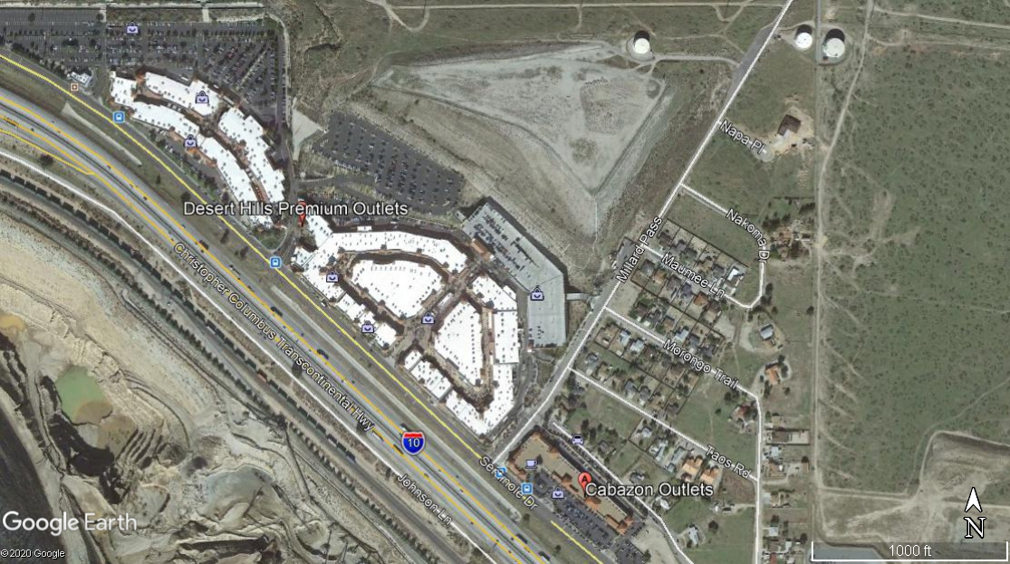
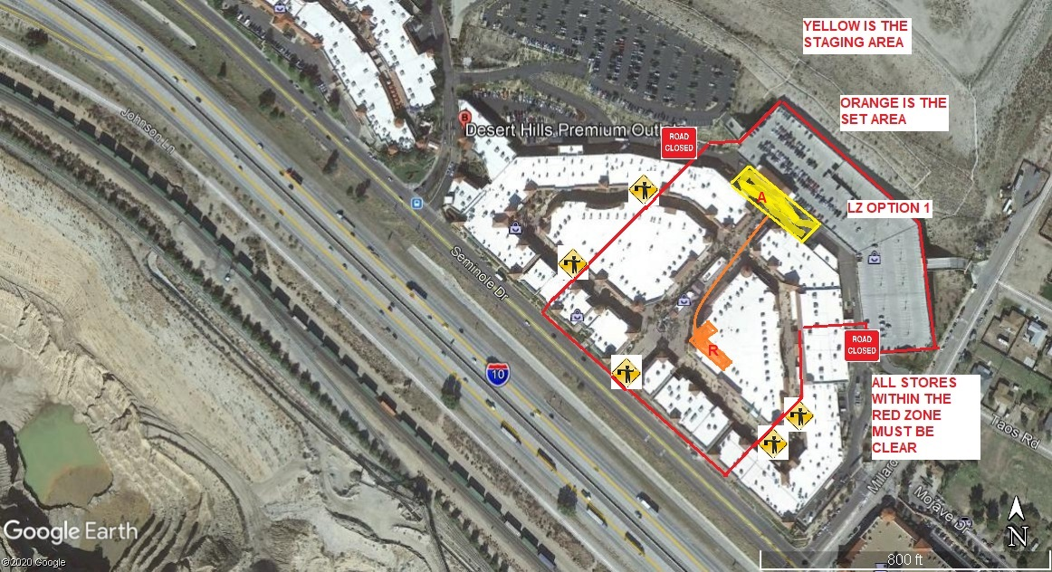
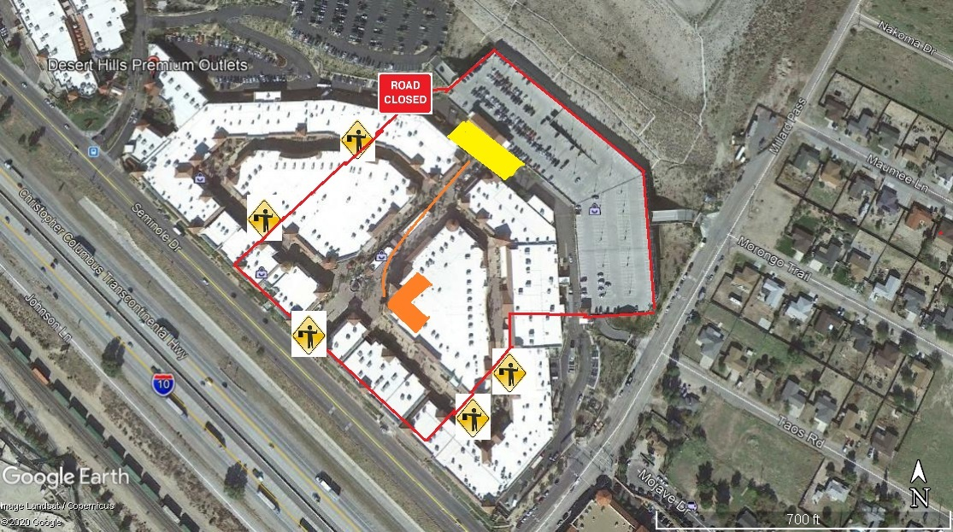
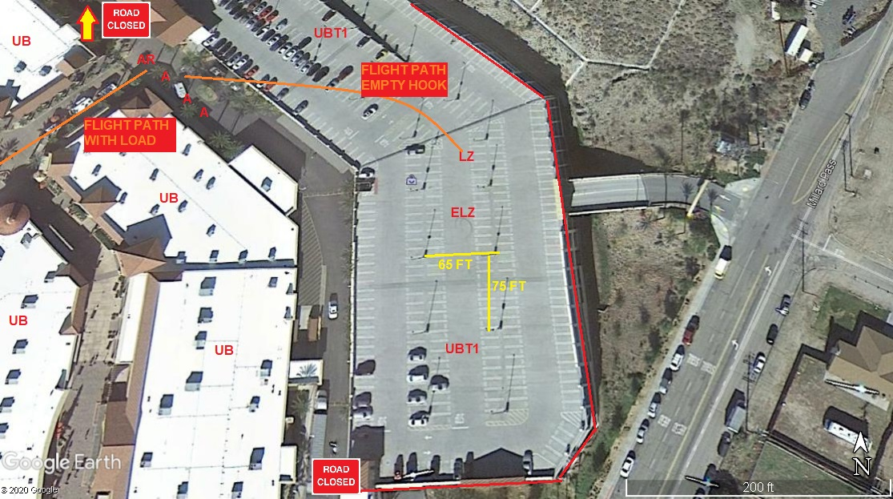

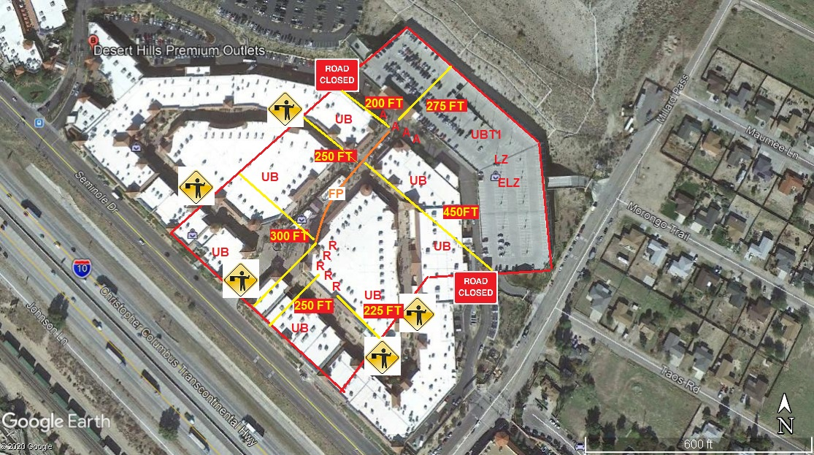

LEGEND
SITE PLAN SYMBOLS: EVACUATION FLIGHT PATH
LANDING AREA = (LZ) | STREET BLOCKED = XXXX | TOP TWO FLOORS = UBT2
ATTACH AREA = (A) | RELEASE AREA = (R)
FLIGHT PATH = >>> | EMERGENCY LAND = (ELZ)
UNOCCUPIED BUILDING = (UBA) | UNOCCUPIED BUILDING TOP FLOOR = (UBT1)

AREA SURVEY CONDUCTED BY : 

SUBMITTED BY: JEFFREY M. TEUBNER DATE: 8-5-2020
TITLE: FLIGHT COORDINATOR

