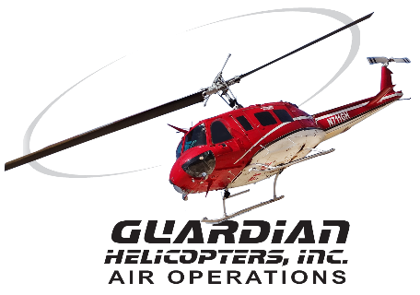
SECTION 7 Part 135 GH 4A Part 133 GH 4L
Congested Area Plan
Operator: Guardian Helicopters, Inc
67 D STREET
Fillmore CA. 93015
Phone (818) 442-9904
FAX (818) 442-9901
PROJECT: PG&E POLE REPLACEMENT WORK ORDER #: 20-01201
ADDRESS 25730 BUCKHORN RIDGE RD : SAN MARCOS CA
LZ STAGING AREA LATITUDE 38°26'16.98"N LONGITUDE 120°33'1.11"W
POLE LATITUDE 38°26'28.71"N LONGITUDE 120°33'2.97"W 50 CL 2 2100 LBS
LINE PULL LATITUDE 38°26'25.78"N LONGITUDE 120°33'2.98"W 1 SPAN 400 FT
CONTACT AT SITE: CURTIS SCHMIDT PHONE#: 209-598-4672
CONTRACTOR: PG&E
PILOT’S NAME(S): 1. JOHN OLSON CERT #: 2769166
2. BUCKEY MACKAY CERT #: 2778051
3. MICHAEL KLINK CERT#: 3018828
4. IAN GOODALE CERT# :3741973
5. ROSS GOULET CERT# : 3396777
TYPE OF AIRCRAFT:
BELL UH-1H N# N711GH A/C CATEGORY: RESTRICTED
BELL UH-1H N# N777GH A/C CATEGORY: RESTRICTED
BELL 407 N# N407GH A/C CATEGORY: STANDARD
BELL 407 N# N447GH A/C CATEGORY: STANDARD
BELL 205A1 N# N216GH A/C CATEGORY: STANDARD
AS350 B2 N# N498PT A/C CATEGORY: STANDARD
AS350 B3 N# N718GH A/C CATEGORY: STANDARD
AS350 B3 N# N215GH A/C CATEGORY: STANDARD
IF SAFETY DICTATES AND OR THE CUSTOMER REQUESTS ADDITIONAL LIFTS THE LIFTS WILL BE CONDUCTED REMAINING WITHIN THE APPROVED TIME PARAMETERS.
TYPE OF LIFTS: (1) 50 CL 2 AND LINE PULL LOAD:EXTL CL B TYPE OF ITEM LIFTING: AERODYNAMIC NON- AERODYNAMIC MAX 2200 LBS
NO. OF LIFTS: 4 LONG LINE: (NO) XXX (YES) LESS THEN 150 FT (LENGTH)
OPERATIONAL ALTITUDE: < 250 STREET CLOSING: (N0) XX (YES)
DATE AND TIMES OPERATION WILL BEGIN AND TERMINATE:
FLIGHT DATES | TIME BEGIN | TIME END | TODAY’S DATE
7-17-2020 | SUNRISE | SUNSET | 7-2-2020
AGENCY NAME: | PHONE#: | PERSON NOTIFIED: | DATE:
JACKSON POLICE DEPARTMENT | 209-223-1771 | WATCH COMMANDER | NOTIFY
AMADOR FIRE PROTECTION DISTRICT | 209-223-6391 | STATION 112 | NOTIFY

Part 135 GH 4A Part 133 GH 4L
Congested Area Plan
Evacuation Crowd Control Street Closure
□No Evacuated Structures Operator Yes □No
Evacuated Structures Contractor Contractor
□Operator
LIST OF BUILDINGS THAT SHALL EITHER BE PARTIALLY OR ENTIRELY UNOCCUPIED PERSONS ALSO HOMES THAT WILL BE NOTIFIED OF ACTIVITY:
BUILDING DESCRIPTION/ADDRESS | REMARKS | METHOD
25176 BUCKHORN RIDGE RD | VACANT DURING OPS | HAND DELIVER
25730 BUCKHORN RIDGE RD | VACANT DURING OPS | HAND DELIVER
25730 BUCKEYE RD | VACANT DURING OPS | HAND DELIVER
25695 BUCKEYE RD | VACANT DURING OPS | HAND DELIVER
25664 BUCKEYE RD | VACANT DURING OPS | HAND DELIVER
ALL HOMES WITHIN OPERATING AREA | VACANT DURING OPS | HAND DELIVER
SEE DIAGRAM = V | VACANT DURING OPS | HAND DELIVER
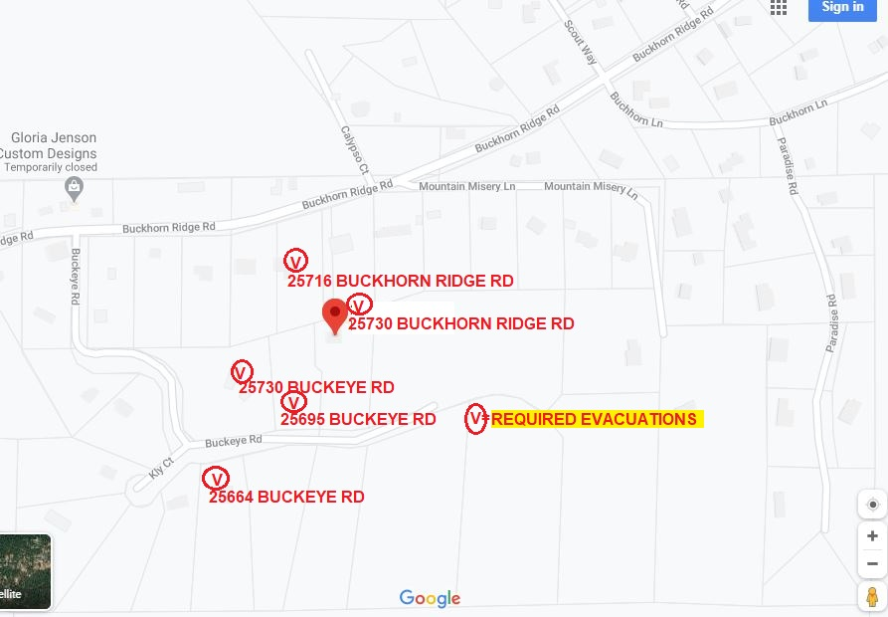

Narrative description of pick-up site, route, delivery site, and plan for ceasing operation if unauthorized persons enter operational area or real hazard occurs.
SITE INSPECTION NOTES

ONLY PERSONNEL ESSENTIAL TO COMPLETING THE JOB SAFELY WILL BE PERMITTED TO PARTICIPATE IN THE EVOLUTION. ONLY PERSONNEL PARTICIPATING IN THE SAFETY BRIEF WILL BE PERMITTED TO BE IN THE AREA OF OPERATIONS. ONLY AUTHORIZED ESSENTIAL PERSONAL WILL BE PERMITTED IN THE IMMEDIATE AREA OF OPERATIONS. IN THE EVENT AN UNAUTHORIZED PERSON ENTERS THE OPERATIONS AREA OR A POTENTIAL HAZARD IS IDENTIFIED THE PILOT WILL HOLD THE AIRCRAFT IN RELATIVE POSITION. THIS WILL BE ACHIEVED WITHOUT OVER FLYING THE GROUND CREW. ALL OPERATIONS WILL BE CEASED UNTIL THE PROBLEM IS RECTIFIED. IN THE EVENT OF AN AIRCRAFT EMERGENCY, THE PILOT WILL RADIO GROUND PERSONNEL AND WILL ATTEMPT TO LAND IN THE EMERGENCY LANDING AREA.
DURING THE LIFT EVOLUTION THE AIRCRAFT AND GROUND CREW WILL ALL BE IN RADIO COMMUNICATIONS. IN THE EVENT OF LOSS COMMUNICATIONS, THE CREW WILL USE STANDARD HAND SIGNALS TO COMMUNICATE WITH THE PILOT. WHEN THE PILOT IS CLEAR HE WILL MOVE THE AIRCRAFT TO A SAFE LOCATION TO ALLOW THE COMMUNICATION PROBLEM TO BE RECTIFIED.
THE OPERATIONS AREA IS WITHIN THE SECURED AREA. ALL ESSENTIAL CREW WITHIN THE OPERATIONS AREA WILL NOT BE INVOLVED IN TAKING PICTURES OR ANY OTHER USE OF CELL PHONES.
PRIOR TO BEGINNING OPERATIONS, A TAILBOARD SAFETY BRIEF WILL BE CONDUCTED.
- HELICOPTER WILL LAND AT THE LZ TO CONNECT THE LONGLINE AND CONDUCT A SAFETY TAILBOARD
- POLE WILL BE STAGED AT THE LZ
- WATER TRUCK REQUIRED AT LZ STAGING AREA
- FUELING WILL BE CONDUCTED AT THE LANDING ZONE
- EMERGENCY LANDING ZONE IS AT THE STAGING AREA AND ALONG THE FLIGHT PATH
- RADIOS WILL BE PROVIDED TO POLE SITE AND LINE PULL START POINT
- BUCKEYE RD WILL EXPERIENCE INTERMITTENT CLOSURES
- REQUIRED EVACUATIONS WILL BE PHYSICALLY VERIFIED PRIOR TO START
- SEE DIAGRAM FOR STREET CLOSURE AND FLAGMAN REQUIREMENTS.
- THE CONTRACTOR WILL TRIM TREES

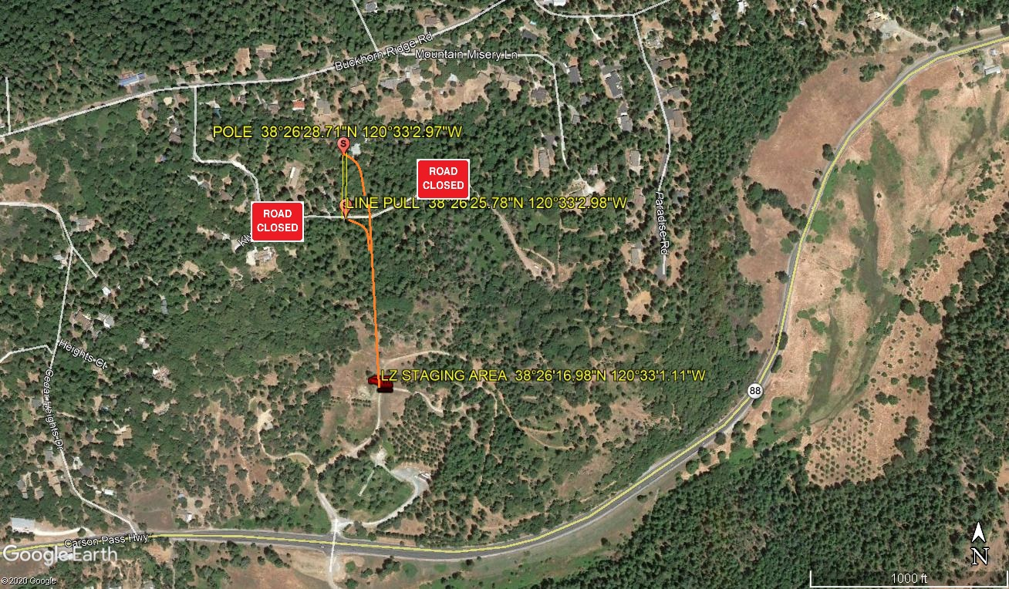
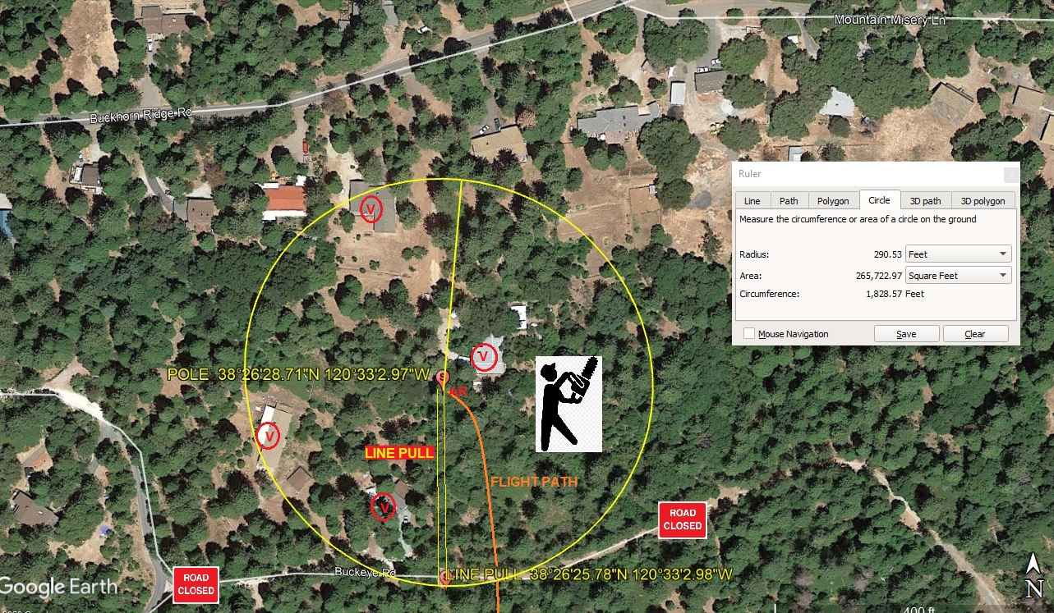
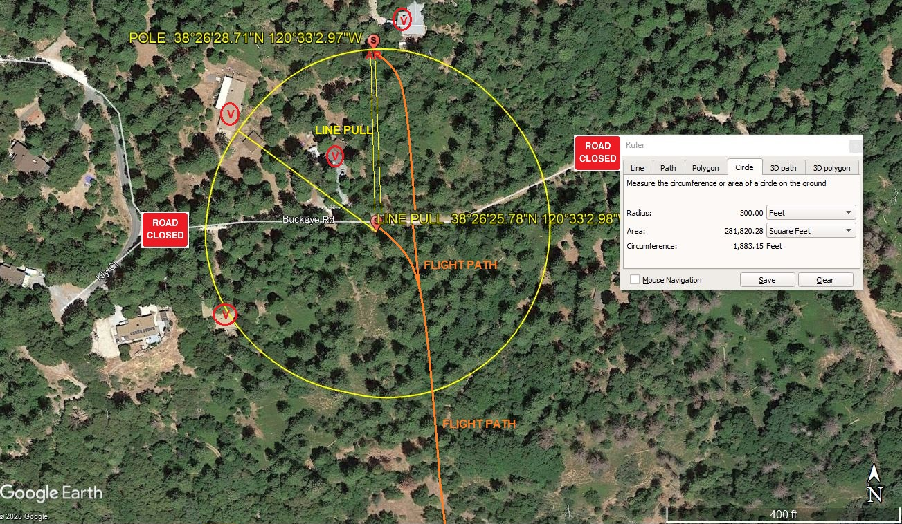
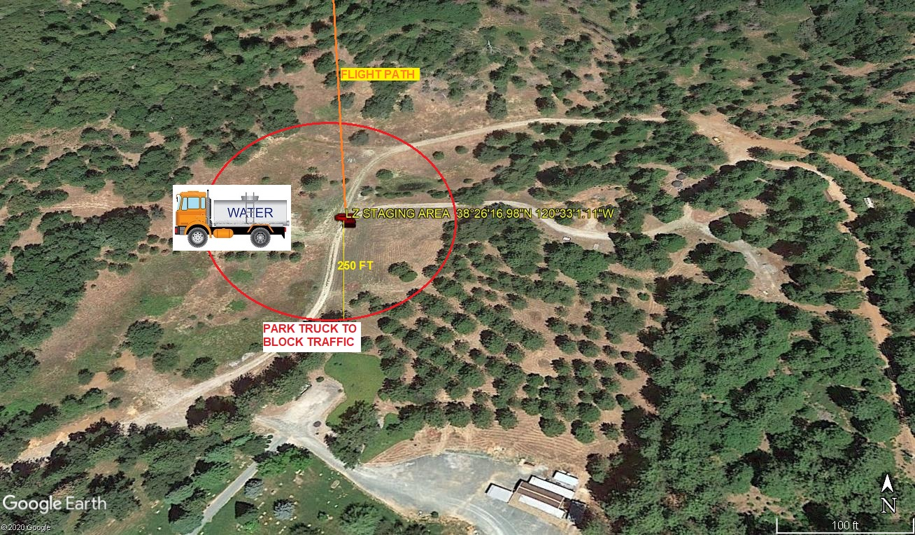
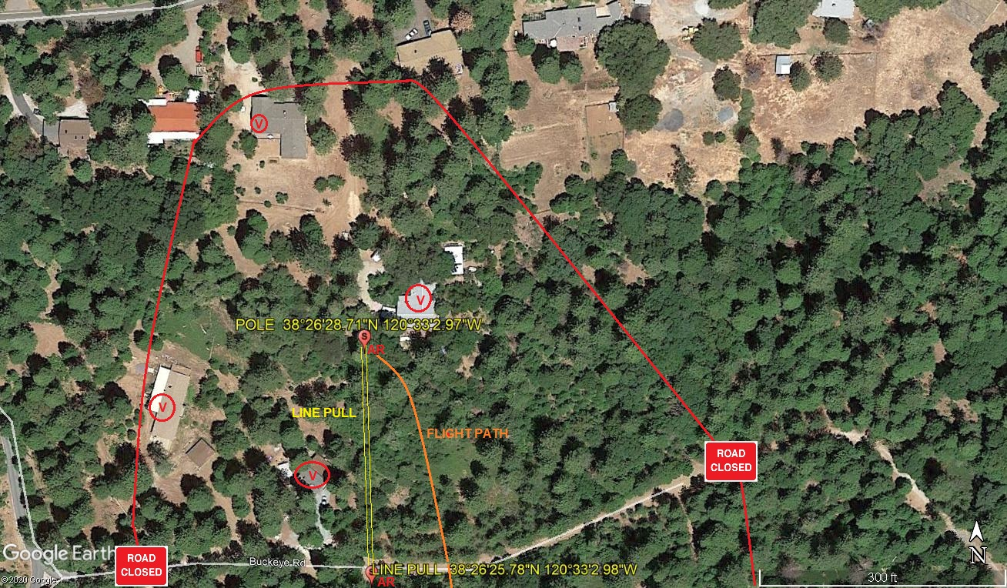
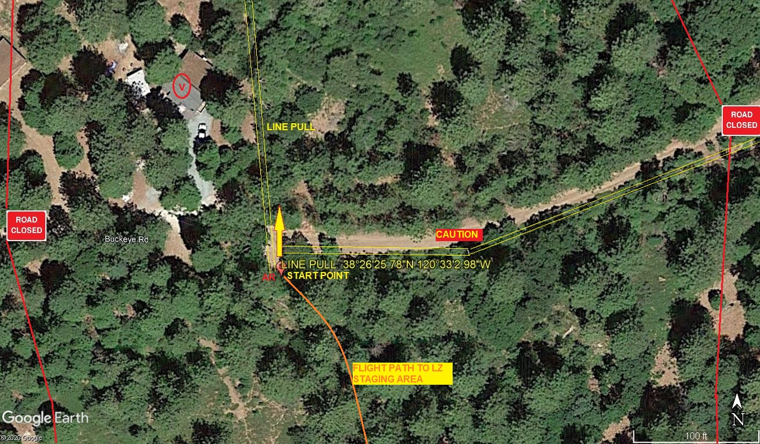
7-2-2020 
DATE OF SUBMISSION COMPANY OFFICIAL / TITLE

