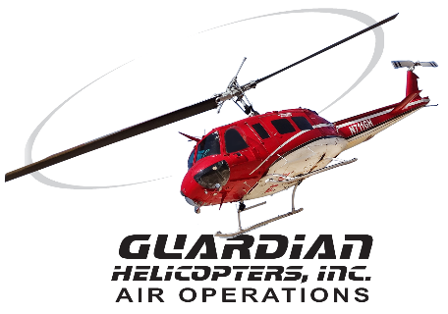
SECTION 7 Part 135 GH 4A Part 133 GH 4L
Congested Area Plan
Operator: Guardian Helicopters, Inc
67 D STREET Phone (818) 442-9904
Fillmore CA. 93015 FAX (818) 442-9901

PROJECT: A/C UNITS WORK ORDER #: Q2020-353
ADDRESS 44109 PACIFIC COMMONS BLVD : FREMONT CA
LZ STAGING AREA LATITUDE 37°29'50.47"N LONGITUDE 121°58'5.88"W
CONTACT AT SITE: SHELDON MECHANICAL DAN BOUTE PHONE#: 661-414-2024
CONTACT AT SITE: PETE ALVAREZ FOREMAN PHONE#:661-505-2660
CONTRACTOR: FAIRLIFTS AUSTIN QUATTROCCHI PHONE#: 470-443-9800
PILOT’S NAME(S): 1. JOHN OLSON CERT #: 2769166
2. BUCKEY MACKAY CERT #: 2778051
3. MICHAEL KLINK CERT#: 3018828
4. IAN GOODALE CERT#: 3741973
5. ROSS GOULET CERT#: 3396777
TYPE OF AIRCRAFT: BELL UH-1H N# N711GH A/C CATEGORY: RESTRICTED
BELL UH-1H N# N777GH A/C CATEGORY: RESTRICTED
BELL 407 N# N407GH A/C CATEGORY: STANDARD
BELL 205A1 N# N216GH A/C CATEGORY: STANDARD
AS350 B2 N# N498PT A/C CATEGORY: STANDARD
AS350 B3 N# N718GH A/C CATEGORY: STANDARD
AS350 B3 N# N215GH A/C CATEGORY: STANDARD
IF SAFETY DICTATES AND OR THE CUSTOMER REQUESTS ADDITIONAL LIFTS THE LIFTS WILL BE CONDUCTED REMAINING WITHIN THE APPROVED TIME PARAMETERS.
TYPE OF LIFTS: (19 ) 1975 LBS UNITS LOAD:EXT CL B TYPE OF ITEM LIFTING: AERODYNAMIC NON- AERODYNAMIC LONG LINE: (NO) XXX (YES) LESS THEN 100 FT (LENGTH)
OPERATIONAL ALTITUDE: < 250 AGL STREET CLOSING: XX (N0) (YES)
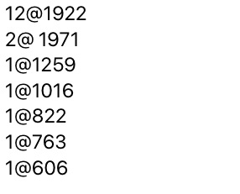
DATE AND TIMES OPERATION WILL BEGIN AND TERMINATE:
FLIGHT DATES | TIME BEGIN | TIME END | TODAY’S DATE
7-22-2020 | SUNRISE | SUNSET | 7-14-2020
AGENCY NAME: | PHONE#: | PERSON NOTIFIED: | DATE:
FREMONT POLICE DEPARTMENT | 510-790-6800 | DISPATCH | NOTIFIED
FREMONT FIRE DEPARTMENT | 510-494-4280 | DISPATCH | NOTIFIED
AIR TRAFFIC CONTROL | N/A | N/A | N/A

Part 135 GH 4A Part 133 GH 4L
Congested Area Plan

Evacuation Crowd Control Street Closure
□No Evacuated Structures Operator □Yes No
Evacuated Structures Contractor Contractor
□Operator
LIST OF BUILDINGS THAT SHALL EITHER BE PARTIALLY OR ENTIRELY UNOCCUPIED PERSONS ALSO HOMES THAT WILL BE NOTIFIED OF ACTIVITY:
BUILDING DESCRIPTION/ADDRESS | REMARKS | METHOD
44109 PACIFIC COMMONS BLVD AMAZON CENTER | VACANT DURING OPS | HAND DELIVER
ALL HOMES WITHIN RED OPERATING AREA | VACANT DURING OPS | HAND DELIVER
SEE DIAGRAM = VACANT | VACANT DURING OPS | HAND DELIVER
Narrative description of pick-up site, route, delivery site, and plan for ceasing operation if unauthorized persons enter operational area or real hazard occurs.
SITE INSPECTION NOTES
ONLY PERSONNEL ESSENTIAL TO COMPLETING THE JOB SAFELY WILL BE PERMITTED TO PARTICIPATE IN THE EVOLUTION. ONLY PERSONNEL PARTICIPATING IN THE SAFETY BRIEF WILL BE PERMITTED TO BE IN THE AREA OF OPERATIONS. ONLY AUTHORIZED ESSENTIAL PERSONAL WILL BE PERMITTED IN THE IMMEDIATE AREA OF OPERATIONS. IN THE EVENT AN UNAUTHORIZED PERSON ENTERS THE OPERATIONS AREA OR A POTENTIAL
HAZARD IS IDENTIFIED THE PILOT WILL HOLD THE AIRCRAFT IN RELATIVE POSITION. THIS WILL BE ACHIEVED WITHOUT OVER FLYING THE GROUND CREW. ALL OPERATIONS WILL BE CEASED UNTIL THE PROBLEM IS RECTIFIED. IN THE EVENT OF AN AIRCRAFT EMERGENCY, THE PILOT WILL RADIO GROUND PERSONNEL AND WILL ATTEMPT TO LAND IN THE EMERGENCY LANDING AREA.
DURING THE LIFT EVOLUTION THE AIRCRAFT AND GROUND CREW WILL ALL BE IN RADIO COMMUNICATIONS. IN THE EVENT OF LOSS COMMUNICATIONS, THE CREW WILL USE STANDARD HAND SIGNALS TO COMMUNICATE WITH THE PILOT. WHEN THE PILOT IS CLEAR HE WILL MOVE THE AIRCRAFT TO A SAFE LOCATION TO ALLOW THE COMMUNICATION PROBLEM TO BE RECTIFIED.
THE OPERATIONS AREA IS WITHIN THE SECURED AREA. ALL ESSENTIAL CREW WITHIN THE OPERATIONS AREA WILL NOT BE INVOLVED IN TAKING PICTURES OR ANY OTHER USE OF CELL PHONES.
PRIOR TO BEGINNING OPERATIONS, A TAILBOARD SAFETY BRIEF WILL BE CONDUCTED.
- TAILBOARD WILL BE CONDUCTED AT THE LANDING ZONE
- THE AIRCRAFT WILL LAND AT THE STAGING AREA TO CONNECT THE LONGLINE AND CONDUCT FUELING
- WATER TRUCK NOT REQUIRED
- EQUIPMENT WILL BE STAGED IN THE STAGING AREA TO THE SOUTH WEST OF THE BUILDING
- EMERGENCY LANDING ZONE IS AT THE STAGING AREA AND ALONG THE FLIGHT PATH
- PILOT AND GROUND CREW WILL BE IN RADIO COMMUNICATIONS
- SUBJECT BUILDING WILL BE VACANT DURING OPERATIONS.
- ALL ACCESS TO THE AMAZON CENTER TO THE OPERATIONS AREA WILL BE SECURED
- GATES WILL BE CLOSED TO THE FACILITY
- THE HELICOPTER WILL LAND AT THE STAGING AREA TO CONDUCT SAFETY BRIEF. ONCE THE UNITS ARE RIGGED AND EVERYONE IS IN PLACE THE PILOT WILL START THE OPERATION. THE UNITS WILL BE PLACED IN THE STAGING AREA IN A SEQUENTIAL ORDER. UNITS WILL BE STAGED ON THE SOUTHWEST OF THE BUILDING. THE PILOT WILL LAND FOR FUEL AS NEEDED.
ONCE THE OPERATION IS COMPLETE THE PILOT WILL LAND AT THE LZ TO REMOVE THE LONGLINE. THE BUILDING CAN BE REOPENED.

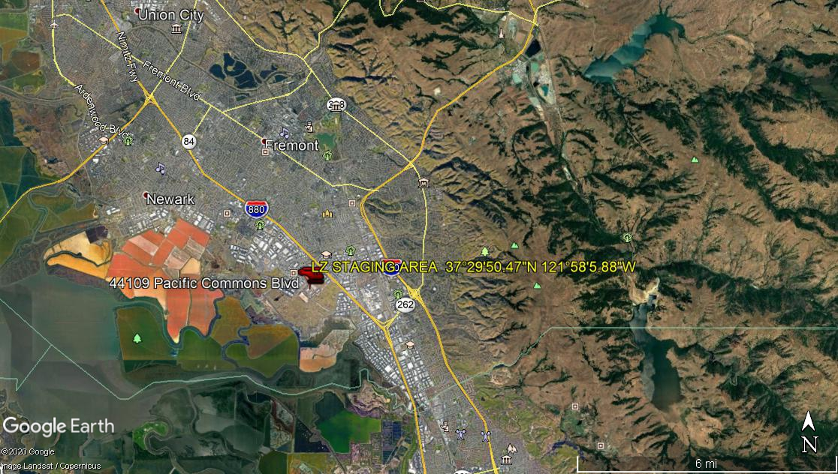
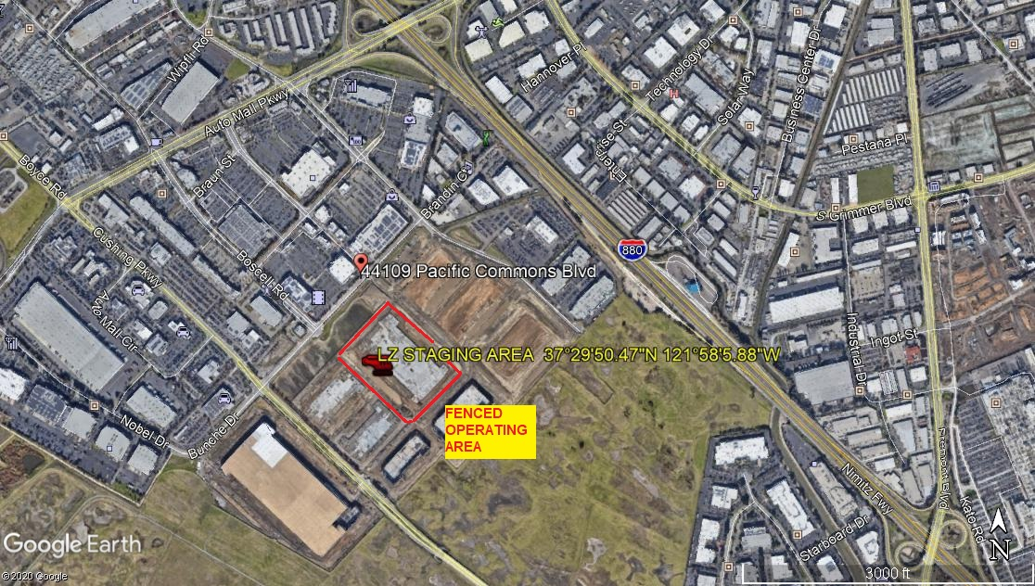
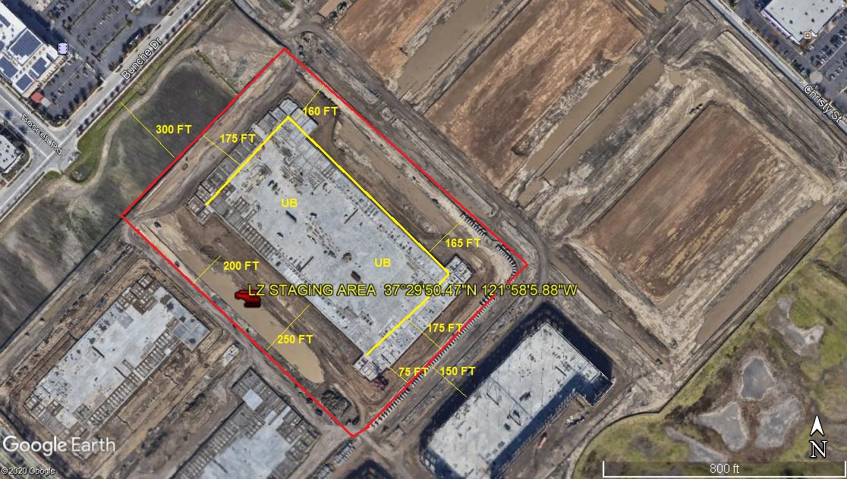
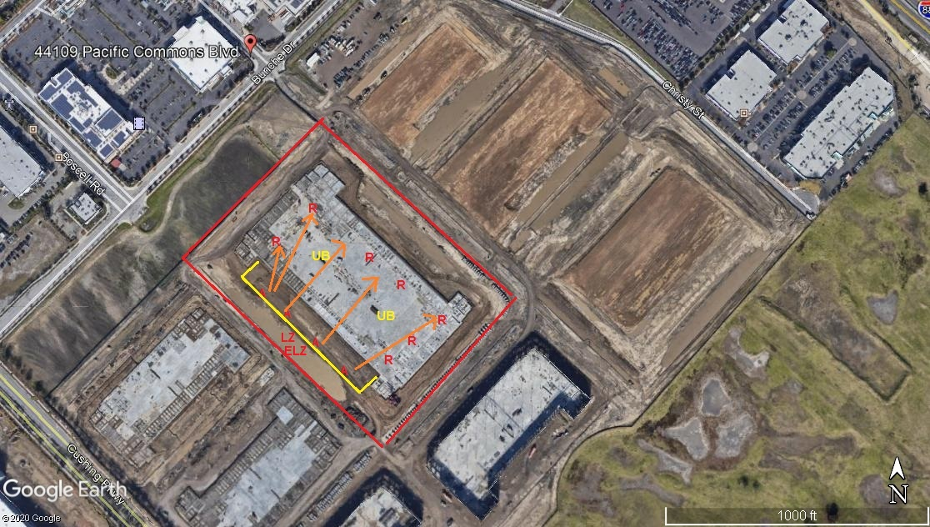
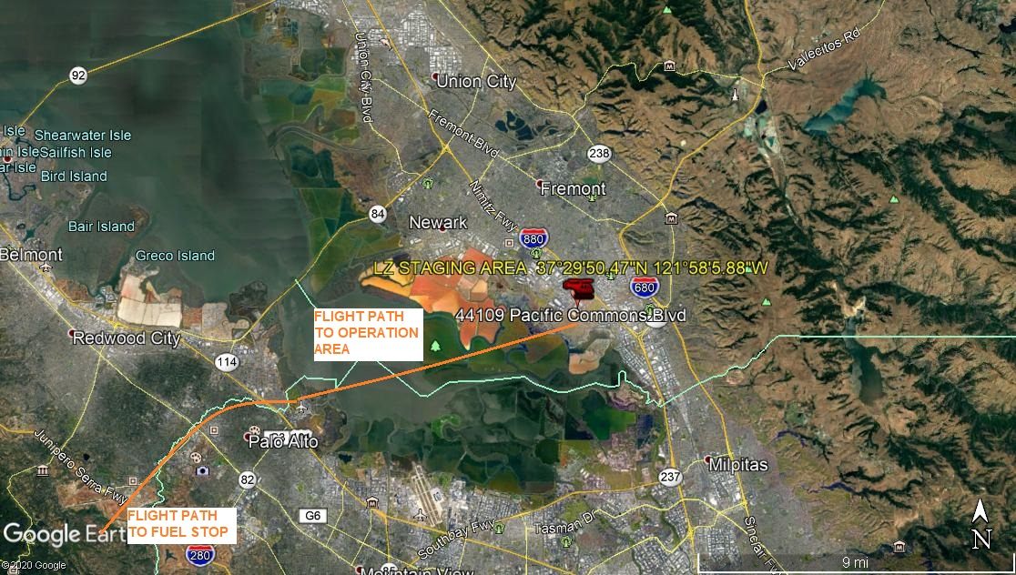LEGEND
SITE PLAN SYMBOLS: EVACUATION FLIGHT PATH
LANDING AREA = (LZ) | STREET BLOCKED = XXXX | TOP TWO FLOORS = UBT2
ATTACH AREA = (A) | RELEASE AREA = (R)
FLIGHT PATH = >>> | EMERGENCY LAND = (ELZ)
UNOCCUPIED BUILDING = (UB) | UNOCCUPIED BUILDING TOP FLOOR = (UBT1)

7-14-2020 
DATE OF SUBMISSION COMPANY OFFICIAL / TITLE
Jeffrey M. Teubner Flight Coordinator

