
SECTION 7 Part 135 GH 4A Part 133 GH 4L
NON- Congested Area Plan
Operator: Guardian Helicopters, Inc
67 D STREET Phone (818) 442-9904
Fillmore CA. 93015 FAX (818) 442-9901
PROJECT: PG&E HEC EQUIPEMNT WORK ORDER #: 21-00267
ADDRESS W. ORMONDE RD : SLO CA
ADDRESS SPANISH SPRINGS RD : SLO CA
LZ STAGING AREA LATITUDE 35°10'9.32"N LONGITUDE 120°35'57.68"W
LATITUDE 35°10'58.20"N LONGITUDE 120°36'24.60"W
LATITUDE 35°11'22.20"N LONGITUDE 120°36'46.80"W
LZ STAGING AREA LATITUDE 35°11'19.01"N 120°38'53.76"W
LATITUDE 35°11'43.80"N LONGITUDE 120°37'28.80"W
LATITUDE 35°12'7.80"N LONGITUDE 120°38'8.40"W
LATITUDE 35°12'21.60"N LONGITUDE 120°38'28.20"W
CONTACT REQUESTOR: JEFFREY E. LOPEZ PHONE#: (209) 602-5240
CONTACT FORMAN: JACOB M. KRISTY PHONE#: (661) 340-5833
PILOT’S NAME(S):
1. JOHN OLSON CERT #: 2769166
2. BUCKEY MACKAY CERT #: 2778051
3. MICHAEL KLINK CERT#: 3018828
4. IAN GOODALE CERT#: 3741973
5. ROSS GOULET CERT#: 3396777
TYPE OF AIRCRAFT:
BELL UH-1H N# N777GH A/C CATEGORY: RESTRICTED
BELL 407 N# N407GH A/C CATEGORY: STANDARD
BELL 407 N# N447GH A/C CATEGORY: STANDARD
BELL 205A1 N# N216GH A/C CATEGORY: STANDARD
AS350 B2 N# N498PT A/C CATEGORY: STANDARD
AS350 B3 N# N718GH A/C CATEGORY: STANDARD
AS350 B3 N# N215GH A/C CATEGORY: STANDARD

IF SAFETY DICTATES AND OR THE CUSTOMER REQUESTS ADDITIONAL LIFTS THE LIFTS WILL BE CONDUCTED REMAINING WITHIN THE APPROVED TIME PARAMETERS.
TYPE OF LIFTS: LADDERS PLATFORMSINSULATORS HEC LOAD:EXT CL B TYPE OF ITEM LIFTING: AERODYNAMIC NON- AERODYNAMIC LONG LINE: (NO) XXX (YES) LESS THEN 100 FT (LENGTH)
OPERATIONAL ALTITUDE: < 250 AGL STREET CLOSING: (N0) XX (YES)
DATE AND TIMES OPERATION WILL BEGIN AND TERMINATE:
FLIGHT DATES | TIME BEGIN | TIME END | TODAY’S DATE
2-9-2021 2-11-2021 | SUNRISE | SUNSET | 2-5-2021
AGENCY NAME: | PHONE#: | PERSON NOTIFIED: | DATE:
SLO FIRE DEPARTMENT | 805-781-7380 | DISPATCH | NOTIFIED
SLO SHERIFF DEPARTMENT | 805-434-4290 | DISPATCH | NOTIFIED
SLO REGIONAL AIRPORT | 805-781-5203 | N/A | N/A

Part 135 GH 4A Part 133 GH 4L
NON Congested Area Plan

Evacuation Crowd Control Street Closure
No Evacuated Structures Operator Yes □No
□Evacuated Structures Contractor Contractor
□Operator

LIST OF BUILDINGS THAT SHALL EITHER BE PARTIALLY OR ENTIRELY UNOCCUPIED PERSONS ALSO HOMES THAT WILL BE NOTIFIED OF ACTIVITY:

BUILDING DESCRIPTION/ADDRESS | REMARKS | METHOD
NONE | VACANT DURING OPS | HAND DELIVER
ALL HOMES WITHIN RED OPERATING AREA | VACANT DURING OPS | HAND DELIVER
SEE DIAGRAM = VACANT | VACANT DURING OPS | HAND DELIVER
Narrative description of pick-up site, route, delivery site, and plan for ceasing operation if unauthorized persons enter operational area or real hazard occurs.
SITE INSPECTION NOTES
ONLY PERSONNEL ESSENTIAL TO COMPLETING THE JOB SAFELY WILL BE PERMITTED TO PARTICIPATE IN THE EVOLUTION. ONLY PERSONNEL PARTICIPATING IN THE SAFETY BRIEF WILL BE PERMITTED TO BE IN THE AREA OF OPERATIONS. ONLY AUTHORIZED ESSENTIAL PERSONAL WILL BE PERMITTED IN THE IMMEDIATE AREA OF OPERATIONS. IN THE EVENT AN UNAUTHORIZED PERSON ENTERS THE OPERATIONS AREA OR A POTENTIAL
HAZARD IS IDENTIFIED THE PILOT WILL HOLD THE AIRCRAFT IN RELATIVE POSITION. THIS WILL BE ACHIEVED WITHOUT OVER FLYING THE GROUND CREW. ALL OPERATIONS WILL BE CEASED UNTIL THE PROBLEM IS RECTIFIED. IN THE EVENT OF AN AIRCRAFT EMERGENCY, THE PILOT WILL RADIO GROUND PERSONNEL AND WILL ATTEMPT TO LAND IN THE EMERGENCY LANDING AREA.
DURING THE LIFT EVOLUTION THE AIRCRAFT AND GROUND CREW WILL ALL BE IN RADIO COMMUNICATIONS. IN THE EVENT OF LOSS COMMUNICATIONS, THE CREW WILL USE STANDARD HAND SIGNALS TO COMMUNICATE WITH THE PILOT. WHEN THE PILOT IS CLEAR HE WILL MOVE THE AIRCRAFT TO A SAFE LOCATION TO ALLOW THE COMMUNICATION PROBLEM TO BE RECTIFIED.
THE OPERATIONS AREA IS WITHIN THE SECURED AREA. ALL ESSENTIAL CREW WITHIN THE OPERATIONS AREA WILL NOT BE INVOLVED IN TAKING PICTURES OR ANY OTHER USE OF CELL PHONES.

PRIOR TO BEGINNING OPERATIONS, A TAILBOARD SAFETY BRIEF WILL BE CONDUCTED.

- HELICOPTER WILL LAND AT THE LANDING ZONE TO CONDUCT TAILBOARD.
- PILOT WILL COORDINATE WITH BOTH POLE SITES TO PERFORM TAILBOARD FOR BOTH CREWS.
- TAILBOARD WILL BE CONDUCTED AT POLE STAGING AREA
- WATER TRUCK IS REQUIRED AT LANDING AREAS
- NO EVACUATIONS
- STREET CLOSURE ONLY DURING AIRCRAFT FLYING A LOAD ACROSS THE STREET SEE DIAGRAM
- TREE TRIMMING IF REQUIRED

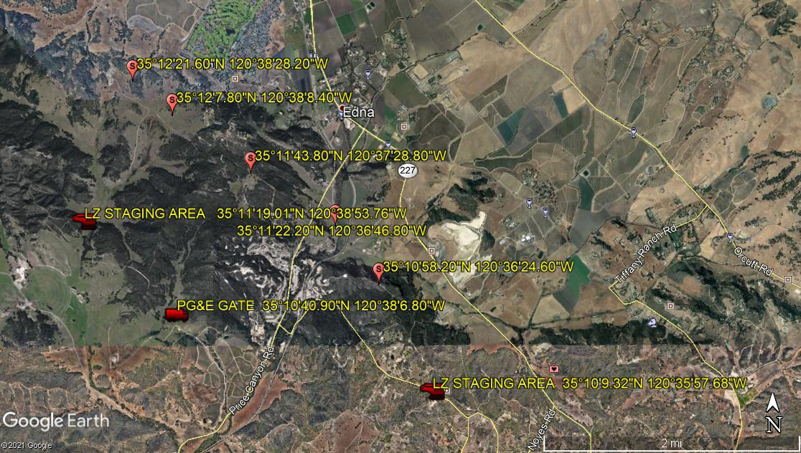
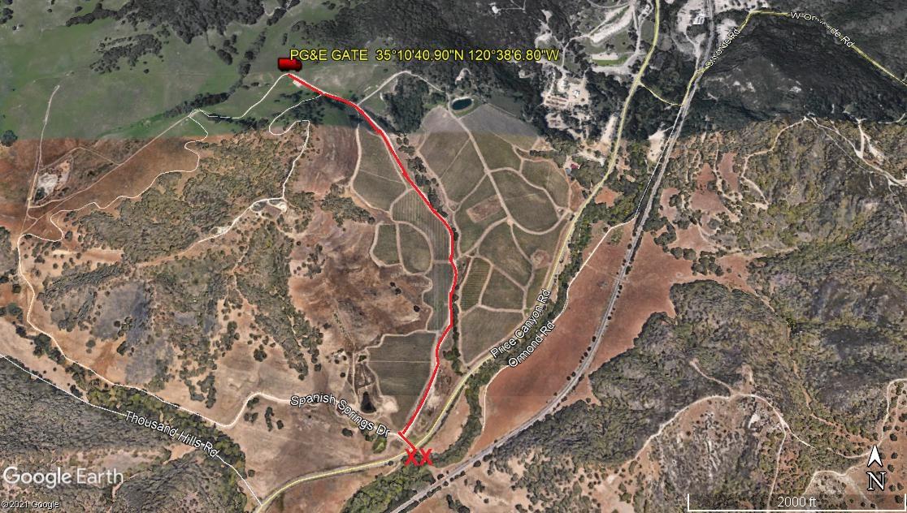
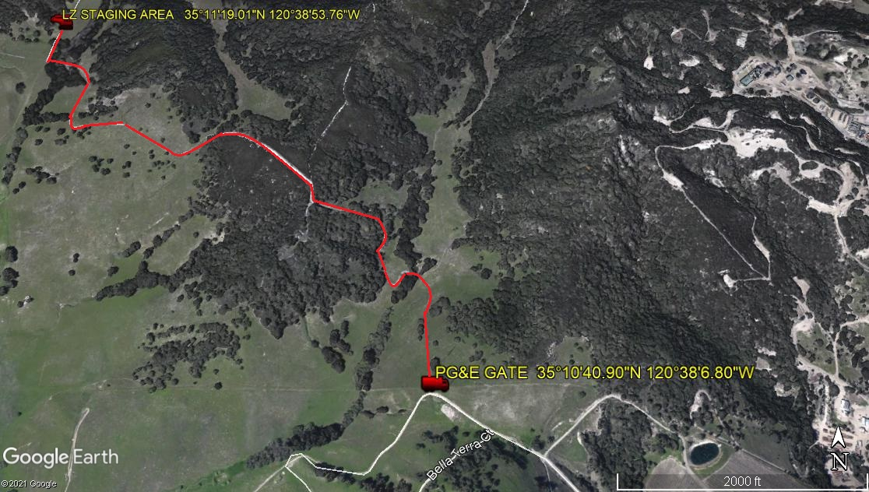

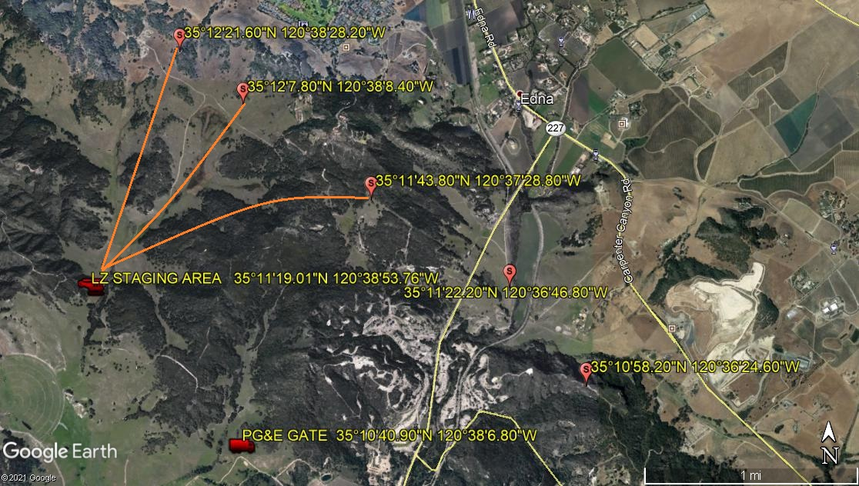
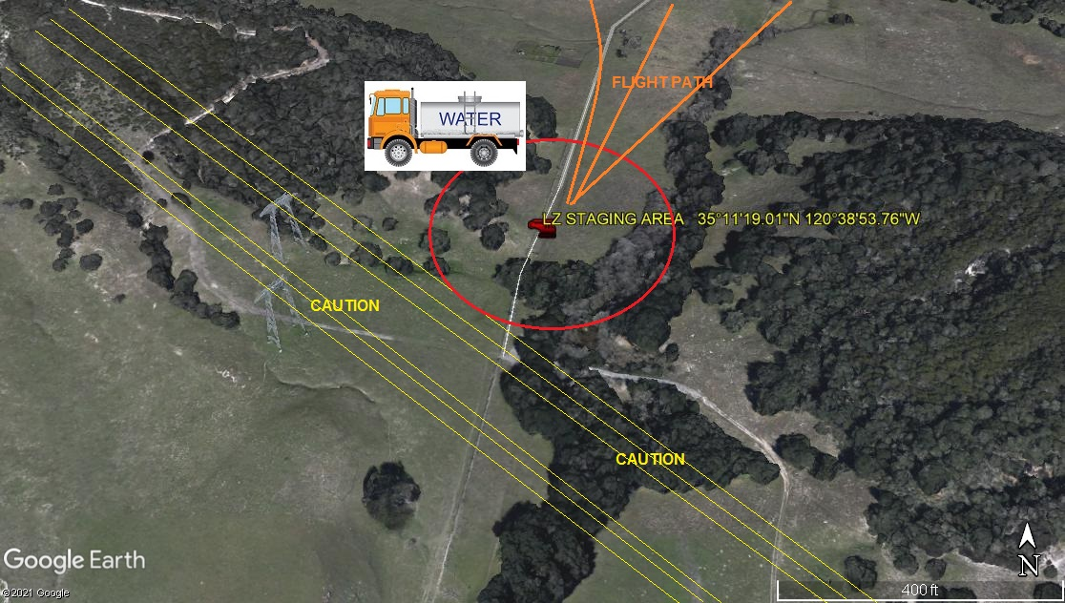
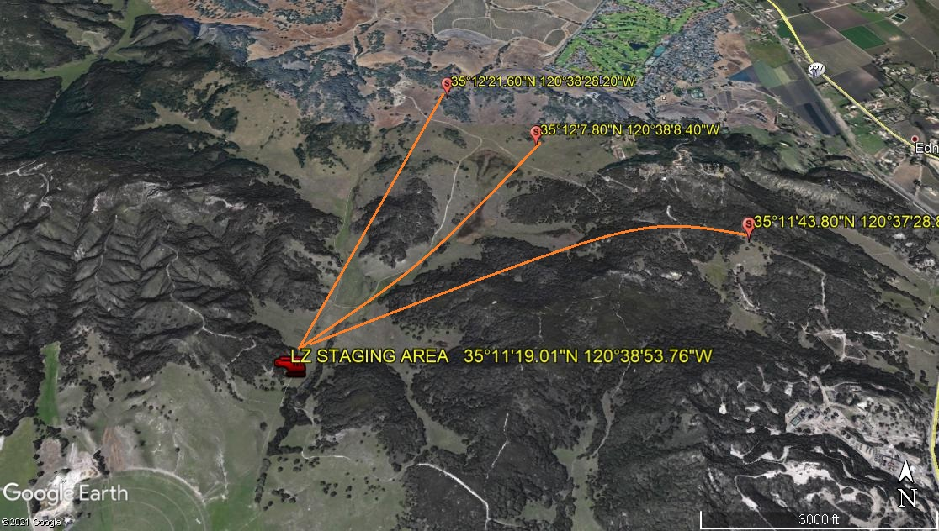
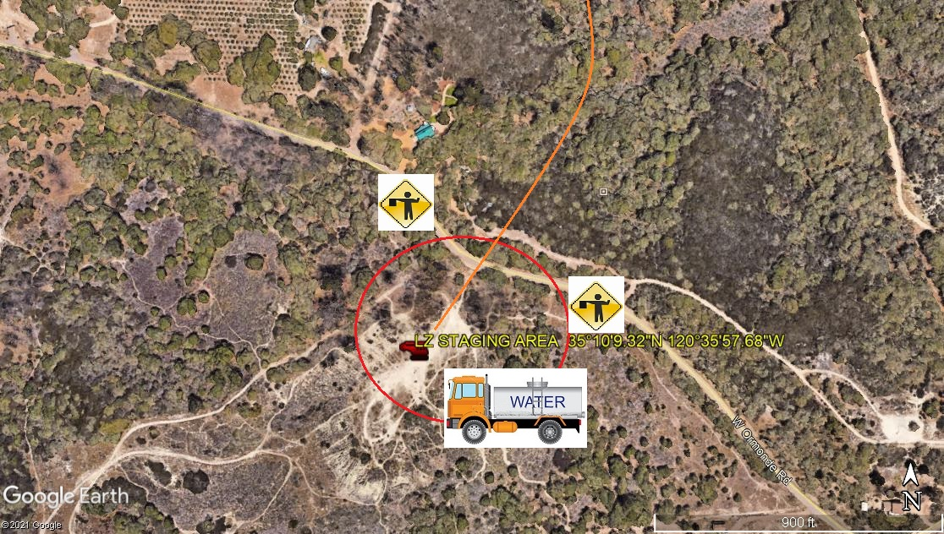
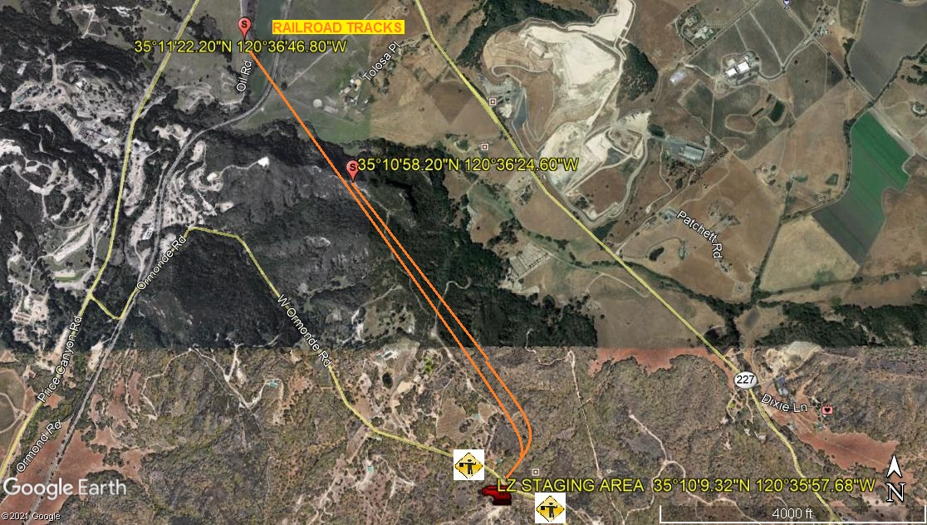
LEGEND
SITE PLAN SYMBOLS: EVACUATION FLIGHT PATH
LANDING AREA = (LZ) | STREET BLOCKED = XXXX | TOP TWO FLOORS = UBT2
ATTACH AREA = (A) | RELEASE AREA = (R)
FLIGHT PATH = >>> | EMERGENCY LAND = (ELZ)
UNOCCUPIED BUILDING = (UB) | UNOCCUPIED BUILDING TOP FLOOR = (UBT1)

12-23-2020 
DATE OF SUBMISSION COMPANY OFFICIAL / TITLE
Jeffrey M. Teubner Flight Coordinator

