
SECTION 7 Part 135 GH 4A Part 133 GH 4L
NON- Congested Area Plan
Operator: Guardian Helicopters, Inc
67 D STREET Phone (818) 442-9904
Fillmore CA. 93015 FAX (818) 442-9901
PROJECT: PG&E HEC WORK ORDER #: 21-00547
ADDRESS: N. POZO RD CITY : SANTA MARGARITA STATE: CA
LZ STAGING AREA LATITUDE 35°19'26.32"N LONGITUDE 120°31'28.74"W 1200 ELEV
52/295 LATITUDE 35°17'54.60"N LONGITUDE 120°33'52.20"W 2000 ELEV
53-296 LATITUDE 35°17'49.80"N LONGITUDE 120°33'55.80"W 2000 ELEV
53/297 LATITUDE 35°17'44.40"N LONGITUDE 120°34'0.60"W 2000 ELEV
53/298 LATITUDE 35°17'30.00"N LONGITUDE 120°34'12.60"W 2000 ELEV
53/299 LATITUDE 35°17'15.00"N LONGITUDE 120°34'25.80"W 2000 ELEV

CONTACT REQUESTOR: KRISTOPHER C NANCOLAS PHONE#: 805-423-4139
CONTACT FORMAN: KRISTOPHER C NANCOLAS PHONE#: 805-423-4139
PILOT’S NAME(S):
1. JOHN OLSON CERT #: 2769166
2. BUCKEY MACKAY CERT #: 2778051
3. MICHAEL KLINK CERT#: 3018828
4. IAN GOODALE CERT#: 3741973
5. ROSS GOULET CERT#: 3396777
TYPE OF AIRCRAFT:
BELL UH-1H N# N777GH A/C CATEGORY: RESTRICTED
BELL 407 N# N407GH A/C CATEGORY: STANDARD
BELL 407 N# N447GH A/C CATEGORY: STANDARD
BELL 205A1 N# N216GH A/C CATEGORY: STANDARD
AS350 B2 N# N498PT A/C CATEGORY: STANDARD
AS350 B3 N# N718GH A/C CATEGORY: STANDARD
AS350 B3 N# N215GH A/C CATEGORY: STANDARD

IF SAFETY DICTATES AND OR THE CUSTOMER REQUESTS ADDITIONAL LIFTS THE LIFTS WILL BE CONDUCTED REMAINING WITHIN THE APPROVED TIME PARAMETERS.
TYPE OF LIFTS: (1) POLES AND (6) MATERIALS LESS 2500 LBS LOAD:EXT CL B TYPE OF ITEM LIFTING: AERODYNAMIC NON- AERODYNAMIC LONG LINE: (NO) XXX (YES) LESS 150 FT (LENGTH) OPERATIONAL ALTITUDE: < 250 AGL STREET CLOSING: (N0) XX (YES)

DATE AND TIMES OPERATION WILL BEGIN AND TERMINATE:
FLIGHT DATES | TIME BEGIN | TIME END | TODAY’S DATE
4-26-2021 PREPOSITION | SUNRISE | SUNSET | 4-15-2021
4-27-2021 | SUNRISE | SUNSET | 4-15-2021
AGENCY NAME: | PHONE#: | PERSON NOTIFIED: | DATE:
SLO POLICE DEPARTMENT | 805-781-7317 | DISPATCH | NOTIFIED
SLO FIRE DEPARTMENT | 805-781-7380 | STATION 3 | NOTIFIED
SLO AIRPORT | 805-781-5205 | FBO | FBO

Part 135 GH 4A Part 133 GH 4L
NON Congested Area Plan

Evacuation Crowd Control Street Closure
No Evacuated Structures Operator □Yes No
□Evacuated Structures Contractor Contractor
□Operator
LIST OF BUILDINGS THAT SHALL EITHER BE PARTIALLY OR ENTIRELY UNOCCUPIED PERSONS ALSO HOMES THAT WILL BE NOTIFIED OF ACTIVITY:

BUILDING DESCRIPTION/ADDRESS | REMARKS | METHOD
NONE | VACANT DURING OPS | HAND DELIVER
ALL HOMES WITHIN RED OPERATING AREA | VACANT DURING OPS | HAND DELIVER
SEE DIAGRAM = VACANT | VACANT DURING OPS | HAND DELIVER
Narrative description of pick-up site, route, delivery site, and plan for ceasing operation if unauthorized persons enter operational area or real hazard occurs.
SITE INSPECTION NOTES
ONLY PERSONNEL ESSENTIAL TO COMPLETING THE JOB SAFELY WILL BE PERMITTED TO PARTICIPATE IN THE EVOLUTION. ONLY PERSONNEL PARTICIPATING IN THE SAFETY BRIEF WILL BE PERMITTED TO BE IN THE AREA OF OPERATIONS. ONLY AUTHORIZED ESSENTIAL PERSONAL WILL BE PERMITTED IN THE IMMEDIATE AREA OF OPERATIONS. IN THE EVENT AN UNAUTHORIZED PERSON ENTERS THE OPERATIONS AREA OR A POTENTIAL
HAZARD IS IDENTIFIED THE PILOT WILL HOLD THE AIRCRAFT IN RELATIVE POSITION. THIS WILL BE ACHIEVED WITHOUT OVER FLYING THE GROUND CREW. ALL OPERATIONS WILL BE CEASED UNTIL THE PROBLEM IS RECTIFIED. IN THE EVENT OF AN AIRCRAFT EMERGENCY, THE PILOT WILL RADIO GROUND PERSONNEL AND WILL ATTEMPT TO LAND IN THE EMERGENCY LANDING AREA.
DURING THE LIFT EVOLUTION THE AIRCRAFT AND GROUND CREW WILL ALL BE IN RADIO COMMUNICATIONS. IN THE EVENT OF LOSS COMMUNICATIONS, THE CREW WILL USE STANDARD HAND SIGNALS TO COMMUNICATE WITH THE PILOT. WHEN THE PILOT IS CLEAR HE WILL MOVE THE AIRCRAFT TO A SAFE LOCATION TO ALLOW THE COMMUNICATION PROBLEM TO BE RECTIFIED.
THE OPERATIONS AREA IS WITHIN THE SECURED AREA. ALL ESSENTIAL CREW WITHIN THE OPERATIONS AREA WILL NOT BE INVOLVED IN TAKING PICTURES OR ANY OTHER USE OF CELL PHONES.

PRIOR TO BEGINNING OPERATIONS, A TAILBOARD SAFETY BRIEF WILL BE CONDUCTED.

- THE HELICOPTER WILL STAND BY AT THE AIRPORT IN AM AND CONFIRM WITH JOB FOREMAN PRIOR TO LANDING AT LZ
- HELICOPTER WILL LAND AT THE LANDING ZONE TO CONDUCT TAILBOARD.
- TAILBOARD WILL BE CONDUCTED AT POLE STAGING AREA
- WATER TRUCK IS REQUIRED AT LANDING AREAS
- NO EVACUATIONS
- RAUL AREA NO STREET CLOSURE
- TREE TRIMMING IF REQUIRED

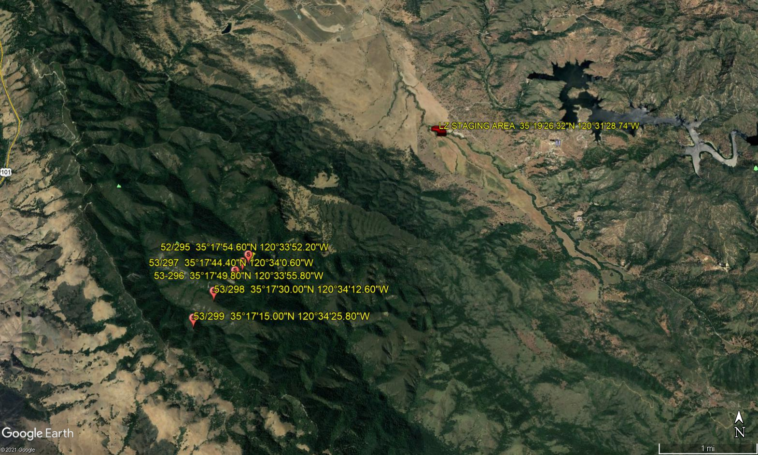
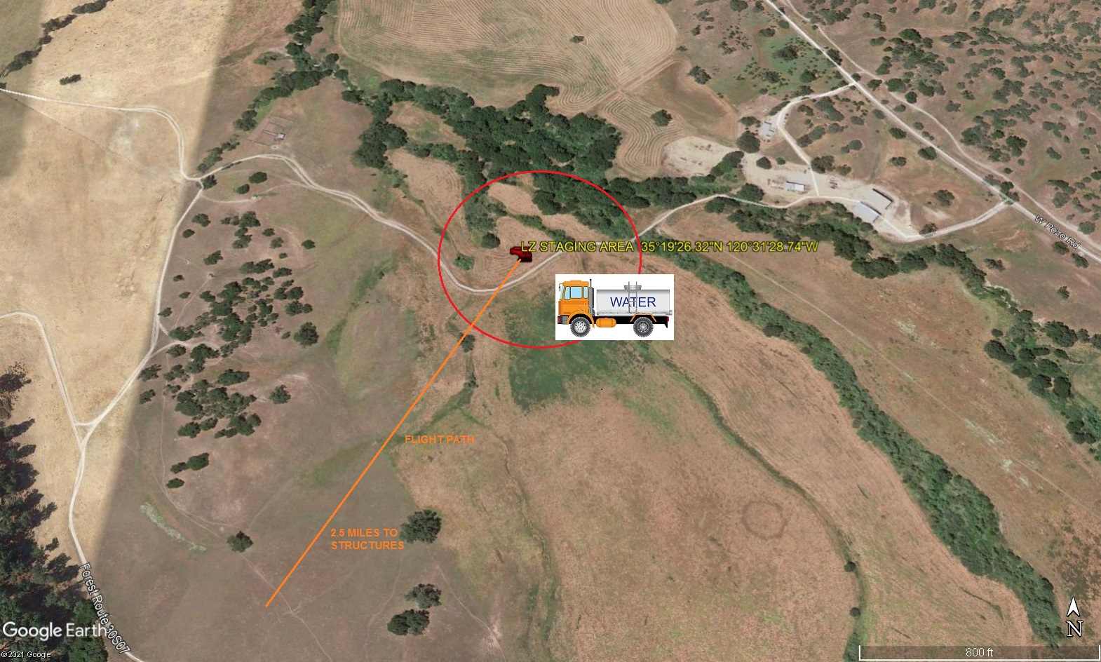
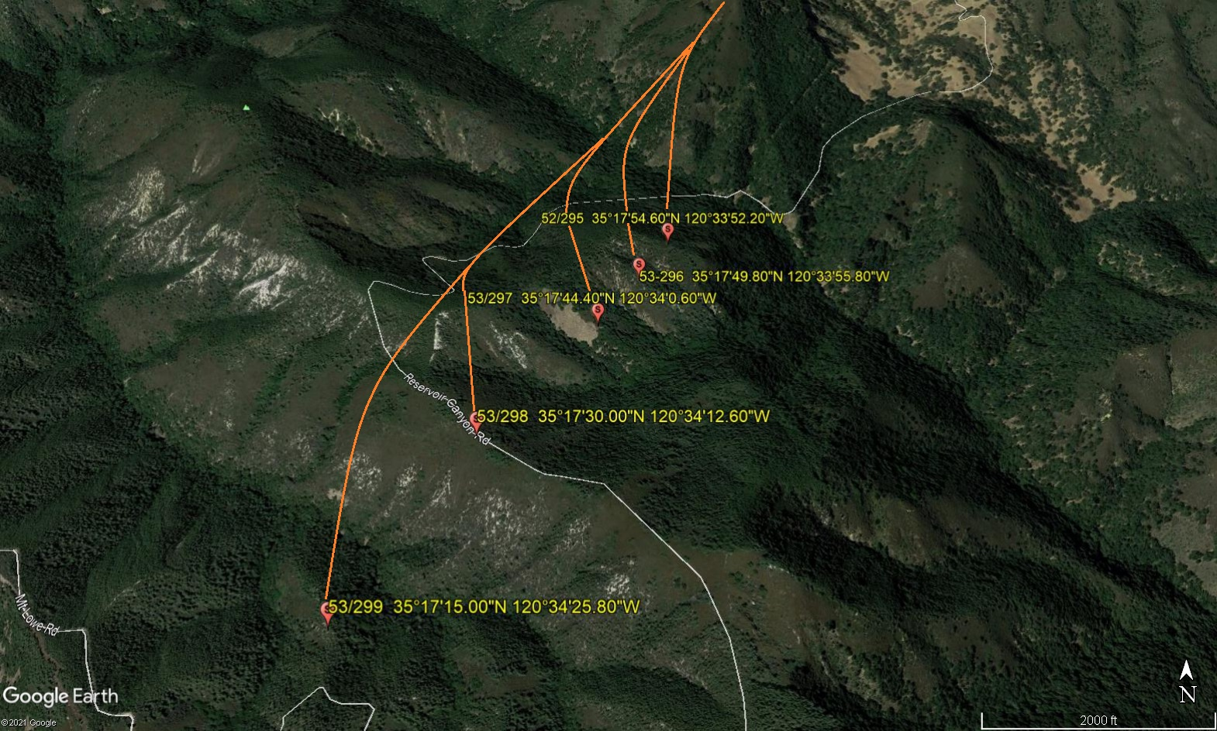

LEGEND
SITE PLAN SYMBOLS: EVACUATION FLIGHT PATH
LANDING AREA = (LZ) | STREET BLOCKED = XXXX | TOP TWO FLOORS = UBT2
ATTACH AREA = (A) | RELEASE AREA = (R)
FLIGHT PATH = >>> | EMERGENCY LAND = (ELZ)
UNOCCUPIED BUILDING = (UB) | UNOCCUPIED BUILDING TOP FLOOR = (UBT1)

4-15-2021 
DATE OF SUBMISSION COMPANY OFFICIAL / TITLE
Jeffrey M. Teubner Flight Coordinator

