
SECTION 7 Part 135 GH 4A Part 133 GH 4L
Congested Area Plan
Operator: Guardian Helicopters, Inc
67 D STREET
Fillmore CA. 93015
Phone (818) 442-9904
FAX (818) 442-9901
BUILDING NAME: CANYON SPRINGS HIGH SCHOOL WORK ORDER # Q2020-393
ADDRESS: 23100 COUGAR DRIVE : CITY/STATE: MORENO VALLEY CA 92557
PHONE: 951-571-4760
POSITION: LATITUDE 33°57'51.56"N LONGITUDE 117°15'36.10"W ELEVATION: 1700 FT
CONTRACTOR’S NAME: ALLISON MECHANICAL PHONE#: 909-654-1165
CONTACT AT SITE: BRIAN BONACIC PHONE #: 909-654-1165
ADDRESS: 1968 ESSEX COURT REDLANDS CA 92373
PILOT’S NAME(S): 1. JOHN OLSON CERT #: 2769166
2. BUCKEY MACKAY CERT #: 2778051
3. MICHAEL KLINK CERT#: 3018828
4. IAN GOODALE CERT#: 3741973
5. ROSS GOULET CERT# :3396777
TYPE OF AIRCRAFT: BELL UH-1H N# N777GH A/C CATEGORY: RESTRICTED
BELL 205 N# N211GH A/C CATEGORY: STANDARD
BELL 205A1 N# N216GH A/C CATEGORY: STANDARD
BELL 407 N# N407GH A/C CATEGORY: STANDARD
BELL 407 N# N447GH A/C CATEGORY: STANDARD
AS350 B2 N# N498PT A/C CATEGORY: STANDARD
AS350 B3 N# N718GH A/C CATEGORY: STANDARD
AS350 B3 N# N215GH A/C CATEGORY: STANDARD
TYPE OF ITEM LIFTING: AC UNITS AERODYNAMIC NON- AERODYNAMIC
IF SAFETY DICTATES AND OR THE CUSTOMER REQUESTS ADDITIONAL LIFTS THE LIFTS WILL BE CONDUCTED REMAINING WITHIN THE APPROVED TIME PARAMETERS.
TYPE OF LIFTS: (0) (3) < 1400 LBS MAX SINGLE – LIFT WEIGHT:1400 LBS CLASS OF LOAD:EXTERNAL CL B NO. OF LIFTS: 3 LONG LINE: (NO) XXX (YES) LESS THEN 100 FT (LENGTH) OPERATIONAL ALTITUDE: < 100 STREET CLOSING: XX (N0) YES)
DATE AND TIMES OPERATION WILL BEGIN AND TERMINATE:
FLIGHT DATES | TIME BEGIN | TIME END | TODAY’S DATE
5-15-2021 | SUNRISE | SUNSET | 5-3-2021
AGENCY NAME: | PHONE#: | PERSON NOTIFIED: | DATE:
MORENO VALLEY PD | 951-486-6700 | DISPATCH | NOTIFY
MORENO VALLEY FD | 951-242-3101 | DISPATCH | NOTIFY
Evacuation Crowd Control Street Closure
□No Evacuated Structures Operator Yes □ No
Evacuated Structures Contractor Contractor
□Operator

NON- Congested Area Plan (Continued)

Operator: Guardian Helicopters, Inc
67 D STREET
Fillmore CA. 93015
Phone (818) 442-9904
FAX (818) 442-9901

LIST OF BUILDINGS THAT SHALL EITHER BE PARTIALLY OR ENTIRELY UNOCCUPIED PERSONS:
BUILDING DESCRIPTION/ADDRESS | OWNER(S): | PHONE #:
CANYON SPRINGS HIGH SCHOOL | DISTRICT | 951-571-4760

Narrative description of pick-up site, route, delivery site, and plan for ceasing operation if unauthorized persons enter operational area or real hazard occurs.
SITE INSPECTION NOTES

ONLY PERSONNEL ESSENTIAL TO COMPLETING THE JOB SAFELY WILL BE PERMITTED TO PARTICIPATE IN THE EVOLUTION. ONLY PERSONNEL PARTICIPATING IN THE SAFETY BRIEF WILL BE PERMITTED TO BE IN THE AREA OF OPERATIONS. ONLY AUTHORIZED ESSENTIAL PERSONAL WILL BE PERMITTED IN THE IMMEDIATE AREA OF OPERATIONS. IN THE EVENT AN UNAUTHORIZED PERSON ENTERS THE OPERATIONS AREA OR A POTENTIAL HAZARD IS IDENTIFIED THE PILOT WILL HOLD THE AIRCRAFT IN RELATIVE POSITION. THIS WILL BE ACHIEVED WITHOUT OVER FLYING THE GROUND CREW. ALL OPERATIONS WILL BE CEASED UNTIL THE PROBLEM IS RECTIFIED. IN THE EVENT OF AN AIRCRAFT EMERGENCY, THE PILOT WILL RADIO GROUND PERSONNEL AND WILL ATTEMPT TO LAND IN THE EMERGENCY LANDING AREA. THE LANDING AND EMERGENCY LANDING AREA IS IN THE PARKING LOT TO THE SOUTH OF THE FACILITY . THE HELICOPTER WILL LAND IN THE LZ TO HOOK UP THE LONG LINE. ALL BUILDINGS IN THE OPERATING AREA WILL BE VACANT.
DURING THE LIFT EVOLUTION THE AIRCRAFT AND GROUND CREW WILL ALL BE IN RADIO COMMUNICATIONS. IN THE EVENT OF LOSS COMMUNICATIONS THE CREW WILL USE STANDARD HAND SIGNALS TO COMMUNICATE WITH THE PILOT. WHEN THE PILOT IS CLEAR HE WILL MOVE THE AIRCRAFT TO A SAFE LOCATION TO ALLOW THE COMMUNICATION PROBLEM TO BE RECTIFIED.
THE OPERATIONS AREA IS WITHIN THE SECURED AREA. ALL ESSENTIAL CREW WITHIN THE OPERATIONS AREA WILL NOT BE INVOLVED IN TAKING PICTURES OR ANY OTHER USE OF CELL PHONES.

1. LANDING ZONE AND EMERGENCY LANDING ZONE IS ASSIGNED
2. ALL AREA IN THE SECURE AREA WILL BE UNOCCUPIED.
3. PEDESTRIANS WILL NOT BE PERMITTED OPERATING AREA
4. SCHOOL CAMPUS WILL BE VACANT DURING OPERATIONS

5-3-2021 
DATE COMPLETED COMPANY OFFICIAL / TITLE

-23-
OPERATIONS AREA DIAGRAM
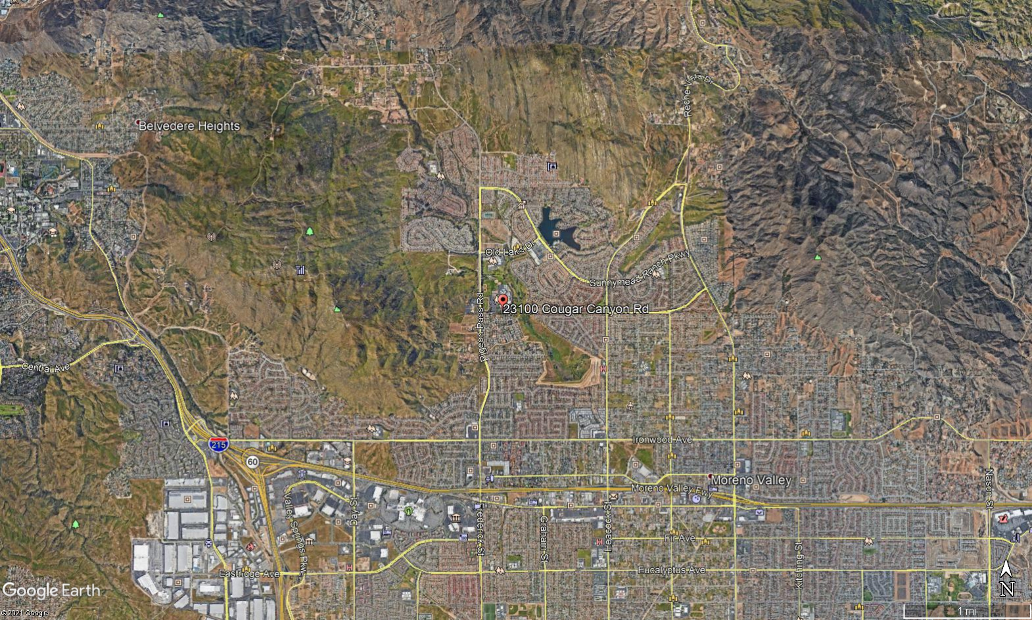
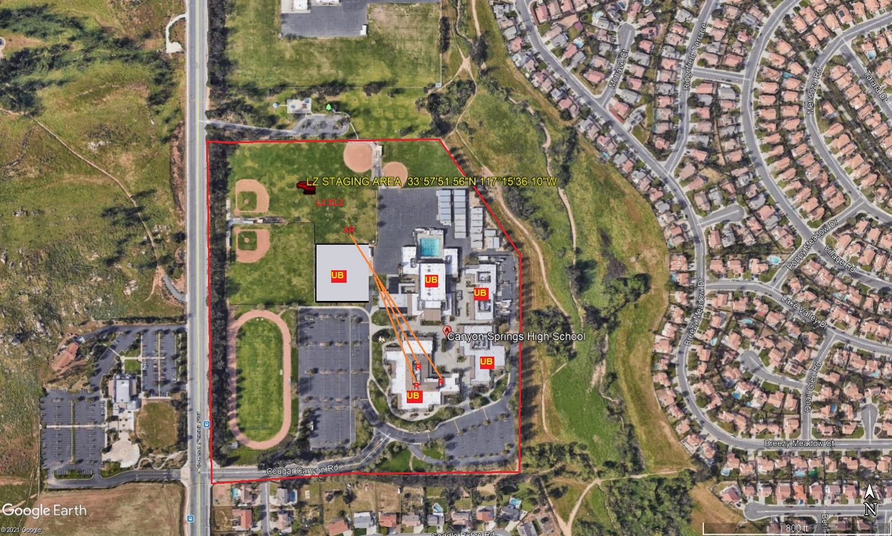
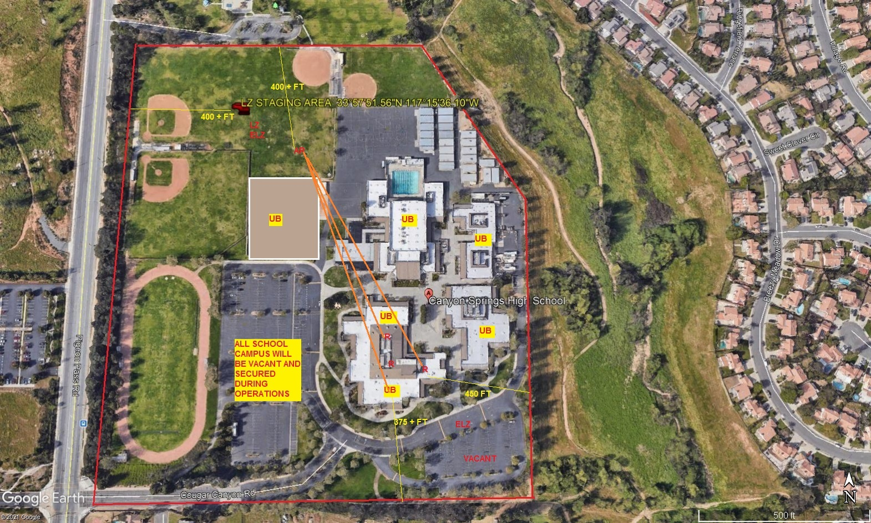
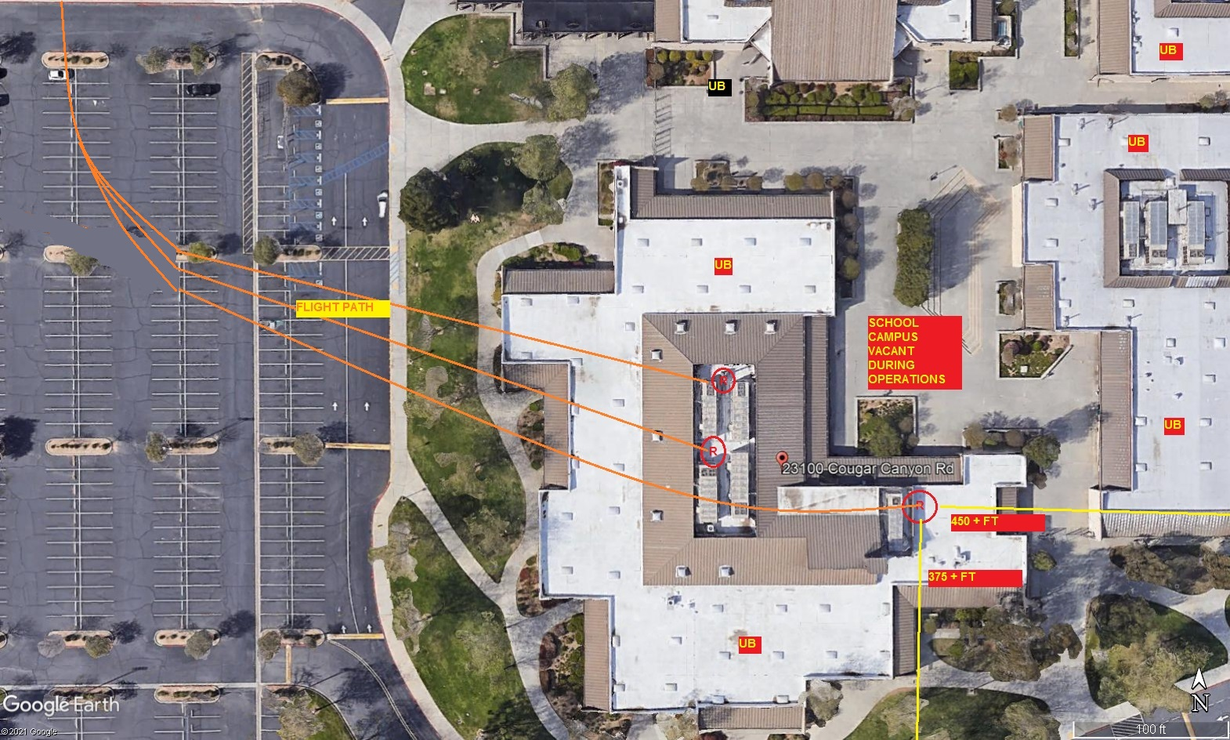
LEGEND
SITE PLAN SYMBOLS: EVACUATION FLIGHT PATH
LANDING AREA = (LZ) | STREET BLOCKED = XXXX | TOP TWO FLOORS = UBT2
ATTACH AREA = (A) | RELEASE AREA = (R)
FLIGHT PATH = >>> | EMERGENCY LAND = (ELZ)
UNOCCUPIED BUILDING = (UB) | UNOCCUPIED BUILDING TOP FLOOR = (UBT1)

5-3-2021
DATE OF SUBMISSION COMPANY OFFICIAL / TITLE
Jeffrey M. Teubner Flight Coordinator

