
SECTION 7 Part 135 GH 4A Part 133 GH 4L
Congested Area Plan
Operator: Guardian Helicopters, Inc
67 D STREET Phone (818) 442-9904
Fillmore CA. 93015 FAX (818) 442-9901
PROJECT: PG&E POLE SET WORK ORDER #: 21-00861
ADDRESS: HWY 50 CITY : KYBURZ STATE: CA
LZ STAGING AREA LATITUDE 38°45'39.49"N LONGITUDE 120°19'32.30"W ELEV 4100 FT
101407164 LATITUDE 38°46'31.80"N LONGITUDE 120°16'10.80"W ELEV 4300 FT
101419671 LATITUDE 38°46'32.40"N LONGITUDE 120°16'10.20"W ELEV 4300 FT
101407161 LATITUDE 38°46'32.97"N LONGITUDE 120°16'9.01"W ELEV 4300 FT
CONTACT REQUESTOR: STEVE WIRTH PHONE#: 503-459-6339
WILSON CONSTRUCTION 5030 HILLSDALE CIRCLE ELDORADO CA 95762
CONTACT FORMAN: MATT GREENE PHONE#: 480-226-2282
PILOT’S NAME(S):
1. JOHN OLSON CERT #: 2769166
2. BUCKEY MACKAY CERT #: 2778051
3. MICHAEL KLINK CERT#: 3018828
4. IAN GOODALE CERT#: 3741973
5. ROSS GOULET CERT#: 3396777
TYPE OF AIRCRAFT:
BELL UH-1H N# N777GH A/C CATEGORY: RESTRICTED
BELL 205A1 N# N216GH A/C CATEGORY: STANDARD

IF RESTRICTED CATEGORY AIRCRAFT IS USED THERE IS A CLEAR FLIGHT PATH INTO THE PART 133 LANDING ZONE. UNPOPULATED.
IF SAFETY DICTATES AND OR THE CUSTOMER REQUESTS ADDITIONAL LIFTS THE LIFTS WILL BE CONDUCTED REMAINING WITHIN THE APPROVED TIME PARAMETERS.
TYPE OF LIFTS: (3) (3) POLES 50 FT H1 (4) GRAVEL,(4) EQUIPMENT MAX 2500 LBS LOAD:EXT CL B
50 FT POLE 10 FT RIGGING 200 FT LONGLINE = MAX 20 FT TYPE OF ITEM LIFTING: AERODYNAMIC NON- AERODYNAMIC LONG LINE: (NO) XXX (YES) LESS 200 FT (LENGTH) OPERATIONAL ALTITUDE: < 500 AGL STREET CLOSING: (N0) XX (YES)
DATE AND TIMES OPERATION WILL BEGIN AND TERMINATE:
FLIGHT DATES | TIME BEGIN | TIME END | TODAY’S DATE
5-20-2021 | SUNRISE | SUNSET | 5-3-2021
AGENCY NAME: | PHONE#: | PERSON NOTIFIED: | DATE:
EL DORADO COUNTY SHERIFF | 530-621-5655 | DISPATCH | 5-14-2021 STEPHANIE
EL DORADO COUNTY FIRE DISTRICT | 530-644-9630 | STATION 16 | 5-14-2021 LAURA

Part 135 GH 4A Part 133 GH 4L
NON Congested Area Plan

Evacuation Crowd Control Street Closure
□No Evacuated Structures Operator Yes □No
Evacuated Structures Contractor Contractor
□Operator
FLAGMAN WILL BE PROVIDED BY WILSON CONSTRUCTION SEE CONTACT LIST ABOVE
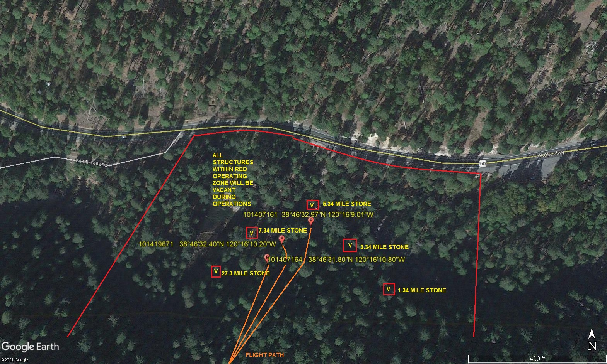

LIST OF BUILDINGS THAT SHALL BE UNOCCUPIED DURING OPERATIONS:

BUILDING DESCRIPTION/ADDRESS | REMARKS | METHOD
7.34 MILE STONE | VACANT DURING OPS | HAND DELIVER
27.34 MILE STONE | VACANT DURING OPS | HAND DELIVER
5.34 MILE STONE | VACANT DURING OPS | HAND DELIVER
3.34 MILE STONE | VACANT DURING OPS | HAND DELIVER
1-34 MILE STONE | VACANT DURING OPS | HAND DELIVER
ALL HOMES WITHIN RED OPERATING AREA | VACANT DURING OPS | HAND DELIVER
SEE DIAGRAM = VACANT | VACANT DURING OPS | HAND DELIVER
Narrative description of pick-up site, route, delivery site, and plan for ceasing operation if unauthorized persons enter operational area or real hazard occurs.
SITE INSPECTION NOTES
ONLY PERSONNEL ESSENTIAL TO COMPLETING THE JOB SAFELY WILL BE PERMITTED TO PARTICIPATE IN THE EVOLUTION. ONLY PERSONNEL PARTICIPATING IN THE SAFETY BRIEF WILL BE PERMITTED TO BE IN THE AREA OF OPERATIONS. ONLY AUTHORIZED ESSENTIAL PERSONAL WILL BE PERMITTED IN THE IMMEDIATE AREA OF OPERATIONS. IN THE EVENT AN UNAUTHORIZED PERSON ENTERS THE OPERATIONS AREA OR A POTENTIAL
HAZARD IS IDENTIFIED THE PILOT WILL HOLD THE AIRCRAFT IN RELATIVE POSITION. THIS WILL BE ACHIEVED WITHOUT OVER FLYING THE GROUND CREW. ALL OPERATIONS WILL BE CEASED UNTIL THE PROBLEM IS RECTIFIED. IN THE EVENT OF AN AIRCRAFT EMERGENCY, THE PILOT WILL RADIO GROUND PERSONNEL AND WILL ATTEMPT TO LAND IN THE EMERGENCY LANDING AREA.
DURING THE LIFT EVOLUTION THE AIRCRAFT AND GROUND CREW WILL ALL BE IN RADIO COMMUNICATIONS. IN THE EVENT OF LOSS COMMUNICATIONS, THE CREW WILL USE STANDARD HAND SIGNALS TO COMMUNICATE WITH THE PILOT. WHEN THE PILOT IS CLEAR HE WILL MOVE THE AIRCRAFT TO A SAFE LOCATION TO ALLOW THE COMMUNICATION PROBLEM TO BE RECTIFIED.
THE OPERATIONS AREA IS WITHIN THE SECURED AREA. ALL ESSENTIAL CREW WITHIN THE OPERATIONS AREA WILL NOT BE INVOLVED IN TAKING PICTURES OR ANY OTHER USE OF CELL PHONES.
.
PRIOR TO BEGINNING OPERATIONS, A TAILBOARD SAFETY BRIEF WILL BE CONDUCTED.

- HELICOPTER WILL LAND AT THE LANDING ZONE TO CONDUCT TAILBOARD.
- THE NEW POLE WILL BE STAGED AT THE LZ
- TAILBOARD WILL BE CONDUCTED AT LANDING ZONE
- WATER TRUCK IS REQUIRED AT LANDING AREAS
- EVACUATIONS PER DIAGRAM
- STREET CLOSURE AT POLE STAGING AREA SEE DIAGRAM
- TREE TRIMMING IF REQUIRED

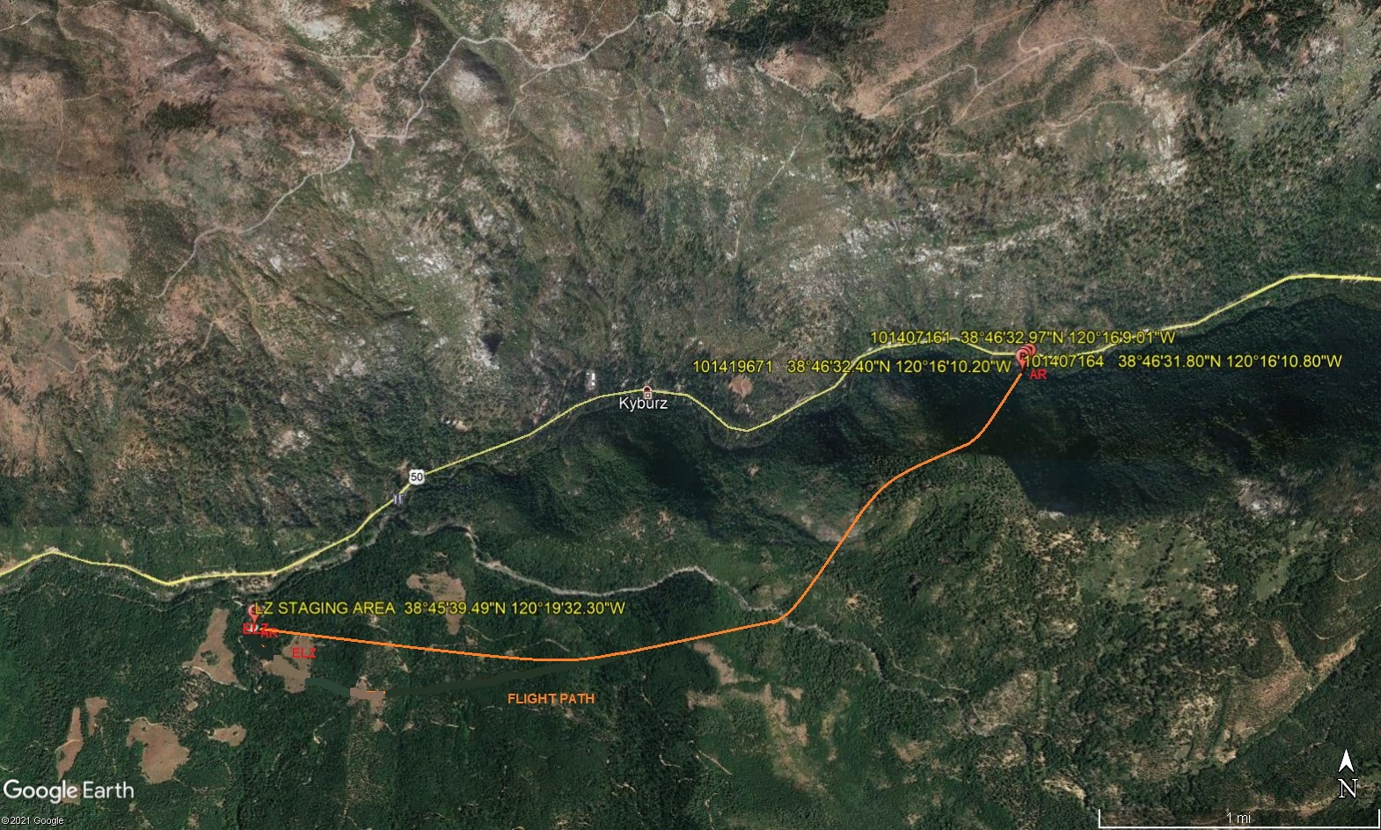
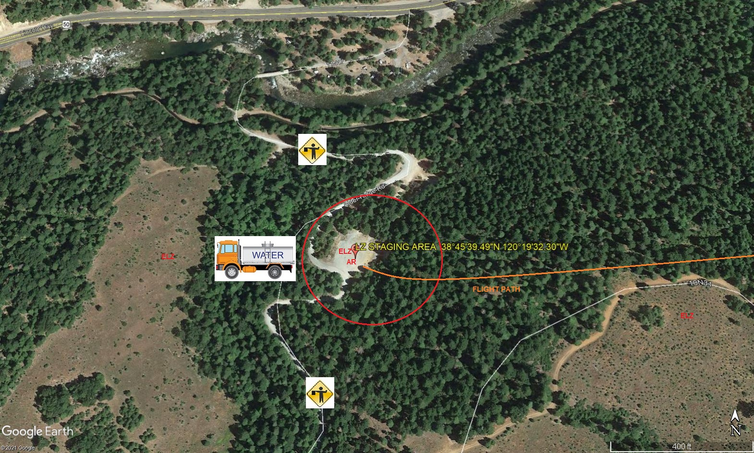
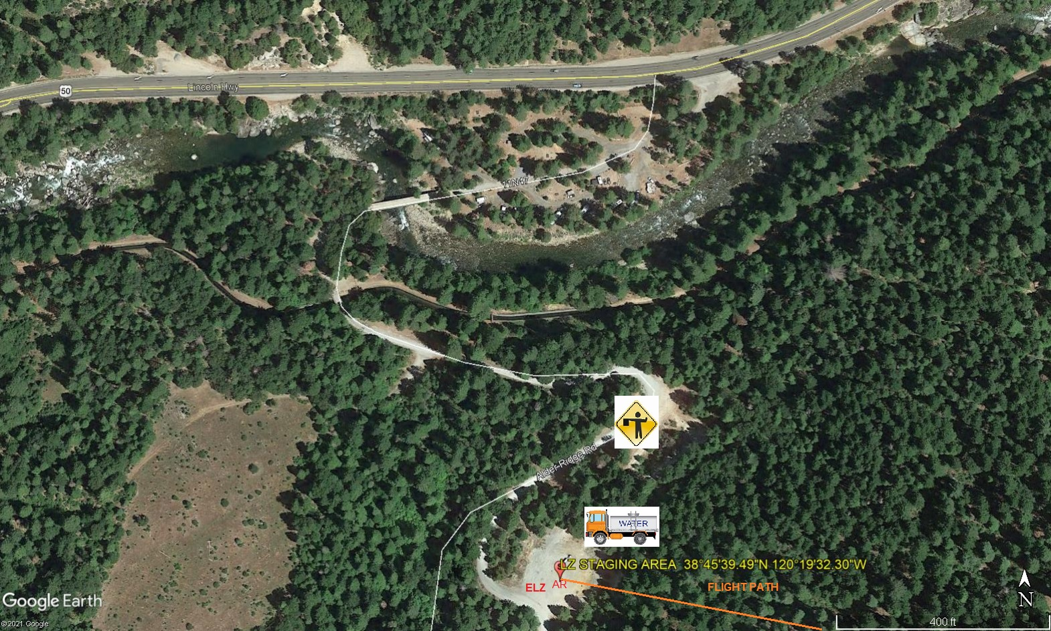
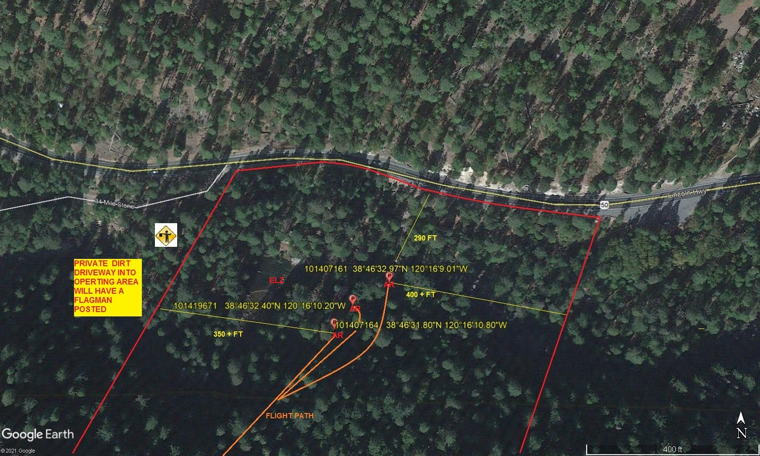
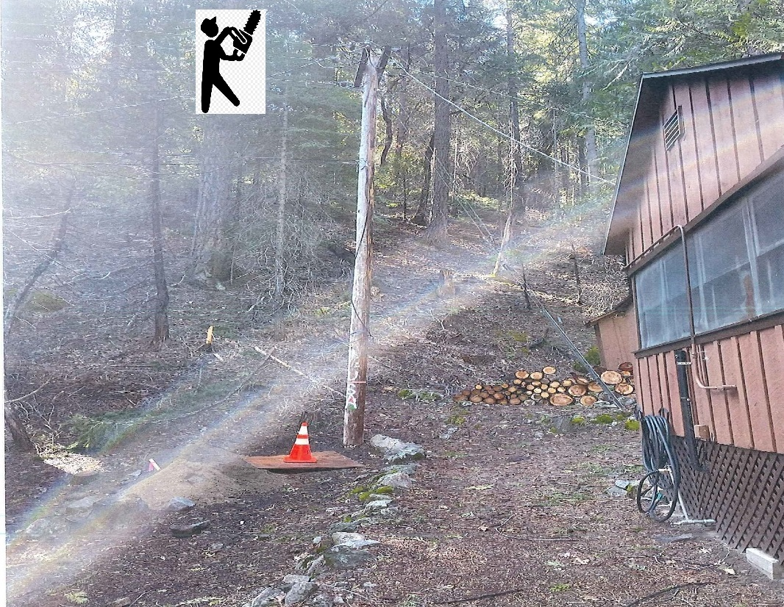
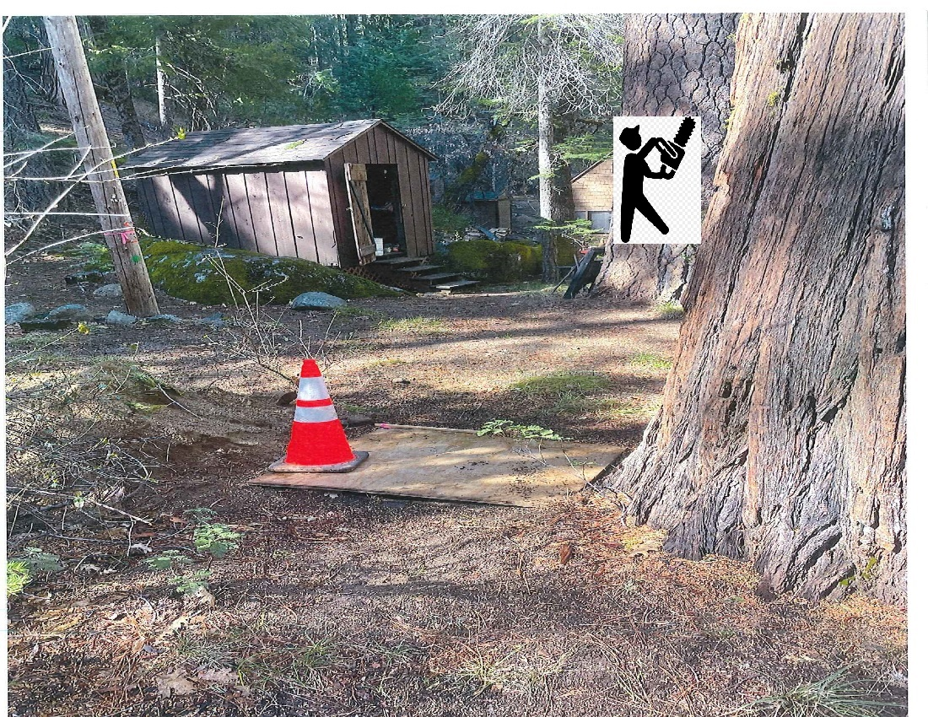
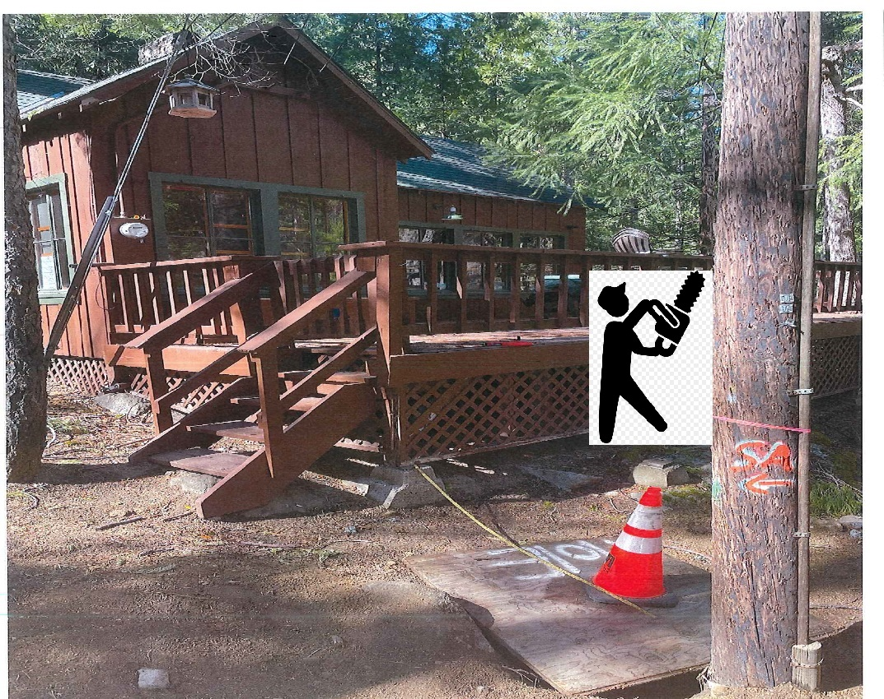
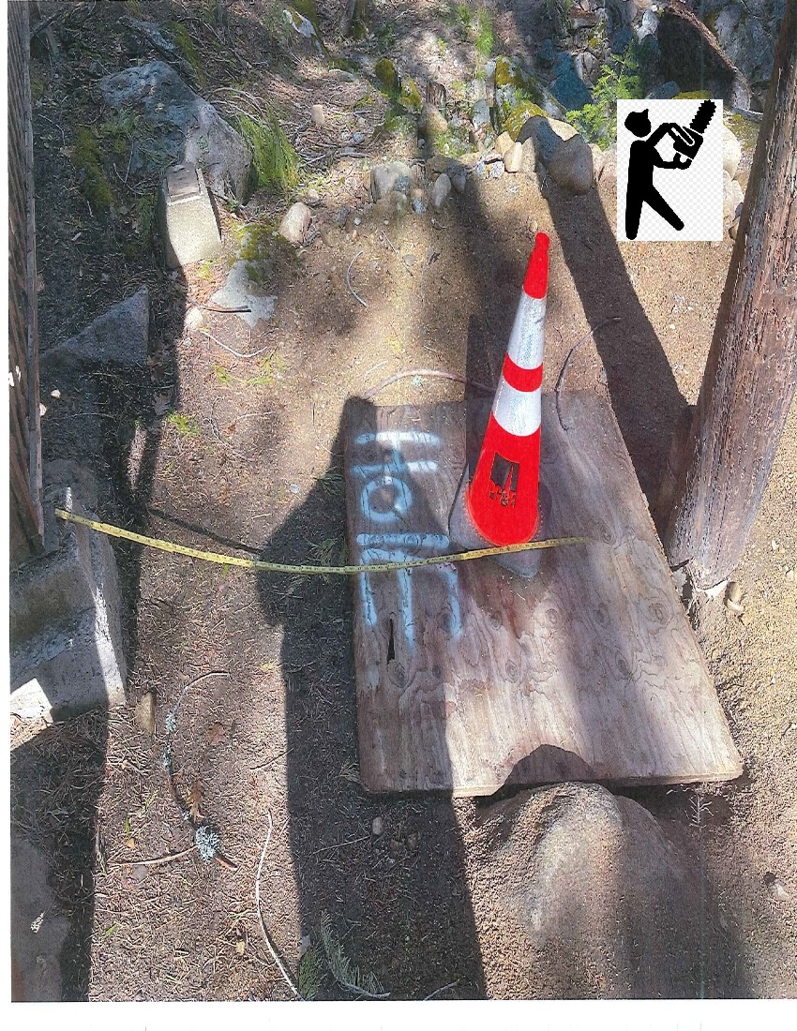
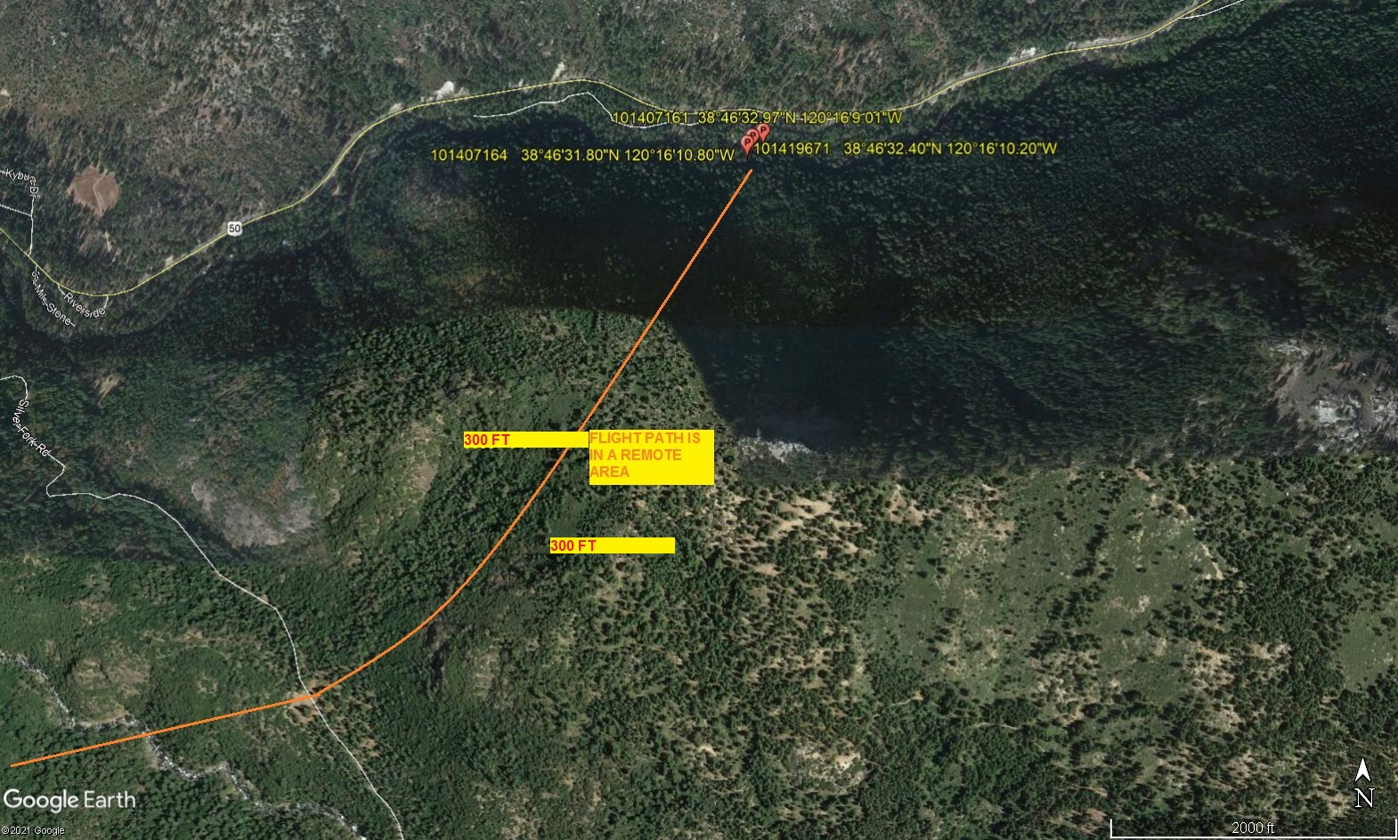
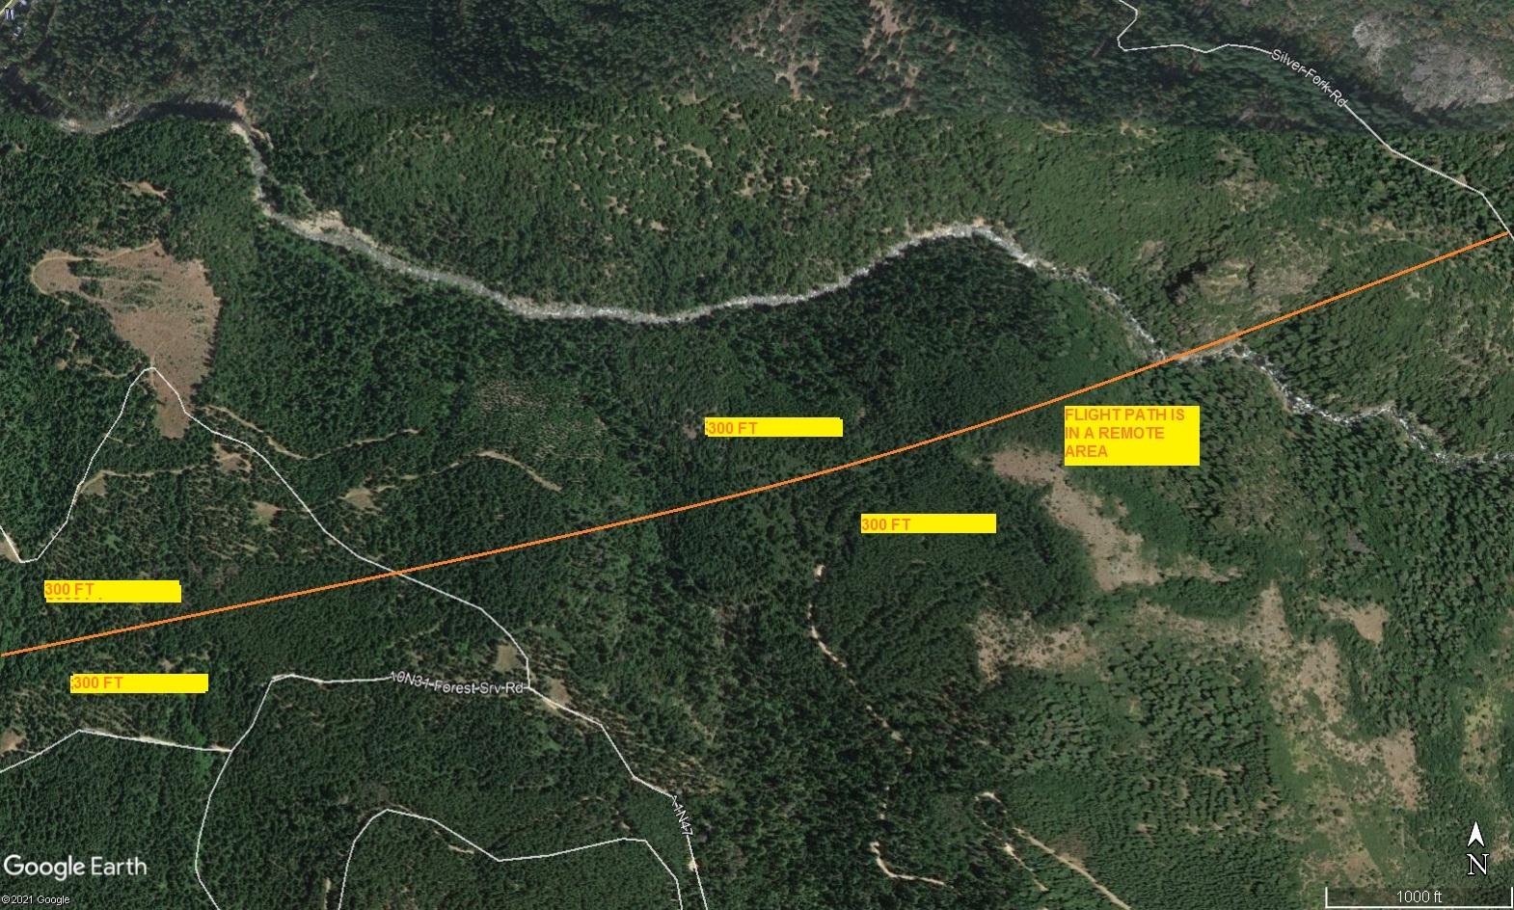
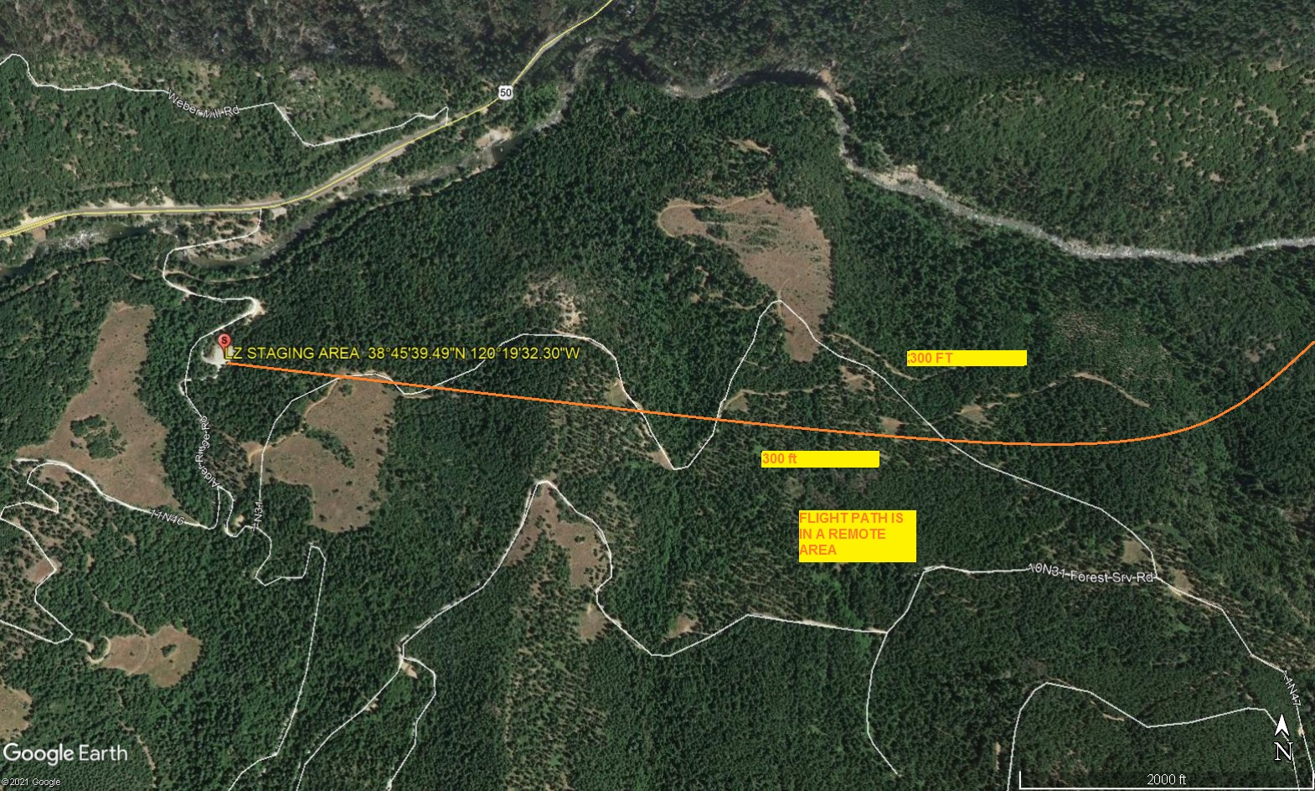LEGEND
SITE PLAN SYMBOLS: EVACUATION FLIGHT PATH
LANDING AREA = (LZ) | STREET BLOCKED = XXXX | TOP TWO FLOORS = UBT2
ATTACH AREA = (A) | RELEASE AREA = (R)
FLIGHT PATH = >>> | EMERGENCY LAND = (ELZ)
UNOCCUPIED BUILDING = (UB) | UNOCCUPIED BUILDING TOP FLOOR = (UBT1)

5-4-2021 
DATE OF SUBMISSION COMPANY OFFICIAL / TITLE
Jeffrey M. Teubner Flight Coordinator

