
SECTION 7 Part 135 GH 4A Part 133 GH 4L
Congested Area Plan
Operator: Guardian Helicopters, Inc
67 D STREET Phone (818) 442-9904
Fillmore CA. 93015 FAX (818) 442-9901
PROJECT: A/C SET WORK ORDER #: GHI Q2021-397
ADDRESS: 7525 VALJEAN AVE CITY : VAN NUYS STATE: CA
LATITUDE 34°12'23.94"N LONGITUDE 118°29'11.48"W

CONTACTOR: PACIFIC MECHANICAL CONTRACTORS PHONE#: 626-960-3971
14120 LIVE OAK AVE BALDWIN PARK CA 91706

CONTACT ON SITE: JOHN FERNADAZ PHONE#: 626-960-3971
PILOT’S NAME(S):
1. JOHN OLSON CERT #: 2769166
2. BUCKEY MACKAY CERT #: 2778051
3. MICHAEL KLINK CERT#: 3018828
4. IAN GOODALE CERT#: 3741973
5. ROSS GOULET CERT#: 3396777
TYPE OF AIRCRAFT:
AS350B3 N# N718GH A/C CATEGORY: STANDARD
AS350BA N# N55TV A/C CATEGORY: STANDARD

IF RESTRICTED CATEGORY AIRCRAFT IS USED THERE IS A CLEAR FLIGHT PATH INTO THE PART 133 LANDING ZONE. UNPOPULATED.
IF SAFETY DICTATES AND OR THE CUSTOMER REQUESTS ADDITIONAL LIFTS THE LIFTS WILL BE CONDUCTED REMAINING WITHIN THE APPROVED TIME PARAMETERS.
TYPE OF LIFTS: (0) (22) A/C UNITS MAX 1000 LBS LOAD:EXT CL B
25 FT RIGGING 50 FT LONGLINE = MAX 75 FT TYPE OF ITEM LIFTING: AERODYNAMIC NON- AERODYNAMIC LONG LINE: (NO) XXX (YES) LESS 50 FT (LENGTH) OPERATIONAL ALTITUDE: < 160 AGL STREET CLOSING: (N0) XX (YES)
DATE AND TIMES OPERATION WILL BEGIN AND TERMINATE:
FLIGHT DATES | TIME BEGIN | TIME END | TODAY’S DATE
7-19-2021 | SUNRISE | SUNSET | 7-10-2021
AGENCY NAME: | PHONE#: | PERSON NOTIFIED: | DATE:
VAN NUYS POLICE DEPARTMENT | 818-374-9500 | DISPATCH | 7-12-2021
VAN NUYS FIRE DEPARTMENT | 818-756-8690 | STATION 90 | 7-12-2021
VAN NUYS TOWER | 818-442-6500 |  | ON THE DAY
VAN NUYS ATC | 818-904-6166 |  | ON THE DAY
Evacuation Crowd Control Street Closure
□No Evacuated Structures Operator Yes □No
Evacuated Structures Contractor Contractor
□Operator

Part 135 GH 4A Part 133 GH 4L
Congested Area Plan

LIST OF BUILDINGS THAT SHALL BE UNOCCUPIED DURING OPERATIONS:

BUILDING DESCRIPTION/ADDRESS | REMARKS | METHOD
7525 VAL JEAN AVE VAN NUYS CA | VACANT DURING OPS | HAND DELIVER
ALL HOMES WITHIN RED OPERATING AREA | VACANT DURING OPS | HAND DELIVER
SEE DIAGRAM = VACANT | VACANT DURING OPS | HAND DELIVER
Narrative description of pick-up site, route, delivery site, and plan for ceasing operation if unauthorized persons enter operational area or real hazard occurs.
SITE INSPECTION NOTES
ONLY PERSONNEL ESSENTIAL TO COMPLETING THE JOB SAFELY WILL BE PERMITTED TO PARTICIPATE IN THE EVOLUTION. ONLY PERSONNEL PARTICIPATING IN THE SAFETY BRIEF WILL BE PERMITTED TO BE IN THE AREA OF OPERATIONS. ONLY AUTHORIZED ESSENTIAL PERSONAL WILL BE PERMITTED IN THE IMMEDIATE AREA OF OPERATIONS. IN THE EVENT AN UNAUTHORIZED PERSON ENTERS THE OPERATIONS AREA OR A POTENTIAL
HAZARD IS IDENTIFIED THE PILOT WILL HOLD THE AIRCRAFT IN RELATIVE POSITION. THIS WILL BE ACHIEVED WITHOUT OVER FLYING THE GROUND CREW. ALL OPERATIONS WILL BE CEASED UNTIL THE PROBLEM IS RECTIFIED. IN THE EVENT OF AN AIRCRAFT EMERGENCY, THE PILOT WILL RADIO GROUND PERSONNEL AND WILL ATTEMPT TO LAND IN THE EMERGENCY LANDING AREA.
DURING THE LIFT EVOLUTION THE AIRCRAFT AND GROUND CREW WILL ALL BE IN RADIO COMMUNICATIONS. IN THE EVENT OF LOSS COMMUNICATIONS, THE CREW WILL USE STANDARD HAND SIGNALS TO COMMUNICATE WITH THE PILOT. WHEN THE PILOT IS CLEAR HE WILL MOVE THE AIRCRAFT TO A SAFE LOCATION TO ALLOW THE COMMUNICATION PROBLEM TO BE RECTIFIED.
THE OPERATIONS AREA IS WITHIN THE SECURED AREA. ALL ESSENTIAL CREW WITHIN THE OPERATIONS AREA WILL NOT BE INVOLVED IN TAKING PICTURES OR ANY OTHER USE OF CELL PHONES.
.
PRIOR TO BEGINNING OPERATIONS, A TAILBOARD SAFETY BRIEF WILL BE CONDUCTED.

- HELICOPTER WILL LAND AT THE LANDING ZONE TO CONDUCT TAILBOARD.
- THE UNITS WILL BE IN THE STAGING ORDER IN NUMERICAL ORDER PER THE DIAGRAM
- BUILDING WILL BE VACANT DURING OPERATIONS
- THE OPERATING AREA WILL BE CLEAR DURING OPERATION
- NO VEHICLE MOVEMENT DURING OPERATION
- ENTRANCES TO THE FACILITY WILL BE BLOCKED DURING OPERATIONS
- OPERATION WILL BE CLEAR OF DEBRIS
- VAL JEAN WILL BE CLOSED DURING OPERATIONS
NARRATIVE
GHI will be conducting air conditioning replacement on subject building. The units being lifted will be staged on the Westside of the building approximately 75-85 ft from the building. The units will be over 250 ft from the airport service road. The contractor will have two people staged at the threshold of the ramp and service road to ensure vehicles don’t turn into the operating area. We will be lifting the row of 4 units closest to Valjean first. North and South bound lanes of Valjean will be closed while setting this row. We will than move to the row to the west. This row if over 105 ft from Valjean and therefor does not require the closure of the north or south bound lanes. We will continue to work our way to west until complete. During the operation subject building ramp and property will be vacant of nonessential personnel.

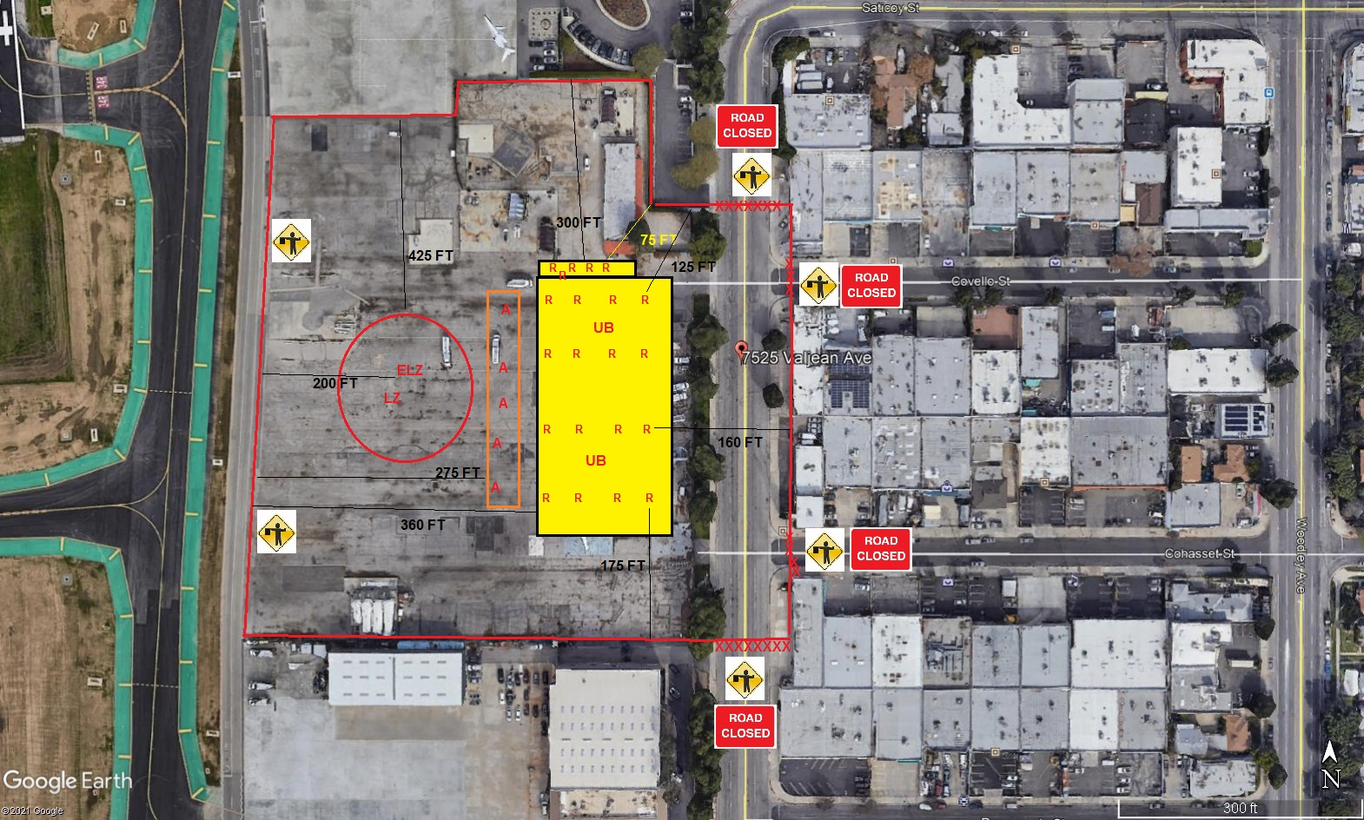
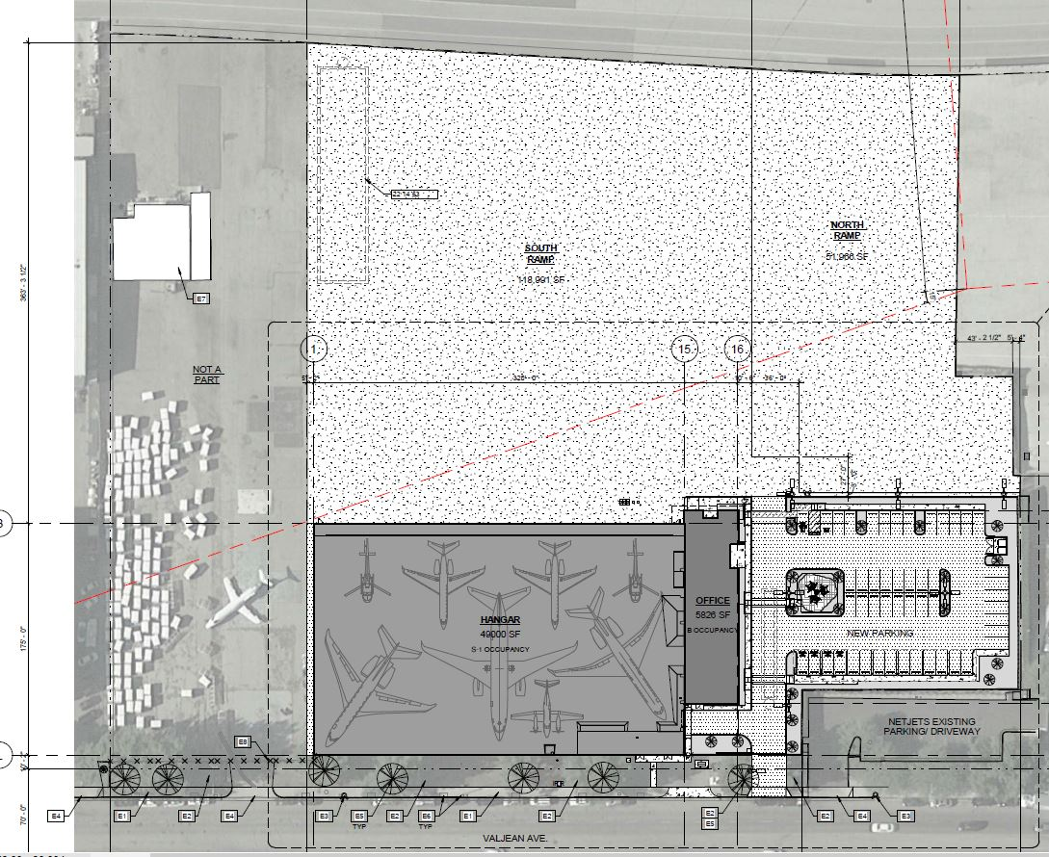
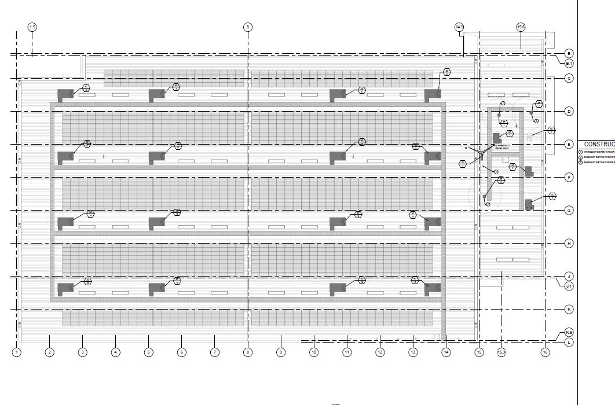
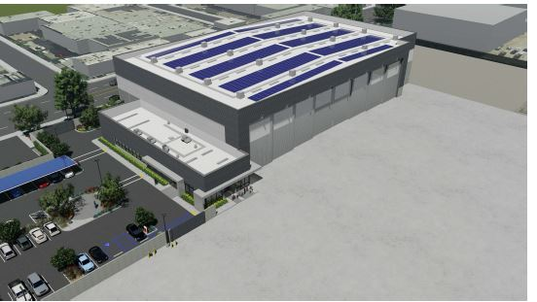
LEGEND
SITE PLAN SYMBOLS: EVACUATION FLIGHT PATH
LANDING AREA = (LZ) | STREET BLOCKED = XXXX | TOP TWO FLOORS = UBT2
ATTACH AREA = (A) | RELEASE AREA = (R)
FLIGHT PATH = >>> | EMERGENCY LAND = (ELZ)
UNOCCUPIED BUILDING = (UB) | UNOCCUPIED BUILDING TOP FLOOR = (UBT1)

7-12-2021 
DATE OF SUBMISSION COMPANY OFFICIAL / TITLE
Jeffrey M. Teubner Flight Coordinator

