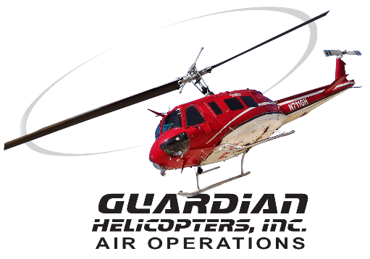
SECTION 7 Part 135 GH 4A Part 133 GH 4L
Congested Area Plan
Operator: Guardian Helicopters, Inc
67 D STREET
Fillmore CA. 93015
Phone (818) 442-9904
FAX (818) 442-9901
BUILDING NAME: NORTHRIDGE FASHION CENTER WORK ORDER # Q2021-399
ADDRESS: 9301 TAMPA AVE: CITY/STATE: NORTHRIDGE CA 91324 PHONE: 818-885-9700
POSITION: LATITUDE 34°14'11.19"N LONGITUDE 118°33'21.12"W ELEVATION: 875 FT
CONTRACTOR’S NAME: ALL TEMPERATURE CONTROL PHONE#: 818-882-1478
9720 TOPANGA CANYON PLACE CHATSWORTH CA 91311
CONTACT AT SITE: KERRY TABAK PHONE #: 818-882-1478
ADDRESS: 1968 ESSEX COURT REDLANDS CA 92373
PILOT’S NAME(S): 1. KEN JOHNSON CERT #: 2757335
2. JOHN OLSON CERT #: 2769166
3. BUCKEY MACKAY CERT #: 2778051
4. MICHAEL KLINK CERT#: 3018828
5. IAN GOODALE CERT#: 3741973
6. ROSS GOULET CERT#:3396777
7.CHRIS CURRIER CERT#:3093383
8. ROBERT SATZ CERT#:2629853
9.TREVOR NEEDHAM CERT#:3597668
10.KYLE JENSEN CERT#:3597668
TYPE OF AIRCRAFT: BELL UH-1H N# N777GH A/C CATEGORY: RESTRICTED
BELL 205 N# N211GH A/C CATEGORY: STANDARD
BELL 205A1 N# N216GH A/C CATEGORY: STANDARD
BELL 407 N# N407GH A/C CATEGORY: STANDARD
BELL 407 N# N447GH A/C CATEGORY: STANDARD
AS350 B2 N# N498PT A/C CATEGORY: STANDARD
AS350 B3 N# N718GH A/C CATEGORY: STANDARD
AS350 B3 N# N215GH A/C CATEGORY: STANDARD
TYPE OF ITEM LIFTING: AC UNITS AERODYNAMIC NON- AERODYNAMIC
IF SAFETY DICTATES AND OR THE CUSTOMER REQUESTS ADDITIONAL LIFTS THE LIFTS WILL BE CONDUCTED REMAINING WITHIN THE APPROVED TIME PARAMETERS.
TYPE OF LIFTS: (1) (1) < 2100 LBS MAX SINGLE – LIFT WEIGHT:2100 LBS CLASS OF LOAD:EXTERNAL CL B NO. OF LIFTS: 2 LONG LINE: (NO) XXX (YES) LESS THEN 50 FT (LENGTH) 50 FT LONG LINE + 25 FT RIGGING = 75 FT SUSPENDED LOAD OPERATIONAL ALTITUDE: < 100 STREET CLOSING: XX (N0) YES)
DATE AND TIMES OPERATION WILL BEGIN AND TERMINATE:
FLIGHT DATES | TIME BEGIN | TIME END | TODAY’S DATE
1-13-2022 | SUNRISE | SUNSET | 1-1-2022
AGENCY NAME: | PHONE#: | PERSON NOTIFIED: | DATE:
LOS ANGELES PD | 818-832-0633 | DEVONSHIRE STATION | NOTIFY
LOS ANGELES FD | 818-756-7670 | STATION 70 | NOTIFY
Congested Area Plan (Continued)
Evacuation Crowd Control Street Closure
□No Evacuated Structures Operator Yes □ No
Evacuated Structures Contractor Contractor
□Operator
LIST OF BUILDINGS THAT SHALL EITHER BE PARTIALLY OR ENTIRELY UNOCCUPIED PERSONS:
BUILDING DESCRIPTION/ADDRESS | OWNER(S): | PHONE #:
NORTHRIDGE FASHION CENTER | MANAGEMENT | 818-885-9700

Narrative description of pick-up site, route, delivery site, and plan for ceasing operation if unauthorized persons enter operational area or real hazard occurs.
SITE INSPECTION NOTES

ONLY PERSONNEL ESSENTIAL TO COMPLETING THE JOB SAFELY WILL BE PERMITTED TO PARTICIPATE IN THE EVOLUTION. ONLY PERSONNEL PARTICIPATING IN THE SAFETY BRIEF WILL BE PERMITTED TO BE IN THE AREA OF OPERATIONS. ONLY AUTHORIZED ESSENTIAL PERSONAL WILL BE PERMITTED IN THE IMMEDIATE AREA OF OPERATIONS. IN THE EVENT AN UNAUTHORIZED PERSON ENTERS THE OPERATIONS AREA OR A POTENTIAL HAZARD IS IDENTIFIED THE PILOT WILL HOLD THE AIRCRAFT IN RELATIVE POSITION. THIS WILL BE ACHIEVED WITHOUT OVER FLYING THE GROUND CREW. ALL OPERATIONS WILL BE CEASED UNTIL THE PROBLEM IS RECTIFIED. IN THE EVENT OF AN AIRCRAFT EMERGENCY, THE PILOT WILL RADIO GROUND PERSONNEL AND WILL ATTEMPT TO LAND IN THE EMERGENCY LANDING AREA..
DURING THE LIFT EVOLUTION THE AIRCRAFT AND GROUND CREW WILL ALL BE IN RADIO COMMUNICATIONS. IN THE EVENT OF LOSS COMMUNICATIONS THE CREW WILL USE STANDARD HAND SIGNALS TO COMMUNICATE WITH THE PILOT. WHEN THE PILOT IS CLEAR HE WILL MOVE THE AIRCRAFT TO A SAFE LOCATION TO ALLOW THE COMMUNICATION PROBLEM TO BE RECTIFIED.
THE OPERATIONS AREA IS WITHIN THE SECURED AREA. ALL ESSENTIAL CREW WITHIN THE OPERATIONS AREA WILL NOT BE INVOLVED IN TAKING PICTURES OR ANY OTHER USE OF CELL PHONES.
THE LANDING AND EMERGENCY LANDING AREA IS IN THE PARKING LOT TO THE SOUTH OF DICKS SPORTING GOODS . THE HELICOPTER WILL LAND IN THE LZ TO HOOK UP THE LONG LINE. ALL BUILDINGS IN THE OPERATING AREA WILL BE VACANT
A TAILBOARD SAFETY MEETING WILL BE HELD AT THE ASSIGNED AREA PRIOR TO BEGINNING HELICOPTER OPERATIONS
- GROUND CREW WILL ARRIVE AT SITE TO CONDUCT AN INSPECTION TO DETERMINE THE SECURE OPERATING AREA IS PREPARED
- THE GROUND CREW WILL RIG THE NEW AND OLD UNITS FOR LIFTING
- THE HELICOPTER WILL LAND AT THE ASSIGNED LANDING ZONE AT APPROX 0730
- THE SUBJECT BUILDING, PARKING LOT WILL BE VACANT.
- AFTER CONDUCTING A TAILBOARD SAFETY BRIEF THE GROUND CREW WILL VERIFY THE MALL IS UNOCCUPIED. ,
- SECURITY WILL BE RESPONSIBLE TO ENSURE THE INSIDE OF THE MALL REMAIN VACANT DURING THE OPERATIONS
- THE PARKING LOT WILL BE CAUTION TAPED OF TO ENSURE IT REMAINS CLEAR
- GHI GROUND CREW WILL VERIFY OPERATING AREA IS STERILE
- THE GHI GROUND CREW AND PILOT WILL BE IN RADIO COMMUNICATIONS DURING THE OPERATIONS
- CUSTOMER WILL ENSURE OPERATING AREA REMAINS STERILE
- EMERGENCY LANDING ZONE IS AT THE STAGING AREA AND ON THE ROOF TOP HELIPAD

OPERATIONS AREA DIAGRAM
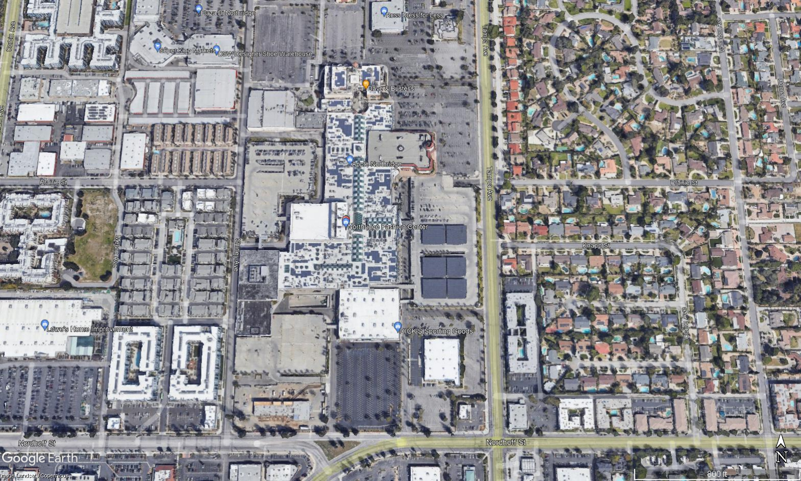
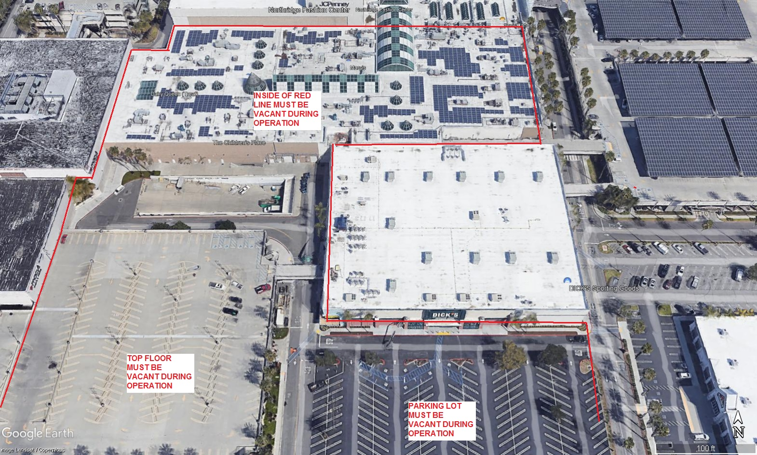
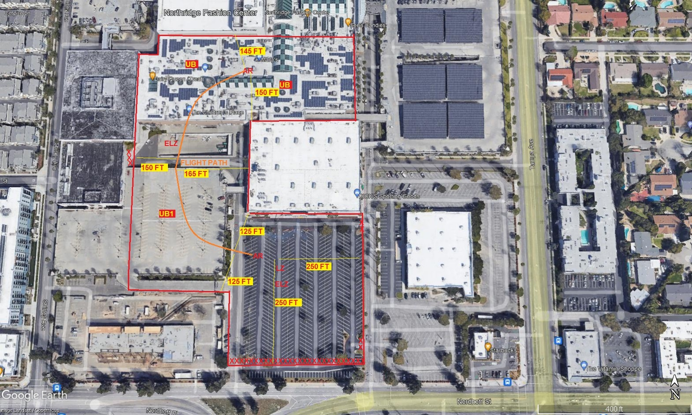

LEGEND
SITE PLAN SYMBOLS: EVACUATION FLIGHT PATH
LANDING AREA = (LZ) | STREET BLOCKED = XXXX | TOP TWO FLOORS = UBT2
ATTACH AREA = (A) | RELEASE AREA = (R)
FLIGHT PATH = >>> | EMERGENCY LAND = (ELZ)
UNOCCUPIED BUILDING = (UB) | UNOCCUPIED BUILDING TOP FLOOR = (UBT1)

10-19-2021 
DATE OF SUBMISSION COMPANY OFFICIAL / TITLE
Jeffrey M. Teubner Flight Coordinator

